# **Spotphish Installation**

1. Download Spotphish. It can be done in two ways,  
   1. spotphish repository is hosted on github. Clone the repo (preferred way)  
        
      # git clone <https://github.com/spotphish/spotphish>  
      # cd spotphish/  
      # git checkout spotphish
   2. Or directly download the zip file from github. Go to link and download zip file <https://github.com/spotphish/spotphish/tree/spotphish>

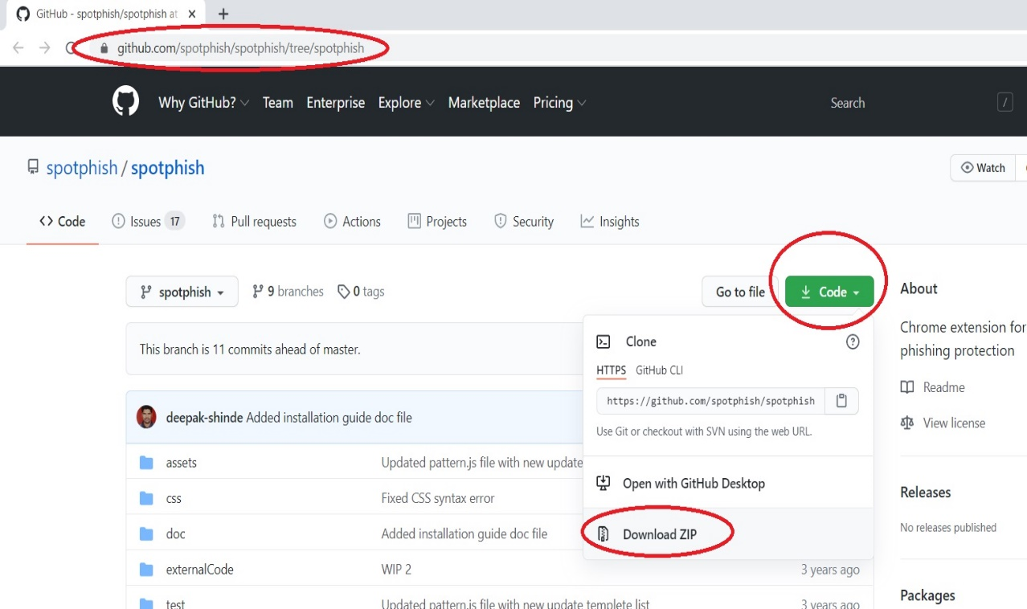

* Downloaded file name will be spotphish-spotphish.zip. Unzip it
* Extracted directory name will be spotphish-spotphish. Rename it to spotphish (not mandatory)  
    
  Content of spotphish will look like this.  
    
    
  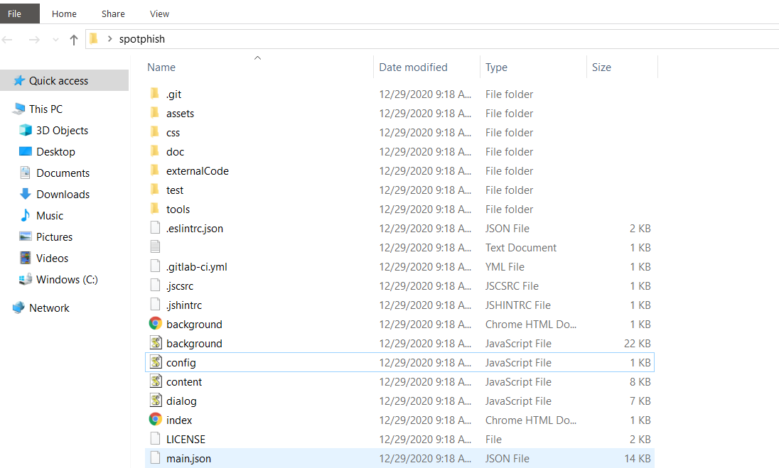

1. Open chrome browser and navigate to extensions  
     
     
   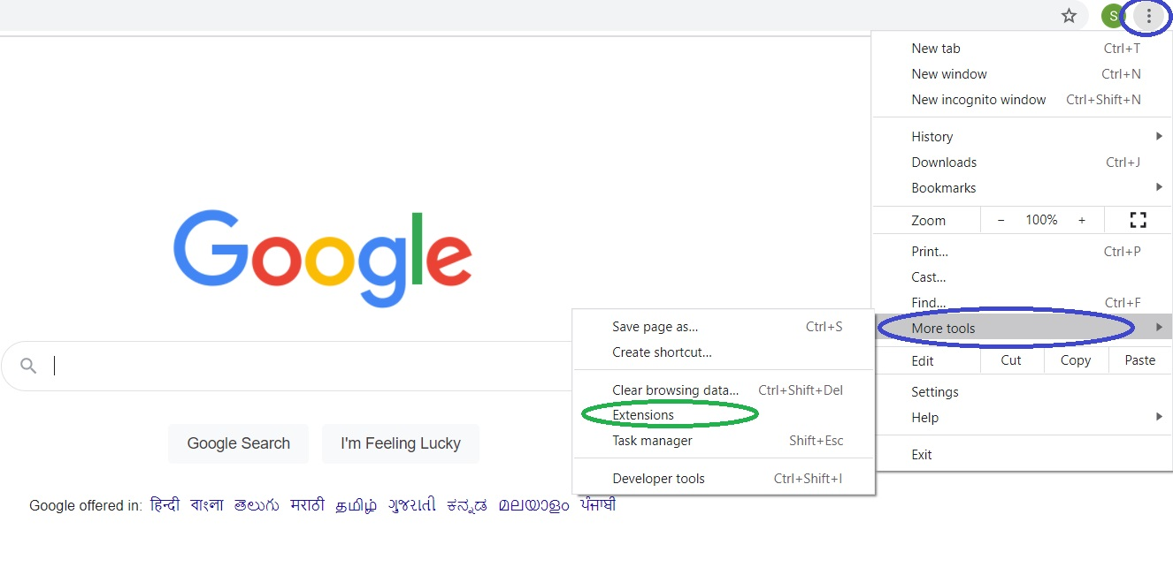
2. Click the checkbox next to "Developer mode" in the upper right hand corner.  
     
   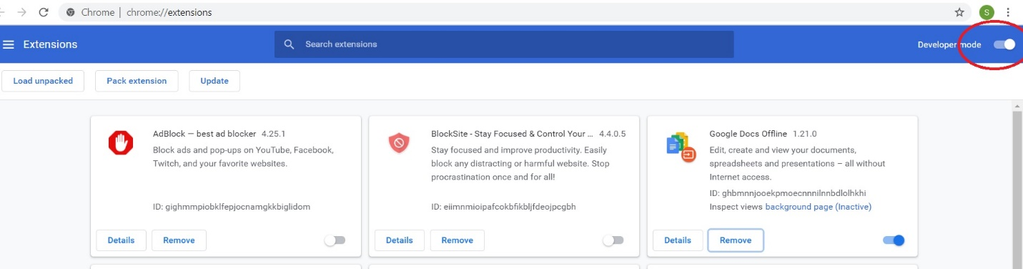
3. Click the "Load unpacked" button below the "Extensions" title and select the "spotphish" folder from your filesystem  
     
     
   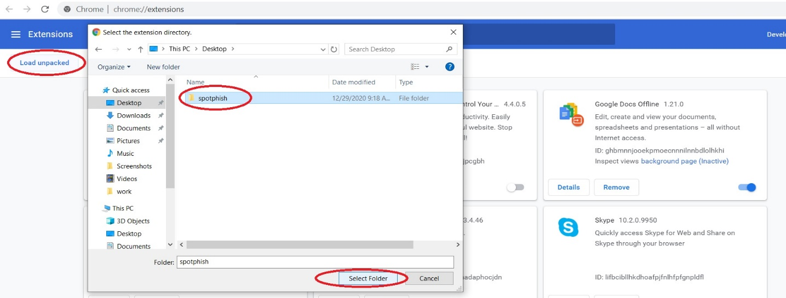
4. Successful loaded spotphish extension will appear like this  
     
   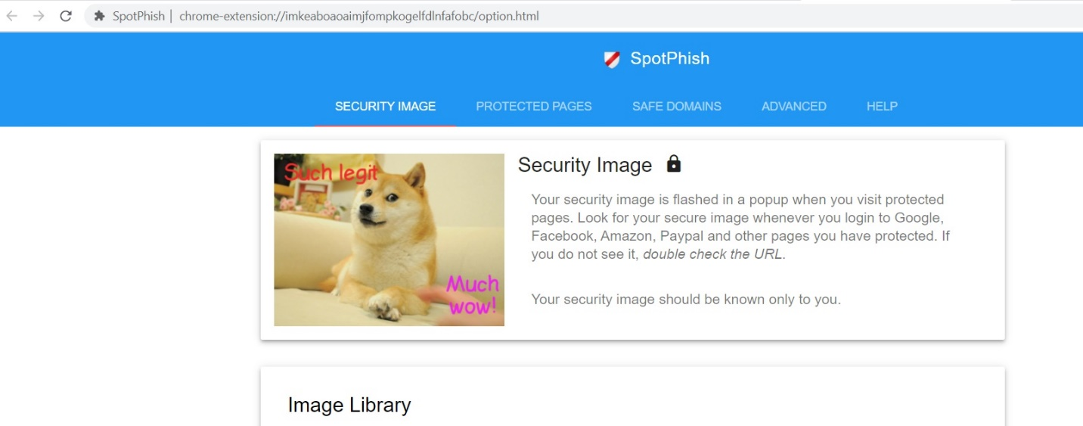
5. For easy navigation to the extension, “pin” the extension in browser   
     
     
   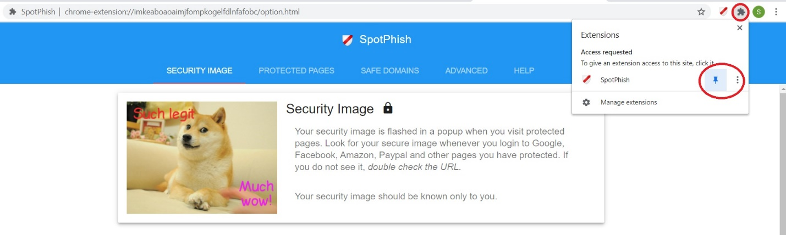
6. To know more on the Spotphish please visit <https://github.com/spotphish/spotphish/tree/spotphish>