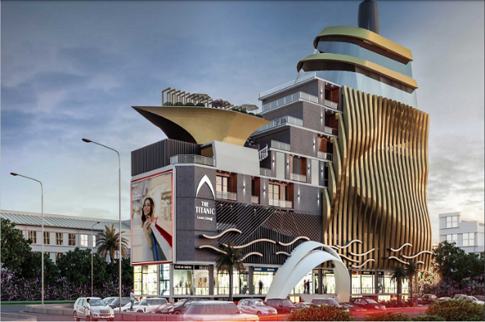

**Project Proposal: The Titanic**

**Project Details**

* **Location:** Bahria Town Phase 8
* **Construction Update:** 70% Completed

**Unit Details**

* **Apartment Type:** 2-Bedroom
* **Size:** 1301 sq. ft.
* **Floor:** Sixth
* **Rate per sq. ft.:** PKR 17,500
* **Total Price:** PKR 22,767,500

**New Year Deal**

| **Duration** | **Payment Details** | **Amount (PKR)** |
| --- | --- | --- |
| **Booking** | Pay first installment only | **397,519** |
| **Down Payment** | None | **0** |
| **First 12 Months** | Fixed monthly payment | **397,519 per month** |
| **13th Month** | Payment at possession | **5,348,750** |
| **Next 11 Months** | Fixed monthly payment | **397,520 per month** |
| **25th Month** | Payment | **1,694,750** |
| **Final 5 Months** | Fixed monthly payment | **397,520 per month** |