

**N**

your guide to new experiences.

**Nearby**

This is the splash screen.

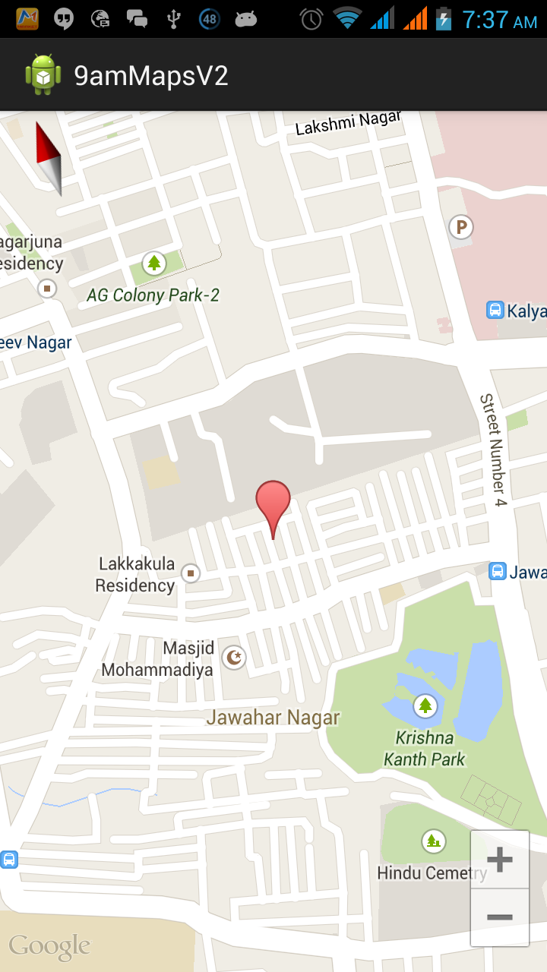

Nearby



> Filter

This is the main screen that displays a map with icons. The icons represent the categories of the different POIs.



Nearby



> Filter

Starbucks, 123 Innovation Avenue, Sunnyvale CA

Add to calendar

Save to favorites

When the user clicks on one of the icons, there will be a popup listing the name and address of the place. The address will be a hyperlink. Once clicked, the address will open Google Maps. The popup will also allow the user to “add to calendar” and “save to favorites.”

Zoo

Airport

Restaurants

Police

Cafes

Bars

☑

☑

☑



Nearby



> Filter

When the user clicks on the “Filter’ bar, he/she is able to check/uncheck the various categories. Only the checked categories will be displayed on the map.