Implementing Figma designs using GitHub Copilot and MCP Server

Overview
- Connect VS Code to Figma MCP Server.
- Use GitHub Copilot Agent Mode to generate a web page from a Figma design.
- Apply Figma Variables as CSS Custom Properties (tokens) instead of external CSS frameworks.

Prerequisites
- VS Code with GitHub Copilot with Agent mode enabled.
- A Figma account

Steps

Import the Figma design to use.
  - On your account page, click the Import button on the top-right.
  - Import the Figma demo file.

Setup Figma MCP Server.
  - Install Figma MCP Server in VS Code via Extensions (search @mcp Figma).
  - In the VS Code search bar, type “>MCP: Add Server”.
  - Select HTTP.
  - Paste the MCP server URL (https://mcp.figma.com/mcp) and press enter.
  - Type in the name for the server and press enter.
  - Select to add the server to the workspace.
  - Complete the authentication process with your Figma account to allow VS Code to access it.
  - The server is now installed and running.

Generate the site with GitHub Copilot.
  - In Figma, right-click the frame of the shopping cart page and select ‘Copy as > Copy link to selection’ to retrieve the component’s URL.
  - Prompt GHCP to build the site (see the example prompt at in the notes section), using the variables and tokens from your design system by providing design details via the URL.
  - Add adjustments as needed.

Notes/Tips
- When creating a Figma file for use:
  - Use structured and relevant names for layers to provide richer context for the LLM regarding the document’s design and intended behaviour.
  - Use Auto Layout in frames for responsive behaviors and relationships.
  - Create a robust design system with tokens and variables that use semantic naming.
- Using the MCP Server requires:
  - A full or dev seat (free tiers get very limited access)
  - A Figma Design file to work from.
  - Edit or view permissions to the file.
- If the server stops running (eg. From closing VS Code), you can start it again like so:
  - Type in the VS Code search bar “>MCP: List Servers”
  - Select the MCP server
  - Select Start

Example Prompt:
<Link to page frame>
Using the Figma MCP server tools, extract all variables used by the selected frame (colors, typography, spacing, etc.). Generate a tokens.css with :root { --DT-* } values based on those variables. Then create index.html and styles.css that only reference var(--DT-...) — no external CSS libraries. Preserve component structure and responsive layout.
When mapping, use semantic token names from Figma variables (e.g., color/text/primary → --DT-color-text-primary). For typography, output CSS variables for font family, sizes, line-heights.
Figma Design
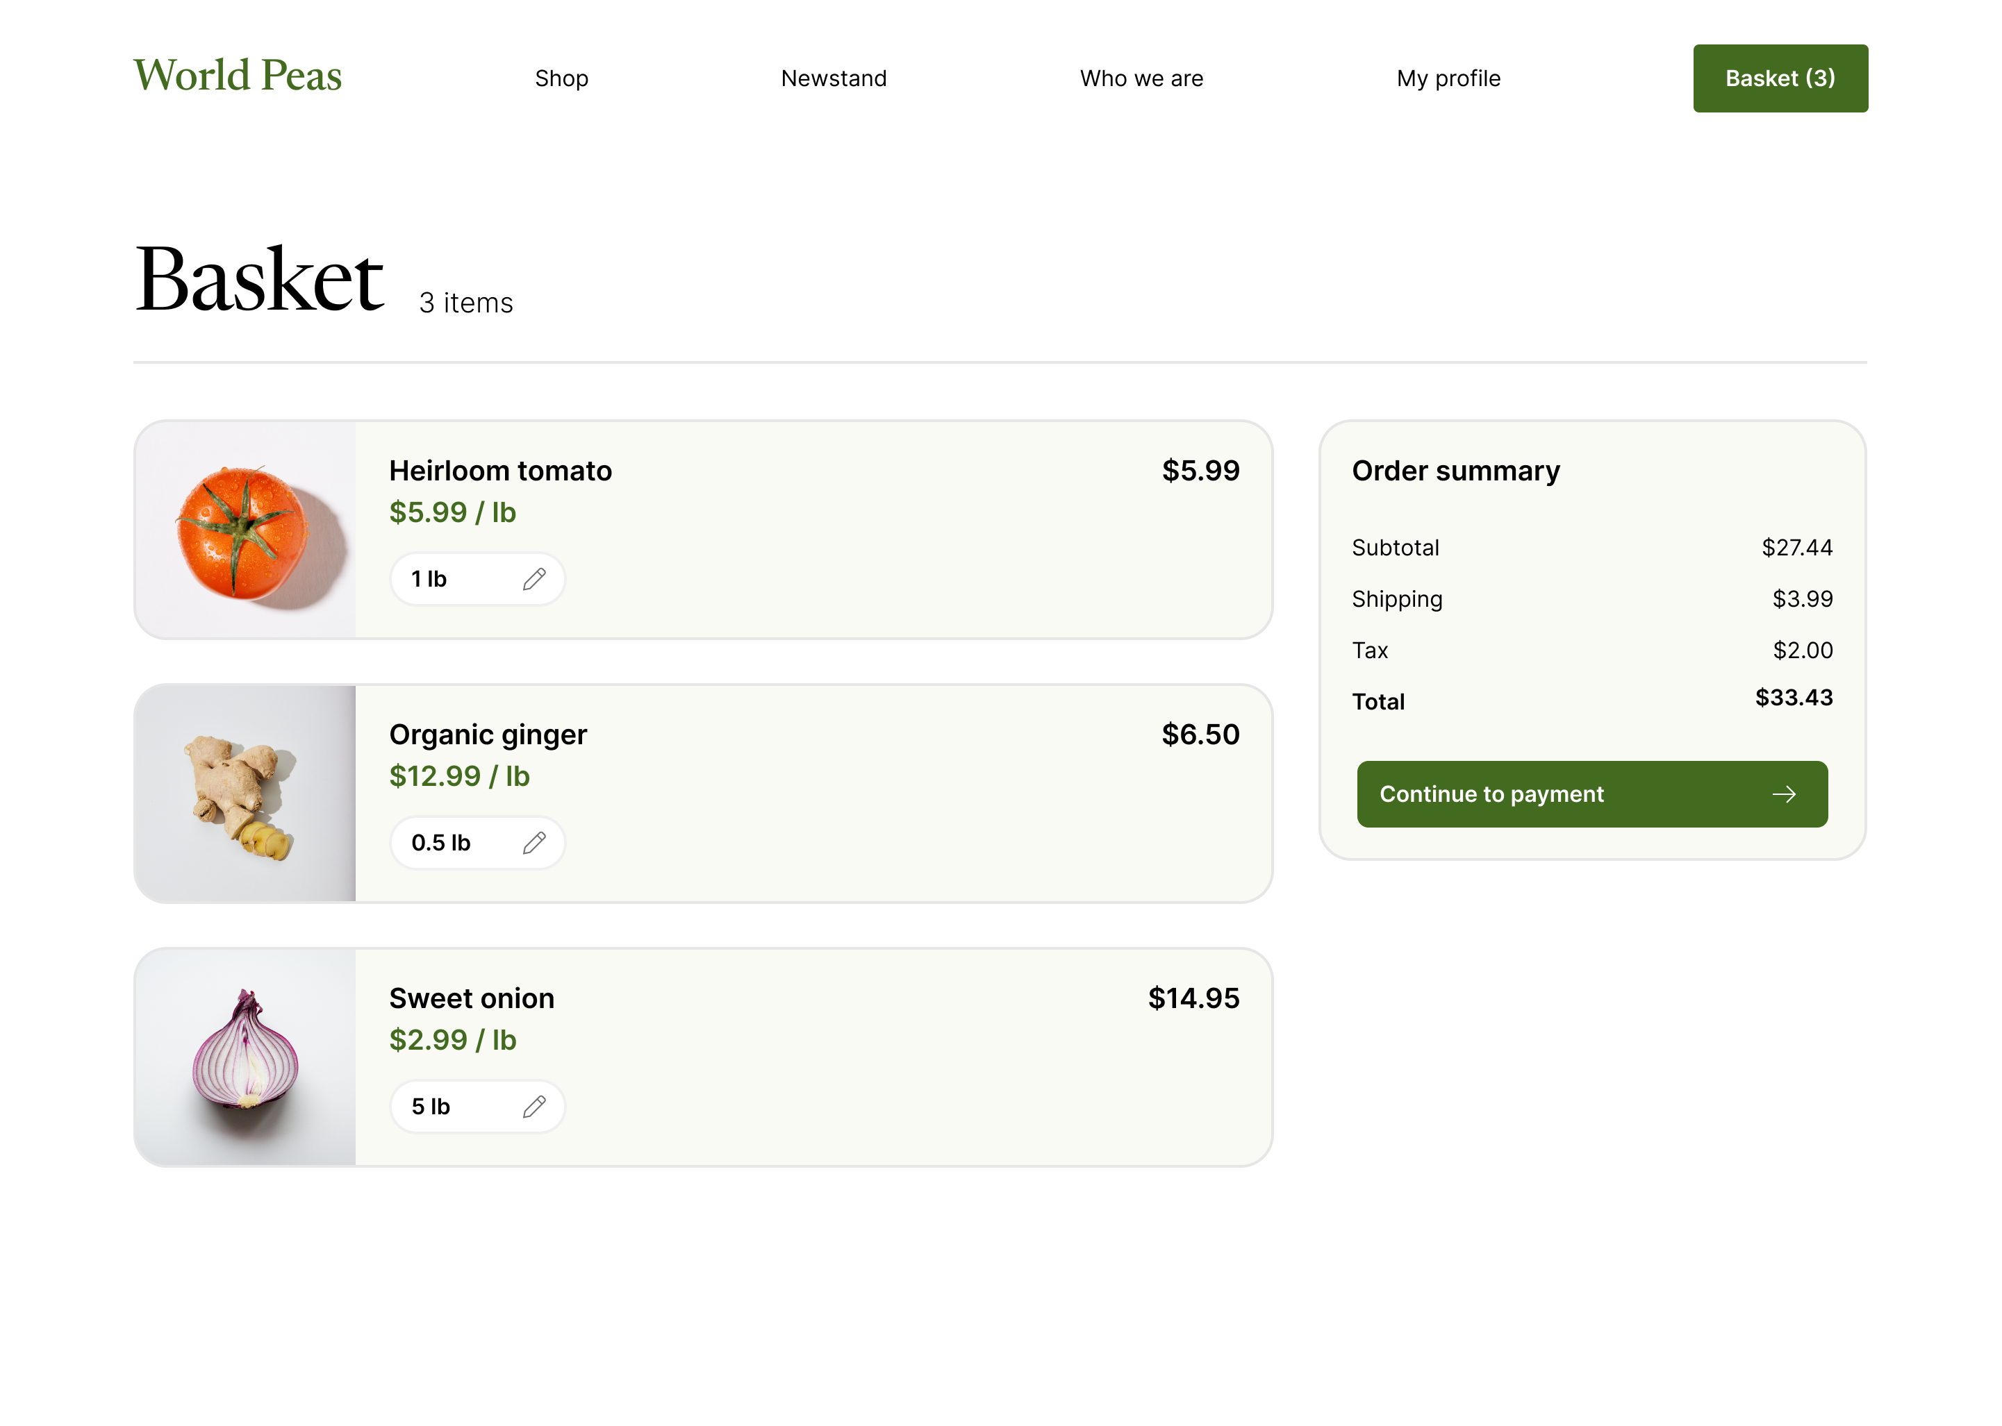

HTML Site
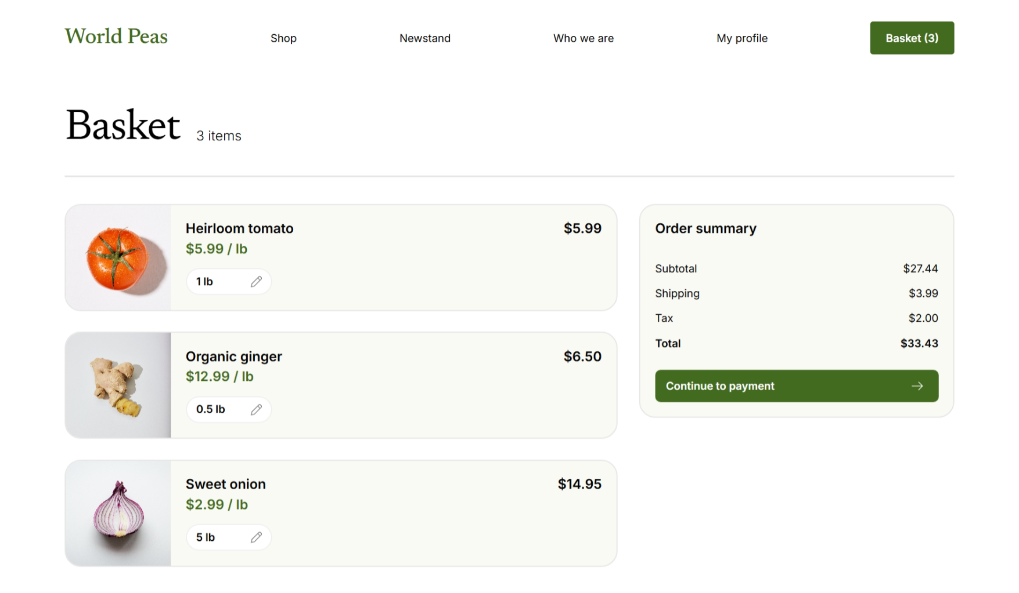

Getting Figma frame URL
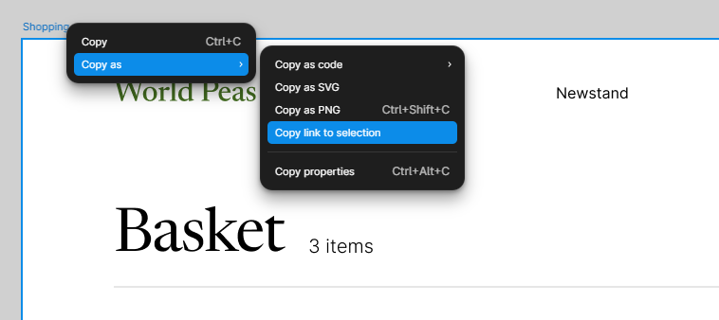
Prompting GHCP

References
- Designing with MCP Server: Bridging Design Systems and AI for Developer-Friendly Prototypes | by Iasonas Georgiadis | Bootcamp | Medium
- Guide to variables in Figma – Figma Learn - Help Center
- Guide to the Figma MCP server – Figma Learn - Help Center
- Figma MCP collection – Figma Learn - Help Center
- Figma MCP collection: How to set up the Figma remote MCP server – Figma Learn - Help Center

