Final Project – Physical Computing Write up

The aim of this project was to create a space that simulated a change in climate. As we are continuing to move into a digitalized age, and our eco system at the verge of collapse, I wanted to explore the convolution of the two opposing directions that we are currently moving towards.

To implement this, I set up a 4m x 4m x 2m (20 LED high) grid. There were 4 simulations of different climates. The first was just a clear blue sky that faded. It then changed to a warm sunset, followed by tranquil rain and thunder.

A big inspiration of this project was Dan Flavin particularly with reference to his work ‘Corners, barriers and corridors’ (Flavin et al., 2016). The simplistic and minimalist approach is very effective in evoking a series of different moods through colour and gives a very pleasing and rich aesthetic. I also find the clear colour partitioning, and use of a carefully curated and opposing colour pallet, gives a very modern and futurist look. Another inspiration for this was James Turrell who similarly uses a combination of clear contrasting colours to evoke a powerful perspective, using very simple yet stunning imagery (Herbert & Turrell, 1998). I wanted a similar effect, so I tried to implement a similar overtly vivid choice of colour, using a warm orange for the sun, a blinding white light for the lightning, a deep blue for the sky and a contrasting blue and green tinge with the rain. I found the choice of colour gave an enhanced artificial aesthetic.

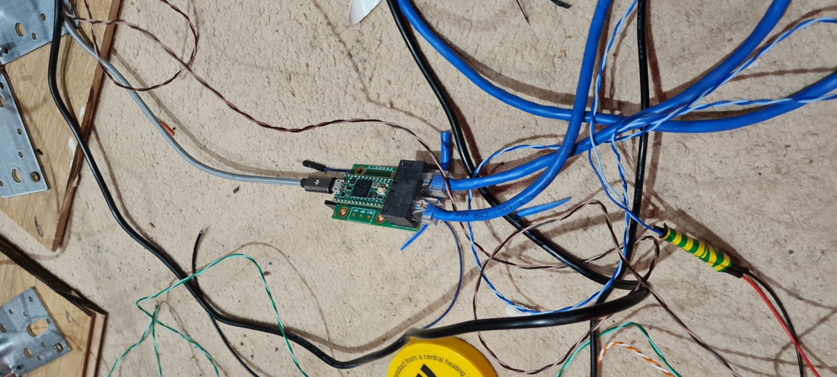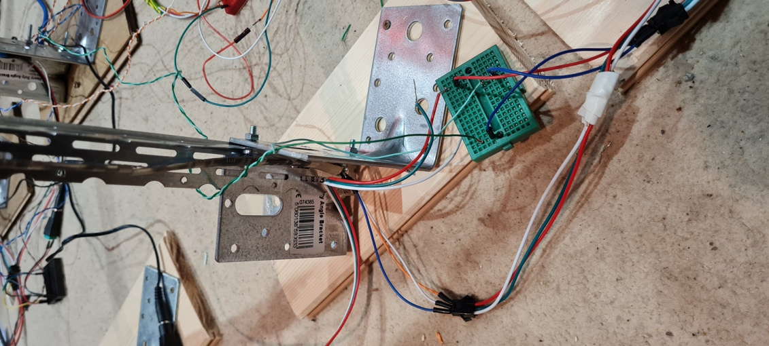

To implement the sun and sky simulations I used a 3D projection mapping technique suggested by Harvey Moon (Horswill, 2018). By mapping the pixel index of the LED strips to the UV of the geometry, you can light up the overlapping points. The rain simulation was done by iterating through 2 ramps, using one as a texture map, and another as a colour map to create a noise effect. Similarly, with the Thunder I used a ramp sampled in 3 different planes (x,y, z) (Heckmann, 2018).

To communicate this with LEDs, I used an OctoWS2811 with Teensy (Ben et al., 2015).

I used the OCTOWS2811 library which runs on teensyduino.

Flavin, D., Auping, M. and Whitney, A. (2016) *Dan Flavin - Corners, barriers and corridors*. New York, NY: David Zwirner.

Herbert, L.M. and Turrell, J. (1998) *James Turrell: Spirit and light ; Ausstellung Contemporary Arts Museum, Houston, 6.6.1998-26.7.1998*. Houston: Contemporary Arts Museum.

Horswill, T. (2018) *3D artnet mapping*, *TouchDesigner forum*. Available at: https://forum.derivative.ca/t/3d-artnet-mapping/8699/14 (Accessed: April 24, 2023).

*Intro to TouchDesigner for Pixel Mapping - Ben Voigt and Markus Heckmann* (2018) *Youtube*. TouchDesigner Summit. Available at: https://www.youtube.com/watch?v=ShYYcr30vJw&t=3848s.

Ben *et al.* (2015) *Hitting bottleneck controlling close to 4,000 leds!*, *TouchDesigner forum*. Available at: https://forum.derivative.ca/t/hitting-bottleneck-controlling-close-to-4-000-leds/5909/32 (Accessed: April 24, 2023).

Heckmann, M. (2018) *Introduction to GLSL - Markus Heckmann*, *YouTube*. YouTube. Available at: https://www.youtube.com/watch?v=FImsLtt4Ab4&t=3261s (Accessed: April 24, 2023).