G00262708 - Design Document

Cormac McHale

Contents

App Name 2

Purpose 2

User Interface 2

ScoreBoard 2

GamePage 2

Notes on UI 2

Functionality 3

Components 3

IDE 3

Milestones 3

Notes 3

Research/Reasons 3

Future Research 3

# App Name

Brainwaves (This is a horrible name, please allow me to change later if possible)

# Purpose

The purpose of my project will be to build a working game that incorporates the technologies of The Devices Sensors in a modern device. The Intended goal will be for the User to play a simple game that will change dynamically based on the Orientation of the Phone.

# User Interface

## ScoreBoard

This will be the Second page that the User will see after a collision, it will display a Score board with the top five scores that the user has achieved. Basic read/write file system for this. Scores will have to be sorted.

## GamePage

This is where the User will play the game. The game itself will be a simple Implementation of the User controlling a Game Object and avoiding other objects moving on screen. Very basic initial design shown here for reference. I’m hoping that the UI will be intuitive enough that after a small bit of Trial and error the user will understand how to play the game.

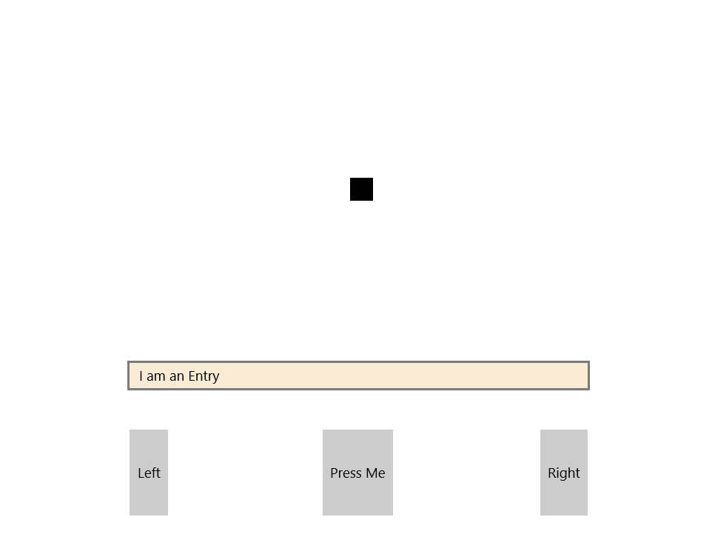

## Notes on UI

The UI in terms of navigation and number of pages in the App I would like to keep simple. As such what you see here will be hopefully the total size of the App. The reason for this is I want to keep the experience oriented around the User using the sensors in the Phone to play the Game. It will allow me to put appropriate time into learning how to implement this and in turn will result in a more rewarding User Experience.

# Functionality

If everything goes to plan (which it won’t) then essentially the app will allow the User to control a Game Object by changing the Orientation of the phone. After a collision the score that the User has received based on how long that they have been playing the Game will be passed onto the score board to be sorted and displayed to the User.

# Components

## IDE

Visual Studio 2017 (Cross Platfrom App(Xamarin))

# Milestones

Having spent a lot of time thinking about developing the project I’ve come up with Milestones that should represent the development cycle of the App clearly.

* Deploy Blank App, learn and understand architecture and local resources.
* Build the UI correctly (Just the Shell of how it should look).
* Implement player movement correctly.
* Implement Game Loop Correctly (Timer).
* Implement Game Objects Moving alongside player.
* Implement Collision between Objects and player.
* Write Methods for Increasing/Decreasing Difficulty
* Getting information based on game displaying to user (score)

### Notes

At this point the Game will hopefully be built correctly and ready to implement the sensor technology. The next Milestones will all be concerned with this. As I have never done anything like this in Software Development I expect this to be the biggest learning curve.

* Research of Cross-Platform Plugins
* Import and learn Library required (NuGet).
* Error handling for movement.
* Acceptable tilt on orientation for changing direction.
* Update Game appropriately.
* Add handling for UWP deployment (Sensor-less buttons)

# Research/Reasons

The entire time I’ve spent with software the most interesting area for me has been anything game development Oriented. I’ve been gaming for 20 years (I’m older than I look). As such things like game loops and producing an app that challenges the User to play a game in a certain way have felt second nature. I believe that with my experience in playing games I’m in an ideal position to produce a piece of software in the form of a game that will provide the user with an innovative and satisfying experience.

# Future Research

As the project is only just in the design stage, I haven’t had time to research similar games thoroughly. This had been added into milestones. Perhaps a huge improvement to the over-all app would be to implement a global score board.