CIRAD
Land and Resources Program

CORMAS
Common-pool Resources
and Multi-Agents Systems

Building a Cormas model from scratch step by step

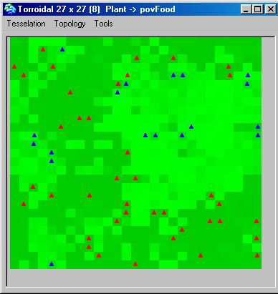

December 2002

Ttable of contents
Building a Cormas model from scratch step by step 1
1. Opening Cormas 4
2. Creating a new Cormas model 4
3. Designing a spatial entity holding a renewable resource 5
3.1. Setting the parameters of a logistic growth 6
3.1.1. Create the new class variables with the contextual menu of the code editor 6
3.2. Adding a new attribute named “energy” 8
3.2.1. Create the new attribute with the contextual menu of the code editor 8
3.2.2. Create the accessing methods 8
3.3. Write a logistic growth method in a new protocol 9
3.4. Write the basic step method in the “control” protocol 10
4. Designing an agent foraging the resource 10
4.1. Setting the life-history parameters of any forager agent 11
4.1.1. Create the new class variables with the contextual menu of the code editor 11
4.1.2. Add two attributes named “energy” and “strategy” and create their accessors 11
4.2. Create a new protocol named “biology” and write the biological methods 11
4.3. Create a protocol named “control” and write the “step” method of the forager agent 12
5. Designing methods to observe the entities 13
5.1. Assigning a green intensity according to the energy level of the plant 13
5.1.1. Add a “point of view” method named “povFood” 13
5.1.2. Write the code of the “povFood” method 13
5.1.3. Adjust the write-access method of all the attributes involved in “pov” methods 14
5.2. Assigning a colour to distinguish foragers according to their strategy 15
5.2.1. Add a “pov” method named “povStrategy” 15
5.2.2. Add the symbols that may be returned by the “pov” method 15
5.2.3. To each added symbol, associate a colour and a shape 15
6. Designing “probes” to record the variations of markers 16
6.1. Open the “probes” definition window from the main Cormas interface 16
6.2. Add probes based on attributes of the model (global level) 16
6.3. Write the code for the first one: a cumulative value over a collection 16
6.4. Define 2 other probes : the number of restrained and unrestrained foragers 17
7. Designing control methods for the scheduling of simulation experiments 17
7.1. Create attribute agentsInitialNumber 17
7.2. Write, in a new protocol (“entities creation”), a method to create the forager agents 18
7.3. Write (in the “init” protocol) 3 different methods to be used as initial situations for simulation experiments 18
7.4. Write (in the “control” protocol) a step method to be executed at each time-step of simulation 19
8. Simulating the model 19
9. Saving, loading and versioning the model 22
9.1. Saving and versioning 22
9.2. Loading the model 23
10. Analysing the model 23
10.1. Choose the parameter's values 24
10.1.1. Choose one value 25
10.1.2. Choose a set of values 25
10.2. Output format 27
10.2.1. Ascii or Excel format 27
10.2.2. Data base format 28
11. Appendices 33
11.1. How to connect VisualWorks to Access 33
11.1.1. Set up the ODBC driver ODBC 33
11.2. UML : Class diagram of Cormas - Entities category 36

The model we present here and that you will build, is inspired from a paper by Pepper and Smuts, "Evolution of Cooperation in an Ecological Context". This ECEC model can be found on the Cormas web site: http://cormas.cirad.fr

Opening Cormas
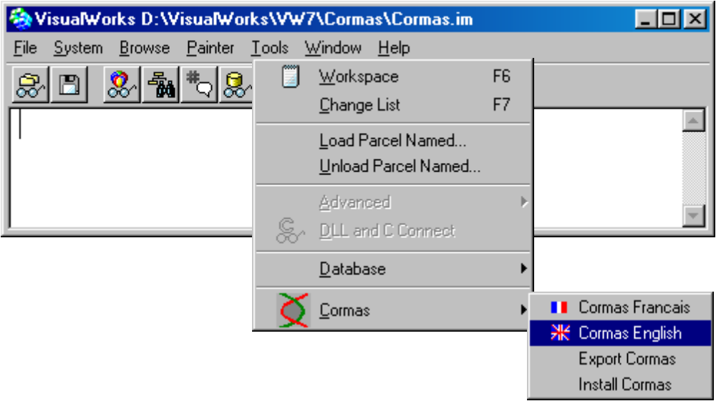

Creating a new Cormas model
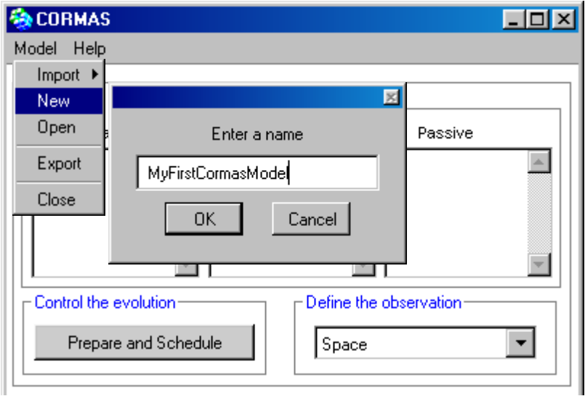

Designing a spatial entity holding a renewable resource
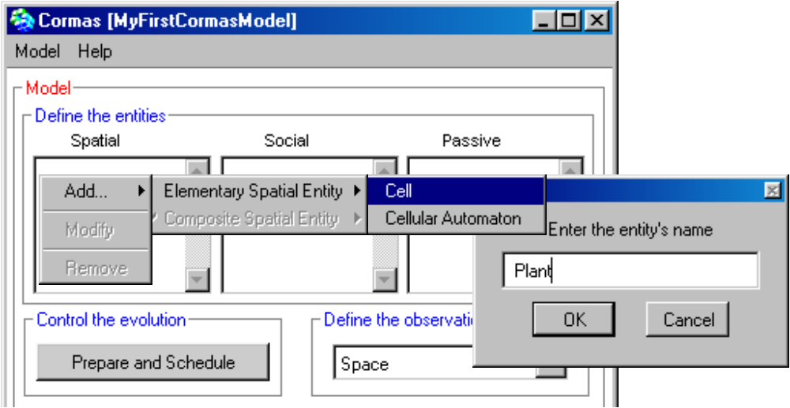

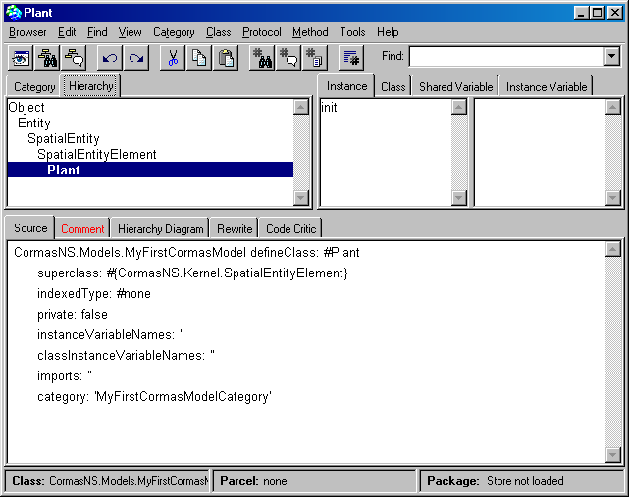

Setting the parameters of a logistic growth
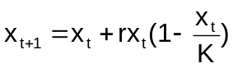The logistic equation needs 2 parameters: the carrying capacity “k” and the growth rate “r”.
The values of these parameters are equals for each Plant instances. We can defines them as class variables.

Create the new class variables with the contextual menu of the code editor
Switch from “Instance” to “Class”.
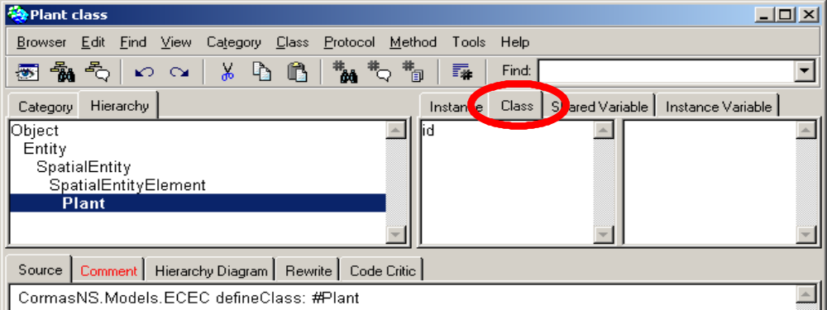

Create the attributes
Create the carrying capacity “k” and “r”:
- write them between the quotes on the line "classInstanceVariableNames:", then
- Accept : right click and select "Accept"
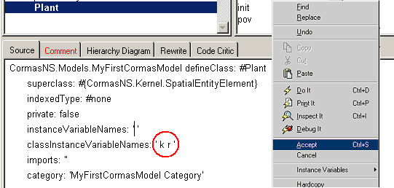

Create the accessing methods
Select the k variable then, with right button,
select "Instance Variables" → "create Accessors".
A new window pops up asking you to define the default value of this attribute k.
Set the value of k equal to 10.
Then click on "OK". If you click on "Cancel" button, the accessors are created with nil as default value.

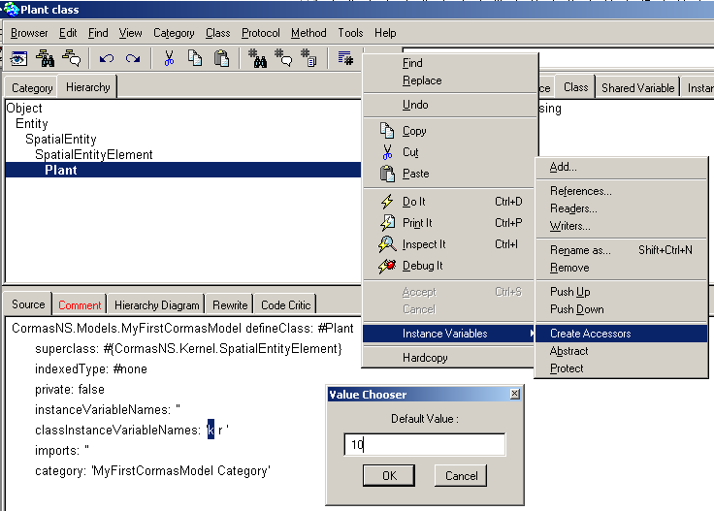

In the same way, let the growth rate parameter “r” be equal to 0.2 (Select the r variable then, with right button, select "Instance Variables" → "create Accessors". In the new pop-up window set the default value of r equal to 0.2. Then click on "OK").

Adding a new attribute named “energy”
Switch back from the “Class” to the “Instance” level.

Create the new attribute with the contextual menu of the code editor
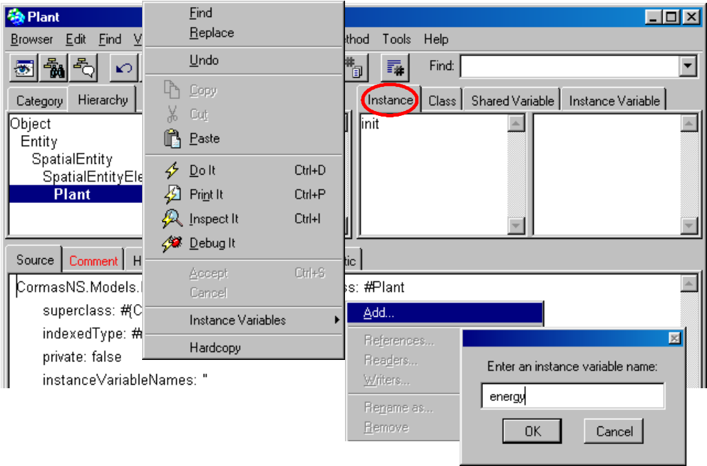

Create the accessing methods
Create the accessing methods of the energy attribute and set the default value equals to 0.
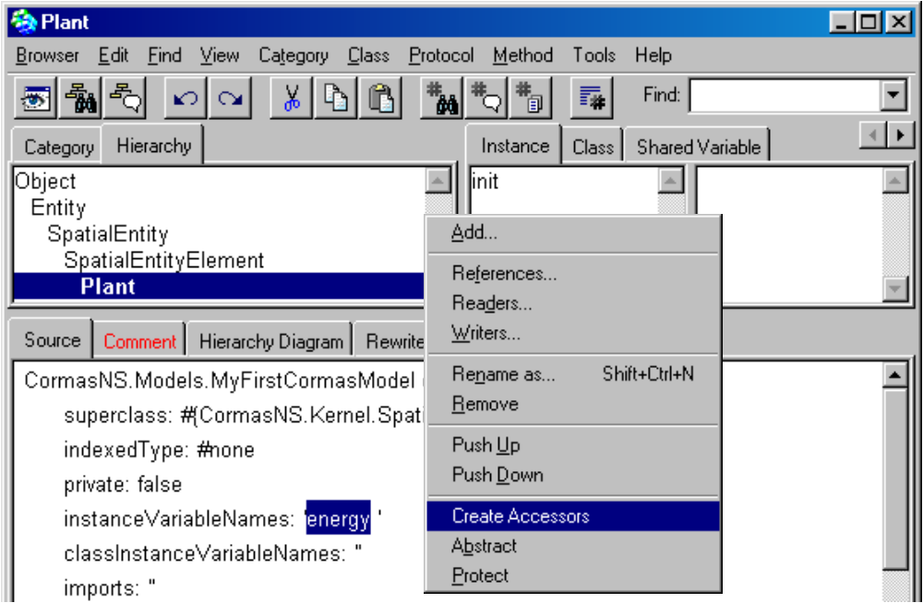

Write a logistic growth method in a new protocol
A protocol is just a way to organize the methods. To create a new protocol, right click on the "protocol" panel and select "new". Then write growth as protocol name.

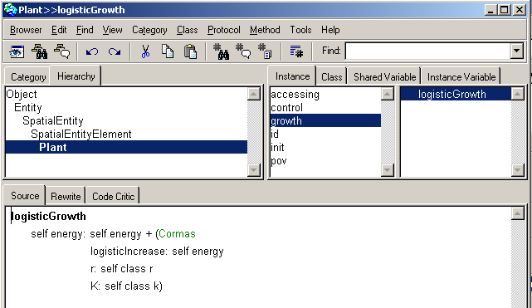
The "protocol" panel : right click on it and select new. Then write growth as protocol name (a protocol is just a way to organize the methods)
The "source" panel : write the text of the logisticGrowth method on it.

To create a new method into the "growth" protocol, remove the text on the "source" panel and write your method on it, then accept (right button → Accept or Ctrl S). The logisticGrowth method uses a static method from Cormas class (logisticIncrease:r:K:).

Write the basic step method in the “control” protocol
In the same way as previously, create a new protocol called control and the step method in it.

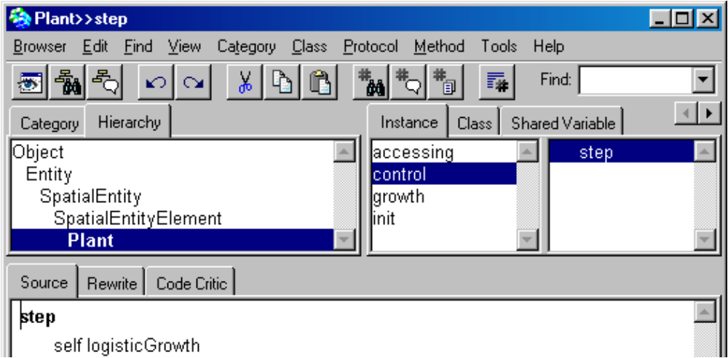

You can now close the browser "Plant".

Designing an agent foraging the resource
Let us define the Forager agent as a kind of situated agent :

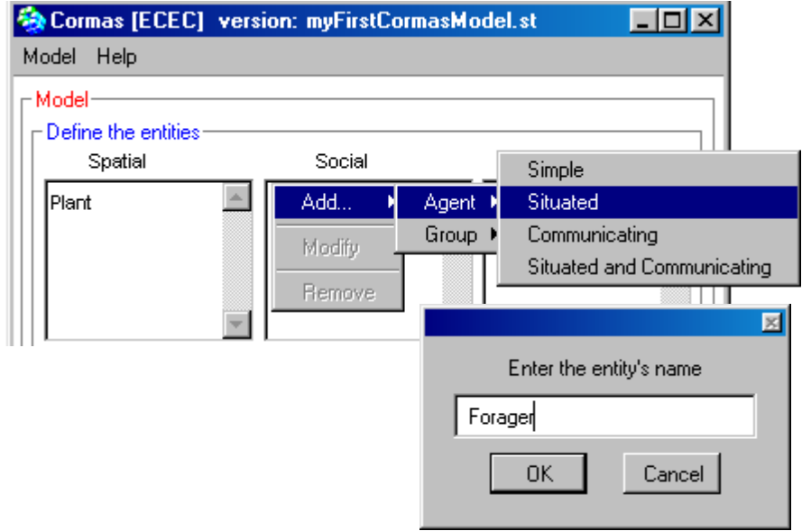

As you can see in the new browser, Forager inherits from AgentLocation

Setting the life-history parameters of any forager agent
The values of these parameters are equals for each agent. We can defines them as class variables as describe in chapter 1 (Setting the parameters of a logistic growth).

Create the new class variables with the contextual menu of the code editor
Switch from “Instance” to “Class”. At this Class level, create the new class variables fertilityThreshold and metabolicRate (write them between the quotes on the line "classInstanceVariableNames:" and accept).
Then create the accessors with 100 as default value for fertilityThreshold and 2 for metabolicRate (Select the variable then, with right button, select "Instance Variables" → "create Accessors". In the new pop-up window set the default value of fertilityThreshold equal to 100. Then click on "OK").

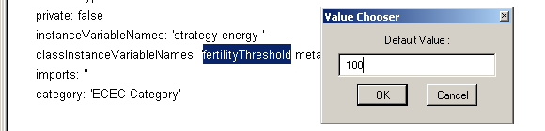

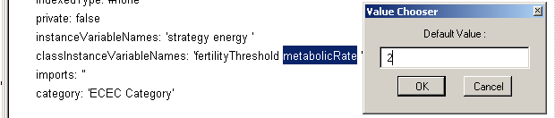

Add two attributes named “energy” and “strategy” and create their accessors
Proceed like in section 3.2.
Set the default value of energy equal to 50.
Click on Cancel for the default value of strategy.

Create a new protocol named “biology” and write the biological methods
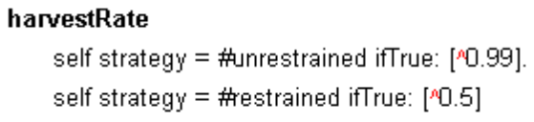
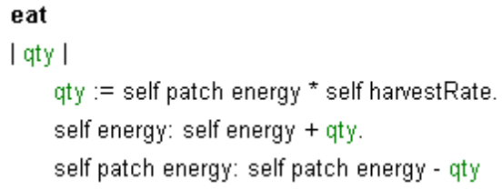
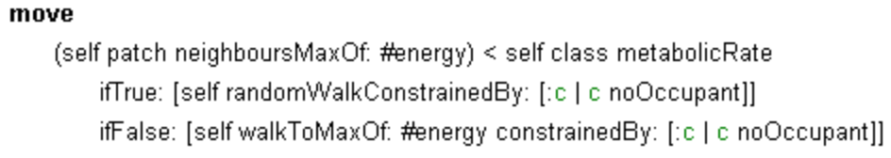
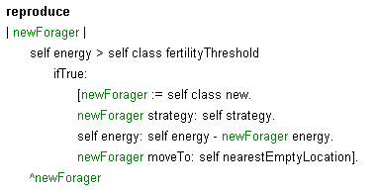
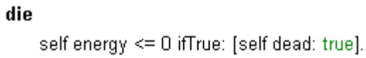
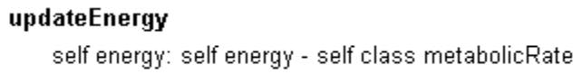

Create a protocol named “control” and write the “step” method of the forager agent
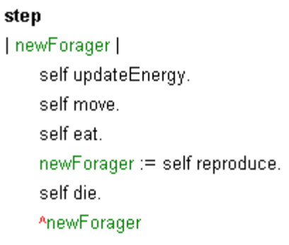

Designing methods to observe the entities

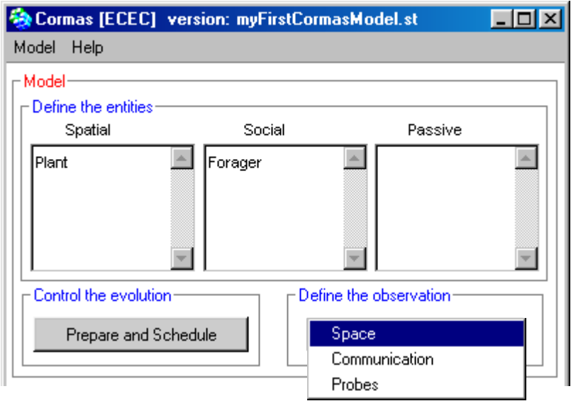

Assigning a green intensity according to the energy level of the plant

Add a “point of view” method named “povFood”
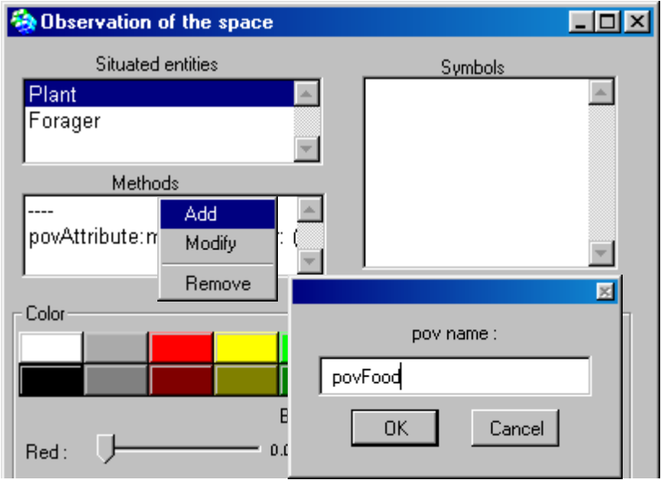

Write the code of the “povFood” method
A “pov” method has to return symbols, which needs to be associated to corresponding colours via the palette tool. This classical way of writing “pov” methods will be presented in section 5.2. Here, another way is used: “pov” methods may return directly colour values. Cormas provides a generic method that relates the brightness of a base colour to the value of a quantitative attribute.

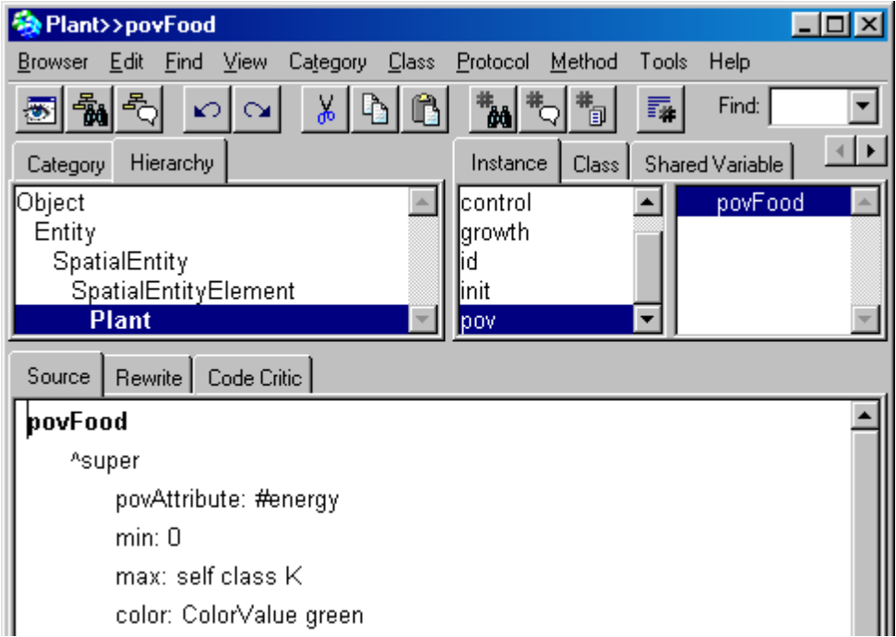

Adjust the write-access method of all the attributes involved in “pov” methods
The only attribute involved in a “pov” method of the Plant entity is “energy”. To ensure that the visualization will be updated each time a new value of energy will be assigned to a plant, you need to add a specific instruction at the end of the corresponding write-access method :

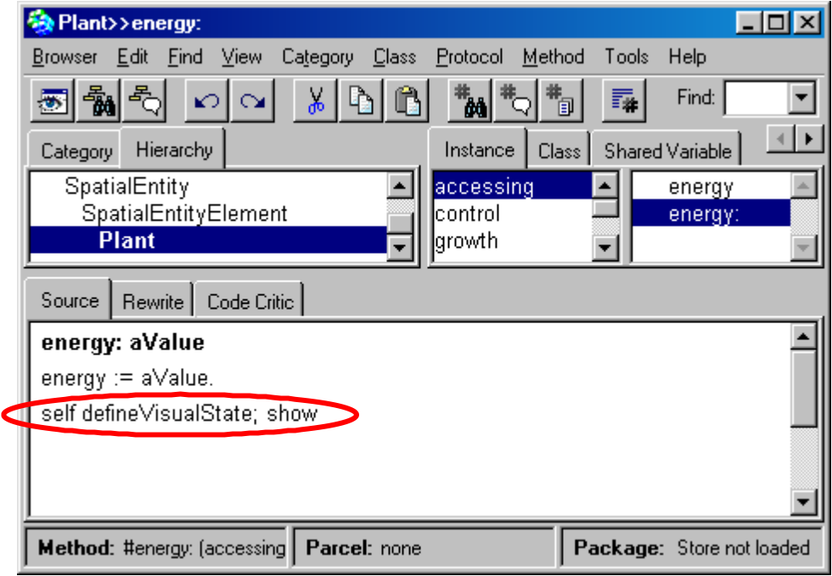

Assigning a colour to distinguish foragers according to their strategy

Add a “pov” method named “povStrategy”
Click on the Forager object and ‘Add a new method’ in the list of methods, and then type the code below:

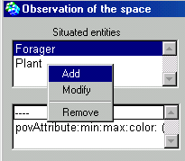 | 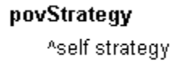

Add the symbols that may be returned by the “pov” method
You need to add, in the “Symbols” window, all the possible symbols that may be returned by any “pov” methods of the selected entity. Here, povStrategy will be the only “pov” method of the Forager entity. This method is returning the strategy of a forager agent. The possible values of a forager’s strategy are #restrained and #unrestrained. When you enter these values in the list of symbols, do not include the initial # character, and use exactly the same spelling (be careful, smalltalk is case-sensitive !).

To each added symbol, associate a colour and a shape
Use the palette or the Red, Green and Blue sliders to choose a colour. Use the contextual menu within the blue squared to choose a polygonal shape. Do not forget to apply after each choice !

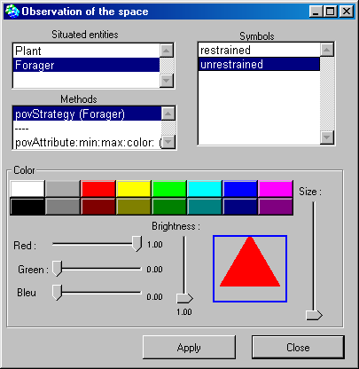

Designing “probes” to record the variations of markers

Open the “probes” definition window from the main Cormas interface
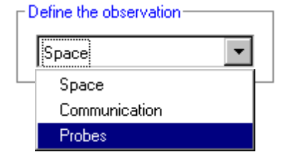

Add probes based on attributes of the model (global level)
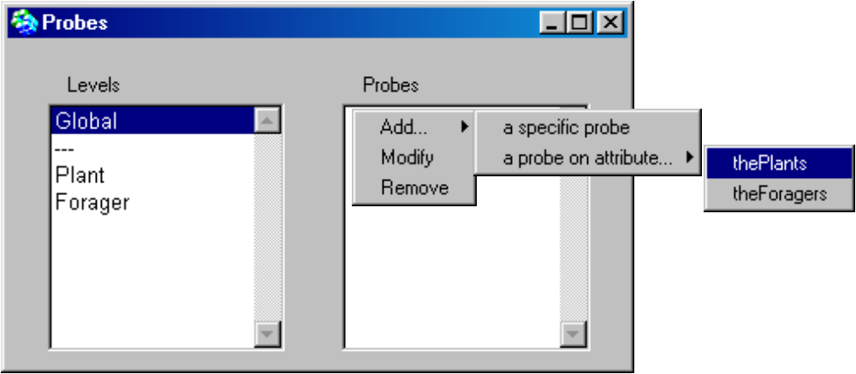
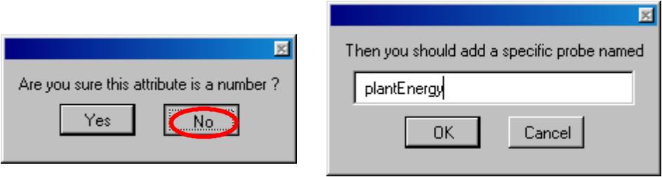

Write the code for the first one: a cumulative value over a collection
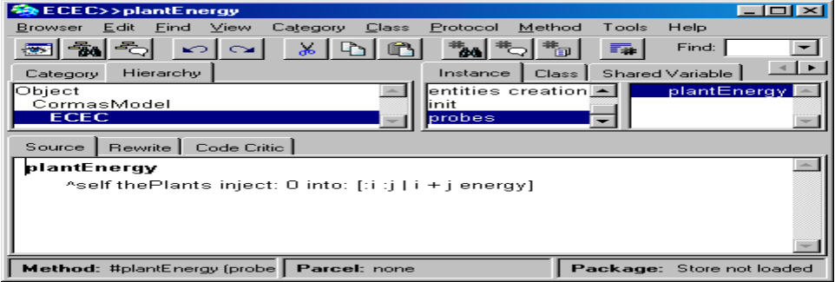

Define 2 other probes : the number of restrained and unrestrained foragers

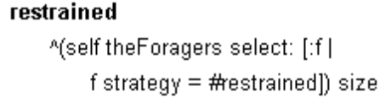 | 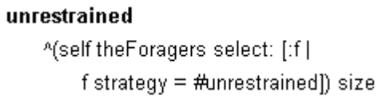

Designing control methods for the scheduling of simulation experiments
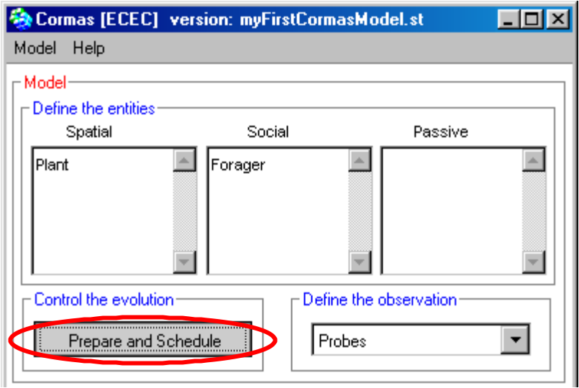

Create attribute agentsInitialNumber
Create the agentsInitialNumber attribute which allows user to choose the initial number of Foragers having each strategy.
Set the default number equals to 10.
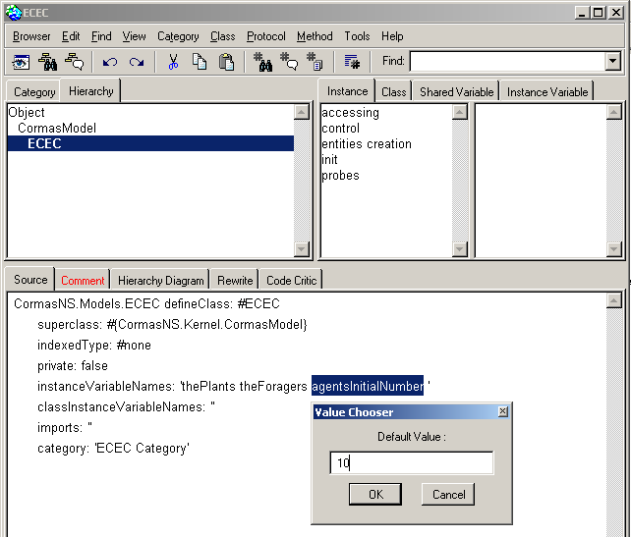

Write, in a new protocol (“entities creation”), a method to create the forager agents
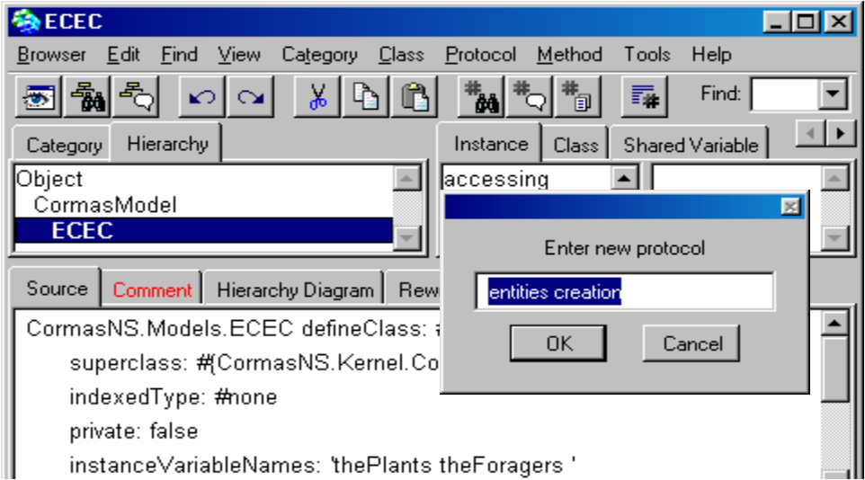

Write the initForagers methods :
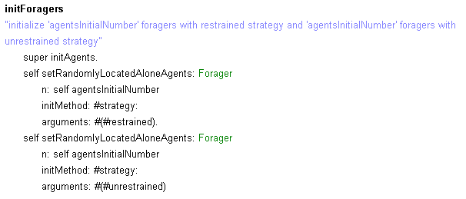

Write (in the “init” protocol) 3 different methods to be used as initial situations for simulation experiments
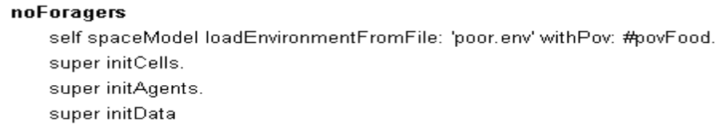
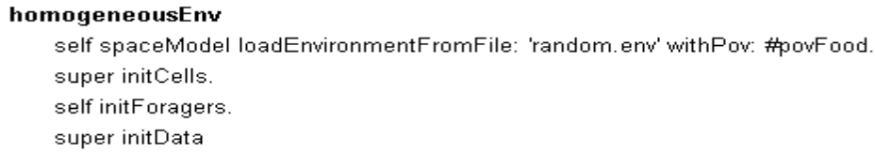
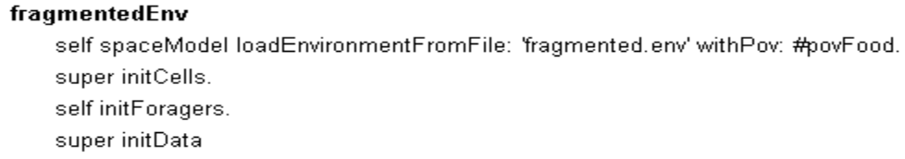

Write (in the “control” protocol) a step method to be executed at each time-step of simulation
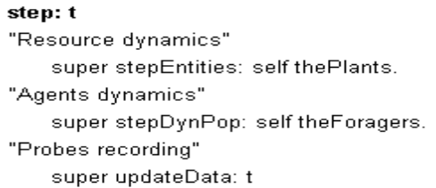

Simulating the model
First of all you have to export your model. This creates a “MyFirstCormasModel” directory under “cormas/models”. Within this new models directory, create a sub-directory “maps” and put into that directory the files ‘poor.env’, ‘random.env’ and ‘fragmented.env’.
Then you have to open the spatial grid interface to be able to visualize the simulation. Click on :
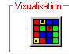

Back to Cormas main interface, you can click on the “Initialize…” button. A window will open where you have to choose an initialisation method and a control method. You can also check the probes you would like to save.

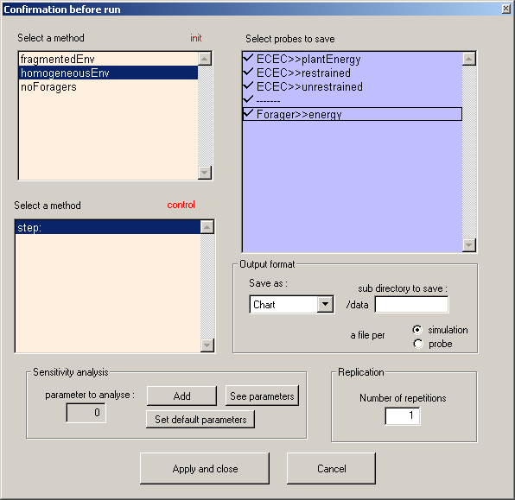

Then click on Apply and close button.
You can now simulate by clicking on the “Step” button or on the “Run” button once you have typed a duration.
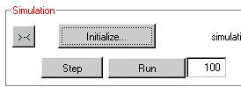

In order to see also the foragers on the map, right click on the grid and select the Forager → povStrategy.

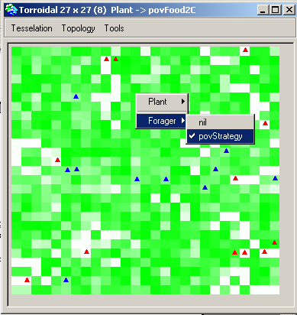

In order to see the resulting curves of the simulation, click on the Charts button 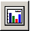. Then click on the probe you want to see. If you want to see several probes at once, select them with Ctrl key.

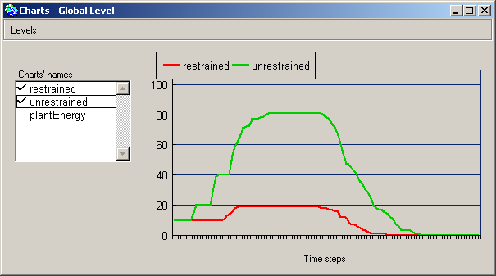

Saving, loading and versioning the model

Saving and versioning
When you want to save your model, click on Model → Export
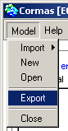
You can then choose the version of your model, for example "myFirstModel_newVersion.st" :
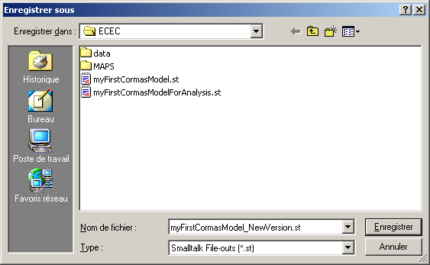
The model is then saved on the disk as a file with .ST extension (ST for SmallTalk). Cormas has created a directory for your model. You should get the following architecture :

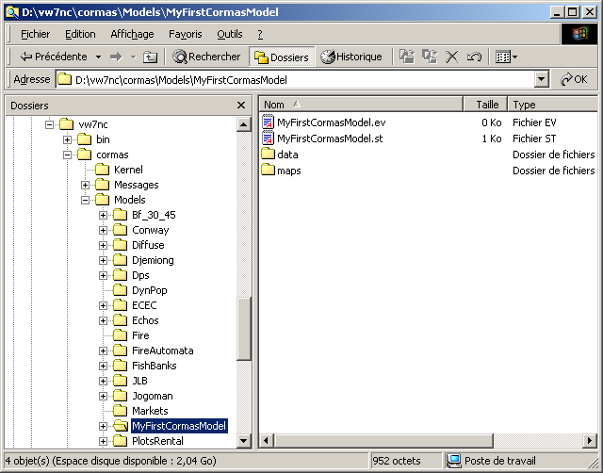

Loading the model
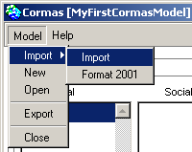
Then choose the version you want to load.

Analysing the model
We present now the ways to conduct sensitivity analysis with Cormas. Analysing is a an important part of the modelling activity and should not be forget.
Cormas don't propose analyse tools; it just allows to launch many simulations according to parameters values and to export the data of the simulations in different kinds of files :
ASCII files,
Excel files or
into data bases.
You can then analyse your data with your favourite software…
Select the output format of the files :
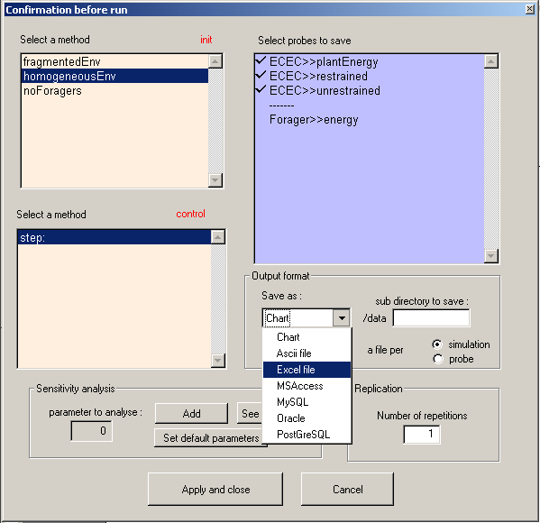
You may create a sub directory on Cormas/Models/MyFirstModel/data/. Works only for your ASCII files
Select the output format
Select a type of file:
One ascii file or one Excel sheet per simulation or per probe

To get more information about the output format, see the Output format section below (page 29).

Choose the parameter's values
Click on the Add button on the Sensitivity analysis panel.

Choose one value
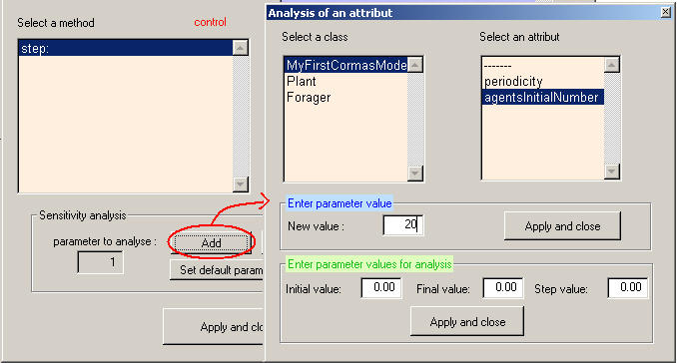
On the "Analysis of an attribute" window, select the class (ex. MyFirstCormasModel) of the parameter you want to choose and then, select the attribute (ex: agentsInitialNumber). You can now enter a new value (ex: 20), then Apply and close.

Choose a set of values
The figure below shows how to analyse the model according to different values of K, the class variable of Plant (from 5 to 20 by step 1) :
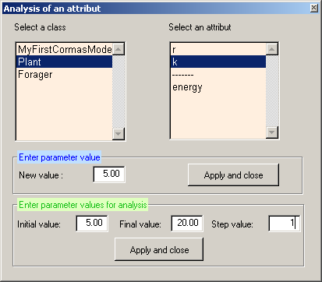
Class variables
Attributes (instance variables)

If you accept now, you can see that you can run 16 simulations (5 to 20 by step 1 = 16 simulations).
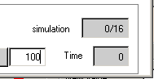

If you want to add a new parameter to analyse to this 16 simulations, click again on Initialize button, then Add button then choose another set of values. Example: metabolicRate, from 0,1 to 1 by step of 0,1.
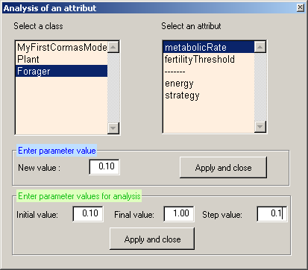

The number of simulations is now equal to 160 : 16 (for the first set of parameter) x 10 (for the second set of parameter).
The previous parameters have been kept in memory.
If your model contains randomness, you can choose to repeat the same simulation for each set of parameters. Click again on Initialize button, then choose a value for the Number of repetitions :
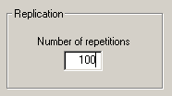
Now, the number of simulations is 16000 !
To see the parameter values you entered, click on button.

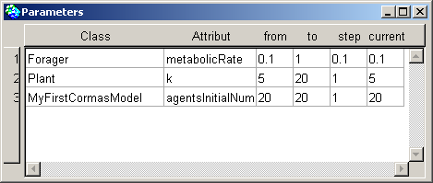

To forget the parameter's sets, click on the button. This action reset the default values of the parameters.

Output format
By default, the probes are "saved" as charts. Be careful : this option shows only the last simulation data.

Ascii or Excel format
If you choose to save the probe's data as Ascii files or Excel sheets, Cormas will only save the global probes.
If you want to save also the instance's information, you should use data base format (see below).
With these format, you can choose to save a file (or an Excel sheet) per simulation or per probe.
If you select a file per probe, you will obtain 3 files as following :

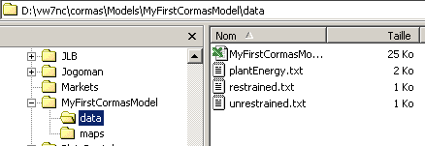
or 3 Excel sheets :
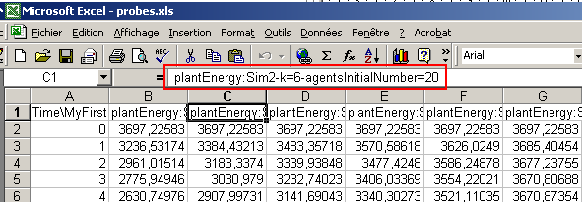
The first cell of each column contains the probe name, the simulation number, and the name of the parameters and their initial value for this simulation.
If you select a file per simulation, you will obtain an Ascii file per simulation (16000 files !) or an Excel sheet per simulation :
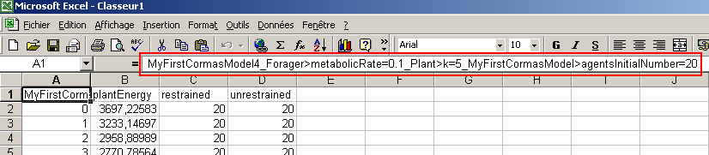
The first Excel cell contains information about the simulation :
The name of the model, the current repeat number and the parameter's current value.

Data base format

Launching the ODBC connection
If you select a data base as output format, you are invited to complete a form :
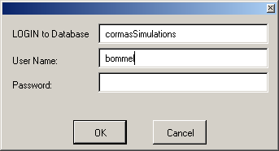

To set up the ODBC bridge under Windows, please see the end notes.
If you don't want to have this form for each analysis session, add a method in your model (you can create a new protocol "ODBC") :

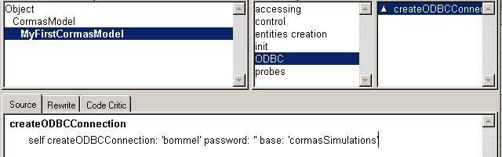
Of course, you should define it with the right data base (<String>) and your username (<String>) and your password (<String>).

Data base description
The 4 tables of the data base (Access) :
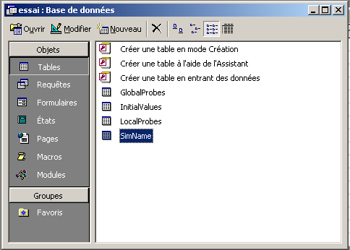

The main table is called "SimName"; it contains information about the simulations :
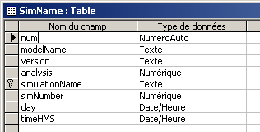
- simulationName: a non ambiguous name with the simulation number, plus the date and the time (ex: 6_8/19/02_7:30:55 am),
- modelName: example 'MyFirstCormasModel'
- version: the version of the model, ie. the ST file (ex: myFirstCormasModelForAnalysis.st)
- analysis: the number of the current analysis session
- simNumber: the number of the current simulation of this analysis session
- day
- time
Example :
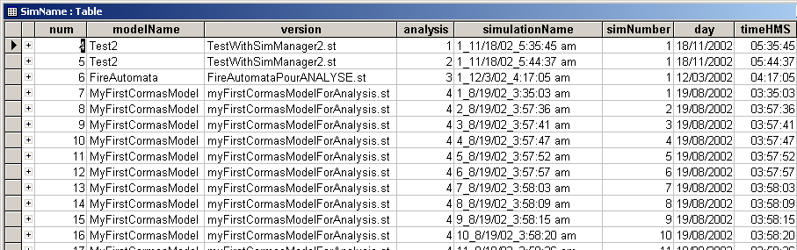

The "InitialValues" table contains 5 fields :
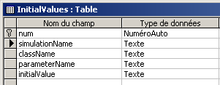
- num: a unique value of the table
- simulationName: the foreign key associated to the primary key of SimName table
- className: example 'MyFirstCormasModel' or ' Plant class' for the class variable value
- parameterName: the name of the attribute
- initialValue: the value of the parameter for the current

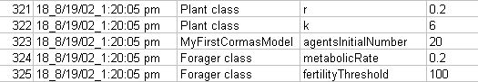

The "GlobalProbes" table contains 5 fields :
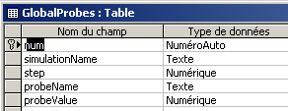

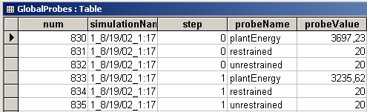

The "LocalProbes" table contains 7 fields :
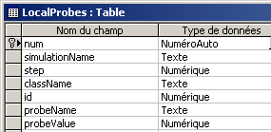

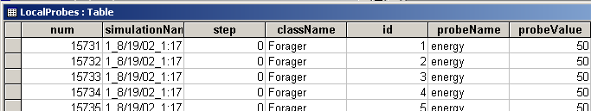

The graph below shows the relations (foreign keys and primary keys) between the 4 tables and their field names.
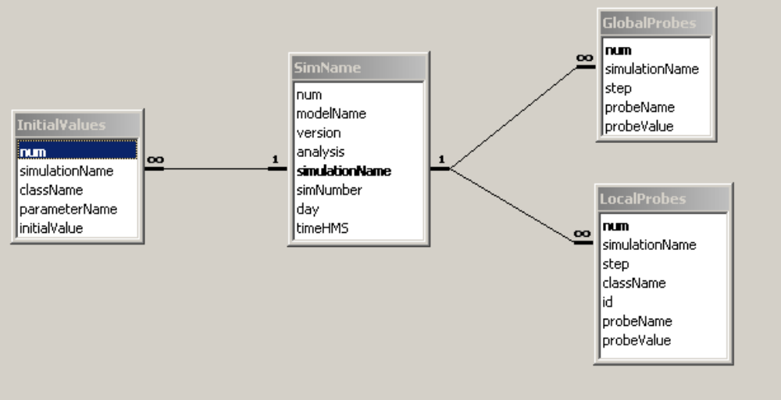

Appendices

How to connect VisualWorks to Access

Set up the ODBC driver ODBC
First of all, create an ACCESS file in the directory VW7\cormas\DataBase. Call it cormasSimulations.mdb.
Launch now the « Data Sources (ODBC) » tool, located in the configuration pannel → Administration tools (or directly launch file "\system32\odbcad32.exe").
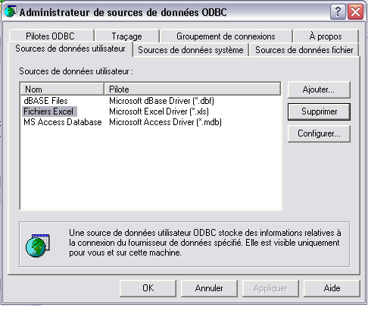
Create now a link for your database with a logical name : Click on « Add » button.
Select the « Microsoft Access Driver (*.mdb) driver, as shown below :
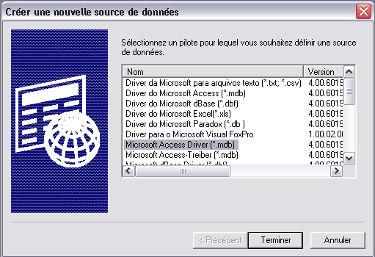
Click on « Finish » .
A new window pops up :
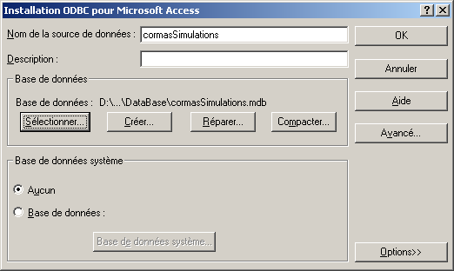
In the field « Data source name », write the logical name of the link. This name will be used in VisualWorks to identify the database.
Click on « Select… » button.

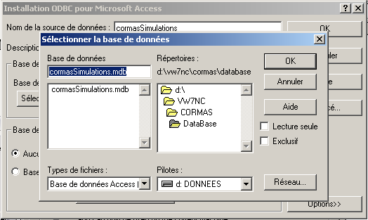
Select the Access file called « cormasSimulations.mdb ».
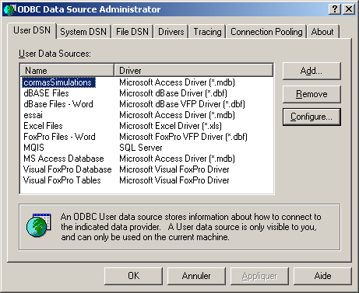
Click on « OK ». That's it !
To use this connection, you must verify that the right parcels are loaded in VisualWorks. Tools → Load Parcel Named… and write « ODBC* ».
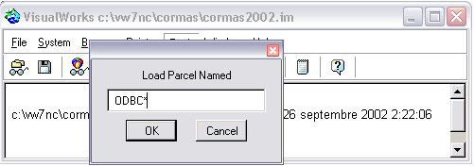
If « ODBCEXDI 7 » and « ODBCThapiEXDI » parcels are not loaded, select them and click OK :
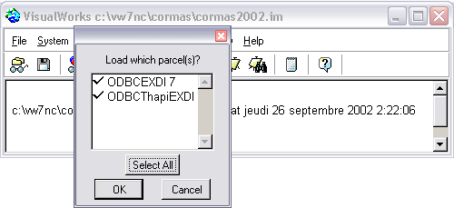
Don't forget to save VisualWorks.

UML : Class diagram of Cormas - Entities category

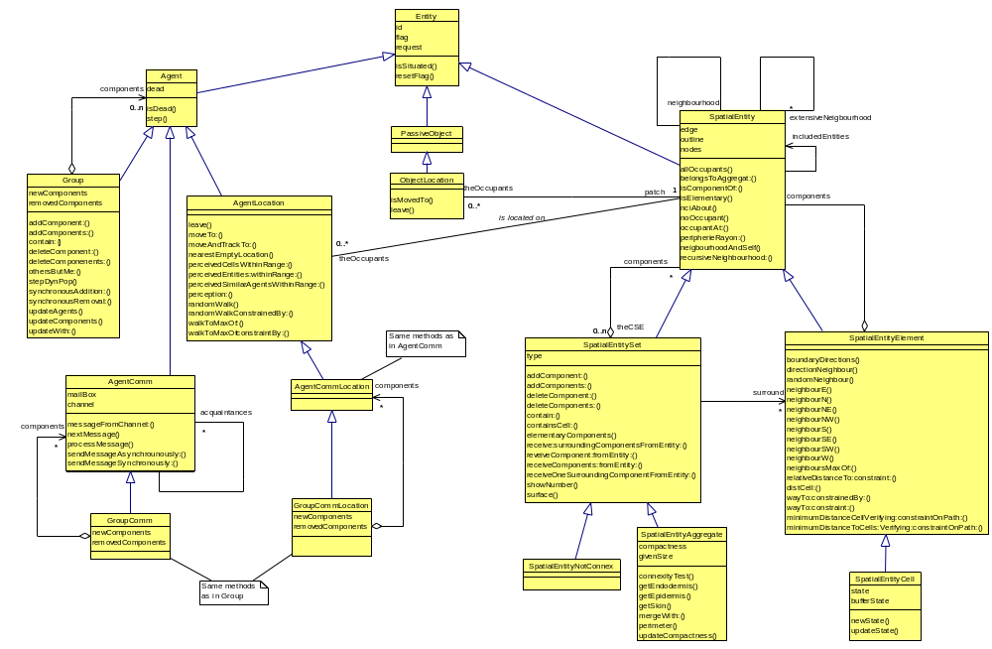
Class diagram of Cormas - Entities category

The Create Accessors menu is activated for the class variables only when the Class tab is selected. 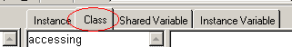
Remember that the Create Accessors menu is activated for the class variables only when the Class tab is selected.
To select all the probes, click on the first one and shift click on the last one.

