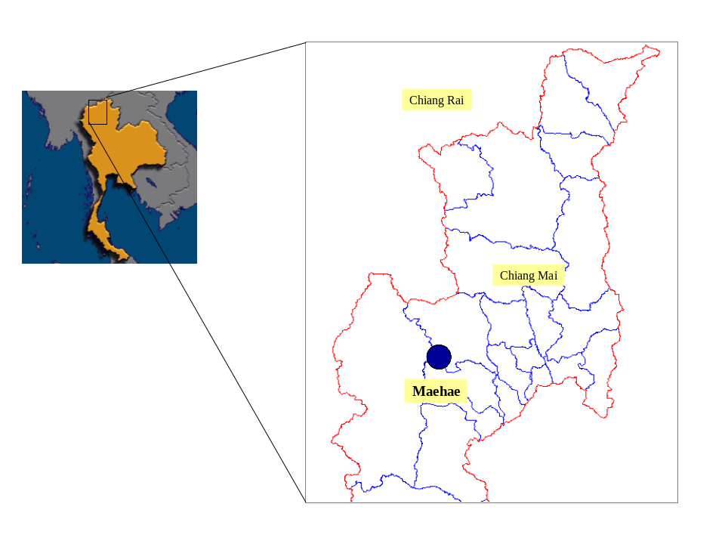

Figure 1 Maehae watershed area, northern Thailand.
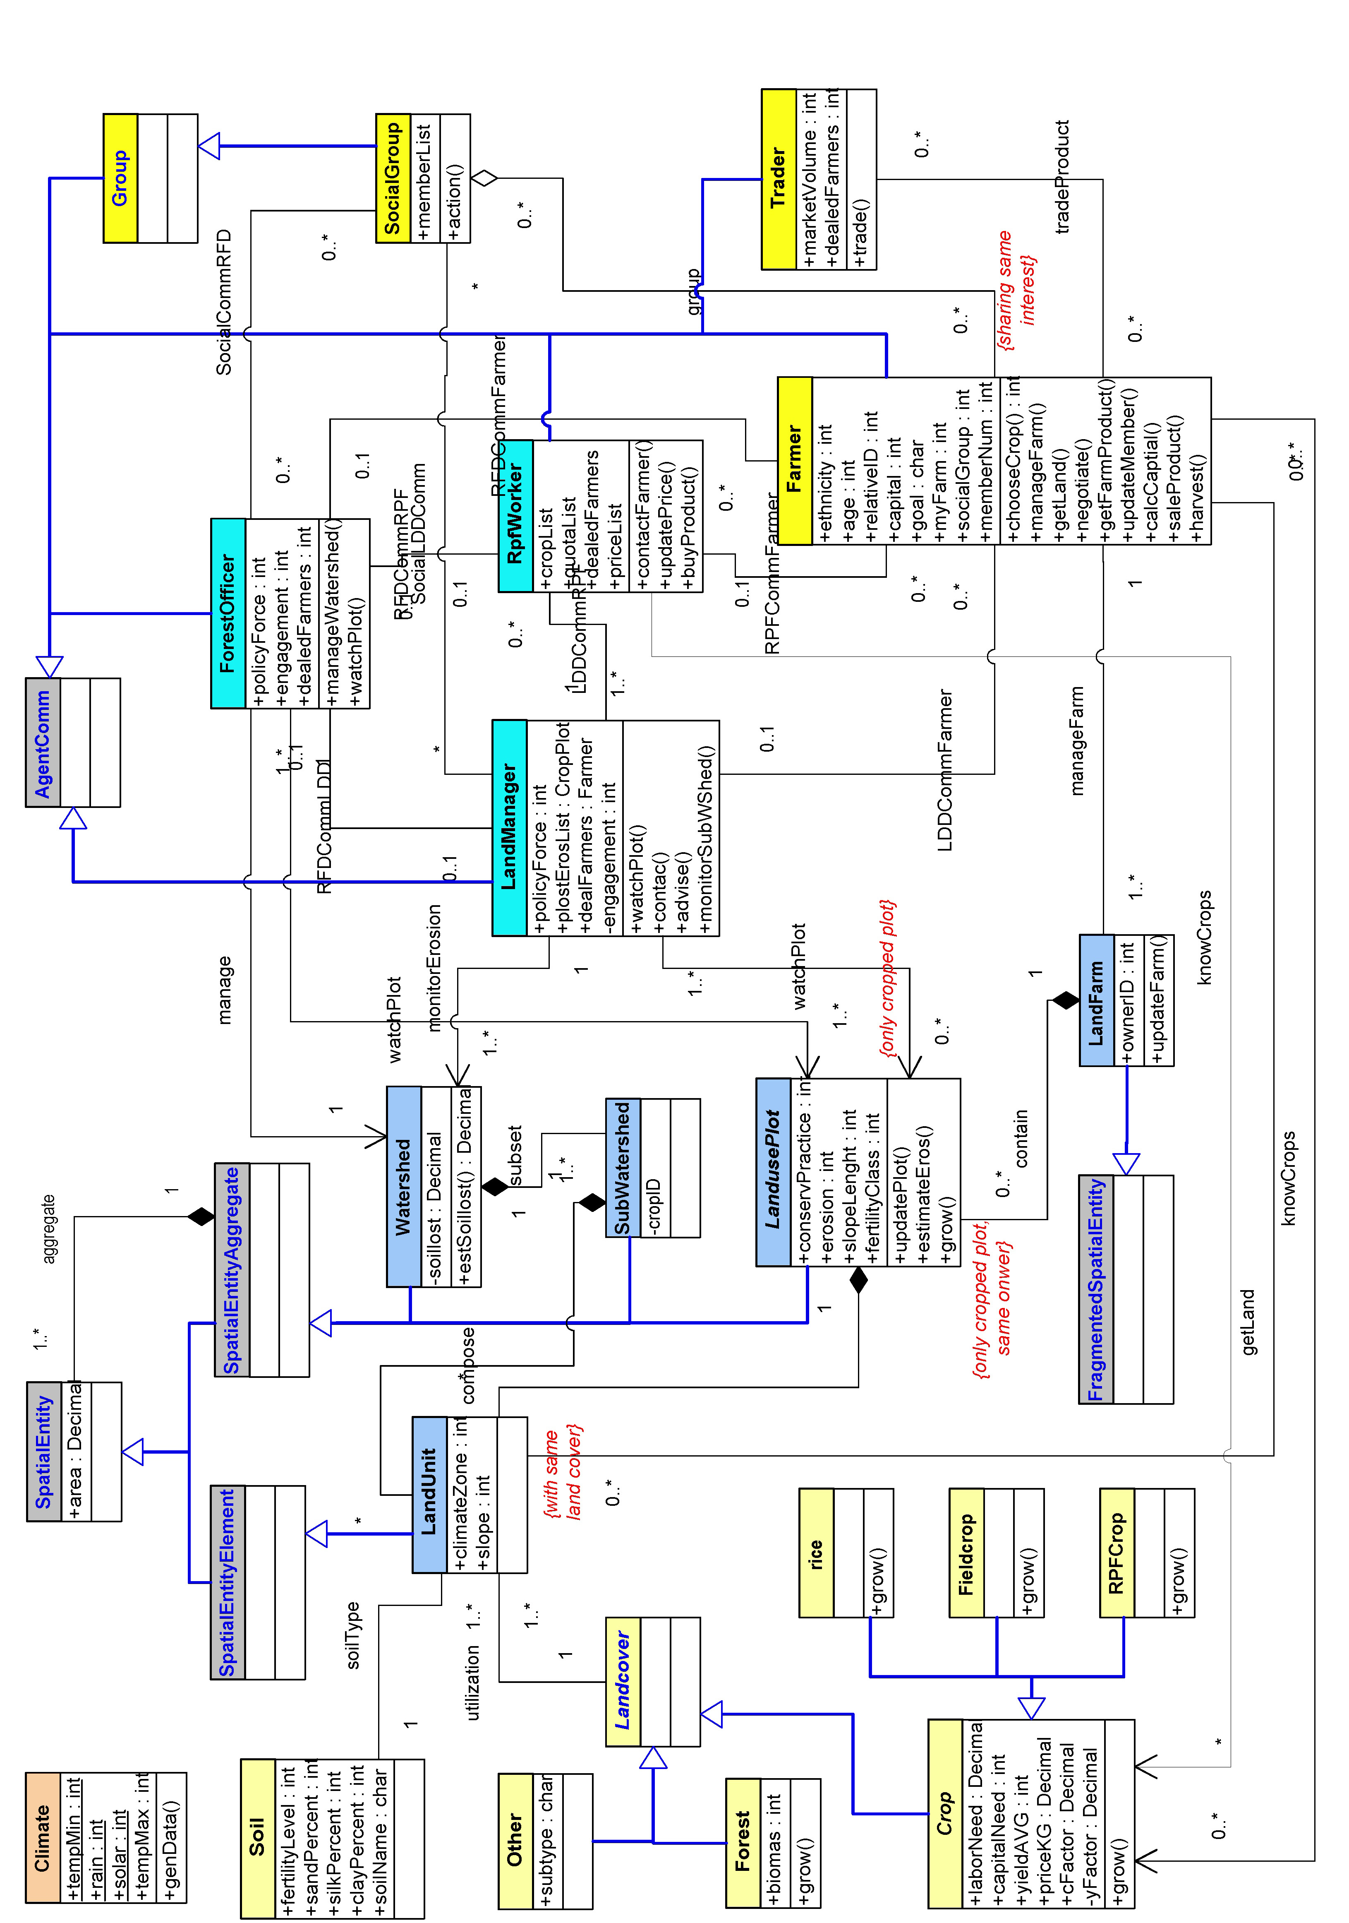

Figure 2 UML class diagram of Maehae human-agroecosystem.

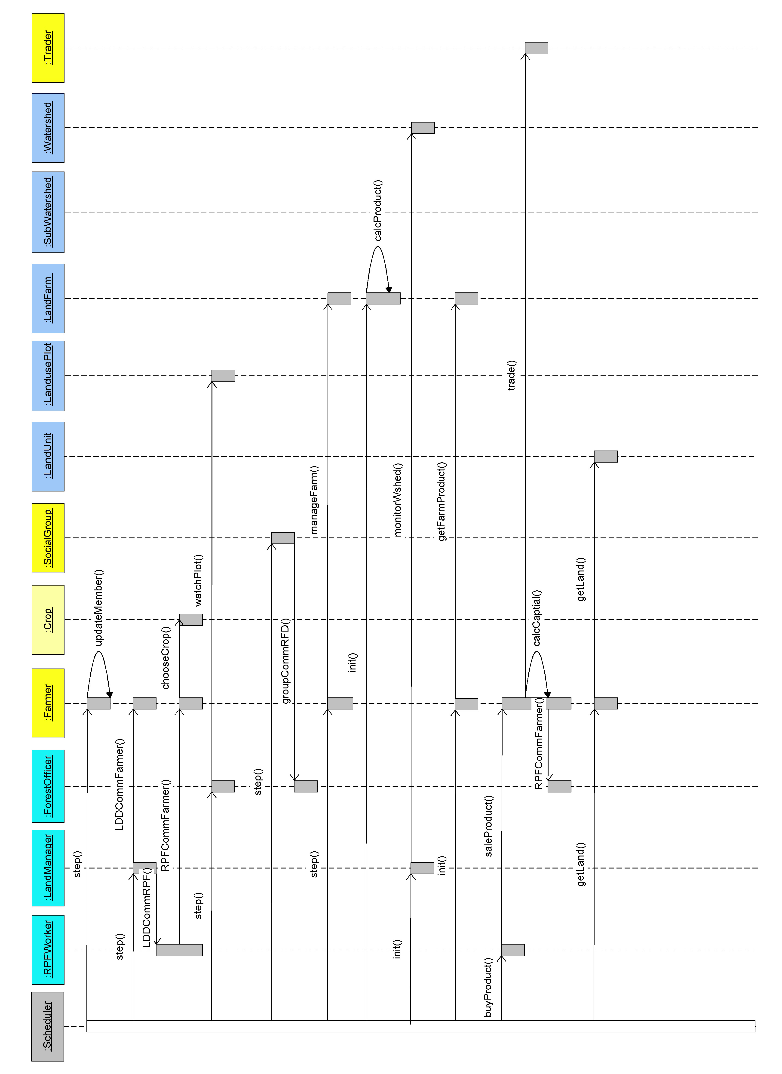
Figure 3 UML sequence diagram.

