Network Measurements

Beatriz Serrano Solano

Carlos Fernandez San Millan

## Throughput comparison

### Ingress & Egress EMBL Outstations

The following graphs represent the throughput achieved from and to EMBL (Heidelberg) and various EMBL outstations.

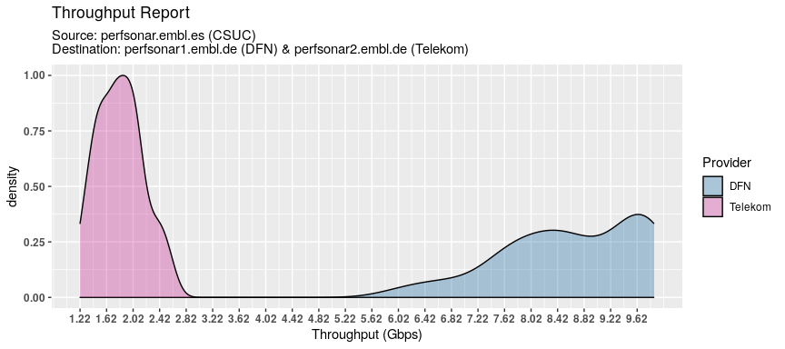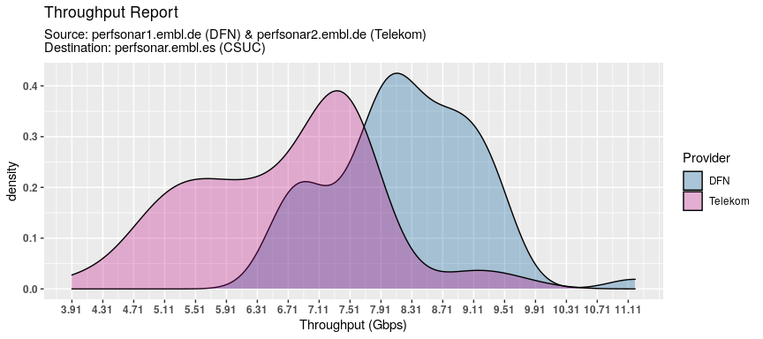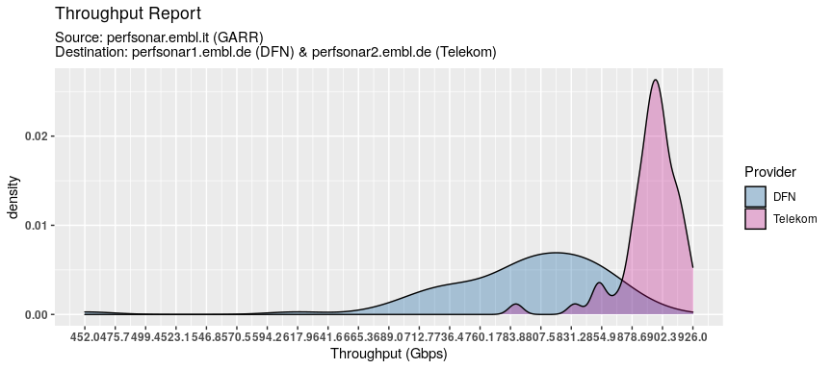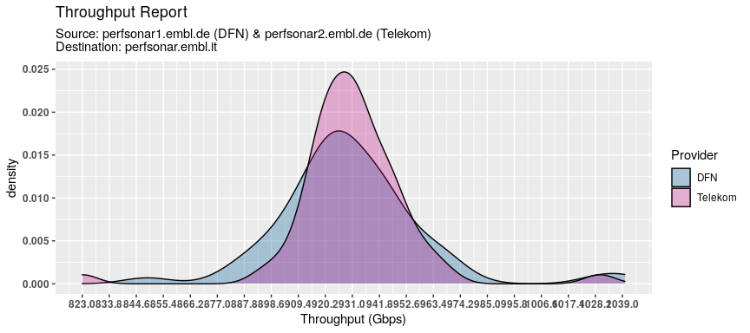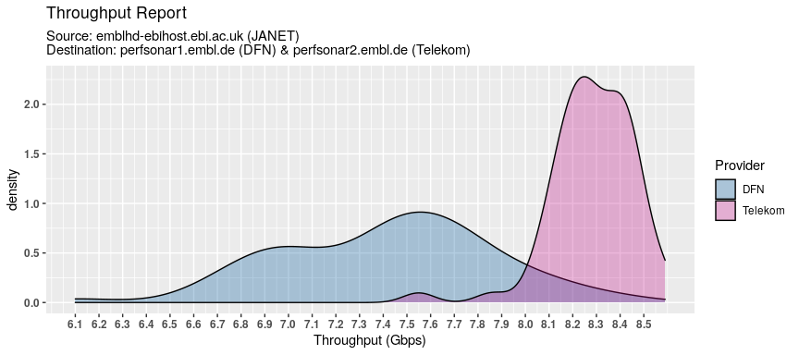

## Traceroute and latency

* Import the data
* Plot 