به نام خدا

تمرین تحویلی اول

آزمایشگاه پایگاه داده

امیرفاضل کوزه گر کالجی

9931099

1)

select s_id, s_name

from Students

where tavg>=17

and

( s_name LIKE 'a%'

or

s_name LIKE '%a')

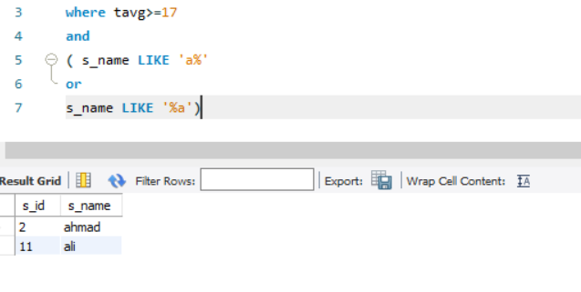

2)

select t_name, t_id

from teacher

where t_name LIKE 'j%'

ORDERBY t_id DESC

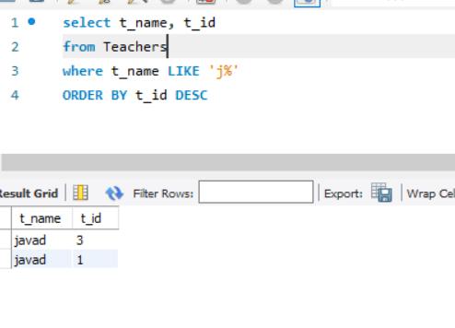

3)

update Student

set tavg =tavg + 1

where city LIKE 'z%' and City LIKE '%n’

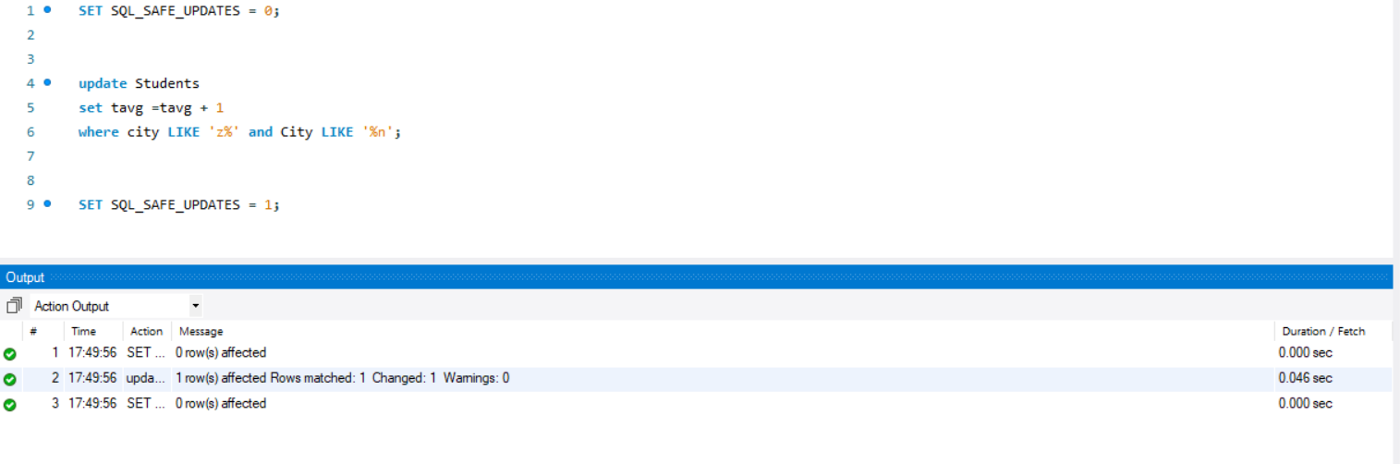

4)

sql server:

select TOP 20% *

from Students

where age>20

ORDERBY age ASC

---------------

mysql:

select *

from Students

where age>20

ORDERBY age ASC

LIMIT 20%

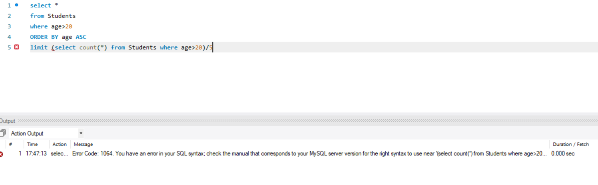

5)

delete

from Students where

s_name = "amirmohammad" and s_family = "hoseini"

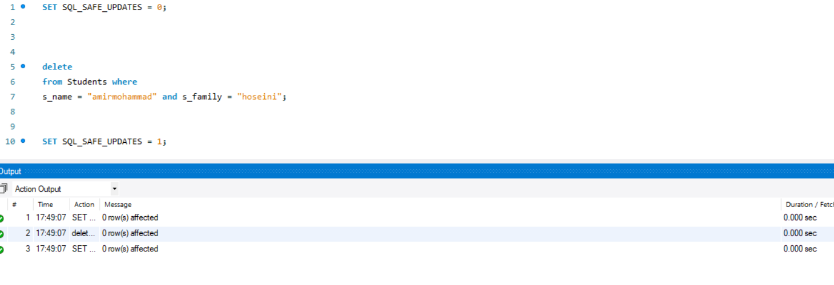

6)

select s_name, s_family

from Students INNER JOIN term ON term.s_id = Students.s_id

where term_no = 3 and age>20

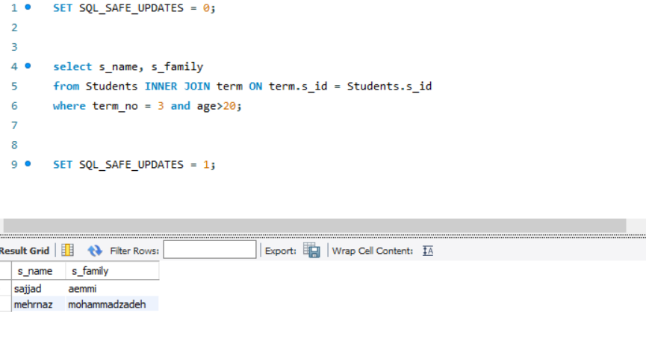

7)

select s_name

from Students INNER JOIN term ON term.s_id = Students.s_id

where term_no BETWEEN 1 and 3 and gender = "m" and grade>18

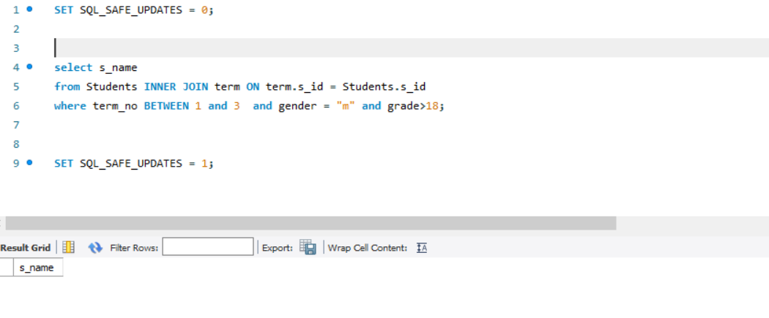

8)

select *

from teacher natural join course

where salary>5000000 and t_field != "computer"

ORDERBY t_id DESC

