

به نام آنکه جانم داد

تمرین تحویلی سری دوم ازمایشگاه پایگاه داده

امیرفاضل کوزه گر کالجی

9931099

1)

select s_name, s_family

from Students natural join Term

where term_no =

3 and age>20

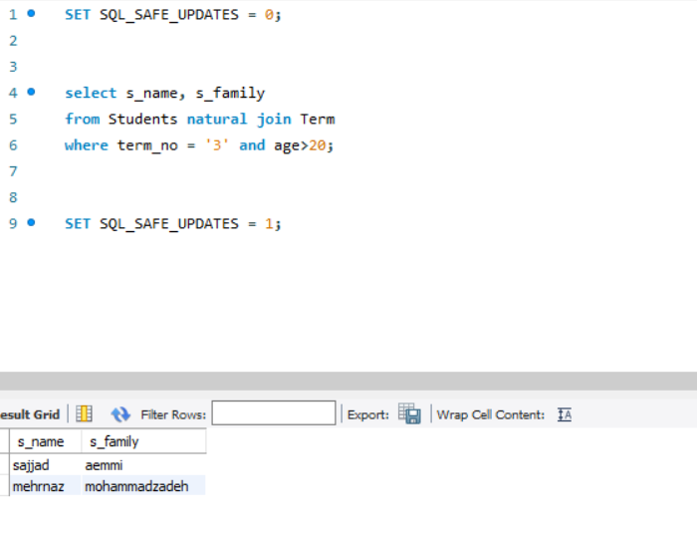

2)

select c_name

from course nautral join term

where term_no = 3

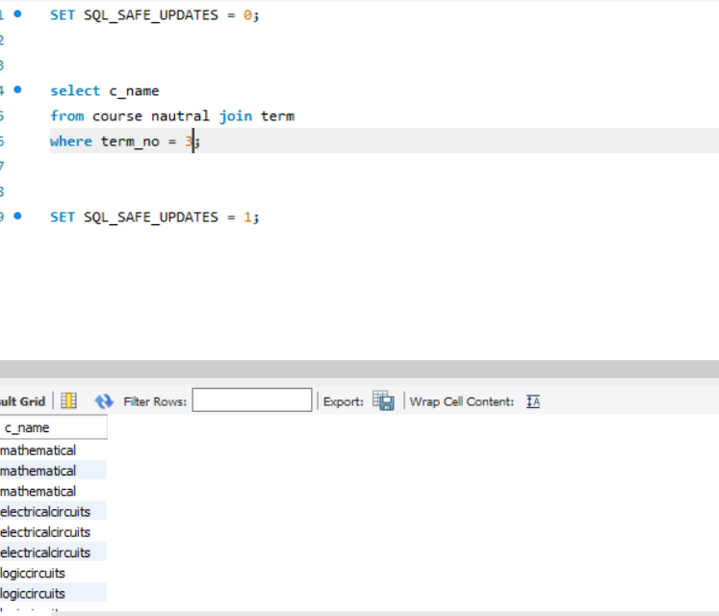

3)

select s_name, s_family

from students

where tavg = (select min(tavg) from students)

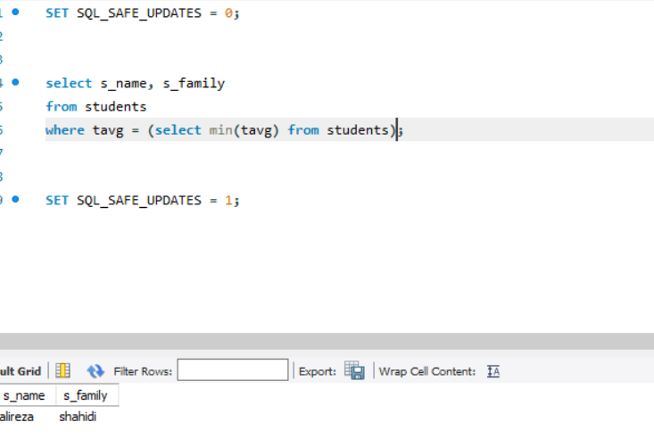

4)

select s_name

from students natural join term

where term_no between 1 and 3 and gender = 'm' and grade > 18

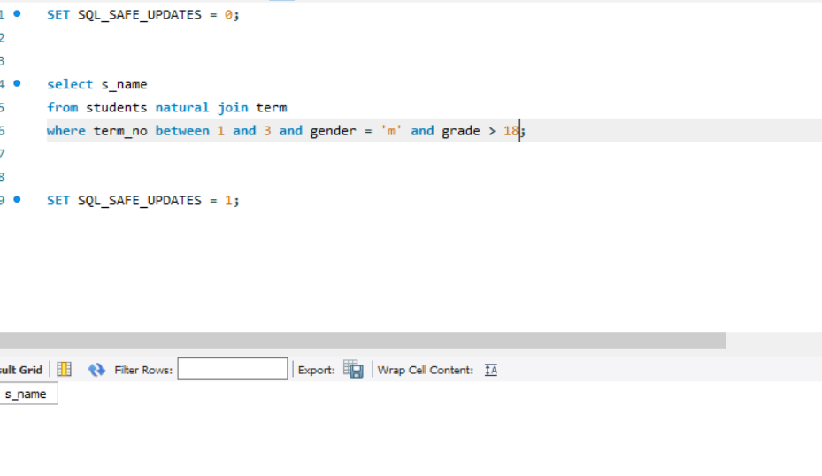

5)

select c_name

from course natural join term

where c_field = "electricity" and dep = "computer" and term_no = 3

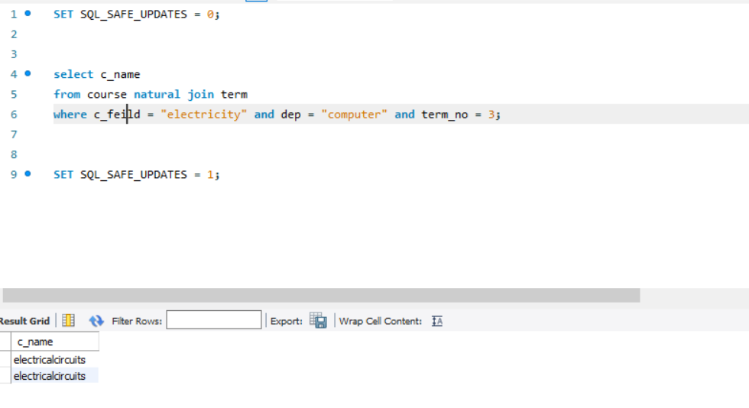

6)

متاسفانه صورت این کوئری برایم واضح نبود و نتوانستم جواب مناسبی برایش پیدا کنم

7)

select s#, quantity

from S natural join SP

where city = "london"

8)

select pname, color

from S natural join P natural join SP

where sname = "s1"

9)

select sname, city

from S

where (sname, city) not in

(

slect sname, city

fron S natural join P natural join SP

where color = "red"

)

10)

select s#, pname, color

from S natural join P natural join SP

where weight>500 and quantity>1000 and status>20

11)

select sname, city

from S natural join P natural join SP

where pname in (select ALL pname

from P

where color = "red")

12)

select pname, color

from S natural join P natural join SP

where city in (select ALL city

from s

where city = "london")

13)

select pname, color

from S natural join P natural join SP

where (name, color) not in (select pname, color

from S natural join P natural join SP

where city in (select ALL city

from s

where city = "london"))

14)

select sname, city

from

(select sname, city

from S natural join P natural join SP

where pname = "p2")

natural join

(select sname, city

from S natural join P natural join SP

where pname = "p4")

15)

select p# and sum(quantity)

from P natural join SP

group by p#

16)

select sname, sum(quantity)

from S natural join P natural join SP

group by sname