به نام خالق زیبایی ها

تمرین تحویلی دوم

درس روش پژوهش و ارائه

استاد درس: جناب آقای دکتر صدیقی

امیرفاضل کوزه گر کالجی

9931099

فهرست

موضوعات منتخب---------------------------------------3

مقالات مرتبط با موضوعات------------------------------4

موضوع اول----------------------------------------------4

موضوع دوم---------------------------------------------5

موضوع سوم--------------------------------------------6

# موضوعات منتخب

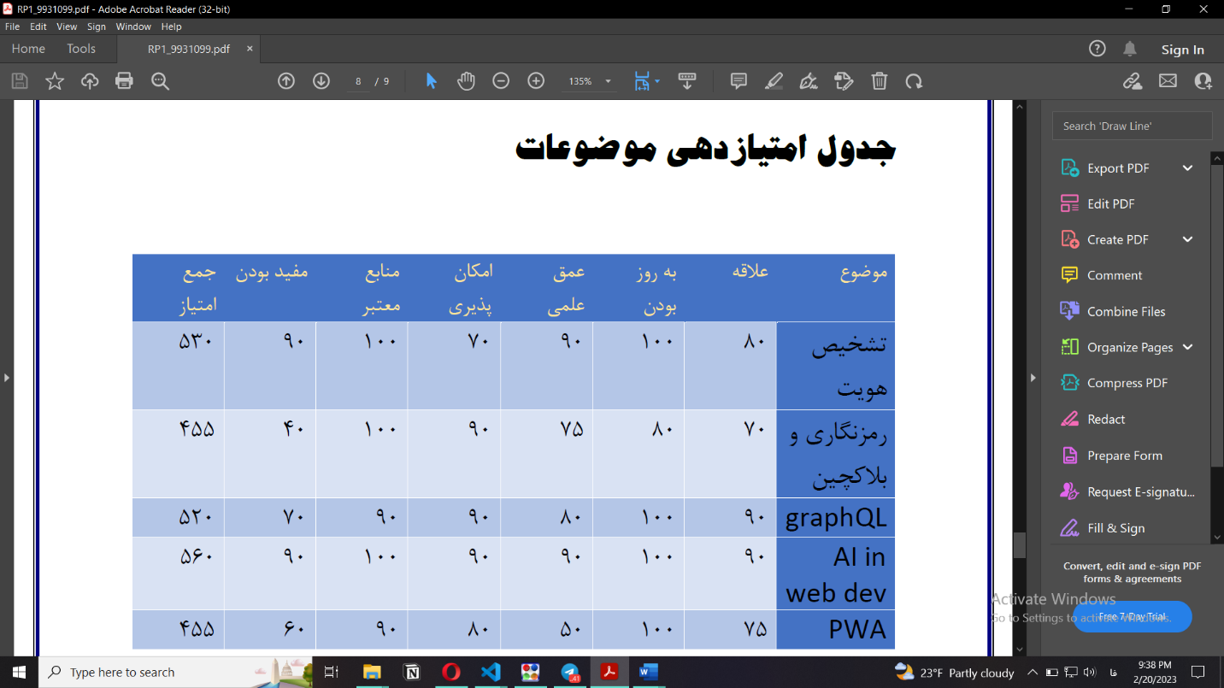

با توجه به جدول بالا، موضوعات زیر به عنوان موضوعات منتخب انتخاب می شوند:

* **هوش مصنوعی و تشخیص هویت با استفاده از تشخیص عکس**
* **Graphql و کاربرد آن در توسعه فرانت اند**
* **استفاده از هوش مصنوعی در روابط کاربری وب**

# مقالات مرتبط با موضوعات

* **هوش مصنوعی و تشخیص هویت با استفاده از تشخیص عکس**

1. Tanupreet Sabharwal , Rashmi Gupta  “Human identification after plastic surgery using region based score level fusion of local facial features” journal of Information Security and Applications [Volume 48](https://www.sciencedirect.com/journal/journal-of-information-security-and-applications/vol/48/suppl/C), October 2019, 102373 (Q2)
2. Van-Huy Pham, Diem-Phuc Tran, and Van-Dung Hoang “Personal Identification Based on Deep Learning Technique Using Facial Images for Intelligent Surveillance Systems” International journal of Machine Learning and Computing Vol 9, No. 4, August 2019 (Q2)
3. Yan Sun,Zhenyun Ren,and **Wenxi Zheng “**Research on Face Recognition Algorithm Based on Image Processing” Volume 2022 18 Mar 2022 (Q2)

# Graphql و کاربرد آن در توسعه فرانت اند

1. [Antonio Quiña-Mera,](javascript:void(0);" \o "Antonio Quiña-Mera) [Pablo Fernandez, Antonio Ruiz-Cortés “GraphQL: A Systematic Mapping Study”](javascript:void(0);" \o "Pablo Fernandez) [[ACM Computing Surveys](javascript:void(0);" \o "Pablo Fernandez)](https://dl.acm.org/toc/csur/2023/55/10)[[Volume 55](javascript:void(0);" \o "Pablo Fernandez)](https://dl.acm.org/toc/csur/2023/55/10)[[Issue 10](javascript:void(0);" \o "Pablo Fernandez)](https://dl.acm.org/toc/csur/2023/55/10) [Article No.: 202 pp 1–35 02 February 2023 (Q1)](javascript:void(0);" \o "Pablo Fernandez)
2. Jeff Doolittle “APIs With GraphQL” [IEEE Software](https://ieeexplore.ieee.org/xpl/RecentIssue.jsp?punumber=52) ( Volume: 40, [Issue: 2](https://ieeexplore.ieee.org/xpl/tocresult.jsp?isnumber=10043596&punumber=52), March-April 2023) (Q2)
3. [Dong-cheol Jeon](https://ieeexplore.ieee.org/author/37086518696); [LIUHAOYANG](https://ieeexplore.ieee.org/author/37087134676); [Heejoung Hwang](https://ieeexplore.ieee.org/author/37086517509) “Design of Hybrid Application Based on GraphQL for Efficient Query for PHR” [2019 International Conference on Information and Communication Technology Convergence (ICTC)](https://ieeexplore.ieee.org/xpl/conhome/8932631/proceeding) (Conference paper)

# استفاده از هوش مصنوعی در روابط کاربری وب

1. [Pegah Malekpour Alamdari](https://ieeexplore.ieee.org/author/37088433067); [Nima Jafari Navimipour](https://ieeexplore.ieee.org/author/37657912700); [Mehdi Hosseinzadeh](https://ieeexplore.ieee.org/author/37400348100); [Ali Asghar Safaei](https://ieeexplore.ieee.org/author/37086914865); [Aso Darwesh](https://ieeexplore.ieee.org/author/37088432792) “A Systematic Study on the Recommender Systems in the E-Commerce” [IEEE Access](https://ieeexplore.ieee.org/xpl/RecentIssue.jsp?punumber=6287639) ( Volume: 8) 16 June 2020 (Q2)
2. [Sara Pérez-Soler](https://ieeexplore.ieee.org/author/37086241698); [Sandra Juárez-Puerta](https://ieeexplore.ieee.org/author/37088896095); [Esther Guerra](https://ieeexplore.ieee.org/author/37563687400); [Juan de Lara](https://ieeexplore.ieee.org/author/38341406800) “Choosing a Chatbot Development Tool” [IEEE Software](https://ieeexplore.ieee.org/xpl/RecentIssue.jsp?punumber=52) ( Volume: 38, [Issue: 4](https://ieeexplore.ieee.org/xpl/tocresult.jsp?isnumber=9460976&punumber=52), July-Aug. 2021) (Q2)
3. [D.H. Sonnenwald](https://ieeexplore.ieee.org/author/37389626000) “Applying artificial intelligence techniques to human-computer interfaces” [IEEE Communications Magazine](https://ieeexplore.ieee.org/xpl/RecentIssue.jsp?punumber=35) ( Volume: 26, [Issue: 3](https://ieeexplore.ieee.org/xpl/tocresult.jsp?isnumber=23&punumber=35), March 1988) (Q1)
4. [B.M. Thuraisingham](https://ieeexplore.ieee.org/author/37268636500); [J.A. Larson](https://ieeexplore.ieee.org/author/38301637000) “AI applications in distributed system design issues” [IEEE Network](https://ieeexplore.ieee.org/xpl/RecentIssue.jsp?punumber=65) ( Volume: 2, [Issue: 6](https://ieeexplore.ieee.org/xpl/tocresult.jsp?isnumber=513&punumber=65), November 1988) (Q1)