In The name of GOD

Amirfazel koozegar

9931099

Writing 02

In this paper, I am going to discuss about javascript and its frameworks.

What is Javascript?

Javascript is used by programmers across the world to create dynamic and interactive web content like applications and browsers. Javascript is so popular that it’s the most used programming language in the world, used as a client-side programming language by 97% of all websites.

What is Javascript Framework?

A [JavaScript](https://generalassemb.ly/education/javascript-development) framework is a collection of JavaScript [code libraries](https://generalassemb.ly/blog/what-is-a-javascript-library/) that provide a web developer with pre-written code for routine programming tasks. Frameworks are structures with a particular context and help you create web applications within that context.

Javascript, provides frameworks for both front-end and back-end development.

Here we have a look at both:

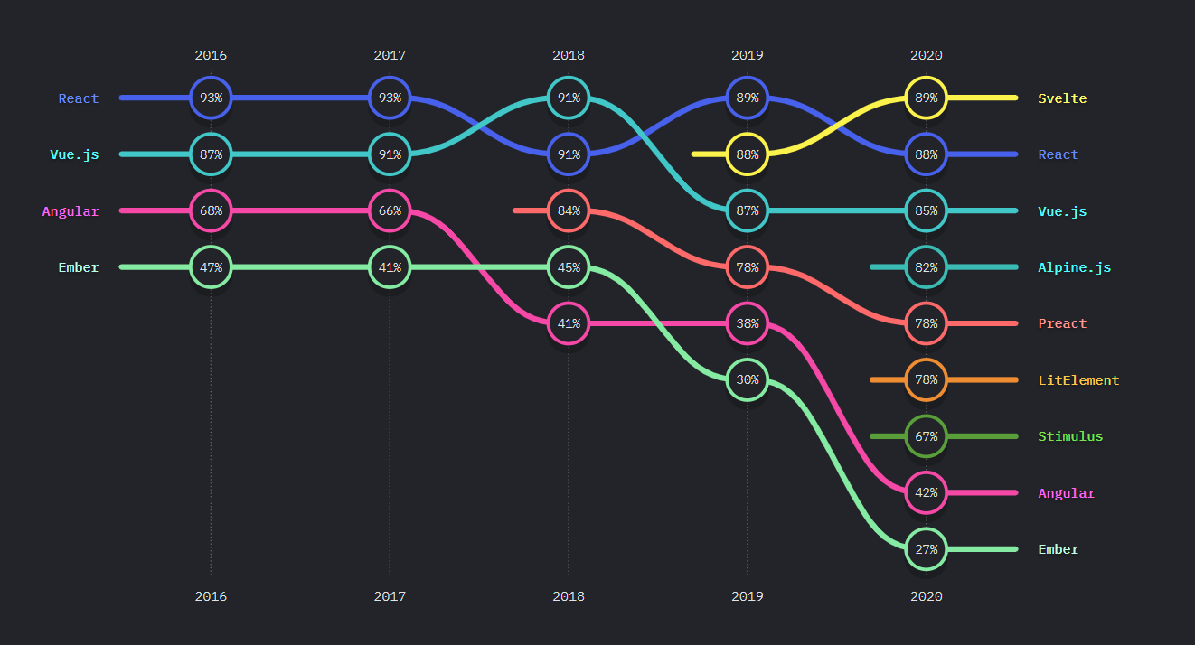

Front-End frameworks

As you can see, Svelte.js had the most usage & rating in 2020.

And React.js as the second framework, which used to have the first place 3 times in 2016, 2017, 2019.

Fun fact: React.js is not a framework. It actually is a Javascript library.

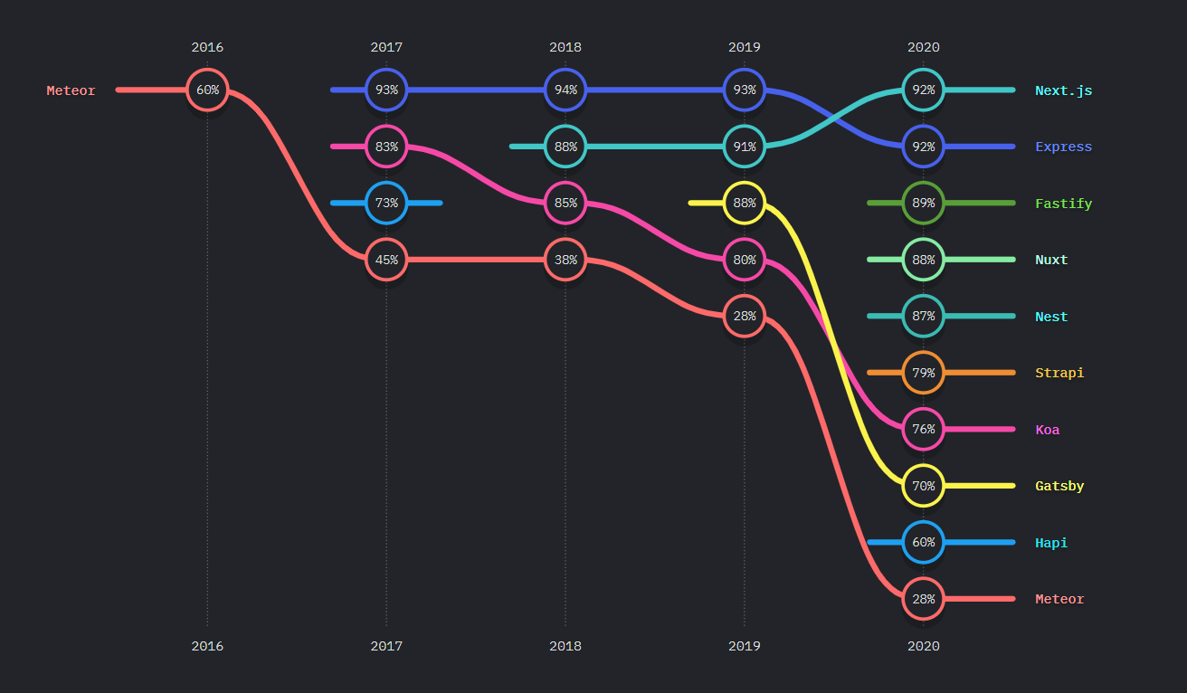

Back-End frameworks

The top back-end framework is Next.js according to the statistics(Actually in 2020!).

As you can see Meteor is in the last place, which was the one and only framework used in 2016.

Express.js is also determined as 2nd most used framework in 2020, and also has been the first and top used framework for 3 years in a row 2017, 2018, 2019.

Javascript also has Testing & Build Tools and the statistics are shown below:

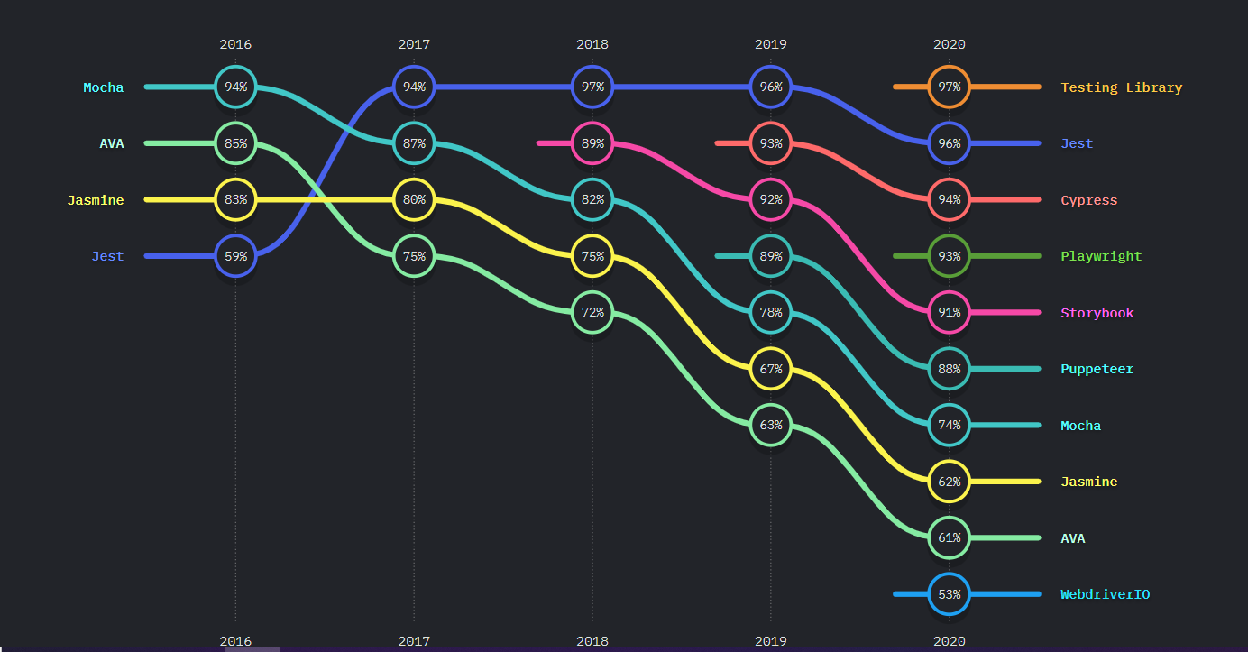

Testing Tools Ranking

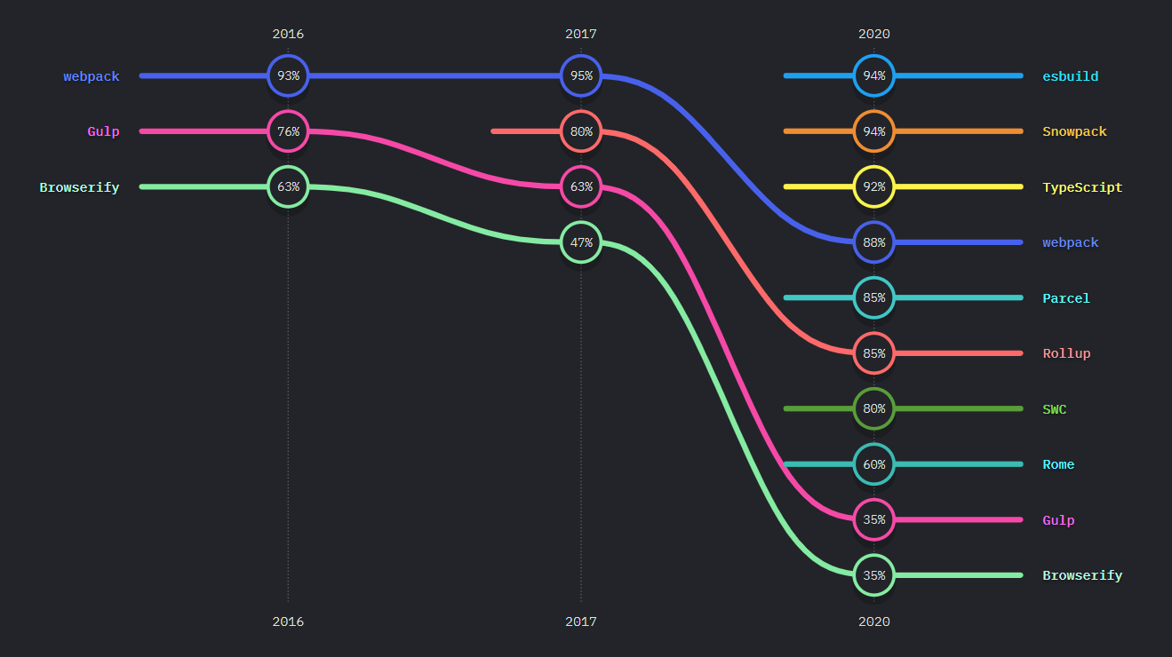

Build Tools Ranking