به نام خدا

امیرفاضل کوزه گر کالجی

9931099

Writing 3

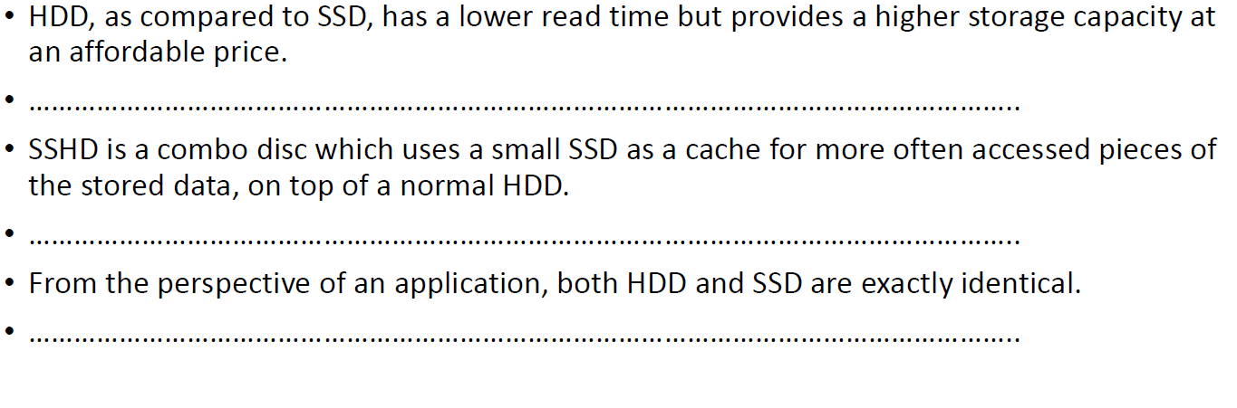

HDD takes more time than SSD in reading data, but has more storage and lower price.

SSHD uses a HDD as its main storage and a SSD as a cache to store recent used data

From an applications POV, HDD and SSD are equal

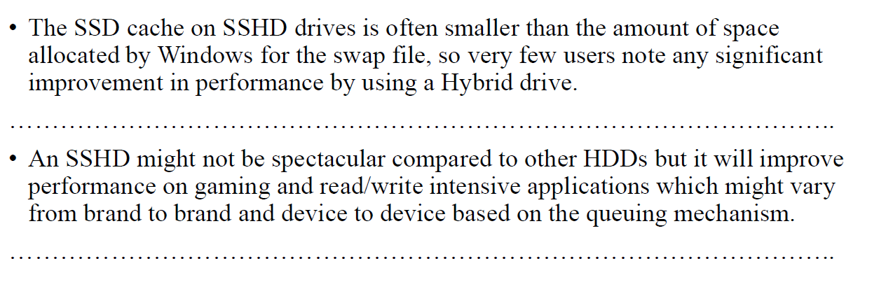

SSHD is superior to HDD on gaming and read/write which has various performance according to different brands and devices and the queuing system.

For swapping, SSD cache in SSHD, uses less space than the allocated space from Windows, so few users notice any improvement.