PROBLEM IDENTIFICATION PROPOSAL

Project Title
Road Accident

Description of the Community Problem
Road accidents are a serious problem that can affect individuals, families, and the wider community. Road accidents may result in injuries, loss of life, damage to vehicles and property, and financial difficulties for those involved. Frequent road accidents can also place pressure on emergency services and healthcare facilities and may cause traffic delays and disruptions.
The purpose of this project is to investigate road accidents in the local community through data analysis. The project will focus on identifying patterns and trends in road accidents and, depending on the variables available in the dataset, examining factors such as accident location, time of occurrence, weather conditions, road conditions, vehicle types, and accident severity. The analysis will help provide a better understanding of where and when accidents occur most frequently and identify areas that may require greater attention.

Why the Problem is Important
Road accidents are an important community problem because they can have serious consequences for road users and the community. The loss of life and injuries caused by accidents can have long-term effects on individuals and their families. Accidents can also result in financial costs, traffic congestion, and increased pressure on emergency and healthcare services.
Understanding road accident patterns through data analysis can help stakeholders identify high-risk areas and periods when accidents occur more frequently. This information can support better decision-making and assist stakeholders in developing targeted strategies to improve road safety and reduce the occurrence and severity of road accidents.

Stakeholders Affected
The stakeholders affected by road accidents include drivers, passengers, pedestrians, cyclists, public transport users, transport operators, traffic authorities, local municipalities, emergency medical services, hospitals, law enforcement agencies, and local communities. These stakeholders may be affected directly or indirectly by road accidents and their consequences.

How Data Analysis Could Contribute to Solving the Problem
Data analysis can be used to identify patterns, trends, and possible contributing factors associated with road accidents. The analysis may examine variables such as accident location, date, time, weather conditions, road conditions, vehicle types, and accident severity, depending on the information available in the dataset.
Descriptive statistics and data visualisations can help identify accident hotspots, high-risk periods, and common patterns in the data. The findings can then be used to develop evidence-based recommendations for relevant stakeholders. These recommendations may include improving road safety measures, increasing traffic monitoring in high-risk areas, improving road infrastructure, and conducting targeted road safety awareness campaigns. By using data to understand the problem, stakeholders can make informed decisions and focus resources on areas where they are most needed.

Data Analysis
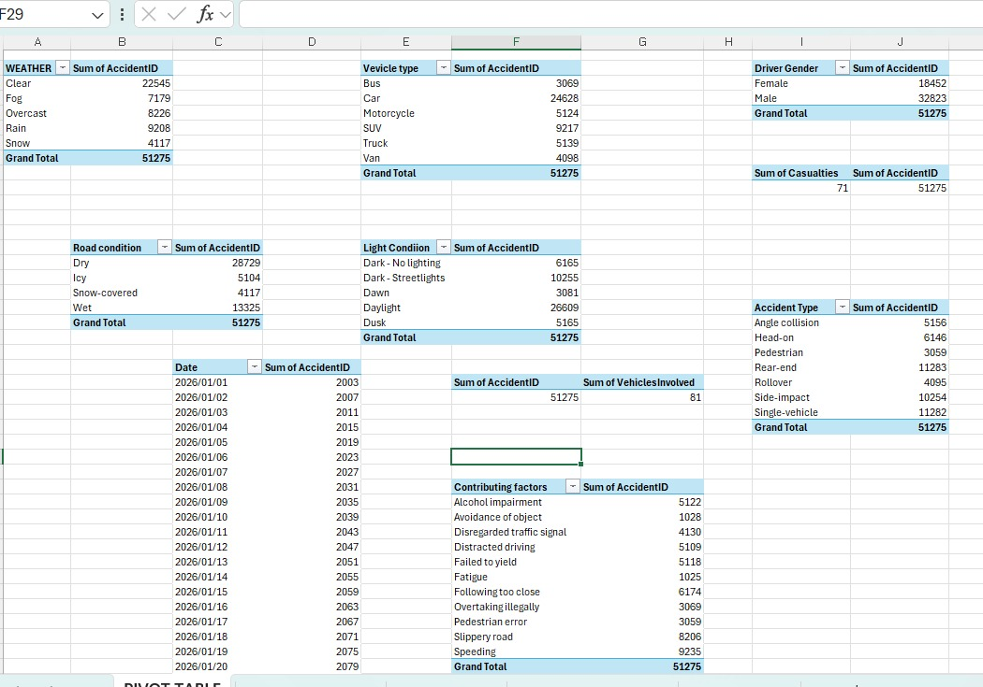
We have used pivot tables in excel to organise and summarise the accident data. This made it easier for us to see the different patterns in the data
Weather conditions
The data shows that accident happened under different weather conditions. The conditions are: Clear weather, fog, overcast, rain and snow. From our analysis, clear weather had the highest number of accidents. Rain and overcast weather also had high number of accidents, while snow had the lowest. This shows that accidents do not only happen when weather conditions are bad. They also can happen during clear weather.
Road conditions
By looking at four road conditions: Dry, Wet, Icy and snow. Based on the results they show that dry roads had the highest number of accidents and wet roads are the second highest, while icy and sow roads had the lowest number of accidents.
Light Conditions
Included conditions are day and night. The results showed that most accidents happened during the day. Other accidents happened during the night(dark) condition. This could be because there are many vehicles during the day, while accidents that happened at night are also important because the lack of clear visibility makes driving difficult.
Vehicle Type
The vehicle types in the data include cars, motorcycles, SUVs, trucks, vans and buses. From the analysis we did, cars had the highest number of accidents following by motorcycles. Vans, trucks, SUVs and Buses had lower numbers. This tells us that cars are the main type of vehicle involved in the accidents in this dataset.
Driver Gender
Between the two genders (male and female) we have, the data shows that male drivers had more accidents than female drivers.
Accident Type
As per analysis different types of accidents in a dataset, included rear-end, single-vehicle, side impact, head on, angle collision, rollover and pedestrian accidents. Based on the results the rear-end and single vehicle accidents were among the highest.
Casualties
The data shows 71 casualties that were recorded. The importance of casualties shows the effect that accidents can have on people. It is very important to not only look the number of accidents but also how serious accidents are.
Main findings
- Most of the accidents in the weather analysis happened during clear weather.
- Dry roads had the highest number of accidents
- Most of the accidents happened during the day
- Cars were the vehicle type with the highest number of accidents.
- Male drivers had more recorded accidents than female drivers
- Rear-end and single vehicle accidents were among the most common accident types.
- There were 71 casualties recorded in the data.
- The accident dates can be used to identify changes in accident numbers over time.

Casualties Analysis
We analysed the number of casualties recorded in the road accident data. We used different formulas in excel to calculate and understand the data better.
The mean number of casualties is 1.42 and this means that on average the are about 1 to two casualties per accident.
The median is 1 casualty, which means that when the casualty values are arranged from the lowest to the highest the middle value is 1.
The mode is also 1 casualty which means that one casualty is the number that appears more often in the data.
The minimum number oof casualties is 0, meaning that some accidents did not result in any casualties.
The maximum is 4 casualties meaning the highest number of casualties recorded for one accident was 4.
The range is 4, which is the difference between the highest value of 4 and the lowest value of 0
The total number of casualties recorded in the data is 71.

Vehicles Involved Analysis

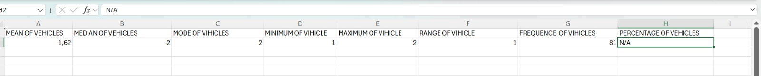

We also analysed the number of vehicles involved in the accidents , different excel formulars to calculate and understand the data better.
The mean number of vehicles is 1.61. This tells us on average about 1 to 2 vehicles were involved in an accident.
The median is 2 vehicles, which means that the middle value in the data is 2 vehicles.
The mode is also 2 vehicles; this tells us that 2 vehicles is the number that appears more often in the data
The minimum number of vehicles is 1, meaning that some accidents involved only 1 vehicle.
The maximum number is 2 vehicles, meaning that the highest number recorded in the data is 2 vehicles.
The range is 1, which is the difference between the maximum of 2 vehicles and the minimum of 1 vehicle.
The total frequency of vehicles involved is 81.

SPEED LIMIT ANALYSIS
We analysed the speed limit in the road accident data. Different excel calculations were used to understand the speed information better.
The mean speed is 49,9 which tells that the average speed limit in the data is 45.
The median speed is 42,5, which means that the middle value in the data 42,5
The mode is 35, meaning that 35 is the speed limit that appears most often in the data.
The minimum speed is 25, while the maximum is 70. This tells us that the speed limit in the data range from 25 to 70.
The range is 45, which shows the difference between the highest speed of 70 and the lowest speed of 25.
The frequency of the speed data is 2,245.

VISUALIZATIONS
