***Sensor & temporal resolution: Introduction***

With an objective to create a low-cost and robust network of climate-sensors, it will be important to find a good balance of costs and accuracy. The data has to be accurate enough to provide data about the climate in the area, and especially the extremes that are occurring in different regions and seasons. The costs can be reduced by having a low-cost housing of the sensors, but also by decreasing the labour required. This means being able to use the sensors in the field for a long period without the need to replace or read the sensor-data. Analysing data is another step in which labour can be reduced by creating *e-Agriculture* applications that require limited input to provide useful information to farmers and researchers. A straightforward option to increase the period the sensors can be used in the field is to adjust the resolution at which the sensors make their observations. The iButton Hygrochron (DS1923)[1] can make temperature measurements at 8- or 11-bit resolution (0.5°C or 0.0625°C), and humidity measurements at 8- or 12-bit resolution, which is either 0.6% or 0.04% RH. The readings, however, are either stored in 8- or 16-bit, with the total memory for this sensor being 8192 bytes. According to the specifications, the temperature accuracy is better than ±0.5°C for most of the range (-10°C to +65°C), while the accuracy of the humidity measurements is ±5% RH. By using a lower resolution sensor for both temperature and humidity, the sensor can store double the number of observation at the same time interval as would be possible at the higher resolution (*see table 1*).

**Table 1: Number of observations and possible observation period at different resolutions**

|  |  |  |  |  |  |
| --- | --- | --- | --- | --- | --- |
|  | Number of observations | Time covered at 2-hour interval | Time covered at 1-hour interval | Time covered at 30-min interval | Time covered at 15-min interval |
| 1 unit at low-res | **8192** | 683 days | 341 days | 171 days | 85 days |
| 1 unit at high-res or |  |  |  |  |  |
| 2 units at low-res | **4096** | 341 days | 171 days | 85 days | 43 days |
| 1 unit at low-res & 1 unit at high-res | **2560[2]** | 213 days | 107 days | 53 days | 27 days |
| 2 units at high-res | **2048** | 171 days | 85 days | 43 days | 21 days |

While changing the sensor resolution has the potential to provide easy gains, a more challenging approach to reduce costs relates to creating low-cost shielding. A large number of recommendations exists (*see box 1*), which relate to issues such as sensor-height and reflectivity and aeration of the sensor-housing. Literature provides data of related experiments that have been conducted to find low-cost sensor shielding[3],[4],[5], in which differences have been found of up to 7.40C. Most of these studies have focused on natural areas – where additional shading can easily be found. As the network that will be created will ideally be easy to use in different regions, the material that will be used for the shields will have to be very basic. This means only standard (relatively thin) PVC tubes, basic materials for shielding (insulating foil, reflective tape), and basic approaches to increase aeration (drilling holes) will be tested. It is unlikely that these shielding constructions can provide the same accuracy as certified weather stations, but ideally the maximum and minimum will be in a small range that can be reduced by smoothing of the dataset. The steps that will be taken to make the basic sensor shields and resolution accurate will be: **1)** analysing the impact that different sensor accuracy has on the provided data – and especially the extremes (*experiment 1A*); **2)** studying the impact that different temporal resolutions have on the extremes; **3)** testing different sensor shields and analysing how these impact on the provided temperature data (*experiment 2*); and **4)** combining the findings from step 1, 2 & 3 to find a good balance between the costs of the network and the accuracy of the temperature and humidity data.

When assessing trade-offs, the most important factor will be the robustness and accuracy of the data. Having similar data in the created shields as in a certified weather station would be ideal (physical calibration), but this is likely not feasible to a very high extent. This difference between the shields and a certified weather station will have to be the same, so that a computer-based correction can take place. It can be expected that a lower temporal resolution will result of a certain smoothing of the data. This can be corrected by different interpolation techniques, but it will be hard to do this for the extremes, as wind and clouds will play role at the local level (*see chapter on local climatic factors*). On the other hand, it can be expected that – in line with existing literature – it will be very hard to reduce the impact of midday radiation on temperature. As the shields are expected to result in an exaggeration of temperature extremes, a reduced temporal interval (possibly in combination with additional smoothing), could be used to offset these differences. An important note made in the *WMO Guide to Meteorological Instruments and Methods of Observation*[6] is that, while it is acknowledged that it might not be economically feasible to work with sensors that directly meet the accuracy requirements, *‘it is necessary to limit the size of the corrections to keep residual errors within bounds*’. The maximum difference between the (max- & min-) correction (in the range -30 to +45°C) is 0.2 K, which might not be possible in this network. As it is not an ‘official’ weather station and has a different objective, this is not a serious limitation, but it should be preferred to work as close to the WMO standards as possible. In addition to this, an important ISO standard that will be taken into account during the comparison of different sensor shields is ISO standard 17714: *Meteorology — Air temperature measurements — Test methods for comparing the performance of thermometer shields/screens and defining important characteristics[7].*

|  |
| --- |
| **Box 1: Summary of relevant recommendations for weather stationsvi**   1. For general meteorological work, the observed air temperature should be representative of the free air conditions surrounding the station at a height of between 1.2 and 2.0 m above ground level. 2. A radiation shield or screen should be designed to provide an enclosure with an internal temperature that is both uniform and the same as that of the outside air; it should completely surround the thermometers and exclude radiant heat, precipitation and other phenomena that might influence the measurement. 3. Thermally insulating plastic-based material is preferred as material for the shield over the better performing highly polished, non-oxidized metal, because of its simple maintenance requirements; thermally insulating material must be used if the system relies on natural ventilation. 4. A humidity sensor may be combined with or co-located with a temperature sensor in its radiation shield as long as the sensor thermal output (self-heating) is very low. 5. Direct contact with liquid water will seriously harm sensors using hygroscopic electrolyte as a sensor element. Great care should be taken to prevent liquid water from reaching the sensitive element sensors. 6. Desirably characteristics include reliability & stability, simplicity of design, durability and acceptable cost. 7. Agricultural meteorological stations should be inspected at interval sufficiently short to ensure the maintenance of a high standard of observations and the correct functioning of the sensor. 8. Recording instruments should be compared frequently with instruments of the direct-reading type. 9. The position of a station referred to in the World Geodetic System 1984 (WGS-84) Earth Geodetic   Model 1996 (EGM96) must be accurately known and recorded (1/1000 degrees latitude & longitude).   1. It is important that records should be kept not only of the temperature data, but also of the circumstances in which the measurements are taken (metadata). |

*Section overview:*

This section will continue with the results of experiments 1 & 2, followed by a discussion of the results and an additional experiment in which the results of the experiments will be combined. The section will conclude with recommendations regarding the sensor/temporal resolution, as well as the preferred sensor shielding.

***Sensor & temporal resolution: Experiment 1A***

*Sensor resolution*

An experiment has been done with a total of 30 sensors, making observations at 5-minute interval during one week. The sensors have been placed in a certified weather station - which also houses an official observation instrument, to make sure the conditions would be the same for all sensors. Half the sensors have been set at the highest temperature and humidity resolution, while the other half has been set at the lower resolution. The sensors have been paired throughout the weather station and linear interpolation has been used to get the value at 1-minute intervals. Statistics have been calculated over the dataset at minute-intervals, which contained 30 sensors with 10.080 observations each. Temperature plots can be seen in figure 1, while the detailed plots from this one-week experiment (including humidity) are provided in *Annex 1*.

**Figure 1A: temperature graph at low-resolution Figure 1B: temperature graph at high-resolution**

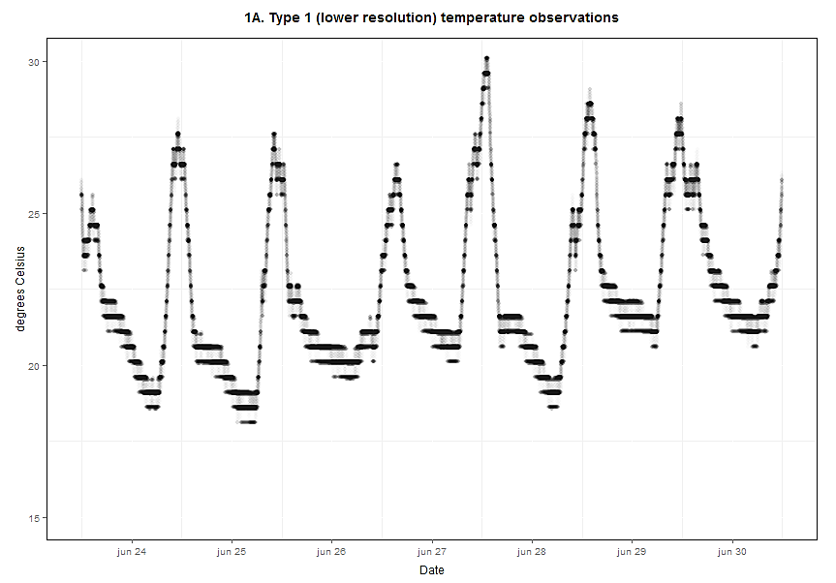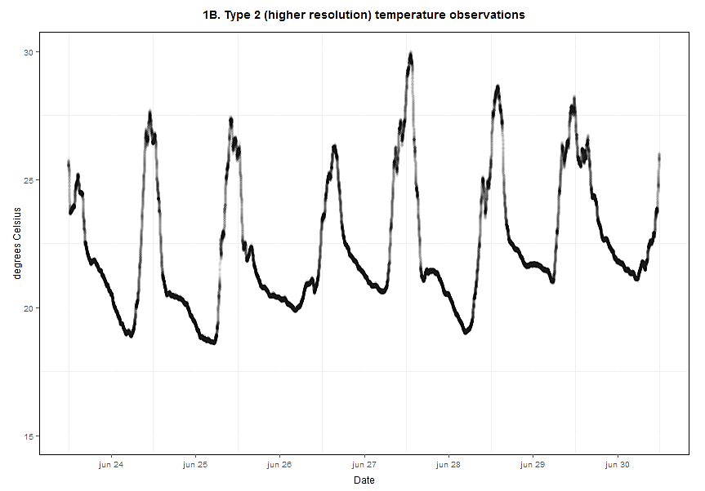

Analysing the sensors provides more detailed information; the temperature range for the low-res sensors is 18.11 – 30.12°C, while this is 18.54 – 30.02°C for the high-res sensor. For humidity the range is 64.33 – 99.94% RH for the low-res and 63.86 – 100.23% RH for the high-res sensors. The mean temperature and humidity for the low-res sensors are 22.37°C and 90.45% RH; for the high-res sensors these values are 22.35°C and 90.93% RH, which is all within a very small range. Another important issue to take into account is the variability between sensors; a visual analysis shows that this is especially an issue for the low-res temperature observations. The standard deviation has been calculated as the mean of every row of the data-matrix which contains 15 sensors with 10.800 observations. The standard deviation for the low-res temperature sensors is 0.26°C; this is < 0.05°C for the high-res sensors. For humidity, the standard deviation is 1.13% for the low-res sensors, whereas this is slightly higher (1.20%) for the high-res sensors. Correlation between temperature and humidity is -0.91 for the low- and -0.92 for the high-resolution sensors.

**Table 1: temperature statistics of the sensors at low- and high-resolution**

|  |  |  |  |  |  |  |  |  |
| --- | --- | --- | --- | --- | --- | --- | --- | --- |
|  | Minimum | 1st Quartile | Median | Mean | 3rd Quartile | Maximum | Standard  deviation | Maximum difference |
| **Type 1 (low-res):** | 18.11 | 20.61 | 21.61 | 22.37 | 24.06 | 30.12 | 0.26 | 1.02 |
| **Type 2 (high-res):** | 18.54 | 20.58 | 21.64 | 22.35 | 23.96 | 30.02 | 0.05 | 0.65 |

A preliminary conclusion which can be drawn from this experiment would indicate that working at a higher-resolution would not make a lot of sense for both temperature and humidity, as the reduced interval at which observations can be made will likely reduce the quality of the data-set more than this can be increased by the higher accuracy of the higher resolution. Especially for relative humidity a high-resolution would not contribute meaningfully. The range of these observations, as well as the standard deviation between the sensors, is higher than for the low-res sensors. In this case, the low-resolution sensor seems to be better. For temperature, the mean is very similar (within 0.02°C), while there is a large difference between the standard deviation in both datasets. This is not necessarily a big problem, as the maximum standard deviation at any moment is less than 0.4°C. While it is already quite clear that measurements at low-res would be fine for relative humidity, the impact of the low-resolution on temperature would require more study. In the case that measurements would only be made at a low-interval (1 or 2 hours), the differences might be exaggerated when using interpolation techniques to estimate the temperature at lower (e.g. 15 min) intervals. Another option that will be studied in a different experiment will be whether using the humidity sensors on all the iButtons would be useful at all; an alternative would be to only use this in one out of every *x* sensors, to be able to make more temperature measurements, while not losing a lot of information about the humidity.

***Notes***

1. <http://datasheets.maximintegrated.com/en/ds/DS1923.pdf>
2. This value is slightly lower than can be expected (2730 observations) with one 8 and one 16-bit observation.
3. Tarara, J.M., and G.-A. Hoheisel. 2007. *Low-cost Shielding to Minimize Radiation Errors of Temperature Sensors in the Field.* HortScience 42(6): 1372-1379.
4. Thomas, K.T., and A.R. Smoot. 2013. *An Effective, Economic, Aspirated Radiation Shield for Air Temperature Observations and Its Spatial Gradients.* J. Atmos. Oceanic Technol., 30, 526–537.
5. Holden, Z.A., A.E. Klene, R.F. Keefe, and G.G. Moisen. 2013. *Design and evaluation of an inexpensive radiation shield for monitoring surface air temperatures*. Agricultural and Forest Meteorology 180 (2013) 281–286
6. <http://www.wmo.int/pages/prog/gcos/documents/gruanmanuals/CIMO/CIMO_Guide-7th_Edition-2008.pdf>
7. <http://www.resenv.cn/Knowledge/ShowPDF?fileName=IX-ISO&docName=ISO%2017714-2007.pdf>