Specifications for development
of
The European Forestry Dynamics Model
Version 1.0

Table of Contents
Table of Contents ii
Revision History ii
1. Introduction 1
1.1 Purpose 1
1.2 Project Scope 1
1.3 References 2
2. Overall Description 2
2.1 Product Perspective 2
2.2 Product Features 2
2.3 User Classes and Characteristics 3
2.4 Operating Environment 4
2.5 Design and Implementation Constraints 4
2.6 User Documentation 4
2.7 Assumptions and Dependencies 5
3. System Features 5
3.1 Wrapper 5
3.2 Enhanced output 6
3.3 Pan-EU data 7
3.4 Hub 7
Appendix A: EFDM within the of the forest-based sector component of the bioeconomy modelling framework 0

Revision History
Name | Date | Reason For Changes | Version
Sarah Mubareka  (in consultation with Dario Rodriguez, Daniele De Rigo, Francesco Boccacci and Giovanni Strona) | 15/09/2014 | First draft | 0
Sarah Mubareka  (in consultation with Minna and Roberto Sgnaolin) | 9/10/2014 | Additional specs on assortments; added set up of CITnet project for GIT repository | 1

Introduction

Purpose
The European Forestry Dynamics Model was developed in R. EFDM was developed in the framework of the Specific Contract 10 under FWC388432 in 2013, and was further enhanced under Specific Contract 14 of the same FWC. The model is currently functional. In addition to its core functionally of calculating the drain in wood volume (m^3) over a given time period, and the area of forest per forest type. It also contains of a series of functions to help the user set up their input data.

The model is intended to be made available to the public. It is in the interest of the JRC to make the model as appealing and user-friendly as possible. This document contains the specifications for future development to render EFDM more usable for the wider community. Four main points of improvement are described in this document:

1. Development of a wrapper (encapsulation) around EFDM with the following functionalities:
a. Graphical user interface to facilitate usability
b. Integrity check of input data before running the model
2. Improvement of output:
a. Timber assortments
b. Estimates of residues
c. Nicer graphs / enhanced output
3. Pan-European input data
4. Distribution platform / EFDM “hub”
a. Software distribution
b. User manual and live discussion board

The model should be made appealing for users. This infers making a good interface, a serious and useful dissemination platform with complete help; glossaries of terms; and discussion forum. The launch of the platform should be followed up by courses and other venues whereby interaction among participants is encouraged.

Project Scope
EFDM was conceived for harmonized forestry modelling for all European countries. It is intended to be able to ingest data from National Forest Inventories. Since the aim of EFDM is also to contribute to the bioeconomy modelling framework, whose mandate is to run outlook studies at a continental scale (or at least pan-EU), EFDM must also have the capability to function for countries whose input data or active participation is not available. JRC should not however, take a solitary initiative in producing country-level data. We should collaborate through the tools made available to us (EFDAC, COST) in order to produce widely-accepted input and output. This is therefore grounds for developing a transparent and user-friendly “hub”, within which all participants should contribute.

References
EFDM is currently made available here: https://gna.org/projects/efdm

The development EFDM pages for project staff only, are here: https://wiki.metla.fi/display/EFDM/EFDM+Home

The EFDM Hub should tie in with the current forestwiki domain on its own partition of the same server http://forestwiki.jrc.it/forest/index.php/Main_Page

..and should be referred to in the FISE web pages under the Bioeconomy topic/ Policy Analysis:
http://fise-dev.ies.jrc.it/topics/bioeconomy/policy-impact-analysis/

It may be useful to consider breaking down functions of EFDM and making them available to other R users: https://r-forge.r-project.org/

EFDM is being developed for the JRC Forest and Climate Unit (http://forest.jrc.ec.europa.eu/activities/ )

Overall Description

Product Perspective
EFDM was developed jointly by METLA and SLU for the European Commission in the context of the EFDAC Framework Contracts 384104, for the initial development of the model; and 388432 for the follow-up development of the model. A functional version of the model will be delivered in its final format in December 2014, to be taken over by the JRC. Although the model is functional, some add-ons would enhance the model, as would inviting a wider community to contribute to the model to improve its functionality.
The JRC will use EFDM to estimate wood availability in Europe within the wider context of the EU bioeconomy. To do so, EFDM will need to interface with the Global Forestry Trade Model (GFTM), possibly though another model for forest-owner decisions. If EFDM interfaces directly with GFTM, the variable that is given to EFDM is demand for wood per forest type per region. If EFDM interfaces with a forest owners decision tool, the variable that is given to EFDM is expected activity per forest type per region (see Annex 1).

Product Features
EFDM consists of a series of R files, which can be broken down into different categories: control files, input files and R code itself. The “control files” determine the model set up and are manually written by the user. Their format is crucial and is rigidly read by the R code files in a particular order, with an expected number of lines. The “input data” can either be produced offline by the user, or may be produced using a function provided with the software package. The R code performs the calculations (Figure 1).

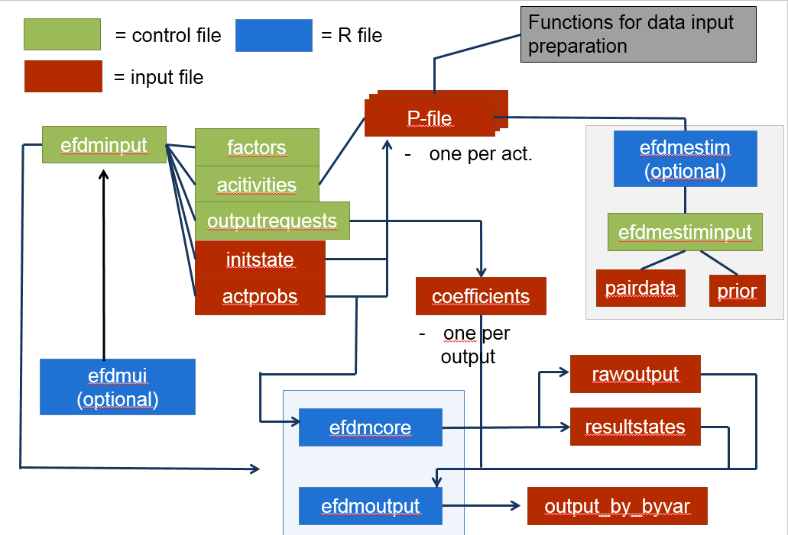
Figure 1. A summary of files in EFDM (taken from METLA tutorial notes, June 12, 2014)

User Classes and Characteristics
User profile | From 1-5, Technical expertise | From 1-5, Knowledge of topic | From 1-5, importance of satisfaction
NFI | Various: 1 to 5 | Excellent: 5 | Most important: 5
JRC internal | 5 | 3-5 | 1
Experienced researcher | Various | 3-5 | 4
Inexperienced researcher | Various | 1-3 | 2

There are two primary user groups for the EFDM software: National Forest Inventory bureaus and the JRC. Other users include researchers, whether experienced or inexperienced. The differentiation in this class is important because the EFDM as a package (software + interface + hub) should benefit from knowledge of experienced researchers, and cater to their technical level, whatever it may be. This is also true for NFIs. It is less important if the package caters to JRC personnel as we have expertise in-house. It is also not necessary to provide information on the reasons for the EFDM, or the theory behind forest growth, for example, which may benefit an inexperienced researcher but is time consuming and beyond the scope set forth in this document.

Operating Environment
The software code is so far in R. The wrapper is foreseen to be in another compatible language, such as Python. The important thing is that the language be compatible with R, but also able to transform user input data to the appropriate format for the core EFDM system to handle, and that it will call the appropriate R functions already in place for data preparation.
The hub, or platform where EFDM will be explained and discussed with users will be in mediaWiki. The software is currently served in GNA but will probably move to an internal DG DIGIT service (CITnet) where JRC can control versions and invite users to share branches of their software and related functions. For the short-term, and to facilitate project management (because many additional features for project management are available in CITnet) the software will remain within its own repository of the larger ‘FISE’ project. If many users begin to request to push software, we will migrate outside of CIT net (because there is currently a limited number of licenses: 500).

Design and Implementation Constraints
Timing:
Dec 2, 2014: completion of SC14 contract under FWC 388432, handover of EFDM software and Wiki to JRC

October 2014 | Preparation of EFDM GIT repository within CITnet ‘FISE’ project development | Sarah, Roberto Sgnaolin
November 2014 – December 2014 | Preparation of wrapper contents, GUI design and integrity check basic functions, to get a beta version | Dario (Francesco?)
November 2014 – December 2014 | Preparation and implementation of improved output (timber assortments and estimates of residues | Minna (Ola)
November 2014 – December 2014 | Preparation and implementation of pan-EU approach | Sarah
November 2014 – December 2014 | Preparation and implementation of Wiki content and page functionalities | Dario, Sarah (for content and layout once the Wiki is set up)
January 2015 | Launch of EFDM hub with beta EFDM software & user feedback
January 2015-May 2015 | Implementation of wrapper | Dario (Francesco?)
 | Updates/ improvement of webpages | Dario (Francesco?) Sarah, Ola, Minna,
 | Contact with country NFIs for active participation in pan-EU approach | Ola, Claude, Sarah, Minna
June 2015 | Launch of EFDM hub and new version of software; “summer school” or workshop with new software | all

User Documentation
A user’s manual on how to set up data as well as how to run the software in its current form are already available. These documents should be made available on the EFDM website (hub) as well, in addition to a dynamic and moderated user’s forum and wiki pages with glossary and further description of how the model works.

Assumptions and Dependencies
- A technical resource is available to work on the wrapper from, at the latest, January 2015 (Dario, Francesco);
- A media-Wiki expert is available to set up the hub (Dario)
- A person can moderate the contents of the forums (Sarah, Ola, Minna)
- A budget to launch the hub by actively inviting participants to workshop/summer school
- Possibility to use COST or EFDAC to promote the EFDM hub, and draw in the less participatory countries.

System Features
Wrapper
As shown in Figure 1, EFDM is composed of different types of files. The control files are written by the user, but the format is very specific for these files. These can be generated using a graphical user interface to avoid errors in the format. Furthermore, where user-generated files are permitted, the files should undergo a basic check for consistency in length, variable type and order of factors before the software is handed that data to process (this is the integrity check). Furthermore, and installation package should be implemented, so the user downloads and the installer will do the rest (including installing R libraries).

Enhanced output
To contribute to the bioeconomy modelling framework, EFDM should provide GFTM with data on the potential supply of wood per species group (conifer / non conifer), per country per time step. This is set as an initial constraint in GFTM (and the forest owner model). This implies breaking down the output into two timber assortments: sawlogs and pulp. For pellets, the residues should also be quantified based on harvested amounts.
Graphs can be enhanced to capture more time steps and to be visually more appealing.

Pan-EU input data
To fill gaps where national data is unavailable, or to generate a seamless and harmonized pan-European dataset, a method for estimating the input values per country using publically-available data should be developed. This approach should be developed collaboratively with countries in order to obtain approval from them.

Hub
A comprehensive, online toolset, including the software, a wiki and a discussion forum, will improve transparency of the software, its applications and its user community. It is estimated that a very good hub will increase the user community, thus increasing contributions to improve the software. For now, the ‘hub’ will include the versioning, but also the Jira project management package for signaling issues (bugs and improvements).
There will be three levels of contact with EFDM
- Through the FISE websites, where EFDM is described in laymans terms for the general public;
- Through the mediaWiki pages, where user manuals and installation instructions are available, for users;
- Through Stash (CITnet), where different versions of the model exist and can be downloaded as well as uploaded. This is for developers, but also where users will download the software.

Wrapper
An example of the control file is the following (Figure 2):
nomgmt estimate estiminput.txt vol age
finalfell read ffellP.txt vol age
thin read thinP.RData vol age

Figure 2. Example of a control file
The graphical user interface can prompt the user to specify the following in order to generate control files automatically:
- Activities type (from drop down list to preserve name formatting)
- Transition factors, names and levels
- Fixed factors, names and levels
- A choice to read or estimate probabilities, how to make the estimation (with one of the software functions or exogenously); if read, what is the file name
- Dropdown menu of output requests

Generating input files automatically is more difficult, as the initial format of the files will differ between users. The basic rules for the initial state are as follows:
- The column must be in a specific order, according to the factors described in 2) and 3)
- In addition to the factors as columns, the forest area is required as a column
- All possible factor combinations must have a forest area assigned, even if it is 0 (see Figure 3).

vol age siteclass species area
1 1 SE11 BT 1951.96
2 1 SE11 BT 0
3 1 SE11 BT 0
4 1 SE11 BT 0
5 1 SE11 BT 0

Figure 3. Example of an excerpt of a file describing the initial state
3.1.1 Priority
High
3.1.2 Stimulus/Response Sequences
The user should download the software package, and upon installation, begin to dialogue with the graphical user interface. Once the user has completes preparing input, the model wrapper should check that the input data is in the correct format and return relevant error messages. Only once the input is approved, will EFDM actually begin to process the data.
3.1.3 Functional Requirements
REQ-1: Installation package (Python?)
REQ-2: Graphical User Interface (Python?)
REQ-3: Data package preparation (Python or R?)
REQ-4: Check of data format (Python or R?)
REQ-5: Call to launch EFDM core

Enhanced output
Output from EFDM are configured in the “efdmoutput.R” file. This file should be extended to consider the timber assortments for each time step, as well as the residues generated for each time step.
3.2.1 Priority
Medium-High
3.2.2 Stimulus/Response Sequences
The user should have the choice of output to generate in the GUI. This request results in the generation of the EFDM output file (“efdmoutput.txt”), which in turn, activates the relevant algorithms in “efdmoutput.R”. The relevant files are written to disk.
3.2.3 Functional Requirements
REQ-1: Expansion of “efdmoutput.R”
REQ-2: Update of GUI for new output functionalities

Pan-EU data
A pre-packaged pan-EU dataset could be made available for download. This package can include and update data as it is prepared (i.e. can contain test-sites data at first as the full dataset is being developed). The purpose of providing such a dataset is twofold: First, more people will study the data and may find errors, inconsistencies or offer to contribute better data; Second, offering data with the software will increase its user community immensely.
3.3.1 Priority
Low-Medium
3.3.2 Stimulus/Response Sequences
The user should have the choice to download data and point to it through the GUI.
3.3.3 Functional Requirements
REQ-1: Data preparation
REQ-2: Update of GUI for new input functionalities

Hub
The pages accompanying EFDM are crucial to its transparency and hence its acceptance as “the” forestry model for Europe. The more users there are, the more rapidly the software will develop and improve. The pages must include all the information we have: who is using the model, how it works, glossary of terms, discussion forums, R-functions explained etc.
3.3.1 Priority
High
3.3.2 Stimulus/Response Sequences
Visitors to the hub should get all information they need about EFDM. It can go online in a relatively immature format (Wiki only), and develop from there, with more content and sophisticated functions
3.3.3 Functional Requirements
REQ-1: set up Stash & Git on CIT net
REQ-2: Permission for slot on server and domain use for WIKI (different from CITnet)
REQ-3: Wiki Media set up
REQ-4: Upkeep/moderation/improvement

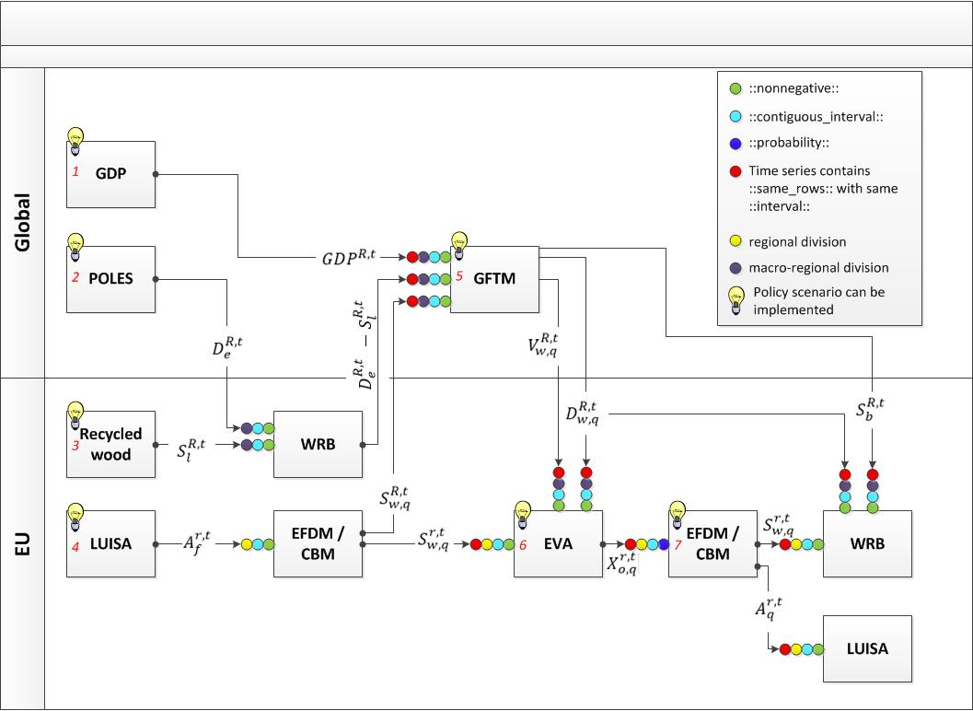
Appendix A: EFDM within the of the forest-based sector component of the bioeconomy modelling framework

 | name | Output for other tool | Required inputs from other | Direct dependencies
CORE | WRB | -Sectorial demand for forest products  -Primary and secondary forest products supply | Demand and supply of forest-based products | Recycled wood sources  EFDM or CBM  GFTM  (POLES)
CORE | GFTM | -Demand for wood  -Supply for industrial by-products and harvest residues  -Value of wood | -GDP to compute demand for material use  -Demand for energy requirements from forest sector  -Maximum available wood | WRB  EFDM or CBM
CORE | EFDM | -Harvestable wood available  -Wood harvested | Area of forest per structural class | (LUISA)  (EVA)
CORE | CBM | -Harvestable wood available  -Wood harvested | Area of forest per structural class | (LUISA)  (EVA)
 | EVA | Probability of owner choice for specific activity given forest structure type | -Initial forest stock  -Trends in demand for wood  -Value of wood | GFTM  EFDM or CBM
 | POLES | Energy requirements from “cellulosic material" (forest + SRC)
 | LUISA | Area of forested land given land-use competition | Forest structure per region | EFDM or CBM

variable | definition | variable | definition
A | Forest area | S | Supply
q | Multi-criteria classification of forest structure (e.g. dominant species group, age, volume, stem density, site class etc.) | w | Primary forest products (wood)
f | Forest (q ∈ f) | b | Industrial by-products
H | Wood harvested | l | Recycled forest products
i | Species group (i ∈ q) | c | Secondary forest products (cascading). It is the sum of recycled materials and industrial by-products ()
r | Simulated region. This can be a 1x1km cell or administrative region | e | Energy
R | Geographical unit encompassing several regions | m | Material
t | Time step class of finite θ length interval | V | Value
T | Final time step of simulation | X | Deterministic probability (0 or 1) of making management decision o for state q
D | Demand | o | Owner’s decision choice

