How to use EFDM?

- Install R and R-studio
- Download R for Windows from:
http://cran.r-project.org/bin/windows/base/
- Install R
- Download R-studio from (to all platforms):
http://www.rstudio.com/products/rstudio/download/
- Install R-studio

- Open R-studio
You should have something like below (except color coding). Red is console, where you can write commands to run. Blue is environment, where will be all functions, variables etc. that you have. Green is basically the file of the project (see section 3). After doing a project you should have here all the files mentioned section 4, output files will be there too.
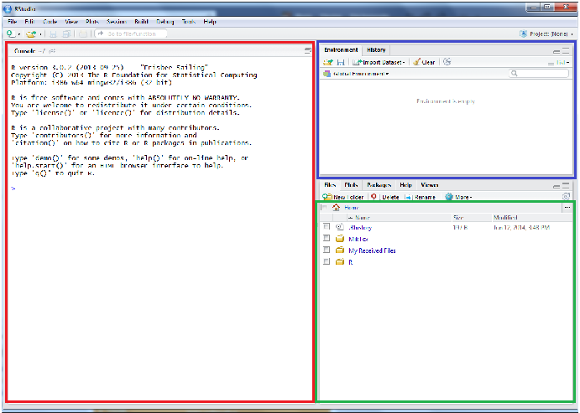

- Make a new project
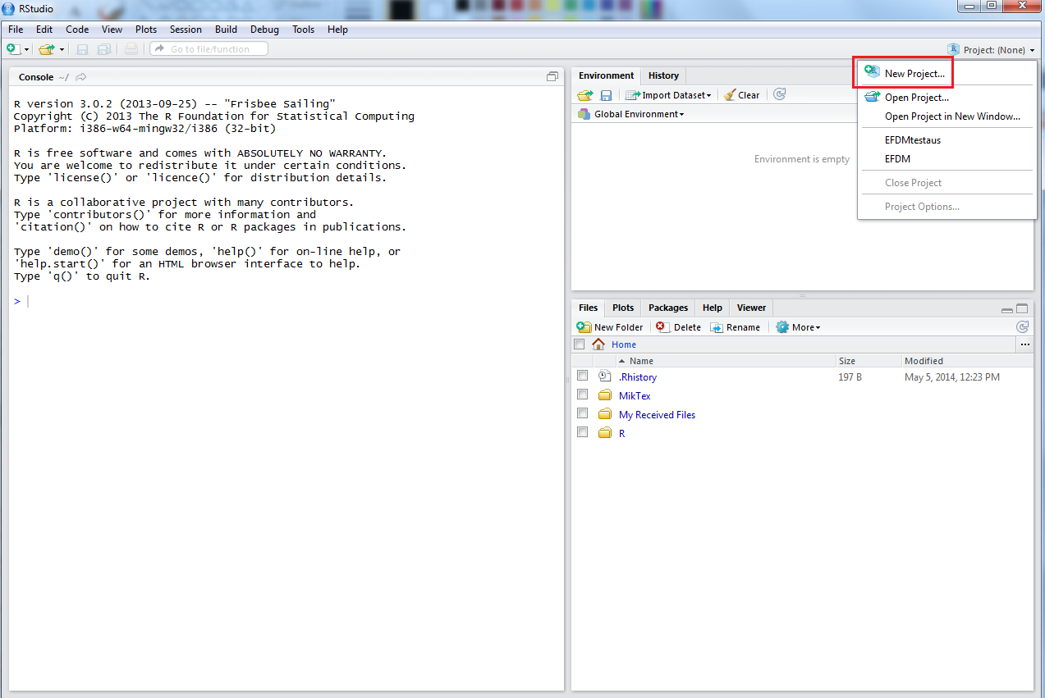
- Choose “New Directory”
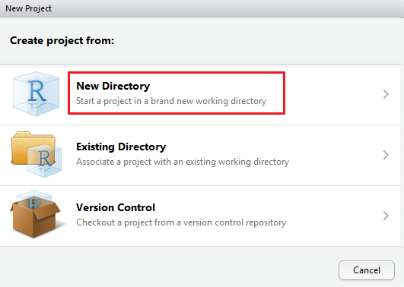

- Choose “Empty Project”
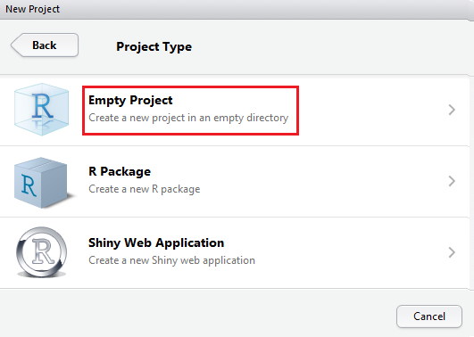

- Give name to your project. Please do not use special character or space in the name of project.
- Choose where you want to save your project
- Click “Create project” 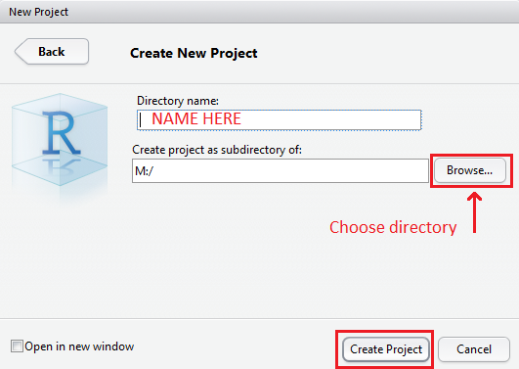

- Before running EFDM through
- Save the code files to your R-project’s directory
  - You should have at least:
    - efdmcore.r
    - efdmesim.r
    - efdmoutput.r
    - efdmutils.r
    - (hackfunctions.r)
    - (initexample.r)
    - nomgmtP.RData
    - thinP.RData
    - efdminput.txt
    - estiminput.txt
    - factors.txt
    - initstate.txt
    - activities.txt
    - actprobs.txt
    - ffellP.txt
    - newprior.txt
    - nomgmtdata.txt
    - thinP.txt
    - (outputrequests.txt)
    - (volume.txt)
    - (drain.txt)
- Install package “abind” (only when you use R for first time). Instruction guide for installing, open instABIND.pdf.

- How to run EFDM through?
  - Type source(“efdmutils.r”)
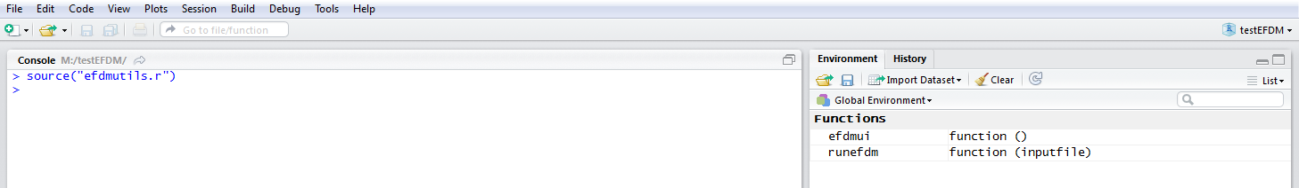

  - You can decide whether you want to use user interface or do this on your own. If you want to use user interface, type efdmui() and the user interface will open. If you want to run program on your own, change to other instruction guide (instB.pdf)
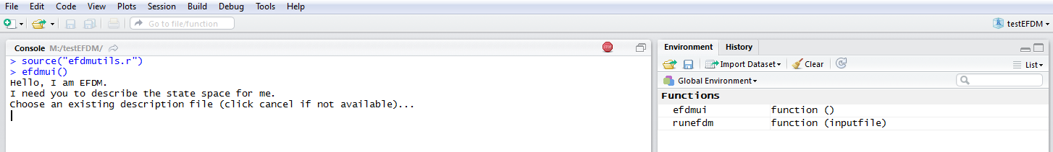

  - Choose file which includes factors, file’s name can be for example factors.txt
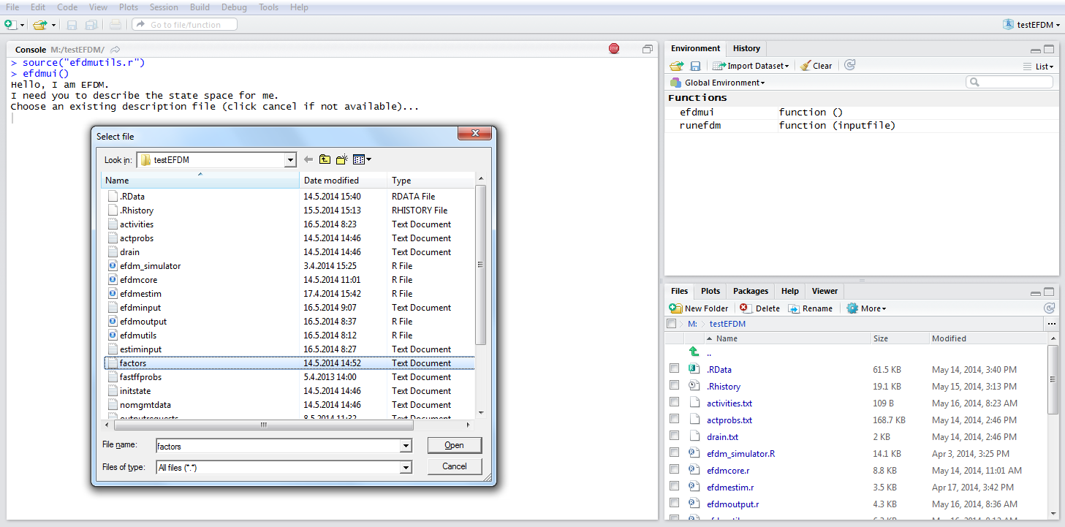

  - Choose file which includes initial state, the name can be for example initstate.txt
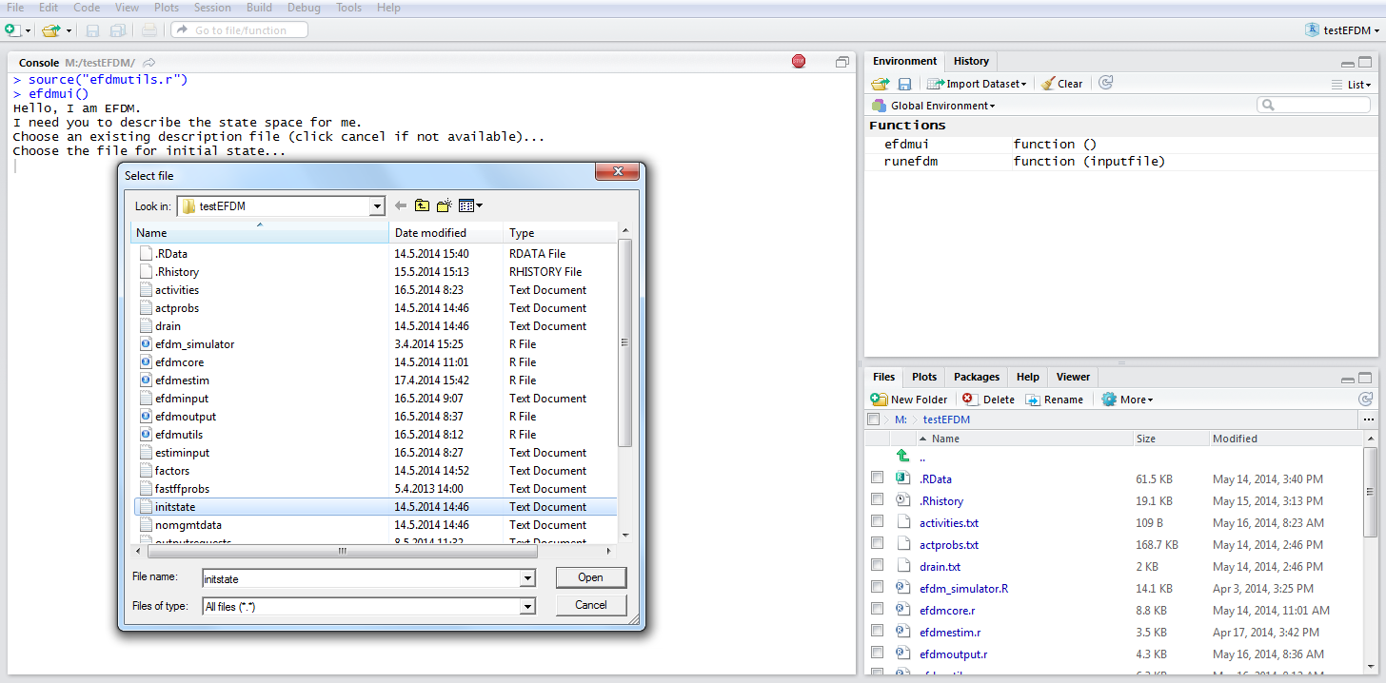

  - Choose file which includes activities, the name can be for example activities.txt
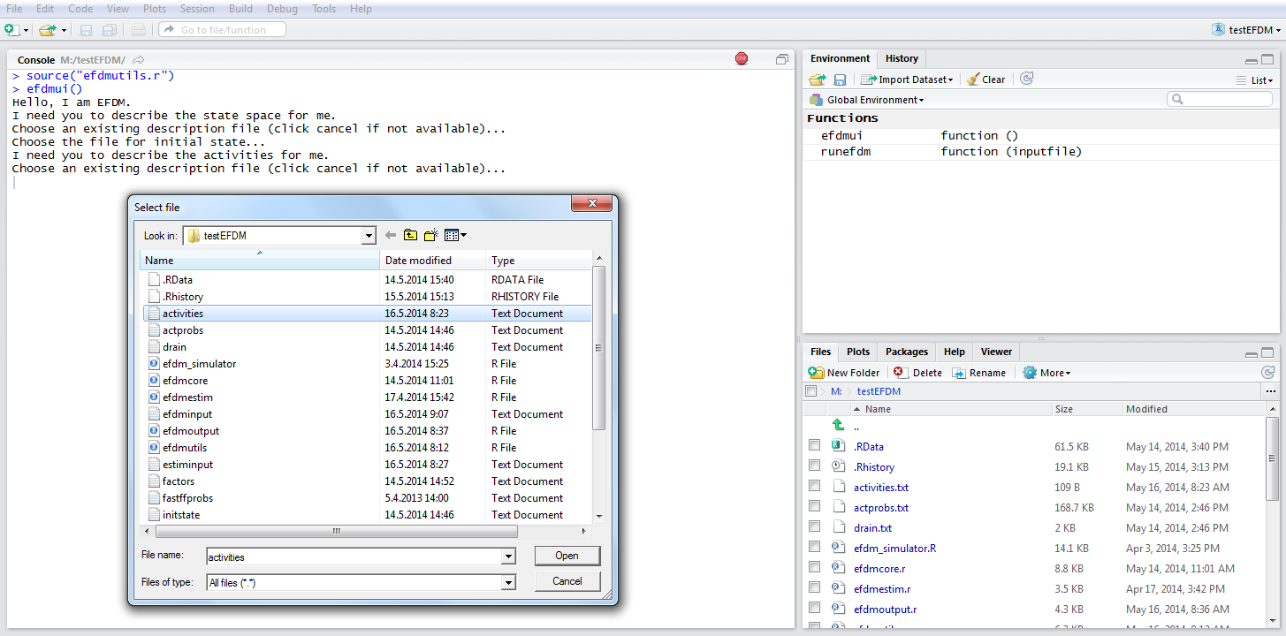

  - Choose file which includes probabilities of activities, the name can be for example actprobs.txt
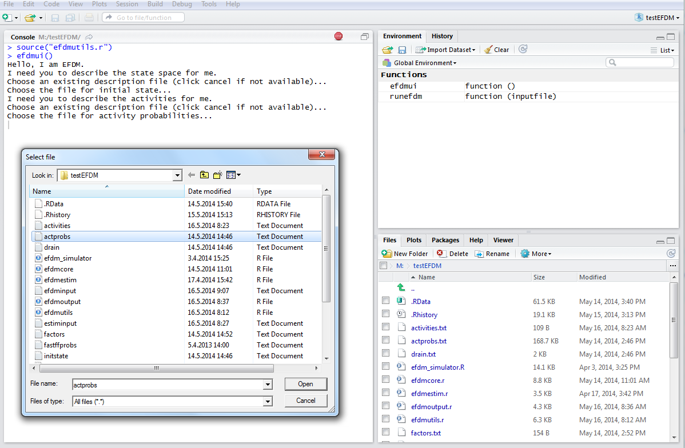

  - Give an integer, how many steps you want to run
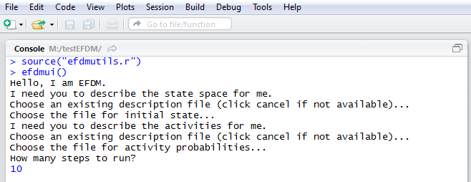
  - You can tell if you want some additional information about the results
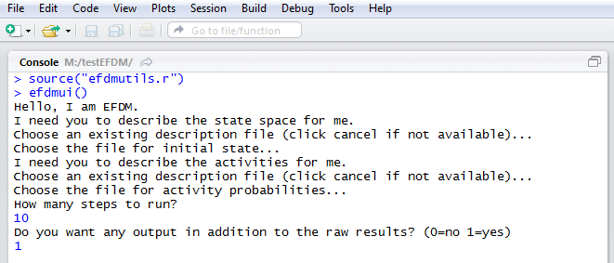
  - If you want some addition, you may need an output request file. If you do not have a file for output requests, you will be able to write requests on your own. The additional information may be for example volume by species. In this case, the output request file should include line “volume by species” and refers to a file which includes the coefficients of volume. Here is an example of output request file:
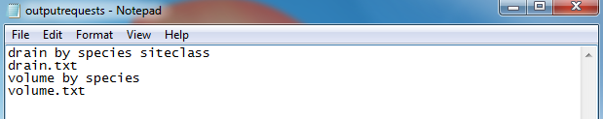

  - Choose file which includes what additional information you want. The name of output request file can be for example outputrequests.txt
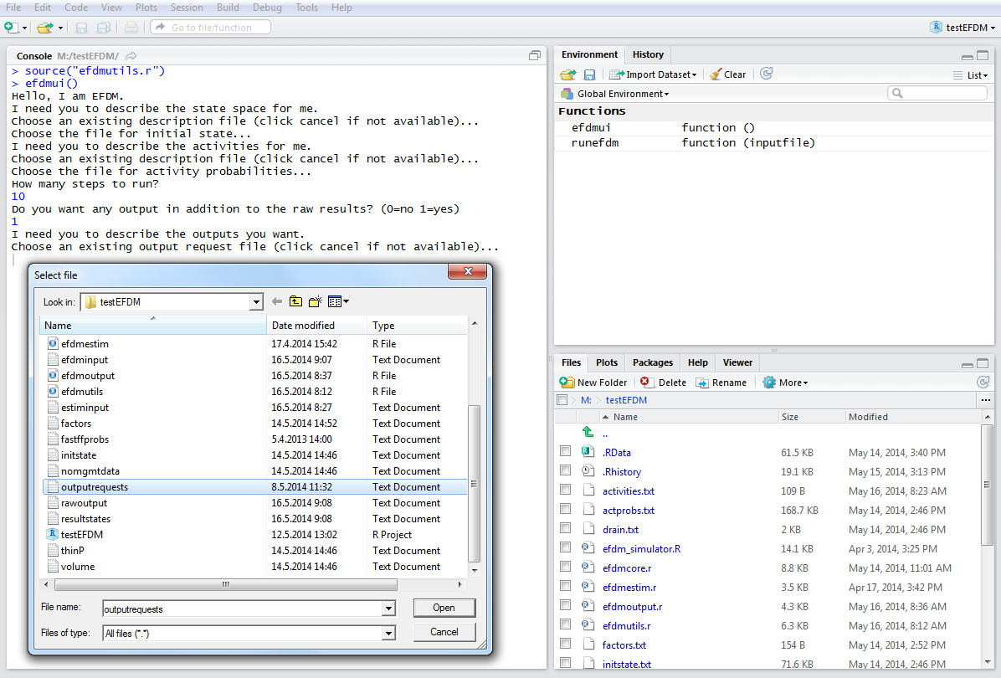
  - Now the program has written a file called efdminput.txt following the inputs.
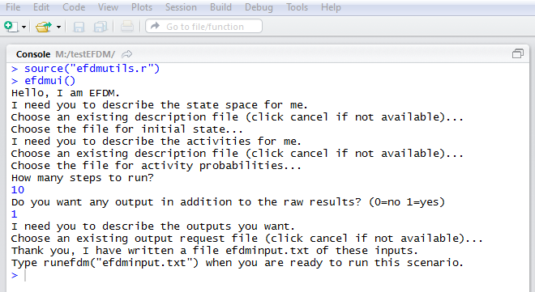

  - Type runefdm(“efdminput.txt”) for running the program through
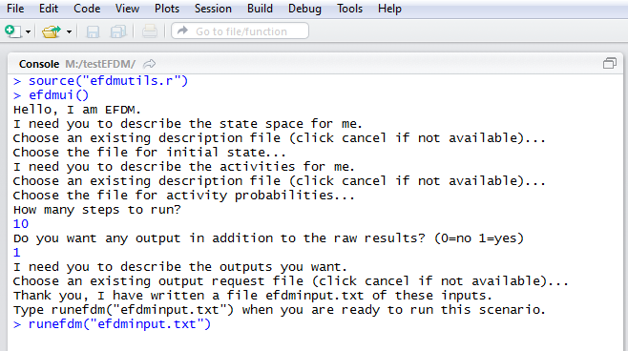
  - While the little “stop” sign is on the upper right corner, it means that the program is doing something, wait until the sign disappears.
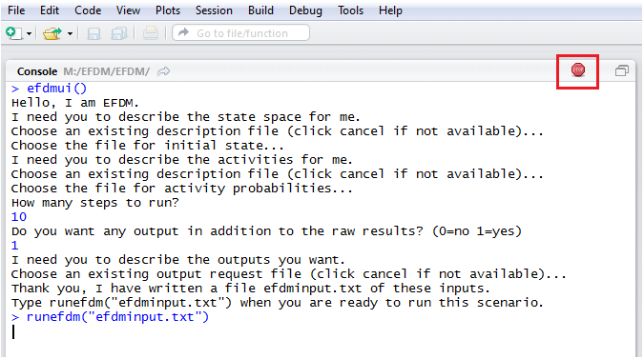

  - Now you can close the R-studio. You can save the workspace if you want, but it is not obligatory. The results have been saved to their own files.
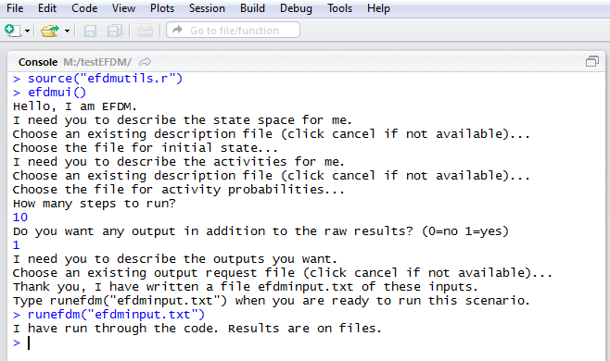
  - If you want to see the result files, you will go to the directory where you saved the R-project.
