How to install package ”abind”?
1. If you don’t have connection to internet:
1.1 Open RStudio
  - Click “Tools”
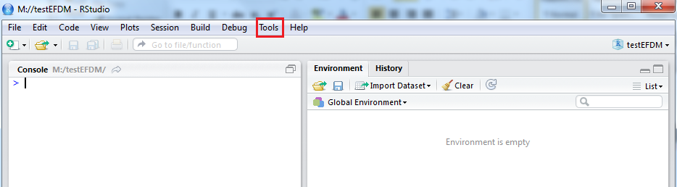
  - Choose “Install Packages…”
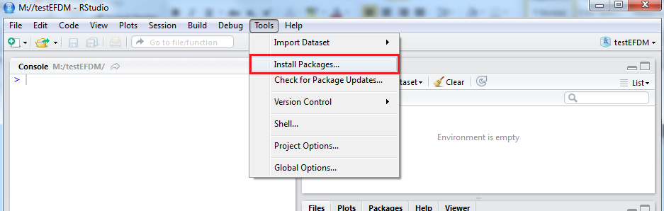
  - Choose “Package Archive File (.zip, .tar, .gz)” from “Install from:” menu.
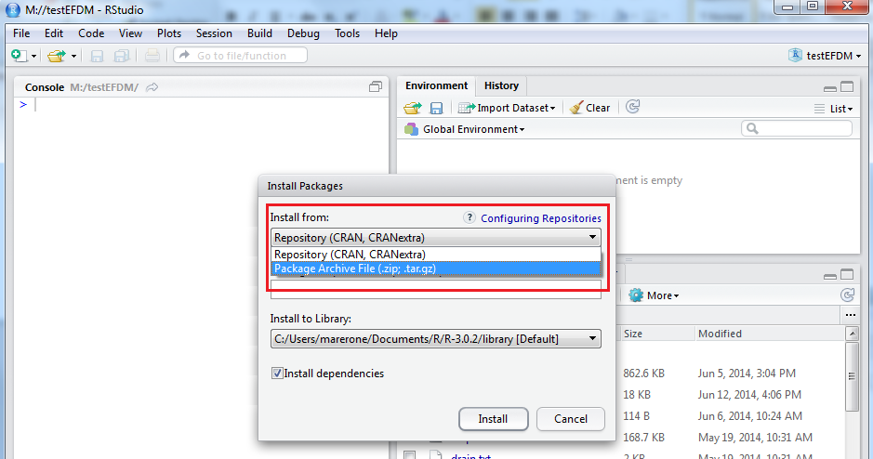
  - Go to directory you saved the files and choose
“abind_1.4-o.tar.gz” and click “Open”
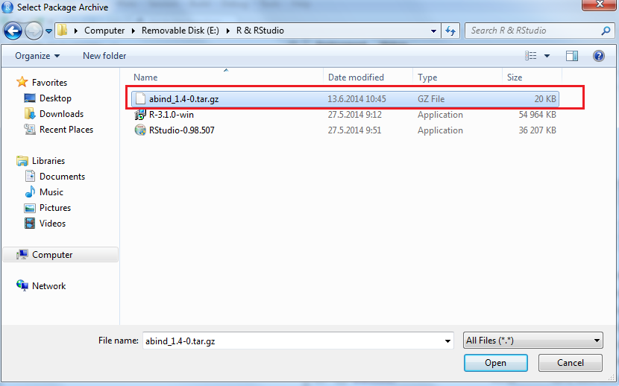
  - Click “Install”
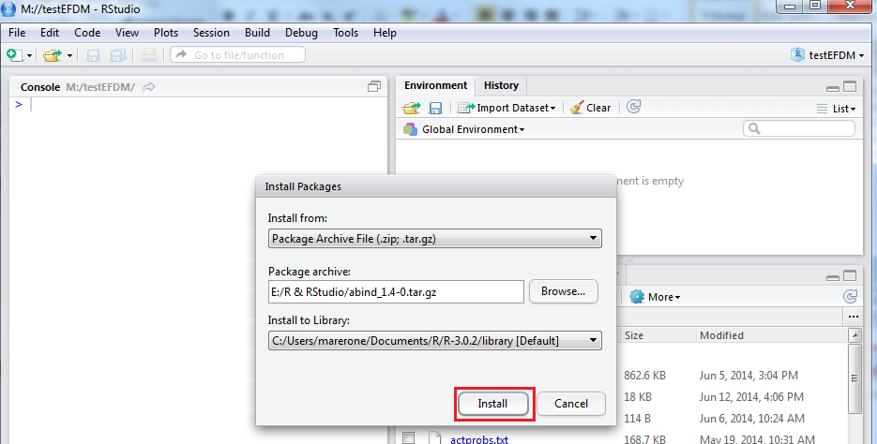
  - After installing RStudio should look something like this:
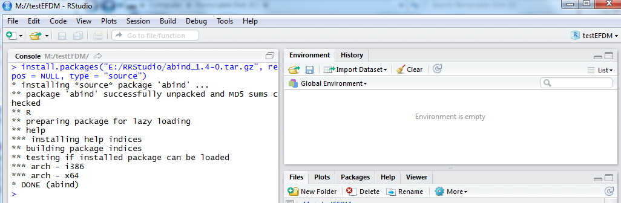
  - Now packages “abind” has been installed.

2. If you have connection to internet:
  - Open RStudio
  - Click “Tools”
2.3 Choose “Install Packages…”
2.4 Choose “Reposiotry (CRAN, CRANextra)” from “Install from:” menu
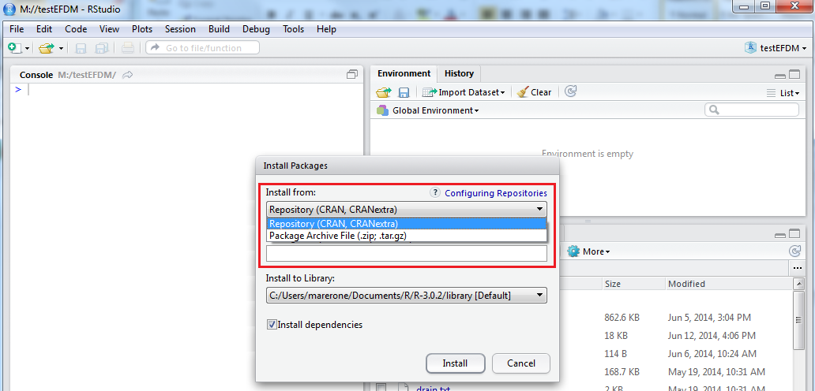
2.5 Write “abind” to “Packages” menu and click “Install”
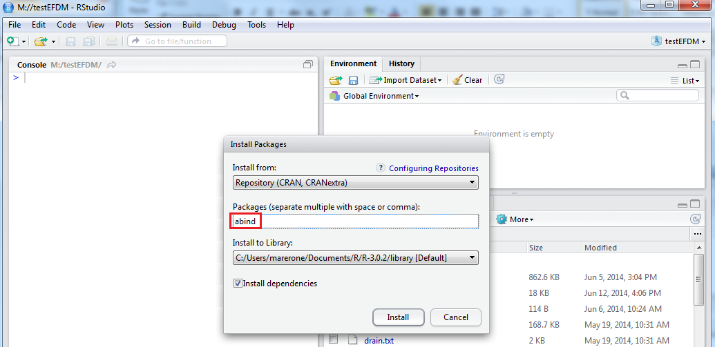
2.6 After installation you should have something like below
