How to run EFDM through without user interface?
You can follow the instructions of instA.pdf to section 5.1 and then change to this instruction guide.

1. You should have an input file (for example efdminput.txt) which includes information about input files, number of steps and information about additional input file
An example input file:
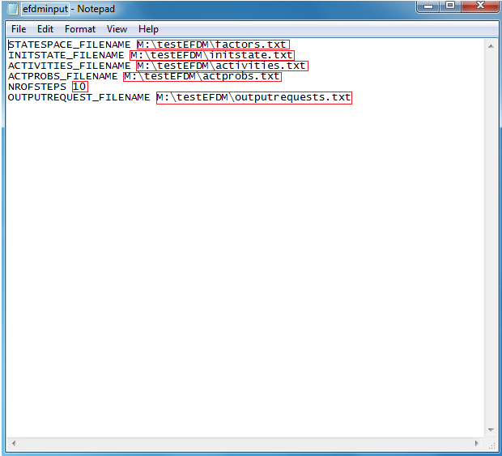
You should change the paths circled red and number of steps. You can also change the name of the file (white on the picture).

2. Type source(“efdmutils.r”) to R’s console.
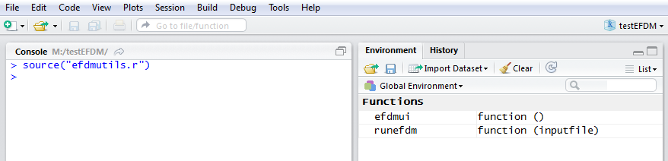
3. Type runefdm(“INPUT FILE’S NAME”), for example runefdm(“efdminput.txt”), if your input files name was efdminput.txt.
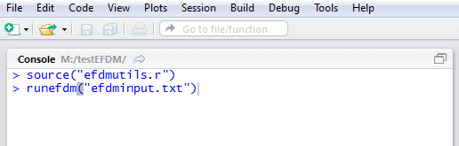
4. While the little “stop” sign is on the upper right corner, it means that the program is doing something, wait until the sign disappears.

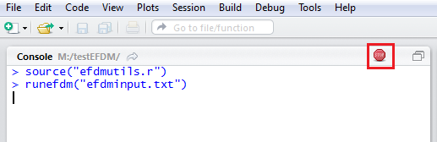

5. When the sign has disappeared, you can close the R-studio. You can save the workspace if you want, but it is not obligatory. The results have been saved to their own files.
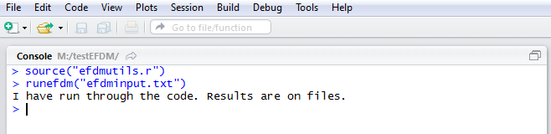

6. If you want to see the result files, you will go to the directory where you saved the R-project
