EXAMPLE:
How to run EFDM through with hack functions?
- Open factors.txt, delete 0 classes. After this your factors.txt should look like this:
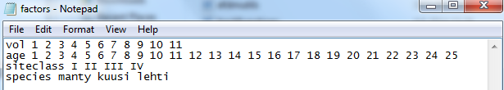
- Open R-studio
- Type source(“hackfunctions.r”)
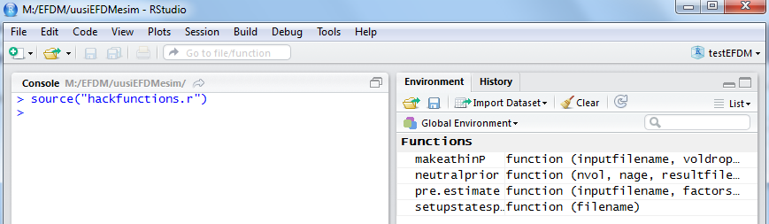
- Type neutralprior(11,25,”newprior.txt”) for to get prior. This command means that the number of volume classes is 11 and the number of age classes is 25. The prior is saved to file “newprior.txt”.
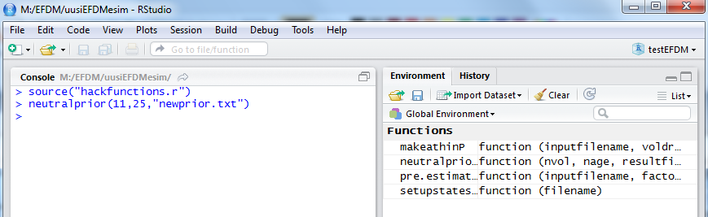
- Open estiminput.txt, change “uninformative” from the 2nd row to “newprior.txt”
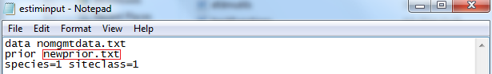
- Use R-Studio again. Type pre.estimate(“estiminput.txt”, “factors.txt”, “vol age”, “nomgmtP.RData”). estiminput.txt is an input file, factors.txt includes factors, vol age is a statespace and nomgmtP.RData is a result file.
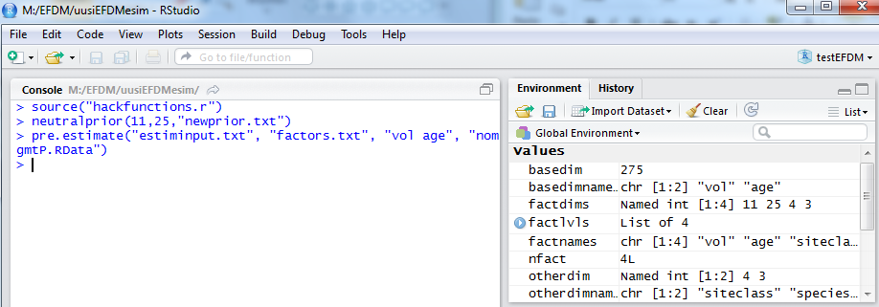
- Type makeathinP(“nomgmtP.RData”, c(0,rep(1,10)), “thinP.RData”)
“c(0,rep(1,10))” describes the drops of volume classes when thinned (how many classes the volume drops). The values of the volume classes have to be at least 1. This means that if the value of the first volume class is 1, the drop has to be 0. The length of the vector is same as the number of volume classes. In this case, the drops are 0,1,1,1,1,1,1,1,1,1,1.
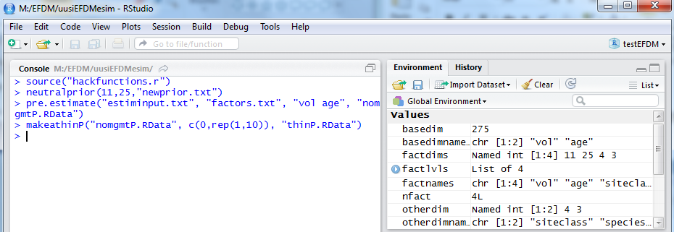
- After this you can run the program through like before. For further instruction use instA.pdf from section 5.1.

