Comparison between ORB and SIFT
feature extraction operation

The comparison is made for the “data_check” dataset wich contains 40 pictures of fingerprints sorted by “different” and “same” as well as the picture of UiA. All comparisons were made with a threshold of 20.

ORB (Oriented FAST and rotated BRIEF) and BFMatcher
data_check:
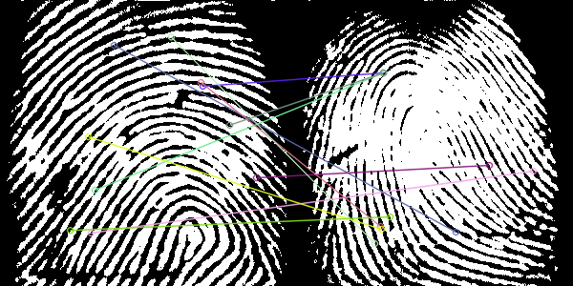
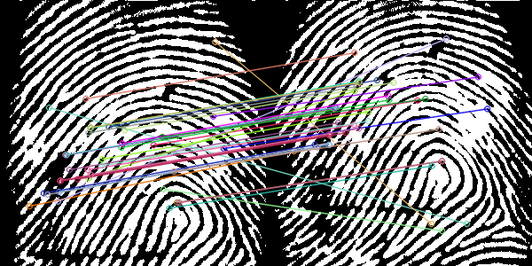
Not a match match

- time: 0.8426s
- accuracy:
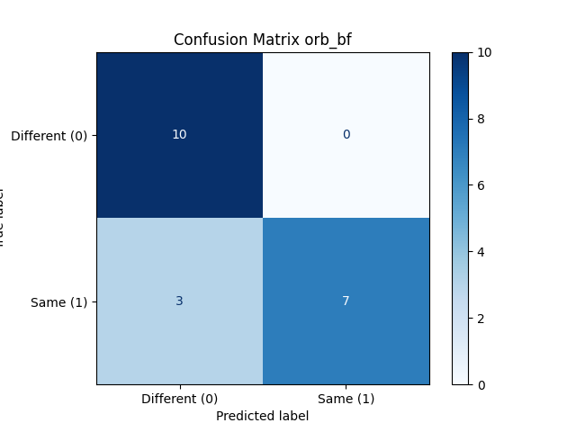

UIA picture:
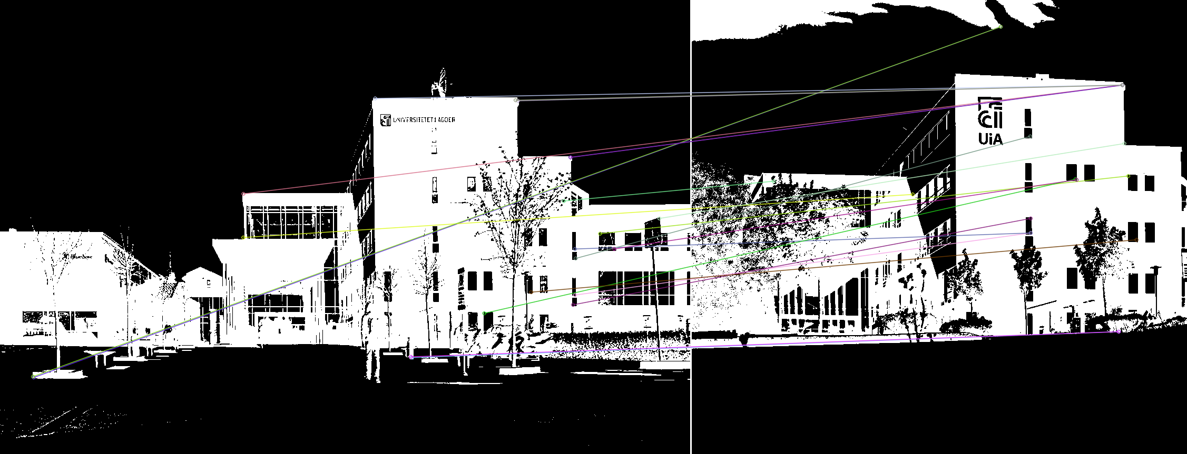
- time: 0.2868s
- result: matched

SIFT (Scale-Invariant Feature Transform) and FLANN
data_check:
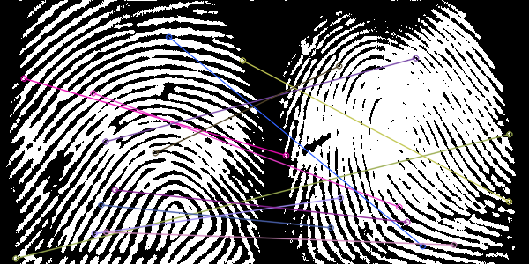
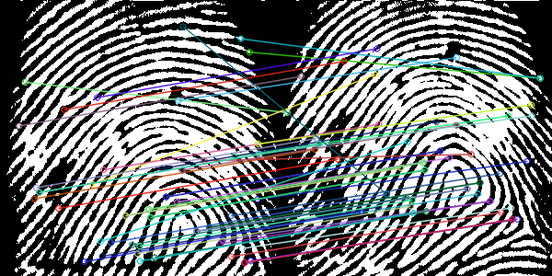
not a match match
- time: 2.6234s
- accuracy:
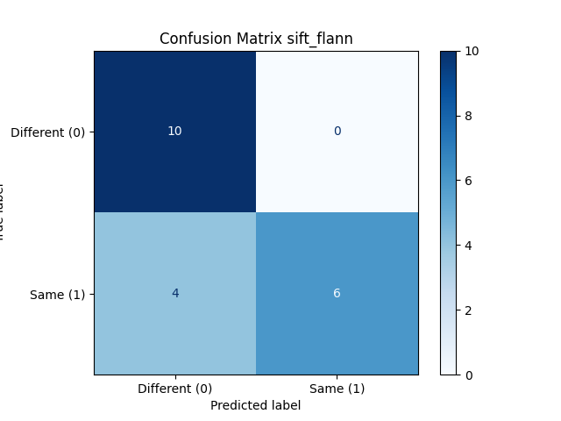

UIA picture:
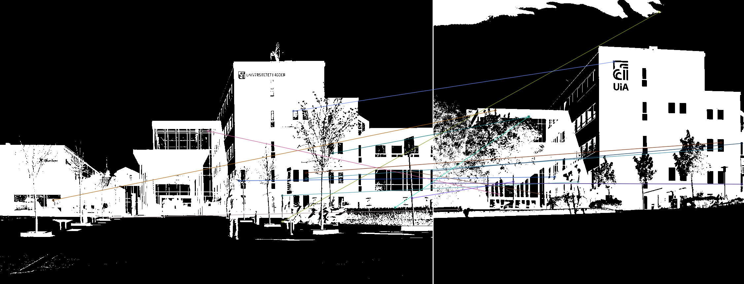
- time: 0.5452s
- result: unmatched

Conclusion
In both cases the ORB pipeline was faster and more accurate. Generally the results for the fingerprints were quite good with a lot of good matches but with the UIA picture a lot of wrong matches were found. For example the tree was matched with a cloud in the sky. Furthermore the ORB pipeline got the right result (matched) for the UIA picture where SIFT got the wrong result (unmatched). Overall ORB worked faster and more accurate in this case.

