Link to repository: https://github.com/corneliusbrandt/IKT213_brandt/tree/main/assignment_4

Task 1
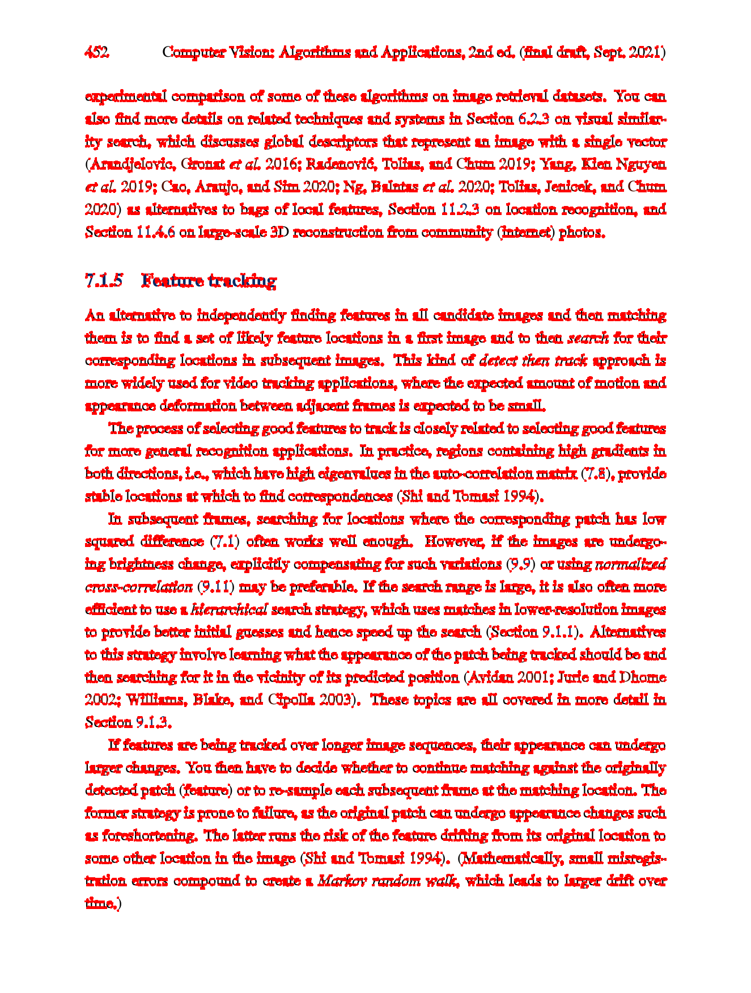
Task 2
Used Method: SIFT
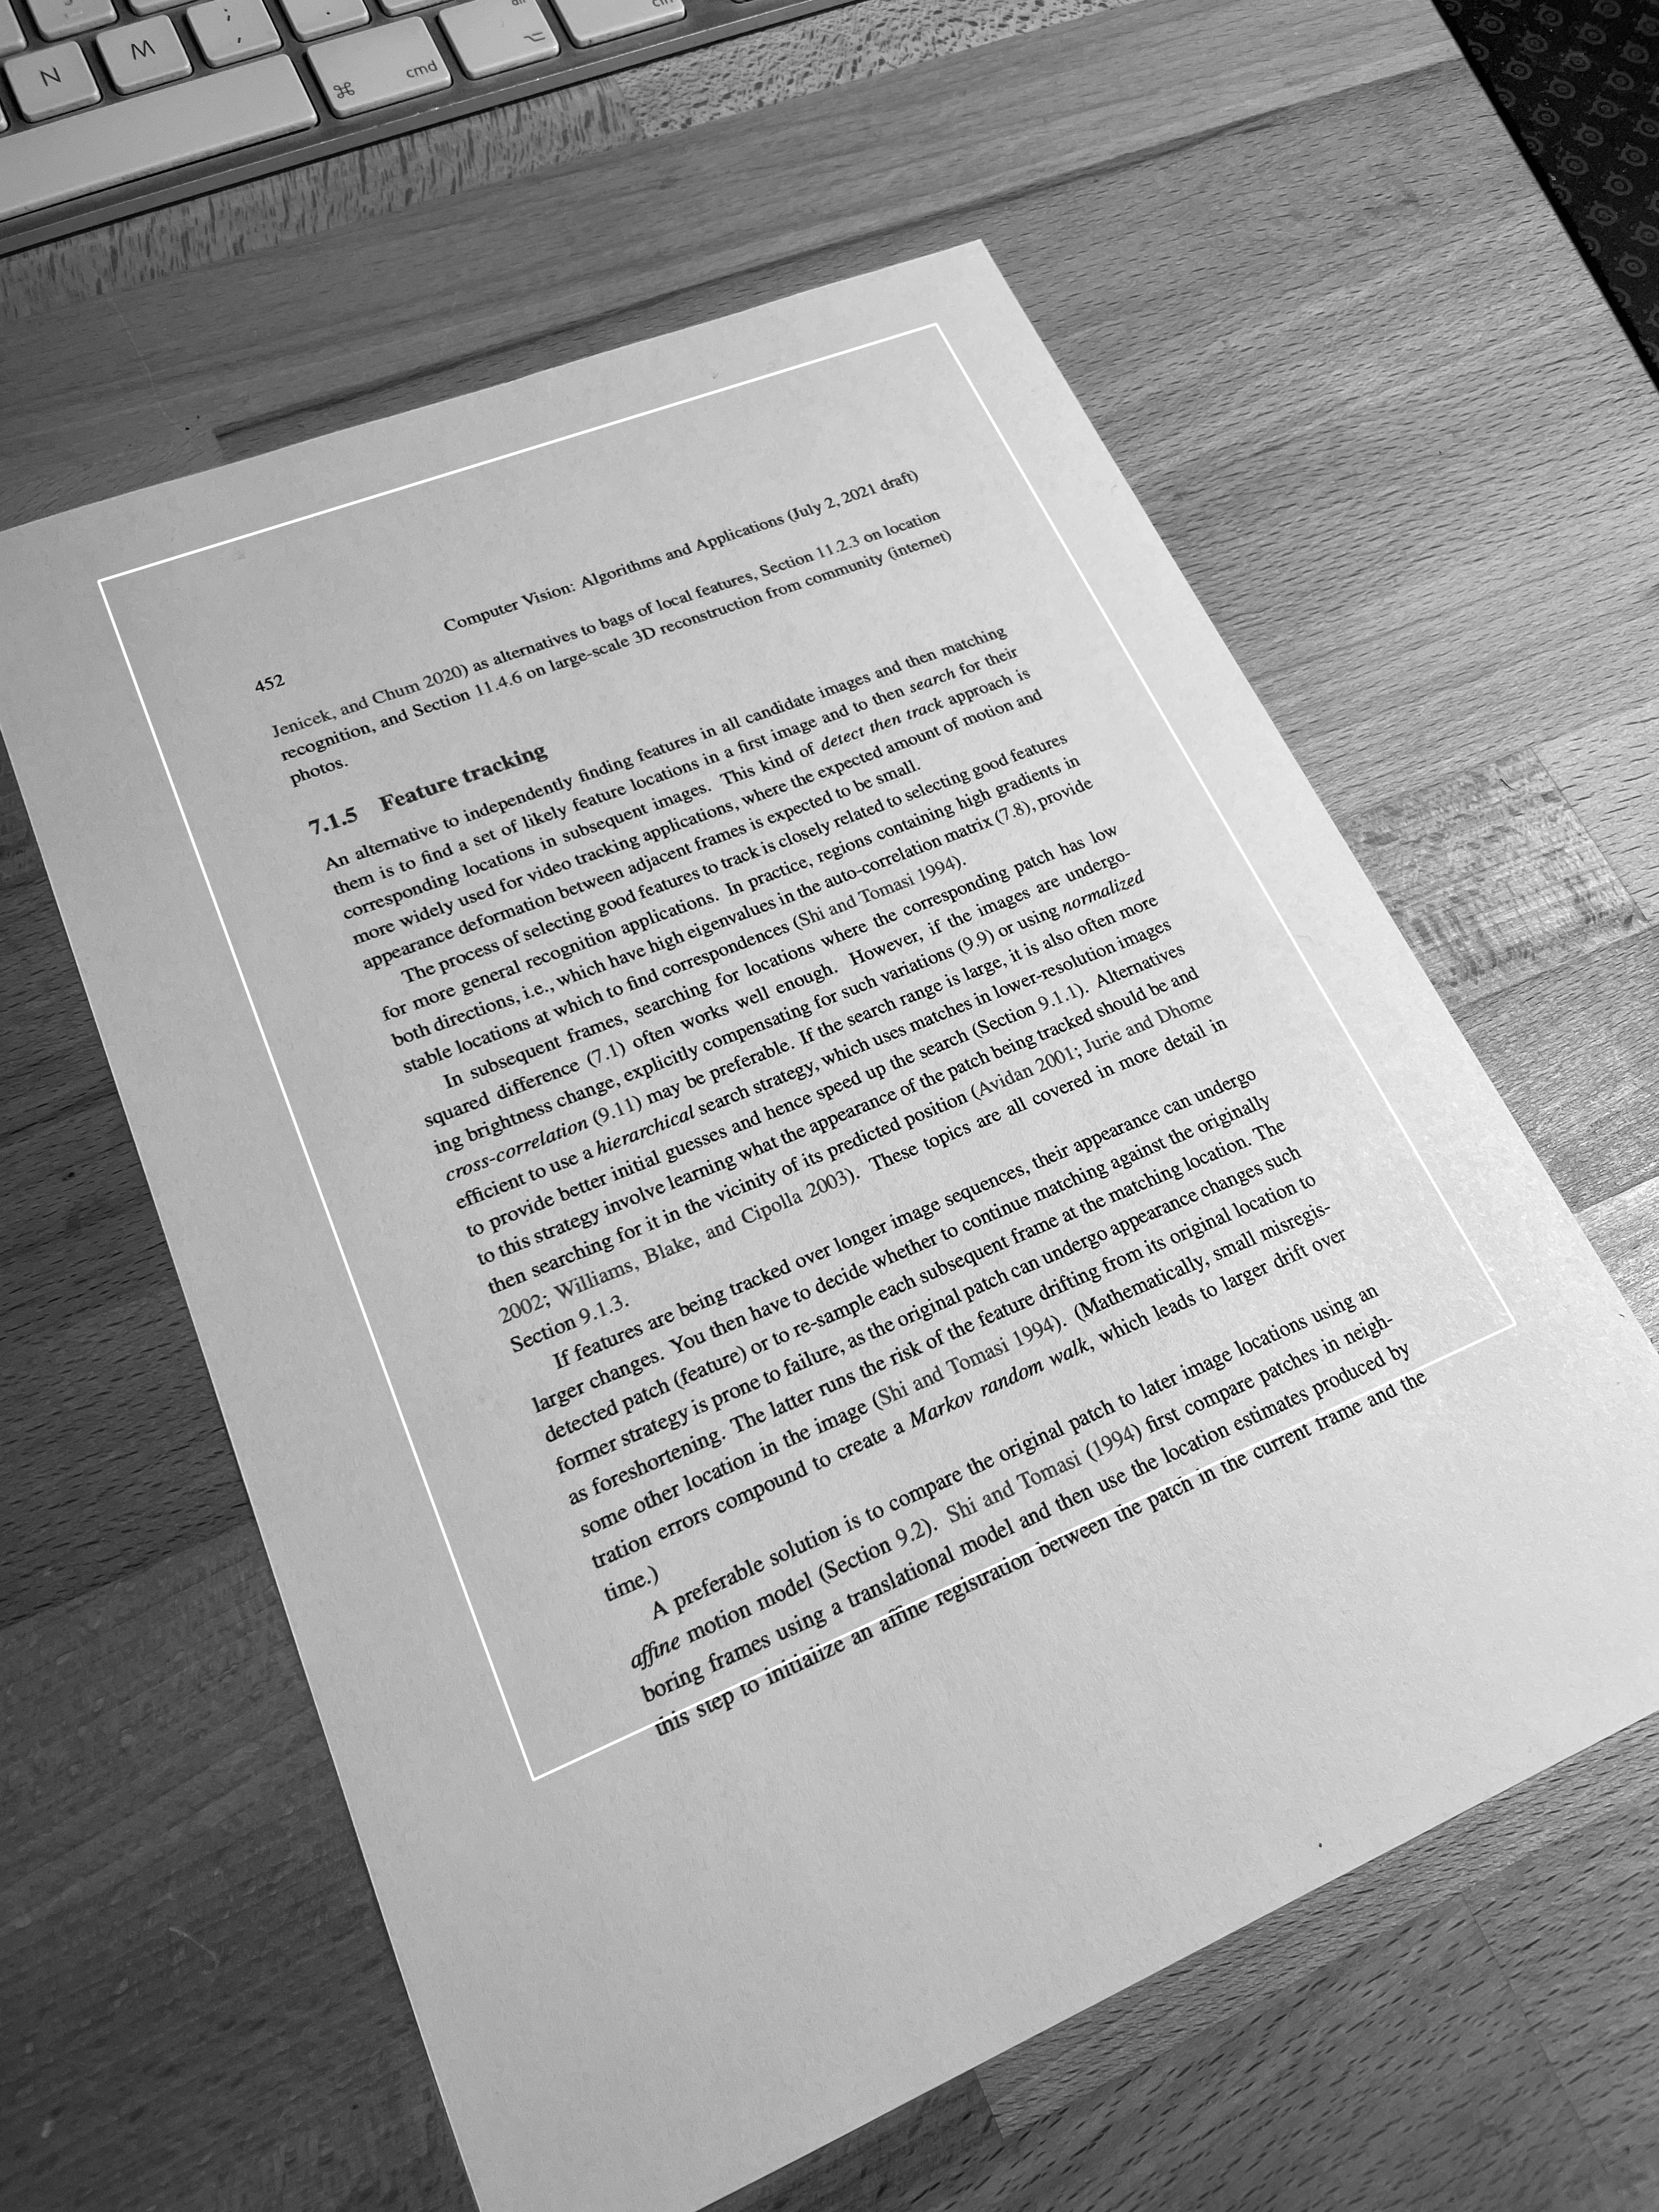
Aligned

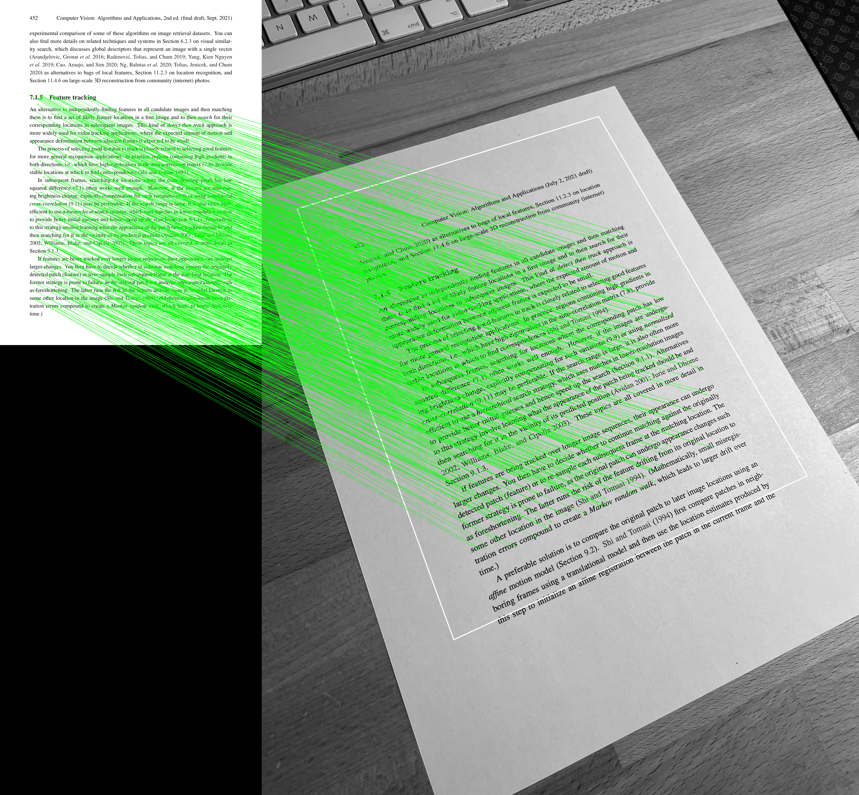
Matches

