Leprechaun Software
3D Immersion

Table of Contents
Table of Contents i
Introduction 1
Introductory 3D Graphics Basics 2
Coordinate System 2
Projection 3
Transformations 4
Matrices 4
Translation 4
Rotation 4
Rotation about the X Axis (Yaw) 5
Rotation about the Y Axis (Pitch) 5
Rotation about the Z Axis (Roll) 5
Scaling 5
Dot Product 5
Cross Product 5
Polygon Lighting 6
Ambient light 6
Directional light sources 6
Polygon Clipping 8
3D Clipping 8
2D Clipping 8
Immersion Programming 9
World Definition File Format 9
World(“Description”, Number of Objects, Number of Cameras, Number of Lights) 9
AddObject(“Object Description File”) 9
SetAlias(“Alias”) 9
Translate(x, y, z) 9
Rotate(x, y, z) 9
Scale(x, y, z) 9
AddCamera() 9
SetAlias(“alias”) 9
Translate(x, y, z) 9
Rotate(x, y, z) 9
SetHither(z) 10
SetYon(z) 10
AddLight() 10
Translate(x, y, z) 10
SetHorizon(“Object Description File”) 10
SetAlias(“Alias”) 10
Translate(x, y, z) 10
Rotate(x, y, z) 10
Scale(x, y, z) 10
SetInterface(“Dynalib”) 10
SetBackgroundColor(R, G, B) 10
Object Definition File Format 11
Object(Number of Vertices, Number of Polygons) 11
SetDynaLib(“DynaLibrary Filename”) 11
AddVertex(x, y, z) 11
Add???Polygon(n, …) 11
SetTexture(“Bitmap filename”) 11
MapVertex(x, y) 11
SetColor(r, g, b) 11

Introduction
For the 1998 science fair it was my intention to develop an operating system which I had named OMEGOS (Open architecture and Modular design Encompassed into an Operating System). The operating system was going to run in the protected mode of the processor of Intel 386+ processors, which enables the direct memory addressing of upto 4 gigabytes (10^6 bytes) and offers a hardware level of protection for applications. The operating system kernel would be modular in design, and devices such as filesystems would be able to be mounted and unmounted during runtime. The name, OMEGOS, originates from the last Greek letter in the alphabet, omega, therefore, the operating system symbolizes the “last” operating system. Furthermore, the operating system would eventually be distributed with complete source code so that the operating system will truly be the last, as people all over the world work on its development.
However, as the science fair approached nearer it became apparent that a demonstration of my operating system in development which the judges would appreciate became apparent. I therefore decided to effectively jump to the end so that I could give a presentation of the many innovative interfacing that can be accomplished in three dimensions. An interface which offers features that either cannot be simulated in two dimensions, or which are simply more intuitive in three dimensions. Later, the interface will be incorporated into OMEGOS project.
The purpose of the 3D Immersion program is to allow the user to become immersed in a virtual world in which they can interact with the objects within. The program will allow for the creation, modification, and interaction of scenes. The scenes will be totally customizable, and programmable… for instance, one world will be a replacement for the windows desktop, by presenting a room in which the user can navigate and use the mouse to interface with objects contained.

Introductory 3D Graphics Basics

Coordinate System
In order to address a point whether it be in two dimensional or three dimensional space it must be relative to something else. Using the Cartesian coordinate system for three dimensions we can reference a point by how far along each of axes you need to travel in order to reach the point if you start at the origin.
Figure 0 Three dimensional coordinate system
X++==++
Z++==++
Y

Projection
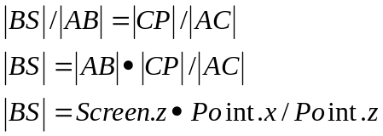
Projection refers to the converting between the three dimensional space to the corresponding screen pixel. Making the assumption that the point of view is at the origin we can use the following formula to convert from a 3D point to a 2D point.
Screen
Z
Y
Point
P
C
B
A
S
Figure 0 Point of view

Transformations
As much as accomplishment the projection of a set of static points on the screen is to the programmer it isn’t very interesting to the user. Some method of dynamically altering these points is necessary to translate, rotate, and scale the points is necessary.

Matrices
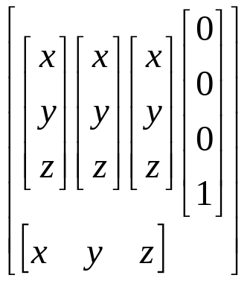
These transformations can be done using matrices.
World space coordinates of the objects local X-axis
World space coordinates of the objects local Y-axis
World space coordinates of the objects local Z-axis
World space coordinates of the objects origin
The diagional is the scaling of the object
These vectors are unit vectors, unit vectors are those with a magnitude of 1 and are used to define directions when magnitude is not important.
A special identity matrix represents a set of object axes that are aligned with the world axes, are is represented by the following matricy:
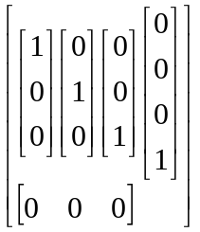

Translation
Translation can be used to move a point linearly in coordinate space. The movement of a point is done using a vector which is similar to a point except that it only encapsulates direction and distance, and not a absolute point in space.
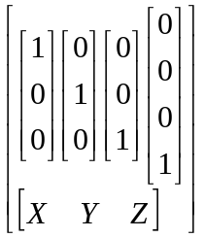

Rotation
Rotation is the process of moving a point in a nonlinear manner in coordinate space.

Rotation about the X Axis (Yaw)
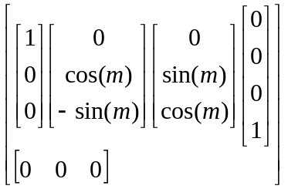

Rotation about the Y Axis (Pitch)
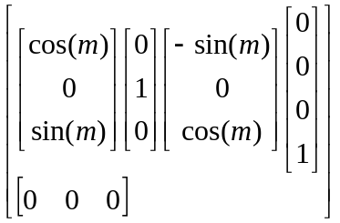

Rotation about the Z Axis (Roll)
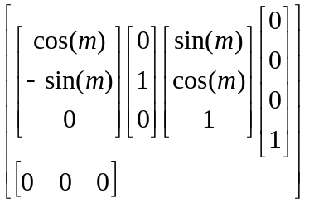

Scaling

Dot Product
You can multiply two vectors together by obtaining the dot product of the two vectors. The dot product is defined as follows (where A and B are vectors with x, y, and z elements):

Cross Product
Another method of multiplying two vectors together is by obtaining the cross product. The cross product is defined as follows (where again A and B are vectors with x, y, and z elements, and returns a vector):

Polygon Lighting
In order to calculate the lighting intensity of the polygon the angle between the polygons normal and the vector of the light source must be computed to receive a value between 0 and 1.
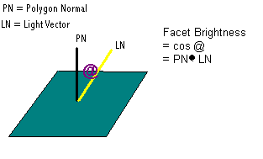

Ambient light
Ambient Light is the amount of light that exists in an environment. It doesn’t have a force, really, it’s just there. In the real world, ambient light is the result of light from all sources reflecting numerous times off all the objects in the vicinity; in a VR system, ambient light can be thought of as the minimum amount of light needed to see things by.
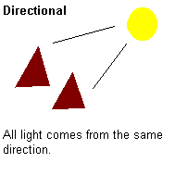

Directional light sources
Directional light sources fall into two categories: point sources and “true” directional sources. A true directional source has all the light travelling in parallel rays originating from an “infinite” distance; sunlight behaves this way. Point soruces, on the other hand, appear to emit their light from a single mathematical point in space; regular light bulbs work this way.
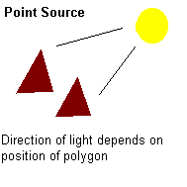

Polygon Clipping
Before drawing the polygons they must be clipped both in three dimensional space and two dimensional space to ensure that they render properly, as without performing this crucial action the polygons may become disformed as they are reflected back when they should be discarded.

3D Clipping
In clipping on the three dimensional plane we clip polygons to what are referred to as hither and yon planes. Objects coming close to the camera will be clipped to that plane as will objects that are close to the hither plane which.
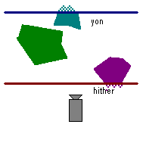

2D Clipping
In clipping on the two dimensional plane we ensure that the polygons projected points are on the screen, and if their not we must use the slope equation to calculate their new projected point.
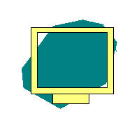

Immersion Programming
The conversion program can generate Immersion compatible objects, and the Immersion program can be used for the placement of these objects, however, manually editing these files may be necessary for the creation of new worlds, and therefore, knowledge of the syntax is necessary.

World Definition File Format
World Definition Files are responsible for the positioning of the objects in three- dimensional space.

World(“Description”, Number of Objects, Number of Cameras, Number of Lights)
The world keyword is used to encompass all the worldly elements such as objects, cameras, lights, etc. The world is used to allocate the appropriate amount of memory before these elements are defined.

AddObject(“Object Description File”)
The AddObject keyword is responsible for inserting an object into the world.

SetAlias(“Alias”)
Attaches a name to the object that can be used to identify the object.

Translate(x, y, z)
Translates the object along the specified x, y, and z axis.

Rotate(x, y, z)
Rotates the object along the specified x, y, and z axis.

Scale(x, y, z)
Scales the object along the specified x, y, and z axis.

AddCamera()
The AddCamera keyword is responsible for inserting an light into the world.

SetAlias(“alias”)
The SetAlias command attaches a string identifier to the camera.

Translate(x, y, z)
The Translate command is responsible for translating the camera the specified amounts along the x, y, and z axis.

Rotate(x, y, z)
The Rotate command is responsible for rotating the camera the specified degree values along the x, y, and z axis.

SetHither(z)
The SetHither command is responsible for setting the cameras near clipping plane. In other words, when the object gets past the camera’s near clipping plane it is clipped.

SetYon(z)
The SetYon command is responsible for setting the camera’s far clipping plane. Similarly to the hither command, this just sets a z value so that all object pass the specified depth will not be rendered.

AddLight()
The AddLight keyword is responsible for inserting an light into the world.

Translate(x, y, z)
The translate command translates the light the specified amounts along the x, y, and z axis

SetHorizon(“Object Description File”)
The SetHorizon keyword is responsible for specifing the object that is to be the horizon (the ground).

SetAlias(“Alias”)
Attaches a name to the object that can be used to identify the horizon.

Translate(x, y, z)
Translates the horizon object along the specified x, y, and z axis.

Rotate(x, y, z)
Rotates the horizon object along the specified x, y, and z axis.

Scale(x, y, z)
Scales the horizon object along the specified x, y, and z axis.

SetInterface(“Dynalib”)
The SetInterface keyword is responsible for specifying a dynalib that will receive messages from the input devices and handle them appropriately.

SetBackgroundColor(R, G, B)
The SetBackgroundColor is used to specify the background color’s (or sky color) red, green, and blue component values are.

Object Definition File Format
Object Definition Files define an objects properties such as it’s vertices and polygons, and how these polygons are to be rendered.

Object(Number of Vertices, Number of Polygons)
The object keyword is used to encompass all the objects elements, and allocates the memory for it’s storage.

SetDynaLib(“DynaLibrary Filename”)
The SetDynaLib keyword can be used to attribute a dynamic link library with the object that will receive periodic messages and will be able to manipulate the object in real-time.

AddVertex(x, y, z)
Adds another vertex, of position x, y, and z, to the object’s list of vertices.

Add???Polygon(n, …)
Adds another polygon to the objects list that has n sides and is composed of the objects vertex list. Where ??? can be Textured, Lambert, Solid, Wire.

SetTexture(“Bitmap filename”)
Sets the polygon to be textured with the specified bitmap.

MapVertex(x, y)
Maps each of the vertices of the polygon to a specified x,y coordinate on the bitmap.

SetColor(r, g, b)
Sets the polygons color by specifying it’s red, green, and blue values.

