Animals Mod Documentation (Draft)
© Sapier
Date: 2012.01.28
Contents
Animals Mod Documentation (Draft) 1
Main components 1
Animal Entity 2
Spawning 2
Available spawn algorithms: 2
Movement Generator 2
Environment 2
Fighting 3
Callbacks: 3
Harvest 3
Random Drop 3
Transform 3

Main components
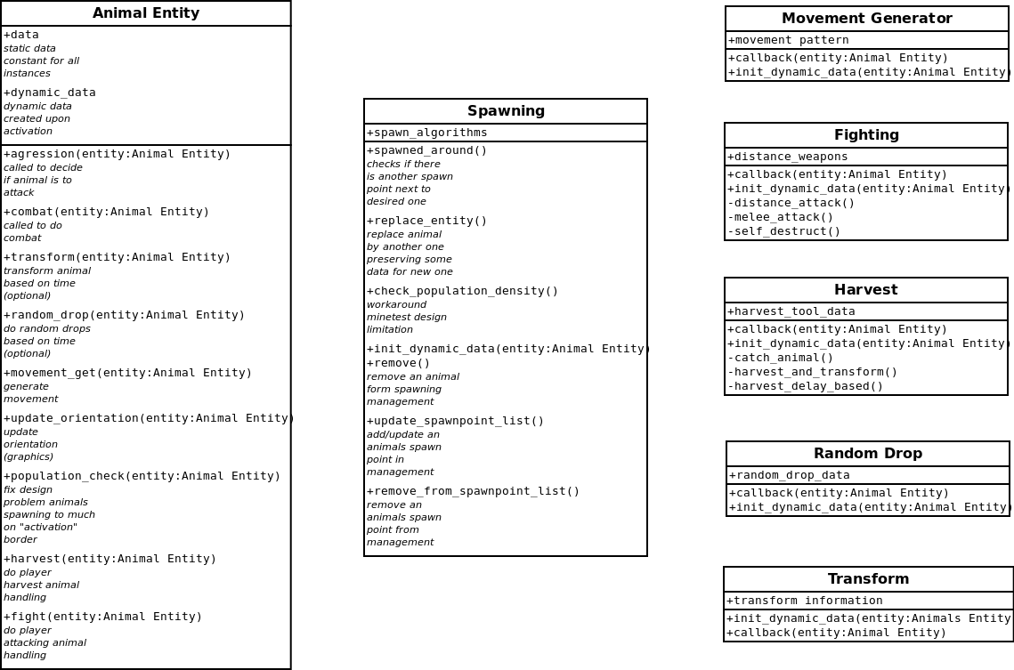Abbildung 1: Main components of animals mod

Animal Entity
Animal Entity is the basic representation of the animal. It's the luaentity doing all the interaction to minetest. Data for all components is accessible from this element. This includes dynamic data attached to a special incarnation of an animal as well as static data common for all animals of a special type. Some data need to be saved on deactivation of animal and loaded on activation this is done by calling a separate module within on_activation and getstaticdata.
As of 28th Jannuary all callbacks to components are called from the on_push and on_step functions of this entity. It's planed to replace this hardcoded behaviour by configurable callbacks in later versions.

Spawning
Spawning is a vital issue to be done. Spawning module tracks all positions animals get spawned and their types. This is necessary to avoid crowding worlds. To decide where exactly to spawn an animal spawning supplies some spawning functions. This can be extended by simply adding additional spawn algorithms.

Available spawn algorithms:
- at_night: Spawns animals in dark areas but only if a position has a huge light difference between day and night.
- forrest: Spawna animals in shadow next to some wood
- shadows: Spawns animal where sun/light never is above a specific (low) value
- willow: Spawns animals on grass
- none: dummy algotithm not spawning anything
- in_air1: spawns a animal in air
- in_shallow_water: spawns a animal near to ground in water

Movement Generators

Random movement gen:
Movement generator supplied has following features:
- random movement based on configuration parameters
- jumping up and down height levels
- medium dependent moving
- random jumps
There's much more considered by internal algorithms of movement generator, I'll improove documentation by time

Path based movement gen (experimental):

Environment
Subsystem handling movement checks mainly used by movement generator

Fighting

Callbacks:
<ANIMAL_PROTOTYPE>.generic.on_hit_callback(entity)
This callback is called anytime a animal is hit. If it returns true generic hit handling of fighting subsystem is skipped

<ANIMAL_PROTOTYPE>.generic.on_kill_callback(entity)
This callback is called as soon as animal health reaches 0. If it returns true generic hit handling of fighting subsystem is skipped.
Note: you need to remove the animal yourself if you return true!

Harvest
TODO

Random Drop
After a specific amount of time an animal drops an entity that can be gathered by player. Entites are used to specify a maximum lifetime for this drops to avoid world getting crowded by animal drops.

Transform
Transforms an animal to another one after certain amount of time. This is used for sheeps wool growing again. An additional use case is creating baby animals that grow up.

