1. **Vegetable Packaging Problem**
2. A packaging company would be interested in automating this process so that any combination of the types of foods can be sent down a conveyor belt, for example, and be packaged appropriately without the aid of manual human labor to assist in sorting it.
3. Camera and color sensors to determine shape, size and color of the objects would be useful in classifying each vegetable as it is sent through the automated packaging system. A weight sensor would also likely be useful because of the different densities each class of food has.

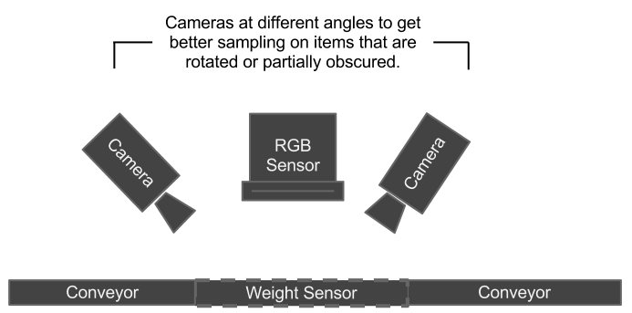

1. It would be useful to preprocess the images sensed by segmenting them into individual vegetables if possible. This would help the classifier leverage the high variety in size and shape of each vegetable when processed in isolation. It would be useful to consider the size of each vegetable as it is sensed as each of the four classes has a very different average size. Furthermore, it would likely be useful to consider hue when detecting each vegetable since, at least in the example of detecting a tomato from an eggplant, two objects of similar size could more easily be classified based on the red or purple color of the two vegetable classes. Texture or noise in the pattern would also be important to differentiate the vegetables. This would help differentiate green beans from broccoli, which have similar size and color, but very different textures.
2. Some of the challenges in classifying these vegetables were listed above in reasoning the different features to use in classification. There is not one defining feature that could positively identify each of the 4 classifications. For example, green beans and broccoli have similar average size and color, while tomatoes and eggplants have similar textures and sizes. Considering texture, size, and shape should provide a relatively distinct set of features in the training samples for each class. This is because even in the challenging cases previously listed, when 2 features are especially similar the 3rd feature is relatively distinct for each of types of vegetable being classified.
3. **Machine Parts Detection**
   1. Pattern Matrix

| Length | Thickness

------------------|----------|-----------

1/4" Flat Washer | 0.2661 | 0.0161

| 0.3050 | 0.0443

| 0.1822 | 0.0056

| 0.2759 | 0.0086

| 0.2596 | 0.0418

| 0.2108 | 0.0880

| 0.2370 | 0.0189

| 0.2603 | 0.0531

| 0.3574 | 0.0352

| 0.3331 | 0.0755

1/8" Flat Washer | 0.0845 | 0.0027

| 0.2160 | 0.0310

| 0.1468 | 0.0466

| 0.1231 | 0.0630

| 0.1464 | 0.0763

| 0.1189 | 0.0326

| 0.1213 | 0.0147

| 0.1697 | 0.0077

| 0.1673 | 0.0018

| 0.1675 | 0.1005

Sheet Metal Screw | 1.0336 | 0.0645

| 0.9396 | 0.1054

| 1.0359 | 0.0772

| 1.0815 | 0.1097

| 1.0244 | 0.0601

| 1.0517 | 0.0409

| 1.0363 | 0.0403

| 0.9848 | 0.0976

| 1.0147 | 0.0777

| 0.9606 | 0.0771

Machine Screw | 1.2944 | 0.1346

| 1.1926 | 0.1007

| 1.1966 | 0.0979

| 1.2095 | 0.1396

| 1.1028 | 0.0679

| 1.3219 | 0.1129

| 1.2663 | 0.1171

| 1.2123 | 0.0847

| 1.3185 | 0.0985

| 1.1644 | 0.0570

Hex Nut | 0.1869 | 0.0935

| 0.1828 | 0.1060

| 0.1996 | 0.1122

| 0.1994 | 0.1309

| 0.1641 | 0.0983

| 0.1891 | 0.1069

| 0.1851 | 0.1042

| 0.2088 | 0.0857

| 0.2228 | 0.1006

| 0.2233 | 0.0871

* 1. and c) Pattern Matrix Plot and Decision Boundary

