## Modified EER Diagram

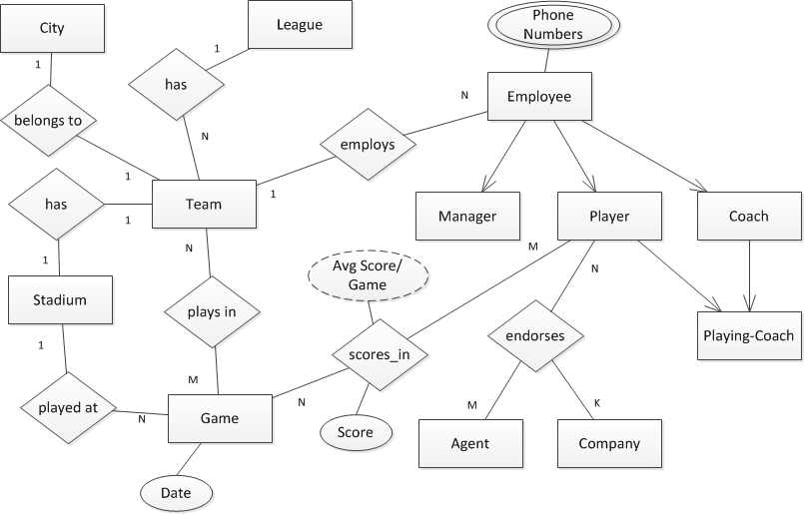

## Modified database schema

drop table leagues cascade constraints;

create table leagues(

lid number primary key,

name varchar2(50) not null unique,

start_date date

);

drop table stadiums cascade constraints;

create table stadiums(

sid number primary key,

name varchar2(50) not null,

built_date date,

capacity number

);

drop table cities cascade constraints;

create table cities(

cid number primary key,

name varchar2(50) not null,

state varchar2(2) not null

);

drop table teams cascade constraints;

create table teams(

tid number primary key,

name varchar2(50) not null unique,

sid number,

cid number,

lid number,

foreign key(sid) references stadiums(sid),

foreign key(cid) references cities(cid),

foreign key(lid) references leagues(lid)

);

drop table plays_in cascade constraints;

create table plays_in (

gid number,

tid number,

constraint plays_in_id primary key (gid, tid),

foreign key (gid) references games(gid),

foreign key (tid) references teams(tid)

);

drop table games cascade constraints;

create table games(

gid number primary key,

game_date date,

sid number,

foreign key(sid) references stadiums(sid)

);

drop table employees cascade constraints;

create table employees(

eid number primary key,

cid number not null,

name varchar2(50) not null,

birth_date date,

age number,

addr_street_no varchar2(50),

tid number not null,

start_date date,

annual_salary number,

country_code number,

area_code number,

phone_number number,

foreign key(cid) references cities(cid),

foreign key(tid) references teams(tid)

);

drop table players cascade constraints;

create table players(

eid number primary key,

position varchar2(20),

foreign key(eid) references employees(eid)

);

drop table scores_in cascade constraints;

create table scores_in (

pid number,

gid number,

score number,

constraint scores_in_key primary key (pid, gid),

foreign key(pid) references players(eid),

foreign key(gid) references games(gid)

);

drop table coaches cascade constraints;

create table coaches(

eid number primary key,

qualification varchar2(20),

type varchar2(20),

foreign key(eid) references employees(eid)

);

drop table managers cascade constraints;

create table managers(

eid number primary key,

type varchar2(20),

foreign key(eid) references employees(eid)

);

drop table playing_coaches cascade constraints;

create table playing_coaches(

eid number primary key,

start_date date,

foreign key(eid) references players(eid),

foreign key(eid) references coaches(eid)

);

drop table agents cascade constraints;

create table agents(

aid number primary key,

name varchar2(50) not null,

addr_street_no varchar2(50)

);

drop table companies cascade constraints;

create table companies(

coid number primary key,

name varchar2(50) not null,

addr_street_no varchar2(50)

);

drop table endorses cascade constraints;

create table endorses(

eid number,

aid number,

coid number,

Constraint endorsement_id Primary key (eid, aid, coid),

start_date date,

end_date date,

amount number,

foreign key(eid) references players(eid),

foreign key(aid) references agents(aid),

foreign key(coid) references companies(coid)

);

## Queries

a) Names of those players who live in the same city as their teams:

SELECT players.name

FROM players, teams, employees

WHERE employees.eid=players.eid AND

employees.tid=teams.tid AND

teams.cid=employees.cid;

b) Names of those teams who have not scored any in a game:

SELECT teams.name

FROM teams, employees, players, scores_in

WHERE employees.eid=players.eid AND

employees.tid=teams.tid AND

scores_in.pid=players.eid

GROUP BY teams.name

HAVING SUM(scores_in.score)=0;

c) Names of those players in NBA (league) who have endorsements of amounts >= $1,000,000.00. Include the players’ average scores, team names and the endorsing companies:

SELECT employees.name, AVG(scores_in.score), teams.name, companies.name

FROM employees, players, endorses, companies, scores_in, teams

WHERE employees.eid=players.eid AND

teams.tid=employees.tid AND

scores_in.pid=players.eid AND

endorses.eid=players.eid AND

endorses.coid=companies.coid AND

endorses.amount>=1000000

GROUP BY employees.name, teams.name, companies.name;

d) Three highest scoring players in each game, the teams played in the game, dates played and the stadium they played at:

SELECT employees.name, teams.name, games.game_date, stadiums.name

FROM employees, scores_in, teams, games, stadiums

WHERE employees.eid=scores_in.pid AND

teams.tid=employees.tid AND

games.gid=scores_in.gid AND

EXISTS (

SELECT *

FROM scores_in si1

WHERE si1.gid=scores_in.gid AND

ROWNUM<=1

ORDER BY si1.score DESC

);

e) Each player and his team in NBA, comparing his average score of year 2006 with average score of 2007:

CREATE OR REPLACE PROCEDURE getAverageScores(

i_pid IN number,

o_2006avg number,

o_2007avg number )

IS

BEGIN

SELECT AVG( scores_in.score )

INTO o_2006avg

FROM scores_in, games

WHERE scores_in.pid=i_pid AND

scores_in.gid=games.gid AND

games.game_date BETWEEN TO_DATE( '2006-JAN-01', 'YYYY-MON-DD' ) AND TO_DATE( '2006-DEC-31', 'YYYY-MON-DD' )

GROUP BY employees.name, teams.name;

SELECT AVG( scores_in.score )

INTO o_2007avg

FROM scores_in, games

WHERE scores_in.pid=i_pid AND

scores_in.gid=games.gid AND

games.game_date BETWEEN TO_DATE( '2007-JAN-01', 'YYYY-MON-DD' ) AND TO_DATE( '2007-DEC-31', 'YYYY-MON-DD' )

GROUP BY employees.name, teams.name;

END;

DECLARE

temp_2006avg number;

temp_2007avg number;

BEGIN

FOR cursor IN (

SELECT players.name pname, teams.name tname, players.eid pid

FROM players, teams, employees

WHERE players.eid=employees.eid AND

employees.tid=teams.tid )

LOOP

getAvgScores( cursor.pid, temp_2006avg, temp_2007avg );

DBMS_OUTPUT.PUT_LINE('Player ' || cursor.pname || ' Team: ' || cursor.tname ||

' 2006: ' || temp_2006avg || ' 2007 ' || temp_2007avg );

END LOOP;

END;