|  |  |
| --- | --- |
| Politika i gospodarstvo – 3.u – pitanja za zadaću i 3. ispit |  |

1. 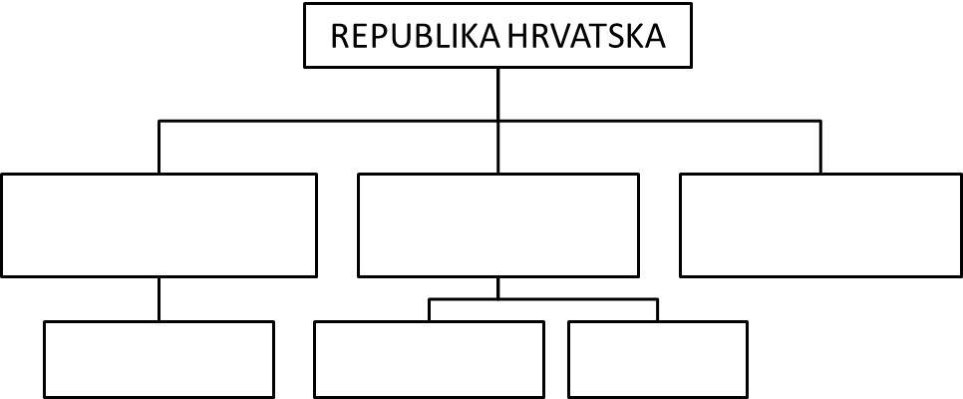Popuni dijagram:
2. Kad je donesen Božićni ustav? (datum i godina)
3. Koje dvije značajke vežemo uz položaj saborskog zastupnika?
4. Kako se zove zakonodavno tijelo u RH?
5. Nabroj barem 5 ovlasti **Hrvatskog sabora**:
   1. _____________________________________________________
   2. _____________________________________________________
   3. _____________________________________________________
   4. _____________________________________________________
   5. _____________________________________________________
6. Tko odlučuje o promjeni granica RH?
7. Državni proračun **predlaže** ____________________________, a **donosi** ga ________________________ .
8. Tko čini izvršnu vlast u RH?
9. Nabroj barem 5 ovlasti **predsjednika RH**:
   1. _____________________________________________________
   2. _____________________________________________________
   3. _____________________________________________________
   4. _____________________________________________________
   5. _____________________________________________________
10. Jedna osoba može biti najviše _______ izabrana za predsjednika RH.
11. Tko čini vladu RH?
12. Tko postavlja i tko može smijeniti vladu?
13. Nabroj 5 ovlasti **vlade RH**:
    1. _____________________________________________________
    2. _____________________________________________________
    3. _____________________________________________________
    4. _____________________________________________________
    5. _____________________________________________________
14. Tko se treba brinuti za gospodarski razvitak RH?
15. Može li sudska vlast biti pod utjecajem vlade, predsjednika ili sabora?
16. Koje su jedinice lokalne samouprave? ________________, ___________________ i ___________________.
17. Na otoku Pagu je ( __ ) ________________________ i ( __ ) _______________ *(u zagradu upiši koliko, a izvan zagrade koji jedinica lokalne samouprave ima na otoku)*