Tutorials of Zigbee LAN Gateway

Features:
1. CC2652P (RF-STAR RF-BM-2652P2) multi-protocol wireless module for TI, maximum transmit power +20dBm;
2. Support for access to 200+ ZigBee devices;
3. On-board BSL button, support firmware upgrade via USB/LAN;
4. SMA antenna port for external antennas;
5. Two operating modes: LAN Coordinator (default) and USB Coordinator/Router;
6. Support Z-Stack coordinator/router firmware;
7. Plug and play; default programming coordinator firmware;
8. Support Z2M (https://www.zigbee2mqtt.io/) and ZHA (https://www.home-assistant.io/integrations/zha/).

Purchase in Aliexpress:
https://www.aliexpress.us/item/3256804554006317.html
How to Use?
1. Plug in a USB-C power cable (5V), and then plug in a network cable;
2. Run DTUConfigTool (click to download https://docs.coltsmart.com/download/client/dtu-config-tool/x64/nostatement/dtu-config-tool-x64-nostatement%20Setup.zip) and click the "Search Device" button, when the device is found, copy the IP address of the gateway for backup; in addition, you can choose the way to obtain the IP address according to your needs, DHCP (recommended) or manual acquisition, after the modification is complete, click "submit",then click “Restart”.

Note: Do not modify other parameters!
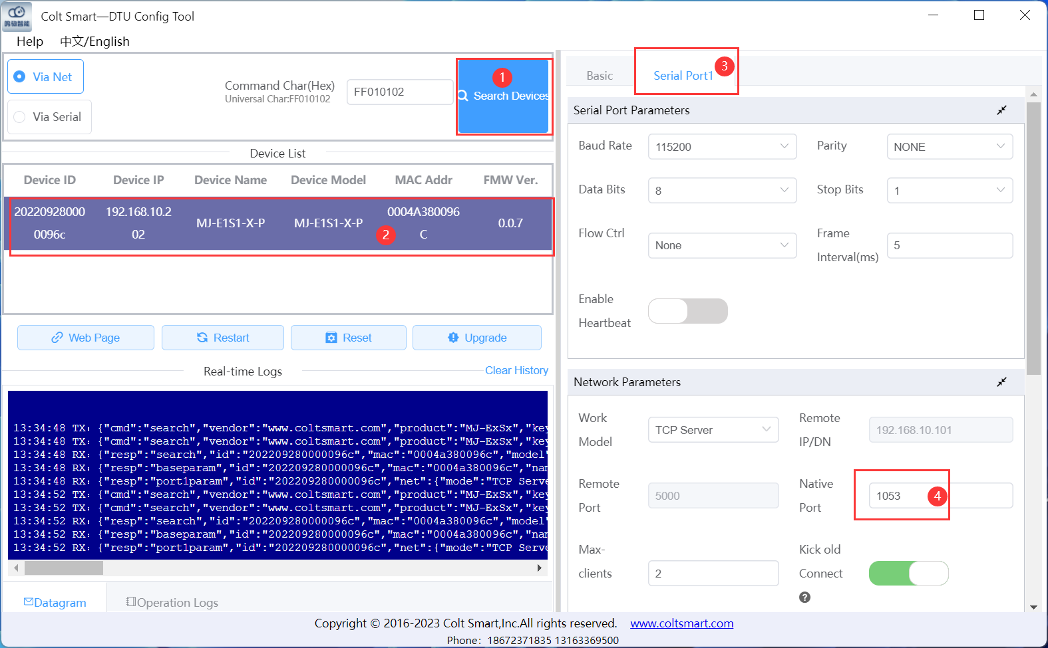
* Used in ZHA
1. Add ZHA integration
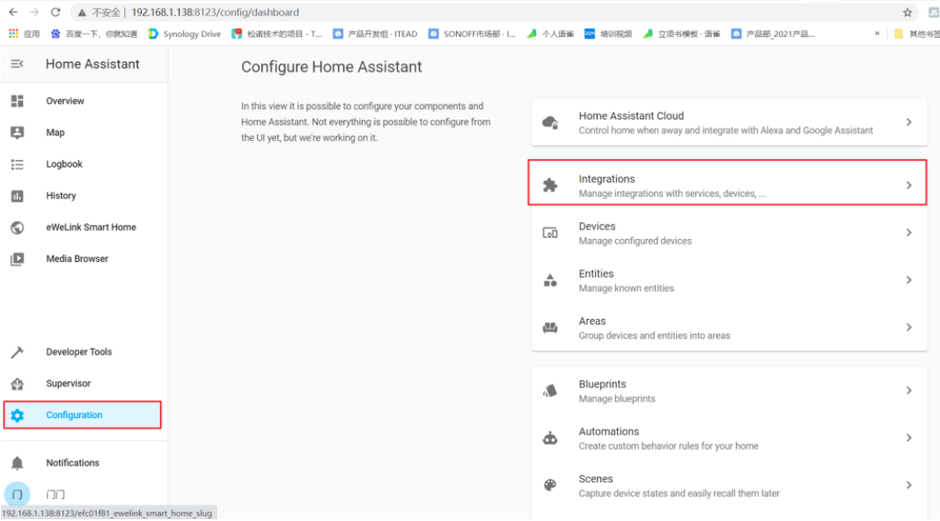

2. Select Manual in the drop-down menu
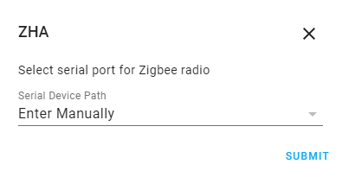

3. Radio type: Select ZNP
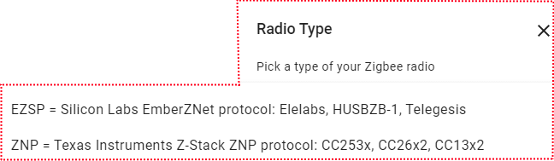

4. Enter socket://ip_address:1053, data flow control: software, and click "Submit". Replace "ip_address" with the IP address of the gateway
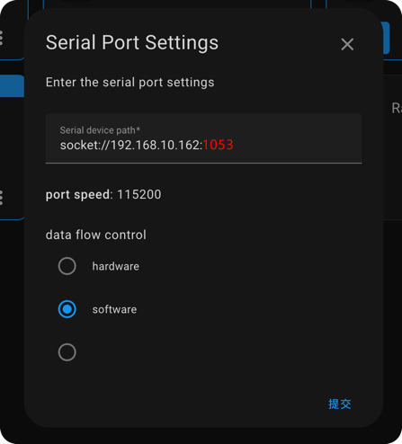

* Used in Z2M
1. Go to the official website of Zigbee2MQTT (https://www.zigbee2mqtt.io/guide/installation/) and select an installation method
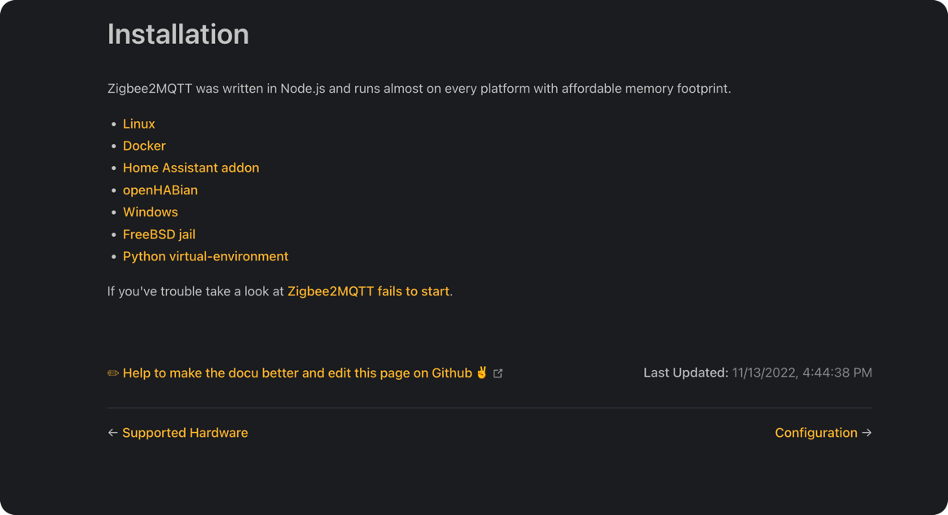
2. Edit the configuration.yaml file of Zigbee2MQTT, please go to the official Z2M documentation (https://www.zigbee2mqtt.io/guide/configuration/adapter-settings.html) for detailed configuration
Replace "ip_address" with the IP address of the gateway

Hardware Upgrade:
1. Download the ZigStar GW Multi tool (https://github.com/xyzroe/ZigStarGW-MT/releases), please select the corresponding version according to your operating system;
2. Stop running zha or z2m;
3. Open the shell, press and hold the button, plug in the USB, then release the button, plug in the network cable and get the IP address;
4. Download the firmware CC1352P2_CC2652P_launchpad_*.zip and unzip it to get. HEX file
Coordinator: https://github.com/Koenkk/Z-Stack-firmware/tree/master/coordinator/Z-Stack_3.x.0/bin
Router: https://github.com/Koenkk/Z-Stack-firmware/tree/master/router/Z-Stack_3.x.0/bin
- Run the ZigStar GW Multi tool, enter the gateway ip:1053,in the input box, and select the .hex file from the PC. Check Erase, Write, Verify, do not check Auto BSL, click Start to start flashing the firmware.

If you encounter problems, you can contact me at Telegram @ corogoo,
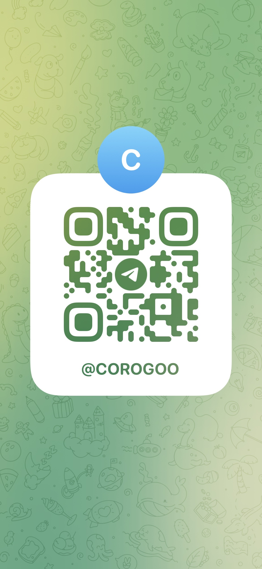

Or send Email ：corogoo@gmail.com

