Tutorials of Zigbee-Gateway-LAN-PRO

Features:
1. CC2652P (RF-STAR RF-BM-2652P2) multi-protocol wireless module for TI, maximum transmit power +20dBm;
2. Access up to 200+ ZigBee devices;
3. Support firmware upgrade via USB/LAN;
4. SMA antenna port for external antennas;
5. Two operating modes: LAN Coordinator (default) and USB Coordinator/Router;
6. Support Z-Stack coordinator/router firmware;
7. Plug and play; default programming coordinator firmware;
8. Support Z2M (https://www.zigbee2mqtt.io/) and ZHA (https://www.home-assistant.io/integrations/zha/).

Purchase:
Zigbee LAN Gateway PRO: https://www.aliexpress.us/item/3256804557892073.html
Zigbee POE Gateway PRO: https://www.aliexpress.us/item/3256804675805140.html

How to Use?
1. Plug in a USB-C power cable (5V) and plug in a network cable;
2. POE version supports IEEE802.3af standard and supports wide input voltage range 37Vdc ~ 57Vdc. Note: The POE version does not require USB power;
3. Download the ZigStar GW Multi tool https://github.com/xyzroe/ZigStarGW-MT/releases, please select the corresponding version according to your operating system;
- Run the ZigStar GW Multi tool, click the refresh button, and select the address with port number 6638 in the drop-down list, at which time you can get the IP address of the gateway.
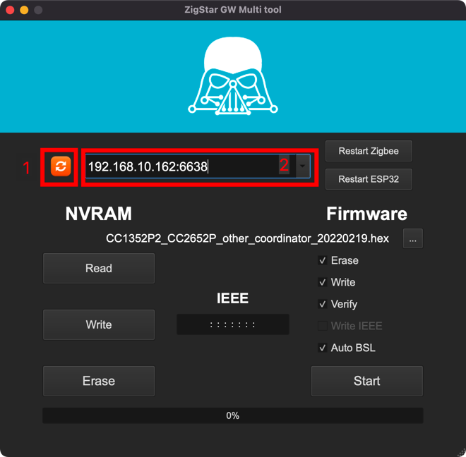
5. Enter the IP address of the gateway in the browser to enter the background page of the gateway
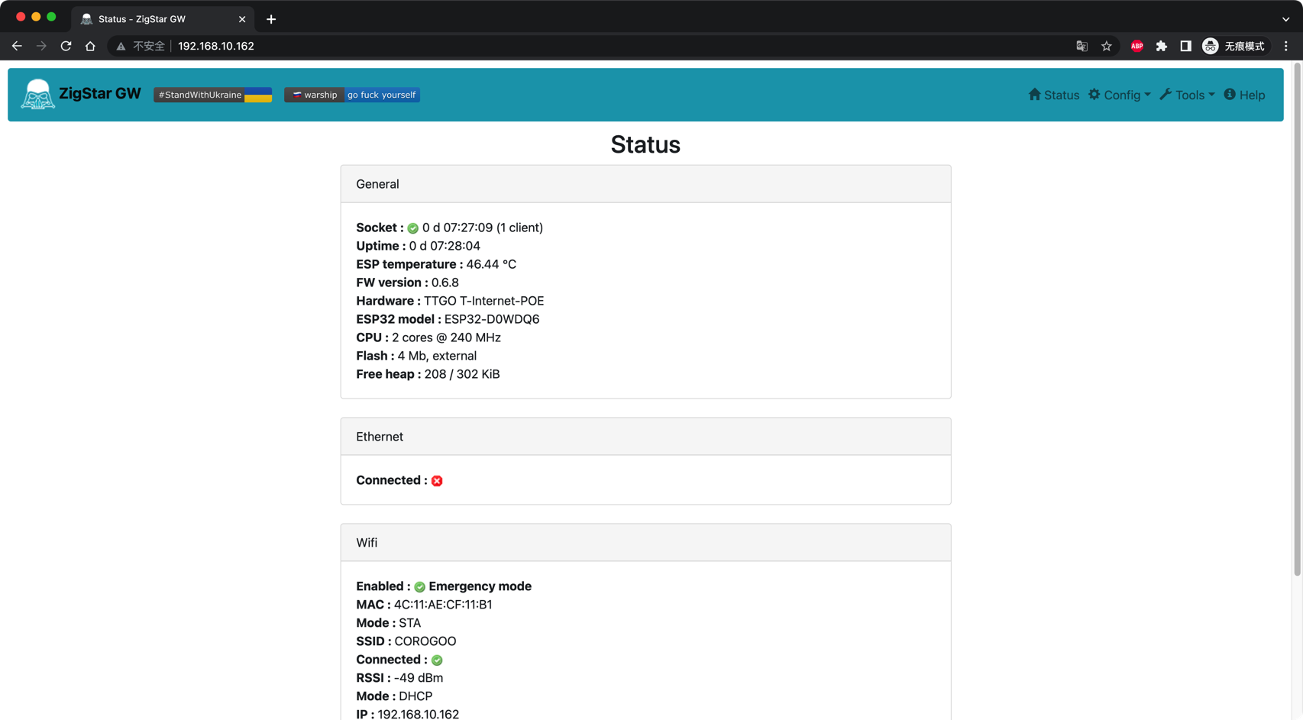

* Used in ZHA
1. Add ZHA integration
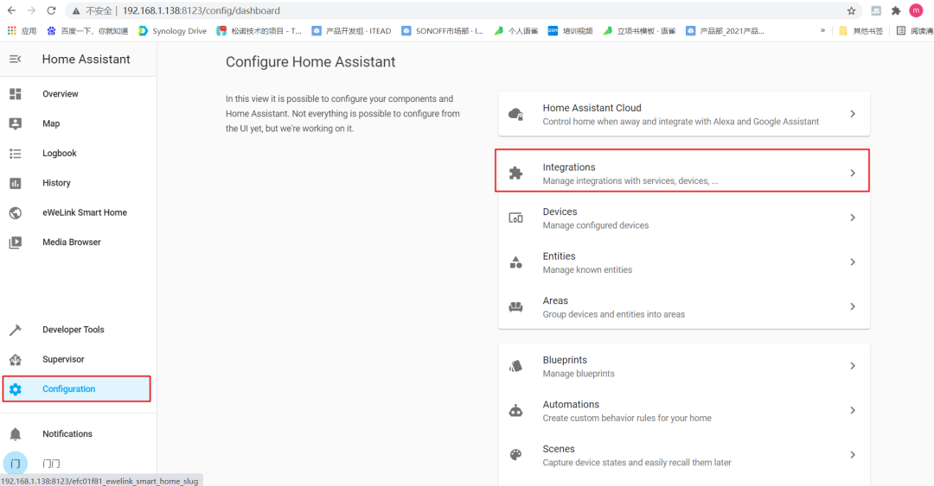
2. Select Manual in the drop-down menu
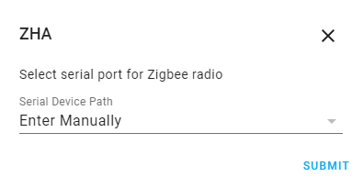

3. Radio type: Select ZNP
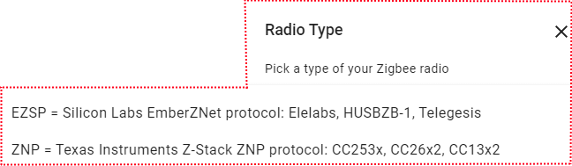

4. Enter socket://ip_address:6638, data flow control: software, and click "Submit". Replace "ip_address" with the IP address of the gateway.
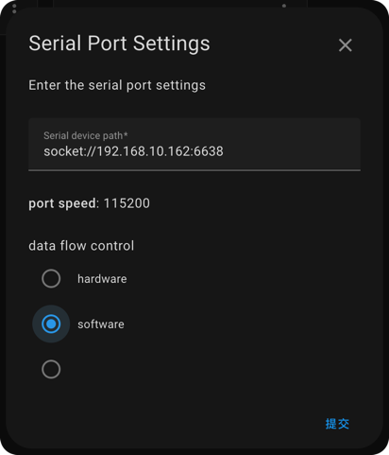

* Used in Z2M
1. Go to the official website of Zigbee2MQTT https://www.zigbee2mqtt.io/guide/installation/ and choose an installation method
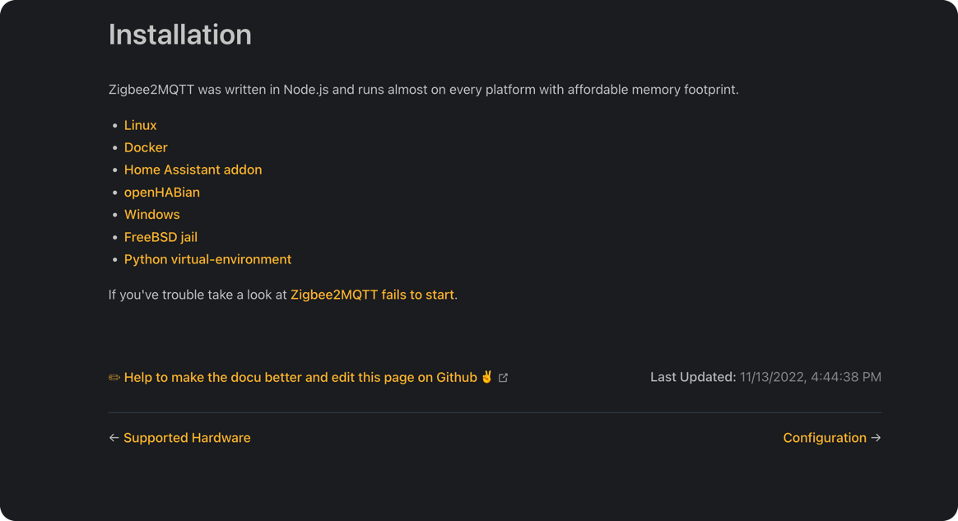

- Edit the configuration.yaml file for Zigbee2MQTT. For detailed configuration, please go to the official Z2M documentation (https://www.zigbee2mqtt.io/guide/configuration/adapter-settings.html)
Replace "ip_address" with the IP address of the gateway

Hardware Upgrade:
1. Download the ZigStar GW Multi tool (https://github.com/xyzroe/ZigStarGW-MT/releases), please select the corresponding version according to your operating system;
2. Stop running zha or z2m;
3. Download the firmware CC1352P2_CC2652P_launchpad_*.zip and unzip it to get .HEX file
Coordinator: https://github.com/Koenkk/Z-Stack-firmware/tree/master/coordinator/Z-Stack_3.x.0/bin
Router: https://github.com/Koenkk/Z-Stack-firmware/tree/master/router/Z-Stack_3.x.0/bin
4. Run the ZigStar GW Multi tool, click the refresh button, select the IP address with port number 6638, and select the .hex file from the PC. Check Erase, Write, Verify, Auto BSL, and click start to start burning the firmware.
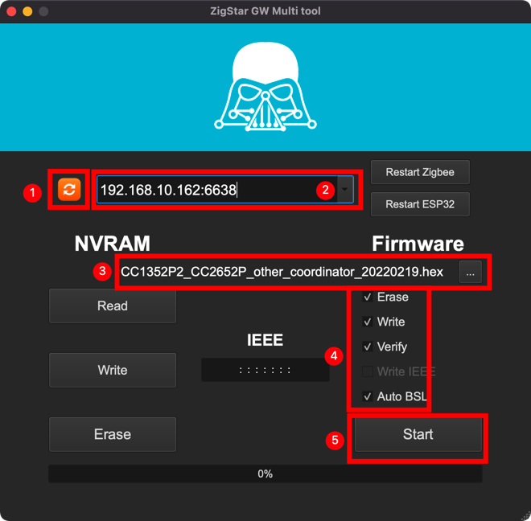

Advanced:
This product combines the excellent design of WT32-ETH01, LILYGO TTGO T-Internet-POE, zigstar (https://zig-star.com/) to draw the circuit, theoretically it supports the Tasmota firmware (need to be self-compiled) of the above hardware, and supports ZigStar ESP Firmware (https://github.com/xyzroe/ZigStarGW-FW/releases), thank you!

If you encounter problems, you can contact me at Telegram @ corogoo,


Or send Email ：corogoo@gmail.com

