Tutorials of Zigbee-Gateway-USB

Features:
1. CC2652P (RF-STAR RF-BM-2652P2) multi-protocol wireless module for TI, maximum transmit power +20dBm;
2. Support access to 200+ ZigBee devices;
3. On-board BSL button, support firmware upgrade via USB;
4. 2pcs LED indicators;
5. SMA antenna port for external antenna;
6. Communication via the universal CH340E/CH340C USB-UART bridge;
7. Support Z-Stack coordinator/router firmware;
8. Plug and play; default burning coordinator firmware;
9. Support Z2M (https://www.zigbee2mqtt.io/) and ZHA (https://www.home-assistant.io/integrations/zha/).

Purchase in Aliexpress:
https://www.aliexpress.us/item/3256803441836847.html

How to Use?
* Used in ZHA
1. Plug in the USB gateway and add the ZHA integration
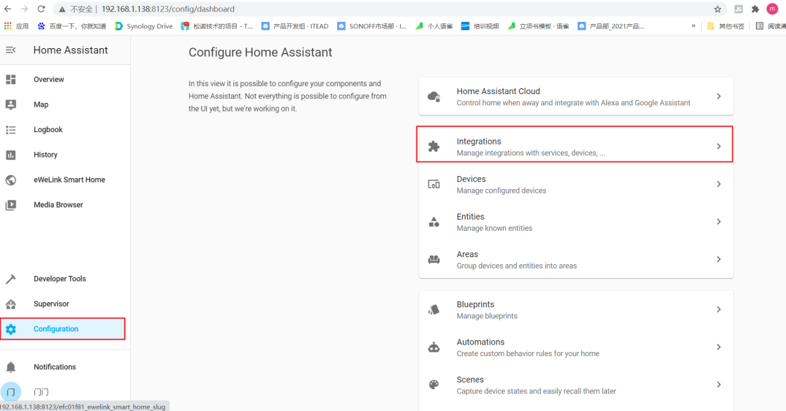
2. Select the corresponding port
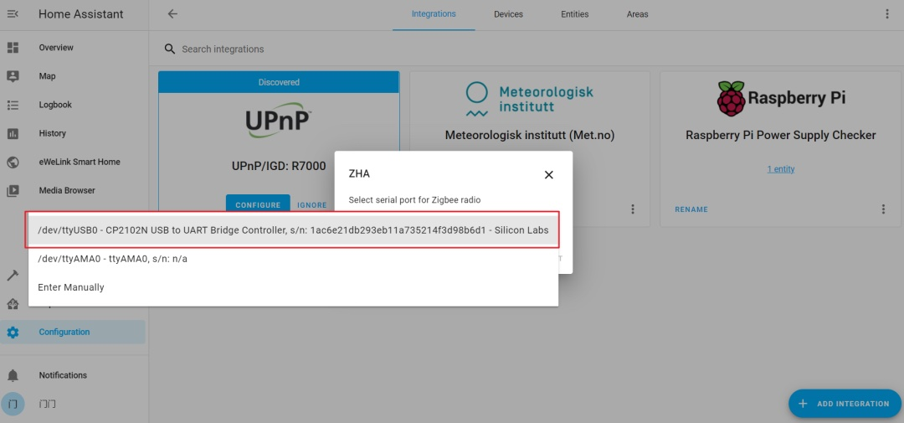
3. By default, flow control is not selected
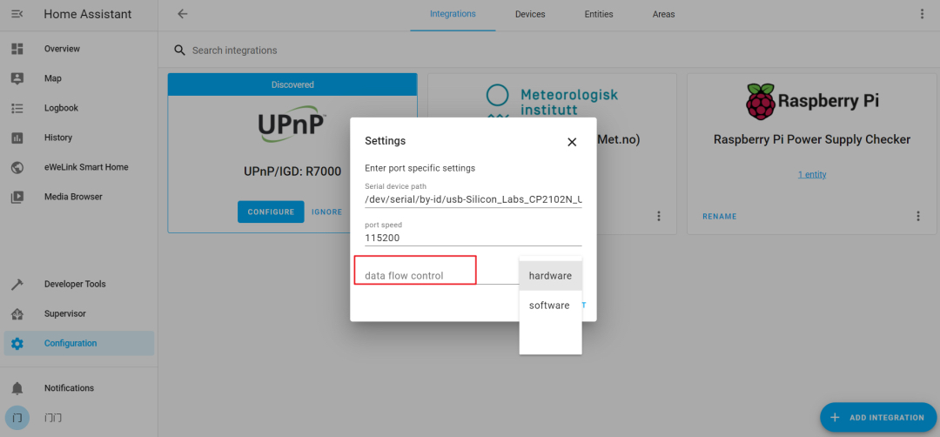
4. It is added.
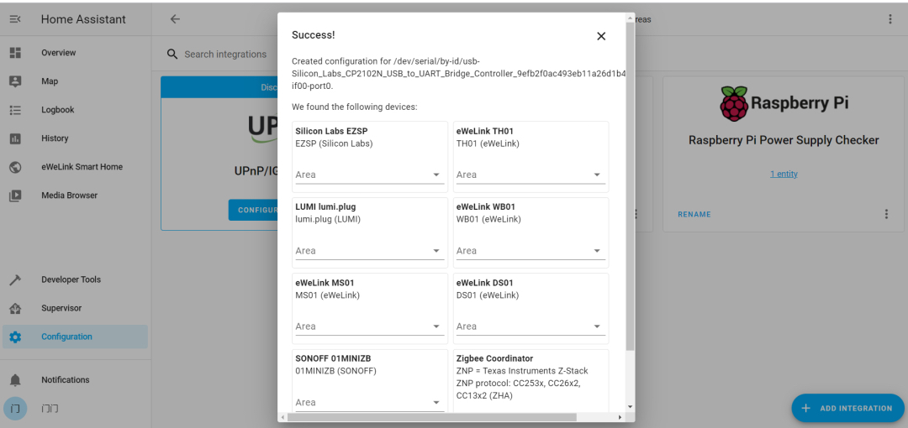

* Used in Z2M
1. Go to the official website of Zigbee2MQTT (https://www.zigbee2mqtt.io/guide/installation/) and choose an installation method
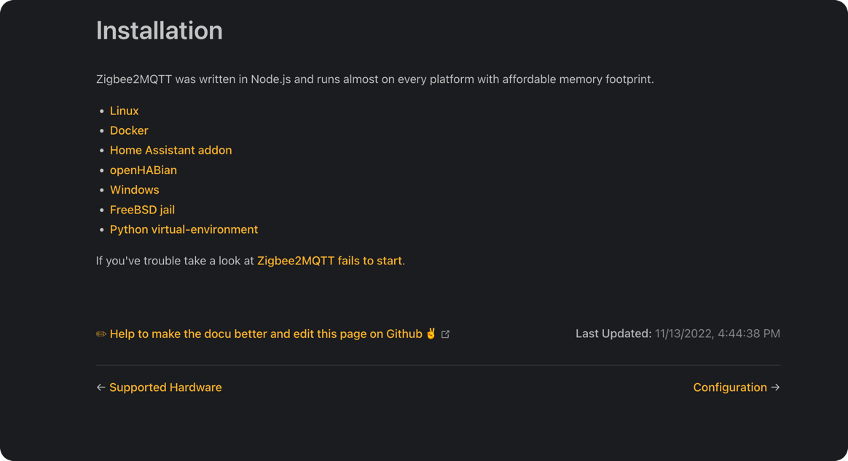
2. Edit the configuration.yaml file for Zigbee2MQTT. For detailed configuration, please go to the official Z2M documentation (https://www.zigbee2mqtt.io/guide/configuration/adapter-settings.html)
Hardware Upgrade:
1. Download the ZigStar GW Multi tool (https://github.com/xyzroe/ZigStarGW-MT/releases), please select the corresponding version according to your operating system;
2. Open the case, press and hold the button, plug in the USB, and then release the button;
3. Serial port driver
3.1. If you use Mac OS system, the serial port driver does not need to be installed;
3.2. If you are using a Windows system, check under "Ports (COM and LPT)" in Device Manager
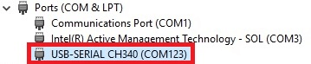
If not, click this link https://www.wch.cn/download/CH341SER_ZIP.html to download and install

- Run the ZigStar GW Multi tool, click the refresh button, and select the correct COM port in the drop-down list
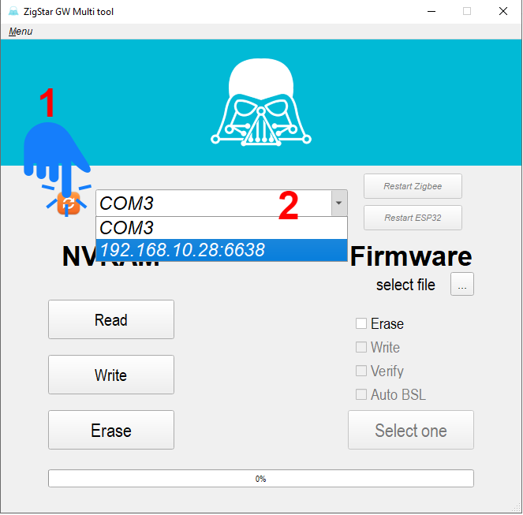

5. Download the firmware CC1352P2_CC2652P_launchpad_*.zip and unzip it to get the .HEX file
Coordinator:https://github.com/Koenkk/Z-Stack-firmware/tree/master/coordinator/Z-Stack_3.x.0/bin
Router:https://github.com/Koenkk/Z-Stack-firmware/tree/master/router/Z-Stack_3.x.0/bin

- Select the .hex file from your PC. Check Erase, Write and Verify and click Start to start burning the firmware.
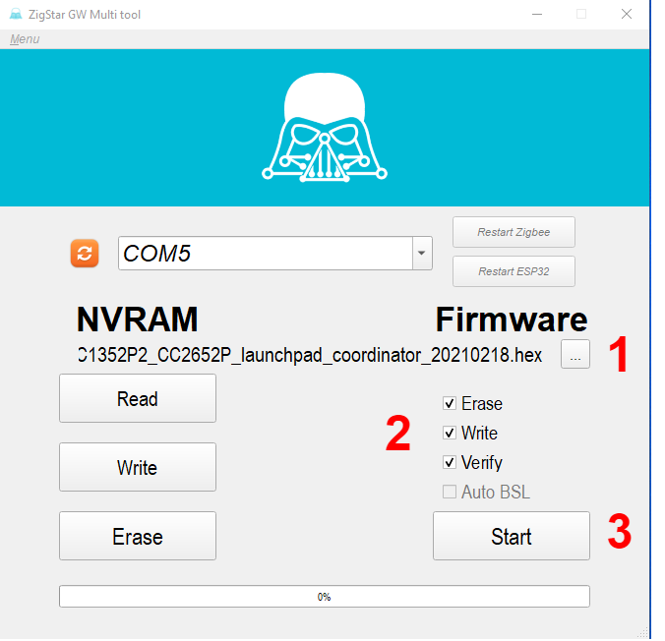

If you encounter problems, you can contact me at Telegram @ corogoo,


Or send Email ：corogoo@gmail.com

