Cebu Technological University
Main Campus (Cebu City)
AP3 — Midterm Project
Agriculture Information System (AIS)
Final System Documentation
Tech Stack
Native PHP (OOP & PDO), Supabase PostgreSQL, Tailwind CSS
Submitted By
Stephen Juntong Coronel
BS Information Systems
November 12, 2026

This document describes the checked-in implementation and migration history. A source-code review is not evidence of a successful current live database session. Items below explicitly distinguish implementation from tests and screenshots that still need evidence.

1. Project Title and Description
The Agriculture Information System - AP3 Midterm Project, Cebu Technological University is a web application for maintaining farmer, farm, crop, planting, and harvest records. Users authenticate as admin or staff. The five operational modules provide record lists, forms, detail pages, and deletion routes; related values are displayed through SQL joins. The dashboard summarizes database records and the Reports area contains six report views.

Architecture
Apache serves native PHP pages. Page scripts check the session/role, construct a PDO connection from config/Database.php, instantiate OOP model classes with that PDO connection, validate submitted values, and render HTML with Tailwind CDN. Models use prepared statements for database operations. PostgreSQL in Supabase stores business rows, lookup rows, user accounts, constraints, and audit timestamps. Dynamic HTML values are escaped with htmlspecialchars().

Repository structure
config/ Database connection and private credential configuration
models/ Farmer, Farm, Crop, Planting, Harvest, Lookup, User, Report
includes/ Shared header/footer, authentication checks, text helper
auth/ Login and logout
farmers/ Farmer list, create, edit, view, delete
farms/ Farm list, create, edit, view, delete
crops/ Crop list, create, edit, view, delete
plantings/ Planting list, create, edit, view, delete
harvests/ Harvest list, create, edit, view, delete
reports/ Index and six report pages
database/ Ordered SQL migrations, seed/audit/maintenance scripts
index.php Authenticated dashboard
Credentials are read by config/Database.php from the private config/db_credentials.php; config/db_credentials.example.php is the placeholder template. Do not include private credential values in the submitted documentation.

2. Project Objectives
• Organize agriculture information in related PostgreSQL relations with identifiable primary and foreign keys.
• Demonstrate the progression from the assignment's five core relations to a 3NF implementation, including lookup relations for fixed-choice labels.
• Implement account authentication, hashed passwords, protected pages, and distinct Administrator and Staff permissions.
• Support create, view, update, and delete workflows for the five operational modules, with validation, prepared statements, and understandable messages.
• Support record discovery through search, filters, sorting, and pagination.
• Summarize stored records in a database-backed dashboard and provide the six required reports.
• Protect referential integrity and retain creation/update timestamps on the five core tables.

3. Functional Requirements & Implementation

Authentication and access control
• auth/login.php handles sign-in; models/User.php::getByUsername() retrieves the account and the login code uses password_verify() against password_hash before establishing session identity and role.
• includes/auth_check.php::requireLogin() protects authenticated pages, isAdmin() checks the current role, and requireAdmin() blocks non-admin write operations.
• auth/logout.php ends the session. models/User.php::create() and updatePassword() use password_hash(); the schema restricts roles to admin and staff.
• Staff can view application records and reports. Administrator can view, create, edit, and delete. Delete routes require Administrator and present a confirmation step in the UI.

Dashboard
index.php is the post-login dashboard. It queries current database metrics for farmer, farm, crop, planting, and harvest totals; the five most recent plantings ordered by planting date/ID; the five most recent harvests ordered by harvest date/ID; counts grouped by every planting status; and total harvested kilograms. Values come from the database. Navigation is supplied through includes/header.php and dashboard links.

Five operational modules
Each module has index.php, create.php, edit.php, view.php, and delete.php. The model method inventory and pages together implement the workflows:
Module | Model methods | Implementing pages and related data
Farmers | Farmer::getAll(), countAll(), getById(), hasDuplicate(), create(), update(), delete() | farmers/index.php, create.php, edit.php, view.php, delete.php; list supports search/address filter, sort, pagination.
Farms | Farm::getAll(), countAll(), getById(), getFarmers(), getIrrigationTypes(), getSoilTypes(), hasValidReferences(), hasDuplicateName(), create(), update(), delete() | farms/ pages; farmer and lookup labels are joined for display; owner, irrigation, and soil selections use database-fed options.
Crops | Crop::getAll(), countAll(), getById(), getCategories(), getRecommendedSeasons(), hasValidReferences(), hasDuplicate(), create(), update(), delete() | crops/ pages; category and season are lookup-backed. Search/category filter, sorting and pagination are supported.
Plantings | Planting::getAll(), countAll(), getById(), getFarms(), getCrops(), getStatuses(), hasValidReferences(), hasDuplicate(), create(), update(), delete() | plantings/ pages; joined farm, farmer, crop, and status details; status filter, search, sorting and pagination.
Harvests | Harvest::getAll(), countAll(), getById(), getPlantingById(), getPlantings(), hasValidReferences(), hasDuplicate(), create(), update(), delete() | harvests/ pages; related planting/farm/crop/farmer and lookup labels are joined; grade filter, search, sorting and pagination.
The page scripts validate inputs on the server, restrict write methods to Administrator, and show success/error feedback. Delete operations are attempted against the database; restrictive foreign keys prevent removing parent rows still referenced by children, and the page presents a friendly failure message.

Controlled lookup dropdowns
models/Lookup.php provides getHarvestRemarks(), getHarvestQualityGrades(), getPlantingStatuses(), getIrrigationTypes(), getSoilTypes(), getCropCategories(), and getRecommendedSeasons(). Related options also come from model methods listed above. Forms submit integer lookup IDs; the corresponding labels are joined for display. The seven lookup relations are soil_types, irrigation_types, crop_categories, recommended_seasons, planting_statuses, harvest_quality_grades, and harvest_remarks.

Search, filtering, sorting, and pagination
List-page model methods accept filters/search and paging/sort parameters. Farmers filter by address; farms by irrigation type; crops by category; plantings by status; harvests by quality grade. Each primary list has free-text search, sortable headings, and 10 rows per page. Sort keys are selected from page/model allowlists, sort direction is normalized, and page/offset values are passed to the model. The report filters are described above and the exact report implementation is in models/Report.php and reports/*.php.

Input validation and audit timestamps
Form handlers validate server-side before persistence. Exact implemented rules include:
• Farmers (farmers/create.php, farmers/edit.php): all five fields are required; first/last name max 50 characters, contact max 20, address max 150; registration date must match YYYY-MM-DD and pass checkdate(). capitalizeInput() is applied to names and address. Farmer::hasDuplicate() checks normalized contact plus address OR same name plus address.
• Farms (farms/create.php, farms/edit.php): all six values required; farm name max 100, location max 150; area must match up to six integer digits and two decimals and be greater than zero. Farmer, soil, and irrigation IDs must be positive digit strings and exist (Farm::hasValidReferences()). Same-owner farm name duplicates are checked.
• Crops (crops/create.php, crops/edit.php): required crop name and variety max 80 characters; growing period must be a positive whole number within the signed integer range; category and season IDs must be positive and exist (Crop::hasValidReferences()). Duplicate crop-name/variety pairs are checked.
• Plantings (plantings/create.php, plantings/edit.php): required fields; area and seed quantity must be positive values with up to six integer digits and two decimal places; dates must be real YYYY-MM-DD dates, and expected harvest must be after planting. Farm, crop, and status IDs must exist. Exact duplicate planting details are checked.
• Harvests (harvests/create.php, harvests/edit.php): quantity must be positive and unit selling price nonnegative; each permits up to eight integer digits and two decimal places. Harvest date must be a real YYYY-MM-DD date and cannot be before its selected planting date. Planting, grade, and remark IDs must exist. Exact duplicate harvest details are checked.
The forms also set HTML required, min, max, and step attributes where appropriate; server checks remain authoritative. Database constraints provide a second integrity layer (Section 7). The five core tables have created_at and updated_at; migration database/06_add_audit_timestamps.sql installs a trigger to refresh updated_at on updates. The application does not store the responsible user's ID on business changes.

Six reports
Report | Page | Model methods and filters
Farmers and their farms | reports/farmers_farms.php | countFarmersAndFarms(), getFarmersAndFarms(); search spans farmer/contact/address and farm name/location; separate address substring filter; left joins retain farmers without farms. Sort and pagination are applied to the result list.
Crops planted per farm | reports/crops_per_farm.php | getFarmOptions(), countCropsPlantedPerFarm(), getCropsPlantedPerFarm(), bindCropReportFilters(); selected farm, inclusive planting-date range, search across farm/location/farmer/crop/variety, sort, and pagination.
Planting records by status | reports/plantings_by_status.php | getPlantingStatusOptions(), getPlantingStatusSummary(), countPlantingsByStatus(), getPlantingsByStatus(), bindPlantingDates(), bindPlantingsByStatusFilters(); status, inclusive planting-date range, search, sort, and pagination. Summary retains status options with zero matching plantings.
Harvest records | reports/harvest_records.php | getHarvestQualityOptions(), countHarvestRecords(), getHarvestRecords(), bindHarvestReportFilters(); grade, inclusive harvest-date range, search across related farmer/farm/crop/grade/remark labels, sort, and pagination.
Total harvested quantity | reports/total_harvested_quantity.php | getTotalHarvestQuantity(), getHarvestQuantityByQuality(); inclusive harvest-date range; returns harvest count, total kg, and quantity/count grouped by grade.
Estimated harvest value | reports/estimated_harvest_value.php | getEstimatedHarvestValue(), getEstimatedHarvestValueByCrop(); inclusive harvest-date range; sums quantity_kg * selling_price_per_kg overall and grouped by crop/variety.
reports/index.php links to the six views. Report SQL is in models/Report.php; report PHP pages validate date filter strings before querying.

4. Entity-Relationship Diagram (ERD)
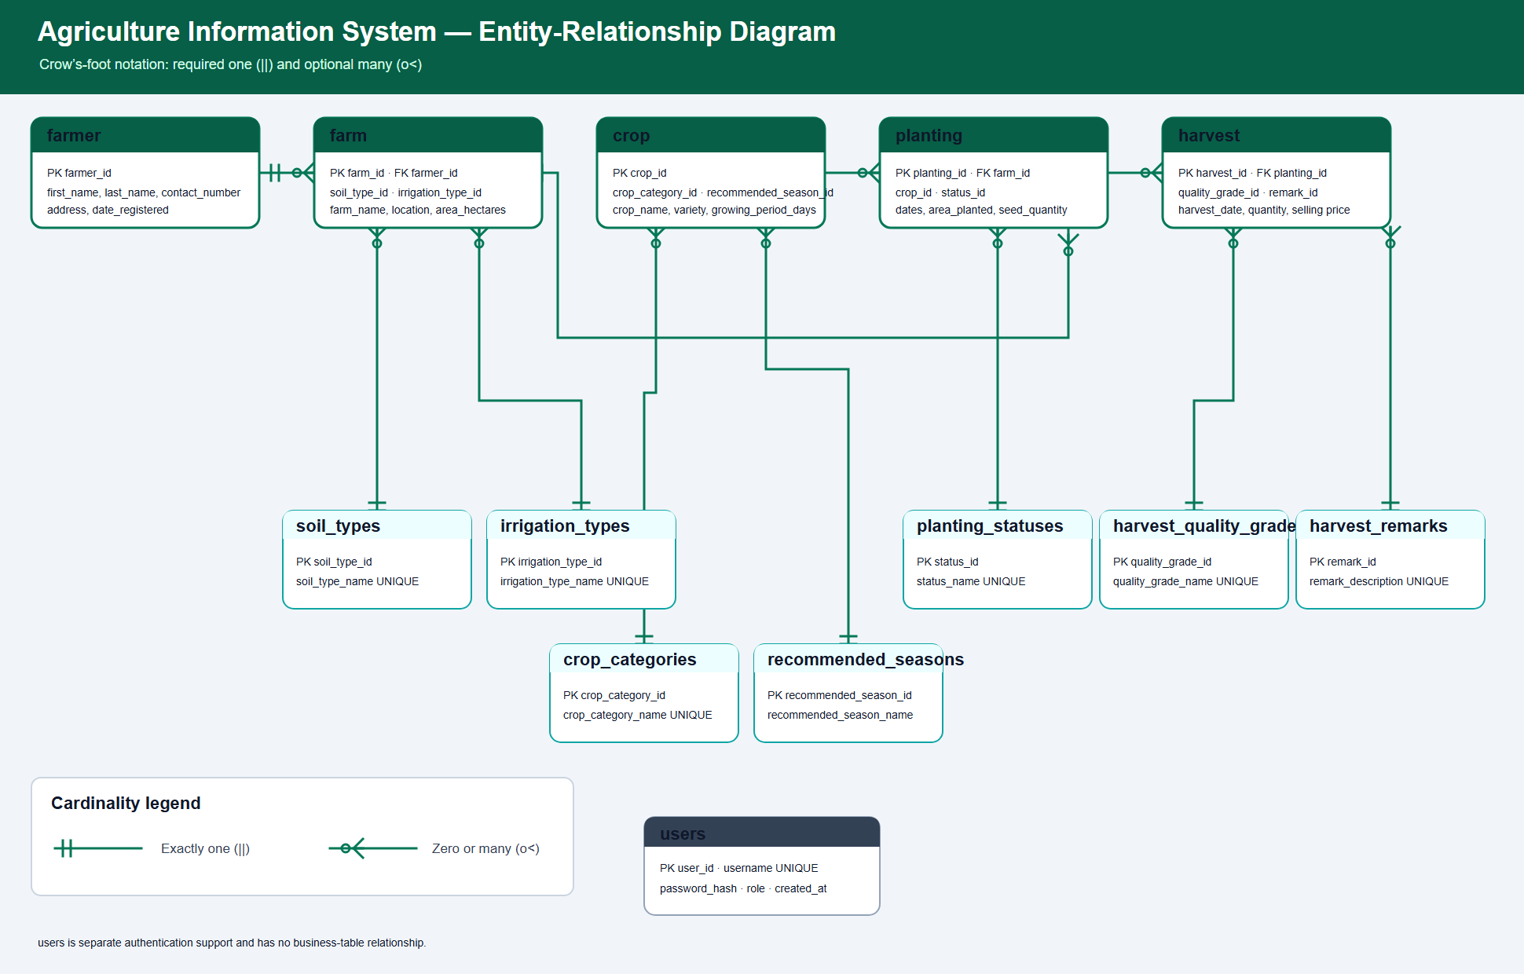
Text cardinalities: one farmer can own zero or many farms; each farm references one farmer. One farm can have zero or many plantings; each planting references one farm. One crop can appear in zero or many plantings; each planting references one crop. One planting can have zero or many harvest rows; each harvest references one planting. Each lookup row can be used by zero or many rows of its associated core table; each associated core row references one lookup row. users is a separate authentication relation and has no business-table foreign key.
The 13 relations are five core (farmer, farm, crop, planting, harvest), seven lookups, and users.

5. Database Normalization (UNF through 3NF)
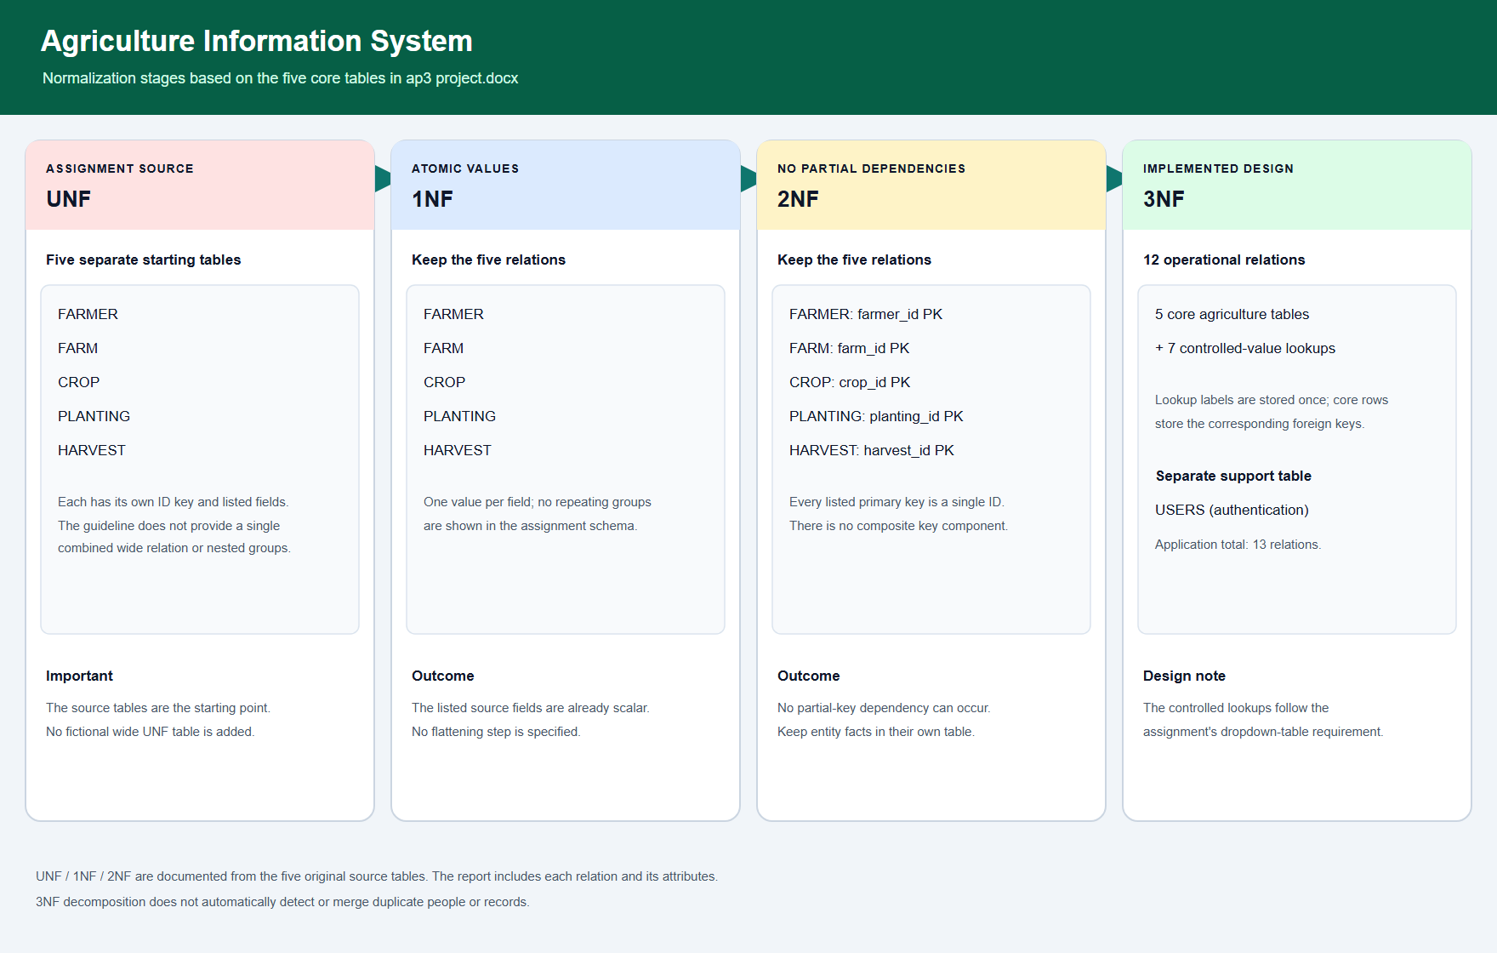
The source guideline supplies five separate core table structures, not one combined denormalized record. The progression below does not invent a wide UNF table or repeating groups.
Stage | Structure and reasoning
UNF (assignment starting point) | The five separate relations are FARMER(farmer_id, first_name, last_name, contact_number, address, date_registered); FARM(farm_id, farmer_id, farm_name, location, area_hectares, soil_type, irrigation_type); CROP(crop_id, crop_name, variety, crop_category, growing_period_days, recommended_season); PLANTING(planting_id, farm_id, crop_id, planting_date, area_planted, seed_quantity, expected_harvest_date, status); HARVEST(harvest_id, planting_id, harvest_date, quantity_kg, selling_price_per_kg, quality_grade, remarks). Each supplied column is scalar; no repeating group is specified.
1NF | Keep each value atomic and one value per row/column. The listed fields already meet this representation; no structural split is needed at this stage.
2NF | Each of the five relations has a single-column primary key. Since no composite key is used, there is no dependency on only part of a key. Keep attributes with their identified farmer, farm, crop, planting, or harvest entity.
3NF implemented | Retain the five entity relations, add audit timestamps, and replace fixed-choice labels with foreign keys into seven lookup relations. A lookup label depends on its lookup key rather than being repeated in every business row. users supports authentication separately and is outside the agriculture assignment's five-relation normalization exercise.
The changes from assignment labels to IDs are: farm.soil_type → soil_type_id; farm.irrigation_type → irrigation_type_id; crop.crop_category → crop_category_id; crop.recommended_season → recommended_season_id; planting.status → status_id; harvest.quality_grade → quality_grade_id; and harvest.remarks → remark_id. Migration database/08_normalize_lookup_columns.sql removes legacy label columns only after checking the label-to-ID mappings; migration 01 creates the harvest remarks lookup and relationship, and migration 02 creates the other fixed-value lookups and relationships.
For each core relation, the row key determines its non-key attributes. For example, farmer_id identifies the farmer's name, contact, address, and registration date. Lookup names are determined by lookup IDs. This avoids transitive storage of fixed-value labels in the business row. The separate users table does not alter those dependencies. Repeated contact numbers are not themselves a 3NF violation because the assignment does not define contact number as a candidate key.

6. Complete Data Dictionary
DDL coverage note: the repository has no initial CREATE TABLE migration for the five core tables. Their original column types and integer identity primary keys below are taken from the assignment schema reproduced in PROJECT_REQUIREMENTS.md; migrations 01–08 show the later lookup, constraint, and audit changes. The nullable/NOT NULL state of core fields is based on migration 07. Migration 01/02 lookup definitions are explicit. users is explicit in migration 05. This distinction is retained rather than presenting assignment definitions as if they came from an absent baseline SQL file. CURRENT_TIMESTAMP applies to timestamp defaults where shown. — means no explicit default is declared in the included DDL. Lookup IDs have primary keys but no identity/default declaration in migrations 01/02.

farmer
Column | Data type & length | Key | Nullable | Default | Description
farmer_id | integer | PK | NOT NULL | identity-generated | Farmer identifier
first_name | varchar(50) | — | NOT NULL | — | Given name; nonblank check
last_name | varchar(50) | — | NOT NULL | — | Family name; nonblank check
contact_number | varchar(20) | — | NOT NULL | — | Contact number; nonblank check
address | varchar(150) | — | NOT NULL | — | Address; nonblank check
date_registered | date | — | NOT NULL | — | Registration date
created_at | timestamptz | — | NOT NULL | CURRENT_TIMESTAMP | Row creation time
updated_at | timestamptz | — | NOT NULL | CURRENT_TIMESTAMP | Refreshed by update trigger

farm
Column | Data type & length | Key | Nullable | Default | Description
farm_id | integer | PK | NOT NULL | identity-generated | Farm identifier
farmer_id | integer | FK → farmer.farmer_id | NOT NULL | — | Owning farmer
farm_name | varchar(100) | UNIQUE with farmer_id | NOT NULL | — | Name, unique for that farmer
location | varchar(150) | — | NOT NULL | — | Farm location
area_hectares | numeric(8,2) | — | NOT NULL | — | Positive area in hectares
soil_type_id | smallint | FK → soil_types.soil_type_id | NOT NULL | — | Soil lookup
irrigation_type_id | smallint | FK → irrigation_types.irrigation_type_id | NOT NULL | — | Irrigation lookup
created_at | timestamptz | — | NOT NULL | CURRENT_TIMESTAMP | Row creation time
updated_at | timestamptz | — | NOT NULL | CURRENT_TIMESTAMP | Refreshed by update trigger

crop
Column | Data type & length | Key | Nullable | Default | Description
crop_id | integer | PK | NOT NULL | identity-generated | Crop/variety record identifier
crop_name | varchar(80) | UNIQUE with variety | NOT NULL | — | Crop name; nonblank check
variety | varchar(80) | UNIQUE with crop_name | NOT NULL | — | Variety; nonblank check
crop_category_id | smallint | FK → crop_categories.crop_category_id | NOT NULL | — | Category lookup
growing_period_days | integer | — | NOT NULL | — | Positive growing duration
recommended_season_id | smallint | FK → recommended_seasons.recommended_season_id | NOT NULL | — | Season lookup
created_at | timestamptz | — | NOT NULL | CURRENT_TIMESTAMP | Row creation time
updated_at | timestamptz | — | NOT NULL | CURRENT_TIMESTAMP | Refreshed by update trigger

planting
Column | Data type & length | Key | Nullable | Default | Description
planting_id | integer | PK | NOT NULL | identity-generated | Planting identifier
farm_id | integer | FK → farm.farm_id | NOT NULL | — | Farm used
crop_id | integer | FK → crop.crop_id | NOT NULL | — | Crop/variety planted
planting_date | date | — | NOT NULL | — | Date planted
area_planted | numeric(8,2) | — | NOT NULL | — | Positive area planted
seed_quantity | numeric(8,2) | — | NOT NULL | — | Positive seed quantity
expected_harvest_date | date | — | NOT NULL | — | Must be later than planting date
status_id | smallint | FK → planting_statuses.status_id | NOT NULL | — | Status lookup
created_at | timestamptz | — | NOT NULL | CURRENT_TIMESTAMP | Row creation time
updated_at | timestamptz | — | NOT NULL | CURRENT_TIMESTAMP | Refreshed by update trigger

harvest
Column | Data type & length | Key | Nullable | Default | Description
harvest_id | integer | PK | NOT NULL | identity-generated | Harvest identifier
planting_id | integer | FK → planting.planting_id | NOT NULL | — | Source planting
harvest_date | date | — | NOT NULL | — | Harvest date; app rejects before planting date
quantity_kg | numeric(10,2) | — | NOT NULL | — | Positive harvested weight
selling_price_per_kg | numeric(10,2) | — | NOT NULL | — | Nonnegative unit price
quality_grade_id | smallint | FK → harvest_quality_grades.quality_grade_id | NOT NULL | — | Quality lookup
remark_id | integer | FK → harvest_remarks.remark_id | NOT NULL | — | Remark lookup
created_at | timestamptz | — | NOT NULL | CURRENT_TIMESTAMP | Row creation time
updated_at | timestamptz | — | NOT NULL | CURRENT_TIMESTAMP | Refreshed by update trigger

Lookup and authentication relations
Relation.Column | Data type & length | Key | Nullable | Default | Description
soil_types.soil_type_id | smallint | PK | NOT NULL | — (migration does not declare identity/default) | Soil option ID
soil_types.soil_type_name | varchar(50) | UNIQUE | NOT NULL | — | Soil label
irrigation_types.irrigation_type_id | smallint | PK | NOT NULL | — (migration does not declare identity/default) | Irrigation option ID
irrigation_types.irrigation_type_name | varchar(50) | UNIQUE | NOT NULL | — | Irrigation label
crop_categories.crop_category_id | smallint | PK | NOT NULL | — (migration does not declare identity/default) | Category option ID
crop_categories.crop_category_name | varchar(50) | UNIQUE | NOT NULL | — | Category label
recommended_seasons.recommended_season_id | smallint | PK | NOT NULL | — (migration does not declare identity/default) | Season option ID
recommended_seasons.recommended_season_name | varchar(30) | UNIQUE | NOT NULL | — | Season label
planting_statuses.status_id | smallint | PK | NOT NULL | — (migration does not declare identity/default) | Status option ID
planting_statuses.status_name | varchar(30) | UNIQUE | NOT NULL | — | Status label
harvest_quality_grades.quality_grade_id | smallint | PK | NOT NULL | — (migration does not declare identity/default) | Grade option ID
harvest_quality_grades.quality_grade_name | varchar(30) | UNIQUE | NOT NULL | — | Grade label
harvest_remarks.remark_id | integer | PK | NOT NULL | — (migration does not declare identity/default) | Remark option ID
harvest_remarks.remark_description | varchar(50) | UNIQUE | NOT NULL | — | Remark label
users.user_id | integer | PK | NOT NULL | GENERATED BY DEFAULT AS IDENTITY | Account identifier
users.username | varchar(50) | UNIQUE | NOT NULL | — | Login name
users.password_hash | varchar(255) | — | NOT NULL | — | PHP password hash
users.role | varchar(20) | CHECK: admin/staff | NOT NULL | — | Authorization role
users.created_at | timestamptz | — | NOT NULL | CURRENT_TIMESTAMP | Account creation time
Migration 02 seeds lookup labels as follows: soil Loam, Clay Loam, Sandy Loam, Clay; irrigation Rainfed, Irrigated, Drip Irrigation; categories Cereal, Vegetable, Fruit, Legume, Root Crop; seasons Wet Season, Dry Season, Year Round; statuses Harvested, Growing; grades Grade A, Grade B, Grade C. Migration 01's remarks are Good Harvest, Acceptable Quality, Low Yield, Poor Quality, Damaged Harvest.

Audit timestamps and deletion fields
The AP3 guideline asks for created_at and updated_at on important tables where appropriate; it does not require deleted_at. The reference SYSTEM_DOCUMENTATION.pdf describes a different application and its soft-delete design, so those fields are not evidence of this AIS schema.
Relation | Audit columns present in checked-in migrations | deleted_at
farmer | created_at, updated_at | Not implemented
farm | created_at, updated_at | Not implemented
crop | created_at, updated_at | Not implemented
planting | created_at, updated_at | Not implemented
harvest | created_at, updated_at | Not implemented
soil_types | None | Not implemented
irrigation_types | None | Not implemented
crop_categories | None | Not implemented
recommended_seasons | None | Not implemented
planting_statuses | None | Not implemented
harvest_quality_grades | None | Not implemented
harvest_remarks | None | Not implemented
users | created_at | Not implemented
Migration 06 adds created_at and updated_at to the five core tables, both NOT NULL with CURRENT_TIMESTAMP defaults, and a trigger refreshes updated_at on updates. Migration 05 adds created_at to users. The lookup table creation scripts do not add audit timestamps.
Column Name | Data Type & Length | Key | Nullable | Default Value | Description / status
deleted_at (proposed) | timestamptz | — | NULL | NULL | Proposed soft-delete timestamp. Not present in current SQL schema or used by PHP; do not treat as implemented.
Current delete routes are hard-delete operations: module delete pages require Administrator and call model delete() methods that execute DELETE statements. Confirmation is shown, and foreign keys prevent deletion of referenced records. Adding deleted_at would require a separate database migration and application changes; no such changes were made here.

7. Table Relationships and Constraints

Relationships and delete behavior
The included migrations declare foreign keys without ON DELETE clauses, so PostgreSQL's default is NO ACTION (effectively preventing parent deletion while dependent rows remain). The lookup FKs are explicitly added by migrations 01/02. The baseline farmer→farm, farm/crop→planting, and planting→harvest relationships are part of the assignment schema and application queries, but their original CREATE TABLE/ALTER TABLE statements are not in the checked-in migration set. The application catches delete failures and does not intentionally cascade-delete child records. Thus the NO ACTION description for baseline relationships reflects PostgreSQL's default if those FKs exist without an override; inspect the live Supabase catalog for final deployed constraint confirmation.
Foreign key | Cardinality | Delete behavior
farm.farmer_id → farmer.farmer_id | Farmer 1:M Farm | NO ACTION/default; referenced farmer deletion is blocked
farm.soil_type_id → soil_types.soil_type_id | Soil 1:M Farm | NO ACTION/default
farm.irrigation_type_id → irrigation_types.irrigation_type_id | Irrigation 1:M Farm | NO ACTION/default
crop.crop_category_id → crop_categories.crop_category_id | Category 1:M Crop | NO ACTION/default
crop.recommended_season_id → recommended_seasons.recommended_season_id | Season 1:M Crop | NO ACTION/default
planting.farm_id → farm.farm_id | Farm 1:M Planting | NO ACTION/default; referenced farm deletion is blocked
planting.crop_id → crop.crop_id | Crop 1:M Planting | NO ACTION/default; referenced crop deletion is blocked
planting.status_id → planting_statuses.status_id | Status 1:M Planting | NO ACTION/default
harvest.planting_id → planting.planting_id | Planting 1:M Harvest | NO ACTION/default; referenced planting deletion is blocked
harvest.quality_grade_id → harvest_quality_grades.quality_grade_id | Grade 1:M Harvest | NO ACTION/default
harvest.remark_id → harvest_remarks.remark_id | Remark 1:M Harvest | NO ACTION/default

Declared primary, unique, not-null, and check constraints
• Primary keys: farmer.farmer_id, farm.farm_id, crop.crop_id, planting.planting_id, harvest.harvest_id, soil_types.soil_type_id, irrigation_types.irrigation_type_id, crop_categories.crop_category_id, recommended_seasons.recommended_season_id, planting_statuses.status_id, harvest_quality_grades.quality_grade_id, harvest_remarks.remark_id, and users.user_id. Core and users identifiers are integer identity columns in the assignment schema/migration 05; lookup key types are shown in Section 6. Lookup scripts define IDs as PKs but do not show identity/default declarations.
• Unique: users.username; each lookup label; (farm.farmer_id, farm.farm_name); (crop.crop_name, crop.variety).
• Not null: business fields marked required by migration 07, lookup labels/IDs in migrations 01/02, and all users fields in migration 05.
• Checks: required farmer names/contact/address and farm/crop strings must not be blank; farm area > 0; crop growing period > 0; planting area and seed quantity > 0; expected harvest date > planting date; harvest quantity > 0; selling price ≥ 0; users.role IN ('admin','staff').
• Audit: migration 06 supplies created_at and updated_at defaults and installs set_updated_at() before-update triggers on the five core tables.
• Duplicate triggers: migration 18 installs trigger guards for five core relations. Farmer matching is normalized contact plus address OR normalized full name plus address; farm uses owner/name; crop uses name/variety; planting and harvest compare all business fields in their respective records. These triggers raise unique-violation errors; they are not declared UNIQUE constraints.

Application-level validation
The form handlers require the expected values, cast IDs/numeric fields, validate date syntax and logical date ordering, check selected parent/lookup IDs through model reference-check methods, and call module duplicate checks. Farmer duplicate checking is a likely-duplicate warning rule (contact plus address, or full name plus address), not a unique-phone database rule. Farm name and crop/variety checks correspond to their database unique keys. Planting and harvest exact duplicates are also guarded by model methods and migration 18 triggers. All SQL statements use prepared parameters where user-supplied values are used.

8. Screenshots of the Working System
Insert actual captures from the running application. The placeholders intentionally make no claim that evidence has already been captured. Hide credentials and any personal information that is not approved for submission.
1. [Insert Screenshot: Login page]
2. [Insert Screenshot: Administrator dashboard with database metrics]
3. [Insert Screenshot: Farmers list]
4. [Insert Screenshot: Farmers create form]
5. [Insert Screenshot: Farmers edit form]
6. [Insert Screenshot: Farmers delete confirmation]
7. [Insert Screenshot: Farms list]
8. [Insert Screenshot: Farms create form]
9. [Insert Screenshot: Farms edit form]
10. [Insert Screenshot: Farms delete confirmation]
11. [Insert Screenshot: Crops list]
12. [Insert Screenshot: Crops create form]
13. [Insert Screenshot: Crops edit form]
14. [Insert Screenshot: Crops delete confirmation]
15. [Insert Screenshot: Plantings list]
16. [Insert Screenshot: Plantings create form]
17. [Insert Screenshot: Plantings edit form]
18. [Insert Screenshot: Plantings delete confirmation]
19. [Insert Screenshot: Harvests list]
20. [Insert Screenshot: Harvests create form]
21. [Insert Screenshot: Harvests edit form]
22. [Insert Screenshot: Harvests delete confirmation]
23. [Insert Screenshot: Report — Farmers and their farms]
24. [Insert Screenshot: Report — Crops planted per farm]
25. [Insert Screenshot: Report — Planting records by status]
26. [Insert Screenshot: Report — Harvest records]
27. [Insert Screenshot: Report — Total harvested quantity]
28. [Insert Screenshot: Report — Estimated harvest value]
29. [Insert Screenshot: Desktop layout at 1440 CSS pixels]
30. [Insert Screenshot: Tablet layout at 768 CSS pixels (simulated browser viewport)]
31. [Insert Screenshot: Mobile layout]

9. System Testing Results
The matrix is a truthful execution record, not a claim that every live workflow passed. Repository notes record earlier syntax checks, local route/auth checks, and validation checks; the final end-to-end run against current Supabase data is still pending. Replace Not run for this submission only after executing and recording actual outcomes. Do not infer a pass from the presence of code.
Test ID | Module | Test scenario & input | Expected result | Actual result | Status
T01 | Authentication | Sign in with valid Administrator account/password | Session established; dashboard shown | Not run for this submission | Pending
T02 | Authentication | Wrong password or unknown username | Login rejected with friendly message; no session | Not run for this submission | Pending
T03 | RBAC | Open protected page without login | Redirect to login | Earlier local route check recorded redirects for protected routes; repeat on final build | Earlier check; rerun
T04 | RBAC | Staff submits create/edit/delete request | Request denied; no row changed | Not run for this submission | Pending
T05 | RBAC | Administrator opens delete action and cancels confirmation | No deletion performed | Not run for this submission | Pending
T06 | Farmers CRUD | Admin creates valid farmer, views, edits, then deletes unreferenced test row | Changes persist; success messages; deletion succeeds | Not run against current populated data | Pending
T07 | Farms CRUD/FK | Create valid farm linked to existing farmer and lookup IDs | Farm persists and joined labels display | Not run for this submission | Pending
T08 | Crops CRUD | Create valid crop/category/season, then edit and view | Data persists and joined labels display | Not run for this submission | Pending
T09 | Plantings CRUD/FK | Create planting using existing farm, crop, status | Persists; farm/crop details shown | Not run for this submission | Pending
T10 | Harvests CRUD/FK | Create harvest using existing planting, grade, remark | Persists; related details and labels shown | Not run for this submission | Pending
T11 | Foreign-key delete protection | Attempt to delete farmer/farm/crop/planting with dependent rows | Delete rejected; dependent data retained; friendly message | Earlier behavior is implemented; live populated-data case not rerun | Pending live verification
T12 | Validation | Submit blank required text or missing dropdown | Save rejected; field-level/friendly error | Not run for this submission | Pending
T13 | Validation | Enter malformed date | Save rejected; no database write | Not run for this submission | Pending
T14 | Validation | Expected harvest date on/before planting date | Save rejected | Database check exists; current form test not run for this submission | Pending
T15 | Validation | Enter zero/negative farm area, growing days, planted area, seed, or harvest quantity | Save rejected | Database checks exist; current form test not run for this submission | Pending
T16 | Validation | Enter negative selling price | Save rejected | Database check exists; current form test not run for this submission | Pending
T17 | Duplicate prevention | Submit duplicate farmer candidate, duplicate farm owner/name, duplicate crop/variety, exact planting or harvest | Duplicate blocked with understandable message | Migration 18 was confirmed installed; current live attempts not run for this submission | Pending live verification
T18 | Lists | Search and apply each module's documented filter | Matching rows only; counts/pagination remain consistent | Earlier module checks recorded; current populated-data rerun pending | Earlier check; rerun
T19 | Lists | Sort useful columns ascending/descending; move page | Correct order/page; no broken links | Earlier module checks recorded; current populated-data rerun pending | Earlier check; rerun
T20 | Lookups/joins | Inspect create dropdowns and joined list/detail values for all fixed fields | Options from lookup rows; labels match stored IDs | Migration mapping checks previously returned zero mismatches; final UI check pending | Earlier database check; rerun UI
T21 | Dashboard | Compare five totals, recent activity, status summary and harvested total with DB rows | Displayed values match query results | Earlier dashboard code path checked; current populated-data reconciliation pending | Pending
T22 | Report | Run Farmers and Farms with address/search filters | Correct joined farmer/farm rows | Report query paths previously checked when tables were empty; populated-data verification pending | Pending
T23 | Report | Run Crops per Farm with farm/date/search filters | Correct matching planting rows | Not run against current populated data | Pending
T24 | Report | Run Plantings by Status with status/date filters | Correct rows and summary | Not run against current populated data | Pending
T25 | Report | Run Harvest Records with quality/date/search filters | Correct harvest rows | Not run against current populated data | Pending
T26 | Report | Run Total Harvested Quantity for date range | Sum matches included harvest rows | Not run against current populated data | Pending
T27 | Report | Run Estimated Harvest Value for date range | Sum of quantity × unit price matches included rows | Not run against current populated data | Pending
T28 | Error handling | Force a database/constraint failure through a safe test case | Friendly message; no credentials/connection details/raw exception exposed | Earlier output scan recorded no raw SQLSTATE/exception/credential output; current UI rerun pending | Earlier check; rerun
T29 | Responsive UI | Capture desktop 1440, simulated tablet 768, and mobile layout | Navigation/forms/tables remain usable | No final rendered device evidence recorded | Pending
Previously recorded checks include PHP syntax checks, earlier authenticated route smoke tests, earlier login/role route checks, an integer boundary check for crop growing days (2147483648 rejected and 2147483647 accepted), and migration 08 mapping checks. These are historical checks, not evidence that the current live system passes the pending workflows. The project tracker reports live populated-data CRUD/report verification and final screenshots as outstanding.

10. User Guide / Basic Operating Instructions

Start and sign in
1. Start Apache in XAMPP. Ensure the PHP pdo_pgsql and pgsql extensions are enabled.
2. Configure the private config/db_credentials.php from config/db_credentials.example.php; do not expose the file or its values.
3. Open http://localhost/FMidterm_Project/.
4. Enter an account already provisioned in public.users. Successful login opens the dashboard. Use the account's assigned role; passwords are stored as hashes.

Dashboard and navigation
Use the main navigation or dashboard links to open Farmers, Farms, Crops, Plantings, Harvests, or Reports. Dashboard totals and activity are sourced from the connected database. Use the shared navigation/settings menu to log out when finished.

Administrator: manage records
1. Create or confirm a Farmer before adding a Farm.
2. Add a Farm and select its Farmer, soil type, and irrigation type from dropdowns.
3. Add a Crop and select its category and recommended season.
4. Add a Planting by selecting an existing Farm, Crop, and Status; enter planting/expected-harvest dates, planted area, and seed quantity.
5. Add a Harvest by selecting an existing Planting, quality grade, and remark; enter harvest date, quantity, and unit selling price.
6. Use a module list's search, filter, sortable heading, and pagination controls to locate records. Open View for joined details. Use Edit to change a record. Use Delete only after reviewing its confirmation; a record referenced by child rows cannot be deleted until those dependencies are resolved.
7. Required fields, numeric ranges, dates, existing relationships, and duplicate rules are checked before saving and by applicable database constraints. Review success/error messages after each action.

Staff: view and report
Staff can navigate lists and detail views, use available search/filter/sort/pagination controls, and open reports. Create, edit, and delete operations are Administrator-only.

Generate reports
Open Reports and select one of the six report pages. Apply the relevant search, lookup, farm, status/quality, or date-range filter, then review the returned rows and totals. Estimated harvest value is quantity in kilograms multiplied by selling price per kilogram. Report pages use current database contents; confirm the displayed filters before using a total.

Log out
Use the Logout action in the navigation/settings menu to end the session. Close the browser after logging out on a shared computer.

Implementation evidence sources: PHP files under models/, auth/, includes/, farmers/, farms/, crops/, plantings/, harvests/, reports/, and index.php; SQL migrations under database/; PROJECT_REQUIREMENTS.md; PROJECT_DOCUMENTATION.md; and the source guideline ap3 project.docx. Migration files represent project history; when no migration shows an identity/default declaration for lookup IDs, this document does not assume one.

