Leran Wang, Yongxin Deng
Physics 326 Section 3
October 30, 2024
LAB 7 & 8: Forced Oscillations
Introduction
This lab is designed for understanding how an oscillating system responds to external force applied, including the pulling force on the spring and air resistance and determining the relationship between parameters including frequency, amplitude, and phase, as well as how they respond to external force.

Experimental Method
As shown in Figure 1, the experiment is set up using a spring hanging mass on a weight holder weighing 50 grams at one end, with another end tied using a string to the arm extended by a fixed motor. While the spring itself can create oscillations by dragging and releasing it, the motor can exert an external force by making the arm spin and hence pull and release the spring. The oscillation is recorded using the ultrasonic sensor connected to the computer with Logger Pro, under different settings including with or without the motor spinning and/or the plate or the plate mass. For all the measurements with disc, we set up the measuring interval of 20 seconds with 30 samples per seconds, giving 600 data points each trial; for measurements with plate, the interval is 10 seconds, giving 200 data points each trial. Data is collected and analyzed using Matlab.
Figure 1
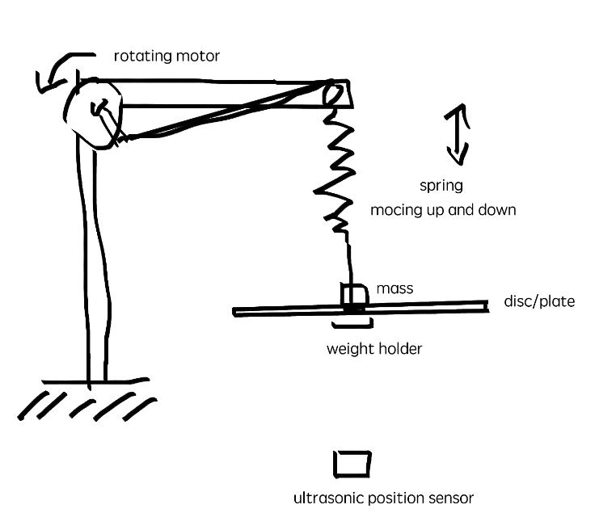
Result and Discussion
We first repeatedly measured oscillations with no external driving force, as Table 1 shows.
Table 1
Conditions/parameters | Measured angular frequency ω (rad/sec) | Natural frequency ω₀=$\sqrt{\frac{k}{m}}$ expected (rad/sec)
m_{A} and damping disc added | 5.946 | 5.915
mass m_{A} of 350 grams added | 7.101 | 6.989
m_{A} and mass equivalent to damping disc (150 grams) added | 5.761 | 5.915

As Table 1 shows, all experimental and actual outcomes are close. It’s observable that the average angular frequency for equivalent mass added to m_{A} is greater than the trial with actual damping disc, indicating the impact of other factors such as air resistance.
Measurements with external force were then taken. With disc and m_{A} installed, 5 different voltages of motor were applied driving the spring. Figure 2 shows amplitude vs. angular frequency for the 5 conditions; Figure 3 shows v_{max}, the velocities at extrema, vs. angular frequency in logarithmic view; Figure 4 shows phase shift vs. angular frequency. Each is taken with 30 samples per second for a 20 second interval after the damper becomes stable.

Figure 2
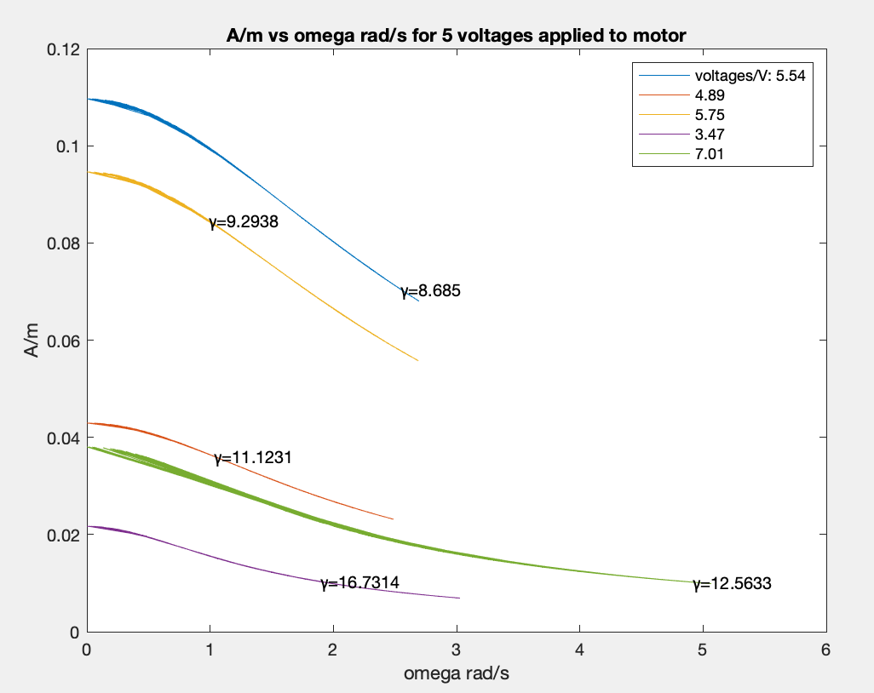
Figure 3
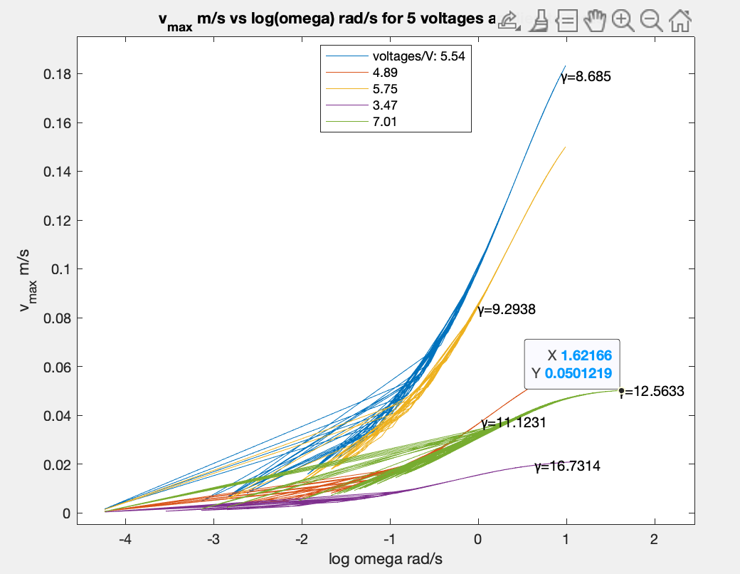

Figure 4
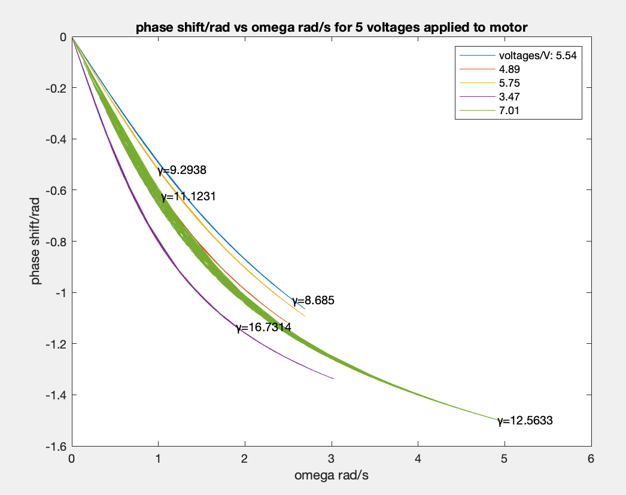
Since k was taken from last lab’s result, using experimental outcome for this week may be more accurate, so ω₀ is taken from the last part’s result, shown in Table 1, given as 5.761 rad/s. Computing damping rate by γ=R/2m, and R is obtained by equation 1:

ma = F₀sin(ωt) -kx - Rv  => R = -(ma-F₀sin(ωt)+kx)/v | (1)

Where a is essentially $\frac{d^{2}x}{dt^{2}}$, and v is $\frac{dx}{dt}$. All the computed γ are close οr over 2ω₀. From our experimental results, ω are all smaller than expected ω₀. The only graph showing v_{max} vs. ω with a barely turning point is the green line, where γ=12.563, is nearby 5.062 rad/s, which is the closest and reasonably close to expected ω₀. Notice that lines with greater γ are going lower with ω becoming greater, though they start from approximately the same places. It is consistent with what is expected, as greater γ indicates quicker energy loss and thus smaller amplitudes and velocities and more lagging response movements.
All of these indicate a heavy damping, , where energy is lost at a larger scale. Intuitively, considering the size of the disc and the spring, it’s reasonable for overdamping to occur. It’s also noticeable from Figure 4 that obtained phase shifts are all negative, indicating a consistently lagging response movements to driving force, which was observable during the experiment––it seems like the oscillator always moves a little slower than the motor’s up-and-down pulling. Considering it’s a heavily damped system, the damping resists motion, the phase shift graph is also explainable.
From Figure 5, by taking place where v=0.7*peak(v_{max}), we are able to determine where 2Δω, difference between peaks of v from positive to negative side. Quality Factor is then given by $\frac{ω_{0}}{2Δω}$, giving an error of:

ΔQ=$\sqrt{(\frac{∂Q}{∂ω_{0}}{Δω_{0})}^{2}+(\frac{∂Q}{∂(2Δω)}{Δ(2Δω))}^{2}}$  =$\sqrt{(\frac{1}{2Δω}{Δω_{0})}^{2}+(\frac{ω_{0}}{(2Δω)^{2}}{Δ(2Δω))}^{2}}$ | (2)
Figure 5
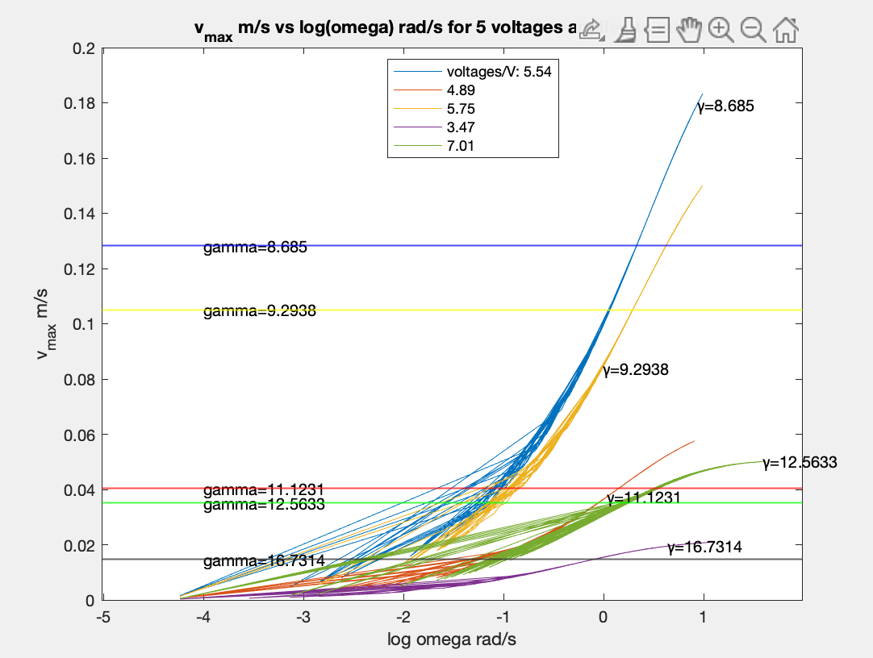
Table 2 shows computed quantities, and Table 3 shows errors for computed quantities. Where error of R is derived from equation 1 and error propagation:

ΔR=  $\sqrt{(\frac{∂R}{∂F_{0}}{ΔF_{0})}^{2}+(\frac{∂R}{∂ω}{Δω)}^{2}+(\frac{∂R}{∂a}{Δa)}^{2}+(\frac{∂R}{∂k}{Δk)}^{2}+(\frac{∂R}{∂x}{Δx)}^{2}+(\frac{∂R}{∂v}{Δv)}^{2}}$  Where $\frac{∂R}{∂F_{0}}$ = $\frac{sin(ωt)}{v}$  $\frac{∂R}{∂ω}$= $\frac{F_{0}t⋅cos(ωt)}{v}$  $\frac{∂R}{∂a}$ = $\frac{m}{v}$  $\frac{∂R}{∂k}$ = $\frac{x}{v}$  $\frac{∂R}{∂v}$ = $\frac{ma-F_{0}sin(ωt)+kx}{v^{2}}$ | (3)

And error of γ is derived from ΔR/2m, Q is obtained by ω₀/2γ.
Table 2
Voltages (V) /quantities | 5.54 | 4.89 | 5.75 | 3.47 | 7.01
Q | 19.803 | 14.145 | 1.547 | 4.605 | 3.094
2Δω (rad/s) | 0.145 | 0.204 | 1.862 | 0.625 | 0.931
γ (s⁻¹) | 8.685 | 11.123 | 9.294 | 16.731 | 12.563
R (N⋅s/m) | 7.817 | 10.011 | 8.364 | 15.058 | 11.307

Table 3
Voltages (V) /error of quantities | 5.54 | 4.89 | 5.75 | 3.47 | 7.01
ω₀=std(ω) | 0.746 | 0.706 | 0.755 | 0.806 | 1.475
2Δω | 1.056 | 0.999 | 1.068 | 1.140 | 2.086
γ | 8.610 | 113.065 | 2.681 | 24.392 | 103.670
R | 7.749 | 101.758 | 2.413 | 21.952 | 93.303
Q | 2.416 | 1.633 | 0.199 | 0.607 | 0.746
Noticeably, γ and R have a large variance, which is made by the term $(\frac{∂R}{∂v}{Δv)}^{2}$. From Figure 5, it’s observable that velocities measured do vary significantly. Considering in this term, velocity is a quadratic term, it would be explainable for why γ and R have errors varying in such a wide range.
With obtained experimental ω₀, v_{max} and φ are computed and dotted in Figure 6 and 7 in addition to Figure 3 and 4. It’s observable that such graphs are overall close, which is explainable by theoretical ω₀ being close to actually obtained one.
Figure 6:v_{max} vs log(ω)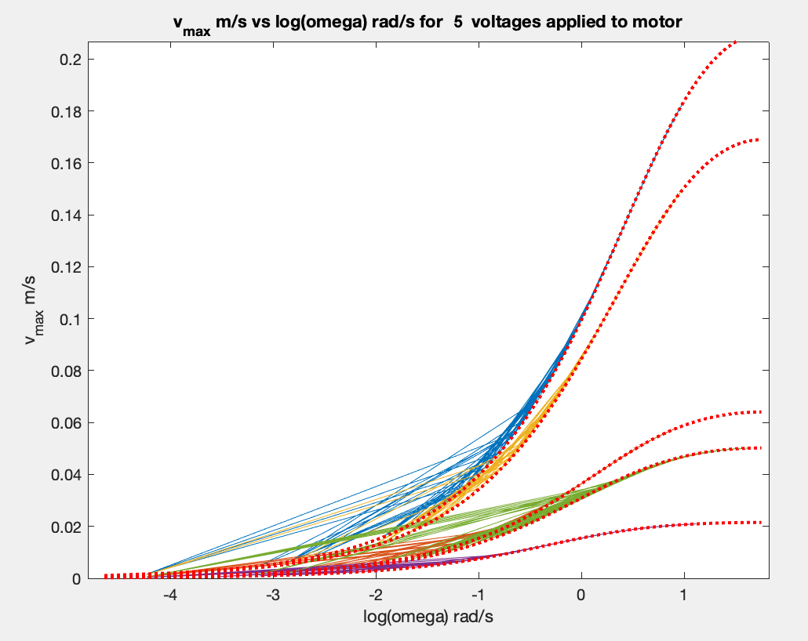Figure 7: φ vs log(ω)
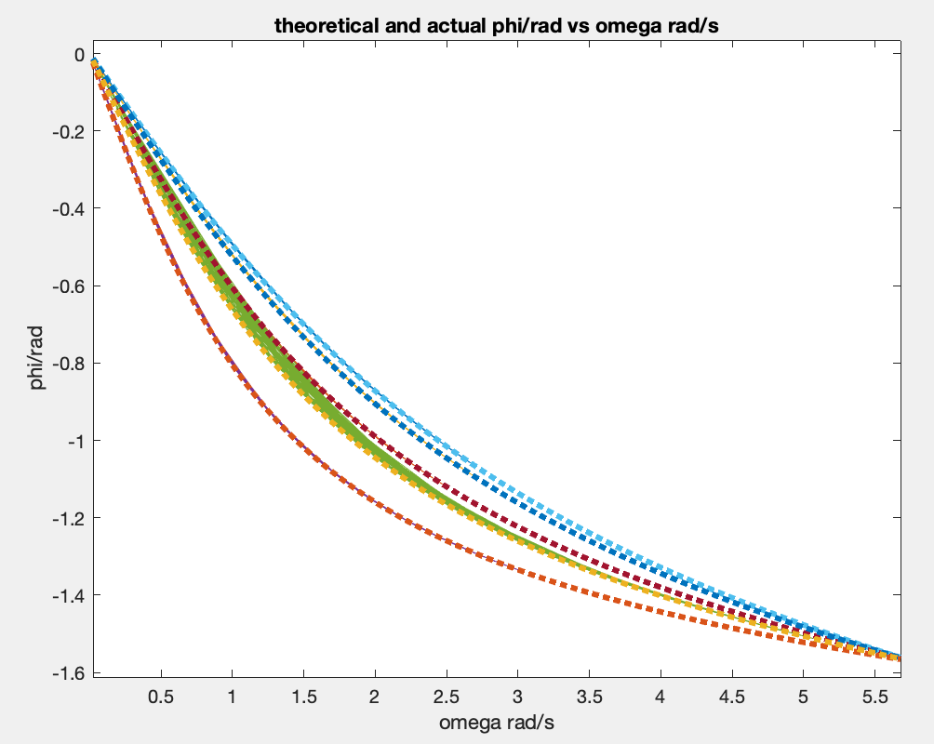
From previous calculations, γ and ω₀ are close enough to experimental results. To better estimate such quantities, it would still give a more idealistic result to measure natural frequency rather than purely theoretical computing for avoiding possible unexpected errors. Some of the plotted lines are having a larger width at some parts. It would therefore be better to simplify dots to a line to the graph first to compute results.
The larger damping disc was replaced with a small paper plate, weighing 10.40 grams. Repeating previous steps, oscillation without external force was recorded. Table 4 shows computed and experimental angular frequency.
Table 4
Conditions/parameters | Measured angular frequency ω (rad/sec) | Natural frequency ω₀=$\sqrt{\frac{k}{m}}$ expected (rad/sec)
mass m_{A} of 500 grams added | 5.860 | 5.680
m_{A} and plate added | 5.915 | 5.712
m_{A} and mass (10 grams) approximately equivalent to plate (10.40 grams) added | 5.616 | 5.858

Compared to experimental outcomes with the large disc, all outcomes and expected values are almost samely close. That is, the plate, which is much smaller and lighter, doesn’t have as much impact in motion as the damping disc.
With motors exerting 11 different forces, Figure 8 shows graphs of amplitude vs. angular frequency, Figure 9 shows v_{max} vs. angular frequency in logarithmic view, and Figure 10 zooms in unclear areas of Figure 9. Figure 11 shows phase shift vs. angular frequency.
Figure 8
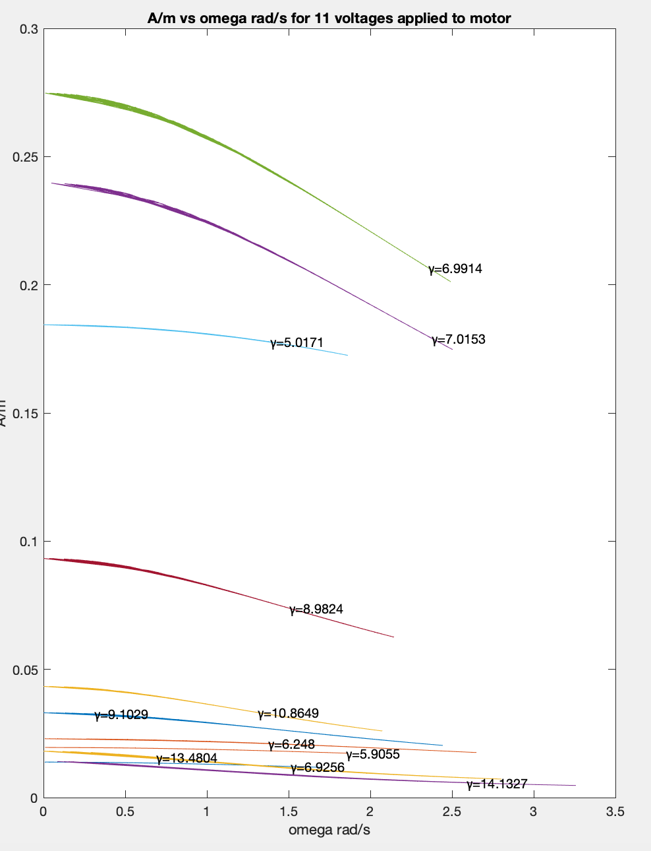

Figure 9
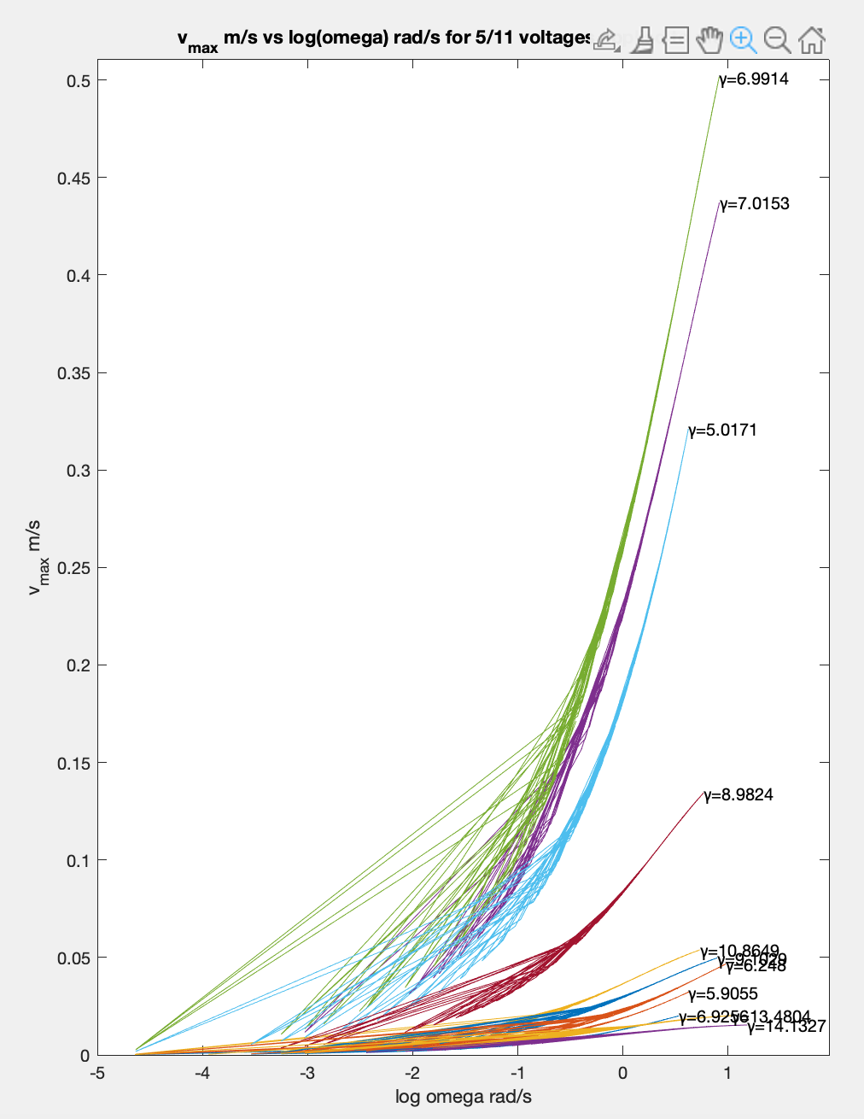

Figure 10
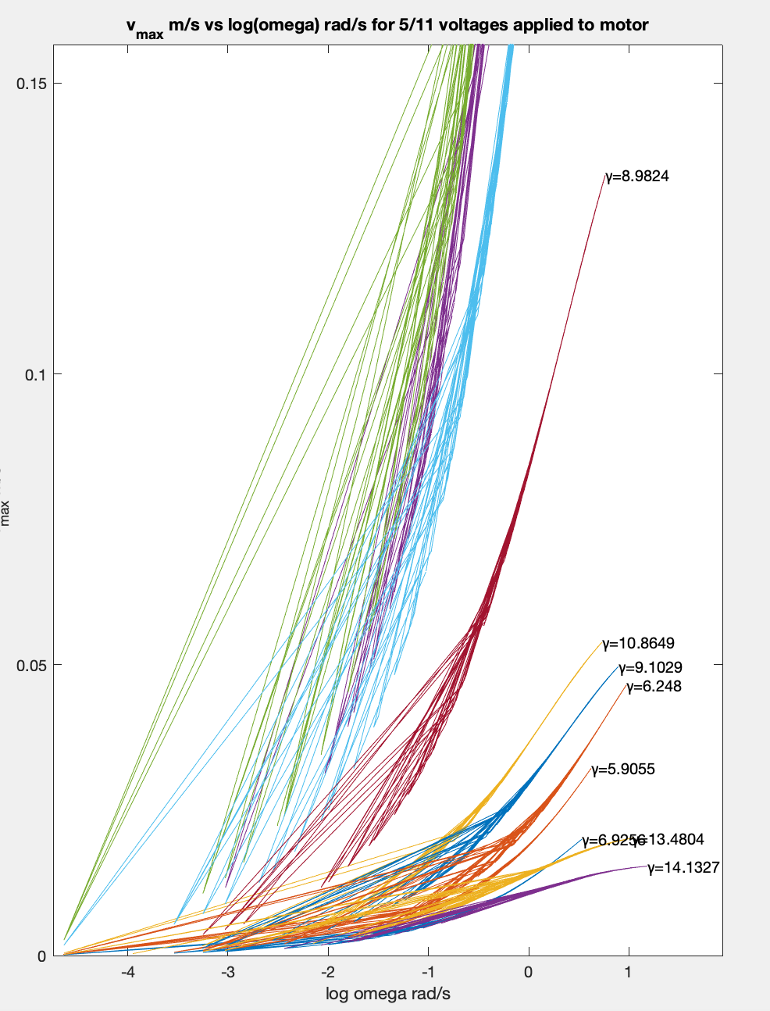
Figure 11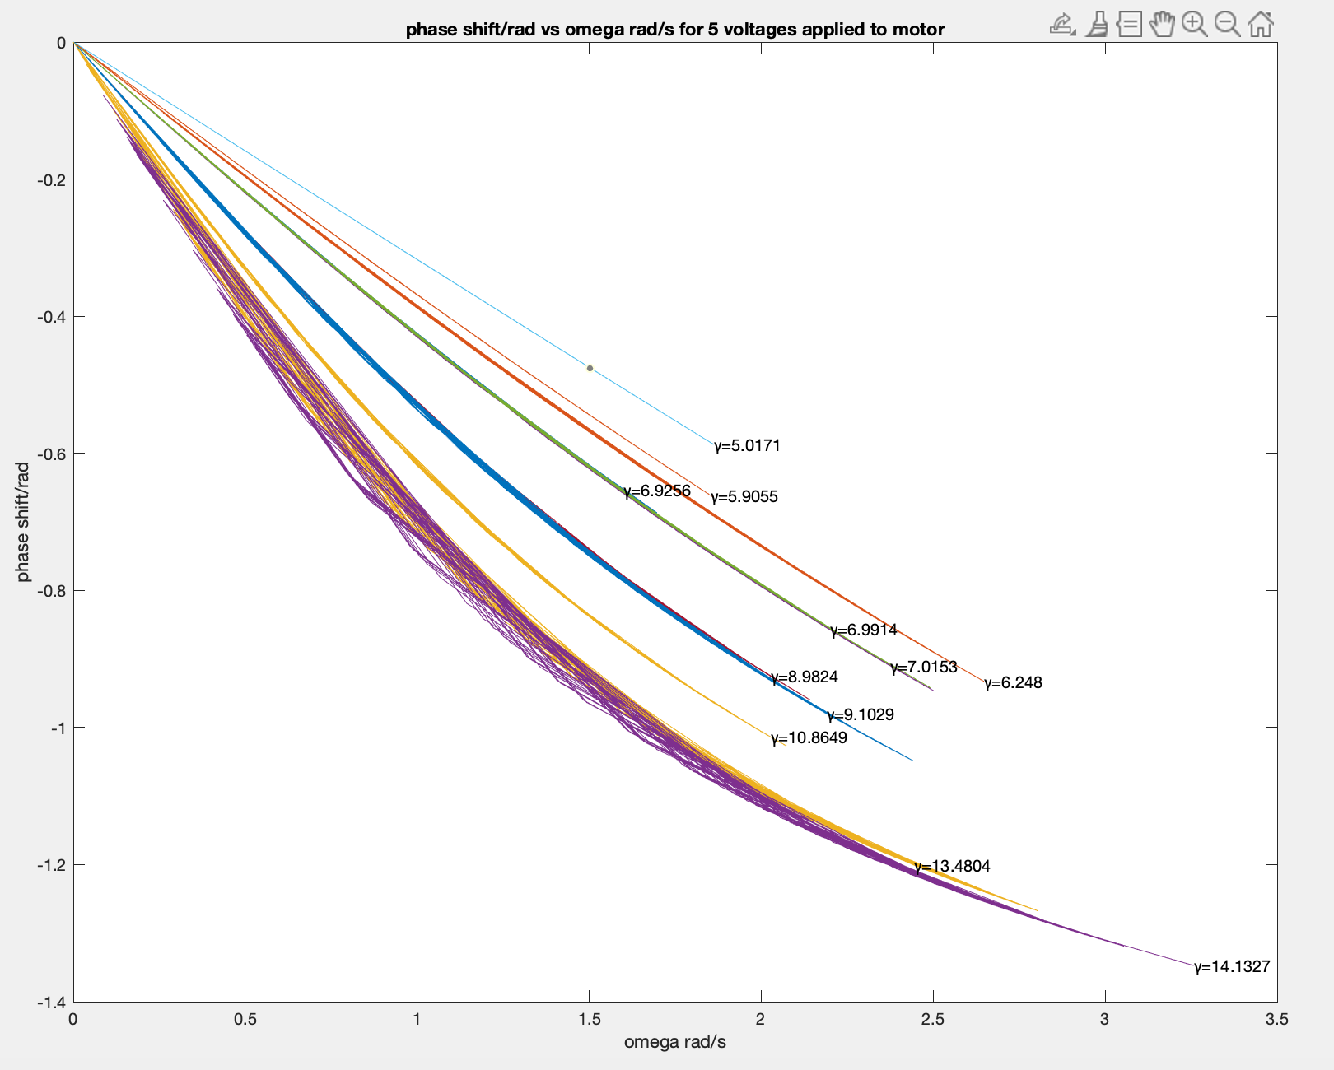
Overall, the graphs seem to be consistent with the graphs of disc’s movements. Unfortunately, at this time, obtained ω are all smaller than expected ω₀. The graphs seem to prove this, as none of them show a turning point. γ from these trials vary from ω₀ to 2ω₀, which includes small damping cases. It fits the theory such that small damping gives a smaller lagging of phase shift and significantly higher amplitudes.
Table 5 shows computed quantities, and Table 6 shows errors for them.

Table 5
Voltages (V) /quantities | Q | 2Δω | γ | R
4.13 | 13.164 | .213 | 6.926 | 9.176
4.59 | 22.278 | .126 | 5.906 | 6.050
5.10 | 36.201 | .078 | 10.865 | 11.476
5.38 | 7.240 | .039 | 7.015 | 7.482
5.46 | 14.480 | .194 | 6.991 | 8.353
5.60 | 12.592 | .223 | 5.017 | 5.547
5.83 | 7.621 | .369 | 8.982 | 10.828
6.37 | 7.064 | .398 | 9.103 | 9.143
6.85 | 8.275 | .339 | 6.248 | 6.626
7.37 | 15.243 | .184 | 13.480 | 12.872
7.98 | 8.045 | .349 | 14.133 | 12.414

Table 6
error of quantities/Voltages (V) | ω₀=std(ω) | 2Δω | γ | R | Q
4.13 | .494 | .070 | 88.391 | 95.339 | 1.841
4.59 | .541 | .077 | 1.168 | 1.260 | 3.413
5.10 | .598 | .085 | 211.367 | 227.981 | 6.128
5.38 | .748 | .106 | 2.697 | 2.910 | 1.534
5.46 | .724 | .102 | 4.072 | 4.392 | 2.966
5.60 | .541 | .076 | .483 | .521 | 1.927
5.83 | .617 | .087 | 41.429 | 44.685 | 1.331
6.37 | .699 | .989 | 12.459 | 13.438 | 1.399
6.85 | .780 | .110 | 1.060 | 1.143 | 1.826
7.37 | .845 | .120 | 26.983 | 29.103 | 3.646
7.98 | .904 | .128 | 30.164 | 32.534 | 2.058

Overall, the result is consistent with the last part. R and gamma both have a large variance of range of error, made by the term $(\frac{∂R}{∂v}{Δv)}^{2}$. Figure 12 shows plots for theoretical and actual graphs for v_{max} vs. ω in logarithmic view, and Figure 13 shows the set for φ vs. ω. Theoretical values are in dotted lines.
Figure 12
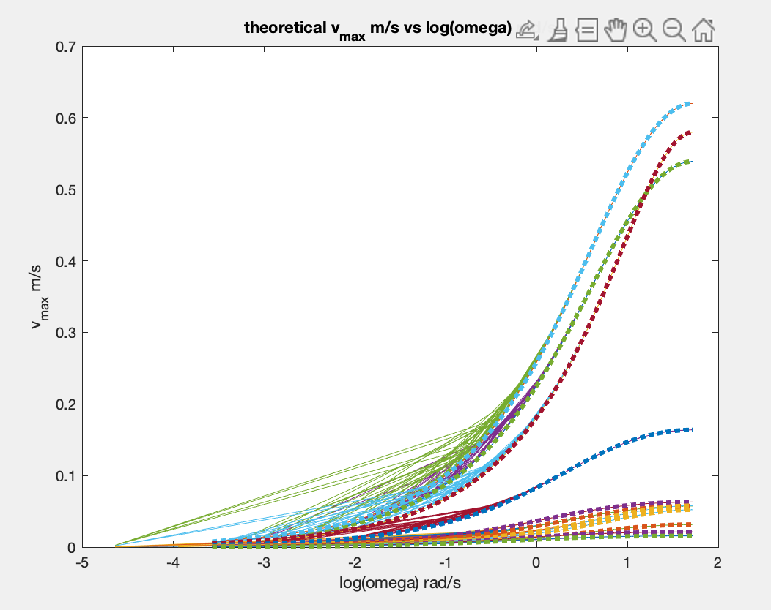
Figure 13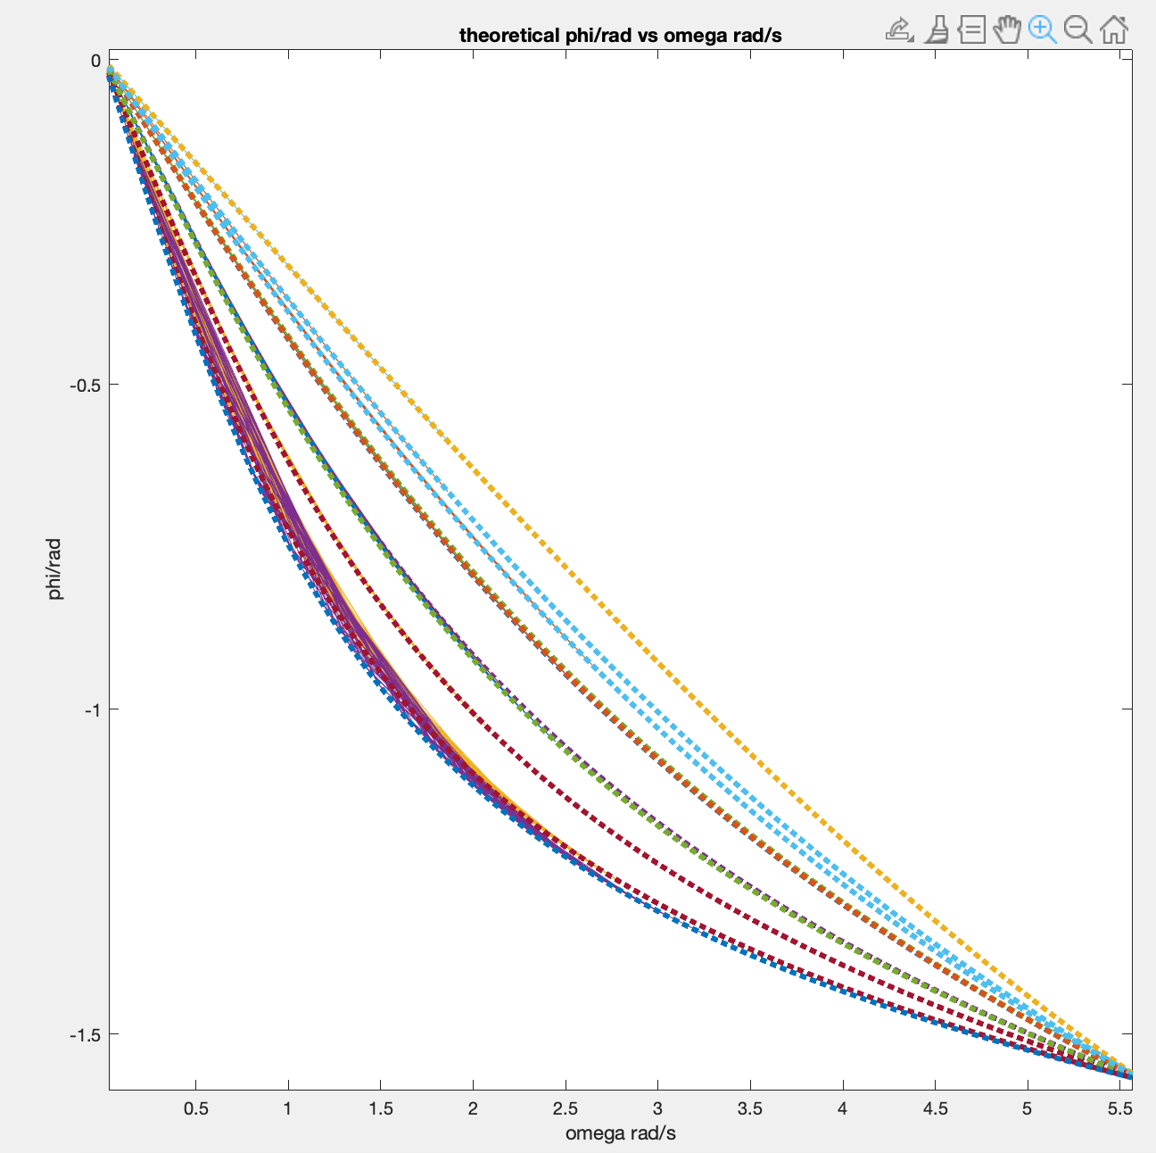
It can be seen that experimental outcomes are generally consistent with theoretical values, besides that none of the experimentally collected angular frequencies is close to expected ω₀. Ιt’s possibly because the data was gathered after the oscillator started oscillating relatively stably to ensure the consistency with data, which excluded higher angular frequencies at the beginning of oscillation.
The plate is then removed, and forced oscillations are recorded. This trial gives ω₀ as 5.648 rad/s, which is also close to the theoretical 5.680 rad/s. Figure 14 shows the graph of x vs. t for this case.
Figure 14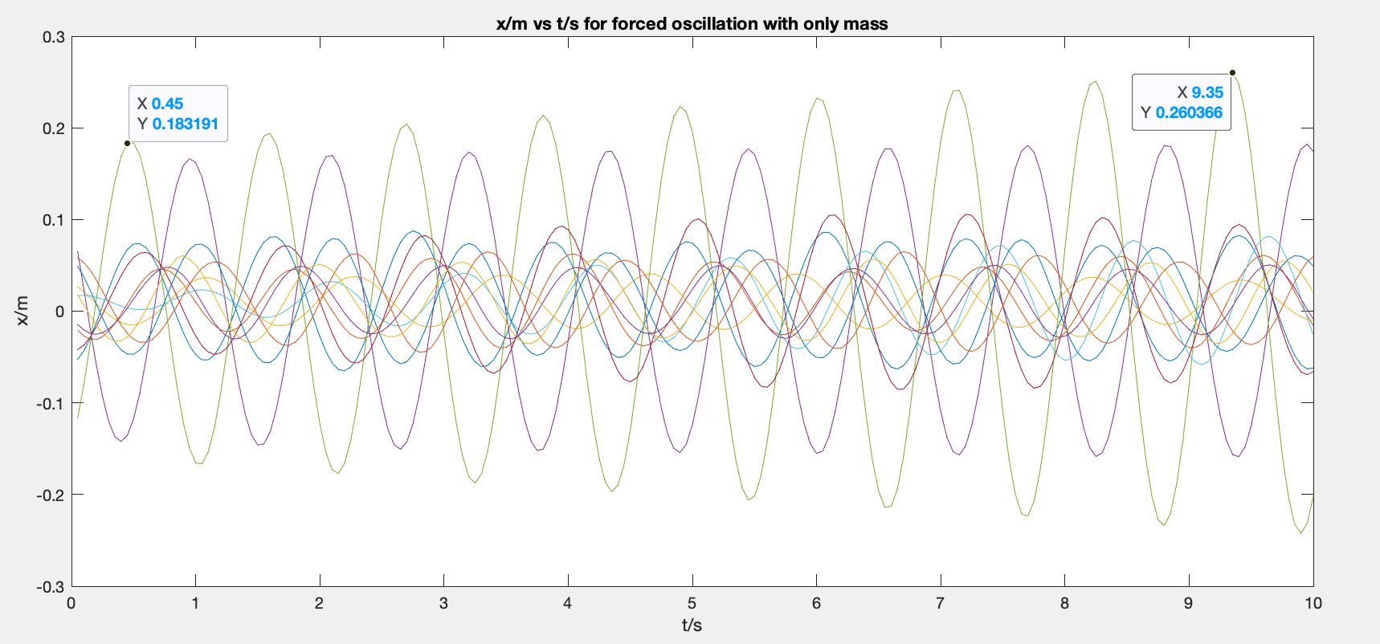

Overall, the motion seems to follow a sinusoidal form, besides that the amplitudes are gradually increasing. Since loss of energy is negligible and the motor is continuously inputting energy, the only way to consume such energy is to increase the amplitude.
Table 7 summarizes the quantities computed for the oscillator with disc and plate.

cases/quantities | disc | plate
m/kg | .500 | .614
F₀/N | .917 | 1.480
ω₀/ rad/s | 5.946 | 5.915
γ/s⁻¹ | 11.679 | 8.606

As suggested intuitively, the large disc gives more significant damping, which is suggested by γ—the larger γ is, the greater damping motion is.
To normalize data, ω is divided by , and normalized amplitude is given by:

ΔQ=$\sqrt{(\frac{∂Q}{∂ω_{0}}{Δω_{0})}^{2}+(\frac{∂Q}{∂(2Δω)}{Δ(2Δω))}^{2}}$
=$\sqrt{(\frac{1}{2Δω}{Δω_{0})}^{2}+(\frac{ω_{0}}{(2Δω)^{2}}{Δ(2Δω))}^{2}}$

Vmax is normalized by g(ω):

Figure 15, 16, and 17 shows f, φ, g with respect to normalize angular frequency for two setups respectively.
Figure 15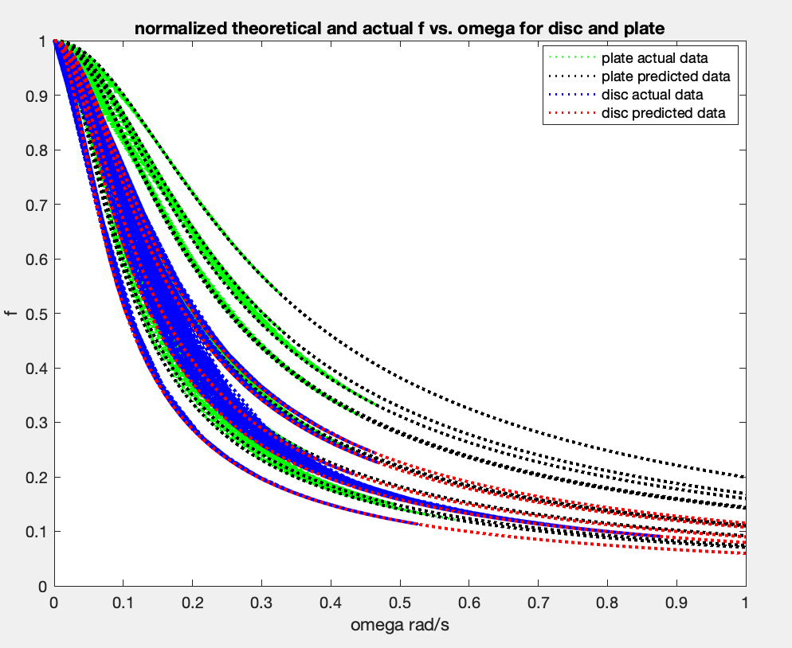
Figure 16
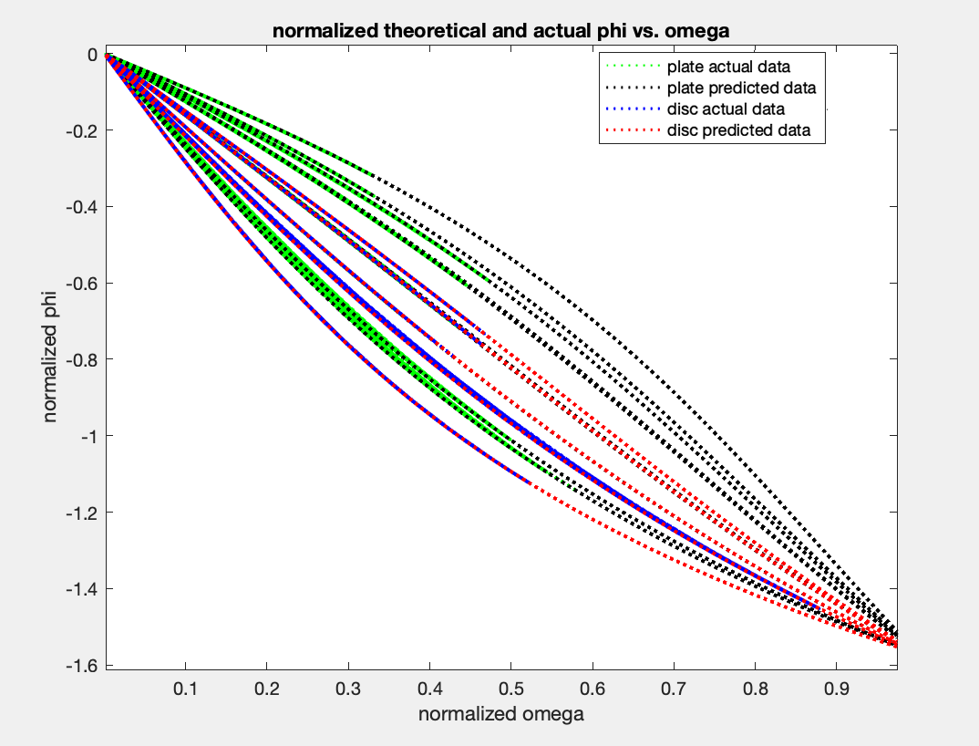
Figure 17
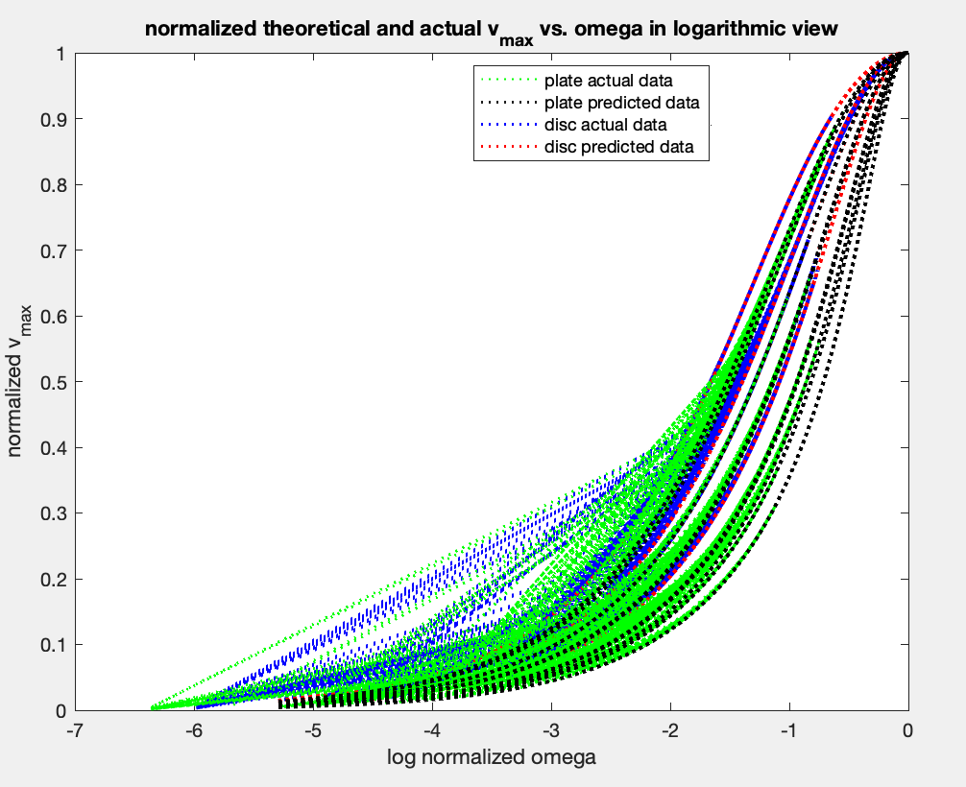
It can be seen that the graphs of the two setups generally follow similar patterns, suggesting the same setups of experiment and environment.

Conclusion
In this experiment, we learned how to analyze and visualize data using various mathematical tools such as normalizing and comparing them. To visualize data, normalizing it seems to be more clear and interpretable.
Outcomes are generally consistent with expected results, besides that all recorded angular frequencies are significantly smaller than natural frequencies for trials with paper plates. In future experiments, to obtain more idealistic results, designing a way to enable collecting oscillations from the beginning of motion would be more optimal.

