Karthik S
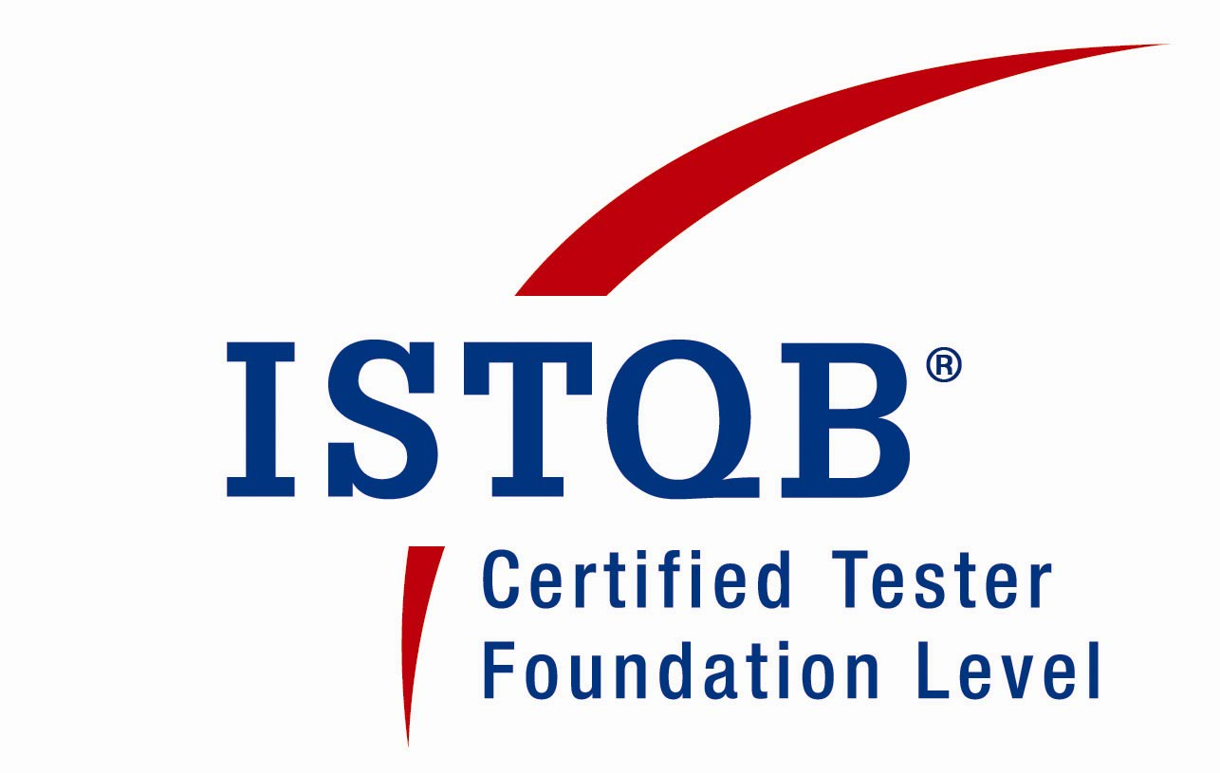

Mobile: 98450 21074
Email: corporatekarthik@gmail.com

Experience Summary

- Experience in Software Testing & Quality Assurance ,having worked on different testing technologies & processes ,Currently working as QA Analyst-3 at ORACLE India Ltd ,Bangalore
- Total Work Experience: 8 +years
- ISTQB and HP QTP Certified Testing Professional
- Core skills cover manual Testing and automated Testing.
- Experienced in QA agile testing with extensive knowledge of agile software testing and development lifecycle.
- Extensive involvement in test design with successful implementation of test design techniques in the release cycle to ensure coverage of Business Requirements as per the domain.
- Auditing artifacts of peers to check and train the junior members when necessary
- Being part of complete system testing End-to-end for every release or sprint, starting from the Functional Testing, Integration testing and regression testing phases.
- Planning the approach for the regression testing and system testing based on the impact analysis and Risk Analysis of the developed features.
- Test planning for system testing effort to ensure the requirements are tested with maximum coverage.
- Thorough Experience working with MTM, Enterprise Tester, Clear Quest tools for test artifact maintenance along with TFS & VSS for analyzing the requirements and design
- My Responsibilities include Quality Assurance and Functional & End-to-End System Testing. Experience in both manual & database testing of software applications, products and components. Deft in handling functionality testing, integration testing, system testing, regression testing as well as defect and test environment management, planning walkthroughs and reviews.
- Performing Internal Audits and reviews for various Quality parameters and metrics
- Develop and implement test plans with effective test estimation.
- An effective communicator with stake owners, team leading, analytical and problem-solving skills.
- Providing effective mentorship and product training on specific Modules for new members.
- Assist the business partners during UAT.
- Translate the Business Requirements of Subject Matter Experts and BAs into Software Solutions for easy understanding of testing Purpose
- Attend the regular client call and discuss the weekly status with the client.
- Requirements review and analysis.
- Have thorough experience on different software Development Life Cycle and Software Test Life Cycle implementations.
- Bug tracking till Closure and Management.
- Identifying Test Cases to be executed by using automation tools.
- Preparation of bug report and involving in Weekly review Conference calls with various stakeholders.
- Maintaining Test Documentation.
- Motivating Team Members for efficient performance.
- Review various reports prepared by the team members.
- Ensure content and structure of all Testing artifacts is documented and maintained.
- Having constant effort for new process initiations towards rendering a superior quality product
Career Objective

To Contribute to the business Goals of the organization and thereby have a defined path for career progression.
Qualification

- Bachelor of Engineering(BE) with First Class, in Electronics & Communication
- Certified Software Tester – ISTQB
- HP Certified Professional Certification on QTP 9.2 (M016)
- Member – ISTE
Awards Received in Testing Professional Career

- “Best Performer” award at Talisma Corporation for delivering Quality Release in spite of existing challenges
- “Star Performer” for the year 2010, and was part of the Talisma “Star Performers Club”
- “Shout-Out” appreciation by top management for stretched effort to make successful releases.

Technical Knowledge

Software Testing &
Test Management Tools : Enterprise Architect, Microsoft Test
Manager (MTM), Team Foundation Server(TFS),Enterprise
Architect (EA), Test Director, QTP 9.2, WinRunner

Testing & QA Skills : Manual testing, Automation QTP, Oracle Oratst Automation,Basic Knowledge of ISO
9001, CMM Levels/ Procedures
Database : SQL,Oracle 9/10i, Basic of Oracle, Microsoft Access, SQL
Server 2008
Operating Systems : Windows 2K/XP, LINUX,UNIX
Applications : Ms-Excel and PowerPoint
Programming Languages : C and MATLAB
Scripting : Perl, Python,VBScript
Software Packages : VHDL, Verilog HDL, Designer 2D

Work Experience

Working as QA Analyst-3 in ORACLE India Pvt. Ltd since June 2014

Worked as Senior Software QA Engineer Level-3 in Talisma Corporation Pvt. Ltd , Bangalore from Dec 2008 till June 2014.

Projects Profile

Oplan with Oracle Real Application Cluster ONE Node(RACOne)

Environment : Java, VB,Weblogic 9.0
DataBase : Oracle 12.1
Role : Test Lead
Testing Methodology & Tools : Manual ,Database and automation using Perl OraTst , MTM,
Team Size : 4
Oracle Oplan is a commandline utility that facilitates enterprise Customers with the application of bundle patches on RAC compute nodes via Opatch. This utility helps with the patch process by generating step-by-step instructions guiding customers in applying a bundle patch for the specific RAC environment. Oplan provides several options to apply Patch. For each 'strategy' Oplan lists the advantages and disadvantages.

Responsibilities:
- Gathering and maintaining regular Test Metrics of the team.
- Involved in the Test Planning phase
- Automation of regression cases
- Analyzing and preparing the estimates for the work requests
- Review of functional requirements
- Participate in the formal reviews of applications designs, business, functional requirements and test cases
- Identify test scenarios/conditions for requirement under test
- Preparation of test data preparation in the testing environment for all scenarios.
- Executing the test cases and log the defect.

Secondary Review of Student Exceptions
Title : Secondary Review of Student Documents
Environment : .Net, VB,Weblogic 9.0
DataBase : SQL Server 2008
Role : Senior Test Analyst
Testing Methodology & Tools : Manual and QTP automation Testing, MTM, SQL Server
Team Size : 4
Secondary Review is a fully integrated, full featured, multi-user, real time Verification of Business Exceptions by a Domain Expert in case of missing Documents. The system owner will be having permissions to assign Secondary Reviewer for individual exceptions generated for specific missing documents. The secondary reviewer can take a need based call based on the priority of the exception generated from missing document, thus maintaining a smooth Registration of the Student for a Program.
Responsibilities:
- Provide guidance and training to the team members on the Business Module
- Auditing artifacts of peers to drive for the guidance adherence
- Reviewing Test documents of team members for the test techniques included for maximum coverage.
- Planning and Identifying Test Cases for Automation Regression Test Suite.
- Automating Test cases for Automation VB scripts for regression.
- Test planning for system testing effort to ensure the requirements are tested with maximum coverage.
- Design Automation Framework and Automation Scripts for Regression Test Suite
- Manual and automation Test case execution and analysis of results.
- Database Testing and GUI Testing of various screens.
- Design of Build verification Test cases.
- Reporting defects.
- Assist the business partners during UAT
- Performed System Testing.
- Managing the exits document for the release

Validations for PELL Formula Amounts as per Federal Education Department Regulations
Title : PELL Grant amount VALIdations
Environment : .Net, VB, Weblogic 9.0
DataBase : SQL Server 2008
Role : Test Analyst
Testing Methodology & Tools : Manual, Database, Enterprise Tester for Test Management
Team Size : 3
There are regulations from the Federal Education department for various awards a student could receive like PELL Grant,ACG Grant, TEACH grant and few Title4 Loans. These amounts are derived from various Formula depending on the Academic Calender of the Program like Standard Term of Quarters, Clock Hour Programs ,Credit Hour Programs etc. The Cost of Attendence(COA), Estimated Family Contribution(EFC), Enrollment Status are few inputs in determining the maximum Award amount.
Responsibilities:
- Review of functional requirements
- Extensive effort to gain mastery on the module and eventually acting as internal SME of the module for the assistance of team.
- Participate in the formal reviews of applications designs, business, functional requirements and test cases, and provide recommendations if needed.
- Maintain the requirements Traceability matrix to ensure coverage of requirements.
- Identify test scenarios/conditions for requirement under test
- Preparation of test data in the testing environment for all scenarios.
- Executing the test cases involving complex data and log the defect.
- To manage, track and defect test status
- Ensures test documentation and deliverables produced by junior team members are consistent with team/project standards
- Escalate the issues encountered to QA Manager timely manner
- Assist the business partners during UAT
- Provide the consolidated status to Test Lead

Eligibility Exception Override
Role : Senior Analyst in Function & System Testing and
Reporting
Environment : .Net, VB,Weblogic 9.0
DataBase : SQL Server 2008
Testing Methodology, Testing Tools: QTP Automation, Enterprise Architect
Team Size : 2 members
Domain : Finance
Project Abstract: This business Critical Module enables scheduled disbursements that the school will want to release for payment even though the disbursement fails the eligibility evaluation based on the current state of data in CampusVue. These scenarios arise when the school knows that conditions causing the eligibility to fail will be mitigated at some point in the future. When this occurs, the school does not want to hold up the processing of the disbursement. In order to address this, the ability to override an individual disbursement eligibility exception will be provided. When the override is performed by an authorized user, the disbursement will be selected/processed in the same way as any disbursement that has passed the applicable eligibility evaluation
Responsibilities:
- Requirements Analysis
- Involved in the preparation of Test plan.
- End-to-End System Testing on different environments to ascertain business Logic
- Performed Functional testing and regression testing.
- Reported Defects and coordinated with the development team till the resolution.
- Creating user defined function.
- Involved in peer review of artifacts and need based training sessions on processes
- Involved in Browser compatibility testing.

Print Checks to Pay Students
Title : Print Checks
Role : Agile Test Analyst
Environment : .NET, ASP, Weblogic 9.0
DataBase : SQL Server2008
Team Size : 2
Business Domain : Finance/Federal Higher Education
Project Abstract: Students have to be paid under various circumstances against Loan Approval, Grade change to next Level, Financial Aid in the form of Grants etc. An authorized user should be able to process the Checks for approval and printing the same, so that the student is not effected. The assigned user should also be able to get a process notification to analyze the total number of passed processes, once the automated Refund Process is run.
Responsibilities:
- Functional testing as per the risk Analysis of the module in point of business.
- Actively Participate in the formal reviews of applications designs, business, functional requirements and test cases
- Preparing Test Documentation according to the Test Objectives.
- Interaction with Business Analyst to suggest further changes to SRS, which were eventually implemented as scope changes for the future release.
- Integration testing to check the functionality of Business Logic flow from other modules.
- Analyzing and preparing the estimates for the work requests
- Preparation of project Plan for each releases
- Organizing the defect management for each release
- Review of functional requirements
- Identify test scenarios/conditions for requirement under test

Professional Certifications in Software Testing

  - ISTQB Certification in Software Testing.
  - Professional Certification on QTP 9.2 from HP(M016)
  - Member-ISTE Certification in software Testing.

Personal Profile

Contact Address : B-003, Manjunatha Homes,
4th ‘A’ Cross,Abbaiah reddy Layout
Kaggadasapura
Bangalore -560 093.

