# 17th October, 2025

There was this error with installing all packages from requirements.txt

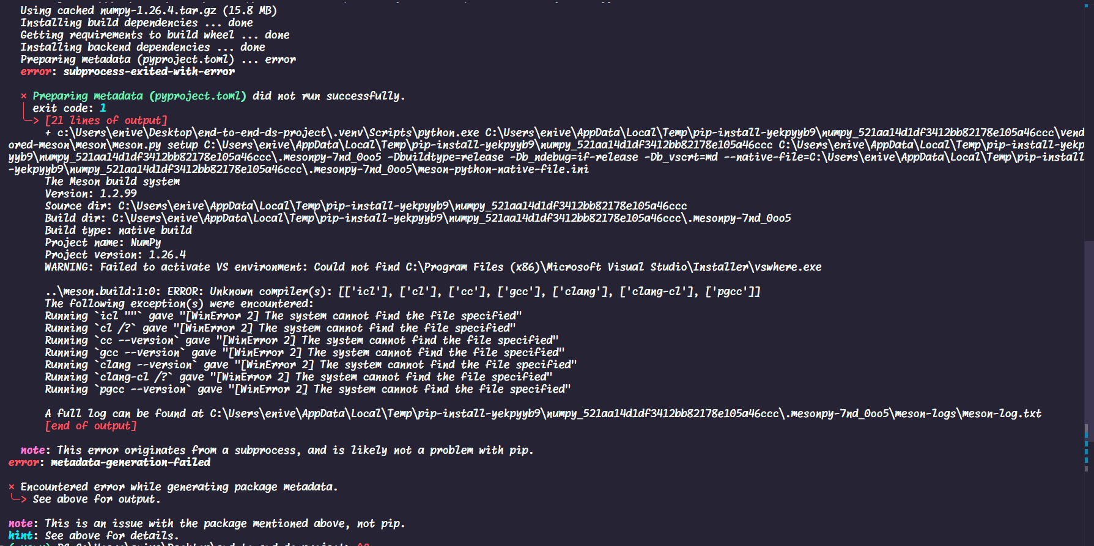

This error led to ds_project module not being imported to main.py

* The reason being python version was 3.13 which does not have support for some of the libraries such as mlflow.