The PAULA Standoff Format, Version 1.0 (May 21st, 2008)

Inhaltsverzeichnis

The PAULA Standoff Format, Version 1.0 (May 21st, 2008) 1
1. Introduction 2
2. An abstract annotation model and its PAULA realization: Overview 2
2.1 Physical realization 2
2.2 Annotation Project Example 3
2.3 Main elements of PAULA 5
3. Format Documentation: Details 7
3.1 General format of all files 7
3.2 Primary Data 7
3.3 Tokenization 8
3.4 Structural Annotation 8
3.4.1 Segment Annotation: <mark> files 8
Discontinuous Markables 9
Virtual Markables 9
Embedding vs. hierarchical relationships 10
3.4.2 Structure Annotation: <struct> files 10
Types of <rel> elements 11
3.4.3 Pointer Relations 11
3.5 Feature Annotation: <feat> files 11
Feature Annotations and sequences of markables 14
3.6 Metadata 14
3.7 Tagset 14
3.8 Corpus Structure 16
3.8.1 Annotation projects: <AnnoSet> files 16
Grouping 16
annoFeat file 17
Namespaces 17
3.8.2 Corpus Directory 17
4. Requirements for a well-formed PAULA corpus 17
4.1 Completeness of a PAULA annotation project 17
4.2 Validation and DTDs 18
4.3 Naming Conventions 18
5. Frequently Asked Questions 19
Encoding of pointing relations 19
Encoding of Coreference 19
Typed Dominance Relations: Edges, Secondary Edges and more ... 20
MultiFeat and MultiFeatList 20
Grouping 20
Timing information 20
References 20
APPENDIX 21
A1 Annotations of sequences of markables: Alternatives 21

1. Introduction
The PAULA Standoff Format is an XML-linearization of the PAULA object model.

This documentation covers the PAULA Standoff Format Version 1.0 (November 2007). This version is supported by the PAULA scripts, ANNIS 0.11, and the transformation scripts to the ODAG model of DDD (Faulstich et al. 2005).

The documentation is structured as follows: In section 2., we present basic notions of the annotation model and its physical realization, an example annotation project and introduce the main elements of PAULA. Section 3 describes the PAULA format in detail. In section 4., we list the constraints for a well-formed PAULA annotation project and name conventions. Finally we discuss frequently asked questions (section 5).

NOTE: This is an internal paper and not intended for publication. It describes the current state of the PAULA Standoff Format (November 2007) and is intended for PAULA users and developers of PAULA-related scripts and tools.

2. An abstract annotation model and its PAULA realization: Overview
In the PAULA corpora and data collections, we distinguish the following notions:

- Primary data, i.e. the text or transcription of speech.
- Tokenization of the primary data, i.e. words or syllables, etc.
- Segmentation of the primary data text into markables, e.g. for referring expressions, sentences or discourse units.
- Structural Annotation, e.g. graph structures or trees.
- Pointing Relations, e.g. for anaphora annotation.
- Feature Annotation of tokens, segments or structural elements, such as part of speech, grammatical function, etc.
- Metadata annotation, e.g. corpus creator, language, corpus size, etc.
- Tagset, specifying the admissible tags of the applied annotation scheme.
- Annotation project, specifiying the files that belong together.
- A corpus is a set of annotation projects.

These notions can broadly be categorized into (i) primary data (1.), (ii) tokenization (2.), (iii) structural annotation (3.-5.), (iv) feature annotation (6.), (v) metadata annotation, (vi) tagset, and (vii) corpus structure information.

2.1 Physical realization
Figure 1 illustrates the physical realization of a PAULA corpus. Such a corpus consists of a set of Annotation Projects that are collected in one Corpus Directory. Each Annotation Project relates the files of one primary datum, i.e. the primary data (e.g. a text) together with all its annotations, metadata, etc. In PAULA 1.0, there is no recommendation for the encoding of a corpus structure above the level of Annotation Projects. So, encoding a more complex corpus structure with subcorpora is not part of the PAULA 1.0 specification.

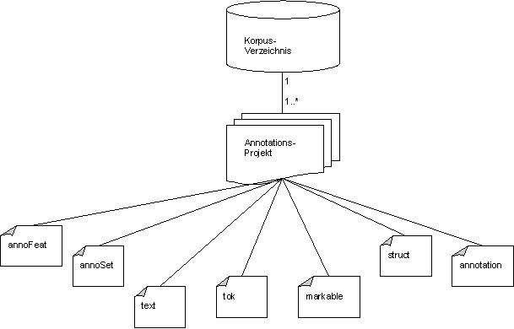
Figure 1: PAULA: Physical Structure in the file system
Within one annotation project, different information is represented according to its data type. The relations between annotation concepts and their file realization are listed in Table 1; the file types and main elements of PAULA will be described in more detail in Section 2.3 and Section 3.

Conceptual level |  | File realization
 | Annotation conept | File Type | DTD
Primary Data | Primary Data | <text> | paula_text.dtd
Tokenization | Tokenization | <tok> | paula_mark.dtd
Structural Annotation | Segmentation | <mark> | paula_mark.dtd
Structural Annotation | Structural Annotation | <struct> | paula_struct.dtd
Structural Annotation | Pointer Relation | <feat> | paula_feat.dtd
Feature Annotation | Feature Annotation | <feat> | paula_feat.dtd
Metadata | Metadata | <feat> | paula_feat.dtd
Tagset | Tagsets | <feat> | paula_feat.dtd
Corpus Structure | Annotation Project | <AnnoSet> | paula_struct.dtd
Corpus Structure | Corpus | Directory
Table 1: File realization of the PAULA annotation concepts

2.2 Annotation Project Example
The following is a short listing of the files belonging to a simple annotation project “rabin1”; the respective file type is given in brackets:

  - rabin1.text.xml (<text>)
  - rabin1.tok.xml (<tok>)
  - rabin1.primmarkSeg.xml (<mark>)
  - rabin1.const.xml (<struct>)
  - rabin1.primmarkSeg_np_form.xml (<feat>)
  - rabin1.pos.xml (<feat>)
  - rabin1.anno.xml (<AnnoSet>)
We distinguish a file with the primary data (rabin1.text.xml), a file with the tokenization (rabin1.tok.xml), a file with segments or markables (rabin1.primmarkseg.xml). Fig. 1 illustrates how elements from one file refer to information in other files.

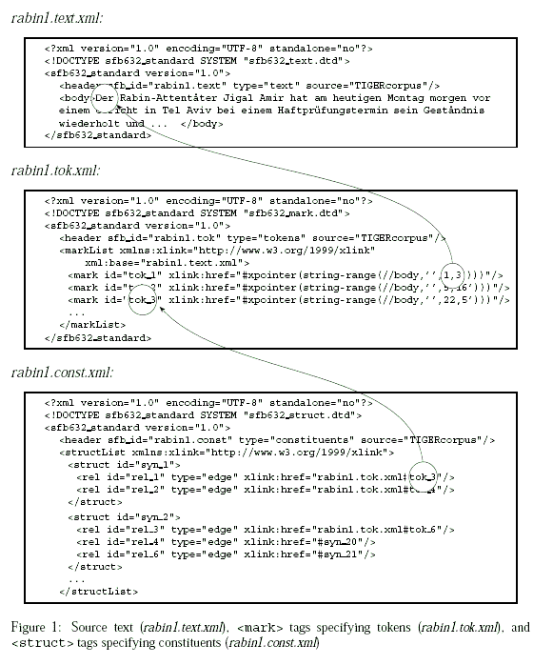
Figure 2: Illustration of the relations between different PAULA files from Dipper (2005)

2.3 Main elements of PAULA
In this section, we sketch the main XML elements of PAULA. Our format involves 4 generic XML elements:

- <mark> (markable),
- <struct> (structure),
- <rel> (relation), and
- <feat> (feature).

These indicate which data type the annotation conforms to. The annotations are stored in separate files and may refer to the source text or to other annotations. The relations are encoded by means of XLinks and XPointers.

- Markables: <mark> tags specify text positions or spans of text (or spans of other markables) that can be annotated by linguistic information. For instance, <mark> tags might indicate discourse segments by specifying ranges of the involved sentences.
Tokens are a special case of <mark> elements.

- Structures: <struct> tags are designed for the representation of hierarchical structures such as trees. Similar to <mark> tags, they specify objects that then can serve as anchors for annotations. Whereas <mark> tags define simple types of anchors (flat spans of text or markables), a <struct> tag represents a complex anchor involving relations between arbitrarily many markables (including <struct> elements).

- Relations: <rel> define child nodes of structures which can be further specified by an attribute type , e.g. as undirected or directed.
Within a <struct>, <rel> elements define dominance relations between parent nodes and child nodes. Put differently, a <structList> specifies a complete tree or a directed acyclic graph (DAG), which consists of single tree fragments specified by the <struct> tags, cf. figure 5.

- Features: <feat> tags specify information annotated to markables or structures, which are referred to by xlinkk attributes. The type of information (e.g., “part of speech”) is encoded by an attribute type , cf. fig. 2. For instance, the information encoded by the first <feat> in fig. 2 can be paraphrased as follows: Take the token that is defined by the tag <mark> with the ID attribute id="tok 1" and assign the part of speech “ART” (article) to that token.

Fig. 3 shows the conceptual structure of the descibed main elements and the relations between them.

<...List> elements (i.e. <markList>, <structList>, <featList>) express the organization of the annotation elements: For a given Annotation Project, all annotation elements that pertain to one specific level of annotation are grouped together under one <...List> element in one file, i.e. one file for a particular type of markables, one for a particular type of structures, and one for a particular type of features. Relations are stored together with structures as they do not represent independent annotations. In the directory structure, one <...List> element corresponds to one file, cf. Fig. 4.

These files, together with the <text> file containing the primary data, are grouped together into an annotation project by means of an <AnnoSet> file (or the directory structure if no <AnnoSet> file is provided).

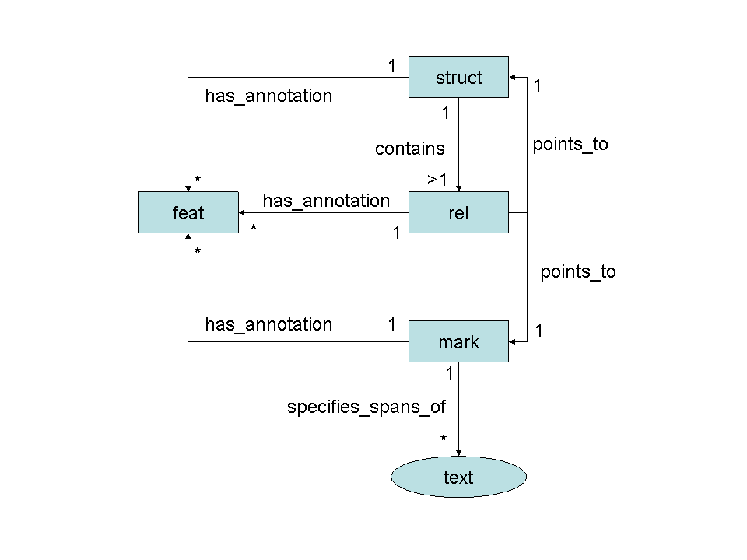
Figure 3: Paula 1.0 Conceptual Structure (Data Model)

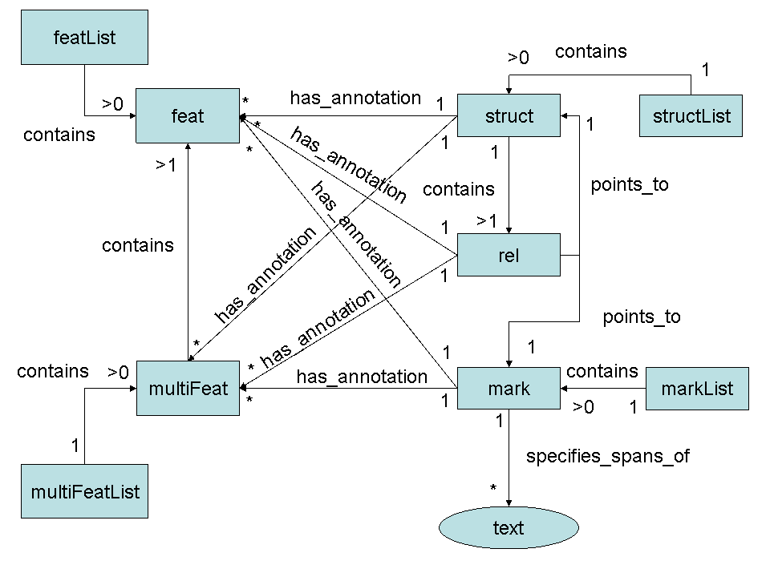
Figure 4: Paula 1.0 Conceptual Structure (Data Model) with <multiFeat> and <...List> elements

3. Format Documentation: Details
In the PAULA Standoff Format, we distinguish:

- AnnoSet files, specifying the files that belong together into one Annotation Project.
- Primary data, i.e. the text or a transcription of speech
- Annotations of the primary data, i.e. tokenization, part-of-speech-annotation or the annotation of syntax structure, and the Metadata.
- Tagsets, specifying the admissible tags of an annotation scheme.
- DTDs specifying the the format of the encoded data.

This information is encoded in separate files in the PAULA standoff format, with the AnnoSet file listing all files of the annotation project. The format of these files is documented in detail in the following sections.

3.1 General format of all files
All files contain a <header> element. The attribute paula_id is referenced by the <annoset> file. You are free to add any further attributes or content. However, these will be ignored by the inline-merging script or ANNIS.

<!ELEMENT paula (header,(body|markList|featList|structList))>
<!ATTLIST paula version (1.0) #REQUIRED
xmlns:xlink CDATA #IMPLIED>
<!ELEMENT header EMPTY>
<!ATTLIST header paula_id ID #REQUIRED
id CDATA #IMPLIED
type (text) #IMPLIED>
paula_header.dtd
Example:
<header paula_id="mmax.maz-10205_text" type="text"/>

The attribute type can be used to encode the type of the file or the annotated information. It can have any value.
[!] However, the following values are reserved for specific file types:
text, tok, annoSet, annoFeat, meta.

3.2 Primary Data
The primary data, i.e. the actual text or the transcription is contained in the tag <body> in files of type „text“.

<!ENTITY % paula_header SYSTEM "paula_header.dtd">
%paula_header;

<!ELEMENT body (#PCDATA)>
text.dtd

Example:

<header paula_id="mmax.maz-10205_text" type="text"/>
<body>Keine Autoritäten Unter den namhaften deutschen Schriftstellern, die von ...
...</body>

[!] The <header> must have the attribute type="text".
[!] The AnnoSet file must contain exactly one file of type text.

3.3 Tokenization
Token markables are somewhat privileged markables (cf. Section 3.4.1) in that they are obligatory within an Annotation Project. Token markables define the elementary structuring of the primary data. They refer to elementary textual units, usually words.

Example:

<markList type="tok" xml:base="mmax.maz-10205.text.xml">
<mark id="tok_1" xlink:href="#xpointer(string-range(//body,'',1,5))"/>
<mark id="tok_2" xlink:href="#xpointer(string-range(//body,'',7,11))"/>
...
</markList>

In this example, the first markable references the string within the <body> tag that starts at position 1, and is of length 5 characters. Following the XML specification, the pointers are interpreted with respect to the attribute xml:base (in the <markList> tag), which specifies a file name. That is, the above XPointer refers to the tag <body> in the file mmax.maz-10205.text.xml.
[!] The type attribute (in the <markList> tag) must have the value tok.

[!] The annotation set must contain exactly one markable file of type tok. (ANNIS assumes that token markables are the most basic unit that any other markable or feature annotation can refer to.)

3.4 Structural Annotation

3.4.1 Segment Annotation: <mark> files
Markable files mark the segments (units) that feature annotations can be attached to. The underlying data model is that of annotation graphs (Bird and Liberman 2001).

<!ENTITY % paula_header SYSTEM "paula_header.dtd">
%paula_header;
<!ELEMENT markList (mark*)>
<!ATTLIST markList xmlns:xlink CDATA #IMPLIED
xml:base CDATA #IMPLIED
type CDATA #REQUIRED>
<!ELEMENT mark EMPTY>
<!ATTLIST mark id ID #REQUIRED
xlink:href CDATA #REQUIRED
xmlns:xlink CDATA #IMPLIED
type (virtual) #IMPLIED>
mark.dtd
We distinguish token markables from other markables:

- Token markables define tokens and refer to textual units (single words or sequences of words). Cf. Section 3.3.
- Complex markables define segments by referring to other markables (e.g., token markables).

Each markable is represented by a <mark> tag, whose range/extension is specified by the attribute xlink:href, by means of XPointer expressions.
The type of the markable is indicated by the attribute type in the <markList> tag, e.g., type="tok" for tokens, type="seg" for segments. The naming of the type is arbitrary, except for token markables.

Example:

<markList type="discUnit" xml:base="tiger.ID_maz-10205.tok.xml">
<mark id="seg_1" xlink:href="#xpointer(id('tok_1')/range-to(id('tok_2')))"/>
<mark id="seg_2" xlink:href="#xpointer(id('tok_3')/range-to(id('tok_17')))"/>
...
</markList>

In this example, the markables are of type „discUnit“. The first markable references the range starting with the element with the ID tok_1 and ending with the element with the ID tok_2. The attribute xml:base in the <markList> tag specifies the file that the xlink:href pointers refer to. That is, the pointer refers to the elements with the IDs tok_1 and tok_2 in the file tiger.ID_maz-10205.tok.xml.

Discontinuous Markables
Discontinuous markables are encoded as follows:
<markList type="primmarkSeg" xml:base="tiger.ID_maz-10205.tok.xml">
...
<mark id="primmarkVirt_1" xlink:href="(primmarkSeg_22,primmarkSeg_34)"
type="virtual"/>
</markList>

In this example, the markable refers to two markables (primmarkSeg_22 and primmarkSeg_34) that don't constitute a continuous sequence in the primary data.

Virtual Markables
The attribute type=“virtual“ can be used for indicating that a markable does not correspond to a markable in the original source file of the annotation-tool format.
In the MMAX source data for instance, the corresponding feature annotation points to two markables, cf. the markable with id="markable_40" in maz-10205_primmark_level.xml: the feature annotation anaphor_antecedent points to two markables.
[!] In ANNIS, feature annotations must not refer to sequences of markables. That is, the xlink:href attributes of <feat> elements may only refer to exactly one ID/markable.

Embedding vs. hierarchical relationships
Note that with multiple layers of markables, some markables might seem to embed others, by virtue of the fact that 1) their start and end positions surround the start and end positions of the "embedded" markables, or 2) they refer to a certain type of markables (e.g. 'discourse segment markables' referring to or embedding 'sentence markables'). However, such configurations do not necessarily define a hierarchical structure in PAULA (this is done by <struct> elements, see Section 3.4.3).

3.4.2 Structure Annotation: <struct> files
<struct> files define structured units, in the form of ordered, directed, and acyclic graphs (ODAGs).

<!ENTITY % paula_header SYSTEM "paula_header.dtd">
%paula_header;

<!ELEMENT structList (struct*)>
<!ATTLIST structList xmlns:xlink CDATA #IMPLIED
xml:base CDATA #IMPLIED
type (const|annoSet|type_pos) #REQUIRED>
<!ELEMENT struct (rel*)>
<!ATTLIST struct id ID #REQUIRED>
<!ELEMENT rel EMPTY>
<!ATTLIST rel id ID #IMPLIED
xlink:href CDATA #REQUIRED
xmlns:xlink CDATA #IMPLIED
type (edge|secedge) #IMPLIED
>
paula_struct.dtd

Each <struct> element specifies a minimal subtree, i.e., a mother node and its children. The relations between a mother and its children are represented by <rel> elements, which point to <mark> or <struct> elements as their children.

- Example:

<structList xmlns:xlink="http://www.w3.org/1999/xlink" type="const">
<struct id="const_1">
<rel id="rel_1" type="edge"
xlink:href="tiger.ID_maz-10205.tok.xml#tok_1"/>
<rel id="rel_2" type="edge"
xlink:href="tiger.ID_maz-10205.tok.xml#tok_2"/>
</struct>
<struct id="const_2">
<rel id="rel_3" type="edge"
xlink:href="tiger.ID_maz-10205.tok.xml#tok_11"/><!-- Gerhard -->
<rel id="rel_4" type="edge"
xlink:href="tiger.ID_maz-10205.tok.xml#tok_12"/><!-- Schröder -->
</struct>
...
</structList>

In the example, the mother node is defined by the element <struct id="const_1">. The child nodes are specified by the xlink:href attributes of the embedded <rel> elements, which point to the IDs of the elements that represent the children: tok_1 and tok_2 (which are contained in the file tiger.ID_maz-10205.tok.xml). The minimal subtree can be sketched as follows:
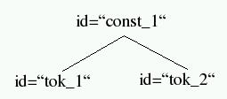
Figure 5: A minimal subtree.
<struct> structures are used to encode, e.g., syntax graphs or discourse trees. Note that the child nodes need not be adjacent!

Types of <rel> elements
You are free to add further attributes.. For instance, <rel> elements can be used with an attribute type to indicate the relation between mother and children; e.g., TIGER XML distinguishes (ordinary) edges from secondary edges (Mengel & Lezius 2000). This information can be encoded in the type attribute (and queried in ANNIS).

3.4.3 Pointer Relations

Pointing relations are non-hierarchical relations between markables or structs, e.g. for the purpose of alignment or coreference annotation. Pointing relations are to be encoded as <feat> elements in PAULA 1.0:

<feat xlink:href="#primmarkSeg_33" value="#primmarkSeg_23"/>

The start of the pointer is encoded as in the value of the attribute xlink:href, and the target of the pointer in the value of the attribute value. Cf. also the example “Coreference annotation” in Section 3.5.

[!] MMAX-Pointers may have multiple targets. PAULA can express this, but it is not yet supported in the current DDDQuery implementation and ANNIS.

[!] MMAX allows to annotate coreference with pointers and with sets. PAULA currently supports pointers only. Sets cacould be transformed into pointers, if wanted in the future.

3.5 Feature Annotation: <feat> files
<feat> files store the actual annotations, in the form of feature-value pairs that are attached to <mark>, <struct> or <rel> elements by means of xlink:href attributes, which refer to markable/structure IDs.
The type attribute in the <featList> tag must specify the name of the annotated feature, e.g. lemma, morph, pos; the value attributes (in the <feat> tags) encode the value of the feature.

<!ENTITY % paula_header SYSTEM "paula_header.dtd">
%paula_header;

<!ELEMENT featList (feat*)>
<!ATTLIST featList xmlns:xlink CDATA #IMPLIED
xml:base CDATA #IMPLIED
type CDATA #REQUIRED
>

<!-- alternatively: list specific features:
<!ATTLIST featList xmlns:xlink CDATA #IMPLIED
xml:base CDATA #IMPLIED
type (pos|lemma|morph|animacy|breaks|class|contrast|focus|given|const|cat|function|func) #REQUIRED
> -->

<!ELEMENT feat EMPTY>
<!ATTLIST feat id ID #IMPLIED
xlink:href CDATA #REQUIRED
xmlns:xlink CDATA #IMPLIED
target CDATA #IMPLIED
value CDATA #REQUIRED
description CDATA #IMPLIED
example CDATA #IMPLIED
>
paula_feat.dtd

Examples:

Morphological annotation: In this example, the token markable with ID tok_1 (contained in the file tiger.ID_maz-10205.tok.xml) is annotated with the tag Nom.Pl.Fem of type morph:

<featList type="morph" xml:base="tiger.ID_maz-10205.tok.xml">
<feat xlink:href="#tok_1" value="Nom.Pl.Fem"/><!-- Keine -->
<feat xlink:href="#tok_2" value="Nom.Pl.Fem"/><!-- Autoritäten -->
...
</featList>

Part-of-speech annotation: In this example, the same markables as above are annotated, this time with tags of type pos (part-of-speech tags). In our sample, the value attribute does not directly specify the annotated value. Instead, it refers to an element in the file stts.type_pos.xml, which defines an (external) tagset for part-of-speech tags:
<featList type="pos" xml:base="tiger.ID_maz-10205.tok.xml">
<feat xlink:href="#tok_1" value="stts.type_pos.xml#PIAT"/><!-- Keine -->
<feat xlink:href="#tok_2" value="stts.type_pos.xml#NN"/><!-- Autoritäten -->
...
</featList>

Categorial annotation: In this example, structures (constituents) rather than markables are annotated with categorial tags. The xlink:href attributes refer to <struct> elements with ID const_1 etc. We can paraphrase the entry of the first <feat> element as follows: "The element with the ID const_1 is of category NP".

<featList type="cat" xml:base="tiger.ID_maz-10205.const.xml">
<feat xlink:href="#const_1" value="NP"/>
<feat xlink:href="#const_2" value="PN"/>
...
</featList>

Functional annotation: Here, the relations between mother and children nodes in <struct> elements are annotated with functional tags. The xlink:href attributes refer to <rel> elements with ID rel_1 etc. We can paraphrase the entry of the first <feat> element as follows: "The daugther element of the relation with the ID rel_1 functions as an NK."
<featList type="func" xml:base="tiger.ID_maz-10205.const.xml">
<feat xlink:href="#rel_1" value="NK"/>
<feat xlink:href="#rel_2" value="NK"/>
...</featList>

Coreference annotation: In this example, the feature annotations specify a coreference relation between some anaphor and its antecedent. The anaphora are referenced by the xlink:href attributes, the corresponding antecedents are referenced by the value attributes. We can paraphrase the entry of the first <feat> element as follows: "The element with the ID primmarkSeg_33 (specified in the file mmax.maz-10205.primmarkSeg.xml) is coreferent with the element with the ID primmarkSeg_23".
<featList type="anaphor_antecedent" xml:base="mmax.maz-10205.primmarkSeg.xml">
<feat xlink:href="#primmarkSeg_33" value="#primmarkSeg_23"/>
<feat xlink:href="#primmarkSeg_47" value="#primmarkSeg_44"/>
<feat xlink:href="#primmarkSeg_54" value="empty"/>
...
</featList>

You are free to add further attributes. However, the following attributes have predefined meanings and receive special treatment in ANNIS:

[!] Reserved attributes in <feat> tags
description and example (on <feat> tags): specify additional information on the meaning of tags, used in tagsets (see Section 2.4).

[!] Labeled dominance relations
If you want to query labeled dominance relations in ANNIS (e.g. "search for a sentence that dominates an NP functioning as the subject"), you have to encode the (functional) labels as the annotations of the <rel> elements.

[!] Features of sequences of markables
For annotations referring to sequences of markables, new markables are created, which refer to sequences of already-existing markables (cf. Appendix 1). They are marked as being of type=“virtual“:

<markList type="primmarkSeg" xml:base="tiger.ID_maz-10205.tok.xml">
<mark id="primmarkSeg_33" xlink:href="#tok_69"/>
<mark id="primmarkSeg_47"
xlink:href="#xpointer(id('tok_148')/range-to(id('tok_149')))" type="virtual"/>
...
</markList>
Next, feature annotations are created that refer to the newly-created markables:
<featList type="np_form" xml:base="mmax.maz-10205.primmarkSeg.xml">
<feat xlink:href="#primmarkSeg_33" value="ne"/>
<feat xlink:href="#primmarkSeg_47" value="defnp"/>
...
</featList>

Feature Annotations and sequences of markables
In ANNIS, feature annotations must not refer to sequences of markables. That is, the xlink:href attributes of <feat> elements may only refer to exactly one ID/markable.

3.6 Metadata

If you want to include meta information, store that information (e.g., in TEI format, or using PAULA formalisms, especially <struct> and <feat> elements ) in separate files and add corresponding links to these files in the AnnoSet file. In the metadata file, you can specify "local" and "global" meta information:

- local information: meta information for the current annotation project, e.g., information about the speaker, the experimental setting, etc.
- global information: meta information for the entire corpus that the current annotation set is part of, e.g., information about the object language.

3.7 Tagset

NOTE: Support for this way of encoding tagset is limited and will replaced by references to external resources (e.g. an ontology for tagsets) with the next PAULA version.

Feature annotations can state the annotated value directly, as in
<feat xlink:href="#primmarkSeg_33" value="ne"/>.

However, they may also refer to tagsets specifying admissible feature values (and their meanings), as in
<feat xlink:href="#tok_1" value="stts.type_pos.xml#NE"/>,

where stts.type_pos.xml is the tagset file and NE the annotated value.

In our format, the definition of a tagset consists of two files:

- The structure of the tagset (type hierarchy) is defined via <struct> elements. The "terminal" nodes of the tagset define the actual, or most specific, tags, e.g., NE, by means of empty <struct> elements:
<structList type="type_pos">
<!-- base type: pos -->
<struct id="pos">
<rel xlink:href="openclass"/>
<rel xlink:href="closedclass"/>
<rel xlink:href="punctuation"/>
<rel xlink:href="misc"/>
</struct>
<!-- open word classes-->
<struct id="openclass">
<rel xlink:href="N"/>
...
</struct>
...
<!-- noun -->
<struct id="N">
<!-- common noun -->
<rel xlink:href="NN"/>
<!-- proper noun -->
<rel xlink:href="NE"/>
</struct>.
<struct id="NN"/>
<struct id="NE"/>
...
</structList>

[!] Note that <struct>-attribute values such as NE are used as IDs and do not encode the actual tag name! We could have used arbitrary values here. The real tag name is determined by <feat> elements, see next item.
- The meaning of the individual types is defined via <feat> elements. Like any other feature annotations, the <feat> elements refer to the IDs of the above <struct> elements via xlink:href attributes. The names of the tags (terminal and non-terminal ones) are specified by the value attribute, further descriptions and/or examples can be added by suitable attributes:
<featList type="value_pos" xml:base="stts.type_pos.xml">
<!-- supertypes -->
<feat xlink:href="#pos" value="pos"
description="base type: pos"/>
<feat xlink:href="#openclass" value="openclass"
description="open word classes"/>
<feat xlink:href="#closedclass" value="closedclass"
description="closed word classes"/>
...
<feat xlink:href="#N" value="N" description="noun"/>
...
<feat xlink:href="#NN" value="NN"
description="common noun" example="Tisch, Herr, [das] Reisen"/>
<feat xlink:href="#NE" value="NE"
description="proper noun" example="Hans, Hamburg, HSV"/>
...
</featList>

Feature annotations may refer to any of the IDs in the <struct> tagset file. That is, annotations can be underspecified by referring to some supertype, such as N (Noun) rather than the most specific NN ("common noun") or NE ("proper noun").

[!] Note that tag values such as "$." or "--" cause problems because such strings do not represent valid IDs in XML. Hence, we introduce special IDs in the <struct> elements for these cases; the value attribute in the <feat> element specifies the actual value.

Examples:
<struct id="DOLLAR_COMMA"/>
<struct id="DOLLAR_PERIOD"/>
<struct id="DOLLAR_OPENPAREN"/>
<struct id="TWO_HYPHENS"/>

<feat xlink:href="#DOLLAR_COMMA"
value="$," description="comma" example=","/>
<feat xlink:href="#DOLLAR_PERIOD"
value="$." description="final punctuation" example=". ? ! ; :"/>
<feat xlink:href="#DOLLAR_OPENPAREN"
value="$(" description="other punctuation marks" example="-[,]()"/>
<feat xlink:href="#TWO_HYPHENS"
value="--" description="untagged"/>

3.8 Corpus Structure

3.8.1 Annotation projects: <AnnoSet> files
The AnnoSet-file collects references to all the files that belong together in one „annotation project“. In PAULA 1.0, one annotation project comprises exactly the annotations of one particular document. AnnoSet files are encoded with „struct“-elements (cf. Section 3.4.3).

<paula version="1.0">
<header paula_id="exmaralda.maz-10205.annoSet"/>
<structList type="annoSet">
<struct id="anno_1">
<rel id="rel_1" xlink:href="exmaralda.maz-10205.anno_feat.xml"/>
</struct>
<struct id="anno_2">
<rel id="rel_2" xlink:href="exmaralda.maz-10205.TopicSeg.xml"/>
<rel id="rel_3" xlink:href="exmaralda.maz-10205.TopicSeg_Topic.xml"/>
</struct>
<struct id="anno_3">
<rel id="rel_4" xlink:href="exmaralda.maz-10205.PPSeg.xml"/>
<rel id="rel_5" xlink:href="exmaralda.maz-10205.PPSeg_PP.xml"/>
</struct>
<struct id="anno_4">
<rel id="rel_6" xlink:href="tiger.ID_maz-10205.tok.xml"/>
</struct>
...
</structList>

Grouping
"Related" elements - e.g., markables and their feature annotations - can be grouped in the AnnoSet-file, by means of <struct> elements. This can be used for structuring the annotation levels, e.g. for managing or displaying the data.

annoFeat file
A <feat> file (cf. Section 3.4.4) defining the names of markables, structures, and features that will be used by the inline-merging script and ANNIS. In many cases, these names can be copied from the type-attribute specifications in the individual files (e.g., seg, const, pos morph, etc.). If you prefer long, self-documenting names, you might want to specify part of speech instead of pos, etc.
<featList type="annoFeat" xml:base="exmaralda.maz-10205.anno.xml">
<feat xlink:href="#rel_1" value="annoFeat"/>
<feat xlink:href="#rel_2" value="exmaralda:TopicSeg"/>
<feat xlink:href="#rel_3" value="exmaralda:Topic"/>
<feat xlink:href="#rel_4" value="exmaralda:PPSeg"/>
<feat xlink:href="#rel_5" value="exmaralda:PP"/>
<feat xlink:href="#rel_6" value="tok"/>
...
</featList>

Namespaces
In some cases, however, it happens that annotations from different sources make use of identical names, such as func, which would result in name clashes. For such cases, we introduce namespaces which indicate the source of the annotation so that it can be interpreted with respect to the source, and, hence, no name clashes occur. That is, we use source-sensitive names like tiger:func and urml:func rather than generic func.

<featList type="annoFeat" xml:base="exmaralda.maz-10205.anno.xml">
...
<feat xlink:href="#rel_42" value="tiger:func" />
<feat xlink:href="#rel_47" value="urml:func" />
...
</featList>

[!] Remember that only one text and token file is allowed per AnnoSet. Hence, there is no need of namespaces for these names.

3.8.2 Corpus Directory
A PAULA corpus consists of the PAULA-files that are collected in one „Corpus directory“. In PAULA 1.0, there is no recommendation for the encoding of a corpus structure above the level of Annotation Projects. So, encoding a more complex corpus structure with subcorpora is not part of the PAULA 1.0 specification.

4. Requirements for a well-formed PAULA corpus

4.1 Completeness of a PAULA annotation project
A complete representation of standoff annotations consists of the following files:

- AnnoSet files, specifiying the files that belong together into one „annotation project“. (obligatory)
- Primary data, i.e. the text or a transcription of speech. (obligatory)
- Annotations of the primary data, i.e. a tokenization, a part-of-speech-annotation or the annotation of a syntax structure, and the Metadata. (optional)
- Tagsets, specifying the admissible tags of an annotation scheme. (optional)
- DTDs specifying the format of the encoded data. (obligatory)

4.2 Validation and DTDs
For validating files in the PAULA Standoff Format, you may use the predefined DTDs, called paula_header.dtd, paula_text.dtd, etc. (paula_header.dtd is the common header, which is included by all other DTDs.) . However, you may also further specify the DTDs to fit your requirements.

[!] The current version of the markables DTD restricts the type attribute to PAULA specific values. You will need to adapt these values to your data (or simply replace the enumeration (tok|seg|primmarkSeg|secmarkSeg|groupsSeg) by the general restriction CDATA).
This concerns the DTDs paula_mark.dtd and paula_struct.dtd.

4.3 Naming Conventions
We adhere to certain (non-mandatory) file-naming conventions:
The first segment indicates the tool (or representation format) the annotations have been created with: exmaralda: EXMARaLDA, tiger: annotate, mmax: MMAX2, urml: RSTTool (and inline for generic XML-inline formats):
mmax.maz-10205.primmarkSeg_np_form.xml
The second segment indicates the origin of the source data: maz-10205: article no. 10205 from the Märkische Allgemeine:

mmax.maz-10205.primmarkSeg_np_form.xml

The third segment encodes the file type:

- Annotation sets must be stored in files called *.anno.xml and *.anno_feat.xml.

mmax.maz-10205.anno.xml

In PAULA 1.0, this file is optional, if it is missing, all
xml files in the current directory are treated as components of one single AnnoSet.

- Primary data is stored in a file called *.text.xml.

mmax.maz-10205.text.xml

This file is obligatory.

- Token markables are stored in a file called *.tok.xml.

mmax.maz-10205.tok.xml

This file is obligatory.

- Markables and structures are stored in files that are called according to the type of markable/structure, e.g. *.tok.xml or *.const.xml.

mmax.maz-10205.const.xml

These files are annotation-specific, hence non-obligatory.

- Feature annotations are stored in files that are called according the to type of annotated markable/structure plus the type of the feature, e.g. *.tok_pos.xml or *.const_func.xml.

mmax.maz-10205.primmarkSeg_np_form.xml

These files are annotation-specific, hence non-obligatory.

So, the file mmax.maz-10205.primmarkSeg_np_form.xml contains data created by the annotation tool MMAX2, with feature annotations of type np_form, which refer to markables called primmarkSeg.

A complete exemplary project with the files above would include the following files:

mmax.maz-10205.anno.xml
mmax.maz-10205.text.xml
mmax.maz-10205.tok.xml
mmax.maz-10205.const.xml
mmax.maz-10205.primmarkSeg_np_form.xml

5. Frequently Asked Questions

Encoding of pointing relations
Pointing relations are non-hierarchical relations between markables or structs, e.g. for the purpose of alignment or coreference annotation.
Pointing relations are to be encoded as <feat> elements in PAULA 1.0:

<feat xlink:href="#primmarkSeg_33" value="#primmarkSeg_23"/>

The start of the pointer is encoded as in the value of the attribute xlink:href, and the target of the pointer in the value of the attribute value. (... see also Section 1.5, example „Coreference annotation“)

[!] MMAX-Pointers may have multiple targets. PAULA can express this, but it is not yet supported in the current DDDQuery implementation and ANNIS.

Encoding of Coreference
For the encoding of Coreference relations, pointing relations can be used.

[!] MMAX allows to annotate coreference with pointers and with sets. PAULA currently supports pointers only. Sets cacould be transformed into pointers, if wanted in the future.

Typed Dominance Relations: Edges, Secondary Edges and more ...
Dominance relations (represented as <rel> elements in a <struct> element) have a type, encoded
with the attribute type. The default type for a graph structure is 'edge'.
Other types can be represented as well. In the Potsdam Commentary Corpus (Stede 2004), the type 'secedge' for „secondary edge“ from the TIGER Annotation Scheme (Mengel and Lezius 2000) is used.

MultiFeat and MultiFeatList
Feature annotations can also be grouped into so-called <MultiFeat> elements. This allows to encode feature bundles for markables:

<multiFeat xlink:href="#primmarkSeg_33">
<feat name="phrase_type" value="np"/>
<feat name="anaphor_antecedent" value="#primmarkSeg_23"/>
<feat name="type" value="anaphoric"/>
<feat name="complex_np" value="no"/>
<feat name="np_form" value="ne"/>
</multiFeat>

Grouping
Grouping of annotation in the AnnoSet file is not so relevant at the moment, but can be used for the structuring e.g. of annotation layers. In later versions of PAULA, we plan to allow for multiple AnnoSets per document, which may also have a hierarchical structure, e.g. for the annotation of alignment. This hierarchical structuring may also be used for the grouping of annotation levels.

Timing information
Reference to an explicit time line is not supported yet. In later versions of PAULA, we plan to introduce an additional ‘reference’ layer which combines tokens, subtokens and timestamps.
In PAULA 1.0, time information can be represented in specialized <feat> elements.

References
Dipper, Stefanie, Michael Götze, Uwe Küssner, and Manfred Stede (2007): Representing and Querying Standoff XML. In Proceedings of the GLDV-Frühjahrstagung, Tübingen, Germany.

Faulstich, Lukas C, Leser, Ulf and Lüdeling, Anke (2005): Storing and Querying Historical Texts in a Database. Technical Report 176 des Instituts für Informatik der Humboldt-Universität zu Berlin, Januar 2005.

Mengel, Andreas and Lezius, Wolfgang (2000): An XML-based encoding format for syntactically annotated corpora. In Proceedings of the Second International Conference on Language Resources and Engineering (LREC 2000) pp. 121-126 Athens.

Stede, Manfred (2004): The Potsdam Commentary Corpus. In: Proceedings of the ACL-04. Workshop on Discourse Annotation, Barcelona, July 2004.

Steven Bird and Mark Liberman (2001): A formal framework for linguistic annotation. In: Speech Communication 33(1,2), pp 23-60, 2001.

APPENDIX

A1 Annotations of sequences of markables: Alternatives
For annotations referring to sequences of markables, there are two possibilities:

(i) First create a new layer of markables, which refer to sequences of already-existing markables:
<markList type="primmarkSeg" xml:base="tiger.ID_maz-10205.tok.xml">
<mark id="primmarkSeg_33" xlink:href="#tok_69"/>
<mark id="primmarkSeg_47"
xlink:href="#xpointer(id('tok_148')/range-to(id('tok_149')))" type="virtual"/>
...
</markList>
Next, feature annotations are created that refer to the newly-created markables:
<featList type="np_form" xml:base="mmax.maz-10205.primmarkSeg.xml">
<feat xlink:href="#primmarkSeg_33" value="ne"/>
<feat xlink:href="#primmarkSeg_47" value="defnp"/>
...
</featList>

(ii) Alternatively: define feature annotations that (directly) refer to sequences of markables:
<featList type="np_form" xml:base="tiger.ID_maz-10205.tok.xml">
<feat xlink:href="#tok_69" value="ne"/>
<feat xlink:href="#xpointer(id('tok_148')/range-to(id('tok_149')))"
value="defnp"/>
...
</featList>

What is the difference between the two variants?

In the first solution, you create a markable, i.e., a linguistic object by itself. This allows you to refer to the same object multiple times. For instance, you can annotate the same object by categorial information (np_form="defnp"), animacy (anim="human"), and information status (inf_status="given").

In the second solution, you may by chance refer to the same sequence of markables multiple times. However, this does not mean that you refer to the same linguistic object.

The difference shows up again in the inline version and in querying the annotated data. For feature annotations as in (ii), the inline version creates so-called "virtual markables" that the feature annotations can be attached to.
[!] ANNIS only supports option (i), i.e., feature annotations must not refer to sequences of markables. That is, the xlink:href attributes of <feat> elements may only refer to exactly one ID/markable.

Another XML-linearization of PAULA is the PAULA Inline Format (cf. Dipper et al. 2007). More information about PAULA can be found here: http://www.sfb632.uni-potsdam.de/homes/d1/paula/doc/. A draft version of the documentation of the PAULA Object model is available on request.
More information about ANNIS: http://www.sfb632.uni-potsdam.de/projects/d1/annis/
The DTDs are discussed in Section 4
For ease of reading, we omit XML comments and the specification xmlns:xlink="http://www.w3.org/1999/xlink" in the examples.
URL: http://www.w3.org/TR/xptr/
A more systematic treatment of metadata is subject to the further development of PAULA.
In following versions of PAULA, multiple annoset files per source document are planned.

