Product Incubator Plan: MedSync Smart Dispenser

Overview
A connected medication dispensing device with 20 dedicated compartments for tablets/capsules/pills. Connects to a mobile app for prescription upload and dosing schedules. Dispenses correct medication combinations at scheduled times with exact tablet counts. Features app-based and on-device dispense buttons, audible/visual reminders, and phone notifications. Loading workflow supports pharmacy containers or manual pill transfer with app-based compartment assignment.

Phase 1: Conceptualization & Design
This section covers the core concept, target audience, and visual design of the product.
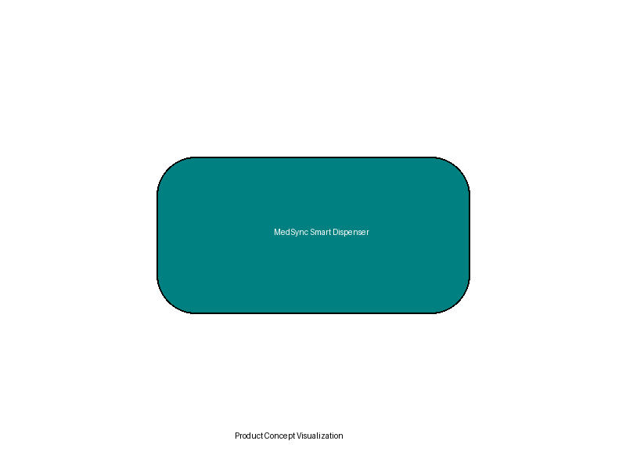
Figure: Product Concept Visualization

Phase 2: Intellectual Property (IP) Check
Preliminary patent search results and novelty assessment.
Disclaimer: This is not legal advice. Consult a patent attorney.

Phase 3: Technical Planning & Workflow
System architecture and Bill of Materials (BOM).
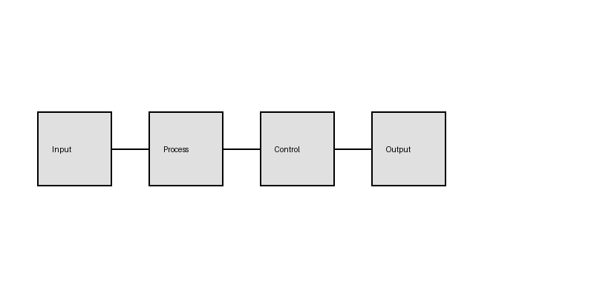
Figure: System Block Diagram

Phase 4: Prototyping Strategy
Fabrication methods, tools, and estimated prototype costs.

Phase 5: Manufacturing & Supply Chain
Component sourcing and manufacturing partners.

Phase 6: Business & Legal Considerations
Business entity type, registration, and certifications.

