Product Incubator Plan: The "Vertebra-Focus" Pad

Overview
This plan outlines the development of a focal, single-vertebra lumbar massager designed to rest on a bed, providing circular and pressing movements with a soft, finger-like touch.

Phase 1: Conceptualization & Design

Core Concept
Product Name: Vertebra-Focus Pad (Working Title)
Form Factor: A slim, low-profile pad (approx. 3-4 inches thick) that rests flat on a mattress.
User Experience: The user lies supine (on their back) or on their side. The device is positioned under the lumbar region (specifically L4-L5).
Key Differentiator: Unlike full-back massage mats, this is a focal device with a "Variable-Height" mechanism that allows the user to move the massage nodes up or down to target a specific vertebra using a remote.
Interface: Soft, medical-grade silicone nodes (Shore A 20-30 hardness) to mimic human fingers, avoiding the "hard plastic" feel of typical massagers.

Visual Description
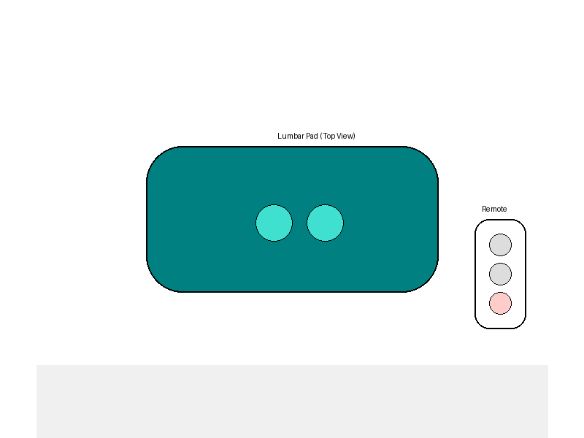
Figure 1: Conceptual Design showing the pad and remote.
Form Factor: A streamlined, pill-shaped pad (approx. 30cm x 15cm x 5cm) with soft, rounded edges to slide easily under the back.
Color & Finish: Calming Teal (Pantone 321C) fabric cover with a smooth, matte white control interface. The silicone nodes are a matching teal but with a soft-touch, skin-like texture.
Remote: Small, pebble-shaped remote in matte white with simple tactile buttons (Up, Down, Knead).

Mechanism Concept
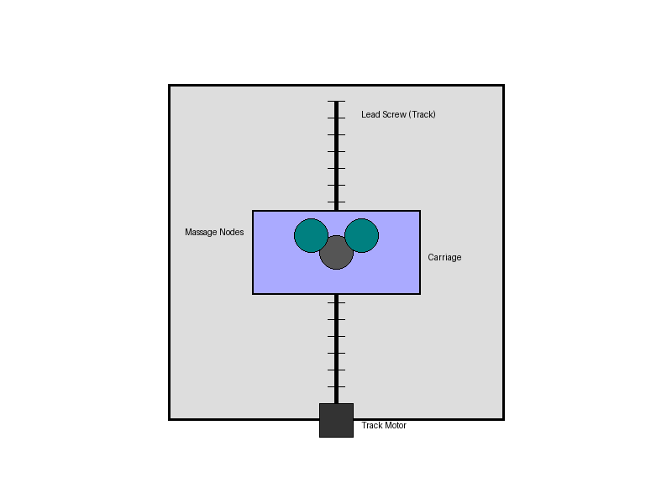
Figure 3: Internal Mechanism Schematic (Top View)
Movement 1 (Massage): Dual eccentrically mounted nodes driven by a high-torque DC motor to create circular/kneading motion.
Movement 2 (Positioning): The entire massage module sits on a mini linear track (lead screw or belt drive) approx. 15cm long. A separate motor moves the module up/down the track based on remote input ("Move Up" / "Move Down").
Pressure: Achieving "pressing motion" can be done by the natural weight of the user pressing down on the nodes, or by a simple cam mechanism that pushes the nodes outward (Z-axis) slightly.

Phase 2: Intellectual Property (IP) Check

Preliminary Search Results
Existing Art: "Acupressure mats" and "Shiatsu massage pillows" exist but typically lack the remote-controlled positional adjustment (moving the mechanism itself up/down a track) in a small pad format.
Differentiator: The combination of "small/portable pad" + "linear track for focal targeting" appear to be a novel integration space.
Patent Caution: Beware of "SL-Track" patents (massage chairs). Ensure your mechanism is distinct (e.g., a simple flat linear actuator, not a complex 3D curve).
Disclaimer: I am an AI, not a patent attorney. A professional patent search (approx. cost $1,000 - $3,000) is highly recommended before commercialization.

Phase 3: Technical Planning

System Diagram
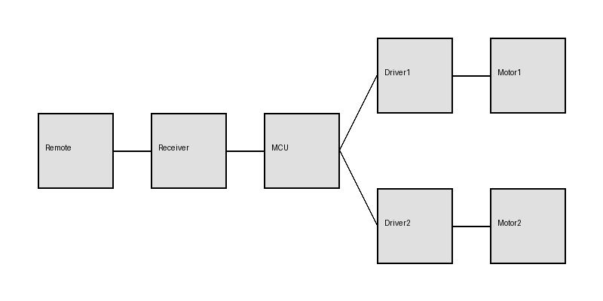
Figure 2: System Block Diagram (Remote to Motors)

Bill of Materials (BOM) - Prototype
- Microcontroller: ESP32 or Arduino Nano (~$5-10)
- Motors: 1x 12V High-Torque DC Geared Motor (for kneading) (~$15), 1x Linear Actuator or Stepper Motor with Lead Screw (15cm travel) (~$30)
- Motor Drivers: 2x L298N or similar (~$5)
- Remote: 433MHz RF Remote & Receiver Kit (~$5-8)
- Power: 12V 2A Power Adapter (~$10)
- Housing: 3D Printed PLA/PETG shell + Silicone cast nodes (~$20 materials)
- Cushioning: Memory foam overlay + Fabric cover (~$10)

Phase 4: Prototyping Strategy

Steps
- Mechanical Proof: Build the "Track" first. Mount a motor on a sliding rail. Ensure it can move 20lbs without stalling.
- Node Casting: 3D print a mold for the massage nodes. Pour skin-safe silicone to get the "soft finger" feel.
- Electronics: Breadboard the RF receiver to control the two motors.
- Assembly: Encase in a soft foam block to test comfort on a bed.

Estimated Prototype Cost
DIY (Self-built): $200 - $400 for parts and materials.
Professional Prototype: $10,000 - $30,000 (Hiring an engineering firm to design custom PCB, CAD, and mechanism).

Phase 5: Manufacturing & Supply Chain

Sourcing
- Motors: Shenzen-based suppliers on Alibaba.
- Silicone Nodes: Custom injection molding (requires tooling).
- Assembly: Contract Manufacturers (CM) in China.

Product Cost Analysis (at 1,000 units)
Target BOM Cost: $25 - $40 per unit.
Retail Price Target: $129 - $159 (typical 4x multiple).

Phase 6: Business & Legal

Regulatory (Crucial!)
FDA: Class I, Product Code ISA. Generally 510(k) Exempt. Must Register and List annually.
FCC: Remote needs certification. Cost ~$3k-$5k.
Safety: UL 1647 recommended for retail.

Business Setup
- Entity: Form an LLC (Limited Liability Company) for liability protection.
- Insurance: get Product Liability Insurance covering bodily injury.

