EduCentre Functional Flow Diagrams

1) High-Level Module Map
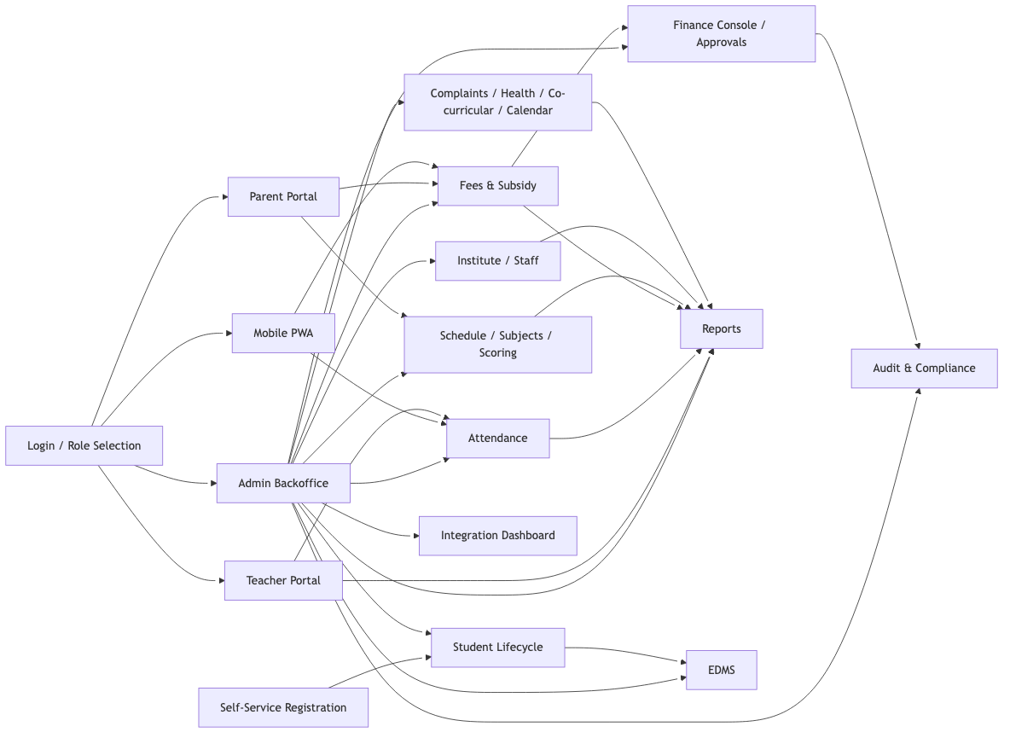
High-Level Module Map

2) Self-Service Registration Module
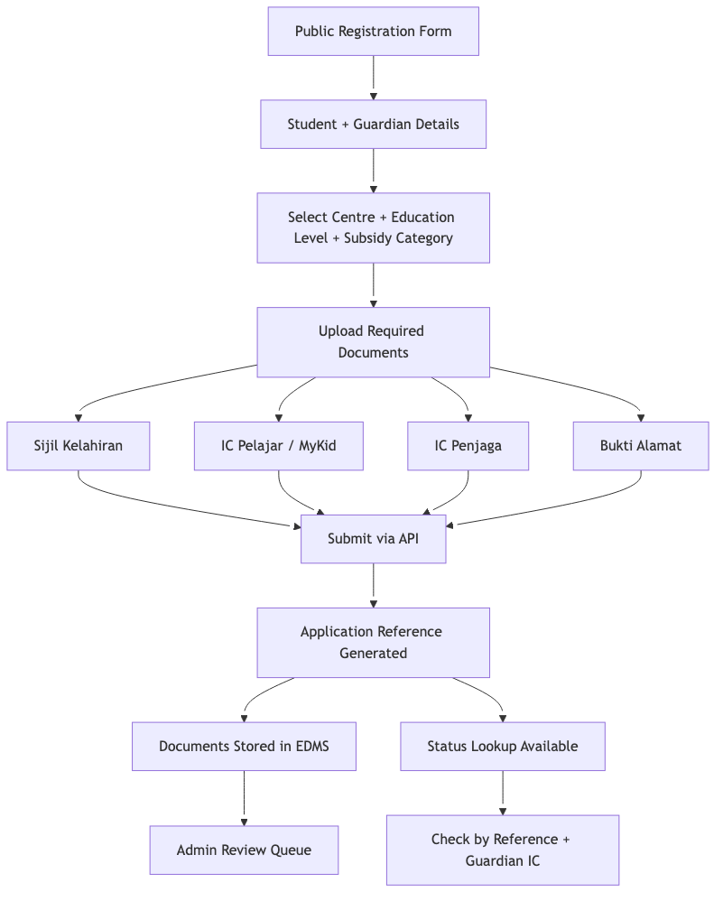
Self-Service Registration Module

3) Student Lifecycle Module
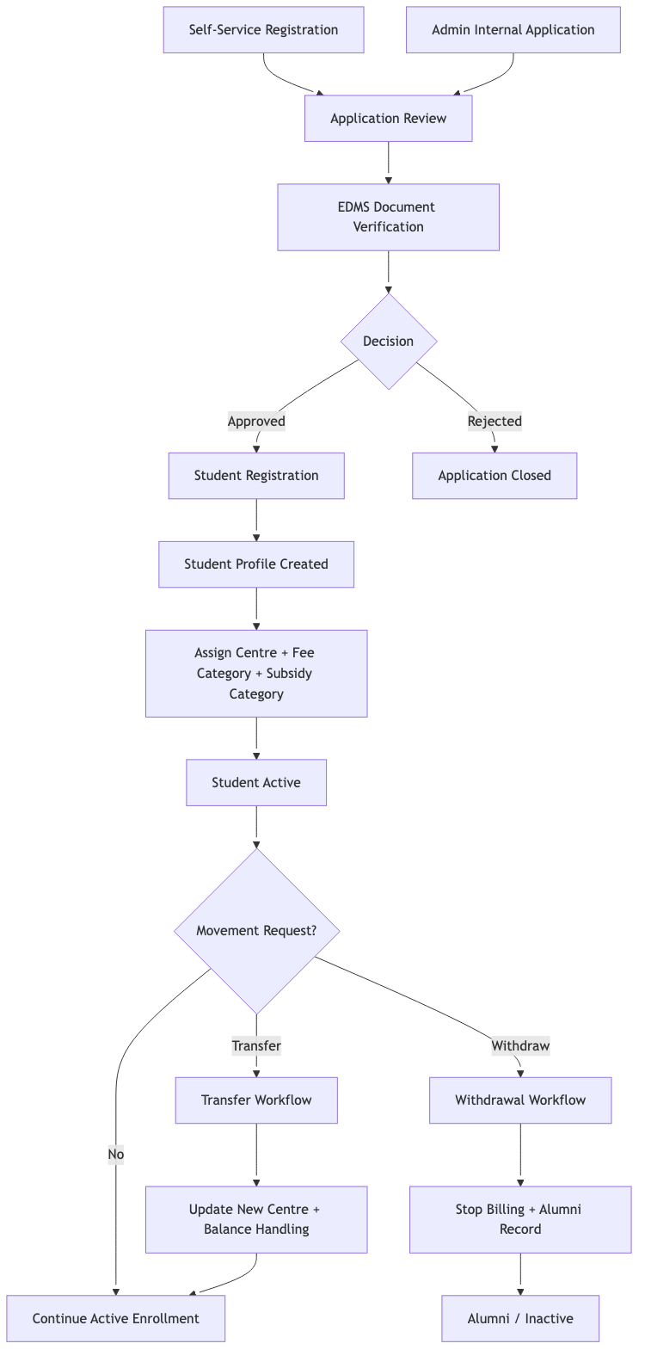
Student Lifecycle Module

4) Attendance Module
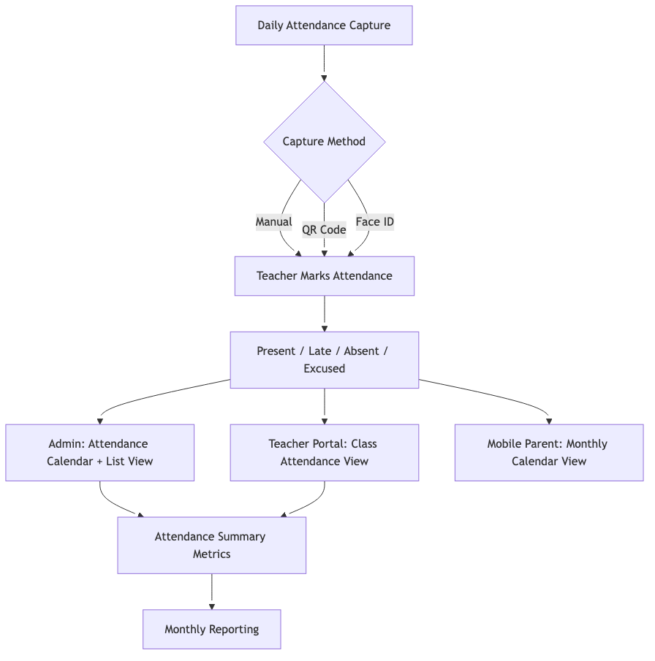
Attendance Module

5) Fees & Subsidy Module
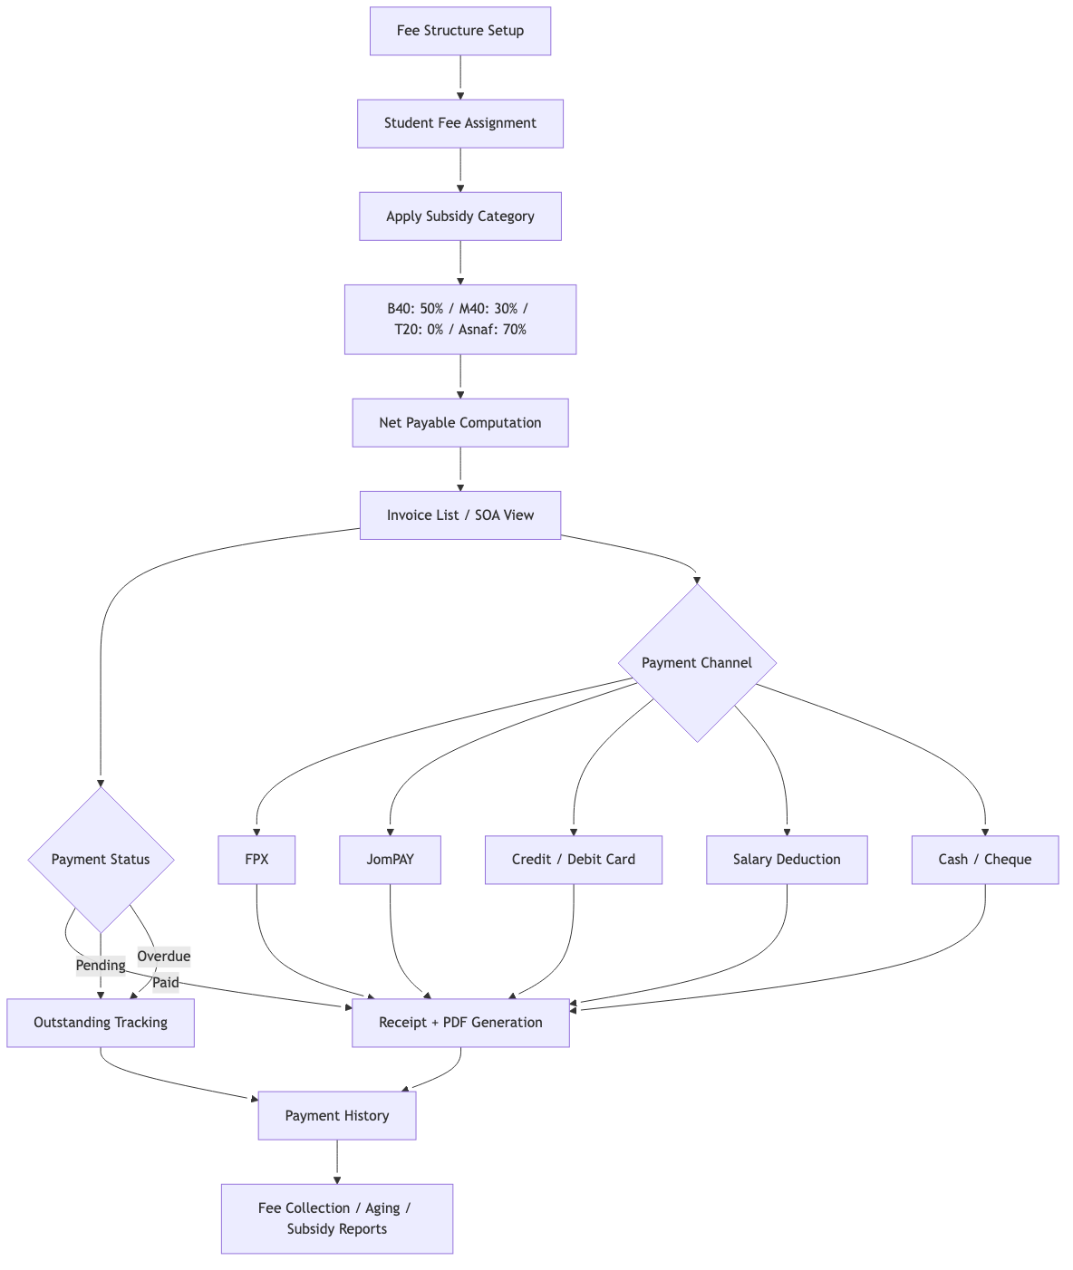
Fees & Subsidy Module

6) Approval & Audit Module
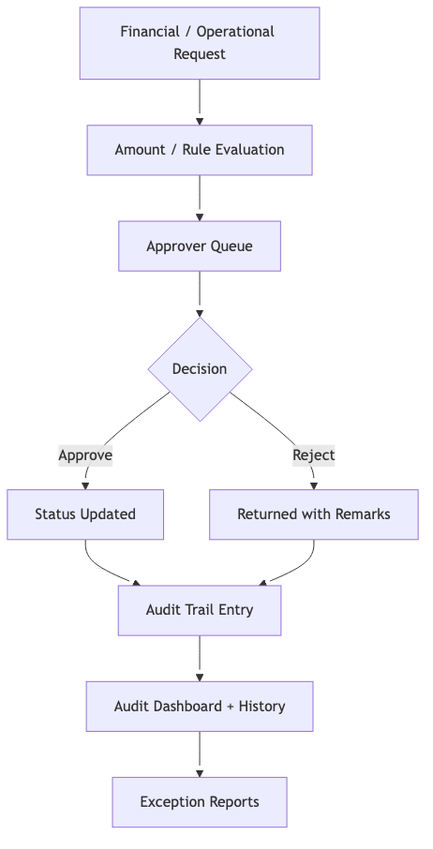
Approval & Audit Module

7) Institute Management Module
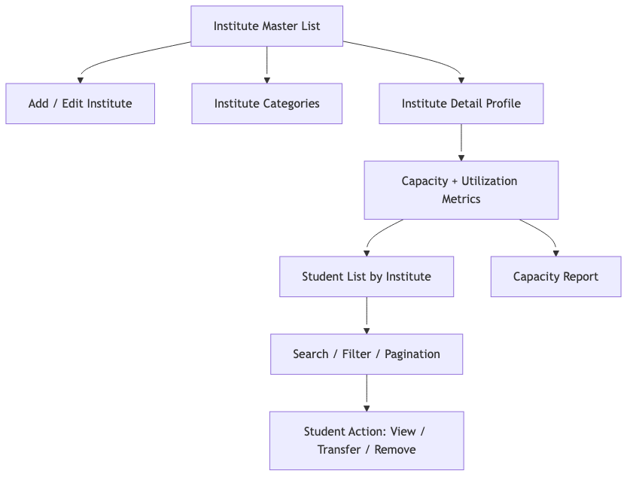
Institute Management Module

8) Staff Management Module
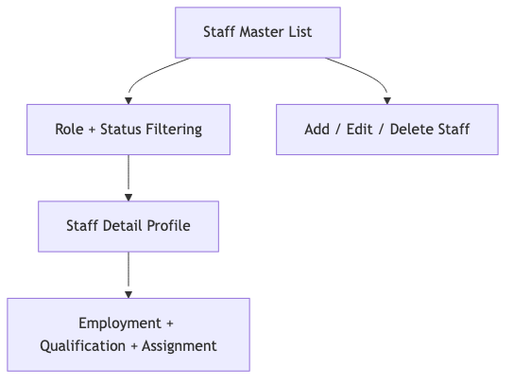
Staff Management Module

9) Schedule & Subjects Module
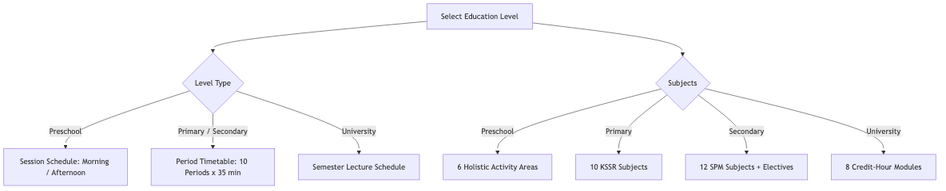
Schedule & Subjects Module

10) Scoring / Academic Module
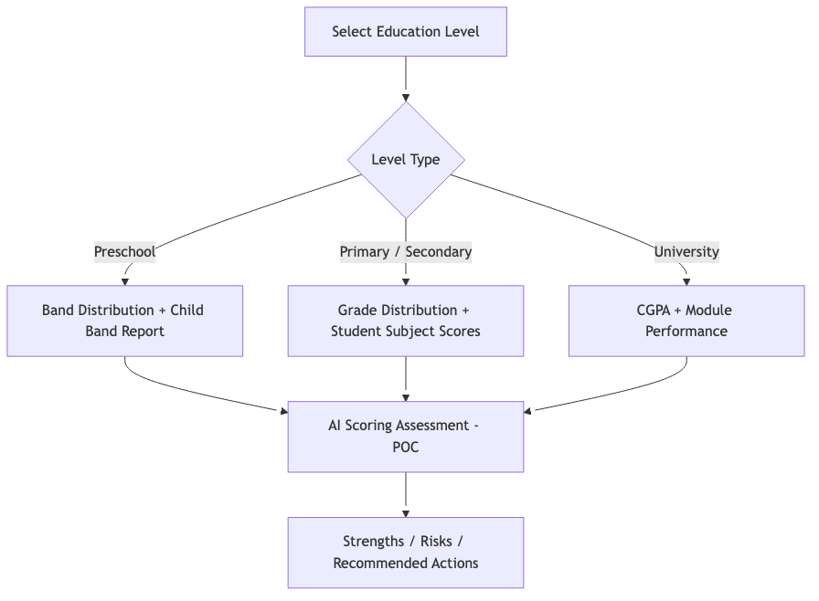
Scoring / Academic Module

11) Complaints Module
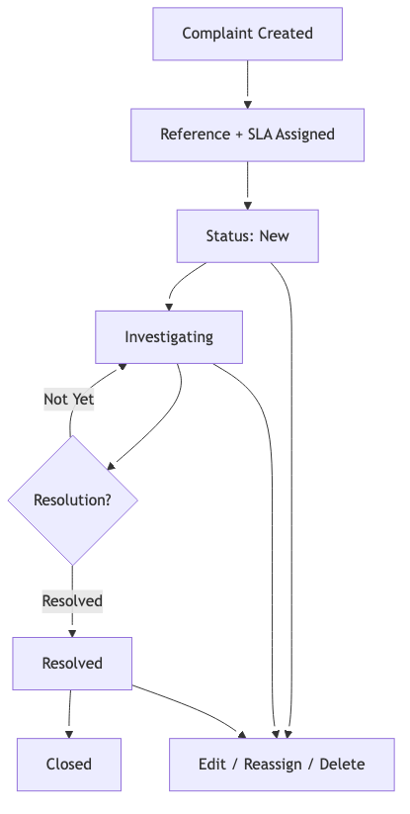
Complaints Module

12) Health Module
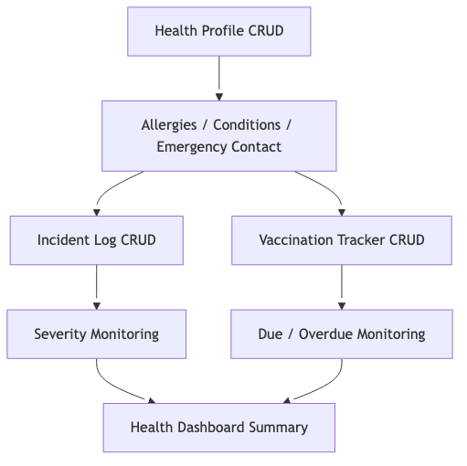
Health Module

13) Co-curricular Module
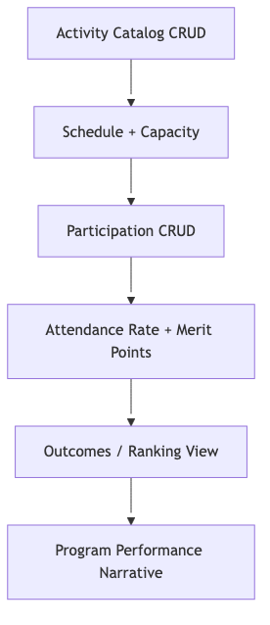
Co-curricular Module

14) Institutional Calendar Module
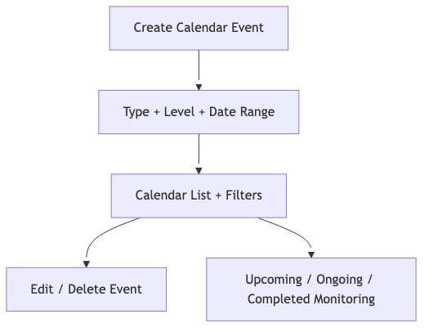
Institutional Calendar Module

15) EDMS (Electronic Document Management)
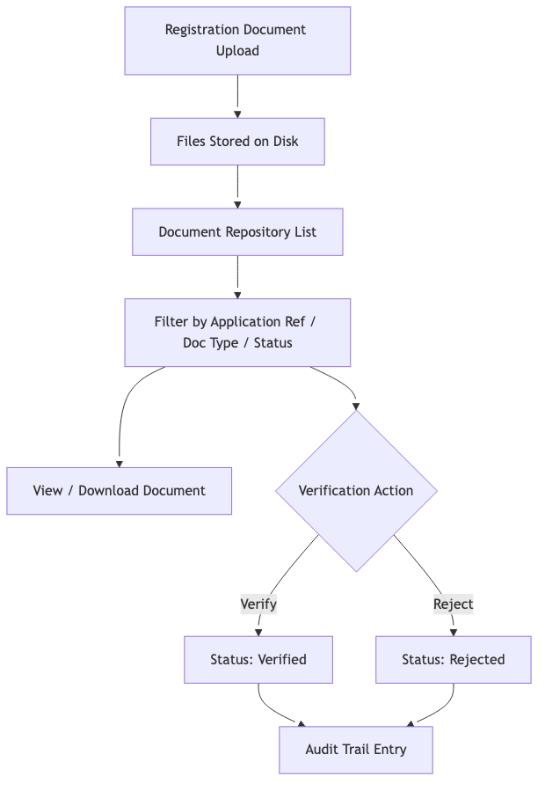
EDMS Module

16) Reporting Module
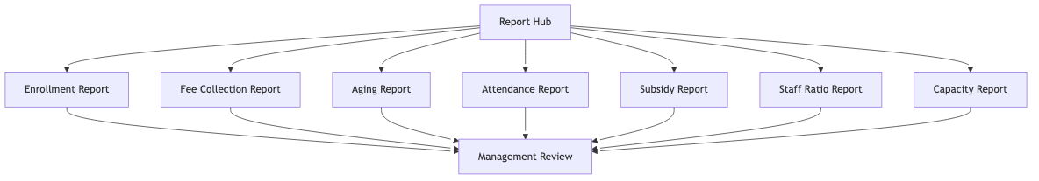
Reporting Module

17) Parent Portal (Desktop)
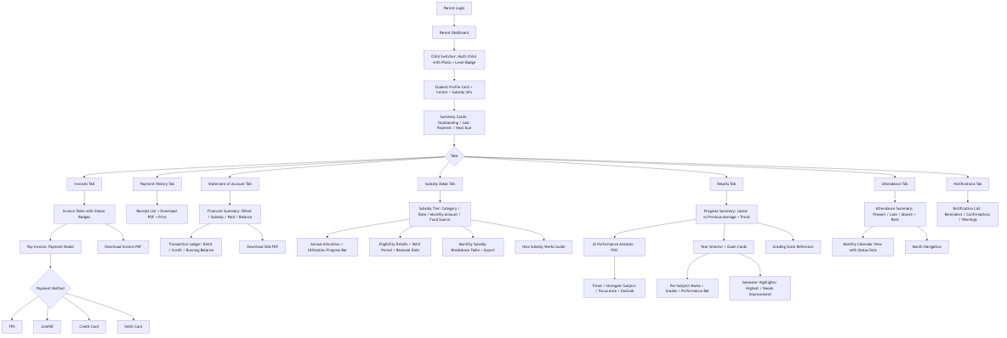
Parent Portal Desktop

18) Teacher Portal (Desktop)
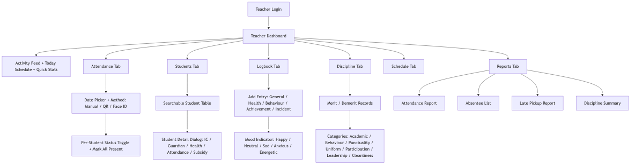
Teacher Portal Desktop

19) Mobile PWA (Parent)
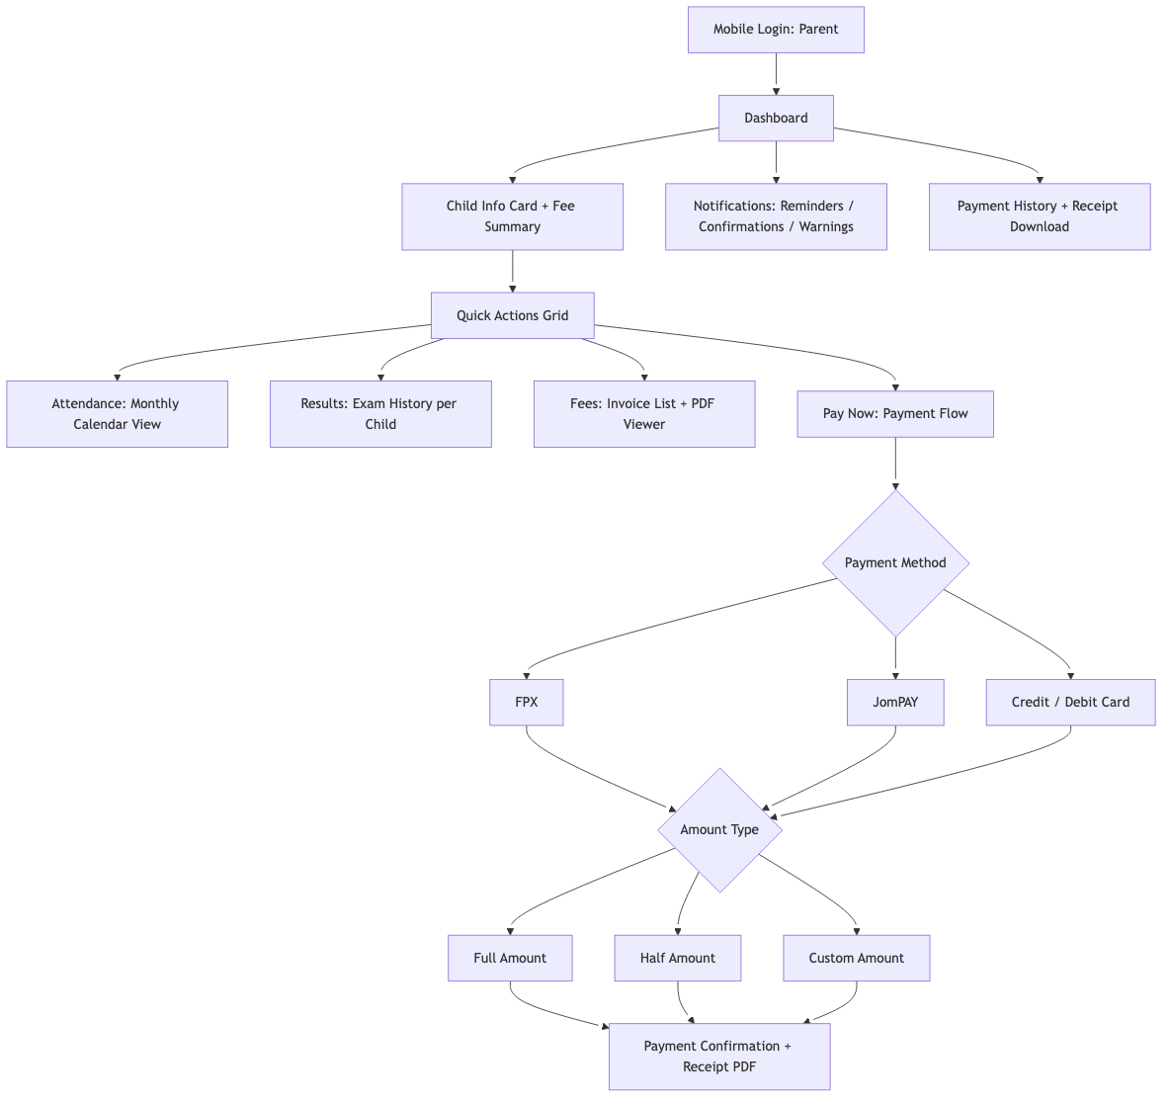
Mobile PWA Parent

20) Mobile PWA (Teacher)
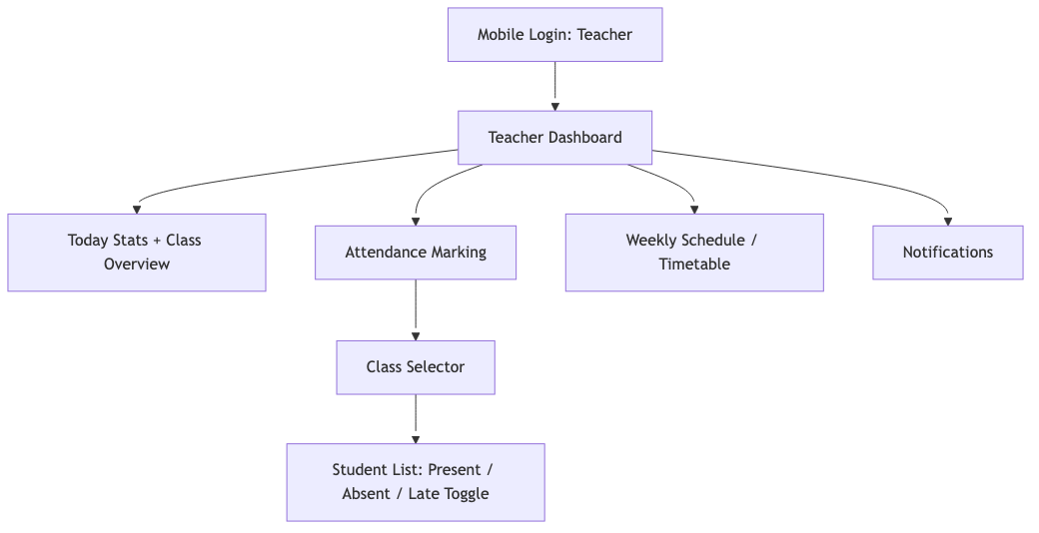
Mobile PWA Teacher

21) Finance Console
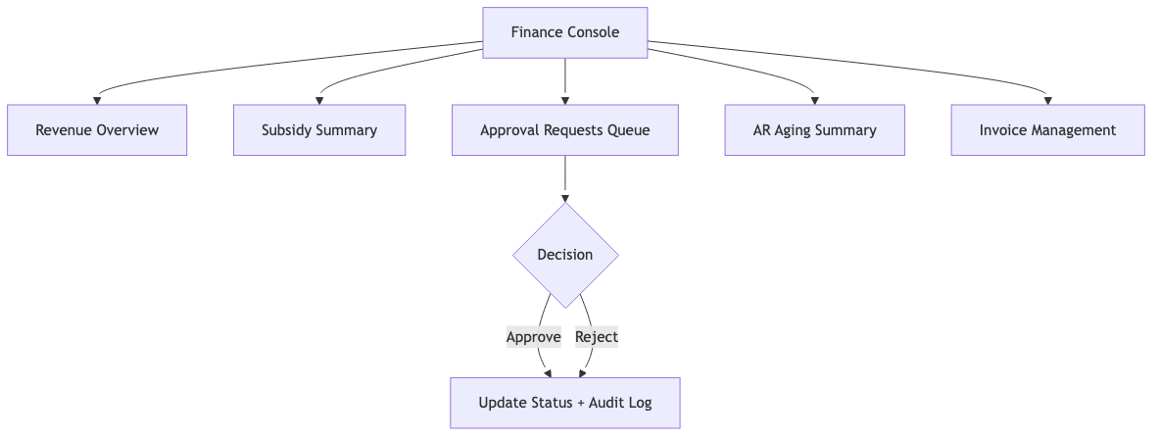
Finance Console

22) Integration Dashboard
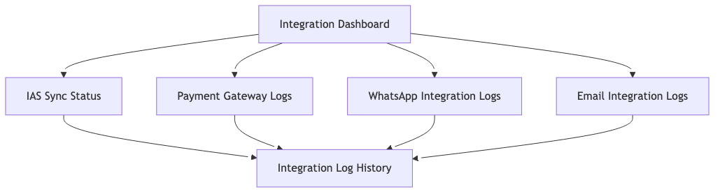
Integration Dashboard

