U-Boot Configuration
Author:
Armando Emmanuel Correa Amorelli

Zapopan, Jalisco, May 9, 2023

Table of Contents
Introduction 3
Context 3
Objective 3
Hypothetical case 4
Questionnaire 4
Information needed to solve this problem 4
Comparison between config files 5
Defconfig 5
Modified defconfig 5
Comparison between config files 6
U-Boot Compilation with modified config file 7
Configuration update and makefile creation 7
Compilation 7
Linking 7
Object generation 8
Images generation 8
Conclusions 8
Bibliography 9

Introduction

Context
With the help of the configuration tool, it is possible to locate and change the values of different configuration options. By being able to understand the results of the modifications made by the tool, the integration of the configuration is validated.

Objective
Compare the results of the configuration based on the changes made by the tool.

Hypothetical case
Let's suppose that the default configuration has been highly modified. Let's also assume that the bootloader was built using this configuration and programmed onto the board. You restart the board and find that the system does not boot. The last time you powered on the board, the system booted successfully, but this time it did not. One might think that the cause of the problem is the recently modified configuration.

Questionnaire
- How can you revert the changes in the configuration if you do not remember exactly which configuration option(s) were modified and led to the system being unable to boot successfully?
If you were lucky enough to save a copy of the original config file at another location, you can simply copy that file to the location where the modified one is and with the same name. Using the following command cp path/to/original-file path/to/modified-file, Also you can use make oldconfig this would update the config file taking a provided .config as a base
- How can I restore the default state of a modified configuration?
As I said previously, if you have a copy you can use that, if not, you can use make defconfig to generate a config file with the default values.

Information needed to solve this problem
- Is there a copy of the previous working configuration file.
- location of the copy of the previous working configuration file.
- Board that you’re using.
- Version of U-Boot being used.

Comparison between config files

Defconfig
For the creation of the default config file, we utlilize the following command
make ARCH=arm defconfig

Modified defconfig
For the modification of the config file generated in the previous step, we utilized the command make ARCH=arm menuconfig to access the configuration menu and locate the CONFIG_USB option and disable it.
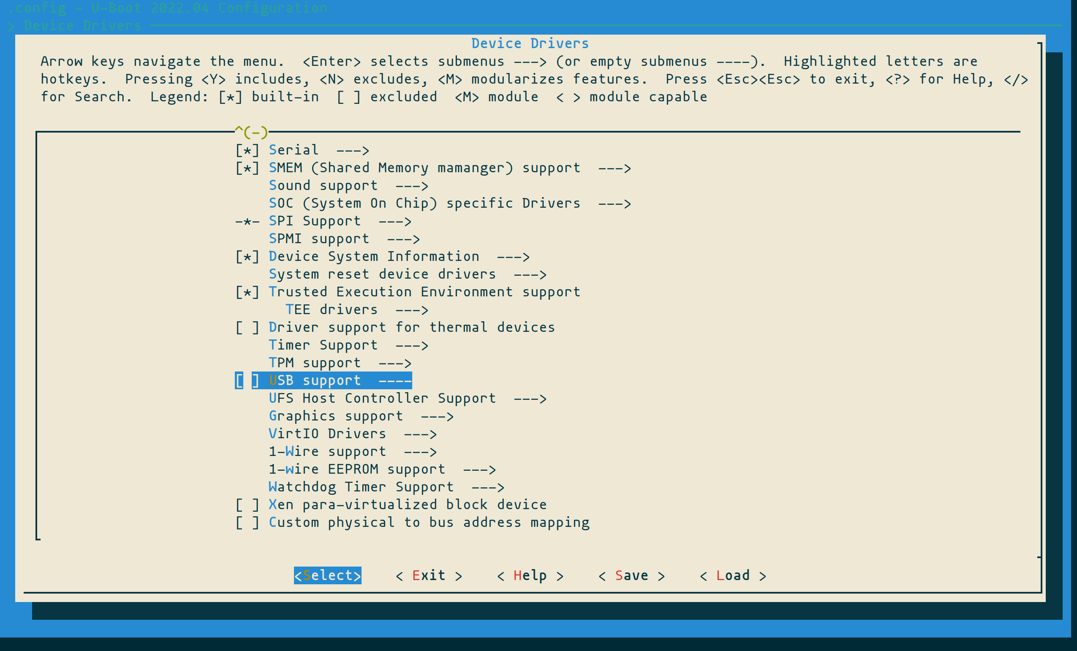

Comparison between config files
Once the config file was modified, we proceed to do a comparison between the default and modified. During this we found that most the configurations related to the USB were deleted, and the remaining ones where set as disabled. Also, there where no other configurations modified.
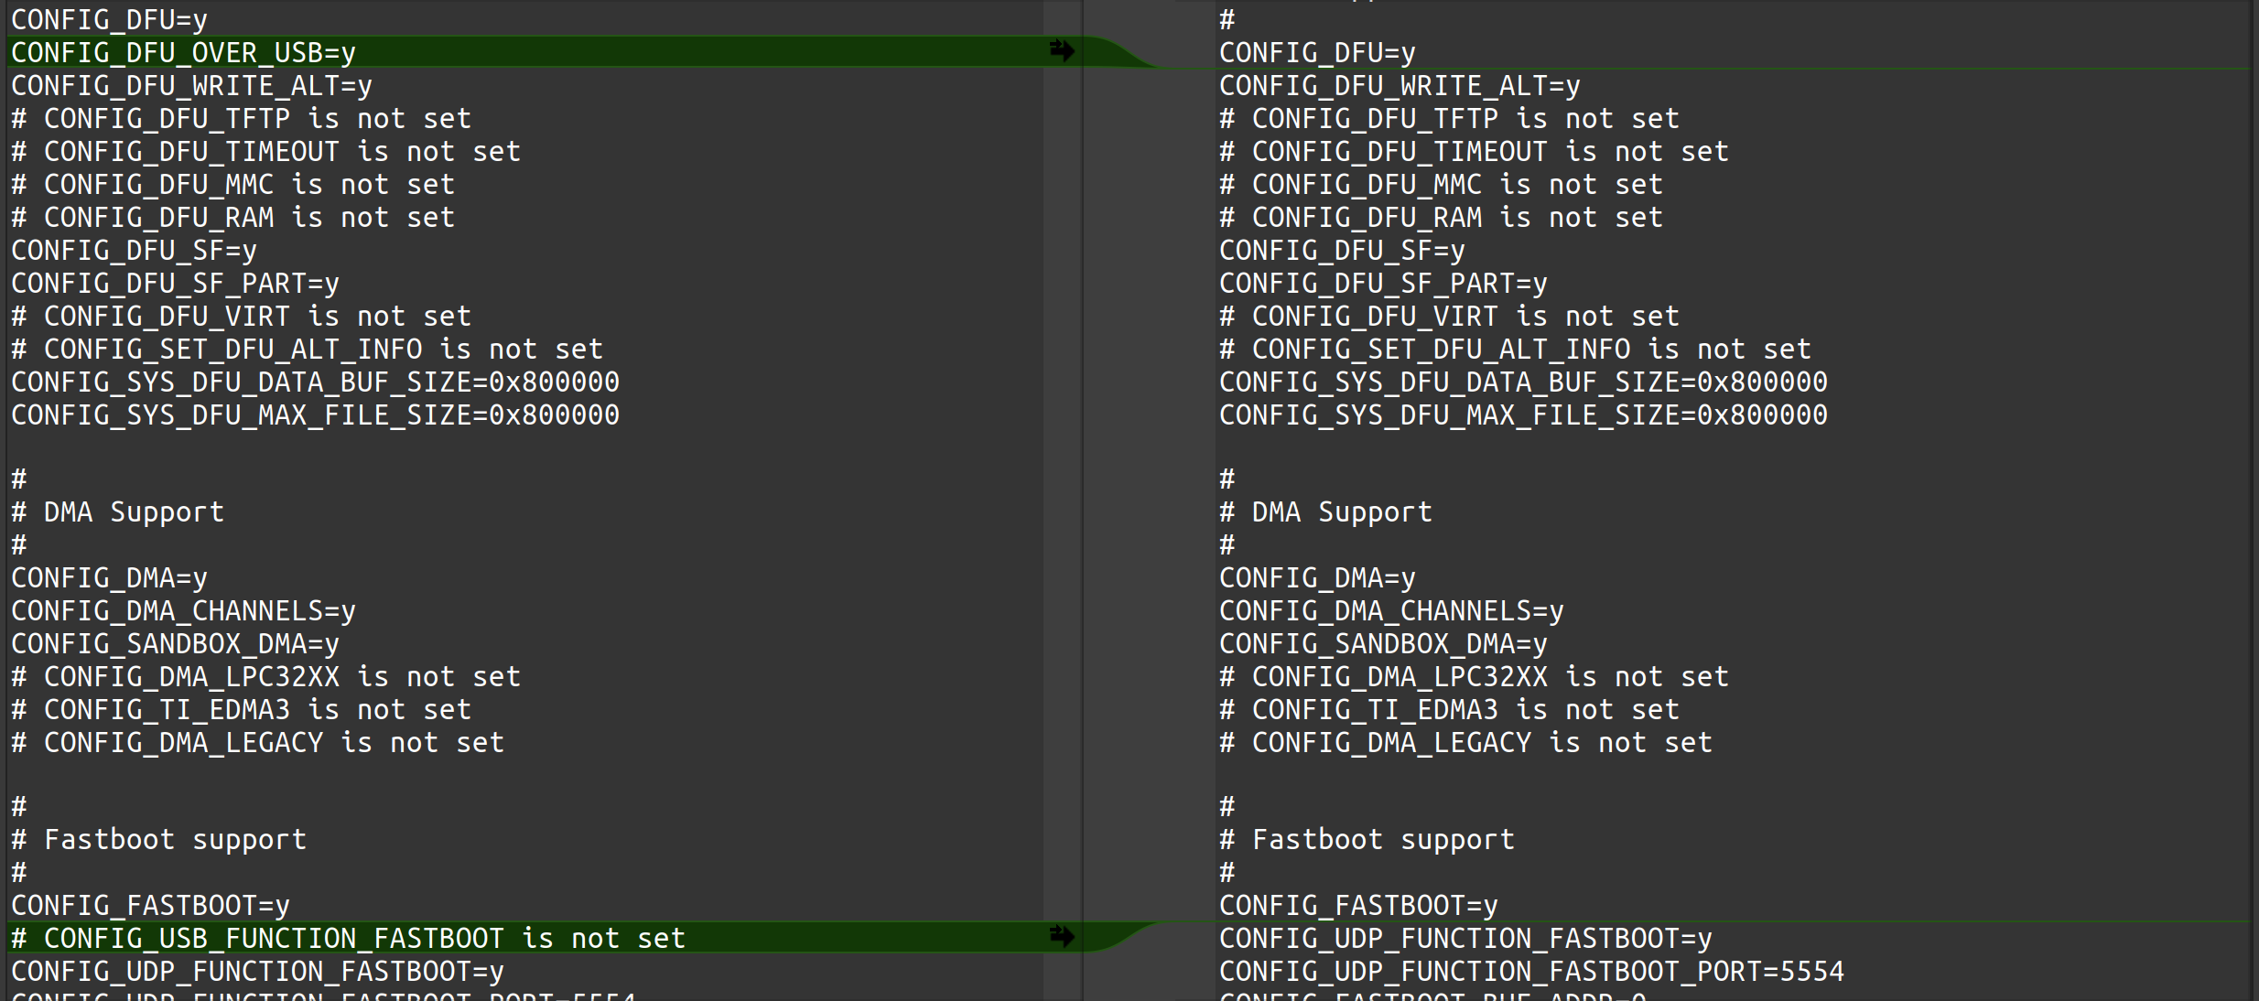
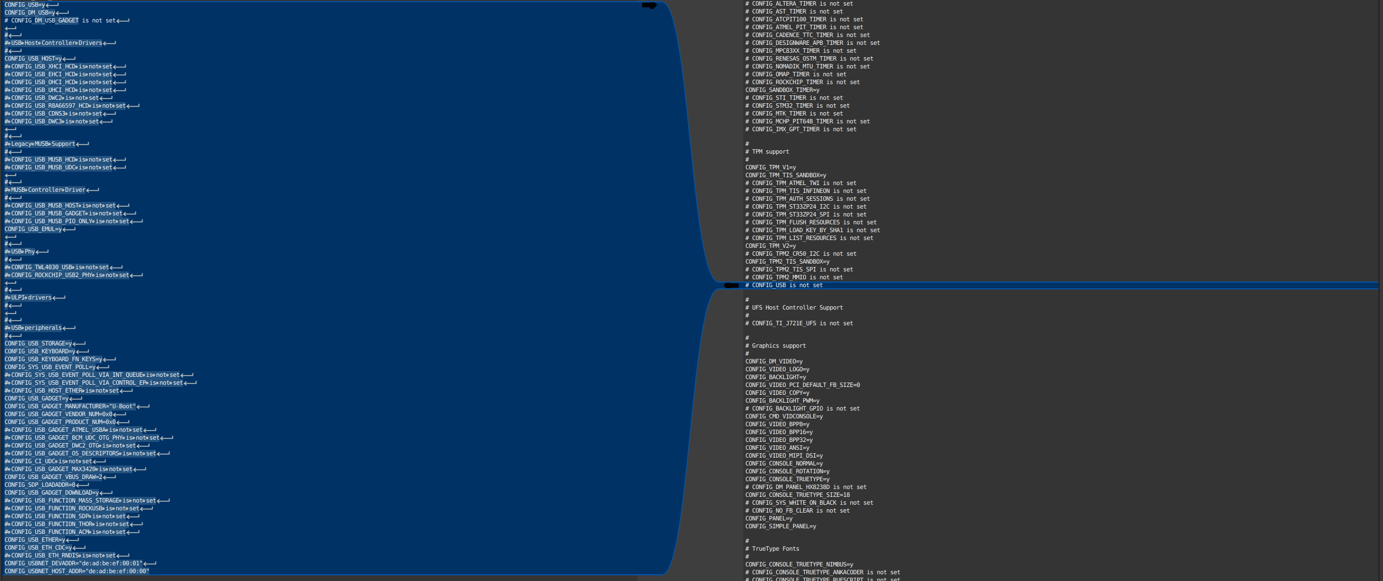

U-Boot Compilation with modified config file

Configuration update and makefile creation
All the update of the configuration an build of the new makefiles, it’s being done at the very beginning of the setup
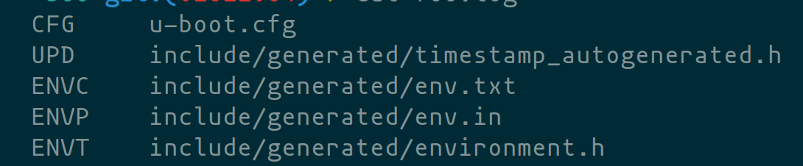

Compilation
Once the new configuration its loaded, and makefiles are generated, the compilation starts
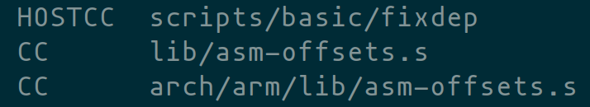

Linking
Once the compilation it’s done, starts the linking

Object generation
Once the linking it’s done, starts generating Object files
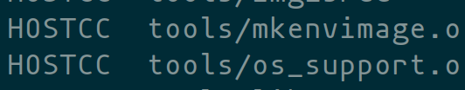

Images generation
Unfortunately, we couldn’t generate the images because a missing make file

Conclusions
The possibility of changing the configuration for each build that we perform it’s a powerful tool, but as it is powerful it can be a complete disaster. If you change a configuration without knowing what it’s related to, it can make you unable to compile the project as it happened to me. Also, if this happens, there might be no documentation about it or it might be difficult to locate.

Bibliography
[1]“The U-Boot Documentation — Das U-Boot unknown version documentation,” u-boot.readthedocs.io. https://u-boot.readthedocs.io/en/v2022.04/index.html (accessed May 07, 2023).
[2]“u-boot/u-boot,” GitHub, May 07, 2023. https://github.com/u-boot/u-boot (accessed May 07, 2023).

