BuildRoot
Author:
Armando Emmanuel Correa Amorelli

Zapopan, Jalisco, August 7, 2023

Table of Contents
Introduction 3
Objective 3
Configure Buildroot 4
Target Options: 4
Toolchain: 4
System Configuration: 4
Kernel: 4
Target Packages: 5
Bootloaders: 5
Creating overlay 6
USB network setup 6
IP configuration 7
SD card preparation 8
Flashing SD card 9
Setting up the BBB 10
Starting the USB Network. 10
Getting the IP address ready 10
Connecting through ssh 11
Conclusions 12
Bibliography 13

Introduction

Buildroot is an open-source software tool that facilitates the process of building customized embedded Linux systems. It is primarily used for creating minimalistic and tailored Linux distributions for embedded devices such as single-board computers, routers, set-top boxes, and other embedded systems.
Buildroot automates the process of cross-compiling all the necessary components and packages required for a functional Linux system, including the kernel, bootloader, libraries, user-space applications, and configuration files. This allows developers to create a lightweight and optimized system tailored to their specific requirements, which is especially important for resource-constrained devices where memory and storage space are limited.

Objective
Configure and build a custom system with Buildroot. This system should use systemd, udev, bash and be able to connect through ssh.

Configure Buildroot
Using menuconfig configure Buildroot as follow

Target Options:
- Target Architecture: ARM (Little endian)
- Target Architecture Variant: cortex-A8

Toolchain:
- Toolchain type: external toolchain
- TToolchain: ARM 2021.07

System Configuration:
- System hostname: billbeaglebone
- Root password: enable
- Init system: systemd

Kernel:
- Linux kernel: 6.0
- Defconfig: omap2plus
- Kernel binary format: zImage
- In-tree Device Tree Source File name: am335x-boneblack
- Needs Host OpenSSL: enable

Target Packages:
- BusyBox: enable
- Networking applications:
  - Dropbear: enable

Bootloaders:
- U-boot: enable
- U-boot configuration: am335x_evm
- Build system: Kconfig
- U-boot version: 2022.04
- U-boot binary format: u-boot.img
- Install U-Boot SPL binary image: enable
- U-boot SPL/TPL binary image name: MLO

Creating overlay

USB network setup
Now that we have our system configured, we need to add an overlay to be able to use Ethernet over USB. For this, we create a new directory at the following path
board/beagleboneblack/rootfs-overlay/etc/init.d/
At this directory, we will create a new file named S30usbgadget that will contain the following
#!/bin/sh

# set -e

GADGET_DIR=/config/usb_gadget/g1
OLDPWD=$(pwd)

printf "Starting USB gadget: "

modprobe cppi41
modprobe musb-dsps
modprobe phy-am335x
modprobe libcomposite

mkdir /config
mount -t configfs none /config
mkdir ${GADGET_DIR}
cd ${GADGET_DIR}
echo "0x05e8" > idVendor
echo "0xa4a1" > idProduct
mkdir strings/0x409
echo "serialnumber" > strings/0x409/serialnumber
echo "manufacturer" > strings/0x409/manufacturer
echo "ECM Gadget" > strings/0x409/product
mkdir functions/ecm.usb0
mkdir configs/c.1
mkdir configs/c.1/strings/0x409
echo Conf 1 > configs/c.1/strings/0x409/configuration
echo 120 > configs/c.1/MaxPower
echo "f8:dc:7a:00:00:01" > functions/ecm.usb0/host_addr
ln -s functions/ecm.usb0 configs/c.1
echo musb-hdrc.0 > UDC
cd ${OLDPWD}

echo "OK"

IP configuration
In board/beagleboneblack/rootfs-overlay, create a file named etc/network/interfaces with the following contents:
auto lo
iface lo inet loopback
auto usb0
iface usb0 inet static
address 192.168.0.2
netmask 255.255.255.0

Once we have all this, we can proceed with the build.

SD card preparation
For preparing the SD card, we will use Gparted, and create the following partitions and labels.

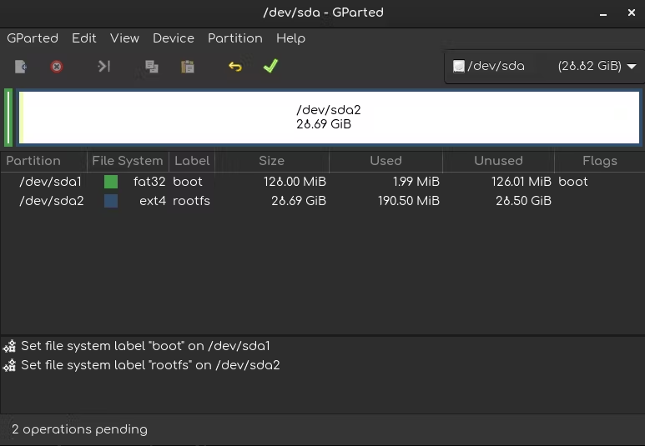

Flashing SD card
Now that we have build our system, and formatted the SD card, we need to flash it with the needed files.
First we copy the MLO zimage and other files to the boot partition
cp MLO u-boot.img zImage am335x-boneblack.dtb /media/$USER/boot/
Next we need to create a file that will specify to U-boot the kernel and device tree. This file should be at boot partition at the path extlinux/extlinux.conf and contain the following:
label buildroot
kernel /zImage
devicetree /am335x-boneblack.dtb
append console=ttyO0,115200 root=/dev/mmcblk0p2 rootwait
Lastly, we need to decompress our file system at the rootfs partitions
sudo tar -C /run/media/$USER/rootfs/ -xf rootfs.tar

Setting up the BBB
Now that we have everything in our SD card, we proceed to boot the BBB from it. And make some last setups.

Starting the USB Network.
Thanks to the overlay that we made for the USB Network setup, we just need to run it
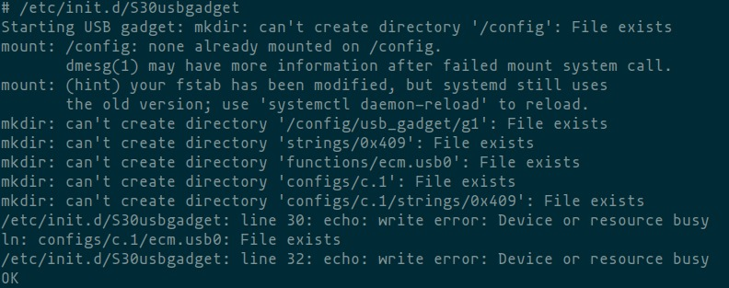

Getting the IP address ready
Same as with the USB Network we need to run a command to get the network interface up and get assigned a IP address
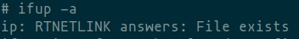

Connecting through ssh
Once we have done the last steps, we should be able to connect to the BBB from our Host by ssh and test that we actually are using bash, systemd and udev
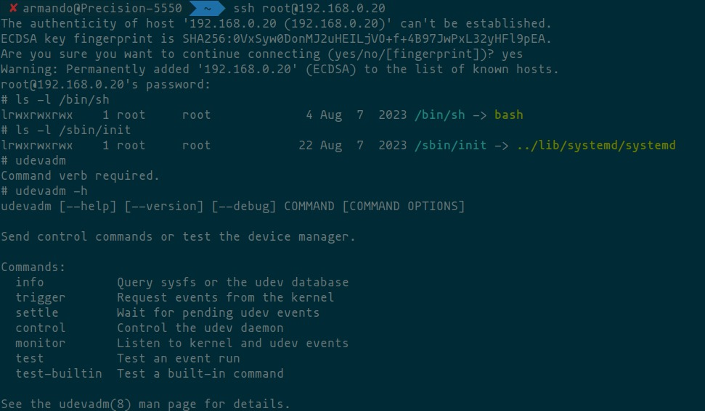

Conclusions
This was a rather easier lab in comparison with all the ones made for the module 4, although I had some issues getting the connection between host and target working. For some reason I couldn’t ping the BBB from my laptop using the suggested IP (192.168.0.2), I needed to change it to 192.168.0.20, and it worked by art of magic.

Bibliography
[1] Buildroot Training - Bootlin, https://bootlin.com/doc/training/buildroot/buildroot-labs.pdf (accessed Aug. 8, 2023).
[2] B. V. Leeuwen, “Buildroot Embedded Linux beaglebone black,” Bill Van Leeuwen’s blog, https://blog.billvanleeuwen.ca/creating-a-minimal-linux-system-for-the-beaglebone-black-with-buildroot (accessed Aug. 7, 2023).

