# **Compilation with gcc**

1. 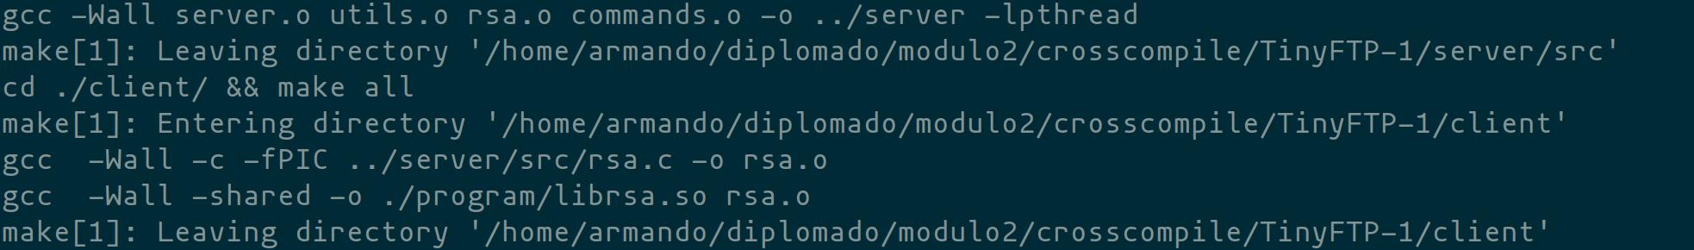

# C**ompilation with arm-linux-gnueabihf-gcc**

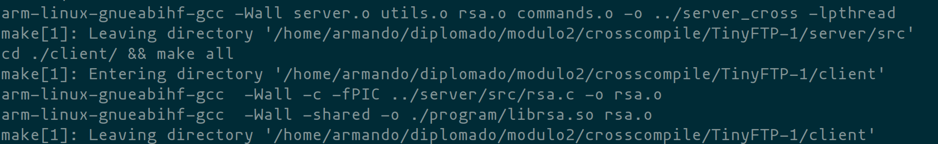

# **Running gcc binary on BBB**





# Running arm-linux-gnueabihf-gcc binary on BBB



