The Potential Economic Impacts of the Proposed Development Corridor in Egypt: An Interregional CGE Approach

Dina N. Elshahawany (Zagazig University, Egypt)
Eduardo A. Haddad (University of São Paulo, Brazil)
Michael L. Lahr (Rutgers University, USA)

Abstract. Egypt has proposed a new development corridor. A main component is a desert-based expansion of the current highway network. This network is founded on a 1200-kilometer north-south route that starts at a proposed new port near El-Alemein and runs parallel to the Nile Valley to the border of Sudan. It also includes 21 east-west branches that connect the main axis to densely populated cities on the Nile. The paper is a first attempt at an economic assessment of the impact of this proposed corridor. It uses an interregional computable general equilibrium (CGE) model developed and reported in a prior paper. Here, that model is integrated with a more detailed geo-coded transportation network model to help quantify the spatial effects of transportation cost change due specifically to changes in accessibility induced by the corridor. The paper focuses on the likely structural economic impacts that such a large investment in transportation could enable through a series of simulations related to the operational phase of the project.

Resumo. Há no Egito uma proposta de construção de um novo corredor de desenvolvimento. Um de seus principais componentes é a expansão da rede de transporte adentrando o deserto. A nova rede seria construída paralela ao Rio Nilo, ao longo de aproximadamente 1.200 quilômetros. O corredor começaria em um novo porto no norte do país, perto de El-Alemein, e percorreria um trajeto paralelo ao vale do Nilo até a fronteira com o Sudão. Além de seu eixo principal no sentido norte-sul, incluiria também 21 troncos no sentido leste-oeste conectando tal eixo aos centros urbanos mais densamente povoados ao longo do rio. Este artigo é uma primeira tentativa de se fazer um estudo de impacto ex ante do corredor proposto. Utilizamos um modelo interregional de equilíbrio geral computável desenvolvido e apresentado em um artigo anterior. Aqui, o modelo é integrado a uma rede de transporte geo-referenciada bastante detalhada, o que permite quantificar os efeitos espaciais de alterações sistêmicas nos custos de transporte associadas a mudanças específicas na acessibilidade das regiões egípcias devidas à operação do corredor. O foco do trabalho é nos efeitos econômicos estruturais potenciais relacionados à fase operacional de um grande projeto em infraestrutura de transporte.

Palavras-chave. Análise de impacto; modelos EGC interregionais; infraestrutura de transporte; acessibilidade; Egito.

Keywords. Impact analysis; interregional CGE models; transport infrastructure; accessibility; Egypt

Área ANPEC. Área 10 – Economia Regional e Urbana

Classificação JEL. R13; R42; C68

1. Introduction

Even before civilizations arose, the Nile served as a mechanism to transport people, news, and products. It has also enabled better mobilization of armies and tax collections – key aspects of a unified, sustainable state. Similarly, Greek, Roman, and Arab empires assured the ease and security of travel within the boundaries of their vast territories (El-Baz, 2007). More recently, transportation access assisted development in Europe and the Americas, leading to the rise of Western Civilization (Bairoch 1988). It is also clear that superb transportation systems allowed the United States to better utilize its vast natural resources to reach its present position of prominence (Glaab and Brown, 1967).

Currently, Egypt’s population is confined to a fine strip of arable land along the Nile River: deserts account for 96% of Egyptian land. Its deserts represent a national wealth that should be used to benefit future generations. The western desert hides energy sources, underground water, and vast spaces for settlement. To alleviate overcrowding and chronic urban problems, it is necessary to move into the deserts, and there to implement some urban development projects that use available local resources.
The transportation is important for enabling economic development. It provides market accessibility by linking producers and consumers. An efficient transport system with modern infrastructure favors many economic changes, most of them positive. Transportation networks are the circulatory systems through which economic and social activities flow. All sectors of an economy depend on the services and facilities of this sector to link supply to demand, thereby enabling markets. They give access to raw materials, services, and factory loading docks.

Economic opportunities are enabled through the mobility of people, goods, and information. A relation between the quantity and quality of transport infrastructure and the level of economic development is apparent. High density transport infrastructure and highly connected networks are commonly associated with high levels of development. When transport systems are efficient, they provide economic and social opportunities and benefits that result in positive multipliers effects such as better accessibility to markets, employment and additional investments. When transport systems are deficient in terms of capacity or reliability, they can have an economic cost such as reduced or missed opportunities and lower quality of life (Rodrigue et al., 2009).

Investments in transportation infrastructure allow efficiencies, which in turn permit regional and national economic growth. They reduce firms’ transaction costs and thereby expand the economic opportunities in a region/country. In this way, such investments can potentially help increase incomes and standards of living for resident populations (Haddad et al., 2011).

Transportation cost plays a significant role not only in forming urban hierarchies, but also in forming the shapes of traditional cities. The spatial organization of land uses determines the plan and characteristics of transport networks and at the same time transport route determine land uses. Decreased commuting costs flatten the population density and land-rent gradients for housing. Reduced commuting costs result in a larger periurban area. If the cost of commuting were zero, the population, employment, and land rent would be uniformly distributed (Edwards, 2007).
Egypt has 23,619 kilometers of roads – from single lane “dirt” roads, to two-way surfaced streets, to multi-lane highways. Car ownership is rising rapidly in Egypt. Plus Egypt’s roads carry the lion’s share of freight. Logistics providers in Egypt have expressed a need for a more consistent distribution infrastructure, as there remains a severe lack of services around road-based transportation. That is, accessibility varies tremendously across Egyptian regions (Felkner et al., 2012). Thus, interregional transportation infrastructure is often lacking to link small centers to large urban areas. This lack disables efficient location decisions. Consequently, while the road network is important to Egypt’s economy, the country could stand more road investment, particularly in its underdeveloped south. In any case, it is clear that highway expansion and improved freight corridors will be vital in relieving congestion and boosting economic development.

A major highway investment proposal is the “Development Corridor”. The Corridor, proposed by Farouk El-Baz (2007) of Boston University, was conceived to provide solutions to numerous problems that Egypt faces. While facilitating transportation, it was designed to limit urban encroachment into the nation’s prime agricultural lands along the Nile and to encourage the deconcentration of congested, overpopulated areas. Meanwhile, it opens up vast areas for industrial zones, trade centers and other developments. It is one of the most promising proposals to date, if not the best, for opening up use of the western desert.

The corridor approach to development uses transport corridors as a backbone or spatial focus for regional cooperation projects and activities (Srivastave, 2013). The idea behind the approach is to cluster such activities along corridors or at nodal centers on the corridors, where certain agglomeration economies naturally arise and are hopefully nurtured. Such agglomerations are expected to facilitate growth in surrounding areas by catalyzing further investment from both within and outside of the region. The spatial focus can also facilitate prioritization of regional projects, and coordination of national projects among neighboring countries. The corridor development approach is thus potentially a very practical way to get the most from limited government resources available for regional development projects.

A main component of the Corridor in Egypt is a super highway network in the western desert (Figure 1). It is to consist of a 1,200 km of eight-lane highway in a north-south direction with 21 east-west spurs that connect the main highway to densely populated river cities along its path. Parallel to it are included a railway to enable low-cost transport of people and products, a pipeline to supply fresh water to corridor developments, and a grid-connected electricity transmission line that could eventually supply energy from desert-based solar farms.

Continued development of a modern network of transportation systems within the confines of the Nile Valley and its Delta would reduce agricultural land. The fertile soil within the inhabited strip of Egypt has been deposited by the Nile River over millions of year; it is a very limited and irreplaceable resource that facilitates national food security. In the meantime, the country’s pace of population expansion counteracts its ability to live on just that narrow green strip, which represents 5% of its land. If we must grow, it is imperative that we expand outside of the inhabited strip. The Corridor provides a potential solution for these numerous problems (El-Baz, 2011).

This paper develops a framework for analyzing the economic impacts of the highway network component of the proposed Development Corridor for Egypt. After this introduction, we proceed, in Section 2, with an overview of the methodological strategy used, considering its main features. Section 3 presents the results of the simulations, focusing on the potential reallocation effects of the Corridor. Final remarks follow.

Figure 1. Egypt’s Development Corridor
2. Methodology

Public agencies are increasingly under fire to justify major spending items. Proposed transportation projects are no exception, and demonstrations of the magnitude of expected consequent economic impacts are typically employed to justify them. Indeed, such cost/benefit analysis, which include economic impact statements, are often used to compare the relative potential economic development effects of spending alternatives. They are thus often used to support planning design decisions and/or investment decisions. In most cases, the focus of economic impact studies is on estimating how projects are likely to affect economic development of the specific populations or regions within which they are placed.

A wide range of methods have been deployed to measure economic impacts. There are qualitative surveys, detailed market studies, and comprehensive economic simulation models to list just a few. The primary economic assessment methods considered include: Social Cost Benefit Analysis (SCBA), Input-Output Analysis (I-O), and Computable General Equilibrium (CGE). SCBA is most effective for determining the value of project objectives and outcomes from a social welfare perspective. I-O and CGE take macroeconomic perspectives of system-wide effects of transport investment including employment, GDP, and taxes (Wallis, 2009). In many cases, the analysis compares a no-build or base case scenario to one or more transportation investment scenarios. Examinations of such impacts often cover the expected life cycle of the investment, which can be 30 or more years. Some even assume the infrastructure costs and benefits are elicited in perpetuity.

If the stream of regional economics literature is a reasonable measure, infrastructure continues to play a strong role in development. A number of alternative approaches appear addressing the relationship between infrastructure and regional economic development. (Martin and Rogers, 1995; Helpman and Krugman, 1985; Vickerman, 1995; World Bank, 2008).

In recent years, applied computable general equilibrium (CGE) models have become standard tools of quantitative policy assessment. Their appeal is built on their rigorous grounding in economic theory: individual agent’s decision-making behaviors are derived from explicit optimization under strictly specified technological or budget constraints, given markets signals that ensure global consistency. These theoretical foundations have made CGE models appear particularly useful for ex ante evaluations of policy reforms (De Palma et al., 2011). The stream of research linking CGE models to transportation networks include, among others Bröcker (1998); Bröcker and Schneider (2002); Kim and Hewings (2003); Kim et al. (2004); Haddad and Hewings (2005); Haddad et al. (2011); Sakamoto (2012).

The analysis in this paper relies on simulations of the ex ante macro-spatial impacts of the Corridor. The exercise is based on an interregional computable general equilibrium model (ICGE) model for Egypt’s economy that was developed by Haddad et al. (2015). An important feature of the ICGE model is its ability to explicit estimate costs of moving products based on origin-destination pairs according to transportation margins. That is, the model accounts for the specific cost structure of the flow of each traded commodity. This paper amends the ICGE model by physically constraining that structure by the available transportation network, which is modeled in a geo-coded transportation module. We examine the trade flows with and without the proposed Development Corridor. The model’s integration with a GIS network helps quantifying the spatial effects of transportation cost change. Moreover it enables us to explicit model commodity-based transportation costs within the ICGE model. Thus, the model intrinsically accounts for the spatial structure of the Egyptian economy. That is, inclusion of the transportation network within the ICGE augments the general model framework for understanding the equilibrating role of transportation (and hence transportation investments) in regional economic development. The transport module measures minimum travel times between regions using actual road routes. The ICGE model estimates the short and long-run spatial spread of national Gross Domestic Production (GDP), as well as other measures of economic activity, caused by expected changes in regional accessibility. Figure 2 summarizes the main methodological aspects of our modeling strategy, further discussed below.

A main feature of the modeling structure used in this paper is the manner in which we have integrated a geo-coded transportation network for Egypt with the ICGE model. Thus, if one wants to simulate changes in the network, which might affect relative accessibility (e.g., the Corridor), a transportation cost matrix can be calculated ex ante and ex post, and mapped to the ICGE model through transportation cost functions. This mapping includes two stages – one for model calibration and another for the simulations.

A detailed national-level GIS road network data was generously provided by the Egyptian Central Agency for Public Mobilization and Statistics (CAPMAS). We merged this database with information on specific technical road attributes. Particularly important was an estimate of the maximum speed of each road in the network so that, when combined with road length information, we could estimate travel times of every single road and, hence, network link and path. In addition, we obtained GIS data for the highway aspect of the Development Corridor and with a bit of effort and consternation connected it to the network (see Figure 3).

Figure 2. Summary of the Integrated System

Figure 3. Egypt’s Transportation Network after Connecting the Proposed Corridor
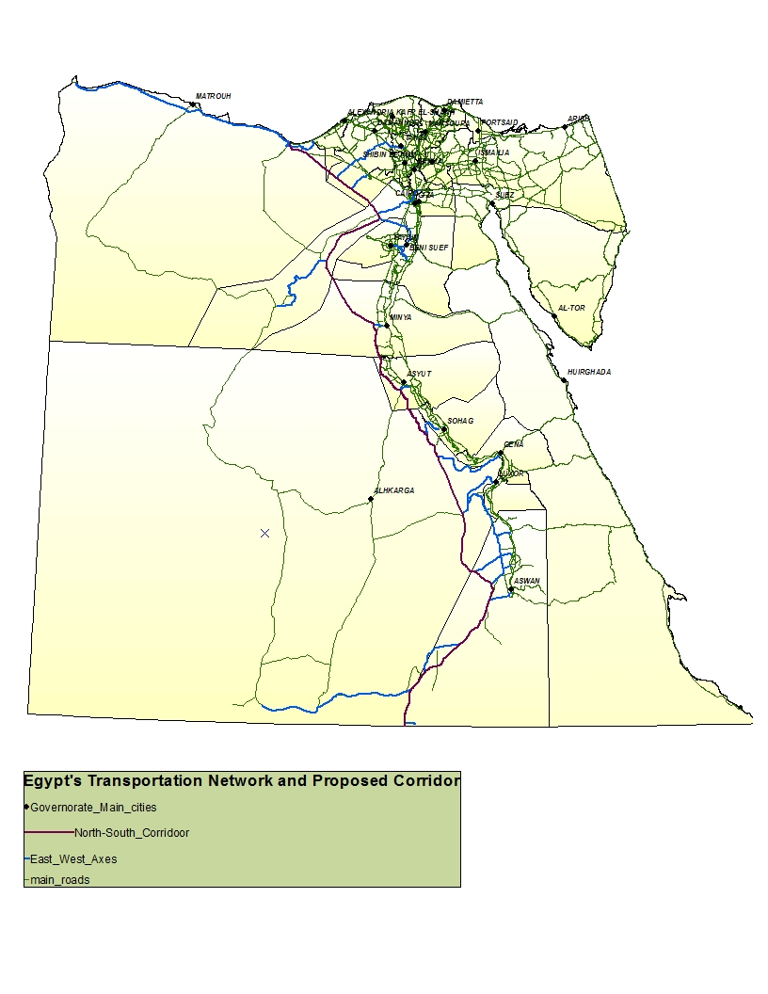

Following Haddad and Hewings (2005), we next integrate the afore-discussed geo-coded transportation network with the pre-existing ICGE model for Egypt. This enables us to simulate changes in the network, which have the potential to affect relative accessibility, which triggers estimation of a new transportation cost matrix, which in turn is mapped to the ICGE model through transportation cost functions to alter freight transport patterns and, thereby, interregional flows of commodities. This mapping includes two stages – calibration and simulation.

As described in Haddad et al. (2015), in integrating the network and ICGE models it is assumed that the locus of production and consumption in each governorate is its capital; moreover, for tractability it is assumed international trade transpires only through Alexandria. Thus, travel times associated with the flows of commodities from points of production (or port of entry) to points of consumption (or port of exit) are, again for the sake of model tractability, restricted to a matrix of travel times among Egypt’s governorate capitals. Moreover, to account for intra-regional transportation costs, the model lets trade within each governorate take place at a “distance” that is time-wise half that to the one other capital city that is most readily accessed. The transportation module then calculates the minimum interregional (path) times, considering the road network as connected. Travel times are then associated via a gravity model formulation to the transportation costs implicit in the transactions of the ICGE database, and tariff functions using data on general cargo prices (for domestic trade flows) and container prices (for international trade flows) based on survey work by Felkner et al. (2012).

General equilibrium effects occur within a system of market relationships that is stable and relatively well understood. According to the model structure (Haddad et al., 2011), this may represent a margin-saving change, i.e. the use of transportation services per unit of output is reduced, implying a direct reduction in the output of the transportation sector, which frees resources for the economy (technical change channel).

The reduction in transport cost also decreases the price of composite commodities, with positive implications for real regional income (price change channel): in this cost-competitiveness approach, firms become more competitive – as production costs go down (inputs are less costly); investors foresee potential higher returns – as the cost of producing capital also declines; and households increase their real income, envisaging higher consumption possibilities. Higher income generates higher domestic demand, while increases in the competitiveness of national products stimulate external demand. This creates room for increasing firms’ output – directed for both domestic and international markets – which requires more inputs and primary factors. Increasing demand puts pressure on the factor markets for price increases, with a concomitant expectation that the prices of domestic goods would increase.

Second-order prices changes go in both directions – decrease and increase. The net effect is determined by the relative strength of the countervailing forces. Figure 4 summarizes the transmission mechanisms associated with major first-order and second-order effects in the adjustment process underlying the model’s aggregate results.

Figure 4. Causal Relationships in the Simulation

Source: Haddad et al. (2011)

3. Economic Impacts of the Proposed Development Corridor

We start by calculating the Corridor’s effect on the travel times among regions. We record the minimum impedance paths in hours among the prime cities of Egypt’s governorates. Figure 5 shows aggregate time savings by governorate. It reflects the reduction in travel time that the Corridor engenders on the average accessibility of a governorate to/from all other governorates. The change in the travel-time matrix associated with the operation of the new transport infrastructure project provides the basis for integrating the transport module to the ICGE model.

Notice that governorates that face higher reductions in travel time are in the direct area of influence of the project – Matrouh, Aswan, El-Wadi El-Gidi, Luxor and Suhag. However, network effects spread the benefits of higher accessibility to other governorates in the country. Table A.2 in the appendix presents the specific travel time changes for every pair of origin-destination.

Figure 5. Change in Average Travel Time to/from Governorates due to the Corridor (in percentage change)
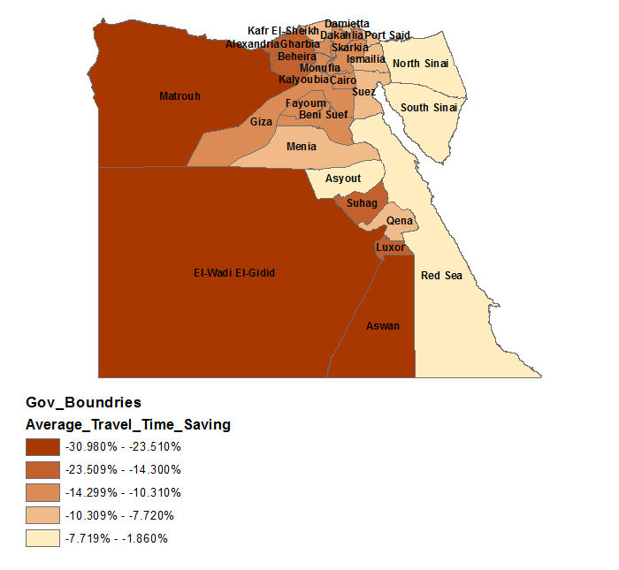

We then use the ICGE model to estimate the short-run and long-run impacts of the project on both national and regional variables. The main results are discussed below.

5.1. National Results

Table 1 presents simulation results for national aggregates in both short run and long run. When growth in gross domestic production (GDP) is positive, efficiency gains are realized from the Corridor. GDP is positive for Real Household Consumption, Real Government Expenditures, international exports, and international imports. However the Corridor’s impact on aggregate investment is negative.

Table.1 Short Run and Long Run Results on Selected National Variables
(in percentage change)

 | Short Run | Long Run
Real GDP | 0.249 | 0.241
Equivalent Variation | (0.075) | 0.706
Real Household consumption | (0.115) | 0.435
Real Aggregate Investment | - | (0.401)
Real Government Expenditures | 0.125 | 0.45
International Export Volume | 0.971 | 0.24
International Import Volume | (0.394) | 0.425

Gains in efficiency realized from the corridor in both short and long run. Welfare gains (equivalent variation) are revealed only in the long run. The export volume and government expenditure are the positive component of the GDP in the short run, while in the long run all the real GDP component have positive change except the real investment expenditures.

Table 2. Sectoral Activity Level and Employment (percentage change)

 | Short Run |  | Long Run
 | Activity Level | Employment | Activity Level | Employment
AGR | 0.08 | 0.541 | 0.09 | 0.33
MNE | 0.03 | 1.15 | 0.19 | 0.3
IND | 0.13 | 0.6 | (0.01) | (0.02)
ELC | (0.26) | (0.62) | 0.28 | 0.41
CNT | 0.07 | 0.18 | (0.32) | (0.3)
RTL | 0.1 | 0.48 | 0.15 | 0.33
TRN | (1.45) | (7.53) | (2.07) | (3.73)
ADP | 0.08 | 0.33 | 0.17 | 0.24
OTS | 0.11 | 0.13 | 0.38 | 0.43

In the short run the change in employment is negative lead by the reduction in employment in both electricity and transportation sectors. The total employment has a positive change in the long run due to high increase in the electricity and other services sectors employment which follow the increase in their activity level in the long run and the lesser degree of the transportation sector negative change. Table 3 shows that both the activity level and employment are in the same direction in both short and long run.

Real household consumption increases in the long run reflecting welfare gains by 0.435%. In the short run the change is negative affected by the decrease in the activity level (employment effect) only since the national real wage is assumed fixed.

The change in real investment expenditures prevails only in the long run since the re-location effect becomes relevant as factors are free to move between regions; new investment decisions define marginal re-location of activities. Table 2 shows that the impact on real investment expenditure in negative. Given the parameter of the model the activity effect on transportation sector related to less resource intensive shipment dominates the price effect. It means that even though lower transportation cost implies lower cost of capital creation, the real investment decreases. In our simulation, the reduction of the transportation requirement of output generates a stronger effect on the capital market. Thus the associated decrease in output of transportation sector creates an excess supply of capital which is adjusted in the long run through lower levels of investment.

5.2. Regional Results

The analysis now focuses on the Corridor’s effects at regional level in the short run and upon the allocation of economic activity in the long run. The model results on some selected regional variables are summarized in table and table. The impact on GRP in the short run is positive in almost all regions due to the high increase in the export only since the household consumption is negative in most regions. The positive change on household consumption in the short run is limited to the regions that gain high savings in travel time to other regions.

Table 4. Short-Run Results on selected Regional Variables (percentage change)

 |  | GRP | Household Consumption | Export
REG_1 | Cairo | 0.139 | -0.672 | 1.374
REG_2 | Alexandria | 0.115 | -0.77 | 0.796
REG_3 | Port Said | 0.015 | -1.07 | 0.858
REG_4 | Suez | 0.133 | -0.889 | 1.013
REG_5 | Damietta | 0.171 | -0.274 | 0.621
REG_6 | Dakahlia | 0.033 | -0.916 | 2.029
REG_7 | Skarkia | 0.041 | -0.527 | 0.956
REG_8 | Kalyoubia | 0.186 | -0.636 | 0.924
REG_9 | Kafr El-Sheikh | -0.18 | -1.122 | 0.991
REG_10 | Gharbia | 0.035 | -0.693 | 1.038
REG_11 | Monufia | 0.041 | -0.666 | 0.965
REG_12 | Beheira | 0.066 | -0.721 | 0.843
REG_13 | Ismailia | -0.033 | -0.922 | 2.143
REG_14 | Giza | 0.08 | -0.751 | 0.905
REG_15 | Beni Suef | 0.238 | 0.125 | 1.09
REG_16 | Fayoum | 0.155 | -0.281 | 1.213
REG_17 | Menia | 0.147 | 0.691 | 0.436
REG_18 | Asyout | 0.052 | -0.28 | 0.897
REG_19 | Suhag | 1.422 | 3.044 | 1.167
REG_20 | Qena | 1.568 | 3.558 | 1.112
REG_21 | Aswan | 2.582 | 8.907 | 0.572
REG_22 | Luxor | 1.745 | 4.816 | 0.442
REG_23 | Red Sea | 0.105 | -0.464 | 0.682
REG_24 | El-Wadi El-Gidid | 4.642 | 13.138 | 0.008
REG_25 | Matrouh | 0.57 | 3.034 | 2.957
REG_26 | North Sinai | -0.041 | -0.787 | 1.281
REG_27 | South Sinai | 0.063 | -0.541 | 1.047

Figure 6 is a map of the distribution of the short run results across regions. GDP (part a) and household consumption (part b) impacts across governorates show those governorates that win travel time savings via the Corridor’s existence tend to gain the most efficiency benefits, while governorates in the Delta region tend to gain less. The impact on export is positive in all regions. However, the regions that gain more export benefits are the regions that locate close to the port (Alexandria).

Figure 6. Regional Results in the Short Run

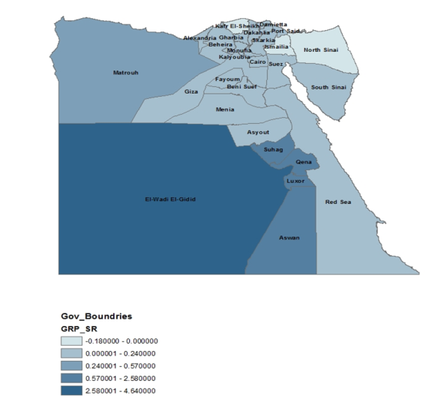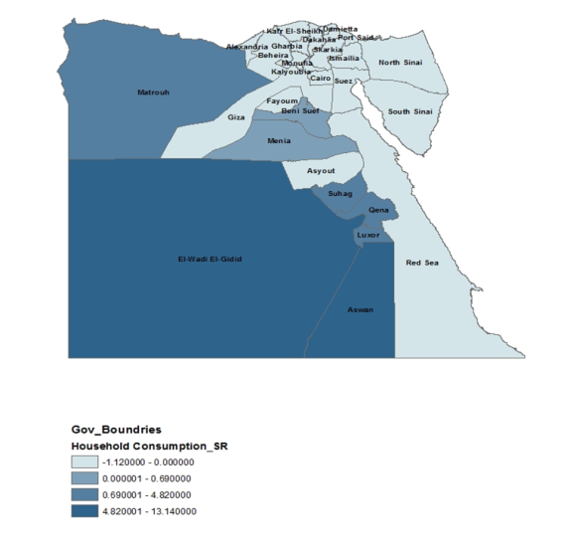
(b)
(a)

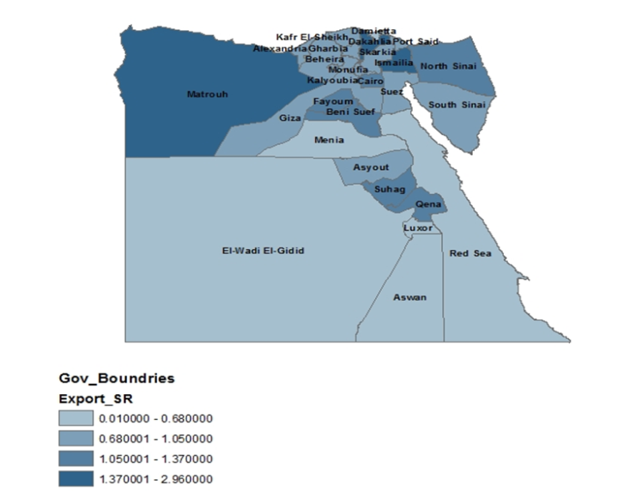
(c)

Table 5. Long-Run Results on selected Regional Variables (percentage change)

 |  | GRP | Household Consumption | Investment Expenditures | Export
REG_1 | Cairo | 0.195 | 0.444 | -0.003 | 0.186
REG_2 | Alexandria | 0.184 | 0.420 | 0.070 | 0.153
REG_3 | Port Said | 0.266 | 0.637 | 0.161 | 0.153
REG_4 | Suez | 0.099 | 0.370 | -0.079 | 0.206
REG_5 | Damietta | 0.209 | 0.483 | 0.085 | 0.128
REG_6 | Dakahlia | 0.125 | 0.449 | -0.013 | 0.293
REG_7 | Skarkia | 0.153 | 0.464 | -0.078 | 0.156
REG_8 | Kalyoubia | 0.197 | 0.417 | 0.008 | 0.263
REG_9 | Kafr El-Sheikh | 0.407 | 0.761 | 0.407 | -0.011
REG_10 | Gharbia | 0.148 | 0.411 | -0.147 | 0.076
REG_11 | Monufia | 0.142 | 0.442 | -0.074 | 0.017
REG_12 | Beheira | 0.371 | 0.581 | 0.043 | -0.048
REG_13 | Ismailia | 0.117 | 0.433 | 0.000 | 0.232
REG_14 | Giza | 0.197 | 0.482 | 0.109 | 0.096
REG_15 | Beni Suef | 0.122 | 0.328 | -0.389 | 0.233
REG_16 | Fayoum | -0.191 | 0.004 | -0.553 | 0.137
REG_17 | Menia | 0.273 | 0.416 | -0.160 | 0.473
REG_18 | Asyout | -0.890 | -0.576 | -1.061 | 0.219
REG_19 | Suhag | -0.650 | -0.601 | -2.249 | 0.790
REG_20 | Qena | -0.035 | 0.100 | -1.537 | 0.995
REG_21 | Aswan | 3.585 | 2.784 | 0.779 | 2.273
REG_22 | Luxor | 1.223 | 1.368 | -0.429 | 1.016
REG_23 | Red Sea | -0.505 | -0.333 | -0.641 | 0.243
REG_24 | El-Wadi El-Gidid | 4.323 | 4.556 | 1.136 | 2.116
REG_25 | Matrouh | 2.151 | 2.065 | 0.148 | 1.855
REG_26 | North Sinai | 0.138 | 0.681 | 0.058 | 0.096
REG_27 | South Sinai | 0.227 | 0.570 | 0.119 | 0.150

In the long run the results is some different. Not only the regions that win the most saving in transportation cost gain efficiency and welfare benefits, as the case in the short run, but also other regions in the country started to gain the corridor benefits since the result on household consumption turned to positive in most regions and the result on export is positive in almost all regions too however, the regions around the corridor still gain more benefits.

Figure 7. Regional Results in the Long Run

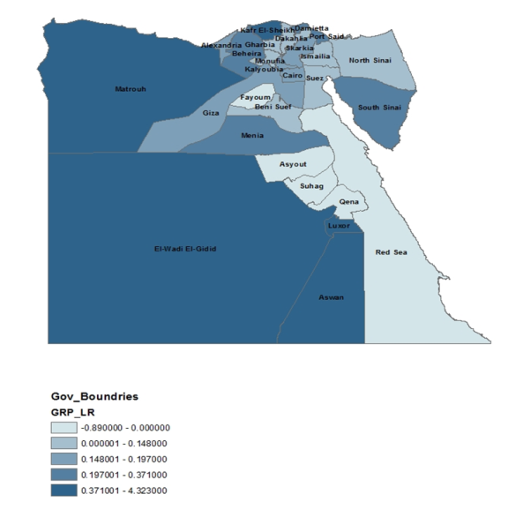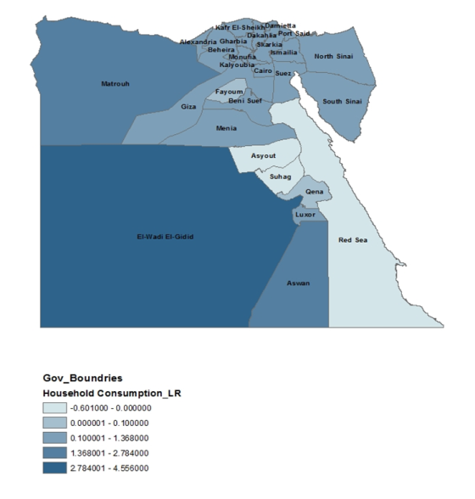
(b)
(a)

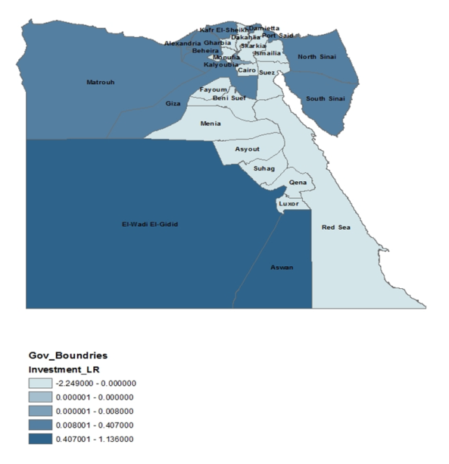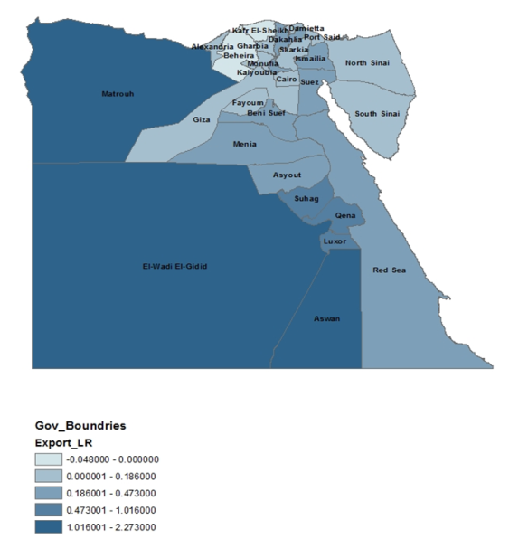
(c)
(d)

Despite the reduction in the aggregate investment, we should notice positive changes in real investment in some regions. Regions that face increase in their capital stock are mainly those are in the immediate area of influence of the project. Figure 5c shows positive impacts on investment around the Corridor especially in the southern governorates and Western Desert, but the Sinai Desert also gains more benefits.

5.3. Structural Analysis of GRP results

The structure analysis of the GRP in both short and long run explain 87% and 92% of the change in GRP respectively. In the short run, high import penetration have a negative effect on GRP. Regions that suffering from high transportation cost for exports will benefit more from the project in the short run. Also, high unemployment rate is associated with positive change in GRP that the activity level is affected only by employ more people i.e. since capital stock is fixed.

In the long run regions who have high transportation cost to sell its products, they will benefit more from the reduction in transportation cost associated with the corridor. For the regions that rely more on imported and interregional inputs there GRP will be lower. However, the high share of export in total sales is associated with a positive change in regions GRP.

A main finding is the entire structure coefficients that drive this broad picture are highly significant. However, one should notice that the coefficient related to the variable AVGTRF (average transportation tariff rate for regional production) is an order magnitude higher than the other coefficients in both short and long run. It means that giving the structure of the model and the simulation, the Development Corridor project would be potentially very important for the most remote regions in Egypt.

Table 6. Structural Analysis of Short-Run GRP Results
Dependent Variable: GRP_SR
Variable | Coefficient | Std. error | t-Statistic | Prob.
Constant | 7.434982 | 2.528222 | -3.89 | 0.008
FOR | -0.631036 | 0.162046 | -5.99 | 0.001
TRFSUP | -0.105501 | 0.17619 | 3.66 | 0.000
AVGTRF | 36.07196 | 9.84475 | 4.00 | 00001
COSTEXP | 0.000361 | 0.000904 | 2.54 | 0.001
UNEP | 5.664157 | 2.231673 | 2.94 | 0.019
R-Squared | 0.8765
GRP_SR= percentage change in GRP in the short run; FOR= import share in total consumption; TRFSUP= transportation margins over basic flows; AVGTRF= average transport tariff rate for domestic products; COSTEXP= export transportation cost; UNEP= unemployment rate.

Table 7. Structural Analysis of Long-Run GRP Results
Dependent Variable: GRP_LR
Variable | Coefficient | Std. error | t-Statistic | Prob.
Constant | 15.32004 | 2.088214 | 7.34 | 0.000
INTER | -0.560492 | 0.192424 | -2.91 | 0.008
FOR | -1.00467 | 0.1310692 | -7.67 | 0.000
EXP | 0.45058 | 0.0087962 | 5.12 | 0.000
TRFMKT | -0.1778614 | 0.159307 | -11.16 | 0.000
AVGTRF | 42.17347 | 8.765896 | 4.81 | 0.000
R-Squared | 0.9187
GRP_LR= percentage change in GRP in the long run; INTER= share of inter-regional flows; FOR= shares of import to other countries; EXP= shares of export to other countries; TRFMKT= transportation margins over basic flows to market. AVGTRF= average transport tariff rate for domestic products.

6. Summary and Conclusion

In this paper, we used an integrated spatial CGE model to assess the interregional economic effects of a new highway network proposed for Egypt as a main component of the Development Corridor project on national economic growth and regional activates. The Corridor is connected to Egypt’s current highway network so as to calculate its impacts on travel time among Egypt’s main cities (changes in the macro O-D matrix). We map network changes via a gravity model to the ICGE model in order to estimate some economic impacts of the corridor.

Results show the Corridor’s presence yields string positive effects on Egypt’s economy. Both nationally and regionally, the measured impacts are positive, reflecting net gains in efficiency. The governorates located in south Egypt and west of the Nile River tend to obtain the most efficiency gains. Hence, it appears the project should lessen regional disparities among governorates.

This paper is a first cut at estimating the economic benefits of the Development Corridor project. We did not consider the construction phase of the project in the analysis, however. This certainly should be considered in a final analysis as should the costs of the Corridor, including the manner by which Egypt will pay for it. Still it is clear an integrated spatial CGE model can be useful in estimating the potential economic impacts of transportation projects in Egypt. In this vein, this or similar models should support government decisions on such projects.

References

Bairoch, Paul. (1988) Cities and Economic Development: From the Dawn of History to the Present. University of Chicago Press.
Brocker, J. 1998. "Operational Spatial Computable General Equilibrium Modeling." The Annals of Regional Science 32: 367-387.
De Palma, Andre, Lindsey, Robin, Quinet & Vickerman, Roger. (2011) A Handbook of Transport Economics, Edward Elgar Publishing Limited, USA.
Edwards, Mary E. (2007). Regional and Urban Economics and Economic Development: theory and Methods, Auerbach Publications, Taylor & Francis Group, LLC.
El-Baz, Farouk. (2007) .Development Corridor: Securing a Better Future for Egypt, El-Ain Publishing House, Egypt.
_____. (2011). “A Corridor to Secure Egypt’s Future”. Built and Natural Environment Research Papers, No. 4, pp. 5-10.
Felkner, J., A. Wilson, and B. Blankenspoor. (2012). “Accessibility and Transport Costs in Egypt: An Empirical Analysis”. In: Reshaping Egypt’s Economic Geography, vol. 2. Washington, DC: World Bank.
Glaab, Charles N. and A. Theodore Brown. (1967) A History of Urban America. New York: Macmillan.
Haddad, E. A., Lahr, M. L., Elshahawany, D. N., Vassallo, M. (2015) “Regional Analysis of Domestic Integration in Egypt”, Working Paper, TD Nereus 01.
Haddad E. A. and G.J.D. Hewings. (2005), “Market Imperfections in a Spatial Economy: Some Experimental Results,” Quarterly Review of Economics and Finance, 45, 476-496.
Haddad, Eduardo. (2009). “Interregional Computable General Equilibrium Models”, Advances in Spatial Science, PP 119-154.
Haddad, E. A., F.S. Perobelli, E.P. Domingues, and M. Aguiar. (2011). “Assessing the Ex Ante Economic Impacts of Transportation Infrastructure Policies in Brazil,” Journal of Development Effectiveness, 3, 44-61.
Helpman and Krugman. (1985). Market Structure and Foreign Trade. Cambridge, MA: MIT Press.
Kim, Euijune, Geoffrey Hewings. (2003). “An Application of Integrated Transport Network-Multiregional CGE Model II: Calibration of Network Effects of Highway, Paper Presented at the 42nd Southern Regional Science Association in Louiseville, KY, April 10-12.
Kim, Euijune, Geoffrey Hewings and Chowoon Hong. (2004). “An Application of an Integrated Transport Network-Multiregional CGE Model: a Framework for the Economic Analysis of Hghway Projects”, Economic Systems Research, Vol. 16, No.3, pp. 235-258.
Kim, Euijune, Hong Kim and Geoffrey Hewings. (2011). “An Application of an Integrated Transport Network-Multiregional CGE Model: An Impact Analysis of Government-Financed Highway Projects. Journal of Transport Economics and Policy, Vol. 45, pp. 223-245.
Martin, Philippe and Carol Rogers. (1995), “Industrial Location and Public Infrastructure”, Journal of International Economics, Vol. 39, pp. 335-351.
NCFRP. (2011). Framework and tools for Estimating Benefitsof Specific Freight Network Investment. Wachington, DC: Nationl Academy of Science, Report No. 12.
OECD. (2008). ITF Round Tables the Wider Economic Benefits of Transport: Macro-,Meso-and Micro-Economic Transport Planning and Investment Tools. OECD Publishing
Rodrigue, JP, C Comtois and B Slack. (2009). The Geography of Transport Systems. New York: Routledge
Rocker, J. and M. Schneider. 2002. “How Does Economic Development in Eastern Europe Affect Austria's Regions? A Multiregional General Equilibrium Framework”, Journal of Regional Science 42 (2): 257-285.
Sakamoto, Hiroshi. (2012). “CGE Analysis of Transportation Cost and Regional Economy: East Asia and Northern Kyushu”, Regional Science Inquiry Journal, Vol. IV, No. 1, PP 121-140.
Srivastava, Pradeep. (2013). “Regional Corridors Development: A Framework”, Journal of International Commerce, Economics and Policy, Vol.4, No.2.
Vikerman, Roger. (1995) “Location, Accessibility and Regional Development: The Appraisal of Trans-European Networks, Transport Policy, Vol. 2, Issue. 4, pp. 225-234.
Wallis, I. Booz. (2009) “Economic Development Benefits of Transport Investment”, Land Transport New Zealand Research Report No. 350.
World Bank. (2008). Brazil Evaluating the Macroeconomic and Distributional Impacts of Lowering Transportation Costs, Report No. 40020-BR.

Table A.1. Sectors/products in the ICGE Model

1. Agriculture, forestry and fishing
2. Mining and quarrying
3. Manufacturing
4. Electricity, gas, steam and air conditioning supply
5. Construction
6. Wholesale and retail trade; repair of motor vehicles and motorcycles
7. Transportation and storage
8. Other services
9. Public services

Table A.2. Change in Travel Time to/from Governorates due to the Corridor (in percentage change)

According to the Ministry of Transport of Egypt, 94% of the nation’s freight is transported by road (http://www.comcec.org/).
Details about the ICGE model can be found in Haddad et al. (2015).
More details in Haddad et al. (2015).
We used the origin-destination (O-D) cost matrix function within the ArcGIS’s Network Analyst software extension.

