**Income Inequality: Some Empirical Evidence from the Brazilian States**

|  |  |
| --- | --- |
| ***Helder Ferreira de Mendonça*** Fluminense Federal University  Department of Economics, and National Council for Scientific and Technological Development (CNPq) | ***Diogo Martins Esteves*** Fluminense Federal University  Department of Economics |
| [helderfm@hotmail.com](mailto:helderfm@hotmail.com) | diogomartinse@yahoo.com.br |

## Abstract

This paper provides some empirical evidence to assess the impact of socioeconomic and political variables on different measures of income inequality based on the 27 units of the Brazilian federation in the period from 1999 to 2008. The Brazilian experience is a good example for understanding the income inequality policies in developing countries. The findings suggest that the improvement observed along the period under analysis is a result of the combination of: increase trade openness, technological and financial development, reduction of the unemployment rate, adoption of social policies that imply a direct effect on the poorest families, and adoption of mechanisms that inhibit corruption.

## Key words: Income inequality; Socioeconomic and political variables; States; Brazilian economy.

## Resumo

O artigo fornece evidências empíricas para avaliar o impacto de variáveis socioeconômicas e variáveis políticas sobre diferentes medidas de desigualdade de renda para as 27 unidades da federação brasileira no período de 1999 a 2008. A experiência brasileira é um bom exemplo para entender as políticas de desigualdade de renda em economias em desenvolvimento. Os resultados sugerem que a melhora observada no período analisado foi resultado de uma combinação de: aumento do comércio internacional, progresso tecnológico e financeiro, redução da taxa de desemprego, adoção de políticas sociais focalizadas nas famílias mais pobres e combate a corrupção.

## Palavras chave: Desigualdade de Renda; Variáveis socioeconômicas e políticas; Estados; Economia brasileira.

**JEL classification:** D31, I32, R10.

**Área 12 -** Economia Social e Demografia Econômica**1. Introduction**

The analysis on the main causes of income inequality and how to mitigate it is essential. A traditional question in the literature on income inequality is the effect caused by an increase in the trade openness. The main idea is that in developing economies, where the inequality is higher and unskilled labor is predominant, an increase in the trade openness may induce an increase in the exportation which, in turn, reduces income inequality (Easterly, 2005). As suggested by Nissanke and Thorbeck (2006), concomitant to the increase in the openness, an increase in the foreign direct investment together with new technologies and know-how is expected. As a consequence, there would be an increase in the productivity and in the output that would be capable of increasing wages and employment.[1]

The globalization process also interferes in the income distribution. According to Adams (2008), in this context, the use of patents as a mechanism for the defense of intellectual property rights and to stimulate innovations in developing economies would imply a reduction in the inequality. The same result is observed by Acemoglu and Newman (2002). According to this view, in developing economies, unskilled labor is abundant and thus technological progress improves productivity. As a result, through a knowledge spillover effect (see Fang, Huang, and Wang, 2008) the income of unskilled workers could increase allowing a better income distribution.

There is no doubt that unemployment is the main cause of poverty. The relation between unemployment and income inequality is well-known in the literature since the Blinder and Esaki (1978) study. The basic idea is that unemployment tends to affect the less skilled and the low-paid more than other groups. As observed by Martínez, Ayala, and Ruiz-Huerta (2001) an unemployed person tends to be concentrated in the lower end of the income distribution.

The success of social polices is controversial in literature. There is empirical evidence that increases in the minimum wage are an important tool for combating income inequality (see Lemos, 2009). Moreover, as pointed out by Engel, Galetovic, and Raddatz (1999), and Goñi, López, and Sérvén (2011), government transfers are an efficient mechanism for reducing inequality. In contrast, since Feldstein (1974), there is the argument that social spending (welfare, social security, etc.) increases income inequality. The idea is that high income families receive a disproportionately large percentage of the benefits (Forteza and Rossi, 2006).

Another relevant issue is the effect of the political competition. The study of the relationship between social and political variables is made since Adelman and Morris (1965). As observed by Rupasingha and Goetz (2007) a greater political competition leads to a lower level of poverty. Connected with political decisions, the analysis on corruption and income inequality is also an object of investigation. The predominant argument is that an increase in the corruption causes greater income inequality (see Gupta, Davoodi, and Alonso-Terme, 2002; Dincer and Gunalp, 2008; and Apergis, Dincer, and Payne, 2010).

This paper addresses the above issues taking into account the Brazilian case. The analysis on this country deserves attention because Brazil is one of the most important leaders of the emerging economies, it is the seventh largest economy in the world, and recently it has been successful in decreasing income inequality. A combination of consolidated democracy, stable macroeconomic environment, and the adoption of several initiatives by the government against poverty (for example, implementation of the Bolsa Família program, successive real increases in the minimum wage, etc.) are an indication that Brazil is experiencing a good period.

A Brazilian characteristic is that, as well as in the USA, the geographical differences cannot be neglected. Hence, first step in this study is to observe the behavior of the main factors that can explain income inequality for each region. This analysis allows one to identify where each factor is more effective. Second step presents empirical evidence using a dynamic panel-data framework that draws on 27 units of the Brazilian federation in the period from 1999 to 2008. In short, the main objective of this research is to provide some empirical evidence to assess the impact of socioeconomic and political variables on different measures of income inequality.

The remainder of this paper is organized as follows. The next section shows the data used in this research and provides a regional analysis for the Brazilian case. Section 3 presents empirical evidence, through panel data analysis, of the impact of socioeconomic and political variables on different measures of income inequality based on 27 units of the federation in the period from 1999 to 2008. The last section presents the conclusion.

**2. Income inequality: regional analyses**

Since 1999, after the adoption of flexible exchange rate regime, inflation targeting, and fiscal primary surplus, Brazil has been successful in macroeconomic stabilization which, in turn, has allowed an improvement in the income distribution. Based on the literature concerning income inequality, several socioeconomic variables (see Roine, Vlachos, and Waldenström, 2009; Easterly, 2005; and Acemoglu, 2002), as well as political (see Gupta, Davoodi, and Alonso-Terme, 1998; and Alt and Lassen, 2010), are considered in this study. The fact that Brazil has a continental dimension implies that there are regional differences that cannot be neglected. Hence, this section shows the regional behavior of the variables that will be used in the empirical model taking into account the period from 1999 to 2008.[2]

For decades income inequality in Brazil was very high in comparison with other countries (Gasparini, 2003). However, at the end of the 1990s there existed evidence that the inequality was decreasing. In order to provide robustness, and as a way of observing this movement, three indicators are considered in this analysis:

- Gini index – measures the inequality of a distribution, a value of “0” expressing total equality and a value of “1” maximal inequality. This coefficient is the result of information available from Monthly Employment Survey - Brazilian Institute of Geography and Statistics (IBGE).

- Theil index is a statistic used to measure [economic inequality](http://en.wikipedia.org/wiki/Economic_inequality). This index is calculated based on information available from Monthly Employment Survey – IBGE. As the Gini coefficient, a value of “0” expresses total equality and a value of “1” maximal inequality.

- Ratio of income of richest 10% to income of poorest 40% of total population (10%/40%). This index is calculated based on information available from National Research for Sample of Domicile (PNAD – IBGE). This ratio is readily interpretable, by expressing the income of the rich as multiples of that of the poor.

The behavior of these indicators over time shows that, independent of the region, there is an improvement in the standard of living (all indicators fall at the end of the period). Figure 1 shows that the Northeast region has the worst level of inequality for all indices during most of the period (the line in graphs is the farthest from the center). However, there was an improvement in the Northeast region and in the end of the period the Midwest region occupied the worst position. The Midwest region had the worst performance in reducing inequality over time. Between 1999 and 2008 the Gini index fell by only 4.3%, the Theil index fell by 8.1%, while the ratio 10%/40% decreased by 15.3%. The region with the best performance is the South that, besides being the region with the smallest inequality throughout the period, showed the steepest decline in inequality (12% decrease in the Gini index, 22.8% decrease in the Theil index, and 32.4% decrease in the ratio 10%/40%).

**Figure 1**

*Inequality indicators*

|  |  |
| --- | --- |
|  |  |
|  | |

*Source:* Brazilian Institute of Geography and Statistics.

Regarding the behavior of economic variables, a variable that is pointed out as relevant for analyzing income inequality is the trade openness (Rodrik, 1997; Easterly, 2005; and Nissanke and Thorbeck, 2006). One reason is that the relation between distributional framework and trade openness is partly related to the extent that productive factors are used in the production of its main products. It is important to highlight that diversity of tax laws and labor laws increases the difference among countries but this effect is negligible when states of the Brazilian federation are considered in the analysis. Hence, based on the information gathered from Ministry of Development, Industry and Foreign Trade (MDIC) and Central Bank of Brazil (CBB), this study makes use of an indicator of trade openness between the states and foreign nations (*OPEN* = (total imports + total exports)/GDP).

In contrast with what is observed in the inequality indicators, although the Midwest region has the worst performance over time, there was a considerable improvement in the trade openness after 2002 and it surpassed the Northeast in 2008. The Southeast region has an intermediate and stable performance among the regions. The North is the region with the greatest openness, but the South has approached this level over time (see figure 2).

**Figure 2**

*Trade openness (OPEN)*

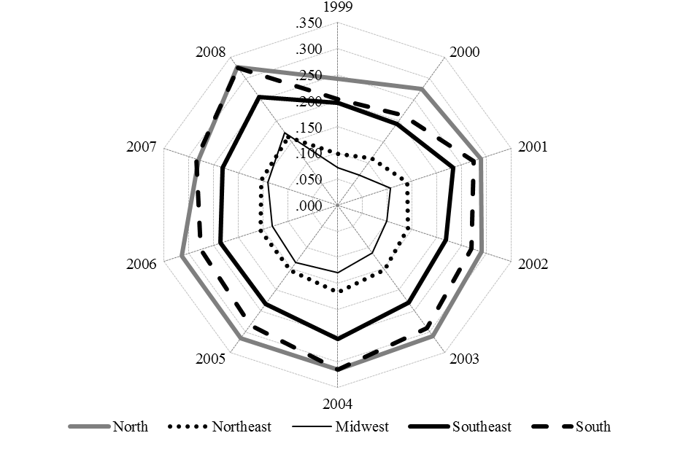

*Source:* Ministry of Development, Industry and Foreign Trade and Central Bank of Brazil.

*Note:* OPEN is the sum of imports and exports divided by GDP

Another variable that is relevant for the analysis concerning income inequality is the technological development (Acemoglu and Newman, 2002; Madsen, 2007; and Fang, Huang and Wang, 2008). In this analysis the ratio of patents in each state with respect to total patents granted by Brazil in the year (*PAT* - information available from National Institute of Industrial Property) is used as a proxy for technological development due to the well-known relationship between them.[3] This proxy allows one to observe the average technological growth of the country. It is important to note that even in the case where a state has increased the number of patents, it can have a decrease in this variable if the growth is lower than that observed in the country’s average growth. Furthermore, with the objective of facilitating the interpretation of the results the proxy is normalized to range from 0 to 1. Figure 3 allows one to see that the Southeast region concentrates a large part of the technological development whereas North and Midwest regions are negligible. We can see that the path of this indicator did not change considerably among the regions during the period.

**Figure 3**

*Technological development (Patents)*

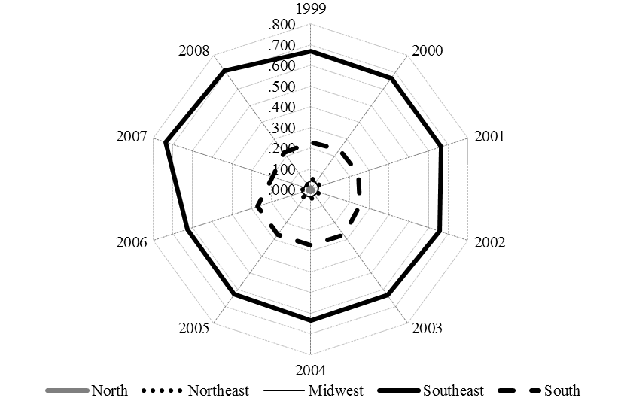

*Source:* National Institute of Industrial Property.

*Note:* PAT is the ratio of patents in each state with respect to total patents granted by Brazil.

Another relevant variable on income inequality is the financial development (see Greenwood and Jovanovic, 1990; Galor and Zeira, 1993; Aghion and Bolton, 1997; and Claessens and Perotti, 2005). As observed by Kumar (2005) individuals with access to financial services can safeguard against periods of low income or unexpected fluctuations in income and thus it improves resource allocation. Furthermore, a developed financial system implies access by poor people to financial services. Due to the fact that special savings deposits are used by the overwhelming majority of clients in Brazil’s banking system.[4] Therefore, using as reference the Brazilian banking statistics provided by CBB, the total balance of savings in December divided by the GDP of each state (in 2000 real terms) is used as proxy for the financial development (*FD*). Figure 4 allows one to see that, independent of the region, the first years in the sample show a fall in this indicator. It is important to note that although the Southeast has the better performance over time, the South and Northeast regions presented a strong recuperation at the end of the period.

**Figure 4**

*Financial Development*

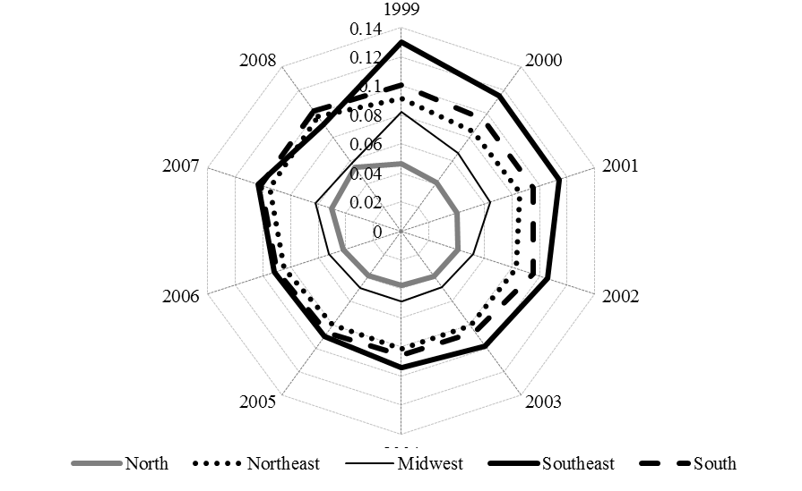

*Source:* Central Bank of Brazil.

*Note:* FD is saving divided by GDP.

It is important to highlight that in the Brazilian case increases in the minimum wage is not limited to someone who receives it. In fact, increases in the minimum wage affect positively a range around it (without increase in unemployment rate) in both formal and informal sectors of the economy (Lemos, 2009). Moreover the effects of the increase are not reduced to wages but also to pension benefits and unemployment insurance.[5] Therefore, a change of this variable changes in a considerable manner the income of the population. With the intention of capturing these effects, the annual variation of the minimum wage in each state (in 2000 real terms) was considered (*MW*) in this study. Figure 5 shows the path for the variation of the minimum wage defined by the federal government and those practiced in states which adopted a different value. In general it is observed that after a state adopted a minimum wage above the national, the tendency is for this state to follow the behavior of the national minimum wage.

**Figure 5**

*Minimum Wage (annual variation)*

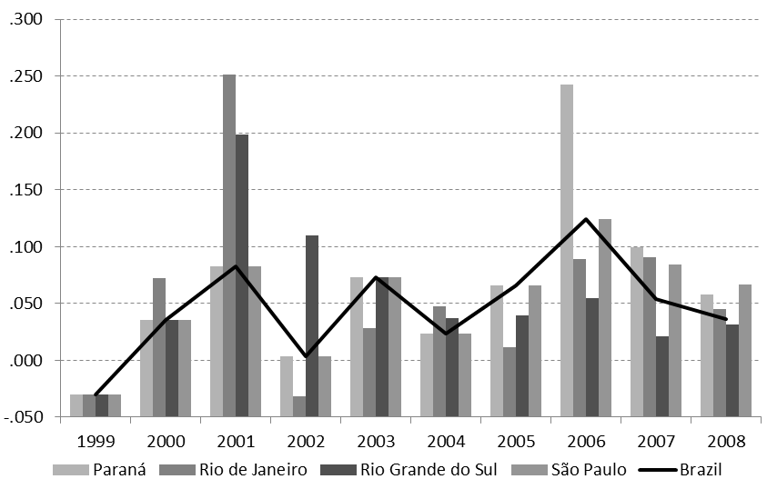

*Source:* Ministry of Labor and Employment and States’ Laws.

*Note:* MW is the annual variation of minimum wage divided by minimum wage.

The relevance of the unemployment in the analysis on inequality is unquestionable. As a consequence, unemployment rate by state - *UNE* - (formal and informal sectors are considered - information available from Institute for Applied Economic Research – IPEA) is also included in this study. Figure 6 shows that all regions had a decline in the unemployment rate. However, there exist significant differences among the regions. The unemployment rate in the Northeast region declined only 3.5% in ten years and had the worst performance. In contrast the South region had a decrease in the unemployment rate of 38%. The Southeast region is one that has the highest unemployment rate in the country, but at the end of the period, had a performance near to those observed in Northeast and Midwest regions (down 27.4% making it the second best performance).

**Figure 6**

*Unemployment rate*

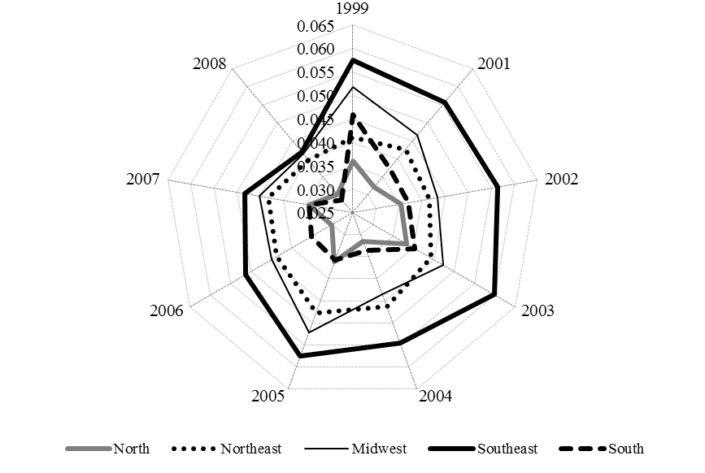

*Source:* Institute for Applied Economic Research.

*Note:* UNE unemployment rate (formal and informal)

Undoubtedly, the most famous policy adopted by the Federal Brazilian Government for reducing the poverty in the period under analysis was the Bolsa Família program. This program was initiated in 2004 and according to it, poor families with children receive an average of R$70.00 (about US$40) in direct transfers. This right is guaranteed to these families since they commit to keeping their children in school and taking them for regular health checks. The Ministry of Social Development and Fight against Hunger (MSD), through this social initiative, reached a major portion of the country’s low-income population (more than 46 million people).

Bolsa Família reaches only a share of the population that has per capita income lower than R$ 140.00 per month. Therefore, the ratio Bolsa Família/population allows one to capture the real weight of the program beneficiaries compared to the total population. It is important to note that although another measure, such as the number of Bolsa Família/poor population ratio can be used, it implies some distortions. In regions where there are fewer poor, an increase in the number of Bolsa Família will create a huge impact on the Bolsa Família/poor population ratio, but it falls short in capturing the effect on the income distribution of the total population. Hence with the objective of capturing the inequality effect and based on data available from IPEA, the ratio (number of Bolsa Família/population) of each state (*BF*) is considered in this analysis.

As can be seen through figure 7 the first three years of the program indicate growth in all regions. Since the program has poor families as its target, it is not a surprise that the South region had the lowest growth in the period (18%). In contrast, the North region had an increase of 93.5% and the Northeast region is the one that had the largest *BF*.

**Figure 7**

*Number of Bolsa Família/population*

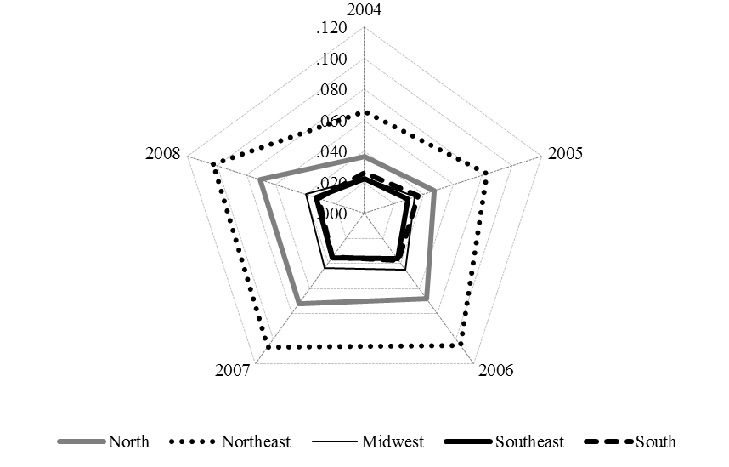

*Source:* Ministry of Social Development and Fight against Hunger.

*Note:* BF is the number of Bolsa Família/population ratio.

As a manner of considering the possibility of political factors having influenced the income distribution, some political variables are included in this analysis. According to Levitt and Poterba (1999) and Rupasingha and Goetz (2007) a democratic system is related to a lower poverty level. Hence, the political change in the states is also considered in this study. Since in the period 1999 to 2008 there were three mandates in the states (1999-2002, 2003-2006, and 2007-2010) an indicator (*PC*) was built through the use of dummy variables (assume value “1” if previous government’s party is different from the current, otherwise assumes value “0”).

The information in table 1 shows that it is common in the period for a political party to stay in power for two or more mandates consecutively. In only 6 states this phenomenon was not seen. It is observed that the states in the South region are classified with two (Paraná and Santa Catarina) and three (Rio Grande do Sul) political changes in the period. Since the South region has the best indices of income inequality, this observation can indicate the validity of the argument that democracy reduces inequality. However, it is not possible to assure this observation for the other regions.

**Table 1**

*Political change*

|  |  |
| --- | --- |
| **Changes** | **States and Federal District** |
| 0 | São Paulo (SE) |
| 1 | Acre (N), Amapá (N), Bahia (NE), Ceará (NE), Maranhão (NE), Pará (N),  Paraíba (NE), Piauí (NE), Rio Grande do Norte (NE) |
| 2 | Alagoas (NE), Distrito Federal (MW), Goiás (MW), Minas Gerais (SE),  Mato Grosso (MW), Pernambuco (NE), Paraná (S), Santa Catarina (S),  Sergipe (NE), Tocantins (MW) |
| 3 | Amazonas (N), Espírito Santo (SE), Rio de Janeiro (SE), Rondônia (N),  Roraima (N), Rio Grande do Sul (S) |

*Source:* Institute for Applied Economic Research.

*Note:* SE = Southeast; S = South; N = North; NE = Northeast; MW = Midwest.

Based on information gathered from Ministry of Finance, state’s social spending (welfare and social security) is also considered in this analysis and corresponds to the ratio of direct transfers to citizens and the state GDP (*SOC*). With the exception of the Northeast region, all regions had a decline in social spending in the period (see figure 8). One reason for this behavior is the Fiscal Responsibility Act approved by the Brazilian Congress in 2000 limits states expenses to 60% for its personnel in relation to the current net revenue.

**Figure 8**

*Social spending*

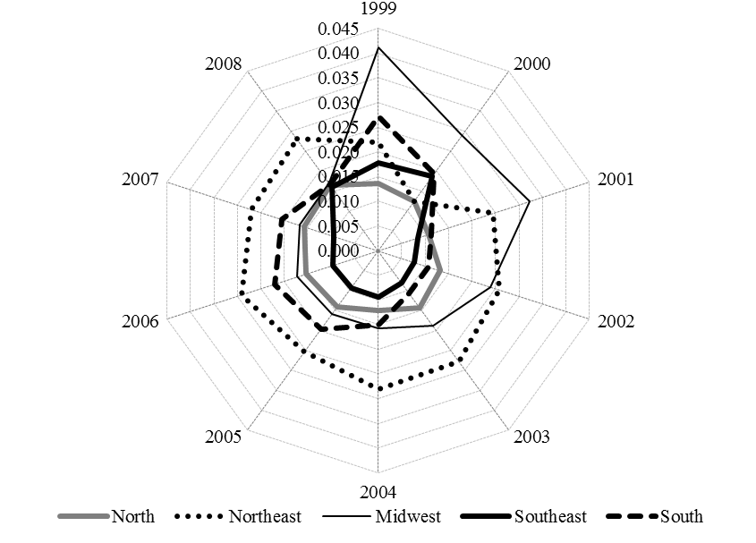

*Source:* Ministry of Finance.

*Note:* SOC is the ratio of direct transfers to citizens and GDP

Another variable that cannot be neglected is the effect of corruption on income inequality (Gupta, Davoodi, and Alonso-Terme, 1998; and Alt and Lassen, 2010). According to the corruption perceptions index disclosed by Transparency International, from 1999 to 2008, Brazil has worsened considerably (fell from 45th to 80th in the least corruption ranking). This study considers the variation of the corruption index (*CORR*) built by Boll (2009) as a result of the weighted average between socioeconomic variables (population and GDP state = 0.33) and the number of processes deemed illegal by the Brazilian Court of Audit (0.66) based on Annual Budget Law. The index ranges from “0” (lowest corruption) to “1” (highest corruption). Figure 9, depicts the average of corruption by state in the period. It allows one to see that the three highest indices belong to the Northeast region (Maranhão, Piauí, and Bahia) while the two lowest indices belong to the South region (Rio Grande do Sul and Santa Catarina).

**Figure 9**

*Corruption by state and federal district (average 1999-2008)*

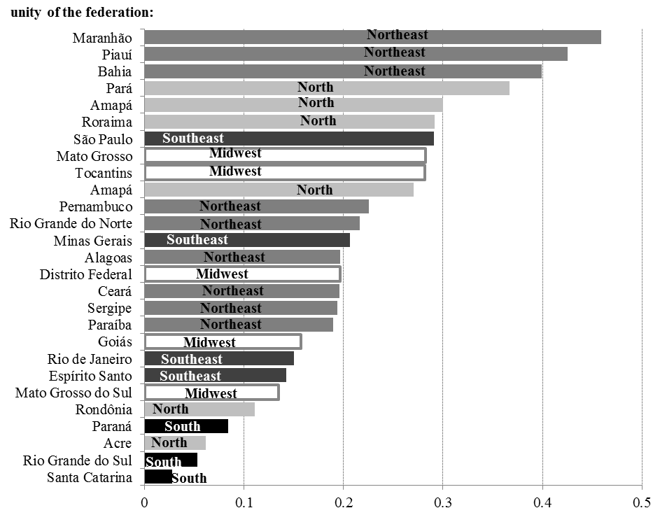

*Source:* Boll (2009).

*Note:* Horizontal axis is the average of corruption index.

**3. Empirical evidence**

Based on the variables presented in the previous section for each state in Brazil in the period from 1999 to 2008 (annual frequency data - totaling 270 observations) this section presents empirical evidence through system GMM panel data analysis (table 2 shows the descriptive statistics). According to Arellano and Bond (1991), an advantage of using the dynamic panel data method (GMM) over others is that, besides eliminating the non-observed effects on the regressions, the estimates are reliable even in the case of omitted variables. In particular, the use of instrumental variables allows the estimation of parameters more consistently, even in the case of endogeneity in explanatory variables and in the presence of measurement errors (Bond, Hoeffler, and Temple, 2001).

Traditional econometric models hypothesize that the error term is not correlated with its estimators. In cases where the estimators are correlated with the error term there is an endogeneity problem and, as a consequence, the result of regressions is inconsistent. Based on Wooldridge (2001) there are three hypotheses for the existence of endogenous variables: omitted variables, measurement error, and simultaneity in regressions. The empirical model developed in this study is subject to those problems. For example, trade openness can reduce income inequality which, in turn, can induce an increase in importation and thus changes the trade openness.

**Table 2**

*Descriptive Statistics*

|  |  |  |  |  |  |
| --- | --- | --- | --- | --- | --- |
|  | *Mean* | *Median* | *Maximum* | *Minimum* | *Std. deviation* |
| Gini | 0.5538 | 0.5545 | 0.6545 | 0.4486 | 0.0375 |
| Theil | 0.1788 | 0.1739 | 0.3266 | 0.0954 | 0.0412 |
| 10%/40% | 0.6376 | 0.6262 | 1.0369 | 0.3875 | 0.1106 |
| OPEN | 0.1707 | 0.1270 | 0.6051 | 0.0023 | 0.1446 |
| PAT | 0.0370 | 0.0043 | 0.6000 | 0.0000 | 0.0940 |
| FD | 0.0751 | 0.0795 | 0.1419 | 0.0282 | 0.0264 |
| MW | 0.0493 | 0.0535 | 0.2511 | -0.1411 | 0.0543 |
| UNE | 0.0419 | 0.0406 | 0.0801 | 0.0180 | 0.0126 |
| BF | 0.0338 | 0.0237 | 0.1208 | 0.0000 | 0.0375 |
| SOC | 0.0196 | 0.0195 | 0.0737 | 0.0017 | 0.0103 |
| CORR | 1.0955 | -0.0074 | 40.5000 | -1.0000 | 4.1627 |

A general solution to the problem of endogeneity is the use of instrumental variables. GMM models permit the use of instruments that are sequentially exogenous, thereby avoiding the endogeneity problem. Arellano and Bond (1991) proposed the estimation of first-difference GMM panel data as a way of eliminating non-observed effects. However, Alonso-Borrego and Arellano (1998), and Blundell and Bond (1998) showed that the first-difference GMM has a bias (for large and small samples) and low accuracy. Furthermore, the use of lags can create weak instruments (Staiger and Stock, 1997). Hence, Blundell and Bond (1998) recommend the use of the system GMM panel data estimation method instead of first-difference GMM. As proposed by Arellano and Bover (1995) and Blundell and Bond (1998) regressions in levels and first differences are combined (see Bond, Hoeffler and Temple, 2001).

In order to check the instruments in the models, the test of over-identifying restrictions (Sargan test) was performed as suggested by Arellano (2003). Furthermore, White’s heteroskedasticity consistent covariance matrix was applied on regressions. In addition, as proposed by Arellano and Bond (1991), test of second-order (m2) serial correlation was used. It is important to note that one premise of system GMM models is the non-correlation of the first difference of endogenous regressors, which implies that it is not necessary to perform unit root tests.

For the purpose of finding empirical evidence of the effect of the variables described in the previous section on inequality indices (*Gini*, *Theil*, and *10%/40%*) two sets of models using panel data (GMM system) were considered. A first set includes, besides the traditional variables in the literature (*OPEN*, *PAT*, and *FD*), socioeconomic variables (*MW*, *UNE*, and *BF*) in the models. The second set also considers the variables *OPEN*, *PAT*, and *FD*, but includes variables that are subject to some political interference (*PC*, *SOC*, and *CORR*). Hence:

(1) ;

(2) ;

(3) ;

(4) ;

(5) ;

(6) ; and

(7) ;

where, , and *X* is the inequality index (*Gini*, *Theil*, or *10%/40%*).

Tables 3, 4, and 5 show the estimation results for the models. Note that all regressions accept the null hypothesis in the Sargan tests and thus the over-identifying restrictions are valid. Furthermore, serial autocorrelation tests reject the hypothesis of the presence of serial autocorrelation.

The findings denote that, independent of the inequality indicator used in the estimations, the coefficient on the variable *OPEN* is negative and statistically significant in all specifications. This result is in agreement with the argument that an increase in the openness is an important mechanism to reduce income inequality. Although statistical significance is not observed in all specifications, *PAT* and *FD* coefficients are also negative which, in turn, suggest that technological and financial development contribute to a lower income inequality.

The *MW* coefficients are negative and statistically significant in the three specifications. This result indicates that the governmental policy of real increases in the minimum wages could be appropriate to combat income inequality. All specifications show that the coefficient of the *UNE* has statistical significance and positive sign. This observation implies that high unemployment is associated with high inequality. The result concerning the effect of the variable *BF* (coefficient is negative and significant) leaves no doubt about the relation between the variables.

**Table 3**

*GINI (system GMM)*

|  |  |  |  |  |  |  |  |
| --- | --- | --- | --- | --- | --- | --- | --- |
|  | *Eq. 1* | *Eq. 2* | *Eq. 3* | *Eq. 4* | *Eq. 5* | *Eq. 6* | *Eq. 7* |
| *GINIi,t-1* | 0.3661**  (0.1542)  [2.3728] | 0.2312*  (0.1328)  [1.7409] | 0.0311  (0.2349)  [0.1323] | 0.1436  (0.1679)  [0.8557] | 0.3959**  (0.1888)  [-2.0970] | 0.2413*  (0.1275)  [1.8922] | 0.6734***  (0.1583)  [4.2536] |
| *OPENi,t-1* | -0.3450***  (0.0945)  [-3.6483] | -0.3036***  (0.0970)  [-3.1281] | -0.2307*  (0.1377)  [-1.6747] | -0.2586**  (0.0818)  [-3.1578] | -0.2899***  (0.1055)  [-2.7472] | -0.2735***  (0.0801)  [-3.4104] | -0.2812**  (0.1083)  [-2.5960] |
| *PAT,t-1* | -0.1815*  (0.0998)  [-1.8189] | -0.2217**  (0.1053)  [-2.1061] | -0.1132  (0.0861)  [-1.3146] | -0.1983***  (0.0704)  [-2.8172] | -0.2195  (0.1685)  [-1.3027] | -0.2194**  (0.0862)  [-2.5435] | -0.1286  (0.1211)  [-1.0614] |
| *FDi,t-1* | -0.5812*  (0.3196)  [-1.8184] | -0.6857**  (0.3032)  [-2.2617] | -0.6188**  (0.2503)  [-2.4715] | -0.3778*  (0.2276)  [-1.6603] | -0.6792*  (0.3718)  [-1.8265] | -0.4910*  (0.2560)  [-1.9179] | -0.2623  (0.3304)  [-0.7940] |
| *MWi,t-1* |  | -0.0641*  (0.0383)  [-1.6697] |  |  |  |  |  |
| *UNEi,t-1* |  |  | 1.1295*  (0.6403)  [1.7638] |  |  |  |  |
| *BFi,t-1* |  |  |  | -0.2502***  (0.0899)  [-2.7830] |  |  |  |
| *PCi,t-1* |  |  |  |  | 0.0197*  (0.0114)  [1.7350] |  |  |
| *SOCi,t-1* |  |  |  |  |  | 1.3791**  (0.5954)  [2.3162] |  |
| *CORRi,t-1* |  |  |  |  |  |  | 0.0011***  (0.0004)  [2.8408] |
| *J-stat.* | 15.7519  p>0.35 | 16.8766  p>0.45 | 4.3807  p>0.95 | 17.8650  p>0.45 | 8.1331  p>0.70 | 23.1068  p>0.25 | 14.8607  p>0.35 |
| *m2* | -0.0796 | -0.1286 | 0.0789 | -0.1100 | -0.0444 | -0.1144 | -0.0325 |
| *p-value* | 0.6703 | 0.4619 | 0.7726 | 0.5058 | 0.7956 | 0.4712 | 0.8362 |
| *Instruments* | 20 | 22 | 21 | 23 | 16 | 25 | 19 |

Note: Marginal significance levels: (***) denotes 0.01, (**) denotes 0.05, and (*) denotes 0.1. Standard errors in parentheses and t-statistics in brackets.

The set of variables that incorporates the influence of the political side on inequality shows interesting results. The *PC* coefficients are contrary to the standard argument that an increase in the change of political power reduces inequality. A possible reason for this result is that successive political changes can disrupt the continuity of social programs. Another possible reason is that when a political party has success in reducing income inequality, the chance of it remaining in power is high. The positive sign of the *SOC* is, at first view, contrary to what would be expected. However, the result is in line with the idea that there is a chance of these resources not reaching the poorest families (see Feldstein, 1974; Browning and Browning, 1994; Mazza, 2001; and Perry et al., 2006). In particular, the *CORR* coefficients (positive and statistically significant in the three models), indicate that an increase in the corruption implies a worsening in the inequality income.

**Table 4**

*THEIL (system GMM)*

|  |  |  |  |  |  |  |  |
| --- | --- | --- | --- | --- | --- | --- | --- |
|  | *Eq. 1* | *Eq. 2* | *Eq. 3* | *Eq. 4* | *Eq. 5* | *Eq. 6* | *Eq. 7* |
| *THEILi,t-1* | 0.3181***  (0.1193)  [2.6657] | 0.2255*  (0.1356)  [1.6626] | 0.0226  (0.2456)  [0.0922] | 0.3322*  (0.1735)  [1.9143] | 0.1798  (0.1391)  [1.2932] | 0.2365*  (0.1378)  [1.7151] | 0.2186  (0.2327)  [0.9394] |
| *OPENi,t-1* | -0.4547**  (0.2170)  [-2.0950] | -0.7298**  (0.2897)  [-2.5188] | -0.7865*  (0.4439)  [-1.7717] | -0.4683*  (0.2640)  [-1.7740] | -1.1196***  (0.2870)  [-3.9001] | -0.8191***  (0.2673)  [-3.0640] | -0.6154*  (0.3487)  [-1.7649] |
| *PAT,t-1* | -0.3656*  (0.2069)  [-1.7664] | -0.3671  (0.2517)  [-1.4584] | -0.1386  (0.3377)  [-0.4104] | -0.2108  (0.1652)  [-1.2763] | -0.4275  (0.3680)  [-1.1617] | -0.5312*  (0.3005)  [-1.7678] | -0.2733  (0.2936)  [-0.9308] |
| *FDi,t-1* | -1.4097**  (0.6760)  [-2.0853] | -1.5366**  (0.5957)  [-2.5791] | -1.4353*  (0.7599)  [-1.8885] | -0.4021  (0.6474)  [-0.6212] | -1.9878***  (0.7372)  [-2.6963] | -1.4884*  (0.7821)  [-1.9029] | -1.5142*  (0.7964)  [-1.9012] |
| *MWi,t-1* |  | -0.1909*  (0.1065)  [-1.7914] |  |  |  |  |  |
| *UNEi,t-1* |  |  | 3.4700*  (1.9531)  [1.7766] |  |  |  |  |
| *BFi,t-1* |  |  |  | -0.4888*  (0.2491)  [-1.9624] |  |  |  |
| *PCi,t-1* |  |  |  |  | 0.0516**  (0.0254)  [2.0319] |  |  |
| *SOCi,t-1* |  |  |  |  |  | 5.8652*  (3.2236)  [1.8194] |  |
| *CORRi,t-1* |  |  |  |  |  |  | 0.0027*  (0.0015)  [1.7249] |
| *J-stat.* | 30.3120  p>0.14 | 23.3662  p>0.35 | 14.6388  p>0.45 | 25.4334  p>0.14 | 12.1678  p>0.80 | 14.0110  p>0.80 | 9.0667  p>0.75 |
| *m2* | -0.1610 | -0.1606 | 0.3007 | -0.1500 | -0.1108 | -0.1755 | -0.1149 |
| *p-value* | 0.5785 | 0.6079 | 0.2603 | 0.6011 | 0.6855 | 0.4884 | 0.6647 |
| *Instruments* | 27 | 27 | 20 | 24 | 23 | 25 | 18 |

Note: Marginal significance levels: (***) denotes 0.01, (**) denotes 0.05, and (*) denotes 0.1. Standard errors in parentheses and t-statistics in brackets.

**Table 5**

*10%/40% (system GMM)*

|  |  |  |  |  |  |  |  |
| --- | --- | --- | --- | --- | --- | --- | --- |
|  | *Eq. 1* | *Eq. 2* | *Eq. 3* | *Eq. 4* | *Eq. 5* | *Eq. 6* | *Eq. 7* |
| *10%/40%i,t-1* | 0.3202*  (0.1651)  [1.9388] | 0.2761  (0.1570)  [1.7577] | 0.0840  (0.2000)  [0.4203] | 0.1089  (0.1408)  [0.7733] | 0.1584  (0.1581)  [1.0015] | 0.3354**  (0.1337)  [2.5085] | 0.4430**  (0.1869)  [2.3695] |
| *OPENi,t-1* | -0.2878***  (0.0856)  [-3.3601] | -0.3318**  (0.0881)  [-3.7663] | -0.2465**  (0.1201)  [-2.0519] | -0.1607**  (0.0636)  [-2.5247] | -0.3259***  (0.0932)  [-3.4957] | -0.1482**  (0.0659)  [-2.2482] | -0.3721***  (0.0840)  [-4.4301] |
| *PAT,t-1* | -0.1512*  (0.0771)  [-1.9609] | -0.1893**  (0.1081)  [-1.7511] | -0.1182  (0.1070)  [-1.1051] | -0.1827***  (0.0639)  [-2.8562] | -0.2285*  (0.1332)  [-1.7145] | -0.1670*  (0.0865)  [-1.9301] | -0.1368  (0.1076)  [-1.2707] |
| *FDi,t-1* | -0.3983*  (0.2289)  [-1.7399] | -0.7164**  (0.3438)  [-2.0838] | -0.6747**  (0.3047)  [-2.2141] | -0.1495  (0.1864)  [-0.8020] | -0.6786**  (0.2797)  [-2.4257] | -0.4622*  (0.2485)  [-1.8600] | -0.1130  (0.2864)  [-0.3946] |
| *MWi,t-1* |  | -0.0684*  (0.0365)  [-1.8727] |  |  |  |  |  |
| *UNEi,t-1* |  |  | 0.9448*  (0.5678)  [1.6639] |  |  |  |  |
| *BFi,t-1* |  |  |  | -0.2582***  (0.0820)  [-3.1482] |  |  |  |
| *PCi,t-1* |  |  |  |  | 0.0219**  (0.0105)  [2.0787] |  |  |
| *SOCi,t-1* |  |  |  |  |  | 0.0568  (0.7209)  [0.0788] |  |
| *CORRi,t-1* |  |  |  |  |  |  | 0.0012***  (0.0004)  [2.9981] |
| *J-stat.* | 21.5093  p>0.25 | 13.7063  p>0.80 | 11.1198  p>0.85 | 26.5805  p>0.14 | 14.5990  p>0.65 | 27.1170  p>0.15 | 8.7405  p>0.80 |
| *m2* | -0.0359 | -0.0637 | 0.1127 | -0.0800 | -0.0119 | -0.0573 | 0.0274 |
| *p-value* | 0.8297 | 0.7042 | 0.6239 | 0.5891 | 0.9375 | 0.7123 | 0.8536 |
| *Instruments* | 23 | 24 | 22 | 25 | 23 | 26 | 19 |

Note: Marginal significance levels: (***) denotes 0.01, (**) denotes 0.05, and (*) denotes 0.1. Standard errors in parentheses and t-statistics in brackets.

**4. Conclusion**

This study presented empirical evidence regarding income inequality in the Brazilian economy. The analysis in a regional perspective showed that there are considerable differences across the regions. In general, the South is the region with the lowest income inequality and best indicators. In contrast, the Northeast is the region with the worst performance over time. However, the introduction of the social policies, such as the Bolsa Família, is associated with an improvement in all regions.

The results of the empirical analysis indicated that there are several factors that can explain the recent fall in the inequality in Brazil. An example is the openness. As highlighted by Rodrick (2007), Easterly (2005), and Nissanke and Thorbeck (2006), in the case of economies that have an export sector which is labor intensive, as in Brazil, an increase in the trade openness contributes to an improvement in the income inequality. In this sense, expanding trade agreements and searching for a tax harmonization can improve trade openness. Furthermore, in consonance with the argument presented by Acemoglu (2002) the results indicate that an increase in the technological progress implies lower income inequality. In the same direction, as observed by Liang (2006) and Ang (2010), the findings also indicate that greater financial development is related to reductions in the inequality. Hence a recommended policy would be an increase in partnerships between companies and universities and a fostering of a legal environment capable of stimulating private sector investing in technology.

In regard to the strategy of the Brazilian government to give real increases in the minimum wage over time, it is observed that it is negatively related with inequality. In contrast, there exists evidence that unemployment increases inequality and thus the adoption of policies for eliminating unemployment is crucial. In addition, the results from the empirical models denoted that the Bolsa Família program is associated with decreases in income inequality.

The empirical evidence regarding the effect of the political side on inequality indicates that the change of political power does not contribute to an improvement in the social condition. Furthermore, an increase in social spending also does not suggest a decrease in the income inequality. In agreement with the argument in the literature (see Feldstein, 1974; Browning and Browning, 1994; Mazza, 2001; and Perry et al., 2006), a possible explanation is that these resources do not reach the poor families. In this sense the use of specific tools against poverty could imply better results. Last but not least, the Brazilian case confirms the assumption that higher corruption implies an increase in inequality (see Gupta, Davoodi, and Alonso-Terme, 1998).

In short, the empirical evidence in this study allows one to observe that it is possible to improve the fight against inequality through the combination of: increase trade openness, technological and financial development, reduction of the unemployment rate, adoption of social policies that imply a direct effect on the poorest families, and adoption of mechanisms that inhibit corruption.

**5. References**

ACEMOGLU, D. (2002). “Technical change, inequality, and the labor market”. *Journal of Economic Literature*,40(1), 7-72.

ACEMOGLU, D. and NEWMAN, A. (2002). “The labour market and corporate structure”. *European Economic Review*, 46(10), 1733-1756.

ADAMS, S. (2008). “Globalization and income inequality: Implications for intellectual property rights”. *Journal of Policy Modeling*, 30(5), 725-735.

ADELMAN, I. and MORRIS, C. (1965). “A factor analysis of the interrelationship between social and political variables and per capita gross national product”.  *Quarterly journal of Economics*, 79(4), 555-578.

AGHION, P. and BOLTON, P. (1997). “A theory of trickle-down growth and development”. *Review of Economic Studies*, 64(2), 151–172.

ALONSO-BORREGO, C. and ARELLANO, M. (1998). “Symmetrically normalized instrumental variable estimation using panel data.” *CEMFI Working Paper* No. 9612, September.

ALT, J. and LASSEN, D. (2010). “ Enforcement and public corruption: Evidence from US states”. University of Copenhagem - Departament of Economics EPRU *Working paper N. 2010-08.*

ANG, J.B. (2010). “Finance and inequality: the case of India”. *Southern Economic Journal*, 76(3), 738–761.

APERGIS, N., DINCER, O.C., and PAYNE, J.E. (2010). “The relationship between corruption and income inequality in U.S. states: evidence from a panel cointegration and error correction model”. *Public Choice*, 145(1), 125-135.

ARELLANO, M. (2003). “Panel data econometrics.” Oxford University press.

ARELLANO, M. and BOND, S. (1991). “Some tests of specification for panel data: Monte Carlo evidence and an application to employment equations.” *Review of Economic Studies*, 58(2), 277-297.

ARELLANO, M. and BOVER, O. (1995). “Another look at the instrumental variable estimation of error-components model.” *Journal of Econometrics*, 68(1), 29-51.

BLINDER, A.S. and ESAKI, H.Y. (1978). “[Macroeconomic activity and income distribution in the postwar United States](http://ideas.repec.org/a/tpr/restat/v60y1978i4p604-09.html)”. [*Review of Economics and Statistics*](http://ideas.repec.org/s/tpr/restat.html), 60(4), 604-09.

BLUNDELL, R. and BOND, S. (1998). “Initial conditions and moment restrictions in dynamic panel data models.” *Journal of Econometrics*, 87(1), 115-143.

BOLL, J.L.S. (2010) “A corrupção governamental no Brasil: construção de indicadores e análise da sua incidência relativa nos estados brasileiros”. 5º Concurso de Monografias da Controladoria-Geral da União - Controladoria-Geral da União, Brasília.

BOND, S.R., HOEFFLER, A., and TEMPLE, J. (2001). “GMM estimation of empirical growth models.” *CEPR Discussion Paper* 3048, London.

BROWNING, E. and BROWNING, J.M. (1994). “Public finance and the price system.” Englewood Cliffs, Prentice Hall.

CLAESSENS, S. and PEROTTI, E. (2005). “The links between finance and inequality: channels and evidence”. Background paper to the World Development Report 2006. World Bank, Washington D.C.

DINCER, O.C. and GUNALP, B. (2008). “Corruption, income inequality and poverty in the United States.” FEEM Working Paper 54.

EASTERLY, W. (2005). “National policies and economic growth”. In: Philippe, Aghion, Steven, Durlauf (Eds.), Handbook of Economic Growth. Elsevier.

ENGEL, E., GALETOVIC, A., and RADDATZ, C. (1999). “Taxes and income distribution in Chile: Some unpleasant redistributive arithmetic”. *Journal of Development Economics*, 59(1), 155–192.

FANG, C., HUANG, L., and WANG, M. (2008). “Technology spillover and wage inequality”. *Economic Modelling*, 25(1), 137-147.

FELDSTEIN, M. (1974). “Social security, induced retirement, and aggregate capital accumulation.” *Journal of Political Economy*, 82 (5), 905-926.

FORTEZA, A. and ROSSI, I. (2009) “The contribution of government transfer programs to inequality: A net-benefit approach”. *Journal of Applied Economics*, XII(1), 55-67.

GALOR, O. and ZEIRA, J. (1993). “Income distribution and macroeconomics”. *Review of Economic Studies*, 60(1), 35–52.

GASPARINI, L. (2003). “Different lives: inequality in Latin America the Caribbean.” (in) Inequality the State in Latin America and the Caribbean, World Bank LAC Flagship Report. Washington, D.C.: World Bank.

GOÑI, E., LÓPEZ, J., and SERVÉN, L. (2011)*. “*Fiscal redistribution and income inequality in Latin America”. *World Development*, 390(9), 1558-1569.

GREENWOOD, J. and JOVANOVIC, B. (1990). “Financial development, growth and, the distribution of income”. *Journal of Political Economy*, 98(5), 1076–1107.

GUPTA, S., DAVOODI, H., and ALONSO-TERME, R. (2002). “Does corruption affect income inequality and poverty?”, *Economics of Governance*, 3(1), 23–45.

KUMAR, A. (2005). “Access to financial services in Brazil”. (in) Directions in development. Washington, D.C.: World Bank.

LEMOS, S. (2009). “Minimum wage effects in a developing country”. *Labour Economics*, 16(2), 224-237.

LEVITT, S. and POTERBA, J. (1999). “Congressional distributive politics and state economic performance”. *Public Choice*,99(1-2), 185-216.

LIANG, Z. (2006). “Financial development and income distribution: a system GMM panel analysis with application to urban China”. *Journal of Economic Development*, 31(2), 1–21.

MADSEN, J. (2007). “Technology spillover through trade and TFP convergence: 135 years of evidence for the OECD countries”. *Journal of International Economics*, 72 (2), 464–480.

MARTÍNEZ, R., AYALA, L., and RUIZ-HUERTA (2001). “The impacto f unemployment on inequality and poverty in OECD countries”. *Economics of Transition*, 9(2), 417-447.

MAZZA, J. (2001). “Unemployment insurance: case studies and lessons for Latin America and the Caribbean.” Research Department Working Paper N. 411, Inter-American Development Bank.

MESCHI, E. and VIVARELLI, M. (2009). “Trade and income inequality in developing countries.” *World Development*, 37(2), 287-302.

NISSANKE, M. and THORBECK, H. (2006) “Channels and policy debate in the globalization-inequality-poverty nexus”. *World Development*, 34(8), 1338-1360.

PERRY, G., ARIAS, O.S., LÓPEZ, J.H., MALONEY, W.F., and SERVÉN, L. (2006) “Poverty reduction and growth: Virtuous and vicious circles. The World Bank, Washington D.C.

RODRIK, D. (1997). “Has globalization gone too far?” Institute for International Economics, Washington DC.

RUPASINGHA, A. and GOETZ, S. (2007). “Social and political forces as determinants of poverty: A spatial analysis”. *Journal of Socio-Economics*, 36(4), 650-671.

STAIGER, D. and STOCK, J. H. (1997). “Instrumental variables regression with weak instruments.” *Econometrica*, 65(3), 557-586.

WOODRIDGE, J. (2001). “Econometric analysis of cross section and panel data”. The MIT Press.

1. For an empirical analysis contrary to the argument that trade openness reduces income inequality, see Meschi and Vivarelli (2009).
2. The period under analysis ends in 2008 due to the lack of data after this period.
3. In 2007 and 2008 the total patents coming from abroad was excluded from those attributed to Rio de Janeiro.
4. According to Kumar (2005) 97% of all clients in Brazil hold their money in the form of special savings deposits.
5. According to Ministry of Labour and Employment these categories impact directly over 8.4% of the population in 2003.