**Interaction between Fiscal and Monetary Policy in a Dynamic Nonlinear Model**

Mario A. Bertella1,2, Henio A. Rego2,3, Celso Neris Jr.4, Jonathas N. Silva1,2, Boris Podobnik5, H. Eugene Stanley2

1 Department of Economics, Sao Paulo State University (UNESP), SP, Brazil

2 Center for Polymer Studies and Department of Physics, Boston University, Boston, MA, USA

3 Physics Department, Federal Institute of Education, Science and Technology, MA, Brazil

4 PhD candidate in Economics, Campinas State University (UNICAMP), SP, Brazil

5 Zagreb School of Economics and Management, Zagreb, Croatia

**Resumo:** O objetivo deste estudo é verificar a dinâmica entre a política fiscal, medida pela dívida pública, e a política monetária, medido por uma função de reação do Banco Central. Mudanças na política monetária devido a desvios da sua meta sempre geram impactos fiscais. Do nosso conhecimento, até a presente data o modo como presente análise foi realizada, não foi explorada na literatura. Neste trabalho, duas funções de reação à política foram examinadas: a de metas de inflação e a de objetivos (metas) de crescimento econômico. Como resultado, concluímos que a condição para o equilíbrio estável é mais restritiva para o primeiro caso. Em seguida, simulamos o modelo proposto para os casos de Brasil e Grã-Bretanha. Observou-se que no caso brasileiro mostra equilíbrio instável, enquanto que no caso britânico o equilíbrio é estável.

**Palavras chave:** SistemasDinâmicos; Economia; Política Fiscal e Monetária; Dívida Pública; Metas de Inflação

**Abstract:** The objective of this study is to verify the dynamics between fiscal policy, measured by the public debt, and monetary policy, measured by a reaction function of the Central Bank. Changes in monetary policy due to deviations from their target always generate fiscal impacts. To our knowledge, the way in which this analysis was conducted has not been explored in the literature yet. Two policy reaction functions were examined: the one of inflation targets and the one of economic growth targets. As a result, we have concluded that the condition for stable equilibrium is more restrictive for the first case. Next, we have simulated the model for Brazil and Great Britain. It was observed that the Brazilian case shows unstable equilibrium, whereas in the British case its equilibrium is stable.

**Key words:** Dynamic System; Economics; Fiscal and Monetary Policies; Public Debt; Inflation Target

**Área da APEC:** 04-Macroeconomia, Economia Monetária e Finanças

**Classificação JEL:** C54 – Modelação quantitativa de políticas

C4 – Métodos econométricos e estatísticos: Tópicos especiais

E6 – Formação da Política Macroecônomica, Aspectos Macroeconômicos das Finanças Públicas, Políticas Macroeconômicas, e Perspectivas gerais

**Interaction between Fiscal and Monetary Policy in a Dynamic Nonlinear Model**

**Introduction**

The inflation targeting regime (from now on IT) is a monetary policy strategy adopted by developed countries such as New Zealand (1990), Canada (1991), United Kingdom (1992), among others, as well as by several developing countries, which uses the interest rate as an instrument to meet the desired inflation goal. In all, up to 2010, the IT regime had been adopted by 25 countries (Svensson, 2010).

A well-known definition of the IT regime can be found in Mishkin (2000). To the author, such monetary policy consists of five primary elements: i) a public announcement of a numerical target (a point or a band) for inflation in a given time horizon; ii) an institutional commitment to price stability as the ultimate goal of the monetary policy, with other goals subordinate to it; iii) the adoption of an information strategy which does not use *solely* variables such as monetary aggregates or the exchange rate as parameters to determine the policy instruments; iv) higher degree of transparency of the monetary policy strategy through communication with the public and the markets in relation to the plans, goals and decisions of the monetary authorities; and v) greater responsibility of the Central Bank to meet inflation targets.

To Bernanke *et al*. (1999), the two reasons that make this regime the best monetary policy strategy are: i) it improves communication between the public and monetary authorities, thus increasing the agents’ capacity to forecast future inflation, and ii) it disciplines the government’s monetary policy, giving it credibility. Credibility is the most important aspect of the conduct of monetary policy as it avoids problems caused by time inconsistency (Barro and Gordon, 1983; Kydland and Prescott, 1977; Calvo, 1978).

Barro and Gordon (1983) highlight this problem based on theory of non-cooperative games adopting a “temptation” approach regarding policymakers and comparing discretion to rules. The solution unravels that public announcement of a target, which should be vigorously pursued, can contribute, through the agents’ (rational) expectations toward the fulfillment of this very target. If the monetary authority is endowed with credibility, from the moment the said monetary authority announces a restrictive policy, the agents will, by themselves, reduce their inflationary expectations, which will lead to a reduction in the cost of inflation. Deviation from the target in favor of a discretionary conduct of the monetary policy produces the so-called inflation bias. This discretion can be used to provide liquidity to the economy and, therefore, growth. However, advocates of the effectiveness of the IT regime support themselves on Barro and Gordon (1983), for whom discretion has only real transient effects and permanent inflationary ones, or even on Kydland and Prescott (1977) who believe there are not even transient effects from this conduct, but rather just inflation. That is, the Central Bank’s gains in credibility are an element capable of reducing the cost of inflation. This line of research is followed by Svensson and Woodford (2003), Woodford (1999a, 1999b), and Clarida *et al* (1999) whose study points out, incidentally, that the literature on credibility can be divided into two fronts: a theoretical one, which analyses the problem of persistent inflation under discretionary behavior of the monetary authority, and that of the adoption of policies which preconizes the fact that if the monetary policy is not aimed at combating inflation, the disinflation process of the economy may result in greater social sacrifice than necessary.

International literature aimed at empirically evaluating the experiences of countries that have implemented inflation targets is inconclusive regarding the effectiveness of this strategy of monetary policy[1]. A widely referred-to study in this case is described by Ball and Sheridan (2003). Using macroeconomic indicators (for sets of periods between 1960 and 2001)[2] for member countries of the OECD, the authors found no evidence that there is a significant difference in the performance of countries which adopted IT and those that did not. For them, the average and volatility of the inflation rate decreased considerably and product growth also showed greater stability, both in countries that adopted IT and in those that did not. Mishkin and Posen (1997), when analyzing the cases of New Zealand, Canada, and the United Kingdom, observed that reduction in the rate of inflation was not due necessarily to the adoption of the regime, but rather to disinflation already in process in these countries.

Despite the same title for their study as that by Ball and Sheridan (2003), Neumann and Hagen (2002) conclude – regarding the efficiency of the IT – that it reduces inflation to lower levels and also its volatility. Likewise are the results by Gonçalves and Salles (2008) who, on analyzing the case of emerging countries, find that the adoption of the IT regime was not entirely irrelevant to the emerging economies. They analyzed the data from 36 countries, among which 13 adopted the inflation targeting regime between 1980 and 2005. Fraga *et al.* (2003) also share this perception.

The objective of this paper is to examine, through a dynamic model, the interaction between fiscal policy, as measured by the public debt, and monetary policy by a reaction function of the Central Bank. Changes in monetary policy due to deviations from their target always generate fiscal impacts. To our knowledge, the way in which this analysis was conducted has not been explored in the literature yet. Thus, in the next section, we use a model that relates public debt to the search of an inflation target by means of a real interest rate. A regime of Growth Target (GT) rather than that of IT is suggested for countries that are in an recessionary environment. In the section that follows, we perform simulations for Brazil and Great Britain in order to observe the trajectory of the public debt and real interest rate, based on the model above. The paper concludes with the final considerations in the last section.

**1. Model**

**1.1** *Inflation Targeting Regime*

We started by establishing a simple model that relates fiscal policy, by means of the public debt, and monetary policy, through interest rate. We define the change of the public debt in time is by:

$\dot{B}=r.B-(T-G)$ (1)

where: $\dot{B}=$ change of the public debt in time;

*G* = public expenditure;

*T* = tax revenue;

*r* = real interest rate;

*B* = debt stock.

If we divide eq. (1) by the GDP (*y*), we have:

$\frac{\dot{B}}{y}=r.\frac{B}{y}-\frac{(T-G)}{y}$ (2)

By denoting $=\frac{B}{y}$, i.e., the relation between public debt and product, we can write:

$\frac{\dot{B}}{y}=r.b-S$ (3)

where $\frac{(T-G)}{y}=S$, which corresponds to the public sector primary balance (deficit or surplus before expenditures with interest) as a share of GDP.

Next, by deriving *b* in relation to time, and carrying out some algebraic manipulation, we obtain:

$\dot{b}=\left(r-g\right)b-S$ (4)

where $g$ corresponds to the growth rate of the economy.

On the other hand, considering a Central Bank focused only on optimal or desired inflation rate $(π^{*})$, that is, a Central Bank adopting inflation targets, then:

$\dot{r}=α(π-π^{*})$ (5)

where $α>0$, that is, the change of the real interest rate in time varies according to the discrepancy between the effective rate of inflation $\left(π\right)$ and the desired rate of inflation $\left(π^{*}\right)$. Thus, when effective inflation is higher (lower) than expected, the real interest rate is raised (decreased) by the Central Bank. Here we are considering that a change in the public debt produces an alteration in the primary balance of public accounts in the same direction, $S_{b}>0$, according to some empirical evidence, such as Bohn (1998). On the other hand, we will assume that the inflation rate is altered in the same direction when there is a change in the public debt as a share of GDP, that is, $π_{b}>0$.

Equations (4) and (5) form a system of differential equations, whose state variables are *b* and *r*. Partial derivatives given by the Jacobian matrix are:

$\frac{∂\dot{b}}{∂b}=\left(r_{b}-g_{b}\right)b+r-g-S_{b}$ (6)

$\frac{∂\dot{b}}{∂r}=\left(1-g_{r}\right)b+\left(r-g\right)b_{r}-S_{r}$ (7)

$\frac{∂\dot{r}}{∂b}=απ_{b}>0$ (8)

$\frac{∂\dot{r}}{∂r}=απ_{r}<0$ (9)

where we assume that $r_{b}>0$, $g_{b}<0$, $S_{b}>0$, $g_{r}<0$, $b_{r}>0$, $S_{r}>0$, $π_{b}>0$ and $π_{r}<0$.

The sign of eq. (6) and eq. (7) is inconclusive. Eq. (8) is positive, indicating that an increase in public debt as a share of GDP raises inflation and, therefore, increases the change of the interest rate. On the other hand, equation (9) is negative, showing that an increase in the interest rate reduces inflation and causes a reduction in the variation of the interest rate. Thus, the Jacobian matrix will be:

$$J=\left[\begin{matrix}\left(r_{b}-g_{b}\right)b+r-g-S_{b} & \left(1-g_{r}\right)b+\left(r-g\right)b_{r}-S_{r} \\ απ_{b} & απ_{r}\end{matrix}\right]$$

Therefore, the possible signs of the Jacobian matrix are:

$$J=\left[\begin{matrix}± & ± \\ + & -\end{matrix}\right]$$

In order to simplify and reduce ambiguities, we will assume that $b_{r}$ and $S_{r}$ are null. Thus, the simplified Jacobian matrix will be:

$$J=\left[\begin{matrix}\left(r_{b}-g_{b}\right)b+r-g-S_{b} & \left(1-g_{r}\right)b \\ απ_{b} & απ_{r}\end{matrix}\right]$$

And its signs will be:

$$J=\left[\begin{matrix}± & + \\ + & -\end{matrix}\right]$$

As we know, the stability condition of the point of equilibrium for a dynamic system 2x2 is:

$Det\left(J\right)>0$ and $Tr\left(J\right)<0$

Assuming that the difference between real interest rate and growth rate responses due to a public debt change is constant, that is, $r_{b}-g_{b}=c$, the determinant of *J* will be positive if:

$$Det\left(J\right)=\left(cb+r-g-S_{b}\right)απ_{r}-\left(b-g_{r}b\right)απ_{b}>0$$

or

$$\left(cb+r-g-S_{b}\right)απ_{r}>(b-g_{r}b)απ_{b}$$

Note $cb>0$ can be understood as a change of the public debt stock due to a variation of the real interest rate and growth.

As $\left(b-g_{r}b\right)απ_{b}>0$ and $απ_{r}<0$, the required condition, even though still insufficient, is

$cb+r-g-S_{b}<0$

or $g+S_{b}>cb+r$.

Moreover, the trace of matrix *J* should be negative, that is,

$\left(cb+r-g-S_{b}\right)+απ_{r}<0$

As $απ_{r}<0$, then $cb+r-g-S_{b}<0$ to ensure that the Tr(*J*) is negative. Note also that in case the Det (*J*) > 0, the Tr (*J*) < 0 necessarily, which excludes the possibility of having unstable node and focus. In this situation the growth rate of the economy plus the sensitivity of the public sector primary balance concerning the public debt should be higher than the sum of the real interest rate with a change of the public debt stock. Therefore, if the Det (*J*) > 0 (required and sufficient condition), then the signs of the trace and the determinant are attained, and the equilibrium will be stable. Note further that, for a given *cb*, if the growth rate of the economy is lower than the real interest rate and this being sufficiently low so that there is no longer room for new reductions in the nominal interest rate[3], then the sensitivity or response of the primary balance of public accounts related to the public debt, that is, $S_{b}$, should increase sufficiently to keep public debt on a stable trajectory. The problem here is that a reduction (increase) of the public deficit (surplus) may affect the rhythm of the economic activity and reduce the economy’s rate of growth even further, which may lead to a new round of adjustments of public accounts to the point that the economy reaches a situation of depression and social convulsion. The solution in these cases is definitely to make the business environment more and more favorable to the private sector in order for the private initiative to resume investing. Furthermore, in the cases of recession and depression, the monetary policy should abandon, at least temporarily, inflation targeting and focus on economic growth targets (with very low or even negative real interest rates) as another means of stimulating the private sector to invest, case which is analyzed next. The phase diagrams of equilibrium are shown below – (stable node) (Figure 1) and saddle point (unstable equilibrium) (Figure 2)[4].

**Figure 1 – Stable Node**

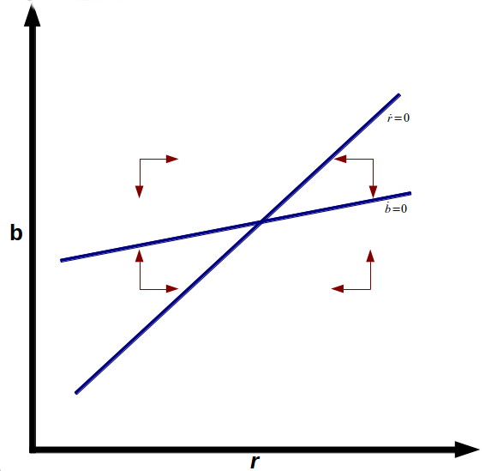

**Figure 2 – Saddle Point**

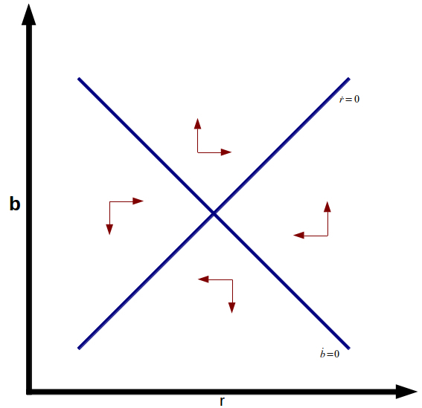

We also show Figures 3 and 4 below, with the areas of stability and instability of the equilibrium on plane *r*-*g*. In Figure 3, we consider $\left[c-\frac{π_{b}}{π_{r}}\left(1-g_{r}\right)\right]b>S_{b}$, while in figure 4 we have the opposite. As we can see, whether $\left[c-\frac{π_{b}}{π_{r}}\left(1-g_{r}\right)\right]b$ $<S_{b}$ (Figure 4), the possibilities to get a stable equilibrium are much higher than in Figure 3.

**Figure 3**

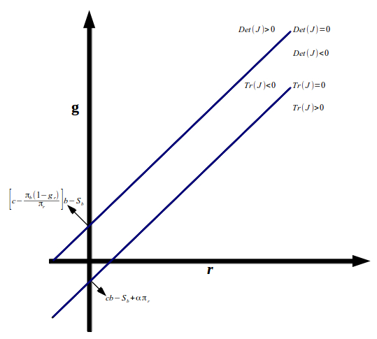

**Figura 4**

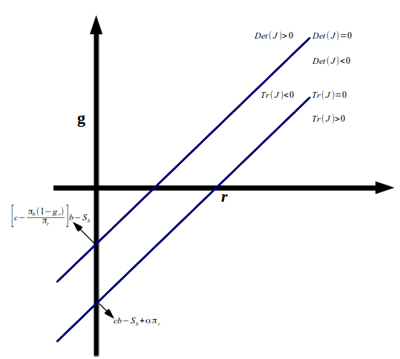

Note further that the equilibrium value will occur when $\dot{b}=0$ and $\dot{r}=0$. In this case, the public debt as a share of GDP of equilibrium $\left(b^{*}\right)$ and the real interest rate of equilibrium $(r^{*})$ correspond to:

$$b^{*}=\frac{S}{r-g}$$

$$r^{*}∈R$$

The real interest rate of equilibrium $\left(r^{*}\right)$ can be any value from the set of real numbers, for it is sufficient that the effective inflation rate be equal to the expected inflation rate $(π=π^{*})$. In order to ensure $b^{*}>0$, a primary public deficit is required, supposing a growth rate of the economy higher than the real interest rate. If lower, the public sector primary balance should be a surplus.

**1.2** *Growth Targeting Regime*

In this subsection, we will analyze an economy that is in a very recessionary or depressive environment. Thus, both differential equations for public debt and monetary policy are:

$\dot{b}=\left(r-g\right)b-S$ (10)

$\dot{r}=β(g-g^{*})$, $β>0$ (11)

Note that equation (11) shows the interest rate as the result of the difference between the effective rate of growth $\left(g\right)$ and that desired ${(g}^{*})$.

Assuming the same null derivatives of the previous case, the Jacobian matrix will be:

$$J=\left[\begin{matrix}cb+r-g-S_{b} & b-g_{r}b \\ βg_{b} & βg_{r}\end{matrix}\right]$$

Considering that the relationship between public debt and economic growth is negative, that is, $g_{b}<0$, then the condition of a stable equilibrium will be:

$\left(cb+r-g-S_{b}\right)βg_{r}>(b-g_{r}b)βg_{b}$ (12)

and

$\left(cb+r-g-S_{b}\right)+βg_{r}<0$ (13)

From expression (12), it is observed that, as the term $\left(b-g_{r}b\right)βg_{b}<0$, it follows that the sufficient condition for the stability of the equilibrium is:

$g+S_{b}>r+cb$ (14)

which is the same condition for the Tr(*J*) < 0, because we assume that $g_{r}<0$. If the real interest rate is null due to economic depression, then:

$$g+S_{b}>cb$$

That means that any rate of economic growth plus the response of the primary surplus due to a change in public debt higher than *cb* is sufficient for the equilibrium to be stable. If the real interest rate is negative, the growth rate may be negative, as long as condition (14) is respected. Note that, as it is assumed that ${ g}_{b}<0$, the Det(*J*) is far more likely to be positive (since the determinant sign depends only on the result of $cb+r-g-S_{b}$ and not on any additional condition) than in the previous subsection, which leads us to reach a conclusion that unstable equilibrium such as the saddle point, whose determinant of *J* is negative, is less likely to occur. It should also be noted that if the Det (*J*) is positive, the Tr(*J*) will necessarily be negative, which excludes the possibility of occurring unstable equilibrium*,* such as unstable node or focus(like in the previous subsection). Note further that, as the interest rate has as its target a certain economic growth, given a hypothetical situation of depression, the real interest rate will have to be quite low, null, or even negative, which contributes substantially to lead public debt and growth rate into a stable equilibrium path. The major difficulty here may be the speed at which this equilibrium will be attained. To enhance this speed, an increase in exports is required so that growth rate $g$ is raised, and/or the government increases its expenditure, if its fiscal situation permits. Both phase diagrams are shown below: for stable case – stable focus – (figure 5) and for the unstable one – saddle point – (figure 6)[5].

**Figure 5 – Stable Focus**

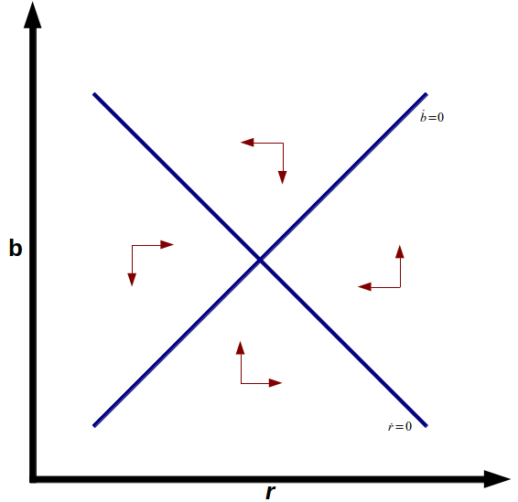

**Figure 6 – Saddle Point**

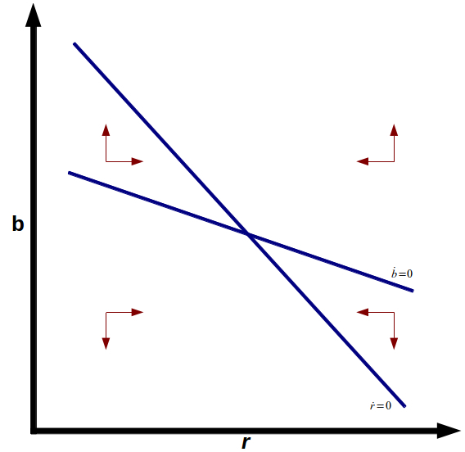

Assuming $S_{b}+(b-g_{r}b)\frac{g_{b}}{g_{r}}$ > $cb$, we show figure 7 below, with stability and instability points on plane *r*-*g*. Note also that as $-\left(b-g_{r}b\right)\frac{g_{b}}{g_{r}}<0$ and $-\left(b-g_{r}b\right)\frac{π_{b}}{π_{r}}>0$, the upright intercept of the Det (*J*) = 0 for GT regime is smaller than for IT regime. We can see that under the GT regime it is far more likely to get a stable equilibrium than under IT regime as already discussed previously.

**Figure 7**

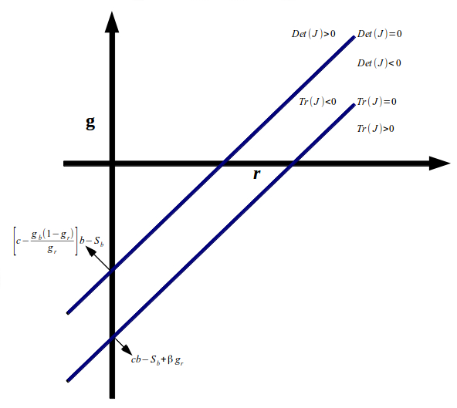

**2. The Brazilian and British cases**

In this section, the objective will be to conduct simulations for the Brazilian and British cases on the basis of the model above. These countries have been chosen as they adopted the inflation targeting regime in 1992 (Great Britain), and in 1999 (Brazil). Moreover, they represent a contrast between a developed country and an emerging one. Their macroeconomic characteristics are very distinguishing. While Great Britain’s economy presented moderate unemployment in the three months to February 2014 (6.9%), high public debt as a share of GDP (90.1%), low economic growth (1.8%), and low inflation rate (2.6%), Brazil showed very low unemployment in December 2013 (4.6%), relatively low public debt (66.3%), low economic growth (2.3%), and high inflation rate (6.2%)[6]. We give a brief description below of their monetary and fiscal policies starting in 2000, and their respective simulations.

**2.1** *Brazilian Fiscal and Monetary Policy*

The Brazilian fiscal policy during the 1999-2002 period was characterized by the maintenance of stability achieved by means of a contractionary fiscal policy. Some important institutional mechanisms were implemented. The Action Plan 1999-2001 that established a growing trajectory for the primary surplus throughout the three years following the Fiscal Stability Program (1998), which preconized fiscal restructuring to meet the targets discussed with the International Monetary Fund (IMF); the adoption of a floating exchange rate in January 1999; the creation of a new anchor to guide inflationary expectations: the inflation targeting regime (IT) in 1999; and the Fiscal Accountability Act – FAA – in 2000, intended for the control and management of public expenditure. During the 1999-2002 period, the primary surplus reached an average of 3.2% of GDP, evidencing the effort put into the fiscal adjustment for the period. However, the fiscal adjustment proved itself insufficient to restrain the increase of the public debt that had been associated with the rate of exchange, and the recognition of contingent liabilities (Giambiagi, 2007), leaving to the next government the legacy of a gross debt of 76.7% in December 2002 (Central Bank of Brazil, 2013). The monetary policy of the period was characterized by high nominal interest rates of about 19% per year over the 1999-2002 period, which led to an increase in expenditure to service the public debt. In this respect, fiscal and monetary policies were successful in controlling inflation; however, the average economic growth for the period was 2.1% p.a.

In January 2003, a leftist central government took office which, in order to face the insecurity of the markets, had as its characteristic, during its first two years, the maintenance of the primary surplus policy initiated in the previous government of Fernando Cardoso. During Lula da Silva’s first term in office, the fiscal policy was kept contractionary, with an average primary surplus of 3.5% over the 2003-2006 period, and a gross average public debt for the period of 68.5%[7]. Moreover, continuing with the Fiscal Stability Program launched in 1999, management of the public debt by the Treasury and the Central Bank was characterized as successful in reducing base interest rate and exchange rate indexed-bonds, and also extending the medium term of the debt (Mendonça and Pinton, 2012). The monetary policy during Lula da Silva’s first term was contractionary, with a base interest rate of about 18% per year, close to the average value of 19% of the previous government.

As from Lula’s second term, which started in 2007, an inflexion occurred in the fiscal policy, characterized by the expansion of social expenditure, transfers of income, expansion of the minimum salary and, afterwards, as an strategic element to attenuate future economic cycles. The Brazilian anticyclical policy of fiscal stimulus to face the 2008 crisis[8] consisted of several actions, such as expenditure increases and tax reductions, reduction of the base interest rate, and gradual abandon of the FAA. The primary surplus target was relaxed and fell to 2% in 2009, staying at an average level of 3% in Lula’s second term in office (2007-2010). Thus, GDP growth in 2009 was -0.2%, but recovered and in 2010 it was 7.5%. The monetary policy also became expansionary, with the base rate of interest reaching the level of one digit during the period between 2009 and 2010, and at the end of Lula’s government its average level was 11.3% per year.

The next government (also leftist) of President Roussef intended to be a continuation of President Lula’s second term and, in order to ensure the maintenance of growth in the subsequent periods, it extended the stimulus measures adopted earlier. The monetary policy proved expansionary, with an average interest rate during the two initial years of 10.8% p.a. and with a tendency to drop. The fiscal policy showed itself as expansionary, with reduction of the primary surplus target, which stayed at 2.7%, on average, for the two first years of her government (2011-2012). These factors, among others, produced a strong reaction from inflation. The target ceiling was reached at the end of 2011 – 6.5% – something that happened for the first time since 2006, when inflation target was established at 4.5% with a band of + or - 2 percentage points, and the growth of 7.5% for 2010 dropped to 2.7% in 2011. In 2012, inflation reached 5.8%, and GDP grew 0.9%.

The data below show the macroeconomic indicators for Brazil in accordance with IMF (2014a, 2014b).

**Macroeconomic Data - Brazil (2013)**

|  |  |  |  |  |
| --- | --- | --- | --- | --- |
| **Public Debt (% GDP)** | **Real Growth (%)** | **Inflation**  **(%)** | **Public Sector Primary Balance (% GDP)** | **Nominal Base Interest Rate (%) per year** |
| 66.3 | 2.3 | 6.2 | 1.9 | 10 |

Source: IMF (2014a, 2014b)

To verify the dynamics of public debt and real interest rate, the data from the table above were used. We also conducted several regressions in order to calculate an estimative for the coefficients of the differential equation system presented in section 1 for the Brazilian case, including that of *S* = *f*(*b*) among others, to incorporate them into the equations for real interest rate and public debt. However, we found that the results were fruitless due to the limited quantity of available data, and(or) due to the fact that the coefficients of the equations were statistically insignificant. Thus, the differential equation system used for Brazil was:

$$\dot{b}=\left(r-0.023\right)b-0.019$$

$$\dot{r}=0.5\left(0.1-r-0.045\right)$$

Remembering that inflation corresponds to the difference between the nominal interest rate (10% per year) and the real interest rate, and that the inflation target is 4.5% per year. Considering the initial condition *b*(0) = 0.663 and *r*(0) = 0.038, then the dynamics of the two variables is given by the figure below.

**Figure 8**

**Public Debt and Real Interest Rate Dynamics**

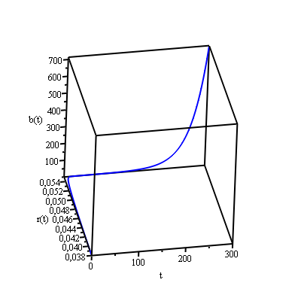

As can be seen in the figure above, the joint trajectory of the interest rate and public debt is unstable. Although the point of equilibrium for the interest rate and public debt are *r* = 5.5% and *b* = 59.4% of GDP, respectively, the trajectory of the public debt surpasses this value due to the explosive behavior of the system. We also used *α* = 0.5, as the various values found in the literature are inconclusive. Any other value only alters the responding speed of the monetary policy to discrepancy in the inflation, but does not alter the quality of the analysis and/or its conclusion. For the Brazilian case, it is pointless to discuss the economic growth regime via real interest rate, as will be analyzed for the British case, since the Brazilian economy is in full employment, and restrictions are on the supply side and not on aggregate demand.

**2.2** *The British fiscal and monetary policy*

Between the late 1990s and 2007, the British fiscal policy was concerned with keeping the public budget relatively balanced throughout the economic cycle with a public deficit of about 2% of GDP, and a public debt close to 40% of GDP (Sawyer, 2011).

When the financial crisis erupted in 2008, the British government, still in the hands of the Labor Party, adopted a more expansionary fiscal policy: they reduced the value added tax from 17.5% to 15% (reverted by the end of 2009), and increased public expenditure by 3 billion pounds. Thus, for the fiscal year 2008, the public deficit rose to 5% of GDP and for 2009 the deficit was 11.3% of GDP (IMF, 2013). With regard to public debt, if until 2007 it was about 40% of GDP, in 2008 it jumped to 52%, and in 2009, to 67% of GDP (IMF, 2013). The new British conservative government, which took office in May 2010, changed the situation of the fiscal policy. Due to growing public deficit and debt, it rapidly cut expenditure (by 5 billion pounds) and rose taxes (by 2.8 billion pounds) in order to eliminate the structural public deficit by 2014/15, and attain a surplus of 0.8% of GDP in 2015/16, according to HM Treasury (2010).

The inflation targeting regime in the United Kingdom was established in 1992 and its target, at 2% per year (Bank of England, 2013). The inflation rate, which was at 7.5% per year in 1991 (World Bank, 2013), dropped to 2% in 1993, and remained around this level until 1998, when the English Central Bank became officially independent of the political authority. From 1998 to 2004, inflation remained between 1 and 2% per year, showing from then on a clear tendency to rise until it reached its highest level in 2011 (4.5% p.a.) (World Bank, 2013). Note that the financial crisis of 2008 caused the monetary policy to be expansionary as well, with a reduction in the base interest rate from 5% per year in September 2008 to 0.5% per year in March 2009, level at which it has remained to date (April, 2014). The British Central Bank has also, like the American Fed, committed itself to purchasing public and private securities (*quantitative easing*) in order to expand the liquidity of the economic system (Bank of England, 2013).

In short, we now find quite an expansionary monetary policy in the United Kingdom. On the other hand, the rate of growth and recovery of the economic activity may become jeopardized in view of the restrictive fiscal policy practiced by the conservative government of Prime Minister James Cameron. We show a table below containing the macroeconomic indicators according to the IMF (2014a, 2014b).

**Macroeconomic Data – United Kingdom (2013)**

|  |  |  |  |  |
| --- | --- | --- | --- | --- |
| **Public Debt (% GDP)** | **Real Growth (%)** | **Inflation (%)** | **Public Sector Primary Balance (% GDP)** | **Nominal Base Interest Rate (%)** |
| 90.1 | 1.8 | 2.6 | -4.5 | 0.5 |

Source: IMF (2014a, 2014b)

To verify the dynamics of public debt and real interest rate, according to the system of differential equations in section 1, the data from the table above were used. We also conducted several regressions in order to calculate an estimative for the coefficients of the differential equation system presented in section 1 for the British case, including that of *S* = *f*(*b*) among others, to incorporate them into the equations for real interest rate and public debt. However, we found that the results were meaningless due to the limited quantity of available data, and(or) due to the fact that the coefficients of the equations were statistically insignificant. So, the system of differential equation becomes:

$$\dot{b}=\left(r-0.018\right)b+0.045$$

$$\dot{r}=0.5\left(0.005-r-0.02\right)$$

Remembering that inflation corresponds to the difference between the nominal interest rate (0.5% per year) and the real interest rate, and the inflation target is 2% per year. Considering the initial condition *b*(0) = 0.901 and *r*(0) = -0.021, then the dynamics of the two variables is given by the figure below:

**Figure 9**

**Public Debt and Real Interest Rate Dynamics**

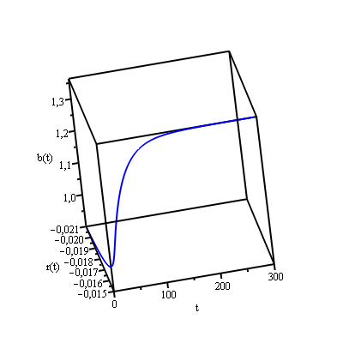

A careful analysis of the figure above shows that the British public debt is stable, taking about 150 time units to reach its equilibrium with 136.4% of GDP and real interest rate of -1.5% per year. The value of α = 0.5 was considered for the same reasons as the Brazilian case. On the other hand, if the adopted regime is that of economic growth targets, we find Figure 10 below, in which the stable equilibrium is reached with the real interest rate at -2.3% per year and public debt of 109.8% as a share of GDP. For this simulation, all data from the previous case (Figure 9) were kept, with the growth target established at 2% per year. We further considered *g* = -0.86*r* as, theoretically, the relationship between economic growth and real interest rate is negative. We used the value 0.86 because it is compatible with the growth rate of 1.8% in 2013. Note that the values of the public debt and real interest rate of equilibrium are lower than those in the previous case (Figure 9), as well as the time required to reach this equilibrium (about 100 time units). Observe further that the British Central Bank seems to practice a monetary policy which prioritizes some real variable, such as the growth rate, to the detriment of the inflation target, as the base interest rate is at quite a low level (0.5% per year) for an inflation rate well above the target (2% per year) since 2010, as shown in the table below.

**Annual Inflation Rate (%) – United Kingdom**

|  |  |  |  |
| --- | --- | --- | --- |
| **2010** | **2011** | **2012** | **2013** |
| 3.3 | 4.5 | 2.8 | 2.6 |

Source: World Bank (2013)

**Figure 10**

**Public Debt and Real Interest Rate Dynamics**

**(Growth Targeting Regime)**

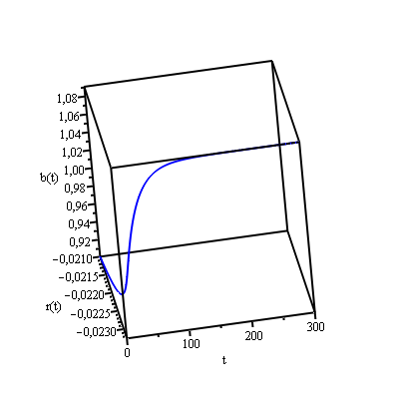

**Final Considerations**

In this study, we investigated something which, as far as we know, does not exist in literature at least not the way it is presented, that is, a dynamic interaction between monetary policy - expressed by an interest rate rule aimed at meeting an inflation or growth targets – and fiscal policy, measured by the public debt.

In the first section of this paper we have seen that the condition that determines a non-explosive behavior of the public debt and real interest rate may occur when the growth rate of the economy is higher than the difference between *cb* plus real interest rate and the response of the primary balance of public accounts in relation to public debt. This condition is required, but it is not sufficient in an IT regime. On the other hand, under a regime of GT, this condition is sufficient to provide stable equilibrium. We also assumed that the relationship between public debt and primary balance of public accounts is positive, as some empirical evidence has shown and for serious and responsible behavior on the part of a government is to be expected.

Next we simulated a theoretical model for the Brazilian and British cases. We observed that the path of public debt in Brazil is explosive and, for the British case, is stable. Of course a government may take measures to change the trajectory, for example, by reducing real interest rates in an attempt to stimulate economic growth. However, this measure should be implemented when the economy is far from full employment. In Brazil’s case, this policy was tried between August 2011 and October 2012 when the Central Bank voluntarily reduced the base interest rate, an action that only resulted in the acceleration of inflation and popular dissatisfaction. Thus, any important measure to be taken in Brazil should occur in the fiscal part (primary surplus increase) while the Central Bank concentrates its attention on combating inflation and regaining its credibility. On the British side the Central Bank pursues a monetary policy which seems to persecute some real variable as the growth rate at the expense of an inflation target. Furthermore, we have seen that its government seems to have made important fiscal adjustment in order to balance the budget for future years. However, and perhaps because of this very measure, economic growth and employment level were negatively affected, thus failing to produce the results desired by the government within the time acceptable to the British society.

**References**

Ball, L.; Sheridan, N. (2003). “Does Inflation Targeting Matter?” *NBER Working Paper Series*, n. 9577, p. 1-47.

Bank of England (2013), [http://www.bankofengland.co.uk](http://www.bankofengland.co.uk/)/

Barro, R., Gordon, D (1983). “Rules, Discretion and Reputation in a Model of Monetary Policy”. *Journal of Monetary Economics*, 12 (July): 101-121.

Bernanke, B., Laubach, T., Mishkin, F, Posen, A.. (1999). *Inflation Targeting: Lessons from the International Experience*. Princeton University Press.

Bohn, H. (1998), “The Behavior of US Public Debt and Deficits”, *The Quarterly Journal of Economics*, 113 (3).

Brazilian Institute of Geography and Statistics (2014), http://www.ibge.gov.br/

Calvo, G. (1978). “On the Time Consistency of Optimal Policy in the Monetary Economy”. *Econometrica*, v. 46, n. 4, p. 1411-1428.

Central Bank of Brazil (BACEN) (2013). *Time Series.*

Clarida, R., Gali, J., Gertler, M. (1999). “The Science of Monetary Policy: a New Keynesian Perspective”. *NBER Working Paper Series,* Cambridge, MA, 7147, May.

Fraga, A., Goldfajn, I., Minella, A. (2003). “Inflation Targeting in Emerging Market Economies”. *NBER Working Paper Series*, n. 10019.

Giambiagi, F. (2007). “Seventeen Years of Fiscal Policy in Brazil: 1991-2007”. A Text for Discussion no. 1309. (Dezessete Anos de Política Fiscal no Brasil: 1991-2007. Texto para Discussão nº 1309). IPEA – Rio de Janeiro. November.

Gonçalves, C., Salles, J. (2008). “Inflation Targeting in Emerging Economies: What do the Data Say?”, *Journal of Development Economics*, 85: 312-318.

HM Treasury. (2010). *Budget 2010: Securing the Recovery*. London: The Stationery Office, HC451.

IMF (2013). *Fiscal Monitor: Taxing Times*, October.

IMF (2014a). *World Economic Outlook: Recovery Strengthens, Remains Uneven*, April.

IMF (2014b). *Fiscal Monitor: Public Expenditure Reform – Making Difficult Choices*, April.

IPEA (2013). *Macroeconomic Synopsis (Sinopse Macroeconômica)*.

Kydland, F., Prescot, E. (1977). “Rules rather than Discretion: The Inconsistency of Optimal Plans”. *Journal of Political Economy*, 85 (June); 473-492, 1977.

Mendonça, H.; Pinton, O. (2012). “Behavior of the Brazilian Fiscal Policy in the 21st Century: An Analysis of Fiscal Impulse”. (O Comportamento da Política Fiscal Brasileira no século XXI: Uma Análise a partir do Impulso Fiscal). *Revista Economia*, v.13, n.2, p. 281-301, May/Aug.

Mishkin, F. (2000). “Inflation Target in Emergent Market Countries”. *NBER Working Paper Series*, n. 7618.

Mishkin, F.; Posen, A. (1997). “Inflation Targeting: Lessons from Four Countries”. *Economic Policy Review*, Federal Reserve Bank of New York, August

Neris Jr., C.; Bertella, M. (2013). “From Financial to Sovereign Debt Crisis: A Debate on Fiscal Policy”. (Da Crise Financeira à Crise da Dívida Soberana: Um Debate sobre a Política Fiscal). *Análise Econômica*, Porto Alegre, year 31, n. 59, p. 123-143, March

Neumann, M., von Hagen, J. (2002). “Does Inflation Target Matter?” *Economic Review of the* Federal *Reserve Bank of St. Louis*, 84, 127-148.

Office for National Statistics (2014), http://www.ons.gov.uk/

Sawyer, M. (2011), “UK Fiscal Policy After the Global Financial Crisis”, *Contributions to Political Economy* 30, 13–29.

Svensson, L., Woodford, M. (2003*). Implementing Optimal Policy through Inflation-Forecast Targeting*. Preliminary version 2.51, Jan.

Svensson, L. (2010). “Inflation Targeting”. *NBER Working Paper Series*, n. 16654.

Woodford, M. (1999a). “Commentary: How Should Monetary Policy Be Conducted in an Era of Price Stability”. In: *New challenges for Monetary Policy*, Federal Reserve Bank of Kansas City, p. 277-316.

Woodford, M. (1999b). “Optimal Monetary Policy Inertia”. *NBER Working Paper Series*, n. 7261.

World Bank (2013), <http://data.worldbank.org/>

1. For a *survey* of recent literature, see also Svensson (2010).
2. The authors studied 20 countries, seven having adopted the IT regime before 1999, and 13 that did not adopt it. For every country, they considered the beginning of the regime the first full quarter, in which the specific inflation target (or the target interval) was in effect. Initial dates vary, with an interval of 1990:1 for New Zealand, and 1995:1 for Spain, with final analysis period in 2001 for all countries, except Finland and Spain due to the advent of the euro. Compared for all countries is a period prior to that of the targets, a longer one beginning in 1960, and a shorter one starting in 1985. The last period prior to the start of the IT regime is the last full quarter.
3. Obviously, the government could accelerate the rate of inflation in order to reduce the rate of real interest.
4. Other types of equilibrium can be found depending on the configuration of the signals of the parameters.
5. Other types of equilibrium can be found depending on the configuration of the signals of the parameters.
6. Great Britain’s data on unemployment is according to Office for National Statistics (2014) and Brazil´s data on unemployment is in accordance with Brazilian Institute of Geography and Statistics (2014). All remaining data are from IMF (2014a, 2014b).
7. The data on gross public debt are from the Central Bank of Brazil (2013), as the Fiscal Monitor series by the IMF only begins as of 2006. Both have distinguishing methodologies: the IMF includes the entire sovereign debt retained in the Brazilian Central Bank’s balance sheet, whereas the latter incorporates only debt securities in the hands of the market, that is, only securities from in repo operations are included in the debt.
8. Fiscal stimulus were fiscal policy actions adopted in response to the 2007/08 crisis, and had impacts on the debt of several countries, as discussed in Neris Jr. and Bertella (2013).