**Services that add value in the city: the rise of the modern economy in Brazil**

**Ana Maria Bonomi Barufi**

NEREUS-USP, Banco Bradesco

**Resumo:** Avanços tecnológicos recentes têm aumentado a importância das atividades econômicas associadas a novas técnicas produtivas e que incluem serviços sofisticados. Neste sentido, serviços de alta tecnologia ou que envolvem conhecimento avançado são oferecidos como insumos intermediários para firmas industriais e constituem um dos principais componentes de ganho de produtividade e desenvolvimento econômico. Entretanto, tais firmas de serviços não estão distribuídas de maneira homogênea no espaço. Este artigo busca investigar a distribuição de firmas de serviço que adicionam valor e a decisão locacional de novas firmas do mesmo setor em mercados de trabalho locais no Brasil. Os principais resultados indicam que apesar da forte conexão com a manufatura, tais firmas não necessariamente se localizam próximas às indústrias. Maior densidade populacional e mão-de-obra qualificada são mais relevantes para determinar sua distribuição no espaço.

**Palavras-chave:** serviços que adicionam valor; modelos de contagem; desenvolvimento regional

**Abstract**

Recent technological advances have increased the importance of economic activities heavily based on new production techniques with embedded sophisticated services. In this sense, high-tech services offered as intermediate inputs for manufacturing firms constitute one of the main components of productivity gains and economic development. However, such service firms are not homogeneously distributed in space. This paper aims to investigate the spatial distribution of service firms which add value and the location decision of new firms in the same sector in labour market areas in Brazil. The main results show that despite the strong linkages with manufacturing, these firms do not necessarily pursue locations close to places that concentrate industrial employment. Higher population density and a qualified labour force are much more relevant to determine the location of these firms.

**Keywords:** services that add value;count data models; regional development.

**Códigos JEL:** R30, R12, L84, O33

**Introduction**

The world has been seeing significant changes in sector composition over the past decades associated to technological advances and changes in consumption patterns. From the mid-twentieth century, the incorporation of information technologies and electronics resulting in the production automatization promoted an escalation of production capacity. Nowadays, a new business model based on cyber-physical systems, which combine consumer-satisfaction, sustainability and production to form intelligent network systems and processes (Bloem et al., 2014). These later advancements are based on mobile connectivity, artificial intelligence, processing power and storage capacity (Schwab, 2016).

However, countries are in distinct development stages with different functions in global value chains, whose role in trade has been increasing over the last years. Less developed countries generally supply basic services with lower value added, given that transnational companies outsource less noble activities to firms in these areas (UNCTAD, 2013).

In this context, many developing countries are still at earlier stages of development, facing the changes imposed by the third industrial revolution in some industrial sectors. Services gained a significant share in the economy of these regions, and their interaction with manufacturing activities is possible through two main ways (Arbache, 2016). On the one hand, services may be related to production cost reduction (logistics, IT, infrastructure, among others). On the other hand, some services may be directly incorporated by firms and add value to the final product and customize products (R&D, consulting, among others). Sophisticated goods require a higher share of services that add value to them in their production. Eichengreen and Gupta (2031) identify two waves of service-sector growth, the first being related to basic services in in countries with low per capita GDP, while the second refers to modern services in developed economies.

This paper aims to shed new light in the main factors that attract firms who provide services that add value to the final manufacturing product. As it will be discussed in the following section, this activity is more prone to be economically relevant in developed economies. Moreover, its expansion is associated to a change in a country’s position in global value chains. The empirical analysis relates to the literature on the location of high growth and ICT firms. In the Brazilian case, there are a few studies on firm locational choices, but none of them focus on the service sector related to value added. The main results show that despite the strong interaction these firms have with manufacturing, their location decision does not seem to be connected to the share of workers in industrial activities.

The remainder of this paper is structured as follows. Section 2 reviews the literature on the service sector emergence and presents a broad analysis on the empirical literature of firm location decisions. Section 3 describes the empirical strategy, while Section 4 presents the data. Section 5 provides the main results and Section 6 concludes.

**Literature review**

The growth and dynamics of the service sector can be analysed through its relationship with manufacturing (Arbache, 2016). Considering the industrial development path, countries usually advance from an initial high share of agriculture in GDP towards the expansion of basic industries, accompanied by the expansion of general services. Then, economies enter another stage of industrial development in which firms and families demand more sophisticated services (including R&D, financial services, marketing and engineering). This movement means that the share of manufacturing in GDP starts to decrease, accompanied by an increasing share in goods of services that create value. The changing nature of services is the basis of the third industrial revolution. Services can be ranked according to the value they add to industrial products, as can be seen in the figure below.

**Figure 1.** Smiley curve in manufacturing



Source: Arbache (2016).

Production activities that generate more value added are usually located at the home country of multinationals, while low-value added activities are outsourced to firms in developing economies (Arbache, 2016). Given the importance of value added services to the advancement of a country in the industrial development path, it is important to understand the determinants of firms’ locational choices within a developing country. Furthermore, there are potential feedback loops in the local development of service and industrial sectors, and the identification of local factors

A large literature has been developed on the economics and geography of new and existing firms. The analysis is generally concentrated in specific sectors, and recent technological advances have shifted it towards high growth firms and the high-tech sector. The identification of the main local factors associated with the emergence of these firms is important to provide guidance for innovation and regional economic growth policies (Li et al., 2016). Geographic characteristics, especially local knowledge resources, are not only relevant for the location decision of the firm, but also to its future performance (Audretsch and Dohse, 2007). In this sense, firms maximize the present value of that may arise from their location decisions.

The location decision of economic agents has been analysed through different theoretical perspectives. Arauzo et al. (2010) group them in three main categories: (i) neoclassical (profit or cost-driving factors such as agglomeration economies, technology and human capital); (ii) institutional (network of economic relations, actions taken by public administration); and (iii) behavioural theories (individual preferences – internal and entrepreneurial characteristics).

Firm entry in Catalan municipalities is explained by Liviano and Arauzo (2013) with a set of variables that account for agglomeration economies, economic conditions, spatial effects, human capital and geographical position. For the location of high growth firms in the United States, Li et al. (2016) consider similar variables to new innovation-based firms models, since high growth firms are relatively new in general. In this sense, one of their references is the model proposed by Acs et al. (2009) and Acs and Armington (2004) for the location decision of new firms, which is based in knowledge spillovers that arise from entrepreneurship. Once again, the three groups of variables presented by Arauzo et al. (2010) discussed above will be the reference for these authors.

According to Liviano and Arauzo (2013), new and relocated establishments can be analysed together, since they may be attracted by the same factors to a specific location. However, Manjón and Arauzo (2011) reach an opposite conclusion. Furthermore, urban regions with high levels of economic growth and diversity of economic activities attract relatively more opportunity-motivated entrepreneurship (Bosma and Sternberg, 2014). The relative importance of agglomeration economies’ mechanisms in new manufacturing firms’ location in Spain is investigated by Jofre et al. (2011). Their main conclusions indicate that all Marshallian mechanisms are present, but that labour pooling is the most important mechanism, followed by input sharing and knowledge spillovers.

Alamá et al. (2011) estimate a spatial discrete model with firms’ location decisions in the Spanish region of Murcia, identifying that the spatial component of the model indicate that externalities or spillovers measured by spatial dependence between municipalities are relevant for these decisions. Focusing on new ICT firms’ location decisions in France, Lasch et al. (2013) find some co-location and knowledge spillovers effects. Li and Zu (2015) adopt a spatial econometric approach to model the location of high tech firms in China and identify the need to account for spatial spillovers in this type of analysis.

The importance of a highly educated labour force is highlighted by Paci and Marrocu (2013), whose study shows that knowledge assets (especially human capital) exert a positive impact on local GDP and in neighbouring areas. One of the channels through which they have this effect is by providing the most appropriate production conditions for the location of high-growth firms.

The role of city size in industry location determination is investigated by Sridhar and Wan (2010) for China, India and Brazil. Their main conclusion is that large capital cities are not attractive for firms to locate. Calá et al. (2014) also focus in a developing economy, showing that there is need to include additional variables that proxy for the specificities of these countries to explain new firm entry.

For the Brazilian case, Silva and Silveira-Neto (2007) follow the New Economic Geography (NEG) theoretical background to find a positive relationship of employment growth with economic linkages and diversity. Resende et al. (2015) explore exit and entry rates of firms in Brazilian manufacturing with a dynamic panel data, and their main conclusions indicate that competition induces efficiency and a selection process, while there is a synergetic movement in which the exit or entry movements induce further movements in the same direction.

Finally, the most appropriate spatial aggregation is discussed by Arauzo et al. (2010), who show that empirical research has moved towards the study of geographically disaggregated data, from metropolitan areas and states to municipalities, counties and districts. The NEG literature states that agglomeration economies arise at the local level and decrease as distance increases. Guimarães et al. (2003) defend that smaller areas should be the unit of analysis, because factors that are relevant for location decisions apply to the local level. On the other direction, Arauzo (2005) suggests that economic territorial units should be adopted in the place of units defined by political boundaries, which could be approached by travel-to-work areas.

These contributions can be summarised in the following way. The expansion of the number of firms who provide services that add value indicate that the country may be achieving a higher stage of economic development. Therefore, the identification of the main local factors that affect these firms’ location decisions is essential to better understand regional and national development.

Moreover, empirical analysis should include local indicators related to agglomeration economies, technology, human capital, institutions, and individual preferences. In the context of a developing economy, additional local characteristics must be controlled for, such as poverty and informality.

**Empirical strategy**

There are two basic models in the empirical literature of firm location decision (Arauzo et al., 2010), namely discrete choice models (when the available information refers to the location decision of firms/plants) and count data models (number of firm/plant births in a geographical area). When count data models are employed, Liviano and Arauzo (2013) show that the estimation method should control for the large number of zeros. If the share of zero values is too large in the dependent variable, the distribution function should encompass the possibility that the variables that cause zeros may also influence the intensity of the phenomenon, the hurdle negative binomial (HNB) and the zero inflated negative binomial (ZINB). Even though both of them are efficient to deal with a large number of zeros in the dependent variable, Li et al. (2016) show that HNB models presuppose that zeros are generated in the database from a completely different process than the one that explains positive values. In this sense, ZINB models should be chosen to provide conceptual consistency with the data generating process.

The location decision of firms who provide services that add value can be modelled as a birth process in each geographical area (Becker and Henderson, 2000). There is a supply of potential entrepreneurs that at each point in time consider creating a new firm in location *j* (). This supply function is upward sloping in the relation between firms’ births and the expected net present value (NPV) per plant. There is also a demand for new plants in each location that shows how the NPV changes with additional births in *j*. This curve may be locally upward (localisation economies) or downward sloping (competition) and shifts in response to changes in wages, county size or local regulation. The number of births *nj* will be given by the intersection of the supply and demand curves. Moreover, both curves depend on location characteristics and on the number of new firms created in *j* over a given time period *t*.

In this setting, the determinants of industrial location decisions can be empirically examined by analysing the partial or marginal effects of location characteristics over the conditional expectation of the number of firms created at *j* over *t*. Thus, it is necessary to specify the probability mass function of *nj*, which is a nonnegative integer variable.

Given the nature of the data available in the Brazilian case, even though it is possible to obtain firm-level characteristics, they are more limited than municipality-level data, a common issue in the literature (for instance, see Li et al., 2015). The ZINB in the present case can be formulated as:

|  |  |
| --- | --- |
|  | (Eq. 1) |

Where is an indicator variable, is the probability that and is the negative binomial distribution function. Then, represents the entrepreneurial formation variables (costs, agglomeration economies, sector composition, etc.), is composed by amenities, institutions, and geographic characteristics, and is the set of parameter to be estimated. Then, and are distributional parameters, is the set of regressors in the inflation stage and is the set of coefficients in that stage. Regressors are included in the model with the appropriate time lags to mitigate endogeneity concerns.

Finally, two main specifications will be considered here. First, the spatial distribution of firms is explored, and in this case will refer to the number of firms in the service sector that add value to manufacturing products in 2015, with alternative estimations for firms divided according to their size (in terms of the number of employees). Even though this type of model is usually considered for the birth of firms, in this case estimations will be based in the number of existing firms. This hypothesis may be somehow strong, but in any case firms who provide services that add value are showing an important expansion, what means that at least part of the calculated effect will be related to the appearance of new firms. Another phenomenon that is being measured here is that existing firms are those who have not decided to leave the market.

Then, the second specification will consider as the number of firms that appeared between 2013 and 2014. This information is obtained through a longitudinal database. It is noticeable that the change in the number of firms between these two years is given by the inflow minus the outflow of firms in the market (new firms – firms that close down), which is different from the number of new firms that appear between two years.

Services are classified in the following way (CNI, 2014, and Arbache, 2016):

* Cost reduction: CNAE[1] 2-digit divisions 35 to 39, 45 to 69 and 75 to 99, including transport and logistics, infrastructure services, storage, repairs and maintenance, outsourcing services, general IT, credit and financial services, accommodation, food and distributional services;
* Add value: CNAE 2-digit divisions 70 to 74, including R&D, design, engineering and architecture projects, consulting, professional technical services, sophisticated IT, branding, marketing and sales.

The following section will provide a description of the database and the recent evolution of services that add value to manufacturing products.

**Data description**

The distribution of firms in space is obtained from RAIS (Annual Report of Social Information, from the Ministry of Labor), which consists of identified registration data of all formal firms and their employees, focusing on the characteristics of the work contract. It provides annual information on all firms in the private sector (or part of the public sector, depending on the type of contract), with a significant regional disaggregation (municipal level). This database provides the data for firms in 2015, while most explanatory variables are obtained from the Demographic Census of 2010, from IBGE. Data on bank branches are collected from the Brazilian Central Bank. Further details about the definition and sources of each variable can be found in Table 1.

On the other hand, the number of firms that were created between 2013 and 2014 is obtained from the identified RAIS. This microdata has the proper identification of each firm by its registration number (CNPJ). Then, the number of new firms with at least one employee is obtained as the count of firms that did not exist in 2013 but were in the database in 2014.

**Table 1.** Summary statistics and description of variables for 2015 regression.



Source: author elaboration.

The basic unit of analysis is the REGIC area, which is defined as a labour market area that aggregates municipalities in regions of immediate articulation (482 regions containing all 5,565 municipalities of 2010 division), defined by the Brazilian Institute of Geography and Statistics for 2007 (IBGE, 2013), taking into account all daily commuting and transportation connections among municipalities. Despite the recent effort to account for spatial effects in local estimations, labour market areas tend to encompass most of the relevant daily dynamics in the labour market, capturing at least part of these spatial effects. Therefore, the models estimated here do not control for possible spatial dependence effects.

The main descriptive analysis of the database are presented in Table 1. Figure 2 shows that from 2006 to 2015 the number of service firms with at least one employee increased significantly, with a remarkable expansion of the firms that are responsible for cost reduction. Firms who provide services that add value almost doubled in absolute terms in the period. However, a large share of this expansion is due to firms with 1 to 9 employees. The analysis that follows will not consider firms without employees, given that their location decisions may respond to different factors than firms with at least one employee.

Firms in manufacturing, mining and quarrying sectors are proportionately bigger, while firms in service and agriculture are more concentrated in the group with 1 to 9 employees. In fact, the dynamics of the service sector is largely determined by small firms, which are more subject to economic fluctuations.

**Graph 1.** Firms in the service sector (in thousands).



Source: RAIS – Ministry of Labour.

**Table 2.** Distribution of firms in each sector according to the number of employees, 2015.



Source: RAIS – Ministry of Labour.

The regional distribution of firms who provide services that add value indicates that their location decisions are influenced by population size. In larger cities, service firms are able to reach their clients (other firms and individuals). Figure 1a presents the distribution of service firms that add value with 10 or more employees (to obtain a better visualization, firms with 1 to 9 employees are not represented in the maps). In fact, São Paulo and Rio de Janeiro, the two largest cities of the country, present the highest concentration of service firms that add value. When the analysis is restricted to larger firms (Figures 1c and 1d), only the main state capitals present at least 50 firms.

**Figure 1.** Spatial distribution of firms who provide services that add value, 2015.

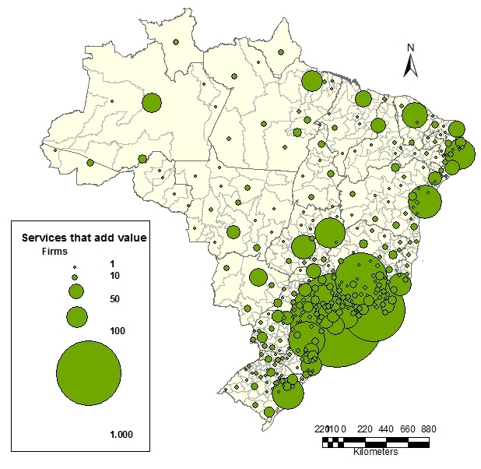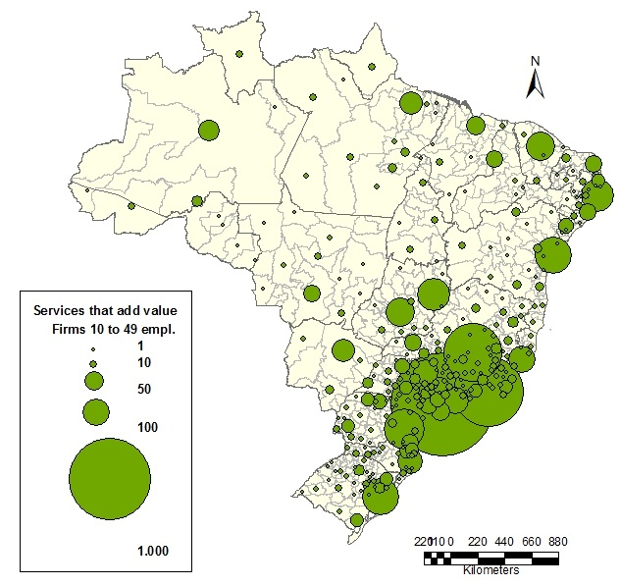

**1a**

**1b**

**1**

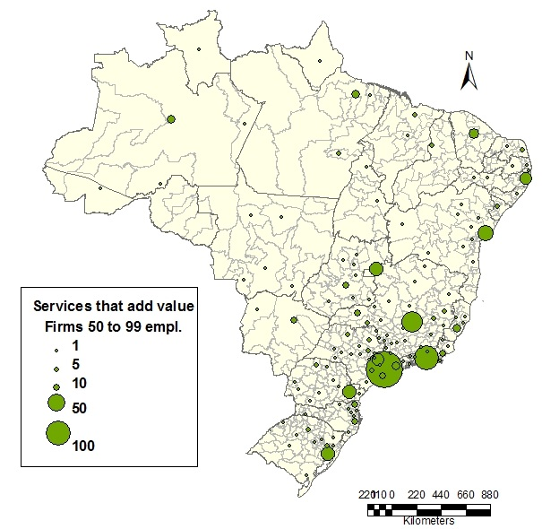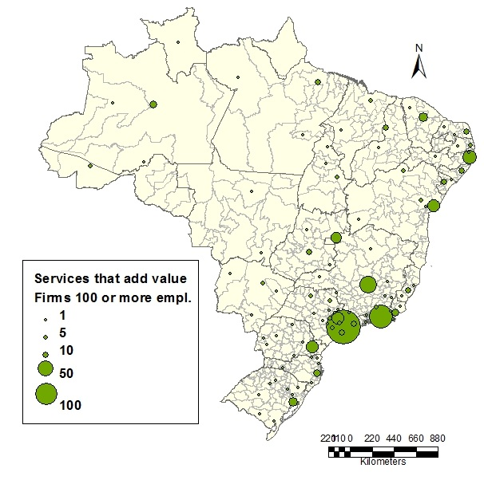

**1c**

**1d**

Source: RAIS – Ministry of Labour.

**Results**

Based on the proposed estimation strategy, Table 3 presents regression results for location determinants of service firms that add value in 2015 for all Brazilian labour market areas. The Vuong test indicated that the model with all firms and the one for smaller firms should be estimated by negative binomial (NB) regressions. This result is expected, since for these two models almost all labour market areas had data. Moreover, the parameter ln(alpha) was not statistically different from zero, indicating that in the case of firms with 100 or more employees, the regression should be estimated with a zero inflated Poisson model (ZIP).

**Table 3.** Benchmark regression and results for firm size, total firms, 2015.



* p<0.10, ** p<0.05, *** p<0.01

Source: Author elaboration.

For continuous variables, in the case of ZINB estimation, the coefficients can be interpreted as the expected change in log(number of firms) for a one-unit increase in the explanatory variable. On the other hand, for ZIP coefficients, they should be exponentiated to provide the effect of a one-unit change in the explanatory variable over the number of firms. Finally, in the case of NB models, a one-unit increase in the explanatory variable will have the effect of the coefficient over the log of the dependent variable.

Population density seems to be positively associated to the location decision of service firms that add value, with a lower effect for smaller firms. This means that denser cities will be more attractive for bigger firms who will be able to afford the higher location cost. In the same direction, the share of urban population is positive and significant only for bigger firms. If the labour market area is composed by a state capital, the chance it may house this type of service firms is higher.

Regarding sector composition, a higher share of employment in manufacture does not seem to be related to the location of service firms that add value. On the other hand, a higher presence of other service firms (related to cost reduction) increases significantly the chance that a firm of the service sector that adds value will choose to locate there. In any case, these firms search locations in which sector diversity is higher – and diversity seems to be more important for smaller firms.

On average, firms who provide sophisticated services will locate in areas with bigger companies. If the unemployment and informality rates are considered measures of tightness in the labour market, service firms may profit from the fact that more individuals are unemployed or unregistered to get better outcomes in wage bargaining.

Finally, a larger pool of qualified workers attracts service firms, while a larger share of unqualified workers acts in the opposite direction, especially for smaller firms. This result is in accordance to the literature, which advocates the importance of human capital for local development and the attraction of more productive firms.

The second set of results, presented in Table 4, refer to ZINB regressions for new firms in the service sector that adds value. In this case, the Vuong test indicates that there are enough zero values to adopt this estimation strategy.

Similarly to the previous results, sector diversity is a relevant characteristic in labour market areas to attract new firms in the service sector that adds value. Furthermore, state capitals are more prone to house new firms in this sector, especially smaller ones. The concentration of manufacturing activities in the labour market area seems to pushback new firms with at least 10 employees, and this effect is not significant for smaller firms. Furthermore, a higher share of urban population is positively correlated to the probability that a new firm in the service sector that adds value will appear in the labour market area. The same effect is found for the share of informal jobs a few years earlier, what may be capturing a lower hiring cost. Finally, a larger share of highly educated workers is significant at the 10% level to attract smaller service firms.

**Table 4.** Benchmark regression and results for firm size, new firms, 2013 to 2014.



* p<0.10, ** p<0.05, *** p<0.01

Source: Author elaboration.

**Discussion**

Firms who provide services that add value to manufacturing products do not necessarily aim to locate close to industrial firms. They are more prone to be near other service firms and in a diversified economic environment. There is also indication that they try to locate in denser cities, especially capitals, in places with a higher share of qualified workers. These results relate to the location choice literature and the fact that service providers need to be close to potential clients and other service firms. Furthermore, highly qualified services such as R&D and sophisticated IT services do not necessarily require direct proximity with manufacturing firms all the time.

Therefore, despite the strong relationship that exists between firms who provide services that add value and manufacturing companies, as measured in the input-output system (Arbache, 2016), there seems to be no explicit requirement of geographical proximity. These firms may have other clients than manufacturers, and they may also provide remote services.

**Conclusion**

The location decision of firms has been widely explored in the literature, with a special focus in high growth and high-technology firms. The development path of a country can be analysed through the perspective of the changing role of manufacturing activities over time and its interaction with the service sector. In this sense, the expansion of firms who provide services that add value to manufacturing products seem to be an essential ingredient for a country to advance in its development path.

The empirical strategy based on count data models is then employed to analyse service firm location and formation in Brazil. This specific segment is concentrated in the largest cities of the country. The results show that there is no indication of a direct association between manufacturing concentration and the location of firms who provide services that add value.

This conclusion contributes to the literature by providing a better characterization of the interaction between firms of different sectors in space. It also indicates that these services will be located in areas with more human capital and better amenities.

Future steps involve the analysis of the location decisions of new firms on a more disaggregated service sector analysis, with estimations for each two-digit CNAE sector of sophisticated services.

**References**

Acs Z.J.; Armington C. (2004) Employment growth and entrepreneurial activity in cities, *Regional Studies*, 38, 911-927.

Acs, Z.J.; Braunerhjelm, P.; Audretsch, D.B.; Carlsson, B. (2009) The knowledge spillover theory of entrepreneurship. *Small Business Economics*. 32(1), 15-30.

Alamá, L.; Artal, A.; Navarro, J.M. (2011) Industrial location, spatial discrete choice models and the need to account for neighbourhood effects. *The* *Annals of Regional Science*, 47, 393-418.

Arauzo, J.M.(2005) Determinants of industrial location: an application for Catalan municipalities. *Papers in Regional Science*. 84(1), 105-120.

Arauzo, J.M; Liviano, D.; Manjón, M. (2010) Empirical studies in industrial location: as assessment of ther methods and results. *Journal of Regional Science*, 50(3), 685-711.

Arbache, J. (2016) The contribution of services to manufacturing competitiveness in Brazil. In: Hernández, R.A.; Hualde, A.; Mulder, N.; Sauvé, P. (Eds.) *Innovation and Internationalization of Latin American Services*. ECLAC, Santiago, 65-98.

Audretsch, D.B.; Dohse, D. (2007) Location: a neglected determinant of firm growth. *Review of World Economics*, 143(1), 79-107.

Becker, R.; Henderson, V. (2000) Effects of air quality regulations on polluting industries. *Journal of Political Economy*, 108(2), 379-421.

Bloem, J.; van Doorn, M.; Duivestein, S.; Excoffier, D.; Maas, R.; van Ommeren, E. (2014) The Fourth Industrial Revolution: Things to tighten the link between IT and OT. *VINT Research Report 3 of 4*, Groningen, SOGETI.

Bosma, N.; Sternberg, R. (2014) Entrepreneurship as an urban event? Empirical evidence from European cities, *Regional* *Studies*, 48(6), 1016-1033.

Calá, C.D.; Manjón, M.; Arauzo, J.M. (2016) Regional determinants of firm entry in a developing country. *Papers in Regional Science*. 95(2), 259-280.

CNI – Confederação Nacional da Indústria (2014). *Serviços e Competitividade no Brasil / Confederação Nacional da Indústria*. Brasília, CNI.

Eichengreen, B.; Gupta, P. (2013) The two waves of service-sector growth. *Oxford Economic Papers*, 65, 96-123.

Guimarães, P.; Figueiredo, O.; Woodward, D. (2003) A tractable approach to the firm location decision problem. *The Review of Economics and Statistics*, 85(1), 201-204.

IBGE – Instituto Brasileiro de Geografia e Estatística (2013) *Divisão Urbano Regional.*

Jofre, J.; Marín, R.; Viladeçans, E. (2011) The mechanisms of agglomeration: evidence from the effect of inter-industry relations on the location of new firms. *Journal of Urban Economics*. 70, 61-74.

Lasch, F.; Robert, F.; Le Roy, F. (2013) Regional determinants of ICT new firm formation. *Small Business Economics*, 40, 671-686.

Li, M.; Goetz, S.J.; Partridge, M.; Fleming, D.A. (2016) Location determinants of high-growth firms. *Entrepreneurship and Regional Development*, 28(1-2), 97-125.

Li, Y.; Zhu, K. (2015) Spatial dependence and heterogeneity in the location processes of new high-tech firms in Nanjing, China. *Papers in Regional Science*, doi: [10.1111/pirs.12202](http://dx.doi.org/10.1111/pirs.12202).

Liviano, D.; Arauzo, J.M. (2013). Industrial location and interpretation of zero counts. *The Annals of Regional Science*, 50, 515-534.

Manjón, M.C.; Arauzo, J.M. (2011) Locations and relocations: determinants, modelling and interrelations. *The Annals of Regional Science*, 47, 131-146.

Paci, R.; Marrocu, E. (2013) Knowledge assets and regional performance. *Growth and Change*, 44(2), 228-257.

Resende, M.; Ribeiro, E.P.; Zeidan, R. (2015) Dynamic entry and exit linkages in the Brazilian manufacturing industry: an econometric investigation. *International Journal of the Economics of Business*. 22(3), 379-392.

Schwab, K. (2016) *The Fourth Industrial Revolution*, World Economic Forum, 1st Edition, Geneva.

Silva, M.V.B.; Silveira-Neto, R.M. (2007) Determinantes da localização industrial no Brasil e geografia econômica: Evidências para o período pós-real. *Revista Economia*, 8, 269-288.

Sridhar K.S.; Wan, G. (2010) Firm location choice in cities: evidence from China, India and Brazil. *China Economic Review*. 21(1), 113-122.

UNCTAD (2013) *World Investment Report – Global value chains: investment and trade for development*. Geneva, UNCTAD.

1. See

   <http://cnae.ibge.gov.br/?option=com_cnae&view=estrutura&Itemid=6160&chave=&tipo=cnae&versao_classe=7.0.0&versao_subclasse=9.1.0> (accessed in June 15, 2017).