***Quo Vadis*? Professional careers of Brazilian regulators**

Bruno César Araújo (IPEA) Alketa Peci (FGV/EBAPE) Aline Santos (FGV/EBAPE)

**ABSTRACT**

Independence of Independent Regulatory Agencies (IRA) is associated to a set of legal measures and expertise requirements that is supposed to guarantee stability to IRA’s board members despite government’s term of office. One strand of literature has analyzed independence of IRA’s board members based on their professional trajectories, before and after their mandates. Thus, this article analyzes the trajectories of 117 regulators, according to dimensions such as origin in the public or private sector, political affiliation and wages. Most regulators in Brazil (77 of 117) come from the public sector, showing that the public sector is surely a “talent pool” for recruiting IRA board members. Most of former public servants tend to return to the public sector after their mandates. Reversely, only 40 members of IRA boards come from the private sector, and most of post-mandate private sector workers come from the public sector. Revolving door trajectories - originally private sector workers that manage to return to the private sector afterwards -are not the most common in Brazilian IRAs. The 25 revolving door professionals tend to be the best paid workers, but we can not infer causality. Public servants are probably chosen for IRA’s boards due to their specific experience – according to a human capital perspective – or even because the manage to expand the “market” for their skills – according to market expansion theory. This theory focuses on the incentive for regulators to expand the market demand for services they would be providing when they exit the agency, even for the government itself.

**Keywords:** independent regulatory agencies, professional trajectories, revolving door, market expansion theory.

**RESUMO**

A Independência das Agências Reguladoras Independentes (ARI) está associada a um conjunto de medidas e requisitos que garantem estabilidade aos membros do conselho das ARIs, apesar do mandato do ciclo politico. Uma vertente da literatura tem analisado a independência dos membros do conselho do ARI com base em suas trajetórias profissionais, antes e depois de seus mandatos. Assim, este artigo analisa as trajetórias de 117 reguladores, segundo dimensões como origem no setor público ou privado, filiação política e salários. A maioria dos reguladores no Brasil (77 de 117) vem do setor público, mostrando que o setor público é certamente um "pool de talentos" para recrutar membros do colegiado das ARIs. A maioria desses reguladores tende a retornar ao setor público depois de seus mandatos. Inversamente, apenas 40 membros dos conselhos do IRA vêm do setor privado, e a maioria dos trabalhadores do setor privado pós-mandato vem do setor público. As trajetórias “porta giratória” - originalmente trabalhadores do setor privado que conseguem retornar ao setor privado depois - não são as mais comuns nas ARIs brasileiras. Os 25 profissionais “porta giratória” tendem a ser os trabalhadores mais bem pagos no pós-mandato, mas não se pode inferir causalidade. Os funcionários públicos são provavelmente escolhidos para os conselhos da ARI devido à sua experiência específica - de acordo com uma perspectiva de capital humano - ou até porque conseguem expandir o “mercado” para suas habilidades - de acordo com a teoria de expansão de mercado. Essa teoria se concentra no incentivo para que os reguladores expandam a demanda do mercado por serviços que poderão fornecer quando deixarem a agência, mesmo para o próprio governo.

**Palavras-chave:** Agências reguladoras independentes, trajetórias profissionais, porta giratória, teoria da expansão dos mercados.

**Área ANPEC:** 5 - Economia do Setor Público **JEL**: L51, L59

**INTRODUCTION**

Independent regulatory agencies (IRAs) have proliferated across a wide range of countries and sectors (Levi-Faur and Jordana, 2005; Gilardi et al.2006, Gilardi 2008; Jordana et al. 2011). While delegation theories have explored the rationale for creating independent regulatory institutions, and focused on the relationship among the agencies and policy makers (Gilardi, 2002; Shapiro, 2002), diffusion theories have also identified mimetic pressured for IRAs diffusion (Beblavy, 2011; Christensen and Lægreid, 2005; Jordana et al., 2011). Independence is associated to a set of legal measures and expertise requirements that is supposed to guarantee stability to IRA`s board members despite government`s term of office. Yet, the formal adoption of the IRAs doesn`t necessarily translate in actual independent decision-making in policymaking domains (Jordana and Ramió, 2010; Maggetti, 2007; Fernández‐i‐Marín, Jordana and Bianculli, 2016).

However, there is broad acceptance that the *de jure* Independence of IRAs is intimately related with the *de facto* independence of IRAs board members (Fernández‐i‐Marín, Jordana and Bianculli, 2016). Understanding the professional trajectories of the regulators, before and after their terms, can shield light on the *de facto* independence of IRAs. Where do the regulators come from, and where to they go after serving their terms in IRAs elucidates how the dynamic of independence enfolds in different policy context.

Theoretically, prior to their mandates, regulators need to be distinguished by professional carrier marked by expertise (training or work experience) in the regulated area and the apolitical profile, since professionals without political interests would experience less interference in decision making, guaranteeing their autonomy (Fernández‐i‐Marín, Jordana and Bianculli, 2016). In practice, political, not expertise-based criteria, might influence regulators’ indications, as commonly exposed by the media. Research indicates that political affiliation of regulators is relevant in different national context (Fernández‐i‐Marín, Jordana and Bianculli, 2016; Thatcher, 2005), but this is also the case of the expertise originated from the public sector (Eckert, 1981; Fernández‐i‐Marín, Jordana and Bianculli, 2016; Spiller, 1990). For regulators moving from the industry to IRAs, there is widespread fear that they will be “friendlier” to the market because they have been socialized within the industry (Zheng, 2014). Gormley (1979) observed that prior employment with the broadcasting industry affected the voting patterns of the commissioners at the FCC, but also found that the party affiliation of the commissioners was a better indicator of their voting behavior than their prior industry employment. More recent research, however, found unexpected results related to the political affiliation of regulator on *de facto* autonomy of IRAs in a different context (e.g. Fernández‐i‐Marín, Jordana and Bianculli, 2016, about Spain).

On the other hand, professional trajectories of the regulators after their terms have corroborated broadly accepted narratives of regulatory capture. Indeed, some studies indicate that after their term, regulators are rewarded with well-paid jobs in the regulated industry (Eckert, 1981; Spiller, 1990). Additionally, the “revolving door” phenomena among regulators, when evidenced, contributes to a negative view related to regulatory capture by industry interests (Zheng, 2014), despite controversial research results (Cohen, 1986).

Notwithstanding, the abovementioned theories of regulatory capture based on trajectories are built on several questionable assumptions. To begin with, there is no conclusive evidence that the revolving door leads to regulatory capture during regulators mandates (Cohen 1986). Incentives that lead to capture are criticized from a human-capital theory that recognizes that regulators might be awarded to a post-term job in the regulated market based on their expertise (Zheng, 2014). Moreover, regulators that come from the public sector may as well adopt market friendly regulations. Last, but not least, regulators can be captured by other groups of interests, beyond regulated industries, such as bureaucracy or politics (Carpenter and Moss, 2014), but yet capture theories privilege markets as the dominant players in the regulatory arena (Laffont e Tirole, 1991; Peltzman, 1976; Stigler, 1971). Nonrational factors may influence regulatory decision bias, such as the regulators “worldview”, “culture” or social networks (Carpenter and Moss, 2012).

Additionally, prior and posterior professional trajectories of regulators are commonly seen as separate and independent stages of regulators’ professional careers. However, it is reasonable to expect that prior professional career will influence future career paths of regulator. Hence, the main contribution of this paper is to trace the professional careers of a group of IRA board members, contrasting their previous trajectory with what comes after their mandates. In our view, mandates should not be seen as something exogenous to the rest of the careers, they should be put in a career context. We also test how political affiliation and previous experience in the public sector helps or hampers the post-mandate careers of regulators.

**THEORY**

The consolidation of the regulatory role of the State was accompanied by the establishment of specialized agencies that play a regulatory role over private companies in several sectors that include energy, water, telecommunications, pharmaceutical industry, among others, in several countries of the world (Jordana et al., 2011). The IRA model is rescued in this new context of the State’s regulatory role, based on the premise of credibility and guarantee of long-term contracts, in a post-privatization context.

For several authors, IRAs cannot be seen as organizations impervious to the influence of interest groups, since the process of selecting and appointing agency staff reflects some kind of political identity with the incumbent (Justen Filho, 2006; Meirelles and Oliva, 2006; Wu, 2008). Nunes (2007) notes that “the personalities of independent regulatory authorities are chosen on the merits of the politicians who choose them (which is not a guarantee that such “merits” are real)” (p.14). The author believes that the existing effort to emphasize that regulatory agencies are politically neutral technical agencies, which exercise imminently technical functions, is, in fact, futile, since they exercise political functions and make political decisions since they result in social and economic repercussions.

Many perspectives analyze IRAs from the point of view of capture. Stigler’s (1971) theory of economic regulation already stressed the important aspect of capturing regulators by the regulated industry. In his view, the benefits obtained by interest groups come from the use of the political machine to serve its purposes. Evaluating the industry-related interest groups in the United States, Stigler (1971: 3) states that “regulation is acquired by industry and is designed and operated primarily for its benefit”.

In Brazil, it is clear to Nunes (2007) that competent people in a certain sector usually work in companies in this sector. It is not surprising, therefore, that professionals are chosen for their experience and competence often leave regulated companies to join regulatory bodies. In addition, once the term of office has expired and some quarantine period has passed, there will be a desire for the former leader to return to the old place of work, and certainly to more prominent and better-paid places than that occupied before assuming the term in a collegiate board of an IRA.

Among the few empirical studies that have verified the professional trajectory of IRA directors from the point of view of capture, the work of Eckert (1981) and Spiller (1988) stand out. Both developed the methodology used to analyze the career trajectory of the regulators and used the starting point for the operationalization of the present research.

Eckert’s (1981) seminal study demonstrates that the typical career path of regulators consists of a strong performance in the public sector in the run-up to IRA’s direction with a high likelihood of subsequent allocation, either directly or indirectly, to the regulated industry that was under its jurisdiction. During the research, the author noted that the former leader tended to be captured by the companies he regulated. The author points out the rewards that regulators could get from the IRA board, since managers did not receive high salaries (the wage was fixed by statute): there was the expectation of high-paying jobs in the regulated private sector that surpassed the uncertain prospect of re-employment of the position in the board of directors.

One of the main problems of the regulatory agency is the competition between politicians and interest groups for the influence on the decisions of the bureaucrats - regulators. Spiller (1988), based on data previously collected by Eckert (1981), analyzed regulators of three Interstate Commerce Commission (CAC) and the Federal Communications Commission (FCC) (eg: age, term of office, pre-agency and post-agency experience, agency discretionary budget, etc.) to create a model capable of estimating the likelihood that a regulator will act in the regulated industry following as the main determinants for this type of choice.

In some cases, regulators were appointed to better positions or even positions in the ministry. According to Spiller, this is one of the ways politicians find to reward the regulators who have been faithful to them. He also distinguished the direct employment relationship, that is, an employee of a regulated company, the indirect relationship that means the provision of service to the regulated organization, such as working for a law firm that advises industry on its legal example. The author also points out that regulators have the power to distribute income from regulation. As regulators are appointed by politicians, they are able to derive benefits from potential regulators, whether in the form of advantages for electorally interesting segments or in the form of prior work on their teams.

The competition between politicians and interest groups for the influence on the decisions of the bureaucrats is narrated as one of the main problems of the agency in the seminal study of Spiller. The hypothesis is that much of this compensation takes the form of well-paid post-agency jobs, directly or indirectly related to the regulated economic sectors. In his analysis, working for regulated companies, their partners or suppliers after the end of their term in a regulatory agency may be an indicator that the regulator is rewarded for decisions he has taken to benefit the regulated industry.

In this research, we analyze some critical dimensions regarding the Brazilian regulators’ autonomy, focusing on their professional and political trajectories during pre- and post-term period.

**METHODS**

This study draws on balanced panel data over several indicators related to the expertise of regulators from IRAs collegiate boards from 1997 to 2018. The data set covers regulators from ten federal regulatory agencies: National Civil Aviation Agency (ANAC), National Film Agency (ANCINE), National Electrical Power Agency (ANEEL), National Telecommunications Agency (ANATEL), National Waterway Transportation Agency (ANTAQ), National Ground Transportation Agency (ANTT), National Health Surveillance Agency (ANVISA), National Health Agency (ANS), National Petroleum Agency (ANP), and National Water Agency (ANA). Because of its recent creation, the data do not cover the National Mining Agency (ANM), which replaced the previous National Department of Mineral Production (DNPM) in December 2017. The collegiate board from a federal regulatory agency consists of directors chosen by a specific process: Brazil’s president appoint them to Senate confirmation before taking over the office.

Our study sample comprises 117 directors’ occupational trajectories five years before and five years after term and report yearly based information. The main source of data is the Federal Senate of Brazil that provides the curricula vitae for every director nominated to compose the collegiate board of a federal regulatory agency. These CVs highlight the academic training, level of education and experience of professionals. We investigated political affiliation in the Supreme Electoral Tribunal (TSE) database, which provides a list of affiliates per party in each state of the federation. We also extract data from the Annual Social Information Report (RAIS), an official registry of all formal workers in Brazil, to capture social characteristics, e.g., employer, occupation according to the Brazilian Classification of Occupations (CBO), compensation and work hours. Finally, we collected both governmental and non-governmental print (newspapers, magazines) and electronic (websites) media to cover information such as allegations of corruption, legal proceedings, and political scandals. Table 1 reports individual variables and data sources considered in this article.

Table 1. Definitions of Study Variables and Data Sources

|  |  |  |
| --- | --- | --- |
| Variables | Definitions | Data Sources |
| Gender | Man or Woman | RAIS |
| Political Affiliation | If one is found on the list of affiliates per party in each state of the federation and/or holds a legislative, administrative or judicial office (either appointed or elected) | TSE and Senate |
| Academia | If one has a Doctoral or Master of Science degree and/or holds a position in academia | Senate |
| Regulatory Agency | If one is a public servant on behalf of a regulatory agency | Senate |
| Public Service | If one is a public servant on behalf of any government department excluding regulatory agencies | Senate |
| Industry | If one works in the regulated industry | RAIS and Senate |
| Consultancy | If one works as a consultant that provides professional advice related to the regulated industry | RAIS and Senate |

Based on the premise that careers are a sequence of job positions over time (Spilerman, 1977), recently one strand in the literature has applied longitudinal data techniques to compare career sequences to map patterns. After some previous results (not shown, but available under request), we observed only marginal differences between trajectories of men and women, academic or non-academic professionals, regulators or public servants in general and private sector workers or consultants. Thus, only two of seven possible dimensions were taken into consideration: politically affiliated vs. non-affiliated and public vs. private sector.

Our empirical strategy follows three paths. First, we analyzed the data using standard statistical techniques, such as descriptive statistics, contingency tables, mosaic plots and chi-squared tests.

Secondly, we employ Optimal Matching Analysis(OMA), introduced in career analysis by Abbott and Hrycak (1990) and revised by Abbott and Tsay (2000), Aisenbrey and Fasang (2010), and Dlouhy and Biemann (2015). The main advantage of applying OMA to our research problem is to deal with career strings without necessarily imposing restrictions regarding the grouping of these strings in common paths. One must notice that in spite of only two dimensions for each state, there are four possible states for each year, thus in theory there are 1,048,576 (410) possible strings.

Briefly, first OMA defines the distance between sequences as the number of changes needed to transform one string of sequence into another. The lower this "cost," the more similar these sequences are. Second, the operations allowed to transform one sequence into another are the substitution, insertion, and elimination (indel operations) of a given state. The output of the comparison between the strings is a symmetric matrix that displays the distance from one sequence to all others. Finally, this matrix is used to cluster sequences that are more or less similar, even though they are not exactly the same.

Thus, we tested explicitly through a binary choice model if political affiliation or previous experience in the public sector influences the probability of working for the private sector after a term in the regulatory board. This simple two-dimension classification proved to be very useful to understand the changes from public to private sector or vice versa, and how political affiliation helps or hampers these transitions.

**DESCRIPTIVE ANALYSIS OF STRINGS**

In spite of the high number or possibilities, in practice there are only 27 strings. The reason for that is the low rate of transitions from one state to the other during the first or last five years of the sequence. When transitions take place, they tend to do before-and-after the term in the regulatory board. This stability may be observed in the tempogram (Figure 1).

Figure 1. Tempogram of the sequences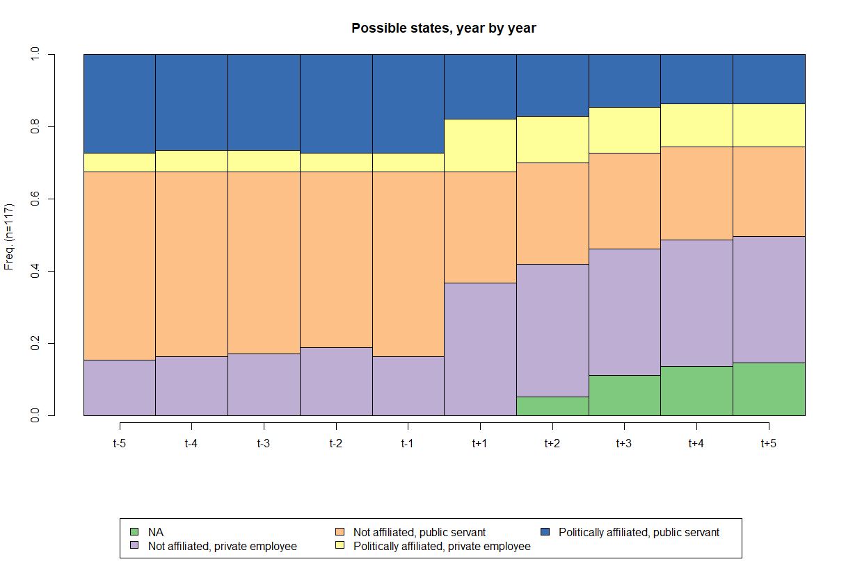

As a result from the low number of observed sequences, ten most common ones correspond to 84.6% of occurrences, as displayed in Figure 2.

Figure 2. Ten most common sequences

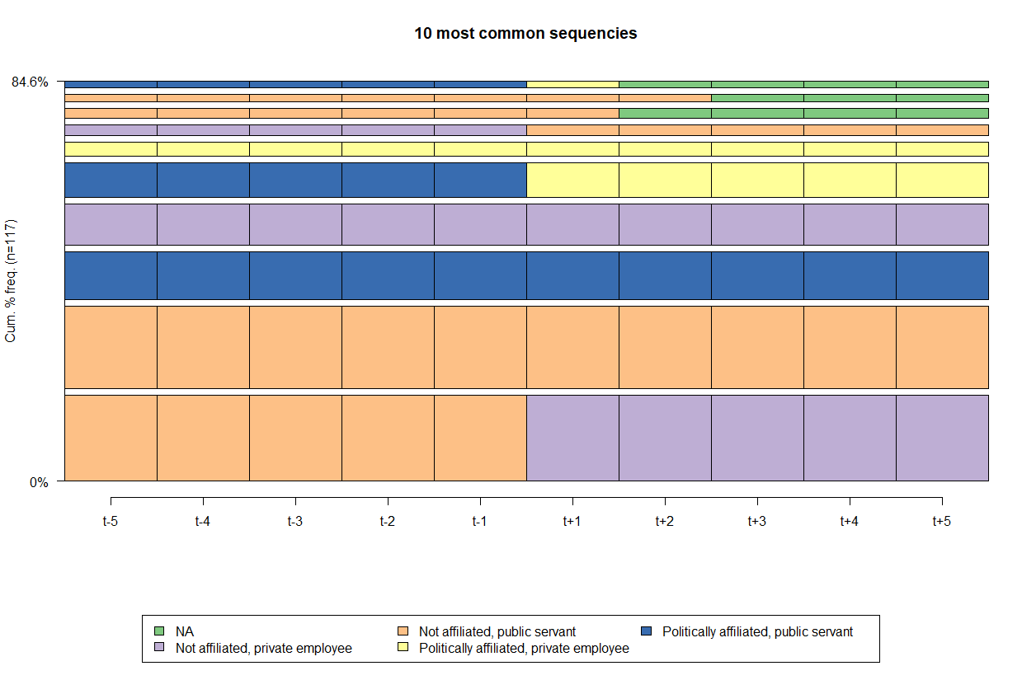

The most frequent string illustrate public servants, without political affiliation, that move to the private sector or become consultants in the regulated area after term (25 occurrencies). The second string shows public servants, without political affiliation, that remain in the public service after term (24). The third string represents public servants, with political affiliation, that remain in the public service after term (14). The fourth string, i.e., private employees, without political affiliation, tend to go back to the regulated private sector (12). The fifth sequence shows public servants, with political affiliation, that are hired by the private sector after term (10). Next, private employees, with political affiliation, remain in the regulated private sector (4). From this simple analysis, one may infer that politicians do not change their positions, i.e., having political affiliation is not a post-term gain. Neither it precludes of being appointed, nor it guarantees any position post-term. Indeed, most of private sector workers in the after-term come from the public sector, but they are not politically affiliated.

A chi-squared test, a contingency table and a mosaic plot may reveal whether there is some trajectory bias related to IRAs. Indeed, the overall chi-squared test rejects the null hypothesis of no bias towards any IRA, at less than 0.001% of significance. A contingency table and a mosaic plot point out the sources of these biases, through the difference between observed (first line of each cell), expected (second line) and their respective standardized residuals (third line). Standardized residuals may be interpreted as ordinary t-statistic observed values.

Hence, according to standard confidence levels (10%, 5% and 1% for rejection of the null hypothesis), only two cells show significant differences between observed and expected values. ANAC (the aviation agency) has a larger-than-expected proportion of regulators coming from the private sector (and eventually returning to private jobs), and ANTAQ (the waterway transportation Agency) has the same for affiliated public servants, who tend to return to the public service after their terms.

Table 2. Types of trajectories per agency

|  |  |  |  |  |  |  |
| --- | --- | --- | --- | --- | --- | --- |
| IRA | Others | Always private, not affilliated | Always public, affilliated | Always public, not affilliated | Public to private, affilliated | Public to private, not affilliated |
| ANP | 3  3.06  (-0.04) | 2  1.15  (0.88) | 2  2.2  (-0.16) | 2  0.96  (1.17) | 1  2.3  (-1.01) | 1  1.34  (-0.33) |
| ANAC | 4  3.9  (0.07) | 4  1.46  (2.37) | 1  2.8  (-1.28) | 1  1.22  (-0.22) | 3  2.92  (0.05) | 1  1.7  (-0.61) |
| ANATEL | 4  4.45  (-0.27) | 1  1.67  (-0.59) | 4  3.2  (0.54) | 2  1.39  (0.58) | 3  3.34  (-0.22) | 2  1.95  (0.04) |
| ANCINE | 3  2.78  (0.16) | 1  1.04  (-0.05) | 1  2  (-0.83) | 1  0.87  (0.15) | 2  2.09  (-0.07) | 2  1.22  (0.79) |
| ANEEL | 5  4.17  (0.51) | 0  1.57  (-1.42) | 5  3  (1.38) | 1  1.3  (-0.3) | 2  3.13  (-0.77) | 2  1.83  (0.15) |
| ANS | 5  4.45  (0.33) | 3  1.67  (1.17) | 3  3.2  (-0.13) | 0  1.39  (-1.33) | 3  3.34  (-0.22) | 2  1.95  (0.04) |
| ANTAQ | 1  1.95  (-0.82) | 0  0.73  (-0.93) | 4  1.4  (2.54) | 0  0.61  (-0.84) | 1  1.46  (-0.44) | 1  0.85  (0.18) |
| ANTT | 2  2.23  (-0.18) | 0  0.83  (-1) | 2  1.6  (0.37) | 1  0.7  (0.4) | 3  1.67  (1.2) | 0  0.97  (-1.09) |
| ANVISA | 3  3.06  (-0.04) | 0  1.15  (-1.19) | 1  2.2  (-0.95) | 1  0.96  (0.05) | 4  2.3  (1.33) | 2  1.34  (0.64) |
| ANA | 2  1.95  (0.05) | 1  0.73  (0.34) | 0  1.4  (-1.37) | 1  0.61  (0.54) | 2  1.46  (0.52) | 1  0.85  (0.18) |

Note: observed and expected values in the first two lines, and standardized difference between parentheses.

Figure 3. Mosaic plot: Types of trajectories per agency

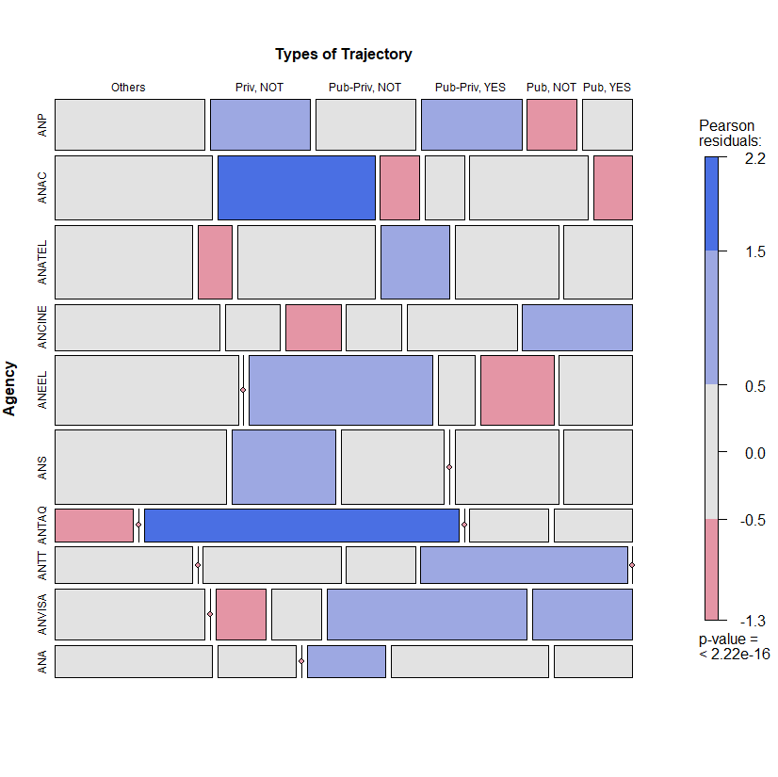

**OPTIMAL MATCHING ANALYSIS (OMA): THE TRAJECTORIES OF REGULATORS**

OMA has been widely accepted in career studies. We identified 83 indexed articles articles at *Web of Science* platform, most of them from 2000 and afterwards.[1] OMA has the main advantage over *ex ante* classifications due to its flexibility to fit to the data, i.e., it is not necessary to impose any *ex ante* restriction to the grouping of the sequences.

Besides the coding of sequences and the time frame, there are two critical decisions in applying OMA: the deletion/insertion and replacement costs between the states, when applicable; and the criterion for grouping the sequences. Simulations were conducted using the R statistical programming language. The TraMineR package was used for the sequence analysis, as described by Gabadinho et al. (2011). The TraMineR algorithm is essentially that of Needleman and Wunsch, with standard optimizations (Gabadinho et al., 2011).

The transition costs between states follow the transition probabilities. This choice has been a growing trend in the literature (Aisenbrey and Fasang, 2010; Dlouhy and Biemann, 2015). Mathematically, the transition cost from state *i* to state *j* (*i ≠ j*) is equal to 2 – *p(i|j) – p (j|i)*, where *p(i|j)* is the transition rate between states *i* and *j* in the sample. The rationale behind this approach is that the transitions observed more frequently are less costly than less frequent transitions. By definition, the probability of a transition from one state to itself is equal to one, which makes the transition cost zero.

The clustering method was Ward’s hierarchical cluster, a standard in the literature. The choice of the number of clusters involved the analysis of some measures available in the R cluster package of and visual dendrogram inspection. No definitive criterion to choose the number of clusters exists; some methods and indicators aid researchers in this decision, but they often do not point towards a single solution. Some criteria for this choice are in Figure 5. Herein, we chose a five-fold solution, based on the dendrogram and the analytical power of such a solution compared to alternatives. All code used to conduct the simulations and generate plots, as well as the simulation results presented herein, are available upon request.

Figure 4. Dendogram of OMA: 5 cluster solution

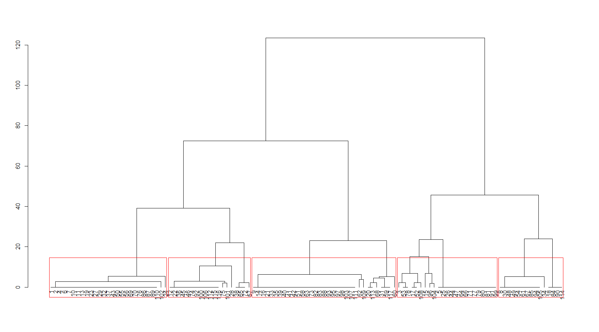

Figure 5. Some indicators regarding the number of Clusters: CH, Silhouette and Elbow Graphs

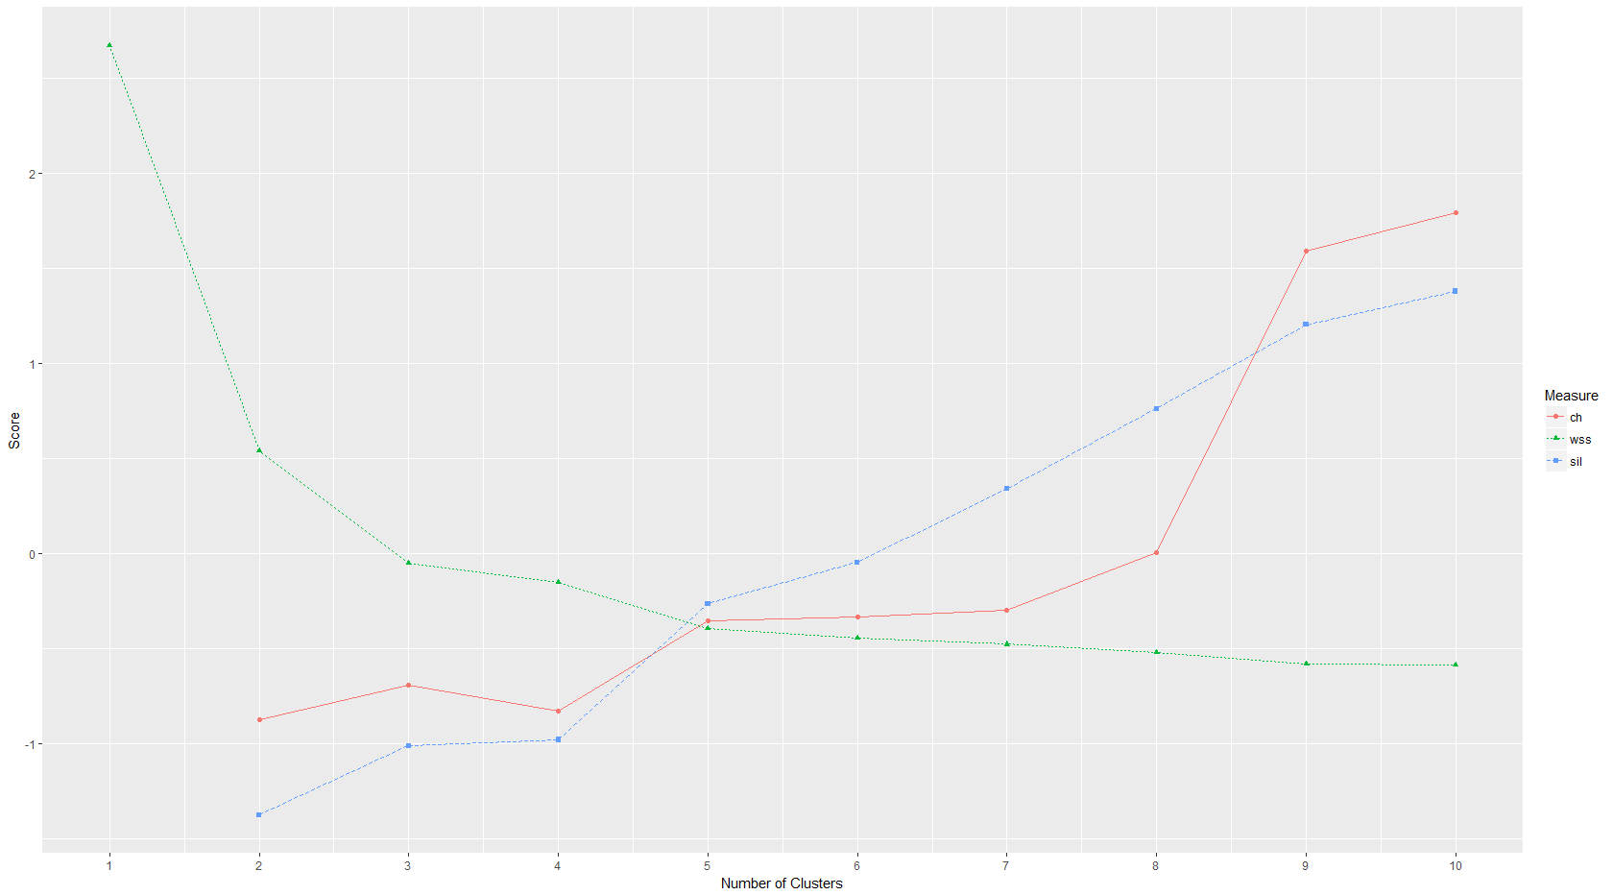

Figure 6. Tempogram: 5 cluster solution

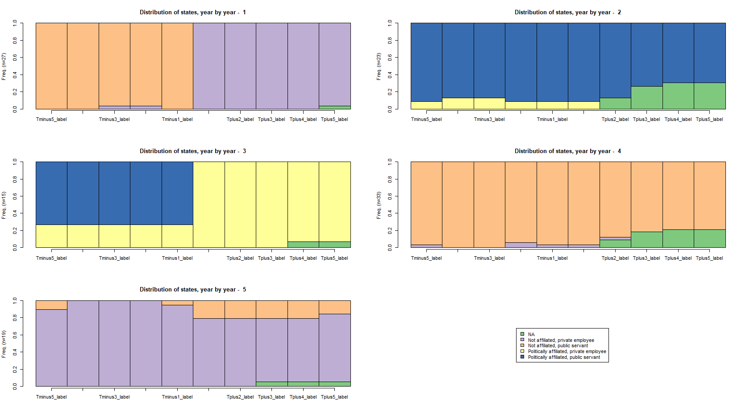

Not surprisingly, the five-cluster solution is very close to the previously presented:

* Cluster 1 (n=27) - public servants, not affiliated, who then become private sector non-affiliated workers;
* Cluster 2 (n=23) – politically affiliated public servants, who return to their positions after their terms as regulators;
* Cluster 3 (n=15) - politically affiliated public servants, who manage to go to the private sector afterwards;
* Cluster 4 (n=33) – not politically affiliated public servants, who return to their positions after their terms;
* Cluster 5 (n=19) – not affiliated private workers.

Figure 7. The most common sequences, 5 cluster solution

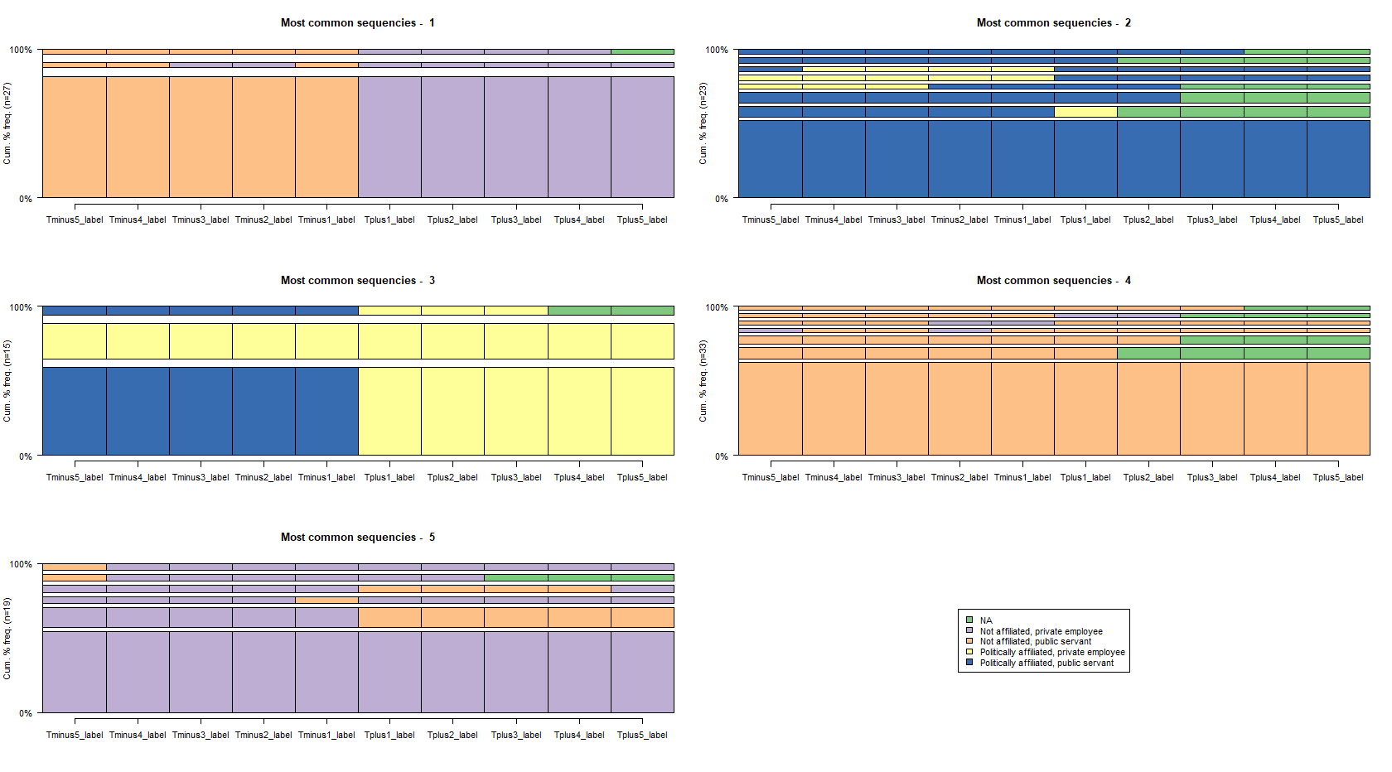

Table 3 brings the communality between the categories, the “hard” one and that from OMA. The “others” cell from the hard categorization is distributed among the five-fold categories that emerge from the OMA. All other categories show a 100% communality when one compares the equivalent cells from the hard categorization and OMA.

Table 3. Comparison between the “hard” classification and OMA

|  |  |  |  |  |  |
| --- | --- | --- | --- | --- | --- |
|  | Always private, not affiliated | Always public, affilliated | Always public, not affiliated | Public to private, affiliated | Public to private, not affiliated |
| Others | 7 | 9 | 9 | 5 | 2 |
| Always private, not affilliated | 12 | 0 | 0 | 0 | 0 |
| Always public, affilliated | 0 | 14 | 0 | 0 | 0 |
| Always public, not affilliated | 0 | 0 | 24 | 0 | 0 |
| Public to private, affilliated | 0 | 0 | 0 | 10 | 0 |
| Public to private, not affilliated | 0 | 0 | 0 | 0 | 25 |

**OK, BUT “WHAT’S IN FOR ME?”**

Figure 7 depicts the before-and-after wages of IRA board members. Perhaps surprisingly, former public servants seem to earn *less* in the private sector after their terms as regulators, at least the non-affiliated ones. In terms of wages, the most prominent category is that of non-affiliated private sector workers who manage to return to the private sector after their mandates – “revolving door” professionals. However, one should notice that they are rather few: 25 out of 117 trajectories. Moreover, we did not run a formal test for wage premia derived by the experience in the IRA. It means there’s nothing to be said, at least from figure 7, regarding whether or not former members of IRA boards earn more or less than their counterfactuals due to their status as IRA board members.

Figure 7. Wages by professional trajectory, 5 years before and after a mandate at IRA

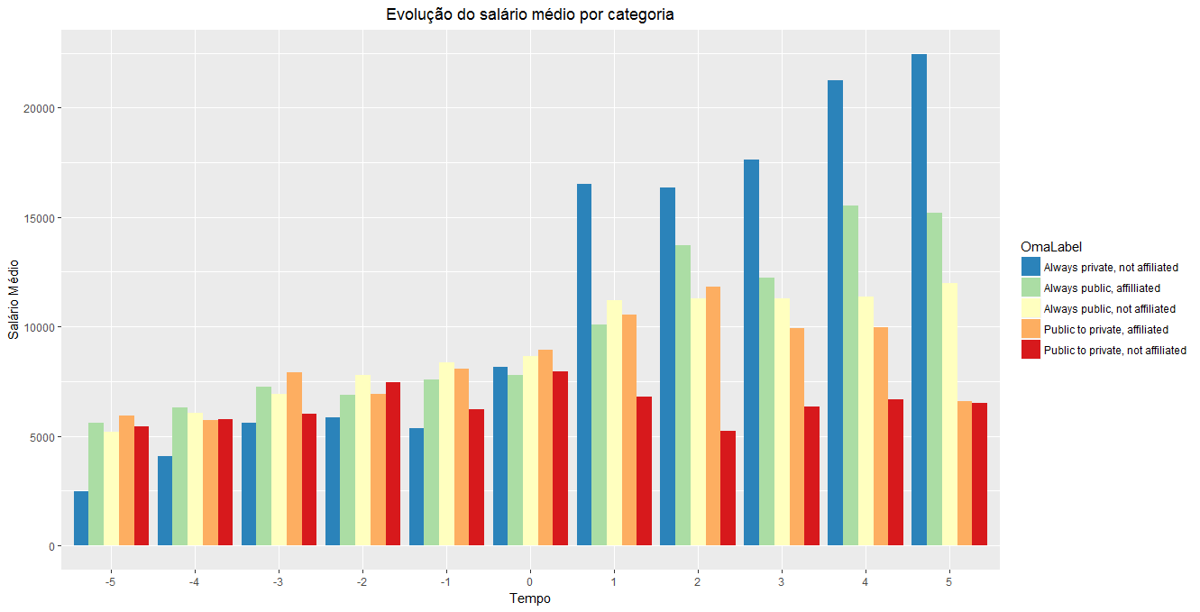

**DOES POLITICS MATTER? WHAT IS THE RELEVANT PREVIOUS EXPERIENCE?**

In this section, we test explicitly the hypothesis whether having previous experience in the public sector helps or hampers an afterwards career in the private sector, the same is done for political affiliation.

The first *probit* model is in table 4. Being a former public servant raises the probability of working in the private sector afterwards. In fact, former public servants have 2.75 more chances to work at the private sector than former private workers do. Politics seems not to affect the after-agency pattern, since one cannot reject the null hypothesis that its coefficient is zero.

Table 4. Probit model (dependent variable: at the private sector after a term as a regulator)

|  |  |  |  |  |
| --- | --- | --- | --- | --- |
|  | Estimate | Std. Error | z value | Pr(>|z|) |
| (Intercept) | -0.975** | 0.464 | -2.103 | 0.036 |
| Previously in public sector | 1.012** | 0.497 | 2.038 | 0.042 |
| Politically affiliated | 0.333 | 0.404 | 0.824 | 0.410 |
| AIC | 162.69 |  |  |  |
| DF | 114 |  |  |  |

* - significant at 5%

We also a run a second model restricted to those former public servants. The underlying hypothesis is that political affiliation may have differentiated effects in the odds of getting a private position depending if the worker comes from the public or private sector. Results are in table 5.

Table 5. Probit model, restricted to public servants (dependent variable: at the private sector after a term as a regulator)

|  |  |  |  |  |
| --- | --- | --- | --- | --- |
|  | Estimate | Std. Error | z value | Pr(>|z|) |
| (Intercept) | 0,033 | 0,256 | 0,128 | 0,898 |
| Politically affiliated | 0,347 | 0,442 | 0,785 | 0,433 |
| AIC | 131.72 |  |  |  |
| DF | 92 |  |  |  |

From this model, one cannot reject the null hypothesis that political affiliation has no impact on the probability of working at the private sector after a term in a regulatory board.

**CONCLUSION**

This study evidenced that most regulators come from the public sector, contributing to the literature that focus on regulatory capture based on the analysis of professional trajectories. No less than 77 of 117 strings under analysis begin their professional trajectories in the public sector. Hence, the public sector is surely a “talent pool” for recruiting IRA board members. Most of former public servants tend to return to the public sector after their mandates.

Reversely, only 40 members of IRA boards come from the private sector. Indeed, most of post-mandate private sector workers come from the public sector. From 48 regulators that work at the private sector after their mandates, almost a half (25) are former public servants. The 25 revolving door professionals - originally private sector workers that manage to return to the private sector afterwards – tend to be the best paid workers, but we can not infer causality because we did not run a formal test for wage premia between the categories. In any case, revolving door trajectories are not the most common in Brazilian IRAs.

Public servants are probably chosen for IRA’s boards due to their specific experience – according to a human capital perspective – or even because the manage to expand the “market” for their skills – according to market expansion theory (Zheng, 2014). This theory focuses on the incentive for regulators to expand the market demand for services they would be providing when they exit the government. “Regulocrats” make rules broad enough and complex enough to require expertise in interpretation/implementation. However, whether this is a rational calculus or reflects the expansion of bureaucratic culture is an open question.

Finally, future research should confront the professional trajectories with some measure of regulatory quality, or even capture. However, we believe that this kind of study should be eminently of qualitative nature.

REFERENCES

Beblavy, M. (2011). Understanding the waves of agencification and the governance problems they have raised in central and eastern european countries.

Carpenter, D. and Moss, D. A. (2013). Preventing regulatory capture: Special interest influence and how to limit it. Cambridge University Press.

Cavalcanti, B. S. and Peci, A. (2001). Para uma leitura política do ambiente regulatório brasileiro: Agências reguladoras e relações com os principais atores políticos.

Christensen, T. and Lægreid, P. (2005). Regulatory reforms and agencification. Cohen, J. E. (1986). The Dynamics of the" Revolving Door" on the FCC. *American Journal of Political Science*, 689-708.

Eckert, R. D. (1981). The life cycle of regulatory commissioners. The Journal of Law and Economics, 24(1):113–120.

Gilardi, F. (2002). Policy credibility and delegation to independent regulatory agencies: a comparative empirical analysis. Journal of European Public Policy, 9(6):873–893.

Fernández‐i‐Marín, X., Jordana, J., & Bianculli, A. C. (2016). Are regulatory agencies independent in practice? Evidence from board members in Spain. *Regulation & Governance*, 10(3), 230-247.

Jordana, J., Levi-Faur, D., and i Marín, X. F. (2011). The global diffusion of regulatory agencies: channels of transfer and stages of diffusion. Comparative political studies, 44(10):1343–1369.

Jordana J, Ramió C (2010) Delegation, Presidential Regimes, and Latin American Regulatory Agencies. *Journal of Politics in Latin*  *America* 2(1), 3–30.

Justen Filho, M. (2006). Agências reguladoras e democracia: existe um déficit democrático na “regulação independente?”. O poder normativo das agências reguladoras, Alexandre Santos de Aragão (Coordenador)...[et al]. Rio de Janeiro: Forense.

Gormley Jr, W. T. (1979). A Test of the Revolving Door Hypothesis at the FCC. *American Journal of Political Science*, 665-683.

Maggetti M (2007) De Facto Independence after Delegation: A Fuzzy-set Analysis. *Regulation & Governance* 1, 271–294.

Meirelles, F. and Oliva, R. (2006). Delegation and political control of the regulatory agencies in brazil. Revista de Administração Pública, 40(4):545–565.

Nunes, A. J. A. (2007). Breve reflexão sobre o chamado estado regulador. Sequência: Estudos Jurídicos e Políticos, 28(54):9–18.

Schrefler, L. (2010). The usage of scientific knowledge by independent regulatory agencies. Governance, 23(2):309–330.

Shapiro, M. (2002). Judicial delegation doctrines: the us, britain, and france. West European Politics, 25(1):173–199.

Spiller, P. T. (1990). Politicians, interest groups, and regulators: A multiple-principals agency theory of regulation, or” let them be bribed”. The Journal of Law and Economics, 33(1):65–101.

Thatcher M (2005) The Third Force? Independent Regulatory Agencies and Elected Politicians in Europe. *Governance: An International Journal of Policy, Administration and Institutions* 18, 347–373.

Zheng, W. (2014). The revolving door. *Notre Dame L. Rev.*, *90*, 1265.

Wu, I. (2008). Who regulates phones, television, and the internet? What makes a communications regulator independent and why it matters. Perspectives on politics, 6(4):769– 783.

1. According to a search in June 2019, without quotes and in the “topics” field.