Exp7b:
Output:
Before:
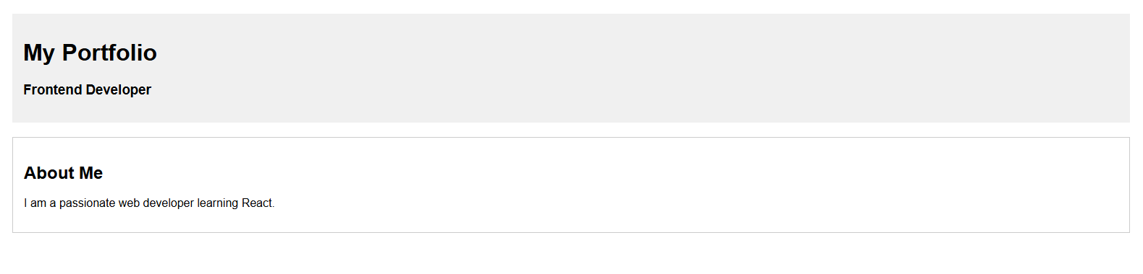

After:
