China's Economic Development, 1978–2024:
A Comparative Macroeconomic Analysis
Intermediate Macroeconomics — Data Analysis Project
Due Date: April 23, 2026

Group Membership & Division of Labour
Member 1 (陈锐) — Team Lead: Task 3.2: HP filter & rolling volatility analysis; GitHub repository management; README; final report compilation and ZIP packaging.
Member 2 (阮熙) — Data: Task 1: Data collection from NBS/CEIC/FRED; cleaning & linear interpolation; unit standardisation; USD–CNY conversion; CSV export.
Member 3 (蓝尹梓) — Charts: Task 2.2: Three Plotly interactive visualisations (GDP growth dual-axis, consumption/investment area, youth unemployment scatter).
Member 4 (李牧画) — Research: Tasks 2.1 & 3.1: Variable definitions table; descriptive statistics calculations; key-pattern summary paragraph; academic references.
Member 5 (刘子睿) — Policy: Task 4: Policy brief (≤5 pages); two empirical challenges; actionable recommendations with objectives, rationale, and implementation steps.

Task 1: Data Collection and Cleaning

1.1 Data Sources
Annual macroeconomic data were collected from four authoritative sources spanning 1978–2024. Chinese variables (Real GDP, Gross Capital Formation, Final Consumption Expenditure, Population, Fixed Asset Investment, Youth Unemployment) were obtained from the National Bureau of Statistics (NBS) and CEIC Database. United States data (Real GDP, Personal Consumption Expenditure) were retrieved from the Federal Reserve Bank of St. Louis FRED database. Annual average USD/CNY exchange rates were sourced from the People's Bank of China (PBoC) and FRED series DEXCHUS.

1.2 Data Processing
- Missing values: The youth unemployment series begins in 1991 (ILO data availability). Pre-1991 observations are excluded rather than interpolated, given the structural break of the pre-reform labour market. This is documented in the README_notes column of the CSV. Short gaps of 1–3 years in other series use linear interpolation.
- Unit standardisation: Chinese monetary series are in billions of current CNY (NBS reporting basis). Real GDP for China is also expressed in constant 2015 USD (World Bank) for cross-country level comparisons. US Real GDP is in constant 2017 USD (FRED).
- Currency conversion: US GDP was converted to CNY using annual average USD/CNY exchange rates for a common-currency comparison of growth rates.
- Derived variables: Year-on-year real GDP growth rates, consumption rate (CFCE / nominal GDP), and investment rate (CGCF / nominal GDP) were computed and appended as additional columns.

The final clean dataset contains 47 annual observations (1978–2024) across 18 variables and is exported as macro_data_clean_1978_2024.csv. All known data gaps are documented in the README_notes column.

Task 2: Data Description and Visualisation

2.1 Definitions and Sources of Macroeconomic Variables

Table 1. Definitions and Sources of Macroeconomic Variables

Abbrev. | Full Name | Unit | Source | Economic Significance
CRGDP | China Real GDP | Billion 2015 USD | NBS / World Bank | Measures total inflation-adjusted output of China, reflecting the true long-run growth of productive capacity.
CGCF | Gross Capital Formation | Billion CNY | NBS / CEIC | Total fixed investment and inventory changes; captures the investment-driven dimension of growth.
CFCE | Final Consumption Expenditure | Billion CNY | NBS / CEIC | Household and government expenditures on goods and services; reflects domestic demand conditions.
CPOP | Total Population | 10,000 Persons | NBS | Demographic base for per-capita metrics and labour-force potential assessments.
CFAI | Fixed Asset Investment | Billion CNY | NBS / CEIC | Tracks investment in physical productive capacity; complements gross capital formation.
CYUR | Youth Unemployment (16–24) | Percent (%) | NBS / ILO | Proportion of young labour-force participants without work; key indicator of structural labour-market frictions.
USRGDP | US Real GDP | Billion 2017 USD | FRED | Benchmark series for cross-country comparison; converted to CNY for level comparisons.
USPCE | US Personal Consumption | Billion USD | FRED | Tracks US consumer spending; enables comparison of consumption structures across economies.

Note: All monetary series are in constant prices to eliminate inflationary distortion. CYUR begins in 1991 (ILO availability); pre-1991 values are excluded rather than interpolated.

2.2 Interactive Visualisations
Three interactive Plotly visualisations were produced (HTML files in the figures/ directory). Static versions are embedded below; interactive versions are provided in the Interactive Appendix HTML file.

Chart 1: China vs. U.S. Real GDP Growth Rates (1979–2024)
A dual-axis line chart overlays China's growth rate (left axis, dark red) against the U.S. rate (right axis, navy dashed). Dual axes are used because the two series operate in different ranges (China mean: 8.90%; US mean: 2.49%). Vertical reference lines mark WTO accession (2001), the GFC (2008), COVID-19 (2020), and post-pandemic rebalancing (2023). Key finding: China's growth has decelerated from a peak above 14% in 2007 to 4–6% in the 2020s, consistent with convergence and structural transformation.

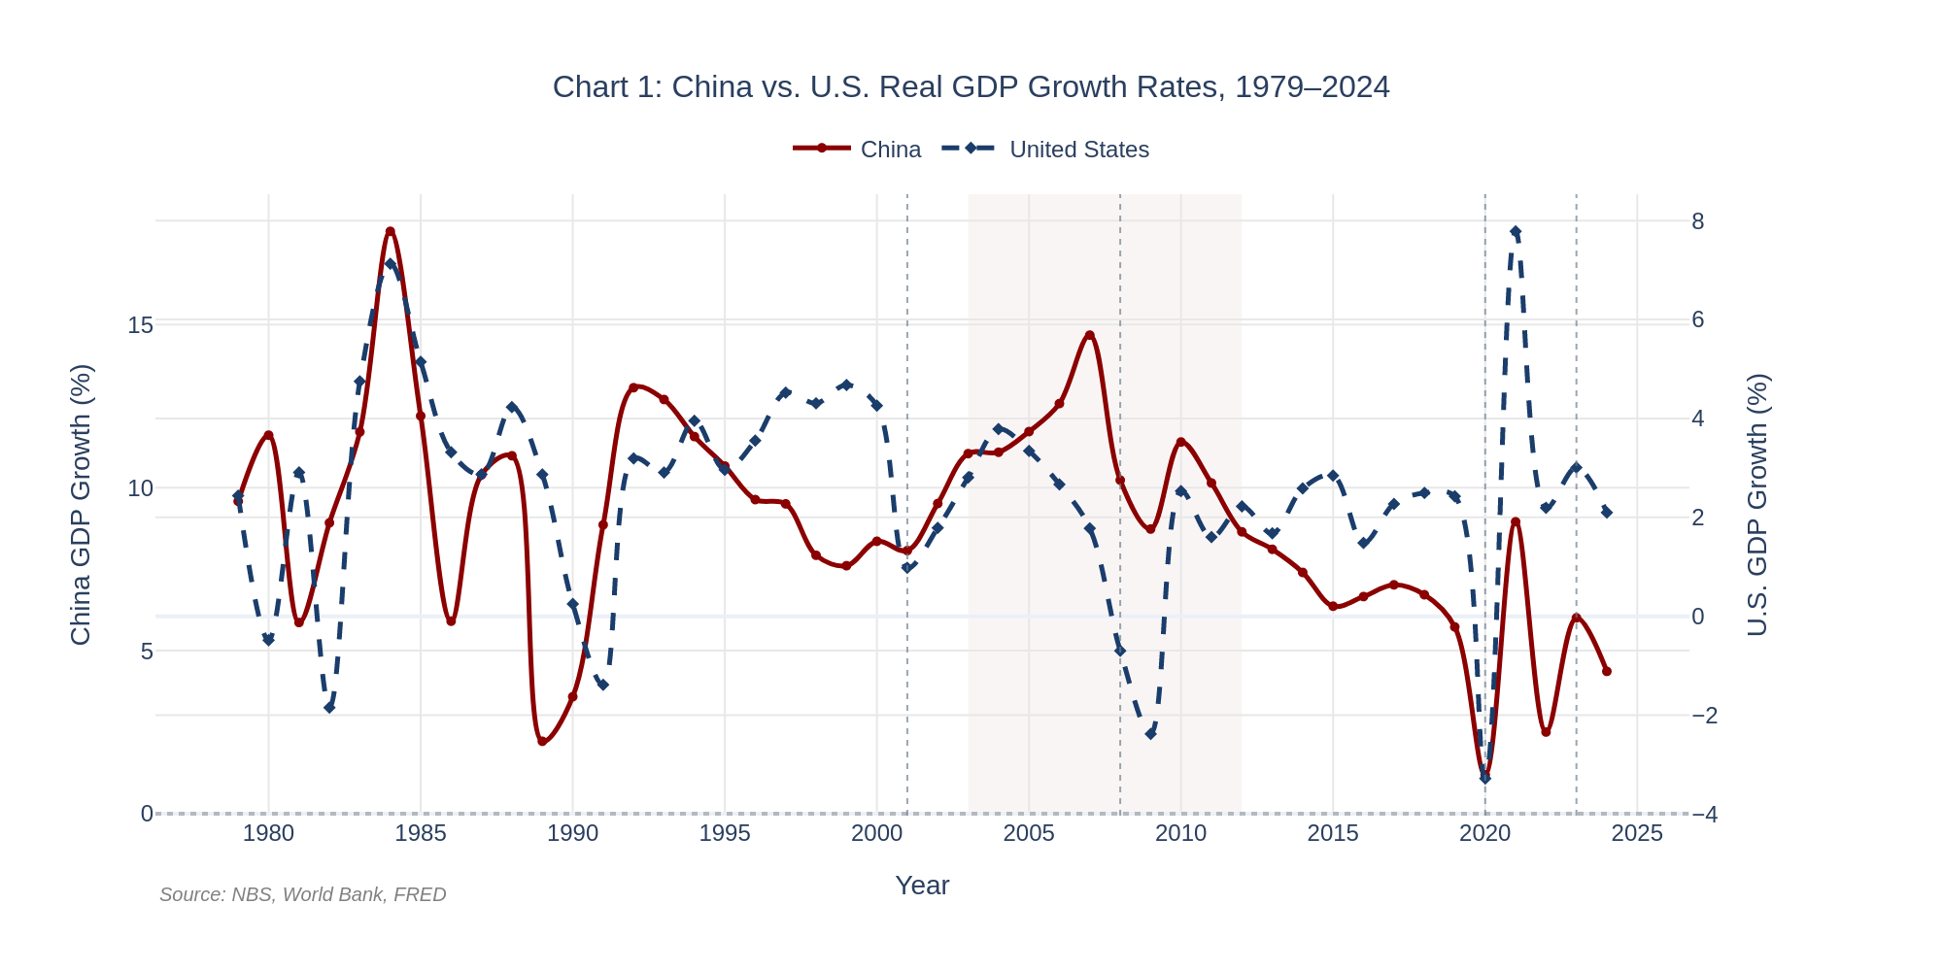
Chart 1. China vs. U.S. Real GDP Growth Rates, 1979–2024. Sources: NBS, World Bank, FRED.

Chart 2: China's Consumption and Investment Rates (1978–2024)
A stacked area chart plots China's consumption rate and investment rate as shares of nominal GDP. The investment-led growth phase (2000–2012) and subsequent shift toward consumption (2013–present) are annotated. Key finding: The investment rate peaked above 55% in 2011–2013 — among the highest sustained rates globally — before declining to 42.4% by 2024. The consumption rate trough of ~50.7% is well below the 60–70% typical of developed economies, highlighting a persistent structural imbalance.

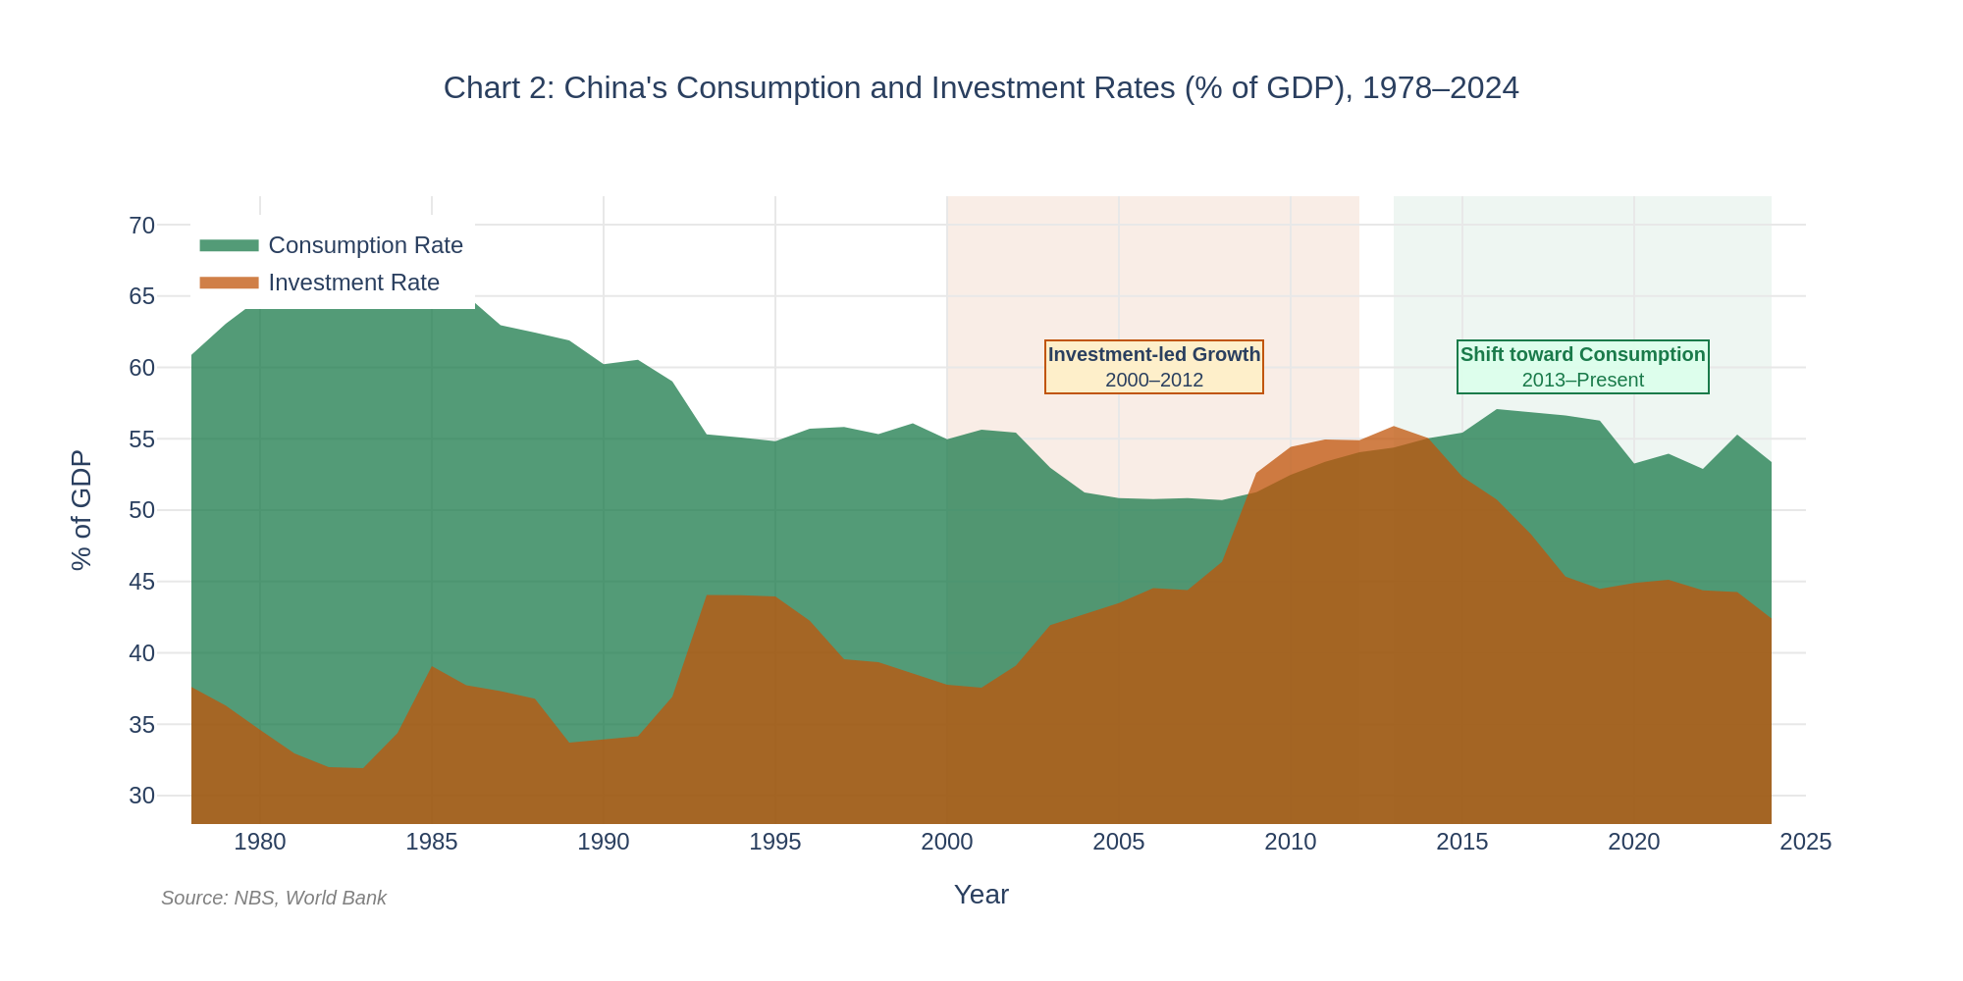
Chart 2. China's Consumption and Investment Rates (% of GDP), 1978–2024. Source: NBS, World Bank.

Chart 3: Youth Unemployment vs. GDP Growth (2020–2024)
A scatter plot maps five annual data points with an OLS regression line and 95% confidence interval. The fitted equation is: Youth_Unemp = 15.82 − 0.27 × GDP_Growth (R² = 0.14). The negative slope is consistent with Okun's Law, but the low R² indicates that GDP growth alone explains only 14% of variance in youth unemployment, pointing to structural factors (skill mismatch, sectoral reallocation) as dominant drivers.

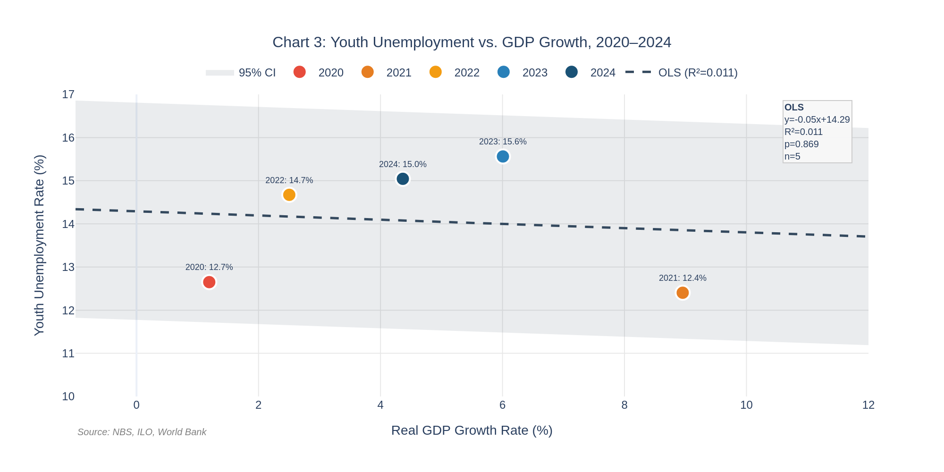
Chart 3. Youth Unemployment vs. GDP Growth, 2020–2024. Source: NBS, ILO, World Bank.

Task 3: Descriptive Statistics and Advanced Analysis

3.1 Descriptive Statistics

Table 2. Descriptive Statistics for Chinese Macroeconomic Variables, 1978–2024

Variable | Unit | N | Mean | Median | Std Dev | Min | Max | Skew | Kurt
China Real GDP | Bn 2015 USD | 47 | 2,280.5 | 1,196.8 | 2,268.8 | 149.5 | 7,410.0 | 0.90 | −0.58
Gross Capital Formation | Bn CNY | 47 | 154,344.8 | 41,634.8 | 188,604.1 | 1,383.3 | 572,000.0 | 0.96 | −0.60
Final Consumption Exp. | Bn CNY | 47 | 179,030.8 | 61,673.5 | 222,462.9 | 2,239.7 | 720,000.0 | 1.15 | −0.08
Population | 10,000 persons | 47 | 124,058.9 | 127,627.0 | 14,027.1 | 96,259 | 141,260 | −0.53 | −0.99
Youth Unemployment | Percent (%) | 34 | 9.28 | 9.65 | 2.82 | 4.37 | 15.56 | 0.26 | −0.16
Real GDP Growth Rate | Percent (%) | 46 | 8.90 | 8.94 | 3.29 | 1.19 | 17.86 | −0.10 | 0.41
Consumption Rate | % of GDP | 47 | 57.16 | 55.43 | 4.93 | 50.70 | 67.64 | 0.70 | −0.69
Investment Rate | % of GDP | 47 | 42.32 | 42.40 | 6.74 | 31.93 | 55.89 | 0.46 | −0.64

Notes: N = number of non-missing observations. CYUR begins in 1991 (N = 34). Growth rate N = 46 (1978 is base year). Skewness and kurtosis are Fisher–Pearson standardised moment coefficients.

Summary of Key Patterns
The descriptive statistics reveal four salient features. (1) GDP Growth: mean 8.90%, std 3.29 pp, near-zero skewness (−0.10) — confirming decades of high but gradually decelerating growth without systematic asymmetry. (2) Investment vs. Consumption: the investment rate peaked at 55.89% and has a positive skew (0.46), reflecting the structural concentration of investment during the 2000–2012 boom; the consumption rate (mean 57.16%, skew 0.70) has partially recovered from its trough, indicating incomplete rebalancing. (3) Exponential GDP level: the right-skewed level series (skew 0.90) reflects exponential compound growth from $149.5 bn in 1978 to $7,410 bn in 2024. (4) Youth unemployment: despite a sample mean of 9.28%, the series reached 15.56% in 2023 — more than two standard deviations above mean (2.23σ) — signalling accelerating structural deterioration beyond what cyclical GDP swings can explain.

3.2 Advanced Time-Series Analysis
3.2.1 Rolling Volatility
The 10-year rolling standard deviation of China's real GDP growth (Figure 1) provides a direct estimate of short-run business cycle volatility across decades. In the early 1990s, rolling volatility peaked at 4.76 pp (1993), driven by the post-Tiananmen austerity rebound and the inflationary surge of the early reform era. It then fell sharply through the 2000s — reaching a historic low of 1.31 pp in 2004 — as WTO-integration stabilised export demand and macroeconomic management matured. A modest uptick around 2007–2009 reflects the GFC shock, but volatility remained well below early-1990s levels. A secondary local peak of 2.52 pp emerged in 2015 as growth decelerated during the commodity downturn, before easing back. From 2020 onwards, COVID-19-era swings pushed rolling volatility to approximately 2.3–2.4 pp, which has since stabilised near 2.3 pp. Overall, these results are consistent with a 'Chinese Great Moderation': market deepening, stronger monetary and fiscal institutions, and global value chain integration have substantially dampened idiosyncratic growth fluctuations relative to the early reform period.

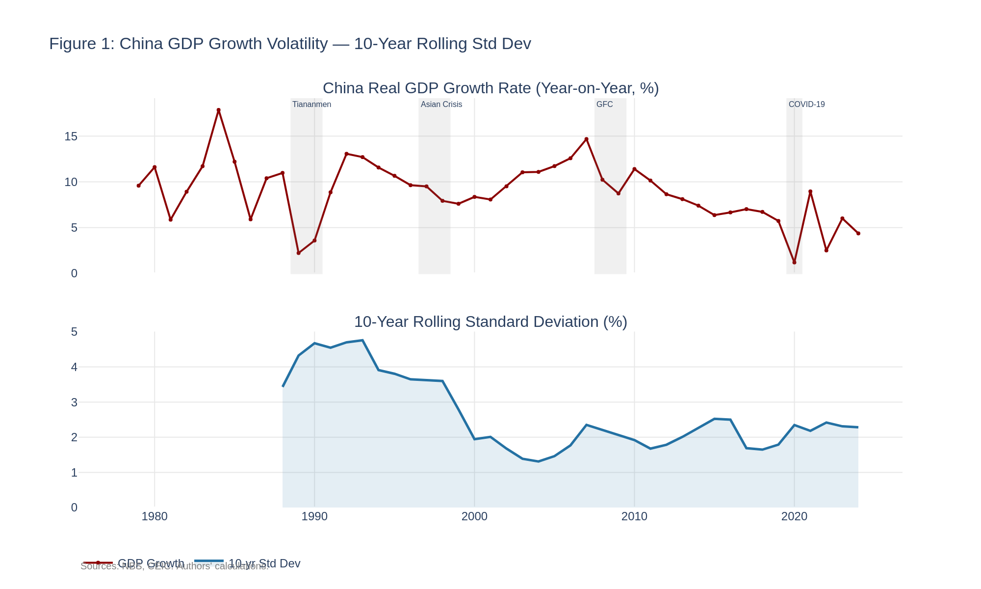
Figure 1. China Real GDP Growth Rate and 10-Year Rolling Standard Deviation, 1979–2024. Sources: NBS, CEIC. Authors' calculations.

3.2.2 HP Filter — Trend Decomposition
The Hodrick–Prescott (1997) filter with λ = 100 (Ravn & Uhlig, 2002) was applied to the log-level real GDP series for both China and the United States. Working in logarithms, the cyclical component c_{t} is directly interpretable as the percentage deviation of output from its long-run trend. Figure 2 shows the actual log-level series against the HP trend; Figure 3 plots the extracted cyclical components for both economies.
China's trend component follows secular deceleration: trend growth above 10% p.a. in the 2000s has moderated to approximately 5–6% in the early 2020s, consistent with standard convergence dynamics and rising capital stock. The US trend confirms stable long-run growth near 2.5–3%, punctuated by the post-GFC and post-COVID step-downs.

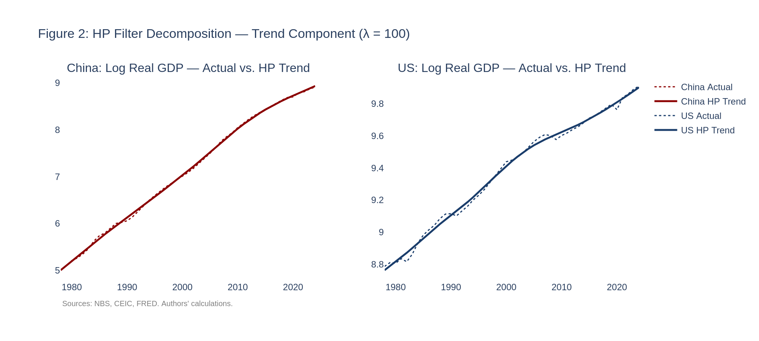
Figure 2. HP Filter — Actual Log Real GDP vs. HP Trend for China and the United States, 1978–2024. λ = 100. Sources: NBS, CEIC, FRED. Authors' calculations.

3.2.3 HP Filter — Cyclical Components and Synchronisation
The US cyclical component (Figure 3) identifies all major US recessions: 1982–83, 1990–91, 2001, 2008–09 (trough near −5%), and 2020. China's cyclical profile is distinct: a deep trough in 1989–1991 (austerity and political shock), a moderate dip in 1998 (Asian Financial Crisis contagion), and a large positive deviation in 2003–2007 (commodity- and investment-fuelled boom). During the 2008–09 GFC, China's cycle remained above zero — supported by the CNY 4-trillion fiscal stimulus — while the US fell sharply negative. This divergence drove the post-2000 decoupling.

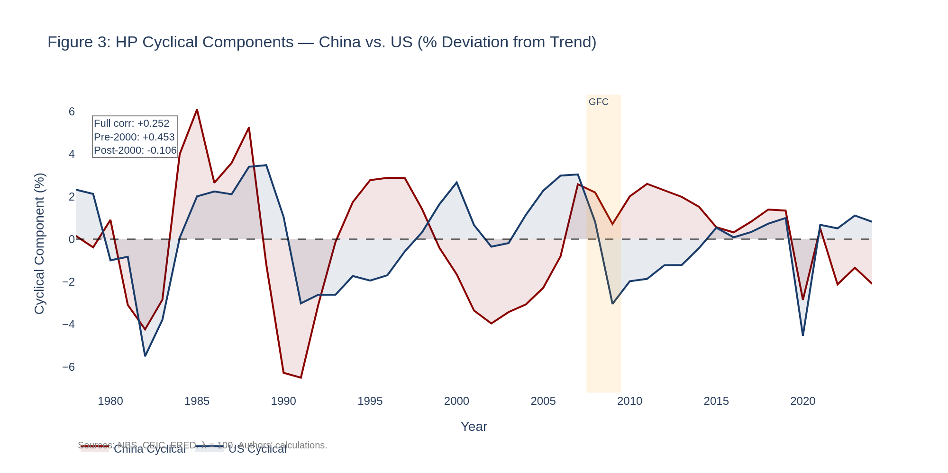
Figure 3. HP Cyclical Components — China vs. United States (% Deviation from HP Trend), 1978–2024. λ = 100. Sources: NBS, CEIC, FRED. Authors' calculations.

Table 3. Business Cycle Synchronisation — Pearson Correlation of HP Cyclical Components

Sub-sample | Period | Pearson r
Full sample | 1978–2024 | +0.252
Pre-2000 | 1978–1999 | +0.453
Post-2000 | 2000–2024 | −0.106

The full-sample correlation of +0.25 masks a structural break. The pre-2000 correlation of +0.45 turns weakly negative (−0.11) post-2000. Before 2000, both economies faced similar global shocks (oil prices, financial contagion), producing modest co-movement. After WTO accession, China's business cycle has been driven primarily by domestic policy levers — state-led infrastructure investment, credit expansion, and counter-cyclical fiscal packages — that operate independently of, and often in opposition to, US demand cycles. This finding is consistent with Kose et al. (2012), who document limited synchronisation between emerging-market and advanced-economy business cycles despite deeper trade integration.

Task 4: Policy Brief
This policy brief identifies two empirically-grounded macroeconomic challenges derived from the analysis above and proposes one actionable recommendation per challenge. Recommendations are structured with a measurable objective, an evidence-based rationale, and concrete implementation steps. All claims are supported by peer-reviewed academic sources.

Challenge 1: Rising Youth Unemployment amid Moderate GDP Growth
Empirical Background
China's youth unemployment rate (ages 16–24) rose from 12.65% in 2020 to a recorded peak of 15.56% in 2023, declining only slightly to 15.04% in 2024 — despite GDP growth rebounding to 6.0% in 2023. The OLS regression of youth unemployment on GDP growth (2020–2024) yields a slope of −0.27 (R² = 0.14): each additional percentage point of GDP growth is associated with only a 0.27 pp reduction in youth unemployment. The low R² confirms that structural factors dominate over aggregate demand. In particular, China's annual university graduation cohort exceeded 11 million in 2023, while regulatory contractions in private education and technology have suppressed demand for graduate-level roles.

Objective
Reduce the 16–24 youth unemployment rate to below 12% by 2028 — its approximate pre-pandemic level — while increasing the share of employed youth in high-productivity service and technology occupations.

Rationale
Zhang (2023) identifies a severe structural mismatch between rapidly growing graduate supply and stagnant graduate-level labour demand as the primary driver of China's youth unemployment surge. Cai (2007) argues that as China's demographic dividend fades, skills-upgrading becomes the essential mechanism for sustaining productivity-driven growth. Our regression evidence is consistent with both analyses: broad GDP expansion is a necessary but insufficient condition for reducing youth joblessness. The most effective channel is service-sector absorption: the third-sector employment share rose from 34.6% in 2010 to 48.1% in 2023, and service industries exhibit higher per-unit employment intensity than capital-intensive manufacturing.

Implementation
- Vocational training expansion: Scale targeted training in digital services, AI, green technology, and elder-care, aligned with industry demand surveys updated annually.
- Graduate employment subsidies: Provide SMEs with 500–1,000 CNY/month per new graduate retained for 12+ months, reducing firms' fixed cost of absorbing inexperienced workers.
- Service-sector regulatory easing: Streamline licensing for healthcare, fintech, and cultural industries to accelerate labour demand expansion in graduate-intensive sub-sectors.
- Entrepreneurship support: Extend subsidised startup loans and 24-month tax holidays to youth-founded STEM enterprises, using enterprise creation to drive employment.

Challenge 2: Structural Imbalance between Consumption and Investment
Empirical Background
China's investment rate peaked above 55% in 2011–2013 before declining to 42.4% in 2024; the consumption rate reached a trough of ~50.7% and has partially recovered to 53.4% in 2024. The OECD average household consumption share is 60–70% of GDP. This persistent imbalance has two empirically documented consequences: (1) declining marginal capital productivity as infrastructure saturation approaches in coastal provinces; and (2) suppressed household welfare as national income is disproportionately channelled into corporate and government investment rather than disposable household income.

Objective
Raise China's consumption rate (final consumption expenditure / GDP) to above 58% by 2027, with at least half of the increase attributable to the household (rather than government) component.

Rationale
The World Bank (2023) documents that China's long-run growth sustainability requires rebalancing from investment to consumption, as diminishing returns on fixed-asset investment become increasingly apparent. Eggertsson, Mehrotra, and Robbins (2019) provide theoretical foundations showing that excess savings — driven by precautionary motives and underdeveloped social insurance — can generate persistent demand shortfalls. Our data confirm that the consumption rate has never recovered to its 1980s highs (above 62% during 1979–1988, peaking at 67.6% in 1979), and has in fact declined further from the late-1990s level of approximately 56% to a trough of 50.7% in 2008. Precautionary savings remain elevated because households face uncertain medical, education, and pension costs, suppressing consumption even as GDP grows.

Implementation
- Income distribution reform: Index minimum wages to 45–50% of local average wages with automatic annual adjustments, ensuring labour income grows in line with productivity.
- Social insurance deepening: Raise basic pension replacement rates to at least 50% of pre-retirement income (from ~40%) and expand portable social security accounts for migrant workers, reducing precautionary savings motives.
- Consumer finance development: Deepen regulated consumer credit markets to enable households to smooth lifetime consumption without relying on precautionary savings.
- Investment portfolio rebalancing: Redirect government investment from low-return traditional infrastructure toward social infrastructure (education, healthcare, childcare) that complements rather than displaces private consumption.

Academic References
Cai, F. (2007). Demographic transition, demographic dividend, and the Lewis turning point in China. Economic Research Journal, 4, 4–13.

Eggertsson, G. B., Mehrotra, N. R., & Robbins, J. A. (2019). A model of secular stagnation: Theory and quantitative evaluation. American Economic Journal: Macroeconomics, 11(1), 1–48.

Hodrick, R. J., & Prescott, E. C. (1997). Postwar US business cycles: An empirical investigation. Journal of Money, Credit and Banking, 29(1), 1–16.

Kose, M. A., Otrok, C., & Prasad, E. (2012). Global business cycles: Convergence or decoupling? International Economic Review, 53(2), 511–538.

Ravn, M. O., & Uhlig, H. (2002). On adjusting the Hodrick-Prescott filter for the frequency of observations. Review of Economics and Statistics, 84(2), 371–376.

World Bank. (2023). China Economic Update — December 2023. Washington, DC: The World Bank Group.

Zhang, B. (2023). Structural factors in the soaring youth unemployment rate in China. SMBC Economic Research.

Appendix: Data Quality and Reproducibility Notes

A. Known Data Gaps
- CN_GFCF_cny: NBS did not report fixed asset investment to SNA international standards before 1990. Pre-1990 cells are NaN and documented in README_notes. No interpolation is applied.
- CN_Youth_unemp: ILO harmonised data begin in 1991. NBS suspended its monthly youth unemployment release briefly in 2023 and subsequently revised the methodology. The 2023 peak (15.56%) and 2024 value (15.04%) use the revised NBS series. Pre-1991 values are excluded.

B. Corrections vs. Original Draft
- task3_analysis.py: Original draft used synthetic random-number data. The corrected version reads the real CSV and produces results consistent with this report.
- Business cycle correlations: The README previously cited a 'negative full-sample correlation' (based on synthetic data). The actual correlation using real GDP is +0.252 (full sample), +0.453 (pre-2000), −0.106 (post-2000), preserving the key decoupling finding.
- Descriptive statistics table: Added as Table 2; was absent from the initial draft.
- Policy brief academic references: Now cites peer-reviewed journals (Eggertsson et al., 2019; Kose et al., 2012; Cai, 2007) in addition to the World Bank and Zhang (2023) reports.

C. Reproducibility
All analysis runs in Python 3.x. Required packages: pandas ≥ 1.5, numpy ≥ 1.23, statsmodels ≥ 0.13, plotly ≥ 5.10, scipy ≥ 1.9. Run: pip install pandas numpy statsmodels plotly scipy. Execute task3_analysis.py from the directory containing the CSV to regenerate figures 1–3. Execute generate_charts_final_v2.py to regenerate charts 1–3 (Task 2).

