# GENRX: BOOSTING SALES AND EFFICIENCY THROUGH THE MEDIUM OF POINT-OF-SALE SYSTEM WITH DATA VISUALIZATION IN PHARMACIA DIMAANO

A Capstone Project Presented to the Faculty of

College of Informatics and Computing Sciences

BATANGAS STATE UNIVERSITY

The National Engineering University

Batangas City

In Partial Fulfillment

Of the Requirements for the Degree

Bachelor of Science in Information Technology

Major in Business Analytics

By:

Joseph S. Cortez

Shaira Mae A. Lopez

Darell Marius S. Lucero

**RIA L. CASTILLO, MSCS**

Adviser

December 2023

# APPROVAL SHEET

This capstone project entitled **“GENRX: BOOSTING SALES AND EFFICIENCY THROUGH THE MEDIUM OF POINT-OF-SALE SYSTEM WITH DATA VISUALIZATION IN PHARMACIA DIMAANO”** prepared and submitted by JOSEPH S. CORTEZ, SHAIRA MAE A. LOPEZ, and DARELL MARIUS S. LUCERO in partial fulfillment of the requirements for the degree Bachelor of Science in Information Technology major in Business Analytics has been examined and is recommended for acceptance and approval for oral examination.

**RIA L. CASTILLIO, MSCS**

                                                                     Adviser

Approved by the Committee on Oral Examination with the grade of ___________

PANEL OF EXAMINERS

ROWELL M. HERNANDEZ, DIT

**Chairperson**

ERWIN L. ENRIQUEZ, BSc JOSEPH ADRIAN F. BALMES, BSc  **Member Member**

Accepted and approved in partial fulfillment of the requirements for the degree of Bachelor of Science in Information Technology major in Business Analytics.

________________ PRINCESS MARIE B. MELO, DIT

          Date **Dean, CISC**

# ABSTRACT

Pharmaceutical companies are fighting for having a less challenging service because of the effects of the global pandemic. The GenRx is designed to assist the employees of Pharmacia Dimaano located at Libjo, Batangas City. Employees of the Pharmacia Dimaano may now use the system as they facilitated with finer implementation of point-of-sale system. Furthermore, the elimination of manual data entry is also the goal of the developed study. Due to the evolution of technology, it is known that companies rely mostly on technology to compete in the business industry, and to not be left out by competitors. The developed system assists to improve the company sale and relevance. End user be provided with an account created by the admin, after having an account the user can now login and access the homepage. The user is the one, who manage the purchasing section of the system, manage customer records and transaction, and view the point of sales of the company, while the admin is granted with the access of inventory control and monitoring of the analytical report. A dashboard also implemented in the developed system. The system used several programming languages to successfully achieve a fully functional web-based system. For the front end of the system, the developers used HTML, CSS, Bootstrap and JavaScript, MySQL for its data base, as it serves as the back-end of the system. In addition, Hostinger is the hosting service that the developers used to allow users to access the system via a web browser. However, the developed system cannot transact with the use of credit card not accessible for offline mode and the retrieval of data also not supported by the system.

\

# ACKNOWLEDGEMENT

The authors would like to express their genuine appreciation to the following for supporting them in this academic journey. Their guidance and advice were imperative towards the completion of this study.

First to Almighty God, heavenly Father, for his steadfast love.

To Mrs. Lanie Palad, our professor in Capstone Project I and II, for her sharing her expertise, her valuable feedback and encouragement in the development of this study.

To Mrs. Ria L. Castillo, our adviser, for sharing his time and meaningful insights in this project.

To Mr. Rowell M. Hernandez, Mr. Erwin L. Enriquez and Mr. Joseph Adrian F. Balmes, our panelists, for comprehensively enriching the content of this project through their comments and suggestions.

We express our appreciation for the collaboration exhibited by our Pharmacia Dimaano client; without their support and participation, the research would not have been accomplished.

And lastly, a huge thank you to everyone in the team for cooperating and making the greatest effort possible during the course of the project.

# DEDICATION

This capstone project entitled “GENRX: Boosting Sales and Efficiency through the Medium of Point-of-Sale System with Data Visualization in Pharmacia Dimaano” is wholeheartedly dedicated to:

Our parents for their unconditional love and effort,

Our professors and faculty, who always provide scholastic and moral support,

Our friends, who willingly support and motivated us throughout this project,

Our institution, Batangas State University for giving us the chance to learn, grow and pursue our chosen career path.

And lastly to God, the creator of us all. To God be the Glory.

J.S.C

S.M.A.L

D.M.S.L

**Table of Contents**

TITLE PAGE i

APPROVAL SHEET ii

ABSTRACT iii

List of Tables vii

List of Figures viii

CHAPTER I 1

INTRODUCTION 1

Background of the Study 1

Objectives of the Study 4

Significance of the Study 5

Scope and Limitation of the Study 7

Definition of Terms 8

CHAPTER II 9

REVIEW OF RELATED STUDIES AND SYSTEMS 9

Technical Background 9

Related Studies and Systems 15

Related Studies 16

Related Systems 26

Conceptual Framework 33

CHAPTER III 35

DESIGN AND METHODOLOGY 35

Software Methodology Method 35

Fishbone Diagram 38

System Boundary 39

Hardware Requirements 40

Software Requirements 41

Functional Requirements 42

Non-Functional Requirements 44

Constraints 45

Systems Design / Architecture 48

Link Architecture 50

Use Case Diagram 51

Sequence Diagram 52

Database Design 54

Graphical User Interface 55

Bibligography 63

**List of Tables**

|  |  |  |
| --- | --- | --- |
| **Table No.** | **Title** | **Page No.** |
| 1 | Internal Hardware Requirements and Specifications | 49 |
| 2 | External Hardware Requirements and Specifications | 49 |
| 3 | Software Requirement Specifications | 50 |
| 4 | Server-Side Scripting Languages | 53 |
| 5 | Database | 53 |
| 6 | Text Editor | 54 |
| 7 | Multiple Technology Stacks | 55 |
| 8 | Software Used for Development | 62 |
| 9 | Unit Testing | 66 |
| 10 | Testing Procedures for Staffs | 67 |
| 11 | Testing Procedures for Admin | 68 |
| 12 | Deployment Process | 69 |
| 13 | Risk Matrix Result | 72 |
| 14 | Risk Ownership | 73 |

**List of Figures**

|  |  |  |
| --- | --- | --- |
| **Figure No.** | **Title** | **Page No.** |
| 1 | Conceptual Framework of the System | 42 |
| 2 | Agile Development Model | 43 |
| 3 | Fishbone Diagram | 47 |
| 4 | System Boundary | 48 |
| 5 | Context Diagram | 56 |
| 6 | Level 0 Diagram | 57 |
| 7 | Use Case Diagram | 58 |
| 8 | Admin Sequence Diagram | 59 |
| 9 | Employee Sequence Diagram | 60 |
| 10 | Database Design | 61 |
| 11 | ISO/IEC9126 | 65 |
| 12 | Risk Matrix | 71 |

# CHAPTER I

INTRODUCTION

This chapter outlines the project's challenge and solution, as well as the researchers' project aims. This part also includes the project's objective and description, the relevance of the project, the scope of the project, the system's restrictions, and an operational explanation of the terminology used throughout the project.

# Background of the Study

The Covid-19 epidemic continues to exert a significant influence on the pharmaceutical industry. The global health crisis has highlighted the need of pharmacists as members of the front-line care team while exacerbating long-standing concerns such as medication shortages, recalls, and diversion. As pharmacists continue to rise to these issues and adjust to the "new normal," it is critical to identify the tools and technologies that may assist them. As medical professionals manage a changing healthcare landscape and deal with difficulties exacerbated by the epidemic, it's critical that they grasp and embrace the technologies available to help them through the shift.

The pandemic's presence has caused a tidal effect on consumer behavior worldwide. A new sensation of curiosity has infiltrated people's thoughts. The emphasis has changed toward a more healthy and holistic way of life. As a result of the present pandemic, health-conscious customers have grown even more so.

Computers can complete jobs with almost little probability of error, whereas people can occasionally make mistakes. Companies are probably more susceptible to errors if they rely heavily on personnel to complete the work. Errors might range from something as minor as an incorrect inventory count to something much more serious. By putting delicate procedures in the capable hands of technology, automating processes can aid in risk mitigation. By reducing the number of times that data must be handled, it also helps. There are fewer touch points or potential for employee error when systems automatically move information from one phase to the next. In most circumstances, adding more technology to a company results in increased productivity, efficiency, and a reduction in wasteful spending and labor-intensive tasks.

Inventory management involves keeping track of a company's stock levels, whether they are kept in its own warehouse or dispersed over multiple sites. It includes overseeing products from the time you have them in stock until their disposal or eventual destination. Additionally, their travel, use, and storage are tracked by an inventory control system.

Inventory and Sales Control is being taught to the employees of the pharmaceutical company specifically, to the Pharmacia Dimaano. Furthermore, this subject is crucial for the proper tracking of records, and the advancement of having an error prone system that can boost a company's sales.

The name Pharmacia Dimaano started May 28, 2016. The physical store is located at Libjo, Batangas City. They gave it the name Dimaano, which is their last name. The owner is devoted to maintaining the outstanding reputation and services that the previous owner has built up throughout the community with their dedication and enthusiasm for medical management. The owner's principal objective is to uphold and raise the high service standards that the community has come to expect from the pharmaceutical industry.

Due to the time-consuming nature of manual procedures, workers may spend more of their time on regular tasks and less of it on activities that contribute to the success of the company, which can reduce overall productivity. They had the opportunity to use that time to generate novel concepts and aid in breakthrough.

For the employees to experience comfort using an inventory and sales management system, GenRx is developed. It is a web-based inventory control and efficient sales management system that supported employees and even business owner in implementing an increased accuracy and efficient method in tracking records.

# Objectives of the Study

The main objective of this study is to design and develop a web-based point-of-sale system with data visualization for Pharmacia Dimaano contributing to the achievement of Sustainable Development Goal (SDG) 9.

Specifically, this study aims to:

1.Design and develop a web-based point-of-sale system that monitor both sales and inventory activity at the same time.

2. Provide an efficient management system for easy access to product information and records, which include:

2.1. Transaction receipts for accurate record-keeping of sales

2.2. Stock records for tracking of inventory movement

2.3. Bar code scanner for accurate and faster purchasing process

3. Improve the quality monitoring program and creative quality practices through dashboard.

3.1. Tracking sales by means of data visualization

3.2. Simplifying the purchasing process to facilitate quicker stock acquisition

3.3. Control of user accounts for secure system access

# Significance of the Study

The study is critical for Pharmacia Dimaano looking to optimize operations and gain a competitive edge in the industry. To increase efficiency and effectiveness, the system identifies areas for improvement in the current method. Businesses get knowledge of best practices, typical problems, and new trends. With this knowledge, the system estimates inventories and sales more accurately while avoiding typical pitfalls.

By using the system, the business keeps track of the stock levels, determines which products are selling well, and decides when to refill their inventory. This makes it possible to avoid stock outs, reduce the expense of keeping inventory on hand, and guarantee that customers always have the goods they require. The sales area of the project keeps track and manages sales processes that improves customer satisfaction, and increases revenue. The project offers a consolidated platform for monitoring inventory levels and sales activity.

Implementing the system significantly impacts the business productivity, revenue and customer contentment. With accurate and up-to-date inventory levels and sales trends, the business have informed decisions about purchasing, pricing and promotions, which lead to more effective sales strategies and increased earnings. The system manages the supply chain more effectively giving it real-time visibility into inventory levels and demands with the use of inventory and sales system; it facilitates production optimization and shortens lead times.

While there has been extensive research on inventory and sales management systems in a particular industry, it is still necessary to compare and contrast these systems' effectiveness in various industries. The system has been shown to be beneficial for large businesses, there is a need to investigate how these systems can be successfully implemented in small businesses with limited resources and expertise.

# Scope and Limitations of the Study

The project is an automated point-of-sale system for a pharmaceutical company named Pharmacia Dimaano. The system is web-based designed only to be used by an admin and user.

The scope of the study includes a thorough analysis of the procedures used to manage inventory and sales, such as keeping track of sales, monitoring inventory levels, and managing stock replenishment. Among the various needs that the system meets are inventory valuation, inventory change monitoring, and inventory level planning. The basis for financial reporting on the balance sheet is the inventory value and that enable the business to prepare for potential inventory requirements.

The limitation of the study is, system cannot transact with the use of credit card and it cannot be accessed without internet. In terms of data retrieval, the system is also limited with this functionality.

# Definition of Terms

The following terms are conceptually defined. Some are operationally defined for them to have a better understanding of the relevance of these terms in the present study.

**Admin**. Who monitors the accounts and reports and provides user access, manages user accounts, keeps an eye on system security, among many other tasks, and who also keeps an eye on the health of the system and allocates resources like disk space. (Rouse, 2017)

**Barcode.** A printed series of parallel bars or lines of varied width used to enter data into a computer system. The bars are usually black on white, and their width and amount vary depending on the application. The bars are used to represent the binary digits 0 and 1, which may then be used to represent numbers ranging from 0 to 9 and processed by a digital computer.

**Dashboard**. In the study, it acts as the system's interface design. It has several panels depending on the procedure the user wants to employ. The proposed approach has two distinct dashboards for employees and administrators. (GmbH, 2023) It is an information management tool that uses data from a linked database to display data. They can frequently be set up to give the end user specific information and control how this information is displayed.

**Data Visualization**. Refers to the graphical representation of data and information using various visual elements, such as charts, graphs, maps, and diagrams. Data visualization refers to the graphical representation of data and information using various visual elements, such as charts, graphs, maps, and diagrams.(Langren, 2022)

**Inventory.** In the study, it is critical to accurately handle the supplies inside the firm. The connection between the components of the inventory to other capabilities of the proposed system serve as a solution to the challenges encountered while using the manual technique. Inventory is regularly referred to as goods. Inventory consists of all raw material, work-in-process and finished goods that a company would sell or would need to make their products. (Tomasetti, 2023)

**Pharmaceutical**. Substance used in the diagnosis, treatment, or prevention of disease and for restoring, correcting, or modifying organic functions. Pharmaceuticals are typically categorized by chemical group, pharmacological effect, and therapeutic use. (Augustyn, 2008)

**Pharmacy.** It is the science and art of creating and distributing drugs that pharmacologists have researched and created. In order to ensure the safe and efficient use of pharmaceutical drugs, it links chemical sciences with health. (Oliver, 2021).

**Point of Sale (POS) System.** A POS system is a software and hardware solution used by retailers to record sales transactions, manage inventory, and process payments. (JAMES, 2019)

**Sales**. A sale is a deal in which two or more parties trade tangible or intangible goods, services, or assets for cash. (TWIN, 2022)

# CHAPTER II

REVIEW OF RELATED STUDIES AND SYSTEM

This chapter they cited the information’s about the needs of the group in order to meet the objectives and some of the related studies that can help us on providing good service and ideas. This includes resources from journals that have already been published and technical details on the project's tools and resources.

# Technical Background

Everyone gains from using technology in their everyday lives. As a result, the system's general usability, compatibility, efficacy, and consistency all increased. This sector are the tools and resources that were used in the project and were researched:

**Text Editor**

According to (Heller, 2022), the Visual Studio Code (VS Code) program is a portable yet capable source code editor for Linux, macOS, and Windows that operates on your desktop. It has embedded compatibility with JavaScript, TypeScript, and Node.js, as well as a robust ecosystem of extensions for additional languages and runtimes (including C++, C#, Java, Python, PHP, and Go).

Visual Studio Code has code completion with IntelliSense for parameters, methods, and imported modules; graphical debugging; linting, multi-cursor editing, parameter hints, and other significant editing features; slick code navigation and refactoring; and built-in source code control, including Git support. A large portion of this was derived from Visual Studio technology.

In addition, the Electron shell, Node.js, TypeScript, and the Language Server protocol are all used in the development of VS Code's official software, which is updated once a month. Every time an update is required, the extensions are updated. The level of support for each programming language and its extensions varies, ranging from basic syntax highlighting and even bracket matching through debugging and refactoring. If there is no language server accessible, minimal support for your preferred language can be added using TextMate colorizers.

Visual Studio Code was chosen by researchers as the primary tool during the system's development since it has several benefits over other integrated development environments (IDEs). It also offers programmers a feature-rich environment for productively and cooperatively creating high-quality code.

**Mark-up Language**

Following (Astari, 2023), HyperText Markup Language, or HTML. It is a common markup language used to create web pages. Using HTML components, which include tags and attributes, it enables the development and structuring of paragraphs, sections, and links. Additionally, it's important to remember that HTML is not regarded as a programming language because it cannot provide dynamic functionality. It is currently regarded as a recognized web standard. The HTML standards are developed and updated often by the World Wide Web Consortium (W3C).

Text components are added, and the content's structure is made using HTML. However, creating a polished, completely responsive website is insufficient. Therefore, the great bulk of website content is created using JavaScript and Cascading Style Sheets (CSS). Background, color, layout, spacing, and animation style are handled by CSS. JavaScript, on the other hand, offers dynamic features like sliders, pop-ups, and picture galleries. The foundational languages for front-end development are these three.

**Web Page Formatting**

(Lamsal, 2020), Cascading Style Sheet, or CSS, is a design tool for websites. Simple and straightforward CSS outlines the style of a web document as well as the look and feel of a web page. The color of the text, the font style, the size of the columns, the background pictures or colors, the spacing between paragraphs, as well as a number of other effects, may all be managed with CSS. Either an HTML file or a separate file with the ".css" extension can be used to write it.

A preceding study done by (Gichuki Ndia et al., 2019), CSS is a standard language used by front-end Web developers to define the look and feel of structured documents written in HTML and eXtensible Mark-up Language (XML). CSS is composed of a sequence of style rules, where each rule has a selector that selects the elements needed to style in the HTML or XML document.

A web-based application must have cascading style sheets (CSS) in order to separate content from display. In essence, the CSS language enables the styling of Web sites based on themes like colors, fonts, and layout. CSS and its extensions are inherently complex, and that complexity only gets more so as they get older, just like conventional software. High complexity is undesirable and results in CSS code that is unreliable, challenging to maintain and comprehend, and prone to errors.

**Programming Language**

According to (Williams et al., 2020), JavaScript may be used to run a Node web server, and the web is now brimming with rich and sophisticated technology that is pushing the limitations of what can be executed in browser.

Accordingly, (Theisen, 2019), JavaScript is a programming language that enables developers to interact with the functionality provided by web browsers. More specifically, JavaScript is a scripting language, which means (a) traditionally, JavaScript source code is interpreted at runtime and not pre-compiled into byte code, and (b) practically, its main purpose is to modify the behavior of another application typically written in a different programming language, in which it is interpreted and run in real time.

While JavaScript is aptly named as a scripting language, the first part of the name misleadingly refers to the Java programming language. JavaScript has no functional relationship with the Java programming language. The Java part of JavaScript was used to inspire interest in the new scripting language, as Java was and still is a very popular programming language. Additionally, the original Netscape browser that included JavaScript was written in Java. JavaScript has since become an essential and arguably more important programming language than the one inspiring its name. Hence, the programming language many developers use today to build and interact with web applications is famously known as JavaScript.

**Pre-processor**

PHP is also known as Hypertext Pre-processor. PHP is an open-source and server-side scripting language, which is mainly used for developing web applications. The syntax of the PHP language is similar to the C language. PHP was originally created by Rasmus Lerdorf, and it first appeared in 1995. PHP is widely used in developing web applications and has become one of the major languages for the developers to create new applications.

Additionally, PHP is free, works on multiple platforms, and is open source (i.e., user-driven development, not part of a corporation). These attributes combined with a large development community and the wealth of available PHP libraries make PHP an attractive choice for Web developers.

**Hosting**

Per (Selvi et al., 2017), individuals have had access to hosting services for years, both free and paid, and it seems like they continue to exist. Due to increased competition and changing user expectations, their quality and range have changed to some extent. The market still has the opportunity for free hosting despite the expansion of paid hosting services and their declining costs.

Hosting comprises the supply of separate server storage together with a service package (software), which governs how and how conveniently the disk space can be utilized, however a significant portion of these hosting providers are no longer in operation, a scenario known as "vanishing hosting." The service is made up of infrastructure (hardware) and software. Just as with any other service, a few things might affect the quality and appeal of hosting services. Each hosting service has particular specifications.

**Hostinger**

There are a number of web hosting possibilities, according to (Selvi et al., 2017), but because Hostinger is reliable and cost-free, it appears like a superior option for hosting. Hostinger was self-funded in 2004. The guiding principle of Hostinger is unlimited free website building with PHP, MySQL, and Panel. It is a well-known hosting provider with a long history and a reputation that is almost unblemished.

It is a great option mainly because it offers hosting for all types of websites as well as specially designed alternatives for particular applications. A virtual private server (VPS) and website optimization tool called Hostinger enables companies to create websites, scan them for vulnerabilities, run daily backups, and create file transfer protocol (FTP) accounts all from a single interface. It enables staff to secure the website using SSL certificates and a caching engine.

# Related Studies and Systems

Reviews of relevant studies that is pertinent to the capstone project are given in this section of the paper and are essential to the development of the project. This section also covers equivalent systems that are in line with the project's aims. In the published journals, references to pertinent research and systems are prevalent.

# Related Studies

According to (Rachmat Hidayat & Irsan Saleh, 2020), effective inventory management lowers the cost of pharmaceutical items purchased and related operating costs, increasing gross earnings and net profits. Cash flow also increase as a result of cost savings from buying and storing less expensive goods. Such cash flow may be put to use for both investing in more services and covering operating costs. Mismanagement of the pharmacy's inventory might have detrimental effects on patient safety in addition to having a bad business impact on financial results. Such results can be attributable to the availability of items that are out-of-date, fake, inferior, or spoilt; the lack of vital products; unclaimed prescriptions; and the failure to update formularies. Effective inventory management is crucial to pharmacy practice from both a financial and operational standpoint. Thus, in addition to include them in continuing education courses for licensed pharmacists, both techniques of inventory management and methods of assessing inventory management should be incorporated into the course of study of pharmacy programs.

A preceding study done by (Lal et al., 2018), retailers and wholesalers must provide a compelling customer experience in order for their businesses to succeed, and in order to do so, certain technologies must meet certain standards. Point of Sale (POS) systems oversee the operation of retail transactions, frequently calculating the amount of payment required for the goods or services being purchased, documenting the receipt of funds, documenting the transaction's completion, and issuing receipts. Some fundamental goals of a firm include minimizing administrative costs, minimizing stock-out situations, increasing flexibility, boosting sales, cutting down on time, etc.

Any company's primary goal is to grow its market share and, as a result, its profits. Tools for market analysis are necessary in order to achieve this objective. It is necessary to discover and analyze the data that is pertinent to their business. One of the most common and organized methods for acquiring and analyzing data these days is competitive intelligence. To make competitive decisions, point of sale data is essential.

The project provides a solution to the query regarding the advantages of a point-of-sale (POS) system implementation for a retailer or wholesaler. It also looks into how POS data may be used for business operations including ordering, inventory management, product positioning, customer service, sales, demand forecasting, marketing effects, product seasonality effects, etc. Finally, this study investigates how POS system installation benefits customers, retailers, and wholesalers.

(Sheakh, 2018) conducted that Supply chain management's most difficult problem area is inventory management. In order to satisfy client demand, businesses must keep inventory in warehouses. However, keeping inventory costs money that can be lost. Finding the number of stocks that satisfy demand while avoiding overstock is the goal of inventory management.

Inventory costs have a lot of impact on the profitability of the firm and its success. Inventory management and its optimized decisions depend on the identification of key success factors and the right decisions at the right moment. In a dynamic market environment, it is necessary to focus on the decision-making process and the factors influencing it in order to optimize the results of the inventory function. The survey approach can shed light on the variables, and these have a lot of biased information. Testing the factors that influence inventory decisions using scientific methods can help improve the reliability of the factors taken as key variables in decision-making. Hence, the present research is focused on the dimensions of identification of factors influencing inventory optimization among SMEs in the steel sector through a structured and unstructured questionnaire, grouping the variables into two sets as internal variables and external variables, and optimization by grouping the information for an appropriate decision.

The inventory audit approach is used in the study of (Basha et al., 2020) to improve the inventory status of pharmaceuticals through selective inventory control strategies. Pharmaceuticals are critical areas of the medical industry, but due to the current COVID-19 epidemic, there has been a significant decline in capsule production, and many pharmaceutical industries have denied orders due to a lack of medicinal items during lockdown.

The study gives a general overview of how pharmacists can use the following techniques to solve current pandemic inventory management issues: Targeted inventory management techniques like ABC, VED, and VEN analysis are used to boost pharmaceutical efficiency. These techniques are individually carried out in various organizations. The ABC study aids in categorizing the factors that require closer observation. ABC-VED matrix analysis, which combines ABC and VED analysis, can be used to obtain significant control over the supply of pharmaceuticals. Numerous other studies have demonstrated that implementing these methods for the prudent use of medications in routine healthcare procedures and inventory management systems can both significantly enhance clinical outcomes and maximize the use of available medical resources.

According to (Priya et al., 2022), the pharmacy management system is designed to replace manual systems with computerized systems. The system is meant to be efficient, useful, and cost-effective in carrying out responsibilities assigned by the pharmacy manager. In a pharmacy, software handles everything from selling to inserting new incoming supplies, creating bills, calculating taxes, and calculating debt. It also computes employee salary, provides product information, generates various statistics on the best month to sell specific products via charts, and supervises staff work.

(Agustini et al., 2022) stated that the purpose of the research was to determine the flow of usage of the electronic drug purchase application, the level of suitability for ordering pharmaceuticals, the constraints through the electronic drug purchase application, and the influence on national health insurance drugs in Indonesia. To assist pharmacists with the Guttman scale, they employ a quantitative descriptive method. The findings revealed that the flow of electronic purchasing applications at the level of ordering pharmaceuticals at pharmacies was consistent with the e-catalog.

Electronic purchases have been effective because the percentage of service level from the value of incoming goods receipts shows results that meet the criteria for conformity levels according to standards. The study provides input to the pharmacy on the use of electronic purchasing applications for procurement.

(Mishra et al., 2022), Induced public demand for stocking drugs, sometimes referred to as 'panic buying,' may result in occasional market shortages, especially for medications for chronic conditions. Studies have shown that, by March 2020, inducement of demand in the global pharmaceutical industry, primarily due to the 'fear purchasing' of pharmaceuticals for severe illnesses, was valued at +8.9%. Research in the USA found that asthma drugs spiked by 65 percent from 13 to 21 March 2020, and type 2 diabetes medicines rose by 25 percent. Likewise, pharmaceutical drugs to cure elevated cholesterol, hypothyroidism and migraine have also seen a notable rise in claims. Excessive sales for asthma, diabetes, cardiovascular and behavioral well-being, and anxiety were also 0.6%, 0.3%, 0.4%, 0.4% and 0.1% respectively in the USA. In some ways, Australia’s a-month-stock law for the delivery of prescription medicines in some way deals with the panic-buying state.

According to (Atnafu & Balda, 2018), The study explains the relationship between inventory management practices, competitive advantage, and organizational performance and offers empirical support for a framework that categorizes inventory management methods into five essential characteristics. The study's findings are based on data collected from respondents, and they all show that inventory management practices have a significant positive impact on MSEs' organizational performance and competitive advantage in the manufacturing subsector. The results of this study also suggest that there is a lag between inventory management methods and organizational success in terms of competitive advantage.

The results of the study generally imply that higher organizational performance and enhanced competitive advantage may have improved levels of inventory management practice. A company may be able to employ a greater level of inventory management practices as a result of its increasing ability to compete and the need to consistently outperform its rivals. On the other hand, improved organizational performance gives a business more resources to put different cutting-edge inventory management strategies into practice.

(Rifandi, 2020), the objective of the research is to analyze the store, where buying and selling data processing is still done manually at the moment. The technique employed is the data gathering technique, which includes interview, library, and observation techniques. also uses the Unified Modeling Language (UML) technique for analysis and design procedures.

The study and observations show that the recording and producing of reports are still insufficient, and the authors plan to develop the point-of-sale system using the Unified Modeling Language (UML) technique to avoid slowing down the decision-making process. The user data, item data, sales data, purchase data, supplier data, item type data, supplier type data, and reports are among the data utilized to process the design.

The study's findings demonstrate that in order to boost customer satisfaction and ensure a smooth data presentation process, the D'STORE SHOP needs a system that streamlines sales performance, saves time, and is simple to operate.

(Acosta et al., 2020) , Spreadsheets are the conventional method used by retailers to keep track of their sales and inventory, but as stores develop bigger, they lose their usefulness. This is because more things be made available in larger numbers, making it difficult and time-consuming for the retailer to track sales made with the level of inventory in the store. Additionally, when the store uses an improper way to identify the goods that customers have purchased, the situation worsens.

By developing an inventory system, the project would thus offer a solution for retailers, like "Yochang Store" in Ising Carmen, Davao del Norte, who are still utilizing the conventional method of recording their inventory data. The shop framework for regulating and maintaining the items to be stocked is provided by the computer-based Sales and Inventory Management System. In order to prevent product overstocks or outrages, sales and inventory management systems frequently integrate the daily "point of sale" with the store's inventory level.

(Nerdelita & Baylen, 2020), Analysis of Inventory Management Systems of Selected Small-Sized Restaurants in Quezon Province: Basis for an Inventory System Manual. The study's objectives were to assess the effectiveness of the inventory management system that contributed to the small restaurants in Quezon Province that were arbitrarily chosen to lose money and to offer advice and solutions for the issues they face on a daily basis. Both quantitative and qualitative methods of data collection were used in this descriptive study. In addition to conducting an interview with restaurant owners, a survey of restaurant staff was also carried out. The data were analyzed and their meaning was deduced using the weighted mean, frequency, and percentage.

According to (Lamberte et al., 2022), Implementing a Sales and Inventory System in Ace Angel Pharmacy Drug Store. Ace Angel Pharmacy has a competitive advantage due to automated sales and inventory systems that connect several automated supply chain activities. By automating customer ordering, production scheduling, and manufacturing adjustments depending on current inventory levels, a corporation may be flexible and decide how to best fulfill client requests. A corporation can take advantage of these links right once when automated processes are connected, enabling quick information flow from one component of the supply chain to the next.

The study’s goal is to gather information to help with inventory management, sales, and production planning. The system evaluates if the amount of production has to be changed by comparing the present inventory, product levels, and production schedule with the required quantity. The system notifies the master production schedule to boost production if necessary. Additionally, when a product's retail sales levels fall short of the company's sales projection and the product is overproduced, the inventory monitoring system slows down production. It might be useful to pinpoint problems like understocking or overstocking of goods that have an impact on cash flow.

By utilizing a method that allows staff members and employees of Ace Angel Pharmacy Drugstore to keep track of the product's remaining supply in the records they can view in the database, the company stands out from the competition. Ace Angel Pharmacy Drugstore will receive good service from the system, such as a smoother transaction process that generates more revenue.

According to (Mendoza, 2019), A point-of-sale system is a business solution that mostly relies on software to manage inventory and sales activities simultaneously. A thorough response that includes updated single transaction entry records, key client information, purchased products, rate, and date is advantageous to manufacturers and retailers alike. The inventory point of sale system may use computers to check and review the company's transactions; this method is quicker and more accurate than doing so manually.

(Leona et al., 2018), Developing a Point-of-Sale Inventory Management System for Lord's Grace General Merchandising using pHp and MySQL.

Entrepreneur Mrs. Sally Bermudo, owner of Lord's Grace General Merchandising, is one of the business owners who wants to improve her business process. She had a total of five (5) businesses under her control, including two (2) Zagu franchises, two (2) reloading stations, and a Sari Sari store that had been open since 1999. Since then, all transactions have been performed by hand. It fixes the issue of switching from a laborious manual system to a computerized point-of-sale inventory management system, whose primary duty is to inspect and monitor sales, income, and stock availability. By supplying data on their stock turnover, it might also produce reports that would help management decide what to buy in the future.

The proponents aim to create a new "client-based" POS inventory management system that uses a bar code method to track inventory sales and purchases. The suggested POS inventory management system would be able to use a search engine to examine and monitor sales and revenue, as well as stock availability. Using a barcode scanner, it would be able to reduce inventory in the database in the event of a sale; it could also produce reports on sales forecast and inventory turnover; and it would be able to issue purchase orders thanks to the "Auto-Management" system built into the system's algorithms.

# Related Systems

(Yokeshwaran & Murugachandravel, 2022), the researchers developed an E-commerce with Point-of-Sale. The developed system will enable smooth operation and company operator-client interactions. The laborious procedure of entering data on sales, stock, inventory, and client payment transactions will be eliminated. The system's deployment will automate and simplify the tracking of stocks and inventory, transactions for purchases and payments, and other regular company procedures. It will enhance marketing efforts and corporate operations. The system will provide straightforward, accurate, and effective centralized corporate processes and transactions.

Business productivity, customer satisfaction, and business empowerment will all be considerably increased by the integration of an e-commerce platform with a point-of-sale system. The study's findings demonstrated that the created web application satisfies the needs and demands of the target audience and respondents. As a result, the developers draw the conclusion that the created web application will further enhance and improve commercial transactions. The manual procedure of entering sales, stock, inventory, purchase, and payment transactions for consumers will be replaced by the online application. The web application will enable frictionless business-to-client interactions.

According to (Hu, B., Xie, H., Ma, Y., Wang, J., Zhang, LJ., 2018), new retail has emerged as one of the most popular ideas globally, especially in China. Considerable progress has been achieved in addressing the shortcomings of the traditional retail industry by utilizing various Internet technologies, such as cloud computing. Notwithstanding these successes, an unsolvable problem with the current cloud-based retail point-of-sale systems is their inability to continue operating when Internet connections are lost.

According to (Peter, 2022), Numerous issues arise when the supermarket is managed manually, and they change periodically. consumption, inadequate communication, a physical count issue, a problem with daily purchases, and supply ordering. The manual administration of a supermarket slows down the updating of daily activities and might result in poor communication, or miscommunication, during the operation of the shop. When using a manual management system, stock taking will always take place in the presence of the supermarket owner or an employee, which takes time. In the event that the transaction record is lost or misconstrued, using a manual management system could harm the business.

The project work includes management and stock control, and it aims to fix irregularities in the grocery industry. It examines the availability to view existing stocks as well as the opening of new ones and stock changes. By collecting and automating manual operations, it offers a quick way to work. The project is useful in computerizing stock maintenance, record keeping, sales activity, and item transactions, which is a labor-intensive operation.

The function of a supermarket management system is to improve the efficiency of such supermarkets by taking the necessary steps to halt the growing issue in all manual retail operations. The project successfully developed the software or system that may be utilized to assist all supermarkets that are still run manually. It is possible to use the program in any kind of supermarket. The software is extremely efficient and precise and has a big memory for storing all of the supermarket's products as well as for keeping track of transactions.

According to (Tope, 2020), There isn't an automated inventory management system in place at the company yet. The purchasing receipts that the purchasing officer presents together with the products are used to register the goods instead. Daily sales are documented in a specific black book with columns for pertinent information like product name, selling price, earnings, total sales, and so on. In the firm receipts and box files, respectively, additional information is also kept, such as contacts and payments from customers and vendors.

The business managers record the company's revenues, costs, and regular and recurring expenses on specifically created forms, which are subsequently archived for future reference. In general, the company's present system is entirely manual and paper-based, making it vulnerable to problems like employee error and natural calamities like fires, floods, and mold. There are still no reports that can be generated automatically for all firms. According to the firm managers, this is a major difficulty and putting the company behind because of internal transactions.

The project that was created is a functional prototype of an automated inventory control system that can carry out the key tasks of logging the goods and materials bought, increasing sales and profits, guaranteeing customer happiness, and managing stock.

The new system is intended to be used effectively, and the developers examine the numerous technical factors that contributed to its successful implementation and established its efficient functioning.

Another related system from (Acopiado et al., 2018), The implementation of a sales and inventory system to the Pharmacia Josefa creates a thorough sales and inventory system capable of giving customers and partners simple access to sales and inventory circumstances.

Software called "Sales and Inventory System" was created for an organization with the goal of maximizing efficiency and cutting down on the time needed to manage payroll activity. It is made to take the place of an existing manual record-keeping system, speeding up computations and data storage. The database backend for the system is Microsoft SQL, and the front end is Vb.Net.

The Pharmacia Josefa Drug Store ran across several issues. One of them is that the data they personally recorded and the data in their records don't match. Another issue is that they frequently overlook recording the sold goods. The creation of an automated or computerized sales and inventory system will solve these issues. They can process their inventory quickly and efficiently with the aid of this method. It is a simple system with easy access. Data can be added or removed by the system. Additionally, it contains a transaction mechanism that ensures that each item a customer purchases is automatically added to the inventory.

In order to access the inventory, transaction process, and adding and removing of data, a user must enter their login and password into the system. A list of the products, their amount, and their cost make up the inventory. The payment received from the consumer is also input during the transaction process, together with information about the product's name, price, and quantity. The user can now save the data after it calculates the modification by pressing the submit button. It will automatically show up on the inventory sales after saving.

Under circumstances where the database is maintained and cleansed over a specific period of time, the system is robust enough to withstand regressive everyday procedures. The organization's data entry time will be greatly reduced by the system's adoption, and reports can be quickly calculated.

(Bautista & Young, 2022), effective inventory management system in efficient supply and distribution management in one of manufacturers of food seasoning products in the Philippines.

One of the most important procedures in supply and distribution management is inventory management. One of the key assets of the business is its inventory, particularly that which is used in the production process. Any time there is an inventory issue, such as when a product is out of stock, the business operation of the company will be hampered. When a corporation cannot meet a customer's demand within a reasonable amount of time, it is said to be in an out-of-stock situation. Making sure that there are enough inventories on hand to meet demand without overstocking is hence the goal of successful inventory management.

The major goals of the study are to develop a framework for a reordering system that may be utilized as the primary tool for restocking stock, obtaining the target level of stock, and optimizing truckloads. The researcher established a strong connection between each reordering system component, including the replenishment cycle, intended inventory level, safety stocks, projected lead time, and truckload maximization. The reordering system template can assist in achieving the appropriate inventory level at sales stations, according to this study's findings. The study also demonstrates a truckload optimization technique to obtain the best truckload for each delivery trip.

The same goal of creating a platform that eliminates problems and difficulties in managing business activity using a manual technique has been achieved by implementing a number of systems. The typical shipment-related drug stock-outs and the time to drug availability were measured by the developers to assess how well the DMM performed in comparison to the manual method. Scott and others (2012). In order to acquire precise information that may be used to execute a forecast, GenRx sought to design a web-based system that would track not only the stock in and out of products but also the transaction record of the supply.

While various systems that have been implemented have almost the same objectives of managing the productivity of the system, the researchers developed an e-commerce system with point-of-sale. (Yokeshwaran & Murugachandravel, 2022). The system's deployment will automate and simplify the tracking of stocks and inventory, transactions for purchases and payments, and other regular company procedures. It will enhance marketing efforts and corporate operations. Supermarket management system, the project work includes management and stock control, and it aims to fix irregularities in the grocery industry. It examines the availability of existing stocks as well as the opening of new ones and stock changes. (Peter, 2022). Planning Management and Inventory System with Predictive Analytics: The main purpose of the project is to help the planner control and oversee what is in the production work process and set priorities based on the committed delivery schedule to the customer. (E. Tan, 2021). Another related system from (Acopiado et al., 2018) is the implementation of a sales and inventory system at the Pharmacia Josefa, which creates a thorough sales and inventory system capable of giving customers and partners simple access to sales and inventory circumstances.

The aforementioned developed systems execute the procedures and characteristics of the proposed system with almost identical goals and purposes. The majority of systems are only concerned with the inventory management system, and the other projects are related to point-of-sale. GenRx is suggested to help overcome the challenges of using manual methods in business processes by proposing a point-of-sale system with data visualization in order to analyze and predict the company's sales. With that, it might help the company deal in resolving internal issues and assist in achieving Sustainable Development Goal (SDG) 9, build resilient infrastructure, promote inclusive and sustainable industrialization, and foster innovation.

# Conceptual Framework

This section shows the conceptual framework of the system and the process of how the system works from the perspective of the employee and admin. It is a multifaceted analytical tool with numerous applications. It can be employed in a variety of fields where a thorough picture is necessary. It is used to categorize and 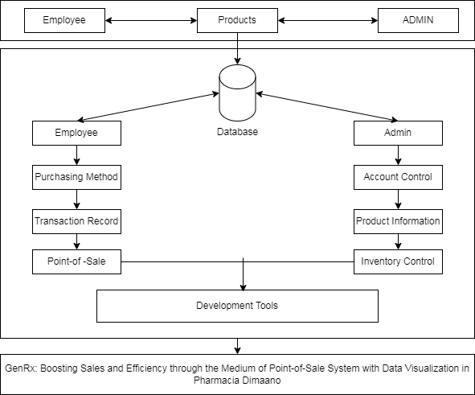organize ideas. Figure 6 depicts the project conceptual framework.

***Figure 1.*** Conceptual Framework of the System

Figure 1 depicts the suggested system's procedure. There is a distinction between admin and employee processes; the admin is only responsible for creating accounts for new employees in the work environment and managing the supply of products, supplier records, and inventory levels, whereas the employee is responsible for managing customer records, purchasing processes, and controlling customer transaction records.

# CHAPRTER III

DESIGN AND METHODOLOGY

This chapter includes the design and methodology of the project used in supervising this Capstone project. Phases of the methodology were discussed and elaborated. Figures and tables are included to further understand the development process of the project.

# Software Development Process

This chapter discusses the creation of the project and the application of the design. It also includes the research techniques and processes used by the researchers. The GenRx system was developed and constructed utilizing the framework of the agile development model. When developing the suggested system to achieve the goals depicted in Figure 2 for this project, the researchers employed the Agile Development Methodology as a guide.

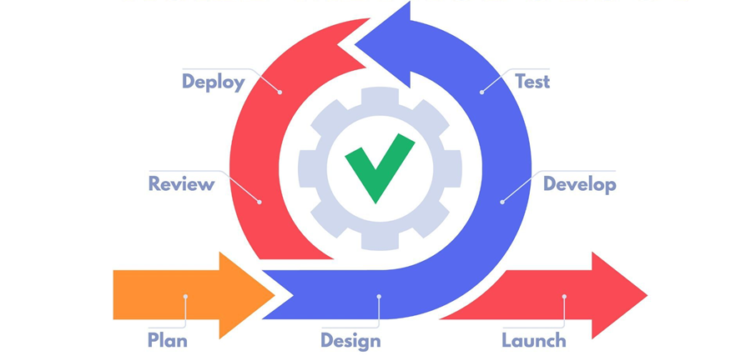

***Figure 2.*** Agile Development Model

The development of the Genrx, which demands adaptability, flexibility, and customer-centricity, is best suited for the agile process. By implementing the Agile concept, the researchers create and maintain the point-of-sale (POS) system that not only satisfies the immediate requirements but also develops to take into account the constantly shifting retail and service industries. Agile's continuous, feedback-driven approach makes it possible to design POS system that are not merely useful but also highly responsive to the needs of the business, eventually fostering the success and a possibility of an expansion of the Pharmacia Dimaano.

**Plan.** In this phase, the researchers begin by understanding the business specific objectives and goals for the implementation of the system, analyze the needs and preferences of the end users and factors like user friendliness, speed and ease of use to ensure that the system aligns with user expectation and choose the appropriate hardware components (e.g., terminals, barcode scanners) and software platforms (e.g., operating system, programming languages) that meet the defined requirements and budget constraints.

**Design.** Data flow diagrams were created by the researchers to show how data flows through the system. Understanding the information exchange between various components. For the objective of collecting transaction data, product details, customer information, and other relevant information, the developers design the database structure and schema.

**Develop.** Following the design and architecture guidelines, developers create the genuine system code. The code is organized and adheres to design patterns and recommended coding practices. Integrate the selected hardware components, including barcode scanners, and payment processing system. Ensure that the system interacts smoothly with the hardware.

**Test.** The researchers concentrated on enhancing system performance and quality for the user throughout this phase, as well as adding value for the project team by lowering administrative costs and speeding up the rate of response. Generate thorough test cases that cover the transaction processing, user interface, hardware integration, security, and compliance components of the Genrx system.

**Deploy.** Following the testing phase, the system is prepared for delivery and the deployment phase commences. The developers physically install and set up the hardware components, including the system terminals, barcode scanners, receipt printers, cash drawers, and payment processing system, at the designated locations. Ensure that all connections and peripherals are properly configured. As a result, provided the system has performed as expected and fulfilled all standards, the client starts to implement the course.

**Review.** The developers seek input from the client and incorporate it into the requirements for the following iteration. Maintain an arrangement for tracking and classifying reported bugs, mistakes, and issues. Ascertain that a well-structured procedure is in place for identifying and resolving these issues. Researchers address future issues after the reviewing step since they've acquired a better understanding of their workflow, what performed well, and also what wasn't.

**Launch.** This phase refers to the final delivery of the system after the completion of multiple iterations, the release of the initial development of the system.

# Requirement Analysis

The researchers assessed the specifications as they worked on the system. The data collected serves as the foundation for all new features added to the system. The researchers looked far and wide for the data and information that would be required for this project.

The researchers were aware that the Pharmacia Dimaano in Libjo, Batangas City, was receiving instruction in inventory and sales management via point of sale. For sales management and inventory control, this project is essential. It serves as the company's structure and basis. But the Pharmacia Dimaano only tracks records manually and creates receipts by hand. Additionally, the cost of these systems makes inventory and sales management difficult to obtain. The researchers intended to use these to create a system that would aid in fixing each of those issues. With this, the researchers were able to solve their issue and create GENRx, which would optimize corporate operations through quick and easy transactions.

# Fishbone Analysis

The Fishbone Diagram shows the visual representation of the issues encountered in Figure 3.

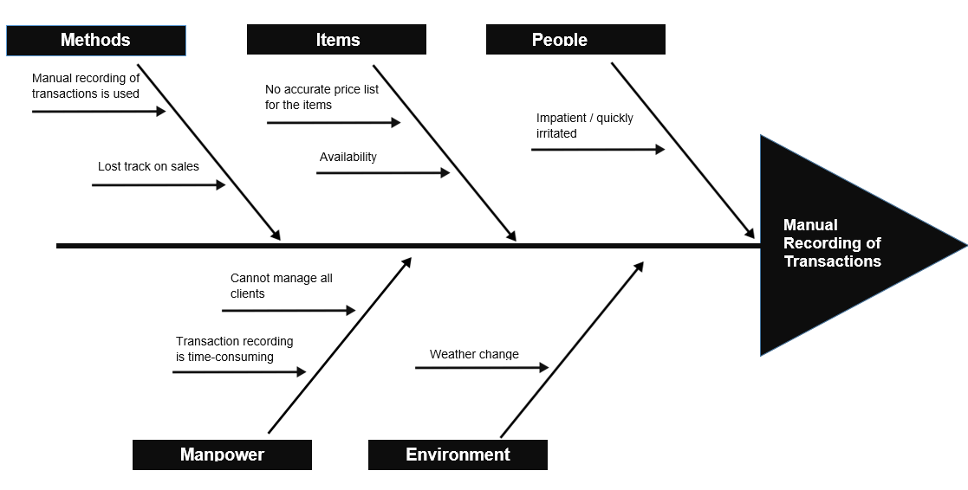

***Figure 3.*** Fishbone Diagram

The researchers gathered a group discussion to carefully identify a wide variety of prospective reasons and classify these potential sources of difficulties or concerns in an organized manner, as shown in Figure 3. As a result, the researchers evaluated each bone's relevance by evaluating data and determining which bones are questionable.

The researchers used a fishbone diagram to identify five causes in the system’s process including Methods, Items, People, Manpower, and Environment, as well as their associated consequences. The most significant bone pointed to the method aspect as the likely source of the problem, based on the observation of the proponents: manual recording of transactions. Furthermore, as the major drivers of the issue, the categorization of the method and items are regarded to be the fundamental reasons throughout the system’s process.

# System Boundary

The System Boundaries are displayed in the diagram below, which shows how individuals were involved in the system's development. It also entails assigning duties to all key players and developers. Figure 4 also emphasizes the part that each of the aforementioned entities played in the capstone project. The proposed system also has its boundaries, but identifying its boundaries can provide the researchers more effort in innovating the system. The proposed system cannot accept credit card and barcode or QR code payment. Additionally, the proposed system is also not accessible online.

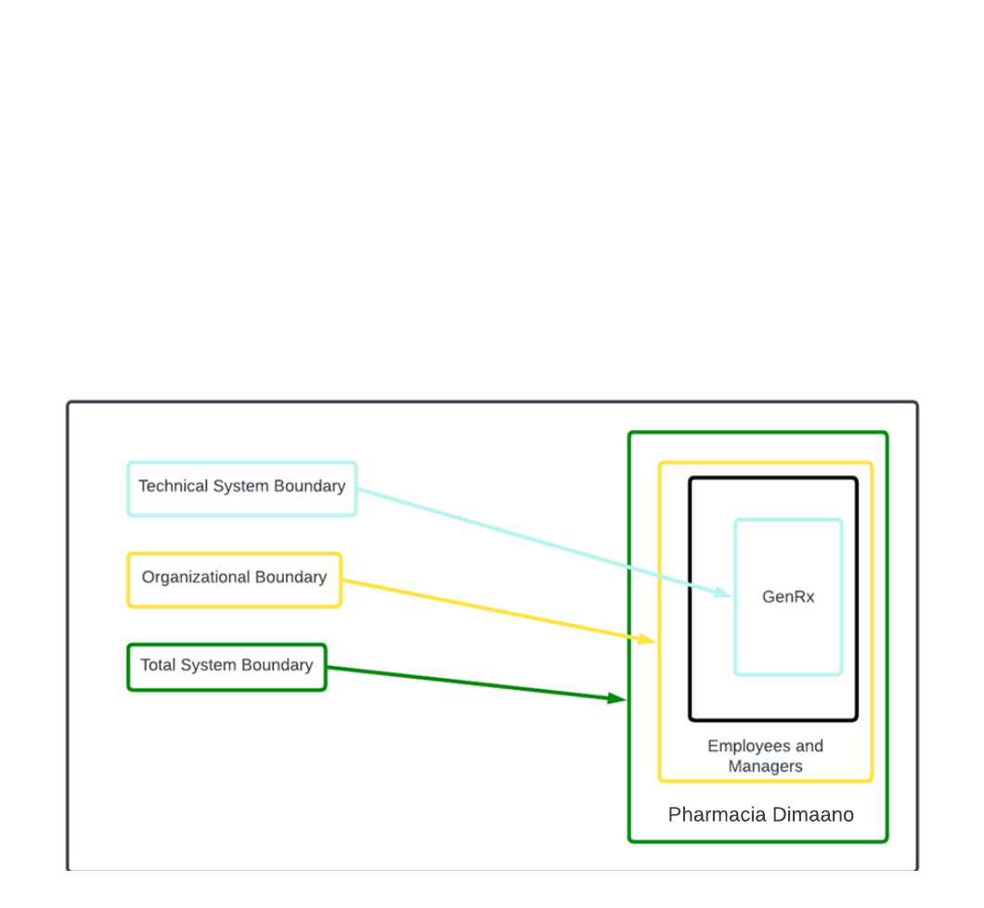

***Figure 4.*** System Boundary

System operators are included within the technical system boundary, and the main system bound as the automation boundary was "GenRx: Boosting Sales and Efficiency through the medium of Point-of-Sale System with Data Visualization in Pharmacia Dimaano," which was bound by the beneficiary or users of the said system, which were the manager and employee. In the end, the Pharmacia Dimaano in Batangas City served as the boundary of the entire system.

# Hardware Requirements

Hardware specifications are technical descriptions of the computer's components and capabilities to and access to the system.

Table 1.

*Internal Hardware Requirements and Specifications*

|  |  |  |
| --- | --- | --- |
| **Hardware** | **Minimum Requirement** | **Suggested** |
| Processor | 2.2 GHz (Core i3) | 2.2 GHz (Core i3) or higher |
| RAM | 4GB | 4 GB or higher |
| Disk Space | 500 GB | 500 GB or higher |

Table 1 shows the minimum and suggested internal hardware requirements with the desired specification needs, which supported the development of the developed system.

Table 2.

*External Hardware Requirements and Specifications*

|  |  |  |
| --- | --- | --- |
| **Hardware** | **Minimum Requirement** | **Suggested** |
| Display | 800x600 pixels | 4 GB or higher |
| Monitor | Any brand of LED monitors intel | Any brand of LED monitors intel |
| Mouse | USB or optical mouse | USB or optical mouse |
| Keyboard | Universal series bus or built-in keyboard | Any universal series bus or built-in keyboard |

Table 2 shows the minimum and suggested external hardware requirements, items that are often externally connected to the computer to control either input or output functions.

# Software Requirements

This section presents the requirements for the system implementation for efficient and effective system’s performance.

Table 3.

*Software Requirement Specifications*

|  |  |  |
| --- | --- | --- |
| **Software** | **Minimum Requirement** | **Suggested** |
| Operating System | Windows 7 | Windows 7 or higher |
| Programming IDE | VS Code | Visual Studio Code |
| Web Browser | Chrome, Microsoft Edge, Mozilla Firefox | Latest Version of web browser |
| Database | Xampp | Xampp |

Table 3 shows the minimum and suggested software requirements. The OS should be at least Windows 7 but it is more efficient when it is higher. Programming IDE, web browser as well as the database act accordingly to what operating system you are using.

# Functional Requirements

The functional requirements contained in this section outline the actions and processes that the system undertook. It explained how the system worked and the services it provided. As defined in software development, functional requirements are desired operations of the system.

**1. Admin**

1.1 The Admin shall have an account within the system.

1.2 The Admin shall be able to create, read, update, and delete user account

1.3 The Admin shall be able to create, read, update, and delete category

1.4 The Admin shall be able to create, read, update and delete specific product that is stored to the inventory.

1.5 The Admin shall be able to view the stock record of the inventory

1.6 The Admin shall monitor the sales of the pharmacy.

**2. Employee**

2.1 The Employee shall have an account within the system

2.2 The Employee shall be able to view the stock records of products in the inventory panel

2.3 The Employee shall be able to create, read, update, and delete new transaction in purchasing products

2.4 The Employee shall be able to print the transaction receipt of the purchased products

# Non-Functional Requirements

Non-functional requirement is a requirement that specifies criteria that can be used to judge the operation of a system, rather than specific behaviors.

**1. Security**

1.1. The system shall have authorization access via login to avoid unwanted access to the data of the system.

**2. Usability**

2.1. Online accessibility shall be available, however only registered users are allowed to use the website.

2.2. Users may navigate the system's menus with ease because of its intuitive button design.

**3. Reliability**

3.1. The system shall give accurate response to the user when data is filtered.

3.2. The system must have all the data in its exact form, and the generated reports must be accurate.

**4. Performance**

4.1. Every time the user uses the website, all the functions in the system must work according to its task.

4.2. The system must function flawlessly and without any interruption whilst expecting for the service to finish a task.

# Constraints

This section cover each option's reviews as well as the limitations of various software solutions. As a result, the software alternatives for designing and putting the system into use might be limited by the researchers. The five server-side scripting languages that the researchers identify are Python, CSS, JavaScript, PHP, and HTML, as seen in Table 4. The other languages utilized to create the system's front-end; the researchers decided to use JavaScript for the system's backend and PHP for its MySQL connection. Additionally, it is the system's suggested programming language, and researchers are proficient users of it.

Table 4.

*Server-Side Scripting Languages*

|  |  |  |  |
| --- | --- | --- | --- |
| **Programming Languages** | **Usability** | **Reliability** | **Performance** |
| Python | 8 | 8 | 8 |
| CSS | 8 | 8 | 8 |
| JavaScript | 9 | 9 | 10 |
| PHP | 8 | 9 | 10 |
| HTML | 9 | 8 | 9 |

Table 4. shows the difference of server-side scripting languages in terms of their performances that is useful in developing the system

Oracle, MS SQL Server, and MySQL are the three database software applications displayed, as stated in Table 5. MySQL is highly regarded because it is quick, dependable, and simple to use. When it comes to functionality, MySQL has several benefits over MS SQL Server and Oracle.

Table 5.

*Database*

|  |  |  |  |
| --- | --- | --- | --- |
| **Database Software** | **Reliability** | **Usability** | **Performance** |
| MySQL | 9 | 9 | 9 |
| MS SQL Server | 8 | 8 | 7 |
| Oracle | 7 | 7 | 8 |

Table 5 shows the ratings of various databases in terms of reliability, usability and performance

Table 6, conversely, lists the most popular text editors, including VS Code, Sublime Text, and Notepad++. Sublime Text provides rapid and easy-to-use code but is not appropriate for full-time project development. Meanwhile, in terms of debugging, both editors can analyze code; however, unlike Notepad++, which does not require any extensions to be installed, they are all third-party and, at best, unsafe. Debugging features in the node.js runtime is incorporated into Visual Studio Code. It can also debug JavaScript, TypeScript, and any other language that has been translated to JavaScript. By utilizing debugging extensions, VS Code is equally adept at debugging popular backend languages such as PHP, C#, Ruby, and Python.

Table 6.

*Text Editor*

|  |  |  |  |
| --- | --- | --- | --- |
| **Text Editor** | **Reliability** | **Usability** | **Performance** |
| VS Code | 9 | 9 | 9 |
| Sublime Text | 8 | 7 | 8 |
| Notepad++ | 8 | 7 | 8 |

Table 6 shows the ratings of different text editors in terms of reliability, usability and performance

# Trade-Offs

The researchers try different system designs that can be utilized for the development of the study. This help to ensure that all users, including project managers, technical teams, and users have a clear understanding of what is feasible and what needs to be compromised in order to meet the project's objectives.

Table 7

*Multiple Technology Stacks*

|  |  |
| --- | --- |
| **Design** | **Technology Stack** |
| Design A | HTML  CSS  Bootstrap  JavaScript  PHP  MySql  Hostinger |
| Design B | Python  MySql |
| Design C | Java  Oracle Sql  HostGator |

Table 7 shows the different designs that tries by the researchers.

The project developed using HTML, CSS, and Bootstrap, which are not interchangeable programming languages. Since they are the most fundamental building blocks for web development, they are the constant languages. One of the most well-known frameworks for HTML, CSS, and JavaScript for simpler web interface creation is Bootstrap. Based on their strengths and drawbacks, other frameworks are taken into consideration for a better development process.

Overall, the development of the system would benefit greatly from all of the technology stacks displayed above. Additionally, because the researchers are experienced with using Design A, it is the top priority technology stack. Design B and C are other alternatives.

# System Design / Architecture

To visualize the information flow throughout the proposed system's representations. Figure 5 graphically illustrates the operations that gather, modify, document, and redistribute data between the system and its environment as well as between the parts of the system. It is a process for locating, developing, and designing systems that satisfy the unique goals and requirements of an organization or business.

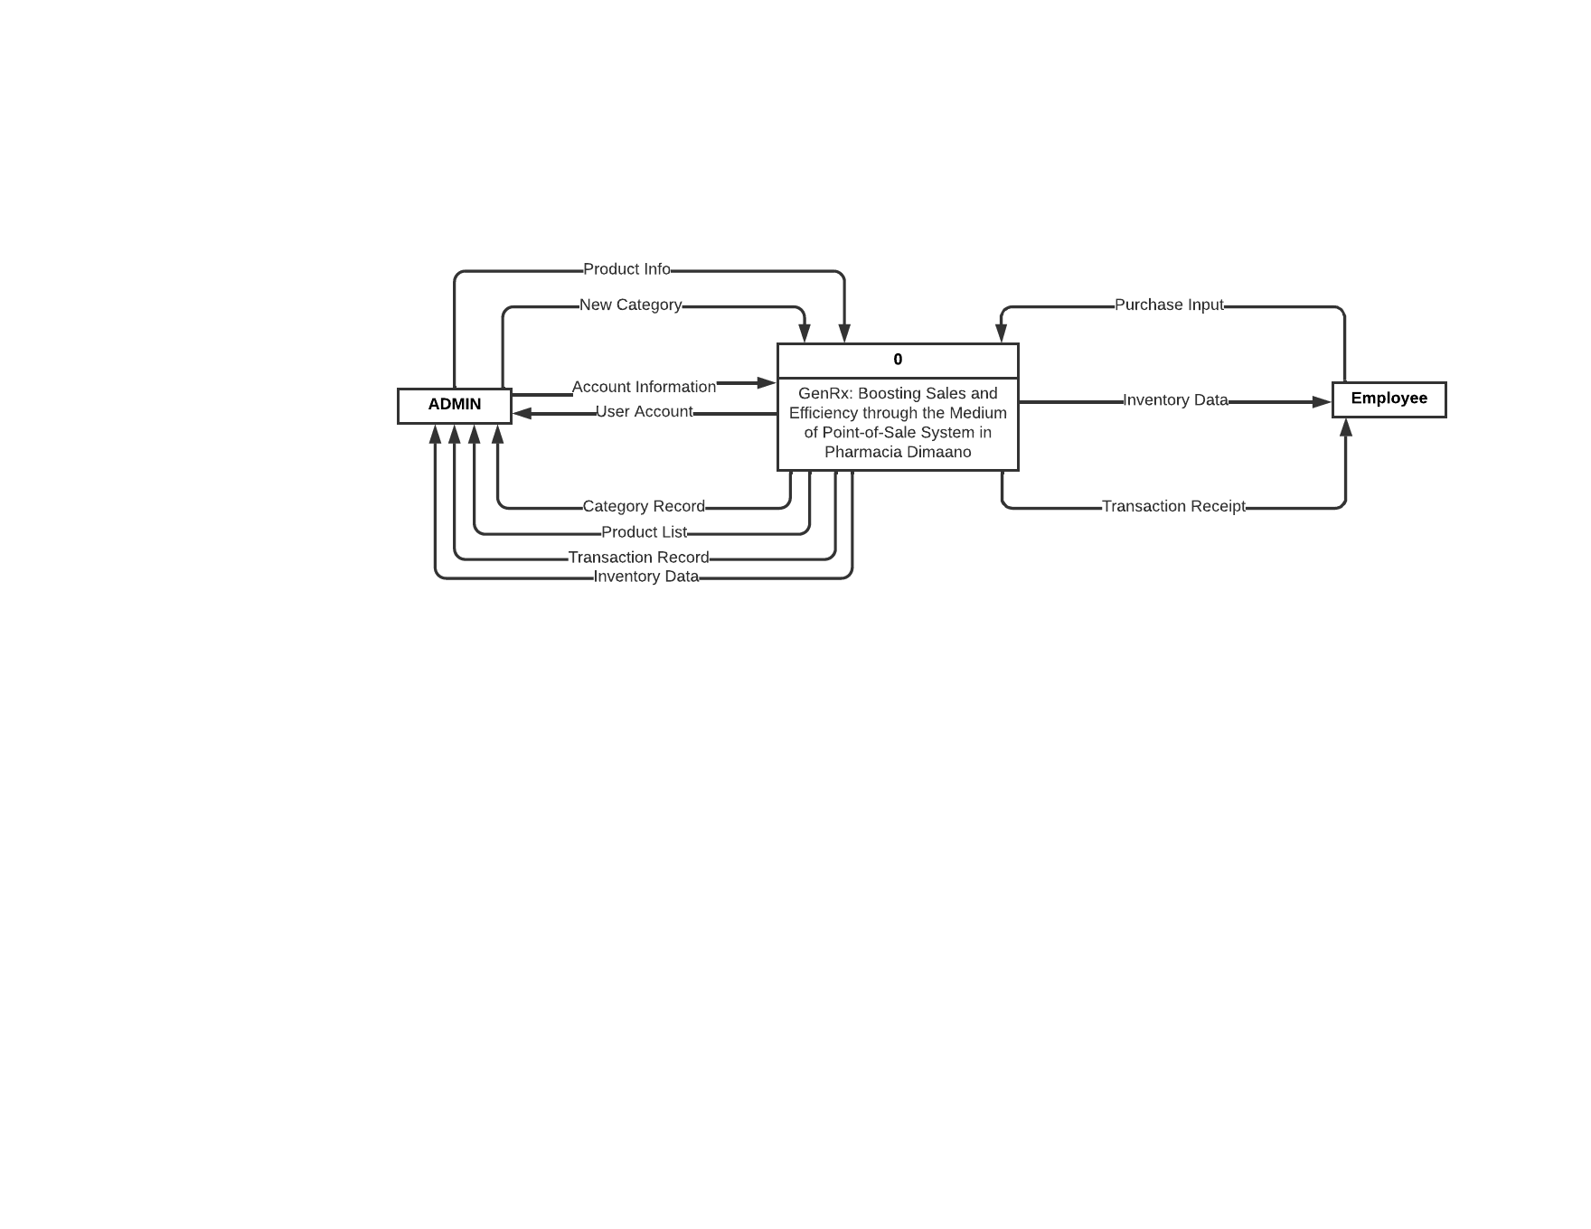***Figure 5.*** Context Diagram

Figure 5 shows the process of the whole system. The input and output of the process. Context diagrams outline the interactions between a computer system or business activity and its surroundings. The constituents of the system are described using context diagrams early in a project. As shown in the figure there are two external entities presented on the diagram. First, the admin entity, which modifies product details and supplier details. The second employee is the one who processes the customer's purchases and collects the customer's information.

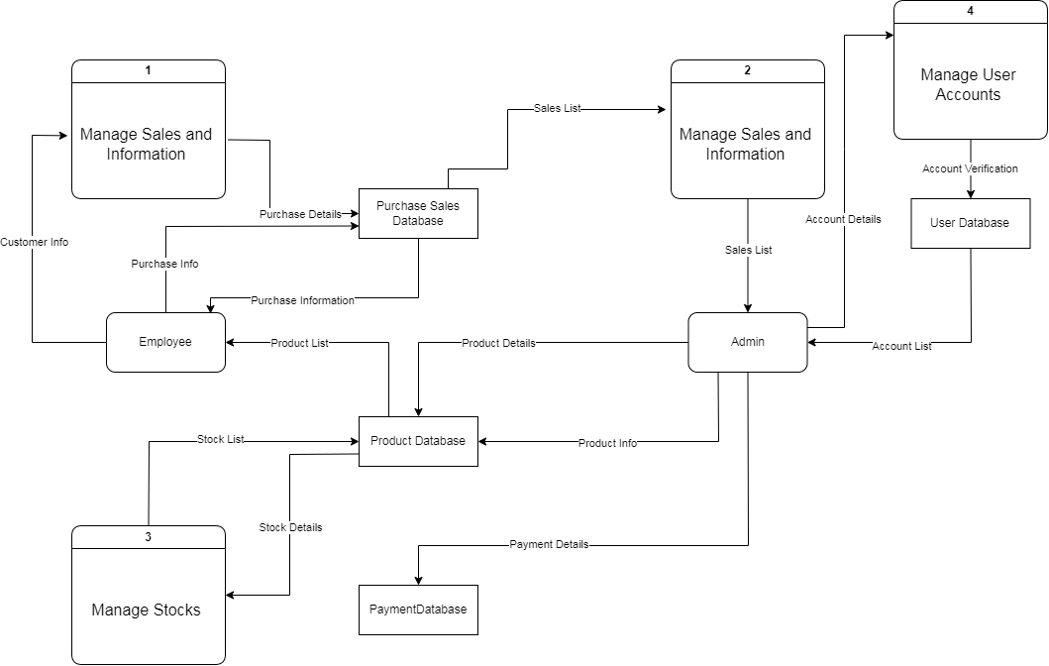

***Figure 6.*** Level 0 Diagram

# Use Case Diagram

Figure 7 shows the user and the admin as the two primary actors. The relationships between the user and admin, along with every scenario can meet are illustrated in the use case diagram.

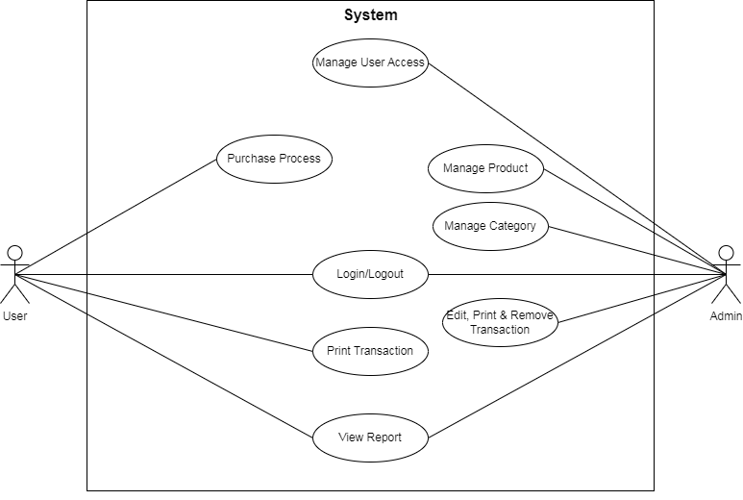***Figure 7.*** Use Case Diagram

As depicted in figure 8, both the user and the admin nearly have opposed functionality to the system, as they both have their own process and play different roles in the system. The admin handles the inventory control of the company, while the user engulfs the sales of the company. They are only comparable during the login process thus; the administrator has complete control on the user's system accessibility.

# Sequence Diagram

This section depicts the processes and objects involved and the sequence of messages exchanged between the processes and objects needed to carry out the functionality.

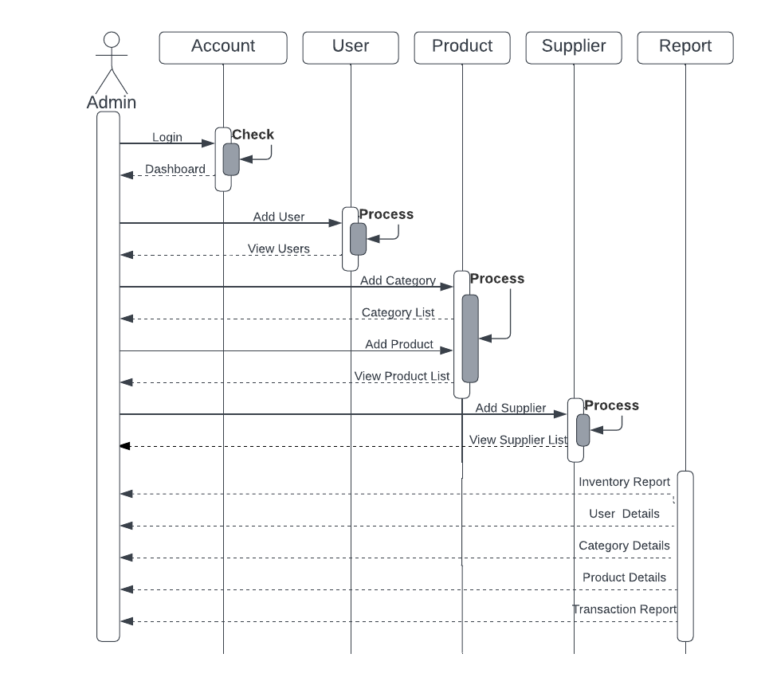

***Figure 8.*** Admin Sequence Diagram

Figure 8 shows the admins activity sequence to the system. When the admin account was successfully logged in, a dashboard appears in the homepage then also if it needs to create a user account, admin also has its functionality. To its main process admin can add a product and categories that is beneficial to control the record, admin also have the credibility to manage the supplier transaction and information

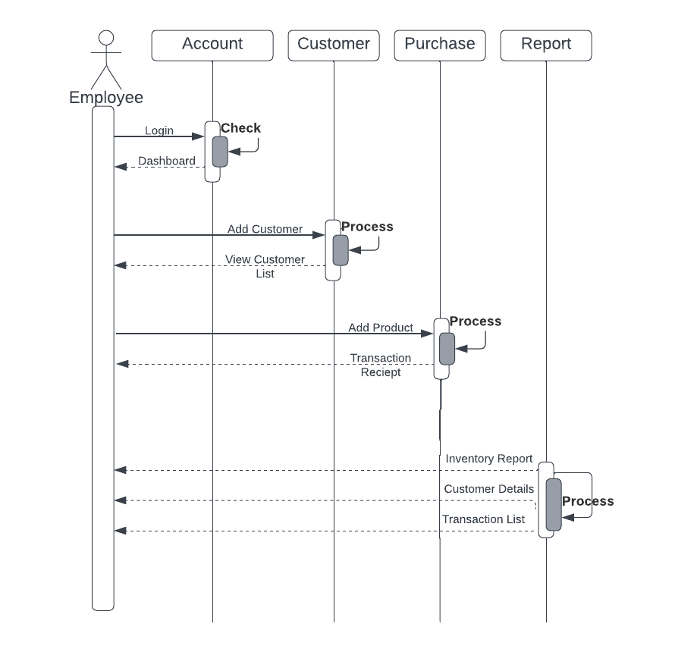 ***Figure 9.*** Employee Sequence Diagram

Figure 9 depicts the functionality of the user to the system, which are mainly to the sales process of the company. Similarly, to the admin, the user needs to login to the system then a dashboard, display in the homepage, the user manages the customer details in the system, along with the purchase management which end up with the transaction receipt. Lastly, with the generation of reports that serves as the basis of generating the analytical process.

# Database Design

In this area of the study, shows the data organization based on a database model. The designer decides what data must be stored and how the data pieces interact with one another. With this knowledge, researchers may start fitting the data to the database model. A database management system controls the data in this manner.

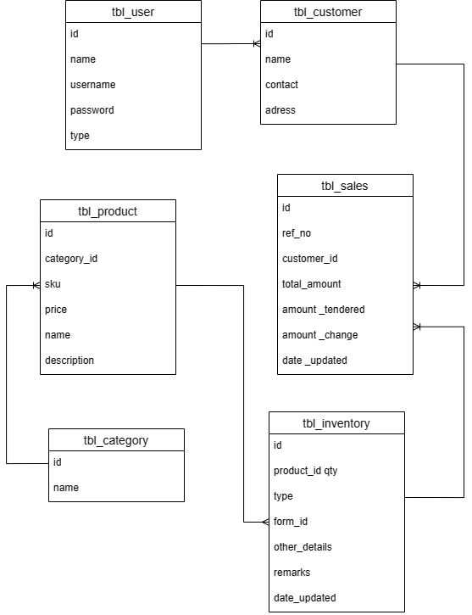

***Figure 10.*** Database Design

The database design illustrates the database entities as well as the relationships with each other as presented in Figure 10.

# Development Phase

The researchers started developing the program at this round of development. Before converting the design code, the researchers incorporated all system needs and user input. By the end of the first revision, the product's basic functionality is completed. Additional features and changes are included in later iterations. This phase serves as the basis for agile software development, enabling researchers to swiftly create functional software and modify it to meet the requirements of the client.

# Software

In this context, "software" refers to the group of devices that run platforms and programming languages. Throughout the system's development, the researchers met a number of requirements to make it simpler and more intuitive. Three categories are used to group the software. As stated in table_, this covers platform, programming languages, and subscription.

Table 8.

*Software Used for Development*

|  |  |
| --- | --- |
| Software Development Tool | Requirements |
| Operating System | Windows |
| Platforms | Microsoft Edge  Google Chrome  Visual Studio |
| Programming Languages | HTML  CSS  Bootstrap  Php |
| Hosting | Hostinger |

The software development is based on the development of the system, researchers used google chrome as a data gathering tool to search different sources and visual studio code used as a platform for programming. In addition, the researchers used HTML for the structure of the webpage and its content and then it was styled using CSS and fractionated using JavaScript and Bootstrap, then PHP for the server-side to interact with the data-base

**Operating System**

Since Windows is one of the most popular operating systems for development, it qualified for the developed system. It provided the researchers with a range of resources, such as new features and tools that facilitate web development. Additionally, Visual Studio Code offers the flexibility and open tools required to develop and implement cutting-edge Windows-compatible online apps.

# Database

The researchers used Hostinger's hPanel to access phpMyAdmin directly. With phpMyAdmin, researchers may modify the database and data directly and do data modeling, create SQL queries, and access all administration tools for managing users, servers, backups, and other tasks. Similar to phpMyAdmin from XAMPP, which the developers used to work on the system locally, is phpMyadmin from Hostinger.

# Subscriptions

The researcher subscribed to Hostinger to gain access to server resources that are available with a plan subscription, for upholding safe and reliable storage spaces. Web hosts offer much more than just basic data storage; it's an essential component of their capabilities. Hosts stored in the data on devices known as web servers so that internet users can easily access and maintain it.

# Hardware for Development

The hardware tool that the researcher used on developing the system, had its average specifications. With 8 GB random access memory, 500GB hard disk, Intel Core i9 11900H. Furthermore, for the implementation of the point of sale of the system the researchers also used a barcode scanner.

# Testing Phase

The system is tested throughout the testing phase to find errors and defects. The system's quality was also assessed, and during this stage, the goal was to demonstrate that the outcome of the web development process could not possibly be flawed. Considering that the system's testing will determine its future. To make sure that every part of the system is operating as it should, testing has been done. Finding system defects and determining if the product produces the intended results were the two main goals of testing. The system was tested using ISO/IEC 9126.

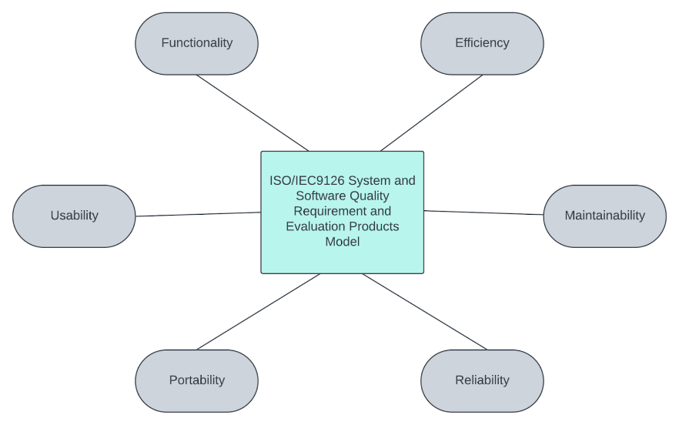 Figure_ displays the criteria that was used in evaluating the system

***Figure 11.*** ISO/IEC9126

To check whether a Genrx: Boosting Sales and Efficiency in the medium of Point-of-Sale in Pharmacia Dimaano matches the expected requirements, distinctive testing procedures were employed based on the ISO/IEC 9126.

The system was tested based on its six quality characteristics:

**Functional Testing.** This test focuses on examining the actions end users take to successfully complete the given tasks and objectives within the system.

**Efficiency Testing.** In order to guarantee that the user is satisfied with the system, this test assesses how well the system's functionality satisfies the necessary execution time and performance requirements. This testing concentrates on evaluating the system's overall performance, resource usage, and responsiveness under various workloads and conditions.

**Usability testing.** This test evaluates the system's functionality and performance efficiency while depending on the user's level of satisfaction.

**Maintainability Testing.** This test makes sure the system can manage error correction while undergoing changes and yet retain software integrity.

**Portability Testing.** This test evaluates the system's capacity to adjust to changing circumstances while users use it on different devices.

**Reliability Testing.** This test made sure that the system continued to function under various circumstances.

# Unit Testing

Table 9 shows the unit testing of the system and the steps taken, expected result as well as the actual report.

Table 9.

*GENRX: Point-Of-Sale System for Pharmacia Dimaano Unit Testing*

|  |  |  |
| --- | --- | --- |
| Steps | Expected Result | Actual Report |
| Admin should input correct username and password | Admin dashboard will show | Admin dashboard appeared |
| Admin/Employee should scan a product stored in inventory for new order | The product will be added with its corresponding details | Product added |
| Admin/Employee should delete product in order | The product will be removed | Product removed |
| Admin/Employee should input correct payment | Total change will be computed | Exact change appeared |
| Admin/Employee save order | The form will be cleared and order will be listed on transaction panel | The form cleared and transaction added |
| Admin should encode product info in new product panel | Success pop-up message will appear and product will be added on product list | Message appeared and product added |
| Admin should add new category | Category will be listed on data table and form will reset | Category added, form was reset |
| Admin should edit product data | Product will be updated | Product information changed |
| Admin should delete specific product | Warning error will show and product will be removed | Warning displayed; product deleted |
| Admin/Employee should print product and order data | Data will be generated on file type based on the chosen button | Data downloaded/printed |
| Admin should edit transaction history information | Information will be updated | Order info updated |
| Admin should delete a transaction record | Transaction will be deleted | Transaction deleted |
| Admin/Employee should print transaction data | Transaction will be printed/downloaded | Transaction printed/downloaded |
| Admin should add new employee | Data will be added on users table | New user added |
| Admin should delete an account | Account will be deleted | Account deleted |

The researcher’s tested the web-based system using the unit testing to know if the objectives of the system were met. Run through the hosted website to explore the system. Two accounts were used in total: Admin for the owner and employee account The two (2) accounts used were registered with the system. If they have browsers and internet connections in our devices, the developed system works properly.

# Testing Procedure

Table 10 shows the testing procedure for the system’s functionality including the login, create order and view product. This phase describes the testing procedure that was used. The testing period was based on the agile development approach’s incremental testing approach. The testing procedure were repeated until the results were satisfactory.

Table 10.

*Testing Procedure for Staff*

|  |  |
| --- | --- |
| **Staff Side** | **Testing Procedure** |
| Login | Test if the staff can access their accounts  Test if the buttons are related to the functioning  Test if incorrect username or password are working |
| Create Order | Test if the user can create orders |
| View Product | Test if the user can view the listed products |
| View Order History | Test if the user can view the order history |

Table 11.

*Testing Procedures for Admin Side*

|  |  |
| --- | --- |
| **Administrator Side** | **Testing Procedure** |
| Login | Test if the admin can access their accounts  Test if the buttons are related to the functioning  Test if incorrect username or password are working |
| Create Order | Test if the admin can create orders |
| Add New Products | Test if the admin can add new products |
| Add New Category | Test if the admin can add new category |
| View Product | Test if the admin can view the listed products |
| View Order History | Test if the admin can view the order history |
| Create User Account | Test if the admin can add and delete new account |

Table 11 shows the testing procedure in admin perspective for the system’s functionality including the creation of orders, adding of new products, adding new category, view transaction history and create an account for a user.

# Deployment

The Deployment phase includes deployment process, hardware requirement, software requirements and network requirements.

# Deployment Process

This process consists of the segments that drive deployment and the responsibilities that go along with each phase. GenRx was eventually made available to Pharmacia Dimaano's firm by doing domain search shortly after the system had been evaluated until there were no errors or malfunctions.

The procedure diagram for the agile methodology which has several phases and serves as a development timeline for the system are shown in Table 12.

The procedure diagram for the agile methodology which has several phases and serves as a development timeline for the system are shown in Table 12.

Table 12.

*Deployment Process*

|  |  |  |  |
| --- | --- | --- | --- |
| **Task** | **Duration (Days)** | **Expected Start Date** | **Expected Finish Date** |
| **Analysis** | 33 | 01/17/2023 | 02/19/2023 |
| **Design** | 49 | 02/21/2023 | 04/11/2023 |
| **Development** | 176 | 04/13/2023 | 10/6/2023 |
| **Testing** | 95 | 07/20/2023 | 10/23/2023 |
| **Implementation** | 1 | 10/23/2023 | 10/23/23 |

The researchers used Hostinger as a web host for the deployment of the web-based system. It has 24/7 customer support and has a user-friendly environment. It also has cheap pricing and plans since this will be one of the most important factors when considering a web host.

# Maintenance Plan

To make sure that the system is still operating in its original state, maintenance is needed. In this case, the researchers would carry out maintenance and restore when there was a detection of errors in the system. Furthermore, maintenance will help the system monitor if the system objectives are still being followed. There is also a possibility of changing the environment of the system when the researchers or the client see a way for improvement in the user interface or in its functions by adding additional functions or designs.

# Risk Management

Risks are the potential and possible negative effects that may have an influence on the system's functionality and performance. This part will go over risk management, which is detecting, assessing, and analyzing risks that might prevent the system from achieving its goals and objectives.

Meanwhile, risk management may help researchers in identifying and forecasting unpredictability in order to limit its impact on the system. Furthermore, the researchers identified four potential threats to the system.

**Risk 001:** Loss of Internet Connection. The system cannot be accessed, resulting in workflow and communication interruptions. The response plan was to ensure connection by troubleshooting the network or contacting the internet service provider for assistance. Use backup internet alternatives, such as secondary providers or mobile data.

**Risk 002**: Data Leakage. Personal user information leaking may be exceedingly dangerous to the affected individual. Identity theft is a danger that the system tries to avoid.

**Risk 003:** System Downtime. As a result, access to the system was lost, resulting in delays, data loss, or disrupted operations. The plan of action was to call the server provider or system administrator in order to investigate and remedy the problem. Follow any established rules or procedures for reporting system outages, and prioritize service restoration.

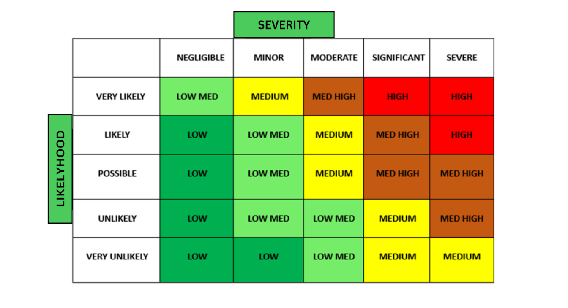**Risk 004:** Power Interruption. Unexpected power outages might have an impact on WiFi and cellular towers. Workers cannot access the system since workplace computers require energy and a dependable internet connection. So, unless they have a backup power source and another internet connection, this scenario is awful.

***Figure 12.*** Risk Matrix

To further analyze those mentioned risks, the researchers provided a risk matrix, which is shown in Figure 12. The risk matrix could be utilized as the basis for the risk analysis shown in Table 13.

Table 13.

*Risk Matrix Result*

|  |  |  |  |  |  |
| --- | --- | --- | --- | --- | --- |
| **ID** | **Risk** | **Category** | **Likelihood** | **Severity** | **Impact** |
| 001  002 | Loss of internet connection  Data Leakage | Technical  Technical | Possible  Unlikely | Significant  Severe | Med High  Med High |
| 003 | System Downtime | Technical | Likely | Severe | High |
| 004 | Power Interruption | Technical | Likely | Severe | High |

The researchers present a table that helps to assess and analyze the risks in order to determine the type, likelihood, severity, and effect of the hazards, which is displayed in Table 13. These risks may have a significant influence on data interchange in the system. Since hazards have been identified and assessed, action for risk management and treatment plan execution must be defined. As a result, the risk treatment illustrated in Table 13 was offered by the researchers.

# Risk Treatment

Loss of Internet connection . If the internet connection goes down, the staff can provide a mobile hotspot to connect to and have internet access. In this way, the staff can continue using the system. If there is no network to connect, the staff will try to contact the internet provider as soon as possible to fix the internet connection problem.

Data Leakage . The researchers must provide regular information security training and foster an information security culture among staff. To control this type of risk, researchers would create preventative mechanisms within the system.

System Downtime When encountering system downtime try to contact the hosting provider to fix the problem with the hosting website. Usually, the cause of this risk is within the server of the website.

Power Interruption Power outages are critical for our system since the administrator and staff operate in an office that requires electricity and an internet connection. The entire process is deadlocked when the power supply fails. To avoid this, they must have a backup power supply as well as a temporary Ethernet to take the place which is mobile data.

The risks identified by the researchers, as well as their treatments. The researchers give risk treatment for each mentioned risk so that dangers may be readily managed and treated when they arise.

Table 14.

*Risk Ownership*

|  |  |
| --- | --- |
| **Review Frequency** | **Owner** |
| The system's potential threats are examined and tested on a regular basis to guarantee that researchers respond quickly to find a solution. This will aid researchers in detecting high and low dangers to the system in order to propose remedies and avert issues. | Joseph S. Cortez  Shaira Mae A. Lopez  Darell Marius S. Lucero |

# CHAPTER IV

RESULT AND DISCUSSION

This chapter displays the result and discussion of the finished project's contents, features, and structure. This is an overview of the project's overall details. It also includes the results of actual testing conducted to assess the overall effectiveness of the system. Additionally, the development of GenRx and the accurate results and analysis that have been provided. Following analysis, the results of the stated objective have been listed.

The following are the results and discussion for each of the specified objectives:

The sales and inventory of the business Pharmacia Dimaano are monitored based on sales performance and inventory management.

The researchers created a web-based system that allows a user or an admin to keep track of their sales and records at the same time. Additionally, to have efficient satisfaction for the customers and the business.

The dashboard shows if the sales are increasing or decreasing. It contains better data visualization to give the business a sight if they’re growing in revenue. Specifically, in their total sales per day. It also displays the most bought product per date. The products that are selling very well are displayed in the chart, finding the most popular or profitable products in the inventory is vital and can reveal the seasonality and long-term use of the product.

The inventory management product list involves a comprehensive approach to developing a web-based application that enables the business to efficiently manage their inventory. The system includes the product catalog with various attributes and features to help businesses keep track of their stock. Additionally, the user can search, add, edit and delete the products.

**A web-based point-of-sale system**

The developed system can be viewed on mobile devices and desktops and was used to monitor and control the sales and inventory of Pharmacia Dimaano. The owner of the store was responsible for managing the admin side of the system, and the employee side was used by the employees.

**Sales and Inventory Report**

Through the medium of point-of-sale system, the owner and employees were able to monitor the activity of sales as well as the quantity of products in one glance. This part displays different graphs that the system has, the line chart for visualizing the total sale of store per day, calculation of several transactions with corresponding dates. Bar chart was utilized for determining the most purchased products and it was calculated by getting the product name and adding up the number of quantities that has been purchased. Pie chart was implemented to identify the number of products under category, products were categorized to organize and structure a large number of products.

The core of the point-of-sale system, this enables the employees and manager as well to add a new transaction. The transaction form encompasses crucial fields to be filled out; date, product code, quantity, and payment. Barcode scanner was used in this function, it assists in streamlining operations, improving accuracy, and enhancing overall efficiency. Product name, stock, price, and total amount were automatically filled out through the assistance of a barcode scanner. Current product was removed from the list when the user hit the delete button. The data that had been verified in this panel automatically be saved in transaction history.

Both roles of the developed system have the ability to access the inventory panel. Inventory panel contains product name, category, price, stock, and description. It also contains an edit and delete button, in which the user can modify the product information and remove specific information. This section allows the user to print this section in different types to provide the user a transparent record that serves as a structured and permanent way to convey information.

Upon submitting the information from the purchasing process the data saved from another panel called transaction list. Transaction list displays all the transactions occurred between the user and the customer; transaction list encompasses elements that greatly assist the workers to identify a specific transaction. It contains invoice id, customer name, order date, total amount, paid, change, payment type and also the three important actions, print, edit and delete. The receipt can be printed, modified and removed by the user.

# CHAPTER V

# SUMMARY, CONCLUSIONS AND RECOMMENDATIONS

This chapter presents the summary of the development of the system, A Web Based Genrx: Boosting Sales and Efficiency through the Medium of Point-of-Sale System with Data Visualization in Pharmacia Dimaano. This also includes the conclusions and recommendations of the study.

# Summary of Findings

The study aims to develop a web-based sales and inventory system in order to assist the employees and the business itself of the Pharmacia Dimaano to be profitable and to have an efficient and effective processing of sales and inventory reducing time consuming manual work.

The user monitors how many products that the company has on hand or on whether there are any shortage or excess by using the system's real time data in inventory levels, data visualization displays the sales of the pharmacy and categorizing the items that are mostly bought and the least bought, preserving an exhaustive log of product lot, serial, and batch numbers to facilitate traceability in case of recalls or quality problems.

The results obtained by the Pharmacia Dimaano inventory and sales system address customer safety, regulatory compliance, ethical issues, and profitability and efficiency. Maintaining the integrity and reliability of the business relies greatly on these findings.

Moreover, the salient findings of the study are as follows:

Having the data visualization in the developed inventory and sales management system, helped the end users to identify easily which pharmaceutical products are selling greatly.

In terms of inventory management, it creates opportunities for the business to have good inventory tracking and planning to decrease the risk of investing in products that won’t sell.

In having a swift buying process of consumers, storing records and automated product management boosts up the employee and customer satisfaction of the business.

# Conclusions

Considering the obtained findings, the researchers came up with the following conclusions:

By improving information reporting accuracy and transaction monitoring at Pharmacia Dimaano, the system supported in making every transaction easier, faster, more secure, efficient, and dependable. This system also concludes that having focused automated inventory and sales reports can provide greater security for their management. To reduce personnel while increasing everyday operations such as transaction processes, it possible to determine the stock balance. Assists in ensuring that the product ordered from a supplier is properly distributed to the customer.

It makes it easy to record the large number of transactions in the system database without any loss of data. This application was created in response to the pharmacist's need to keep track of purchase and transaction data so that sales activity may be tracked as needed. The buyers are also delivered with the receipt of the transaction.

The system provides sales and inventory aided employees, and even business owners to put into practice a more accurate and efficient technique of keeping track of records. Additionally for convenient access to transaction receipts, stock records, and other product information and records.

# Recommendations

Based on the findings and conclusions presented, the following recommendations are suggested:

* The researchers recommend an inclusion of tracking and managing of product expiration dates to prevent the sale or use of expired pharmaceuticals.
* Notification system for expired products
* Include sales forecasting, which predicts how much product will be sold in the coming week, month, quarter, or year.

# Bibliography

Acopiado, S. M., Dabodabo, T., Gomez, A., & Santiago, K. I. (2018). *Sales and Inventory System for Pharmacia Josefa Drugstore*.

Acosta, D. S., Lavelle Alquizar, M. R., Alexes Junio, C., Cris Talara, D., & Van Buladaco, M. (2020). *ANALYSIS AND DESIGN OF SALES AND INVENTORY MANAGEMENT SYSTEM FOR YOCHANG GENERAL MERCHANDISE Background of the Study*. https://ssrn.com/abstract=3643181

Aggarwal, A., Dhindsa, K. S., & Suri, P. K. (2021). *Enhancing Software Quality Assurance by Using Knowledge Discovery and Bug Prediction Techniques*. 97–118. https://doi.org/10.1007/978-981-16-1048-6_8

Agustini, K., Hurriyati, R., Gaffar, V., Tiana, B., & Novianti, W. (2022). The effectiveness of electronic purchase on ordering national health insurance drugs at the West Bandung pharmacy of Indonesia. *Journal of Eastern European and Central Asian Research (JEECAR)*, *9*(5), 815–823. https://doi.org/10.15549/JEECAR.V9I5.1062

Astari. (2023, May 2). *What Is HTML? Hypertext Markup Language Basics for Beginners*. https://www.hostinger.com/tutorials/what-is-html

Atmaja, K. J., & Anandita, I. B. G. (2021). Sales Forecasting System Using Single Exponential Smoothing. *Jurnal Mantik*, *4*(4), 2552–2557. https://doi.org/10.35335/MANTIK.VOL4.2021.1207.PP2552-2557

Atnafu, D., & Balda, A. (2018). The impact of inventory management practice on firms’ competitiveness and organizational performance: Empirical evidence from micro and small enterprises in Ethiopia. *Cogent Business and Management*, *5*(1), 1–16. https://doi.org/10.1080/23311975.2018.1503219

Basha, M. M. J., V.S, N., Wani, S. T., & Gogi, Prof. V. S. (2020). Study of Inventory Management in Pharmaceuticals: A Review of COVID-19 Situation. *International Journal of Innovative Science and Research Technology*, *5*(8), 366–371. https://doi.org/10.38124/IJISRT20AUG257

Bautista, J., & Young, M. (2022, April). *Effective Inventory Management System in Efficient Supply and Distribution Management in one of Manufacturer of Foods Seasoning Products in the Philippines | Request PDF*. https://www.researchgate.net/publication/359992876_Effective_Inventory_Management_System_in_Efficient_Supply_and_Distribution_Management_in_one_of_Manufacturer_of_Foods_Seasoning_Products_in_the_Philippines?fbclid=IwAR2MaQ-2-bHIzZUSABkLN-xQEBnzj-Ov6lmyTG7Cx6YDt7tkyVgRzJGiliU

Divyani Shivkumar Taley. (2020). Comprehensive Study of Software Testing Techniques and Strategies: A Review. *International Journal of Engineering Research And*, *V9*(08). https://doi.org/10.17577/IJERTV9IS080373

E. Tan, A. C. (2021). PLANNING MANAGEMENT AND INVENTORY SYSTEM WITH PREDICTIVE ANALYTICS FOR TECHNOPROBE ASIA PTE LTD (PHIL. BRANCH). *International Journal of Advanced Research in Computer Science*, *12*(4), 23–28. https://doi.org/10.26483/ijarcs.v12i4.6752

Gichuki Ndia, J., Muketha, G. M., & Omieno, K. K. (2019). A SURVEY OF CASCADING STYLE SHEETS COMPLEXITY METRICS. *International Journal of Software Engineering & Applications (IJSEA)*, *10*(3). https://doi.org/10.5121/ijsea.2019.10303

Green, F. (2022). Machine-learning Sales Forecasting: A Review. *Sage Science Review of Applied Machine Learning* , *5*(1), 1–21. https://journals.sagescience.org/index.php/ssraml/article/view/3

Heller, M. (2022, August 8). *Visual Studio vs. Visual Studio Code: How to choose | InfoWorld*. https://www.infoworld.com/article/3436860/visual-studio-vs-visual-studio-code-how-to-choose.html

Lal, M., Shukla, A., & tarangini, a. (2018). Study of Effectiveness of POS Data in Managing Supply Chain. *Industrial Engineering Journal*, *11*(10). https://doi.org/10.26488/IEJ.11.10.1144

Lamberte, J. G., Verdejo, F. S., & Sur, C. (2022). *IMPLEMENTING A SALES AND INVENTORY SYSTEM IN ACE ANGEL PHARMACY DRUGSTORE*.

Lamsal, K. (2020). *Designing and Developing a dynamic website using PHP*.

Leona, A., Bautista, E. R., Maglunog, L. P., Marvin, I. C., Santos, R., Gervey, L., Trambulo, A., & Meleen, E. (2018). *Perpetual Help College of Manila Developing a Point-of-Sale Inventory Management System for Lord’s Grace General Merchandising using pHp and MySQL*.

Littlejohn, I. (2023). *What is Power BI and Why Should You Use it? - Udemy Blog*. https://blog.udemy.com/what-is-power-bi/

López-Gorozabel, O., Cedeño-Palma, E., Pinargote-Ortega, J., Zambrano-Romero, W., & Pazmiño-Campuzano, M. (2021). Bootstrap as a Tool for Web Development and Graphic Optimization on Mobile Devices. *Advances in Intelligent Systems and Computing*, *1326 AISC*, 290–302. https://doi.org/10.1007/978-3-030-68080-0_22

Mendoza, A. R. (2019). POINT OF SALE SYSTEM WITH INVENTORY FOR ARM’S FOOD AND DELICACIES. *International Journal of Advanced Research in Computer Science*, *10*(2), 23–29. https://doi.org/10.26483/IJARCS.V10I2.6378

Mishra, S., Sharma, D., Srivastava, S. P., Verma, S., & Malviya, R. (2022). Impact on Pharmaceutical Industry due to Sudden Pandemic Attack (COVID-19). In *Coronaviruses* (Vol. 3, Issue 2, pp. 23–28). Bentham Science Publishers. https://doi.org/10.2174/2666796702666211122152928

Mohan, C. C., Shoaib Ahmed, S., Priya, N. V., Jahnavi, M., & Praneeth Babu, T. (2022). E-Health Centre Maintenance System using PHP with MySQL and XAMPP Web Server. *International Journal of Advanced Research in Science, Communication and Technology (IJARSCT*, *2*(1). https://doi.org/10.48175/IJARSCT-7577

Nerdelita, L., & Baylen, L. (2020). *Journal of Business and Management Studies (JBMS) Analysis of Inventory Management Systems of Selected Small-Sized Restaurants in Quezon Province: Basis for an Inventory System Manual Inventory Management System of Small Sized Restaurant in Quezon Province*. *2*(3), 1–10. www.al-kindipublisher.com/index.php/jbms

Nordeen, A. (2020). *Learn Software Testing in 24 Hours, Definitive Guide to Learn Software Testing for Beginners - Google Play Books*. https://play.google.com/books/reader?id=hRwGEAAAQBAJ&pg=GBS.PT5_321

Oo, M. C. M., & Thein, T. (2022). An efficient predictive analytics system for high dimensional big data. *Journal of King Saud University - Computer and Information Sciences*, *34*(1), 1521–1532. https://doi.org/10.1016/J.JKSUCI.2019.09.001

Özkan, D., & Mishra, A. (2019). Agile Project Management Tools: A Brief Comprative View. *BULGARIAN ACADEMY OF SCIENCES CYBERNETICS AND INFORMATION TECHNOLOGIES •*, *19*(4). https://doi.org/10.2478/cait-2019-0033

Permatahati, I., & Muqorobin, M. (2022). Computer Sales Forecasting System Application Using Web-Based  Single Moving Average Method. *International Journal of Computer and Information System (IJCIS)*, *3*(2), 56–63. https://doi.org/10.29040/IJCIS.V3I2.68

Peter, K. (2022). *supermarket-management-system*. 1–43.

Praveen K B. (2020). Inventory Management using Machine Learning. *International Journal of Engineering Research And*, *V9*(06). https://doi.org/10.17577/IJERTV9IS060661

Priya, R., Kumari, S., & Kumar, A. (2022, May). *(PDF) Research on Pharmacy management*. https://www.researchgate.net/publication/360963051_Research_on_Pharmacy_management

Rachmat Hidayat, & Irsan Saleh. (2020). The Importance of Inventory Management in Pharmaceutical Practice. *Open Access Indonesia Journal of Social Sciences*, *3*(1), 1–9. https://doi.org/10.37275/OAIJSS.V3I1.22

Rifandi, A. (2020). Analysis And Design Of Point Of Sale System In D’astore Shop. *Aptisi Transactions On Technopreneurship (ATT)*, *2*(1), 34–47. https://doi.org/10.34306/att.v2i1.63

Robillard, M. P. (2022). Unit Testing. *Introduction to Software Design with Java*, 99–124. https://doi.org/10.1007/978-3-030-97899-0_5

Scott, N. A., Lee, K. K., Sadowski, C., Kurbatova, E. V., Goldberg, S. V., Nsubuga, P., Kitshoff, R., Whitelaw, C., Thuy, H. N., Batra, K., Allen-Blige, C., Davis, H., Kim, J., Phan, M., Fedrick, P., Chiu, K. W., Heilig, C. M., & Sizemore, E. (2021). Optimizing drug inventory management with a web-based information system: The TBTC Study 31/ACTG A5349 experience. *Contemporary Clinical Trials*, *105*, 106377. https://doi.org/10.1016/J.CCT.2021.106377

Sheakh, T. (2018). A Study of Inventory Management System Case Study Australian Patent AU View project FORECASTING AND PREDICTION OF AIR POLLUTANTS CONCENTRATES USING MACHINE LEARNING TECHNIQUES: THE CASE OF INDIA View project A Study of Inventory Management System Case Study. In *Jour of Adv Research in Dynamical & Control Systems* (Vol. 10). https://www.researchgate.net/publication/327793184

Shinde, D. D., Ahirrao, S., & Prasad, R. (2018). Fishbone Diagram: Application to Identify the Root Causes of Student–Staff Problems in Technical Education. *Wireless Personal Communications*, *100*(2), 653–664. https://doi.org/10.1007/S11277-018-5344-Y

Theisen, K. J. (2019). Programming languages in chemistry: A review of HTML5/JavaScript. *Journal of Cheminformatics*, *11*(1), 1–19. https://doi.org/10.1186/S13321-019-0331-1/TABLES/3

Tope, A. E. (2020). *automated-inventory-control-system-satellite*. 1–47.

Williams, B., Tadlock, J., & Jacoby, J. J. (2020). JavaScript. *Professional WordPress® Plugin Development*, 133–147. https://doi.org/10.1002/9781119666981.CH6

Yokeshwaran, M. (M), & Murugachandravel, J. (J). (2022). Enhancement of Business Using E-commerce with Point of Sale. *International Journal of Health Sciences*, *6*(II), 3250–3260. https://doi.org/10.53730/IJHS.V6NS2.5811

# Schedule and Timeline

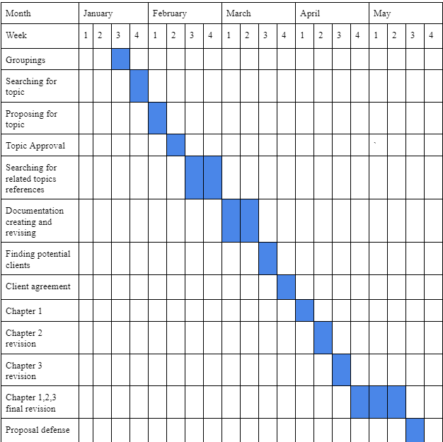Every project has a start date for the first task and an end date for the last task that is scheduled to end. The researchers prepared a Gantt chart in order to have a clearer perspective and comprehension of the time given for the project in order to start and conclude it on time. A Gantt chart is a bar chart that displays how long the project will take and how long each activity will take.

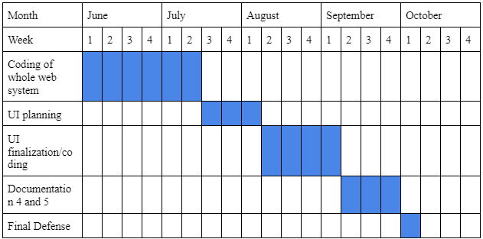

|  |  |  |
| --- | --- | --- |
| Name | Responsibility | Details |
| Cortez, Joseph S. | Team Leader  Lead Programmer  Document Writer | **Address**: Sto. Niño,  Batangas City  **Contact Number:** 09457411182  **Email:** cortezjoseph103@gmail.com |
| Lopez, Shaira Mae A. | Document Writer  Assistant Programmer | **Address:** Conde Labac,  Batangas City  **Contact Number:** 09763676377  **Email:** shairamaelopez23@gmail.com |
| Lucero, Darell Marius S. | Assistant Programmer  Document Writer | **Address:** Alangilan Batangas City  **Contact Number:** 09555422614  **Email:** darelllucero@gmail.com |

|  |  |
| --- | --- |
| Category | Total |
| Hostinger | **Php 2,028.00** |
| Domain | **Php 559.00** |
| Barcode Scanner | **Php 924.00** |
| Total | **Php 4,511.00** |

**LINE BREAK**

1. <?php
2. try{
3. $pdo = new PDO("mysql:host=localhost;dbname=u690288683_pos_main","u690288683_pos_main","Pharmaciadimaano01.");
4. }catch(PDOException $f){echo $f->getmessage();}
5. session_start();
6. if ($_SESSION["useremail"]=="" OR $_SESSION["role"]=="admin" ){
7. header("location:index.php");}
8. include_once"headeruser.php";
9. function fill_product($pdo){
10. $output="";
11. $select=$pdo->prepare("select * from tbl_product order by pid asc");
12. $select->execute();
13. $result=$select->fetchAll();
14. foreach($result as $row){
15. $output.='<option value="'.$row["pid"].'">'.$row["pid"].'</option>';
16. }
17. return $output;
18. }
19. if(isset($_POST["btnsaveorder"])){
20. $customer_name=$_POST["txtcustomer"];
21. $order_date=date("Y-m-d H:i:s",strtotime($_POST['orderdate']));
22. $order_time=date("Y-m-d H:i:s",strtotime($_POST['orderdate']));
23. $total=$_POST["txttotal"];
24. $paid=$_POST["txtpaid"];
25. $due=$_POST["txtdue"];
26. $payment_type=$_POST["rb"];
27. $arr_productid=$_POST['productid'];
28. $arr_productname=$_POST['productname'];
29. $arr_stock=$_POST['stock'];
30. $arr_qty=$_POST['qty'];
31. $arr_price=$_POST['price'];
32. $arr_total=$_POST['total'];
33. $insert=$pdo->prepare("insert into tbl_invoice(customer_name,order_date,order_time,total,paid,due,payment_type) values(:cust,:orderdate,:ordertime,:total,:paid,:due,:ptype)");
34. $insert->bindParam(':cust',$customer_name);
35. $insert->bindParam(':orderdate',$order_date);
36. $insert->bindParam(':ordertime',$order_date);
37. $insert->bindParam(':total', $total);
38. $insert->bindParam(':paid',$paid);
39. $insert->bindParam(':due', $due);
40. $insert->bindParam(':ptype',$payment_type);
41. $insert->execute();
42. $invoice_id=$pdo->lastInsertId();
43. if($invoice_id !=null){
44. for($i=0 ; $i<count($arr_productid); $i++){
45. $rem_qty= $arr_stock[$i]-$arr_qty[$i];
46. if($rem_qty<0){
47. return"Order is Not Complete";
48. }else{
49. $update=$pdo->prepare("update tbl_product SET pstock ='$rem_qty' where pid='".$arr_productid[$i]."'");
50. $update->execute();
51. }
52. $insert=$pdo->prepare("insert into table_invoice_details(invoice_id,product_id,product_name,qty,price,order_date,order_time)values(:invid,:pid,:pname,:qty,:price,:orderdate,:ordertime)");
53. $insert->bindParam(":invid",$invoice_id);
54. $insert->bindParam(":pid",$arr_productid[$i]);
55. $insert->bindParam(":pname", $arr_productname[$i]);
56. $insert->bindParam(":qty", $arr_qty[$i]);
57. $insert->bindParam(":price",$arr_price[$i]);
58. $insert->bindParam(":orderdate",$order_date);
59. $insert->bindParam(":ordertime",$order_date);
60. $insert->execute();
61. }
62. }
63. }
64. ?>
65. <div class="content-wrapper" style="overflow:scroll; height:400px;">
66. <section class="content-header">
67. <div class="container-fluid">
68. <div class="row mb-2">
69. <div class="col-sm-6">
70. <h1 class="m-0">ADD NEW ORDER</h1>
71. </div>
72. <div class="col-sm-6">
73. <ol class="breadcrumb float-sm-right">
74. <li class="breadcrumb-item"><a href="logout.php">LOGOUT</a></li>
75. <li class="breadcrumb-item active">Employee Dashboard</li>
76. </ol>
77. </div>
78. </div>
79. </div>
80. </section>
81. <section class="content container-fluid">
82. <div class="card card-warning">
83. <div class="card-header">
84. <h3 class="card-title">New Order Form</h3>
85. </div>
86. <div class="card-body">
87. <form role="form" action="" method="post">
88. <div class="row">
89. <div class="col-md-6">
90. <div class="form-group">
91. <label for="exampleInputEmail1">Customer Name</label>
92. <div class="input-group">
93. <div class="input-group-prepend">
94. <span class="input-group-text"><i class="fas fa-user"></i></span>
95. </div>
96. <input type="text" class="form-control" id="exampleInputEmail1" placeholder="Enter Name" name="txtcustomer">
97. </div>
98. </div>
99. </div>
100. <div class="col-md-6">
101. <div class="form-group">
102. <label>Date:</label>
103. <div class="input-group date" data-target-input="nearest">
104. <input type="text" class="form-control datetimepicker-input" data-target="#reservationdate" id="reservationdate" name="orderdate" required>
105. <div class="input-group-append" data-target="#reservationdate" data-toggle="datetimepicker">
106. <div class="input-group-text"><i class="fa fa-calendar"></i></div>
107. </div>
108. </div>
109. </div>
110. </div>
111. <div class="col-md-12">
112. <table id="producttable" class="table table-bordered table-hover">
113. <thead>
114. <tr>
115. <th>No.</th>
116. <th>Product Name</th>
117. <th>Stock</th>
118. <th>Price</th>
119. <th>Enter Quantity</th>
120. <th>Total</th>
121. <th><button type="button" name="add"
122. class= "btn btn-success btn-sm btnadd" ><span class="fas fa-plus" ></span>
123. </button></th>
124. </tr>
125. </thead>
126. <tbody>
127. </tbody>
128. </table>
129. </div>
130. <div class="col-md-6">
131. <div class="form-group">
132. <label>Total</label>
133. <div class="input-group">
134. <div class="input-group-prepend">
135. <span class="input-group-text"><i class="fas fa-wallet"></i></span>
136. </div>
137. <input type="text" class="form-control" name="txttotal" id="txttotal" required readonly>
138. </div>
139. </div>
140. <div class="form-group">
141. <label>Paid</label>
142. <div class="input-group">
143. <div class="input-group-prepend">
144. <span class="input-group-text"><i class="fas fa-wallet"></i></span>
145. </div>
146. <input type="text" class="form-control" name="txtpaid" id="txtpaid" required>
147. </div>
148. </div>
149. <div class="form-group">
150. <label>Change</label>
151. <div class="input-group">
152. <div class="input-group-prepend">
153. <span class="input-group-text"><i class="fas fa-wallet"></i></span>
154. </div>
155. <input type="text" class="form-control" name="txtdue" id="txtdue" required readonly>
156. </div>
157. </div>
158. <label>Payment Method:</label>
159. <div class="form-group clearfix">
160. <div class="icheck-primary d-inline">
161. <input type="radio" id="radioPrimary1" name="rb" value="cash" checked>
162. <label for="radioPrimary1">Cash
163. </label>
164. </div>
165. </div>
166. </div>
167. </div>
168. <hr>
169. <div align="center">
170. <input type="submit" name="btnsaveorder" value="Save Order" class="btn btn-info" >
171. </div>
172. </form>
173. </div>
174. </div>
175. </section>
176. </div>
177. <script>
178. $(document).ready(function(){
179. $('.btnadd').click(function(){
180. var html='';
181. html+='<tr>';
182. html+='<td><select style="width:200px;" class="form-control productid" name="productid[]" readonly><?php echo fill_product($pdo); ?> </select></td>';
183. html+='<td><input type ="text" class="form-control pname" name="productname[]" readonly></td>';
184. html+='<td><input type="text" class="form-control stock" name="stock[]" readonly></td>';
185. html+='<td><input type="text" class="form-control price" name="price[]" readonly></td>';
186. html+='<td><input type="number" min="1" value="0" class="form-control qty" name="qty[]" required></td>';
187. html+='<td><input type="text" class="form-control total" name="total[]" readonly></td>';
188. html+='<td><button type="button" name="add" class= "btn btn-danger btn-sm btntbldlt" ><span class="fas fa-trash" ></span></button></td>';
189. $('#producttable').append(html);
190. $('.productid').select2()
191. $('.productid').on('change' , function(e){
192. var productid = this.value;
193. var tr=$(this).parent().parent();
194. $.ajax({
195. url:'getproduct.php',
196. method:'get',
197. data:{myyid: productid},
198. success:function(data){
199. tr.find(".pname").val(data["pname"]);
200. tr.find(".stock").val(data["pstock"]);
201. tr.find(".price").val(data["saleprice"]);
202. tr.find(".qty").val(0);
203. tr.find(".total").val(tr.find(".qty").val() * tr.find(".price").val());
204. calculate(0,0);
205. }
206. });
207. });
208. });
209. $("#producttable").delegate(".qty","keyup change" , function(){
210. var quantity = $(this);
211. var tr=$(this).parent().parent();
212. if( (quantity.val()-0)> (tr.find(".stock").val()-0)){
213. swal.fire("warning!", "Sorry Quantity not available");
214. tr.remove();
215. }else{
216. tr.find(".total").val(quantity.val() * tr.find(".price").val());
217. calculate(0,0);
218. }
219. });
220. function calculate(paid){
221. var net_total=0;
222. var paid_amt= paid;
223. var due=0;
224. $(".total").each(function(){
225. net_total = net_total+($(this).val()*1);
226. })
227. due=paid_amt-net_total;
228. $("#txttotal").val(net_total.toFixed(2));
229. $("#txtdue").val(due.toFixed(2));
230. }
231. $("#txtpaid").keyup(function(){
232. var paid =$(this).val();
233. calculate(paid);
234. });
235. });
236. </script>
237. <script>
238. $(document).on("click",".btntbldlt",function(){
239. $(this).closest('tr').remove();
240. $("#txtdue").val(due);
241. $("#txttotal").val(net_total);
242. });
243. </script>
244. <script>
245. $(function () {
246. $('.select2').select2()
247. $('.select2bs4').select2({
248. theme: 'bootstrap4'
249. })
250. });
251. </script>
252. <script>
253. $(document).ready(function(){
254. $("#reservationdate").datetimepicker({pickTime: true });
255. });
256. </script>
257. <aside class="control-sidebar control-sidebar-dark">
258. <div class="p-3">
259. <h5>Title</h5>
260. <p>Sidebar content</p>
261. </div>
262. </aside>
263. <?php include_once "footer.php";?>

#LINE BREAK

# User’s Manual

**Login Process**

1. Access <https://pharmaciadimaano.com/> in any available browser on your device.



1. Login your account provided by the admin of the system

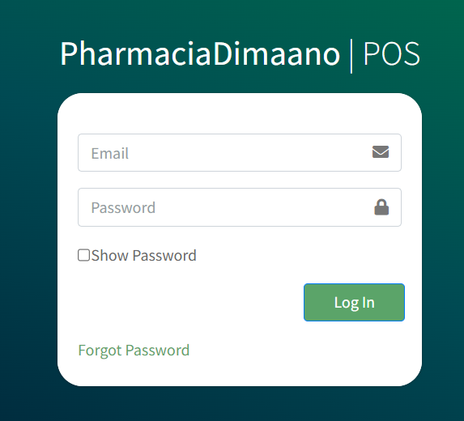

**Admin Dashboard**

1. Dashboard windows shows the sales and inventory report. Total sales per day, total purchased product, and category, are the report available in this panel.

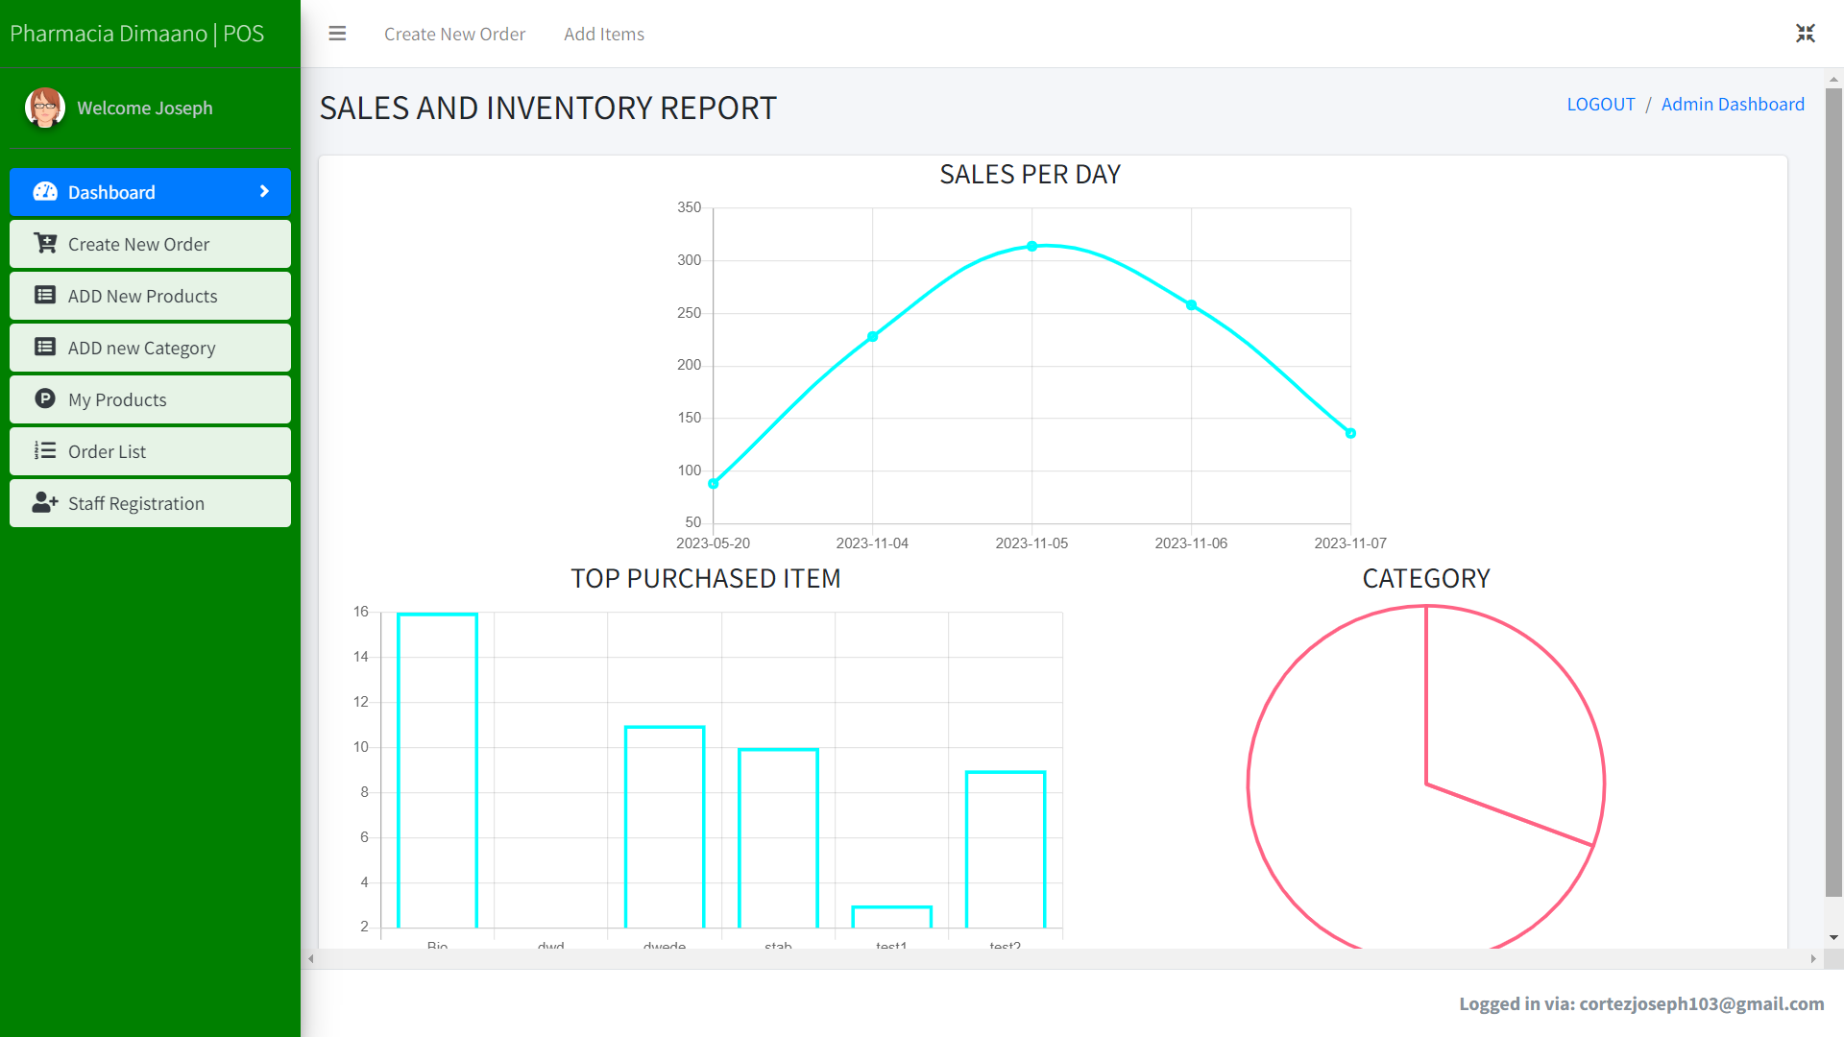

1. The section 'create new order' facilitates a new transaction between customer and employee. It doesn't require a name field and uses a datetime picker for accurate transaction records. To add products, use a barcode scanner, input quantity, and pay. Transaction receipts are stored in the order list section.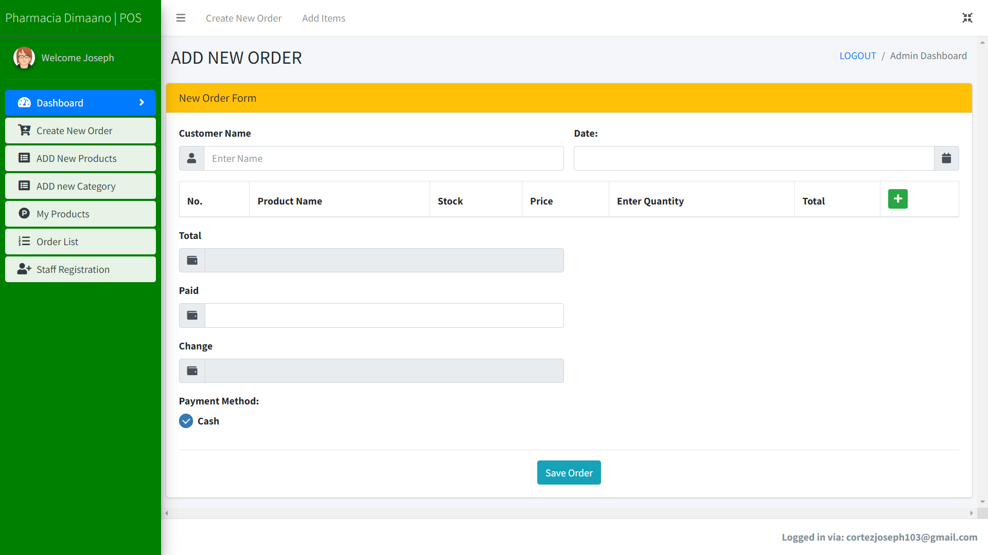
2. Add new product, this part of the system is important as it holds the crucial information that is needed in order to have a relationship with new transaction. To add a new product, just fill out all the required input fields and hit the add item button, the information provided in this section stored in product list panel.

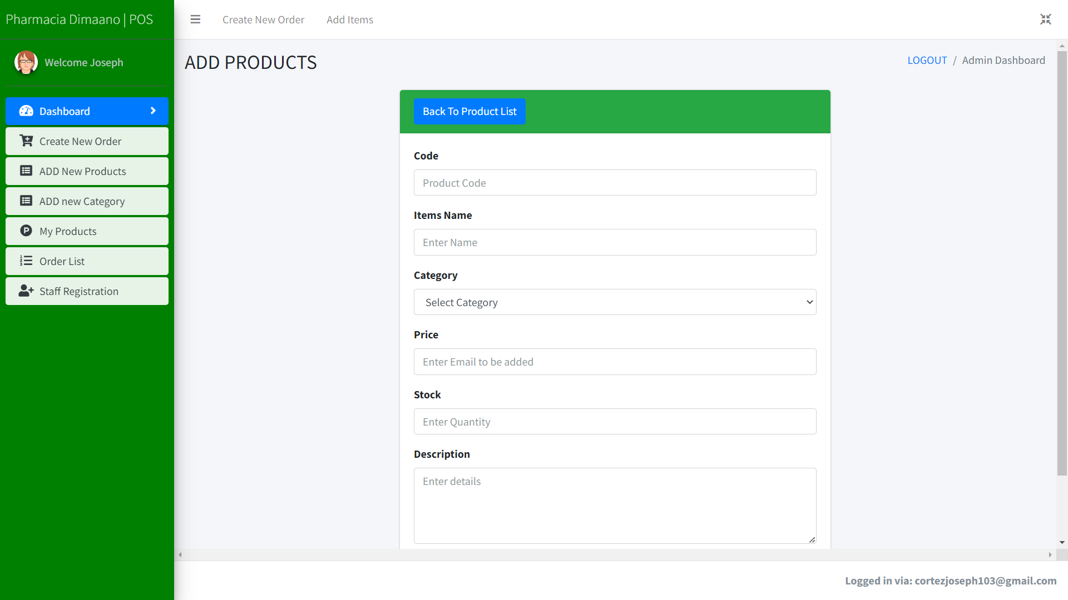

1. New Category, just input what category you want to be added, the data can be downloaded and printed, search bar to find a data in an easy way, and delete for removing an entry.

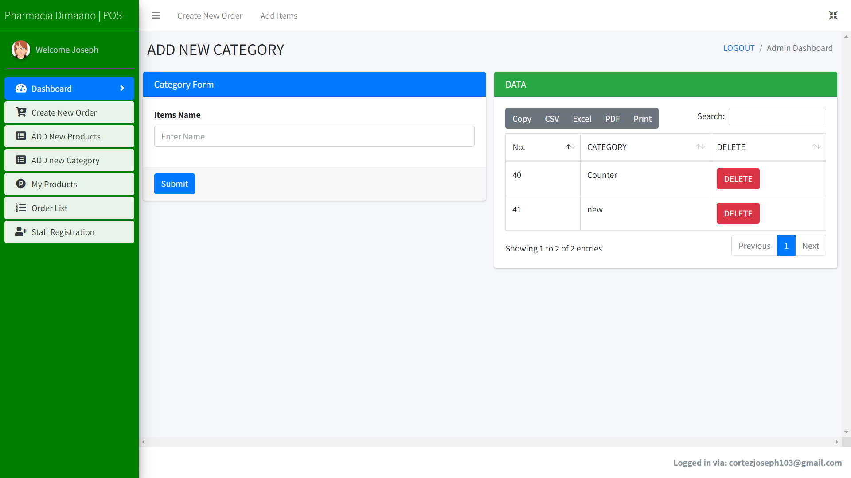

1. Product list, this represents as the inventory management of the system. It displays all the products stored in the system. It contains product code, product name, category, price, stock, and description. Edit button to modify information of a specific product, and delete for removing data. This part also contains different buttons for printing and downloading the data in different type of file.

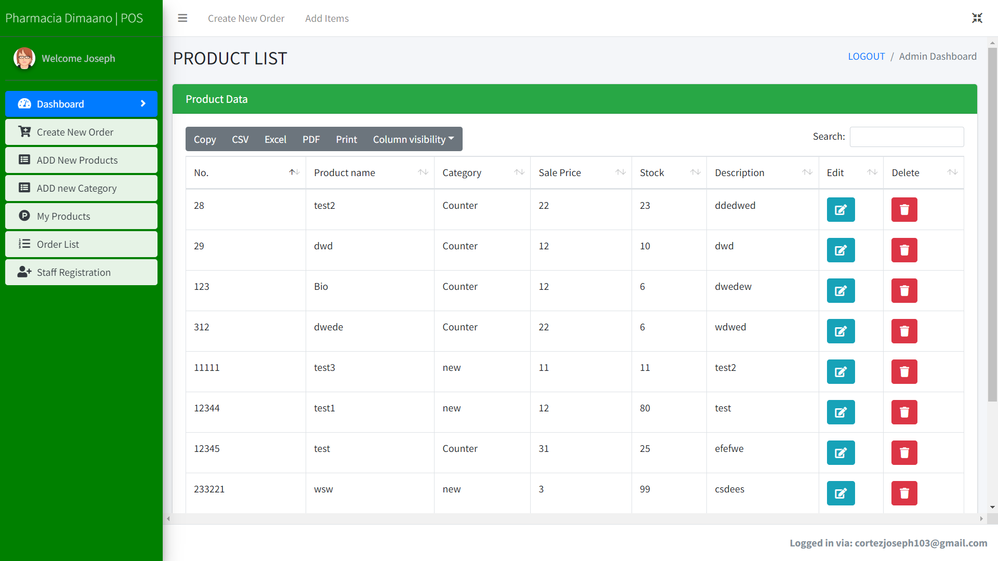

1. Order List, this section represents the transaction between the customer and employee. This panel contains, transaction id, customer name (optional), order date, total, paid, change, and payment type. All the data shown in this window are from the purchasing section. The admin also has the privilege to modify the information of a specific transaction, print a transaction, and delete. The entries can also be generated into excel file and pdf file.

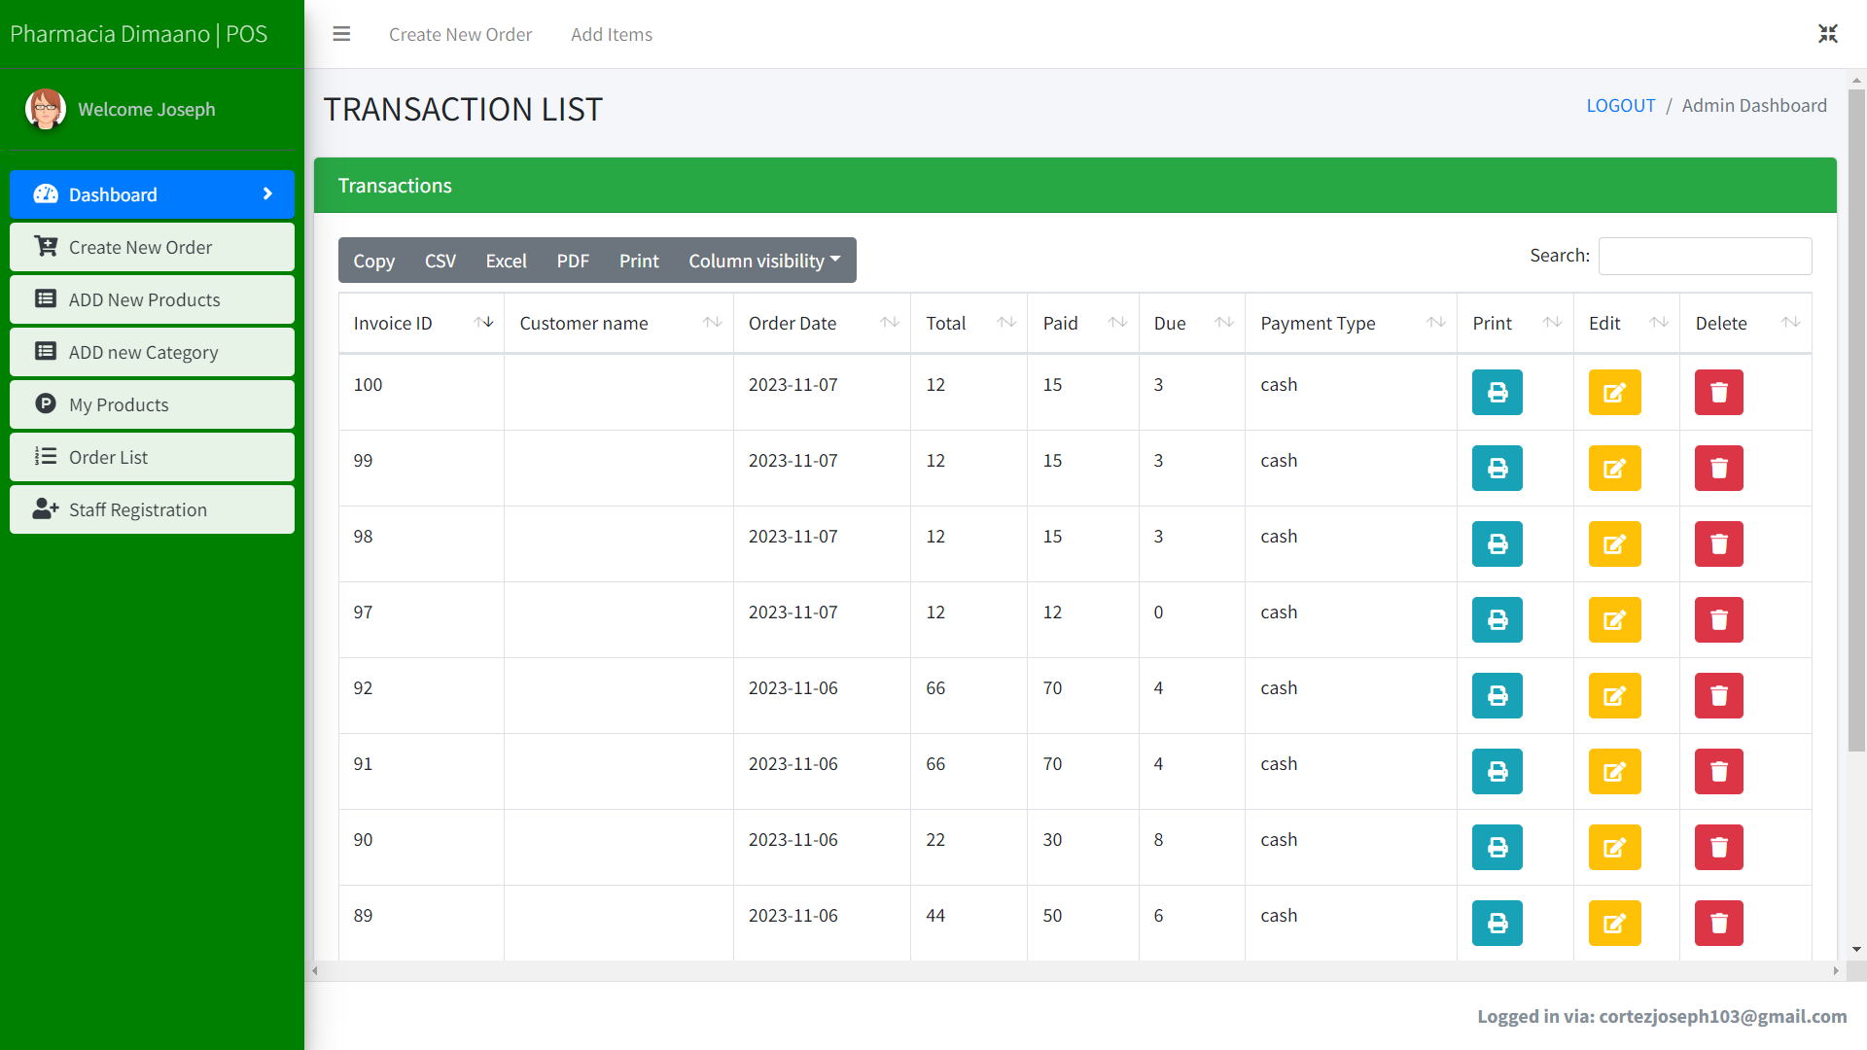

1. Staff registration, in this section happens the adding of new user for the system and this panel will only be shown for admin side for security purposes of data stored in the system. The required information for this activity are; user name, email, password, and role.

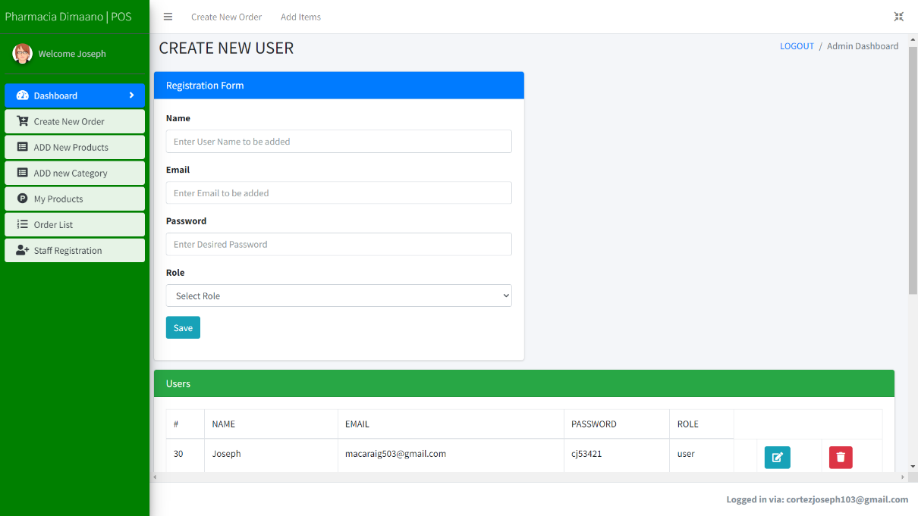

**Employee Dashboard**

1. 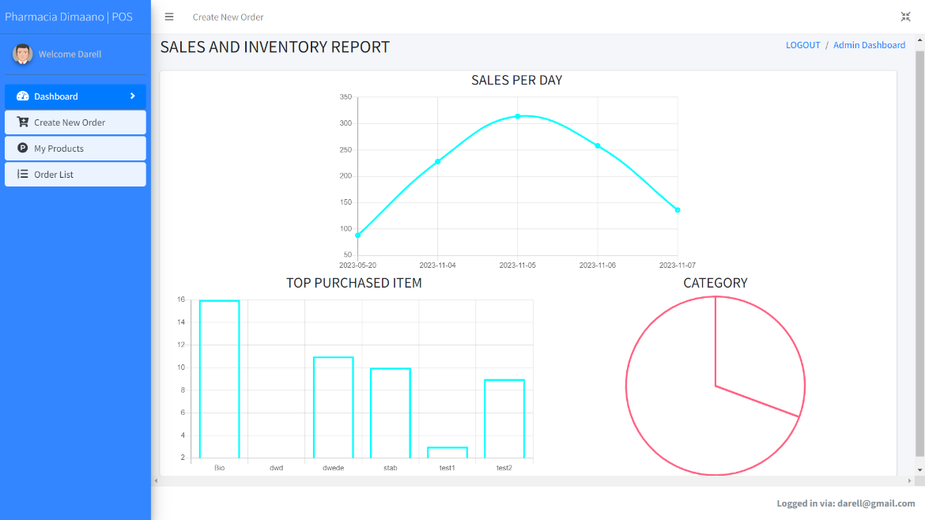In employee dashboard, the only with difference with the admin dashboard is, employee does not have any access to add new category and adding new product. Also employee dashboard is for viewing and printing of data only and it cannot be edited in this section.





**Joseph S. Cortez** is a 4th year college student of Batangas State University, The National Engineering University at Alangilan Campus pursuing the course of Bachelor of Science in Information Technology major in Business Analytics. He was awarded a Dean’s Lister Award for the Second Semester of School Year 2020-2021, First Semester of School Year 2021- 2022, and Second Semester of School Year 2022-2023. He graduated senior high school at STI College Batangas program in Mobile Application and Web Development (MAWD). He attended With Honors at Sto. Niño National High School during his junior year in high school.

He was born on April 01, 2002 in Batangas City. His elemental sign reflects on his personality. His determination and courage to do all the things that he wanted, is his one of his best personality because he always believed that “Dum vita est, spes est “ (While life is, hope is).



**Shaira Mae A. Lopez**, 21 years old, who was born in Conde Labac, Batangas City. She is currently taking up BS Information Technology major in Business Analytics in Batangas State University – The National Engineering University at Alangilan Campus. She completed her senior high school at STI College Batangas (2018-2020), where she studied (TVL) strand. She continues to study and practice to enhance her skills and prepare for her future career.

Her goal is to help her family, but after graduation, she wants to find a stable job to better support her family. According to “Matthew 6:33, we should seek God above everything else in our lives, and all else will be supplied for us.” Education is vital, but it should never come before your relationship with God. When we put Him first in all our worries and all we do, we can trust that He will take care of the rest. As the semester progresses, you'll quickly find that college demands more effort and time. It's natural to feel stressed but make time to talk to God. Encourage oneself through prayer and Bible reading. From high school to college and beyond, life is full of experiences that push us to be our best. Never forget that God is near, that He is eager to listen, and that he can help.



**Darell Marius S. Lucero** is a 4th year college student in Batangas State University at Alangilan campus where he takes Information Technology major in Business Analytics. He was born and raised in Batangas City, living nearly a walking distance from the Alangilan campus. He was once placed in the dean’s list. His desire to take Information Technology honed from his childhood hobby that is playing video games. He was once unsure on what track he will take going into senior high, but the opportunity of going into the field of technological advancement and the jobs that it can offer is expanding, he was assured that it will not disappoint him on finding jobs that suits him.